**How to find *Acland Anatomy* and *Human Anatomy (Gale Interactive)***

Go to the SMC Library site:

smc.edu/student-support/academic-support/library or it is under ‘STUDENT SUPPORT’ from the main SMC webpage.

You will want to click on “Databases”. On the “Databases” pages, you will find both alphabetically. So the ***Acland Anatomy*** is found on this first page in fact. You will have to go to the letter “H” for ***Human Anatomy (Gale Interactive)*** to find that link. Good luck.

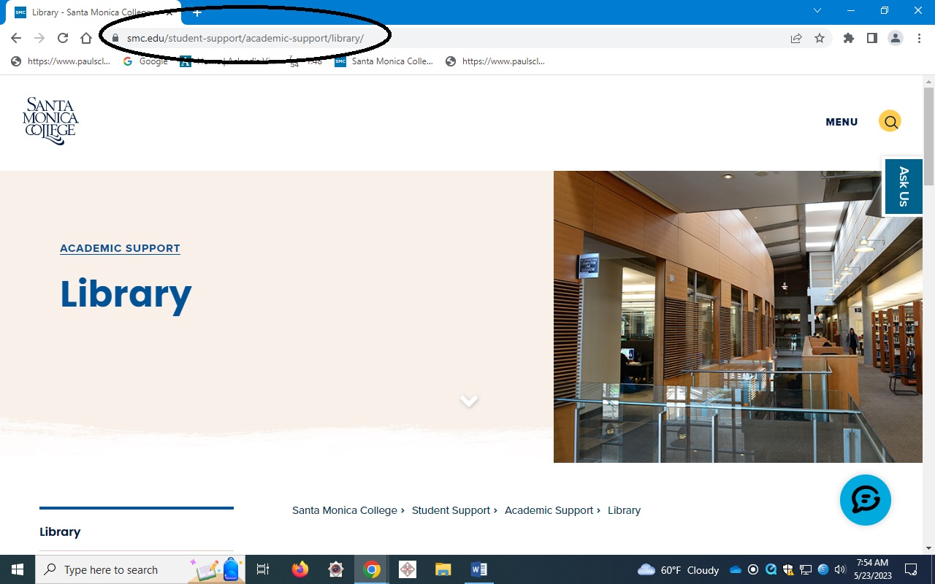

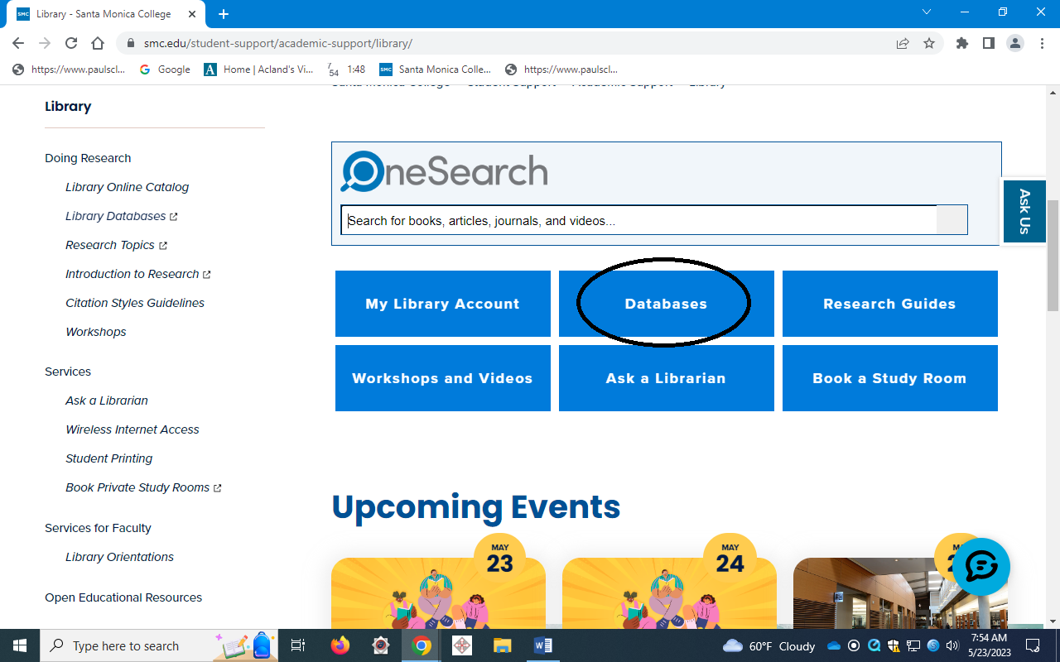

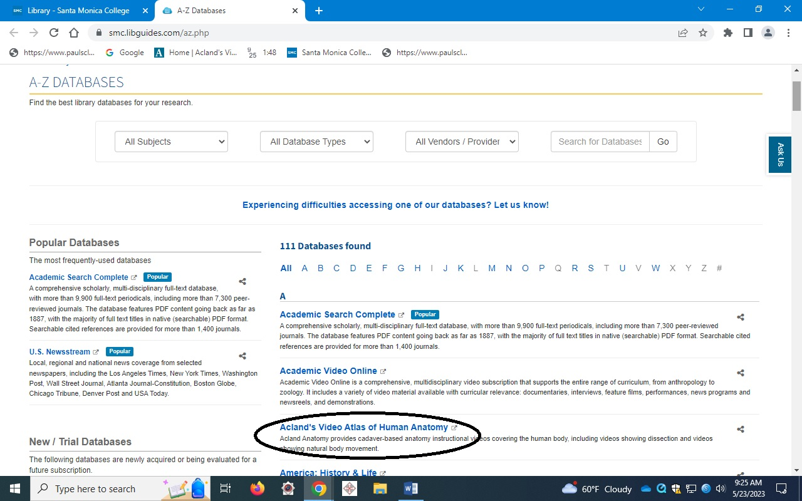

And if you click on “H”, and go directly to the “H’s”, you will find ‘Human Anatomy (Gale Interactive)’:

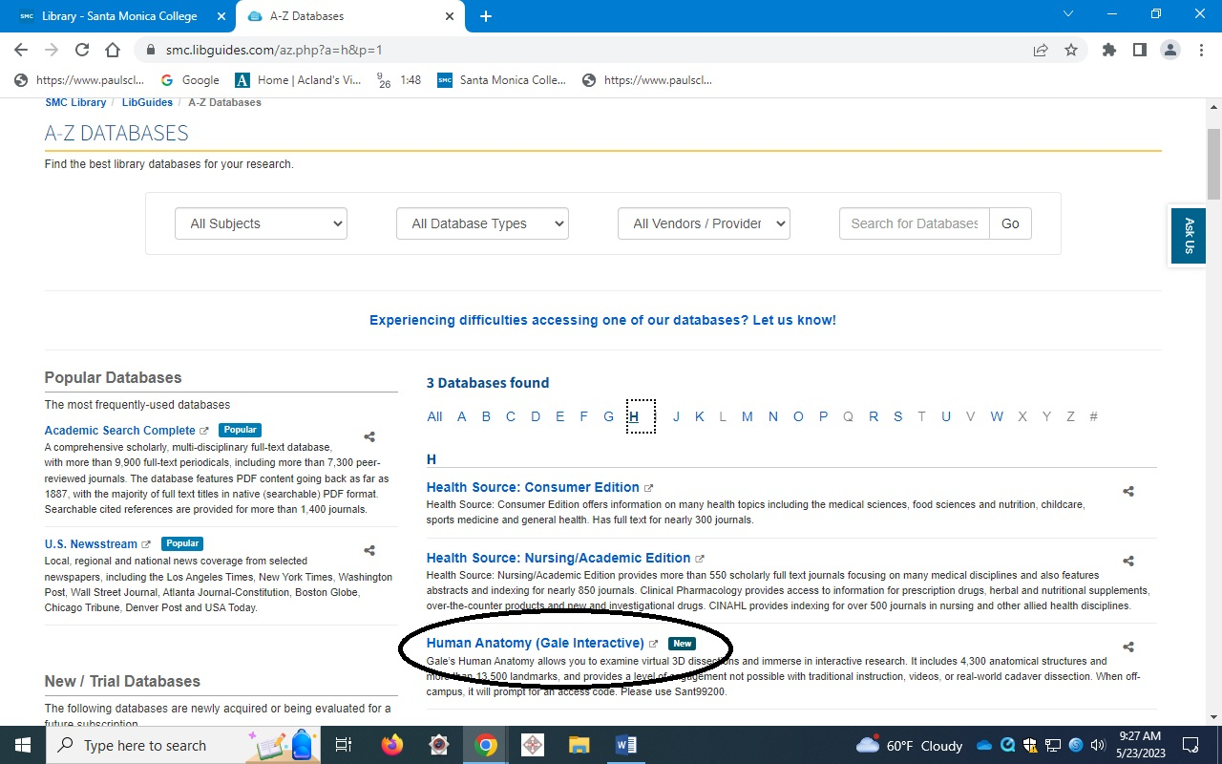

Or you can find both directly if you search “Human Anatomy” under the Databases search. On the Databases page, go to the search box and type in ‘human anatomy’ and click.

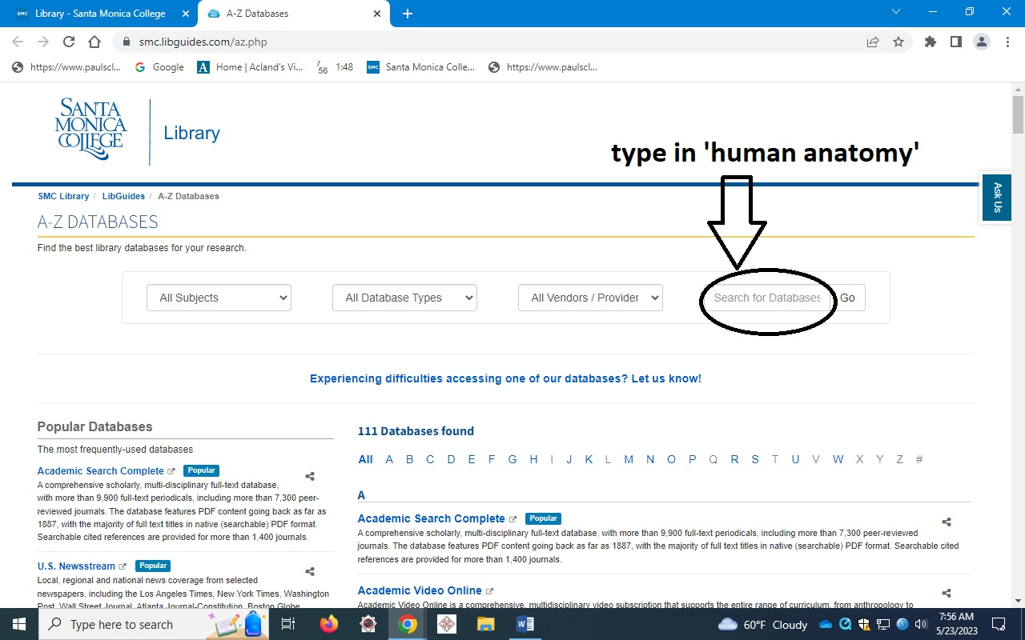

And there you see below, both links you need for Ana-1.

