How to use Microsoft Word for your assignments for free from the SMC website.
Click on this address:
https://smc.teamdynamix.com/TDClient/259/ITPortal/KB/ArticleDet?ID=3788
Or Go To: www.smc.edu;
-click on ‘student support’ at the top of the homepage;
-scroll down ¾ of the way down this page to find ‘Student Services’. Under ‘Student Services’ click on ‘Office 365 for Students’.
At the bottom of this new, short page, click on ‘Please visit our knowledge base article about Microsoft Office 365 through this link’.
(Note: Microsoft Word is part of Microsoft Office 365.)
You will find screens that look like this. Just follow the directions. Enjoy.
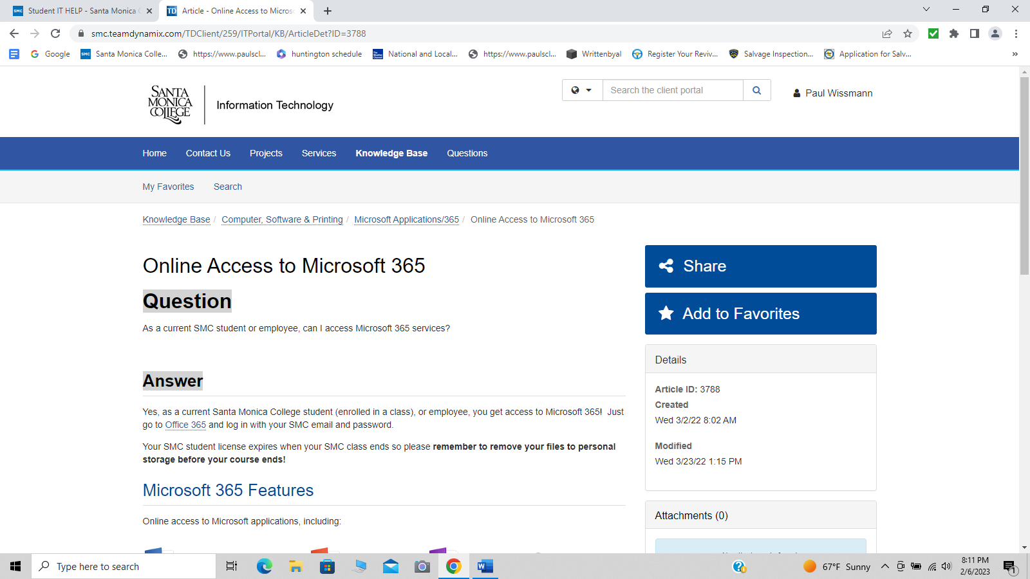
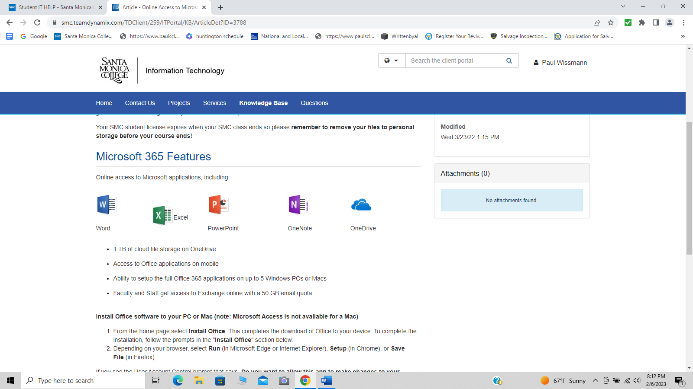
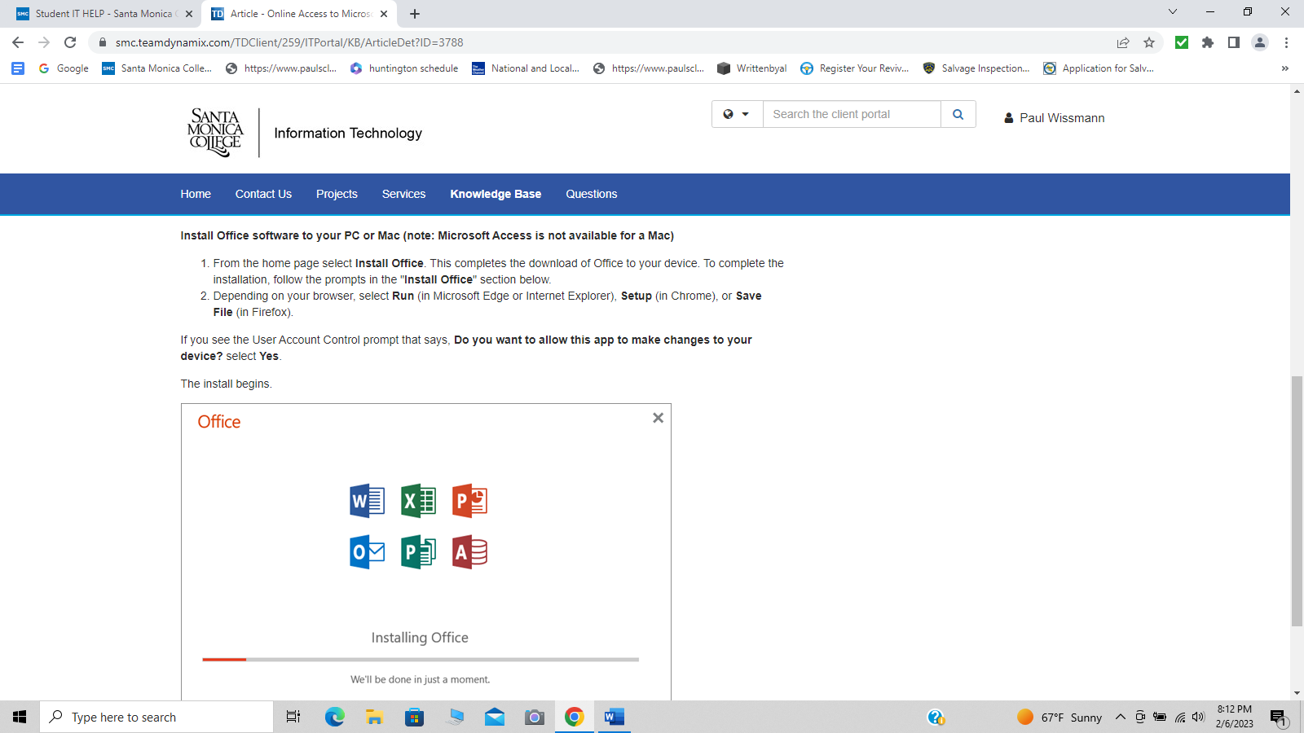
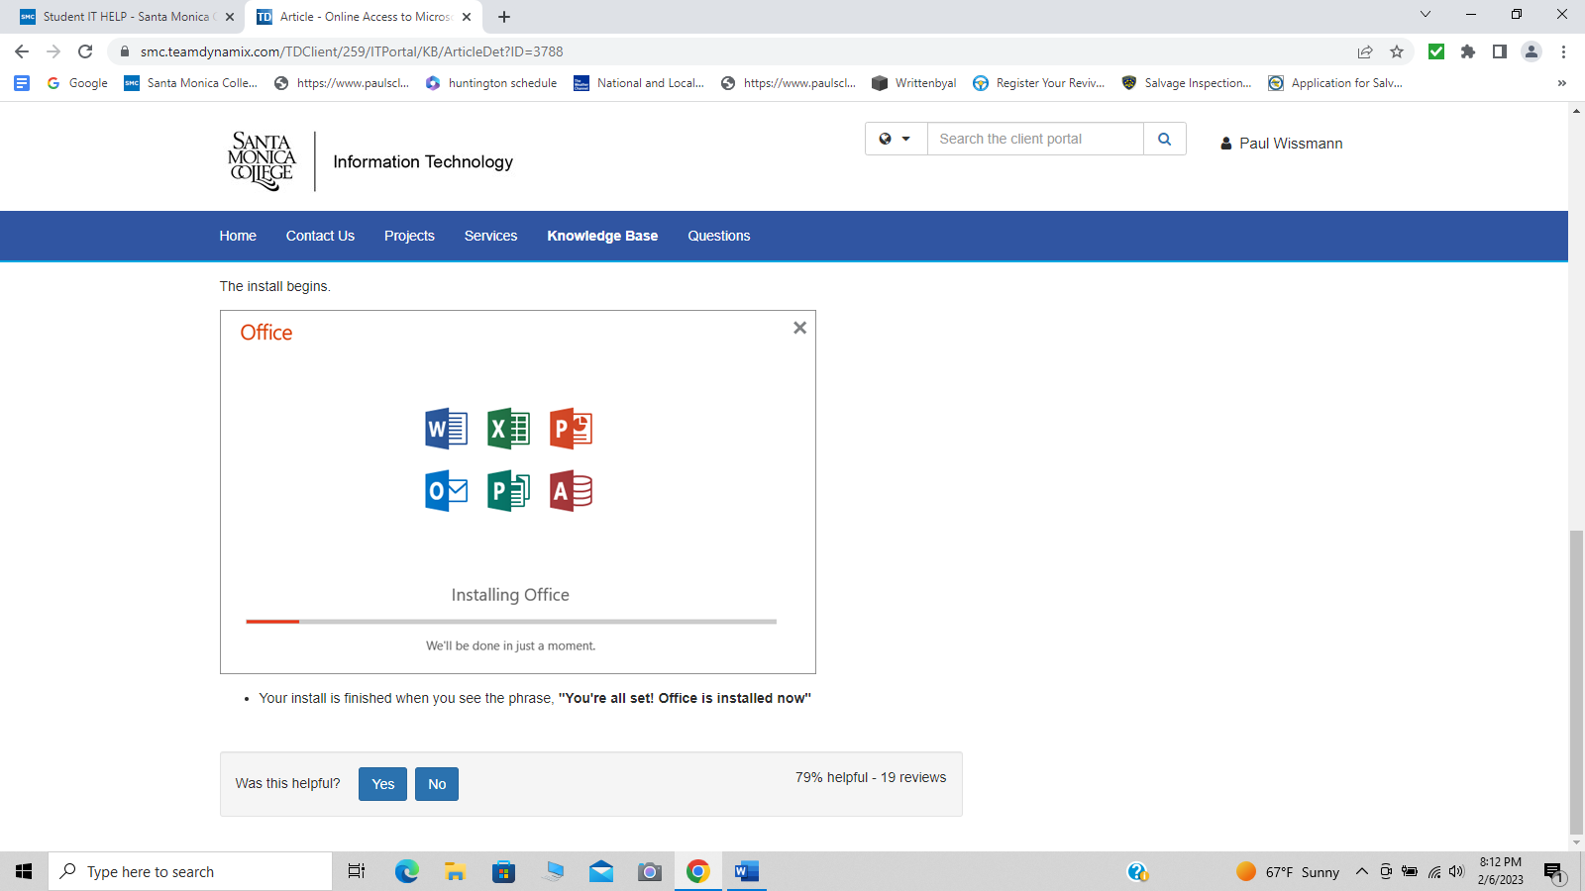
The end.

