**Alcohol Metabolism in the body by the liver:**

By inhibiting the firing of electrical impulses in neurons, alcohol can impair judgment, coordination, alertness, memory, and visual perception, among other things. Exactly, how does alcohol achieve all of these unrelated effects?

Alcohol affects the function of specific proteins or [**receptors**](https://sites.duke.edu/apep/glossary-of-terms/#receptors) embedded in the membranes of neurons. Alcohol can interact with a variety of neurotransmitter receptors, but at non-fatal concentrations of alcohol in the brain, alcohol interacts primarily with receptors for the amino acid neurotransmitters [**γ-aminobutyric acid**](https://sites.duke.edu/apep/glossary-of-terms/#gaba) (or GABA) and [**glutamate**](https://sites.duke.edu/apep/glossary-of-terms/#glutamate) (the same amino acid found in “Chinese food” seasoning—MSG or mono-sodium glutamate). When alcohol binds to GABA and glutamate receptors, it causes many of the intoxicating symptoms that develop when one drinks too much.

How does this happen? To answer this, it’s helpful understand how these neurotransmitter receptors function in a neuron. A closer look at these neurotransmitter receptors reveals that they consist of several smaller proteins (called subunits) arranged to form a pore or channel in the middle. Normally the channel is closed. But when the neurotransmitter binds to the receptors, the channels will open briefly, allowing small [**cations**](https://sites.duke.edu/apep/glossary-of-terms/#cations) such as sodium (Na+) or calcium (Ca2+) or [**anions**](https://sites.duke.edu/apep/glossary-of-terms/#anions) such as chloride (Cl-) to pass into or out of the cell, along the concentration gradient. The type of ion that moves through the channel depends on the whether it’s a GABA or a glutamate receptor.

As ions move through the receptor channels, and threshold is reached, an action potential is achieved. When positive ions (current) enter the cell, neurons fire electrical impulses. When negative charges (current) enter the cell, neuron firing is suppressed.

When GABA binds to its receptor, it opens a Cl- gate, allowing negative Cl- ions to enter the cell, hyperpolarizing the neuron, making its resting membrane potential even more negative. Hence, GABA is an inhibitory neurotransmitter.

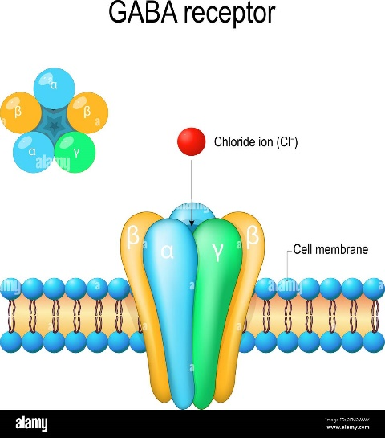 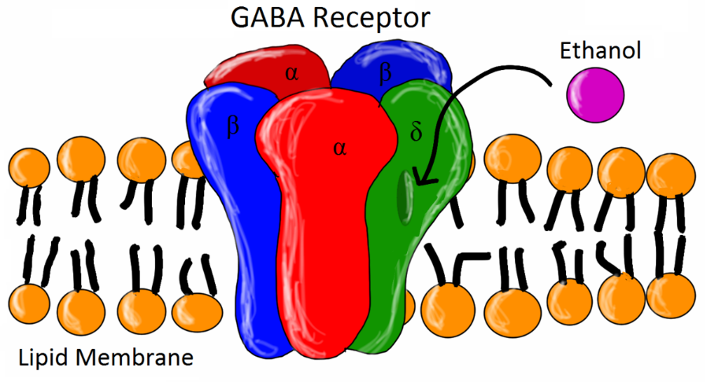

So notice that the GABA receptor is made up of several subunit proteins (shown in different colors).

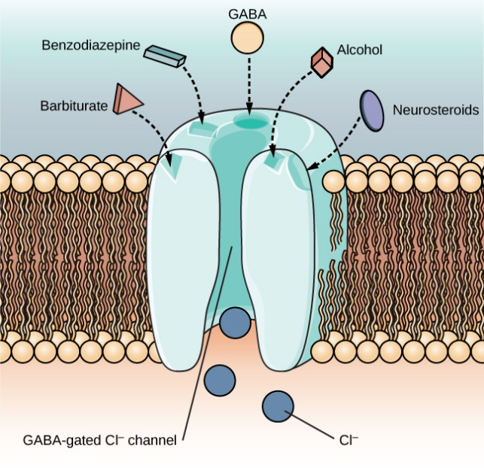Notice in the diagram to the left, the GABA receptor has several binding sites: the GABA neurotransmitter binding site; the alcohol binding site; a binding site for barbiturates; a binding site for benzodiazepines. All of these molecules will open the GABA Cl- channel allowing Cl- to diffuse in, acting in an inhibitory way.

Alcohol works in a “double-duty” fashion. It can bind to GABA receptors to hold the ion channel open longer. This increases the amount of chloride ions (negative charges) entering the neuron. Also, alcohol can bind to glutamate receptors (glutamate receptors are also known as NMDA receptors), where it decreases the amount of sodium and calcium (positive charges) entering the neuron. In both cases, the result is that the environment inside the cell becomes more “negative” and this suppresses the electrical activity (i.e., the firing rate) of the neuron. Thus, communication at the GABA synapses is slowed.

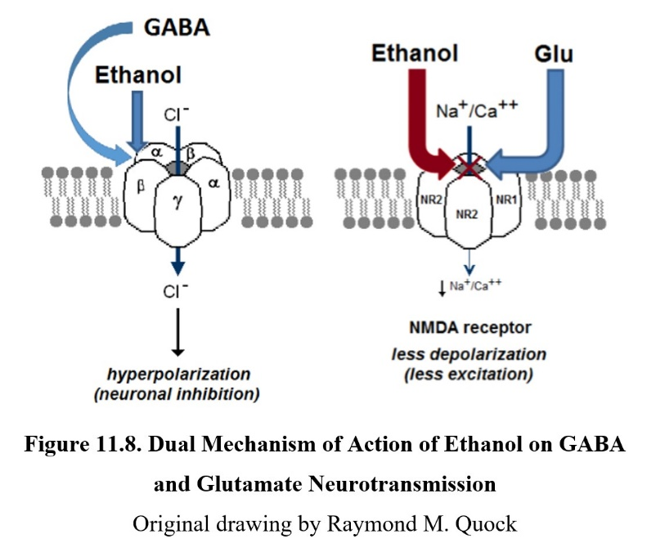The suppression of neural communication causes most of the symptoms of intoxication. The particular symptom of intoxication will depend on where in the brain the suppression of neuron activity occurs. As the blood alcohol concentration increases, new symptoms of intoxication emerge.

Interestingly, repeated use of alcohol can make it harder to get intoxicated, so a person will drink more alcohol to achieve intoxication. This is called [**tolerance**](https://sites.duke.edu/apep/glossary-of-terms/#tolerance). We will explain that later.

Alcohol acts at both GABA and glutamate (NMDA) receptors to decrease the rate of neuron firing. The suppression of neural communication in specific areas of the brain leads to intoxication.

When a person drinks alcohol repeatedly, it takes more drinks to become intoxicated. This means that the person has developed [**tolerance**](https://sites.duke.edu/apep/glossary-of-terms/#tolerance) to alcohol. Tolerance is a consequence of two changes in the body. With repeated use of alcohol, the targets (i.e., GABA receptors) for alcohol adapt by decreasing their number. Now, it’s harder for alcohol to produce its effects. Interestingly, one effect that does not show alcohol tolerance is death. In fact our biological defense mechanisms promote “passing out” from too much alcohol to protect against death. Unfortunately, drinking too much too fast increases the blood alcohol content to a lethal level, bypassing tolerance.

Second, liver cells respond by making more enzymes to metabolize (break down) alcohol. The increased metabolism means there is less alcohol in the body. In both of these situations, the person will drink more alcohol to try and achieve the original effect. By drinking more, the liver enzymes become saturated and some alcohol that was not broken down can move into and out of the liver intact, eventually getting to the brain and CNS. These cellular adaptations and the development of tolerance are key to the progression to addiction.

Researchers have shown that repeated episodes of binging and drinking to intoxication substantially increases the risk of alcohol addiction (now called alcohol use disorder). Once the person is addicted to alcohol, he/she no longer has control over drinking. The loss of control and craving that ensues when the alcohol isn’t available are due to changes that take place in the brain.

One serious change that can result from repeated drinking is shrinkage of the brain. The shrinkage is probably due to a loss of neurons (grey matter) and glial cells (white matter), the other major type of cell in the brain. The shrinkage happens especially in areas of the brain that are important in learning and memory, such as the cerebral cortex and the hippocampus.

The brain adapts to the repeated use of alcohol by decreasing the GABA receptors with which alcohol interacts. This adaptation can explain the development of alcohol tolerance, which can progress to addiction.

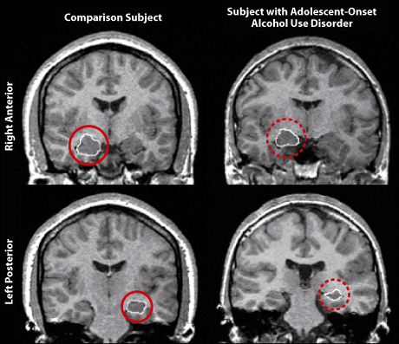

Brain scans (magnetic resonance imaging or MRI) show a smaller hippocampus (in the red circles) in a person with adolescent alcohol-use disorder (right) compared to a healthy person of the same age (left). (Adapted from M.D. De Bellis, with permission). Learn how an MRI is obtained.

Genetics can have a profound influence on the degree of alcohol intoxication, and the basis for this influence lies in our ability to metabolize alcohol. Alcohol is metabolized by enzymes in 2 steps. The first enzyme, **alcohol dehydrogenase** (ADH) helps oxidize ethanol to acetaldehyde, a relatively toxic molecule. The second enzyme, **acetaldehyde dehydrogenase** (ALDH) detoxifies acetaldehyde by helping to oxidize it to acetic acid (vinegar).

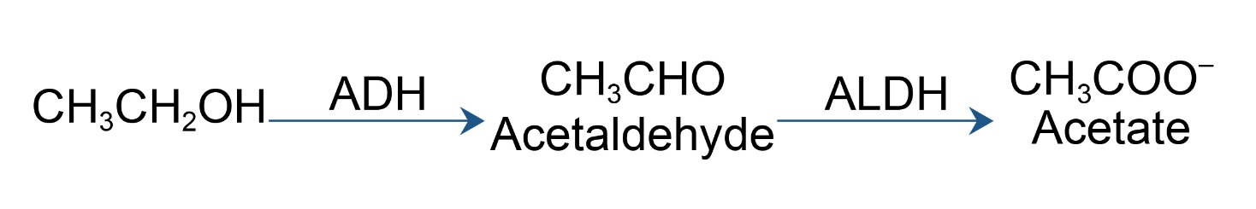

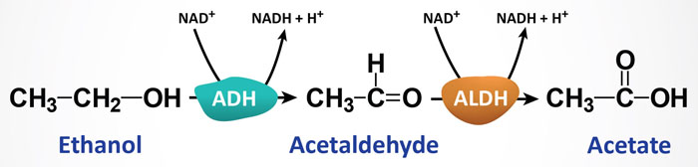

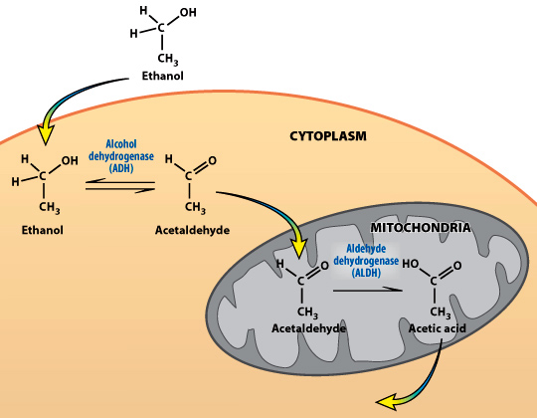

ADH located in the cytoplasm converts alcohol to acetaldehyde, which is toxic. But ALDH in the mitochondria quickly converts acetaldehyde into acetic acid.

All of our proteins, including the two alcohol metabolizing enzymes (ADH and ALDH) are synthesized under the instructions encoded by specific genes. Interestingly, humans have as many as seven different ADH genes and nine different ALDH genes. Of these multiple genes, some are more important than others in their influence on intoxication. Genes are long stretches of [**deoxyribonucleic acid or DNA**](https://sites.duke.edu/apep/glossary-of-terms/#dna). DNA, the “code of life”, is built from combinations of four bases: cytosine, adenine, thymine, and guanine or C, A, T, and G, respectively. Subtle changes in the sequence combinations of these four bases in long stretches of DNA code contribute to genetic diversity among individuals in the population. Genes that exist in multiple forms within the human population are polymorphic genes, while genes that exist in a single form are monomorphic. Let’s consider how different alcohol metabolizing genes affect the degree of intoxication.

**The ADH gene: Helps get rid of alcohol**

Of the seven forms of ADH protein (i.e. ADH1-7), the ADH2 form is highly expressed in the liver. The ADH2 enzyme accounts for most of the alcohol metabolism. Scientists have found three different versions of the ADH2 gene in the human population. These genetic polymorphisms of the ADH2 gene arise from small mutations. One ADH2 polymorphism has been linked with an increased susceptibility to developing alcoholism in Caucasians.

Alternatively, the ADH7 gene is [**monomorphic**](https://sites.duke.edu/apep/glossary-of-terms/#monomorphic) (only one form of the gene exists in the human population). ADH7 is highly expressed in the stomach and metabolizes about 30% of the alcohol before it is absorbed into the blood. One of the reasons females are more sensitive than males to the intoxicating effects of alcohol is because females do not express the ADH7 protein in their stomachs (even though they have the ADH7 gene!) The ADH7 gene in females is not transcribed and translated to protein – it’s switched off or “silent”.

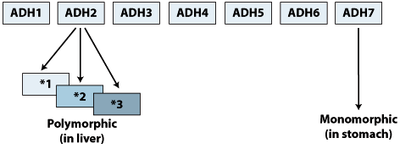

*Of the 7 ADH genes, the ADH2 is polymorphic (3 different forms) and the ADH7 is monomorphic.*

**The ALDH gene: Helps get rid of acetaldehyde, a toxin**

Half of Oriental Asians inherit an ALDH allele (ALDH2) that codes for a nonfunctional ALDH enzyme. The ALDH2 allele carries a single base mutation (a G is converted to an A) to render it non-functional. Normally the ALDH enzyme breaks down acetaldehyde to acetic acid, but the enzyme encoded by the ALDH2 allele can’t carry out this task.

Acetaldehyde levels in individuals expressing the non-functional enzyme can be 20 times higher than the levels of individuals expressing the functional enzyme. This is because the ALDH enzyme is responsible for the break-down of acetaldehyde to acetic acid in the body. Because they are not able to metabolize the acetaldehyde, Oriental Asians with the ALDH2 allele feel sick when they drink ethanol. Their symptoms can include a flushed face, headache, nausea, and a rapid heart rate. As a result, the high levels of acetaldehyde cause such an unpleasant feeling that people with the ALDH2 allele don’t drink alcohol. In fact, alcoholism is virtually unknown in people with this allele. The gene has actually protected them from alcohol addiction.

Although most of the nine ALDH genes are polymorphic, ALDH2 is the single genetic factor that most strongly correlates with the incidence of alcoholism in humans.

The alcohol flush reaction is a type of alcohol intolerance—not an “alcohol allergy”—and is a condition predominantly due to inherited variations in genes of certain enzymes, causing people to [metabolize alcohol](https://www.niaaa.nih.gov/publications/alcohol-metabolism) less efficiently.

During alcohol metabolism, the enzyme alcohol dehydrogenase (ADH) converts alcohol to acetaldehyde, a toxic molecule. The resulting acetaldehyde is metabolized to nontoxic molecules by another enzyme called aldehyde dehydrogenase (ALDH). If acetaldehyde is not metabolized efficiently, it can cause release of histamine and thereby trigger flushing and other unpleasant symptoms.

The primary feature of the alcohol flush reaction is a red face—or flush—but it can also be accompanied by hives, nausea, low blood pressure, the worsening of asthma, or an episode of migraine.

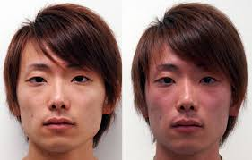 

[By the way, For most molecules, it’s not so easy to get into the brain. There is a barrier called the [**blood-brain-barrier**](https://sites.duke.edu/apep/glossary-of-terms/#blood-brain-barrier) that protects the brain from foreign substances that could potentially harm this highly specialized organ. Unfortunately for the brain, there is no barrier for ethanol. Ethanol crosses the blood-brain-barrier very easily since alcohol dissolves in water and lipid easily.]

[By the way again, alcohol consumption, has been shown to increase the risk of acquiring the following cancers.]

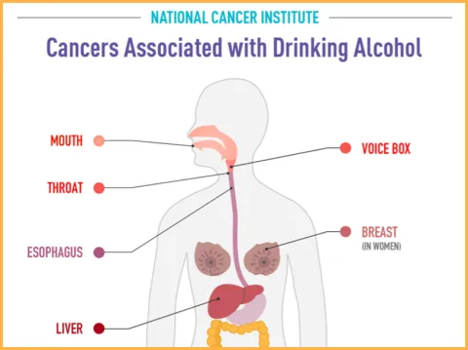

Further reading:

<https://sites.duke.edu/apep/module-3-alcohol-cell-suicide-and-the-adolescent-brain/>