BIOPAC: Lab 12: Pulmonary Function I: Volumes and Capacities:
The volume of air a person inhales (inspires) and exhales (expires) can be measured with a spirometer (spiro=breath, meter=to measure). A bell spirometer consists of a double-walled cylinder in which an inverted bell filled with oxygen-enriched air is immersed in water to form a seal (figs. 12.1). A pully attaches the bell to a recording pen that writes on a drum rotating at a constant speed. During inspiration, air is removed from the bell and the pen rises, recording an inspired volume. As expired air enters the bell, the pen falls and an expired volume is recorded. The resultant record of volume change vs. time is called a spirogram.
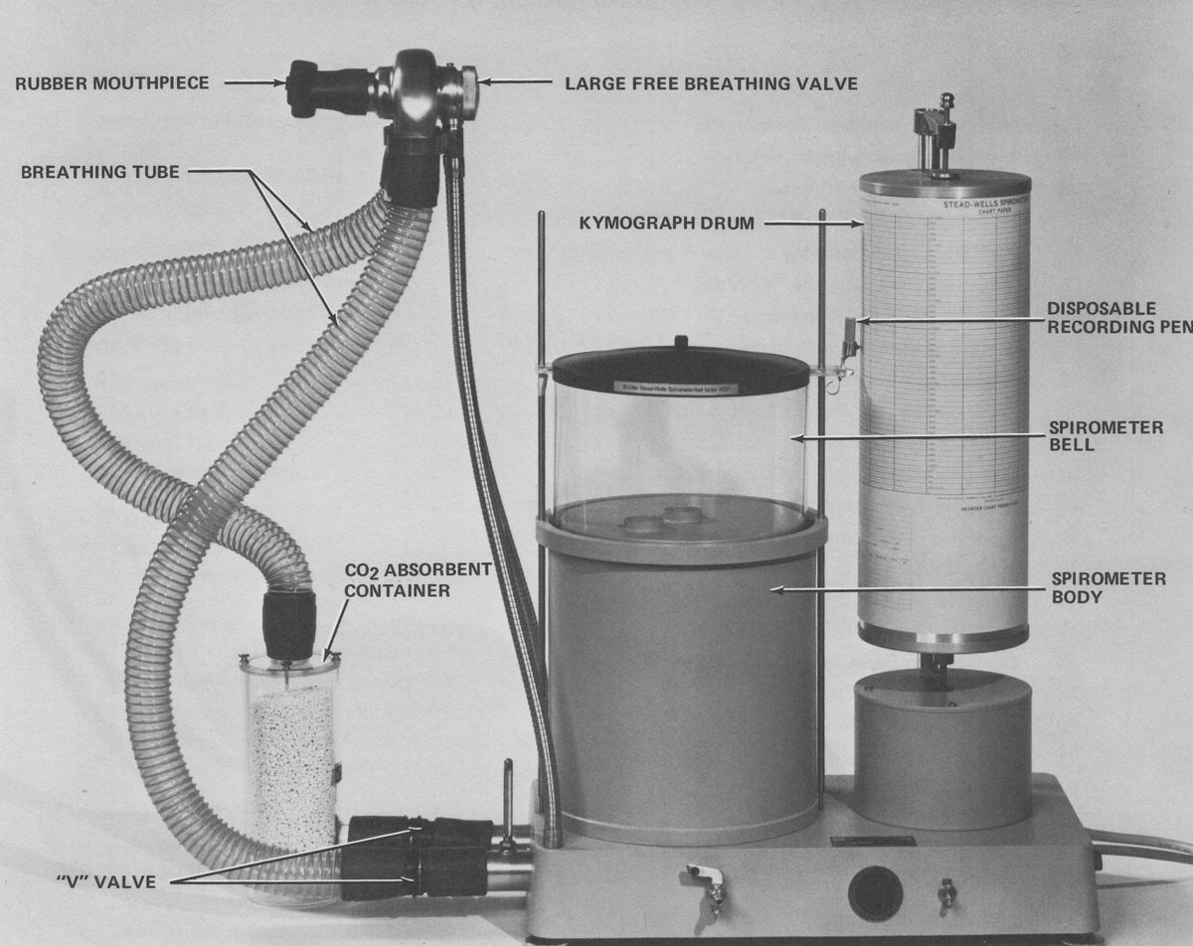
Did you notice our old bell spirometer by the door at the front of the classroom?
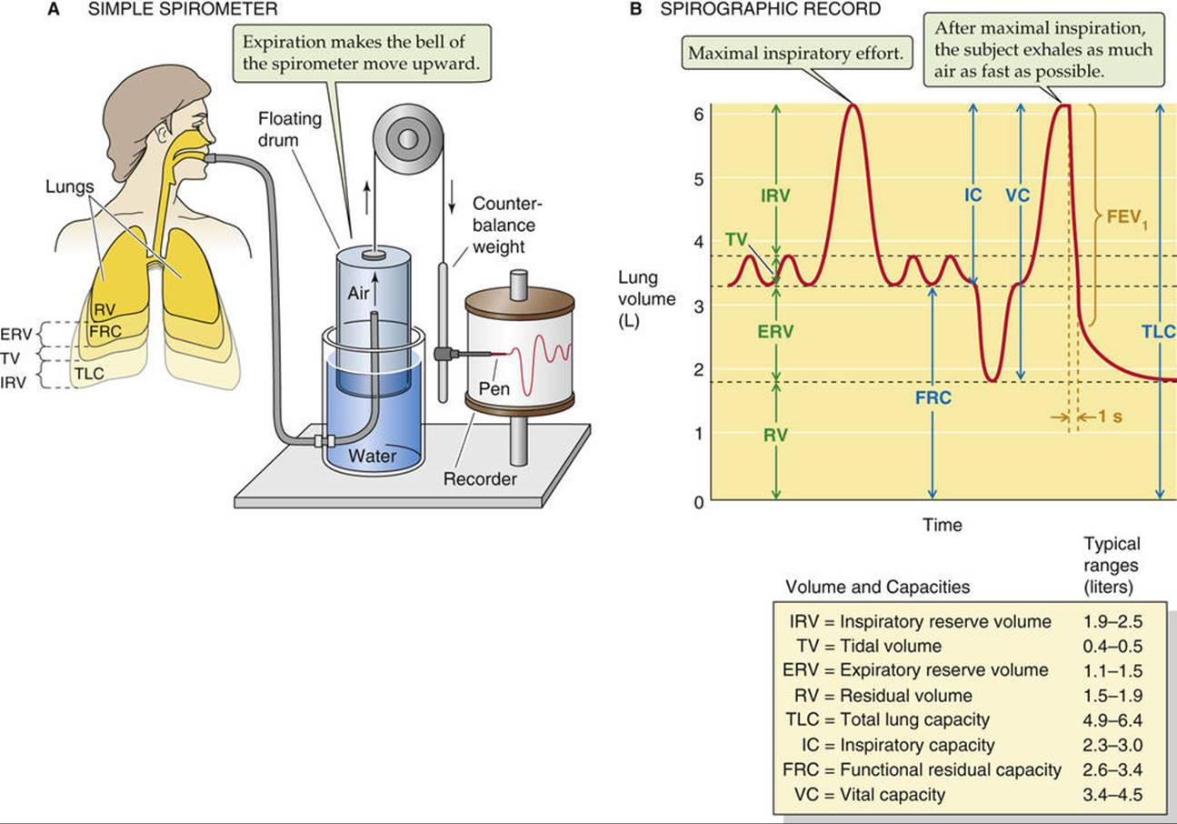
Figs. 12.1. You will notice our very own Bell Spirometer near the front door of our classroom. We will not be using the Bell Spirometer.
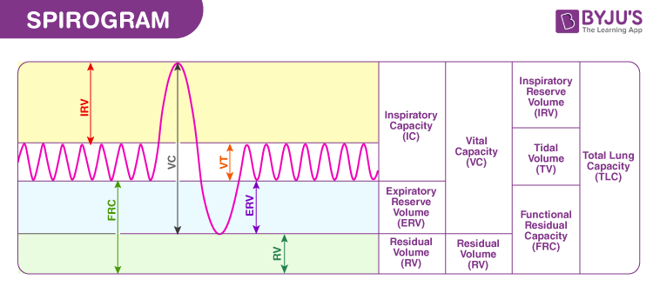
Fig. 12.2. Spirogram. All that spirometer can measure are the lung volumes that can be breathed in and out. Residual volume cannot be measured directly by a spirometer. Residual volume is the amount of air that remains in a person's lungs after fully exhaling. Reference values for RV are between 1.0 and 2.0 L but these values are dependent factors such as age, gender, height, weight, and physical activity levels.
The function of the residual volume is to keep the alveoli open even after maximum expiration. In healthy individuals, the RV allows for continual gas exchange to occur between breaths.
We will use these numbers for residual volume for this lab and lab 13. Average adult values for RV are 1,200 ml for males and 1,100 ml for females.
In this lab, you will use an airflow transducer and the software will convert airflow into volume, thus approximating the volume reading of a spirometer. This is a much quicker method of obtaining lung capacity data, however, the disadvantage is that the recording procedure must be followed exactly for an accurate conversion from airflow to volume.
There are four non-overlapping primary compartments of total lung capacity (fig. 12.2):
- Tidal volume 2) inspiratory reserve volume
3) expiratory reserve volume 4) residual volume
Tidal Volume is the volume of air inspired and expired during a single, quiet breath. When a resting person breathes normally, tidal volume is approximately 500 ml. During exercise, tidal volume can be more than 3 liters.
Inspiratory Reserve Volume is the volume of air that can be maximally inhaled at the end of a tidal inspiration. Resting IRV is approximately 3,300 ml in young adult males and 1900 ml in young adult females. The diagram below shows that you are NOT to include TV with IRV.
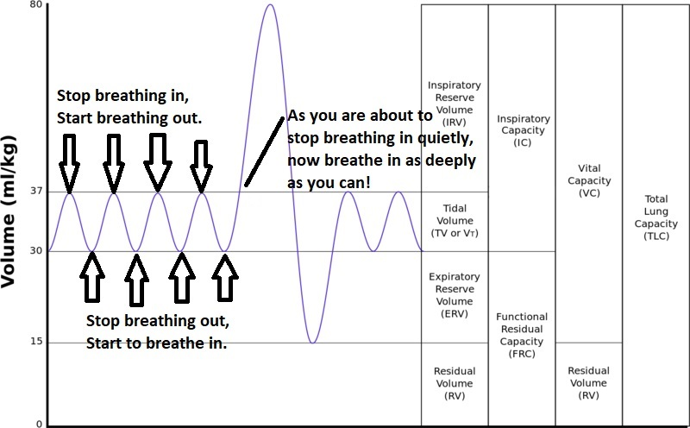
Expiratory Reserve Volume is the volume of air that can be maximally exhaled at the end of a tidal expiration. Resting ERV is approximately 1,000 ml in young adult males and 700 ml in young adult females. As with IRV, do NOT include TV with ERV.
Residual Volume is the volume of gas remaining in the lungs at the end of a maximal expiration. In contrast, IRV, TV and ERV, residual volume does not change with exercise. Average adult values for RV are 1200 ml for males and 1100 ml for females.
Pulmonary Capacity is the sum of two or more primary lung volumes. There are five pulmonary capacities, which can be calculated as shown below:
Inspiratory capacity (IC): IC = TV + IRV
Expiratory capacity (EC): EC = TV + ERV
Functional residual capacity (FRC): FRC = ERV + RV
Vital capacity (VC): VC = IRV + TV + ERV
Total lung capacity (TLC): TLC = IRV + TV + ERV + RV
Pulmonary volumes and capacities are generally measured when assessing health of the respiratory system because the volume and capacity values change with pulmonary disease. In asthma, the small airways are narrowed (constricted) making it harder for air to flow in and out, trapping more air in the lungs, hence, increasing the RV. Remember, in quiet breathing, the only force pushing air out of the lungs is the elastic fibers of the lungs going back to their normal lengths after having been stretched during inspiration (inspiration due to the contraction of the diaphragm muscle).
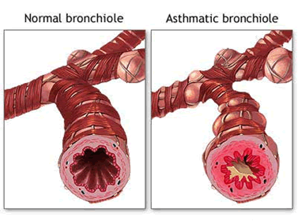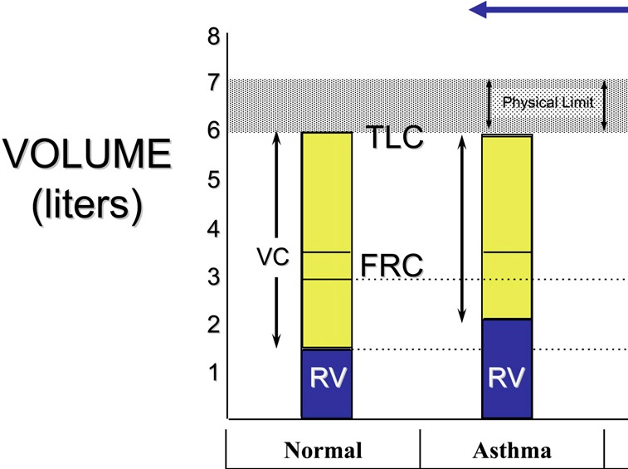
In this lesson, you will measure tidal volume, inspiratory reserve volume, and expiratory reserve volume. Residual volume cannot be measured using this BIOPAC apparatus. Use the values provided previously in this introduction. You will then calculate inspiratory capacity, vital capacity and the percent observed vital capacity to the average values for comparison. Next, you will compare your observed vital capacity with the predicted vital capacity.
The following equations can be used to obtain the predicted vital capacities for men or women of your height and age. Vital capacities are dependent on other factors besides age and height. Therefore, 80% of the calculated values are still considered normal.
EQUATIONS for Predicted Vital Capacity:
Male: VC = 0.052 X (Height-cm) – 0.022 X (Age) – 3.60
Female: VC = 0.041 X (Height-cm) – 0.018 X (Age) – 2.69
You can use the classroom metersticks to measure your height, either directly in cm, or measure in inches then convert.
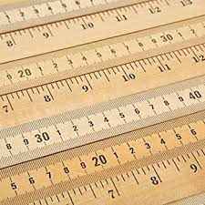
Experimental Methods:

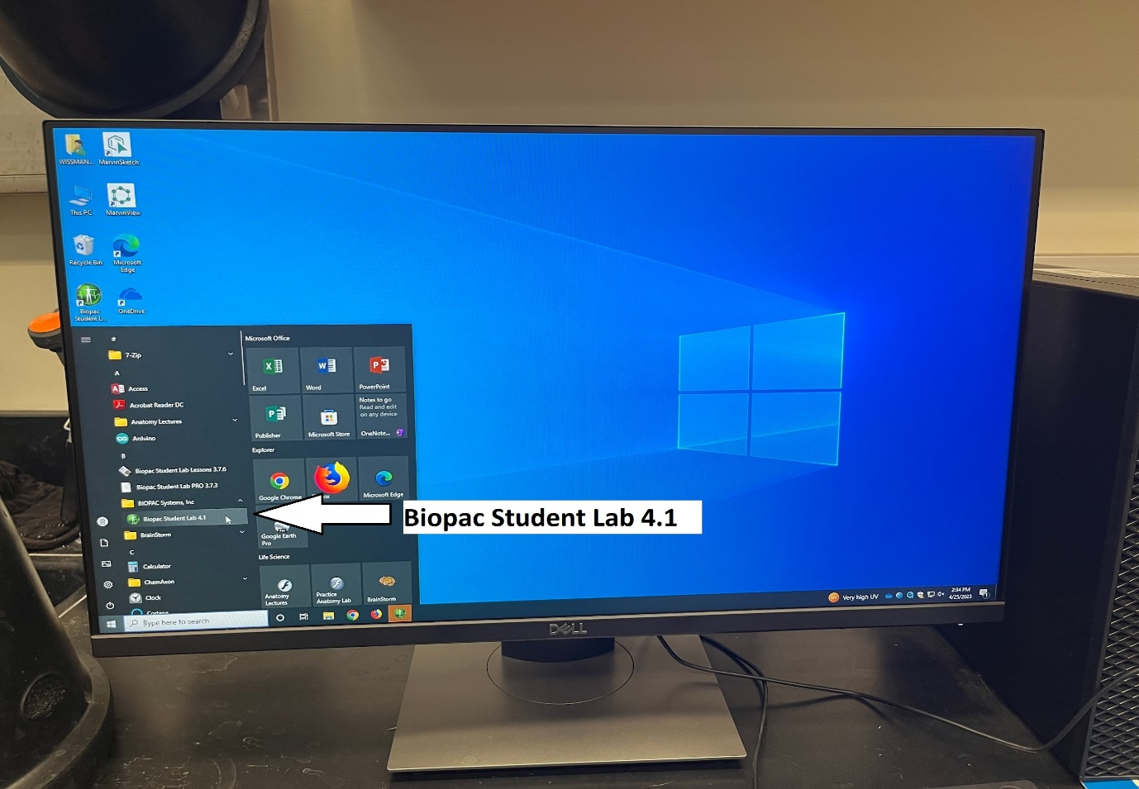
Go to one of the classroom desktop computers. Go to the lower left hand corner and click on the symbol, find BIOPAC in the alphabetic listing of all programs on this laptop computer.
BIOPAC Systems, Inc., choose ‘BIOPAC Student Lab 4.1’. There may be several BIOPAC programs to choose from. You must choose the BIOPAC Student Lab 4.1. You will see the screen shown below, click on ‘Record or Analyze a BIOPAC Lesson’, then choose L12 – Pulmonary Function I. (Note: You will repeat this process later to open L13 – Pulmonary Function II.)
To reiterate, for this step, click on L12 to highlight it and click OK.

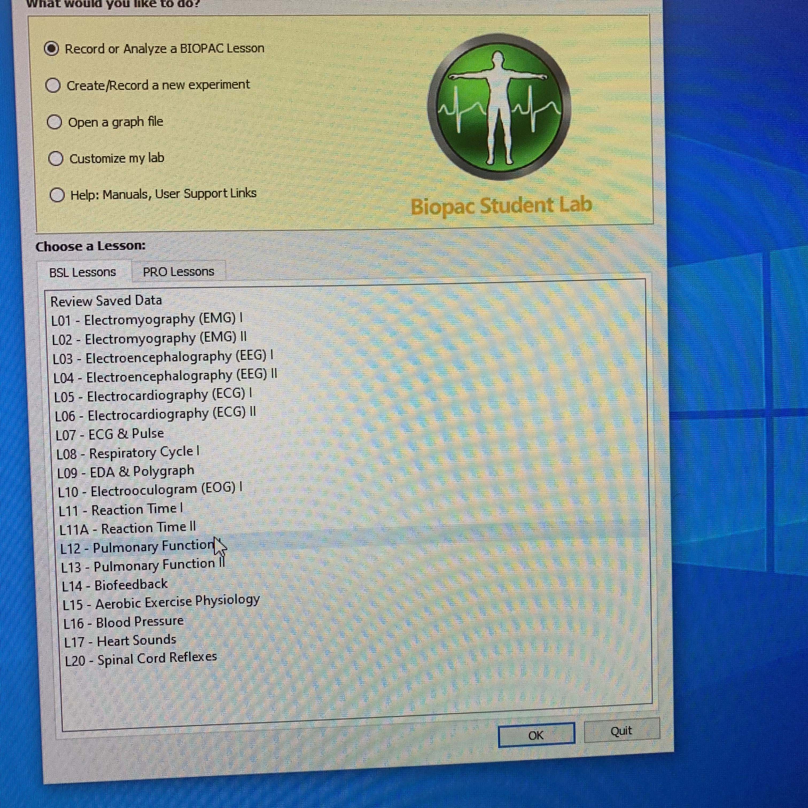

The screen seen below should now appear, enter your name, and then following the instructions by inputting your gender, age and height and clicking [OK].
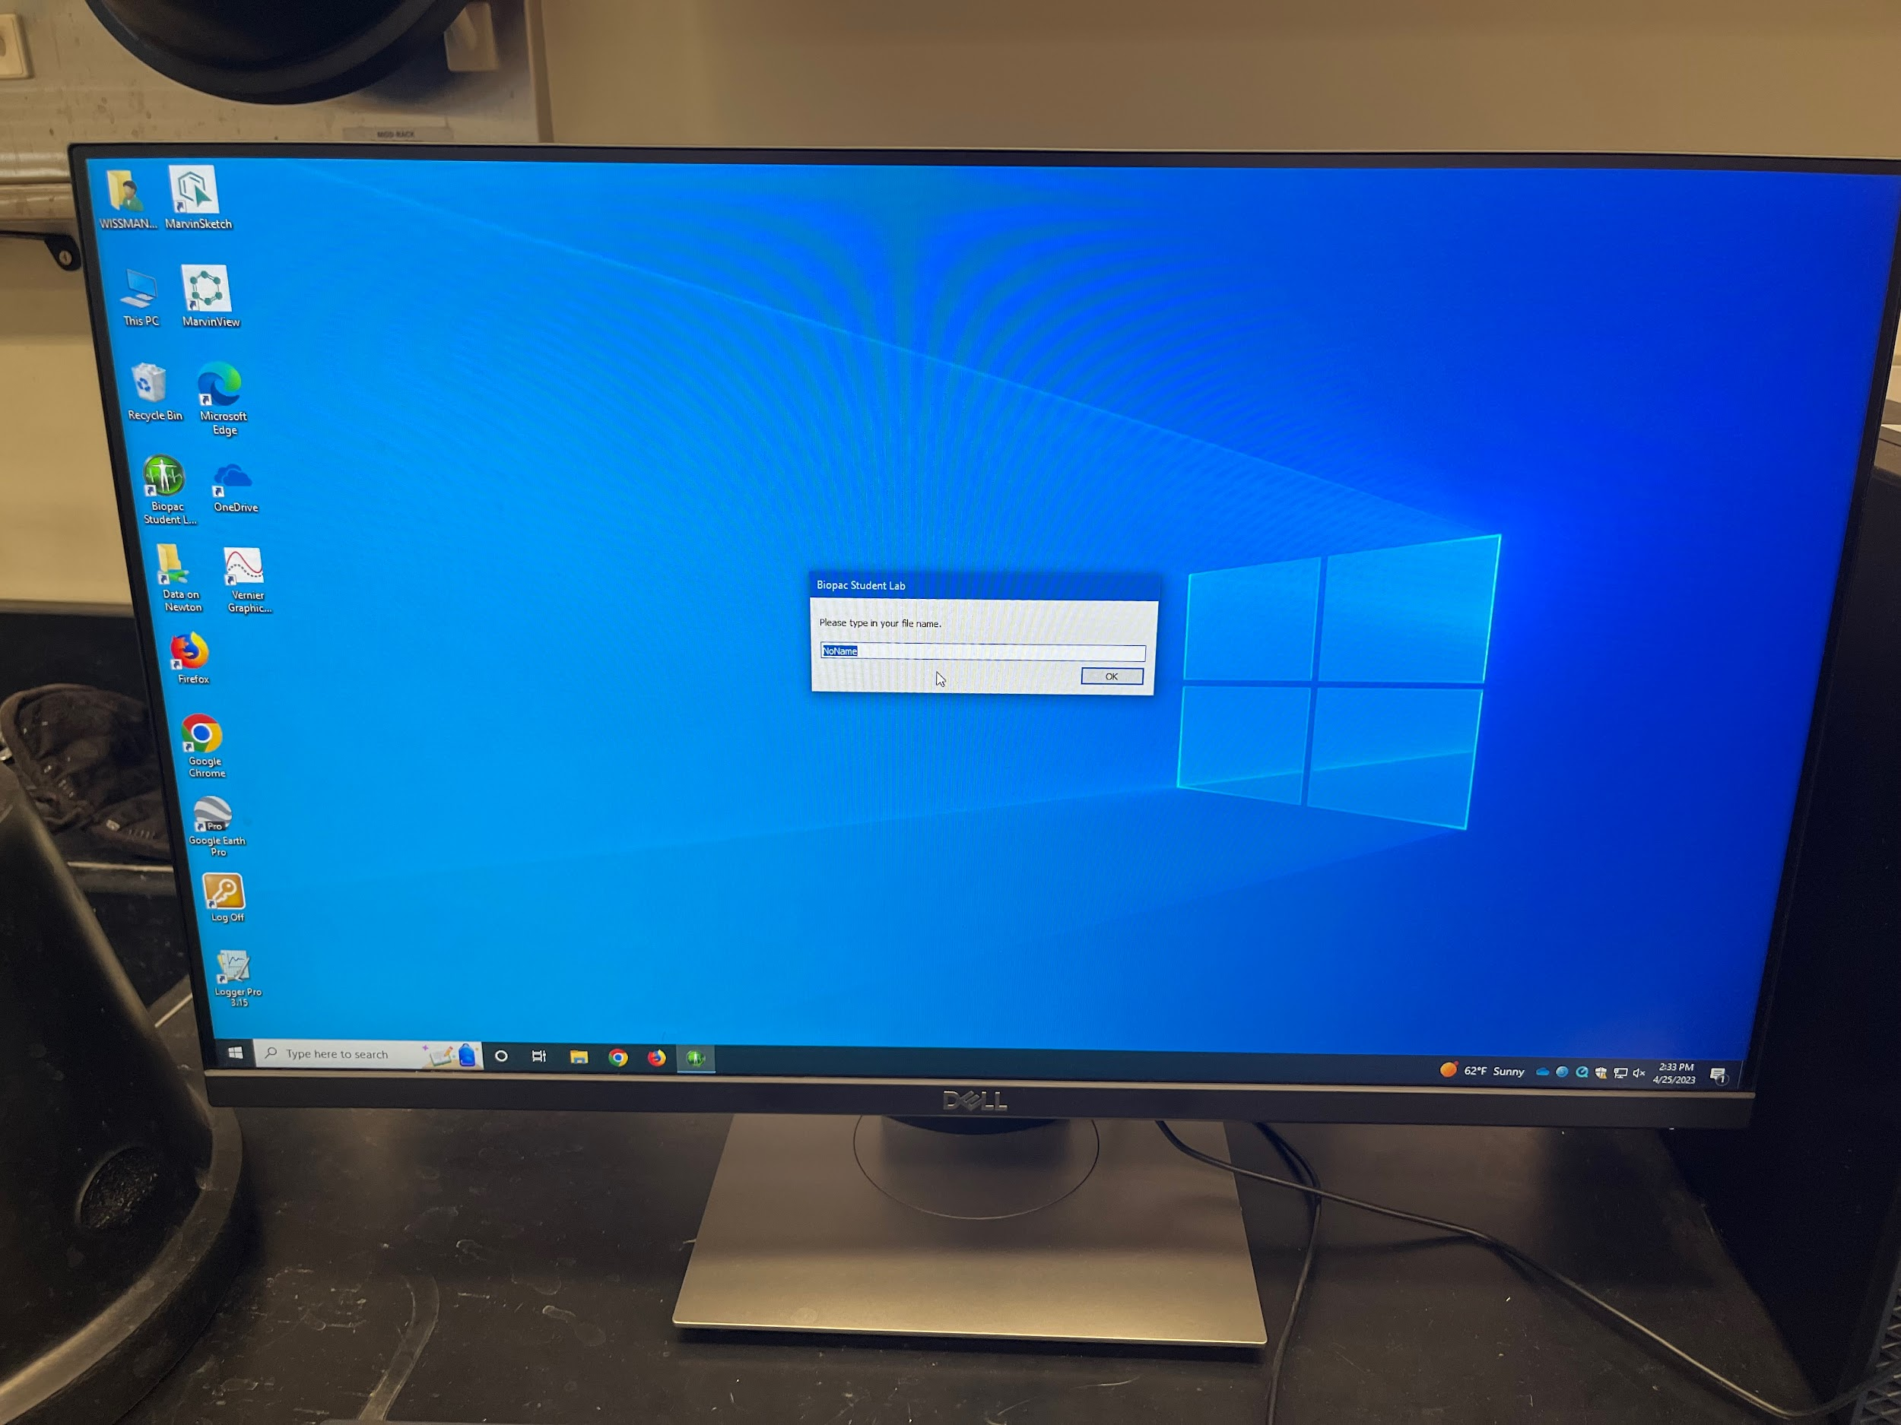
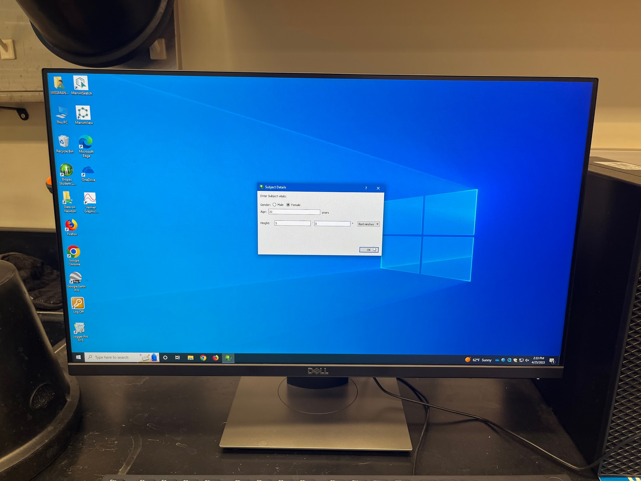

See the image below on your computer screen. You need to calibrate the airflow transducer and the flat, blue box before you can start to blow air into the black airflow transducer. This step is testing to see that the black, airflow transducer is plugged in correctly into the CH 1 (channel 1) plug on the flat, blue box. Nothing for you to do. The airflow transducer should have been correctly plugged in by your instructor or the lab technician. Commonly the error that is made is that the airflow transducer is plugged into the first plug on the left, the ‘electrode check’. So, go ahead and click on [next tab].

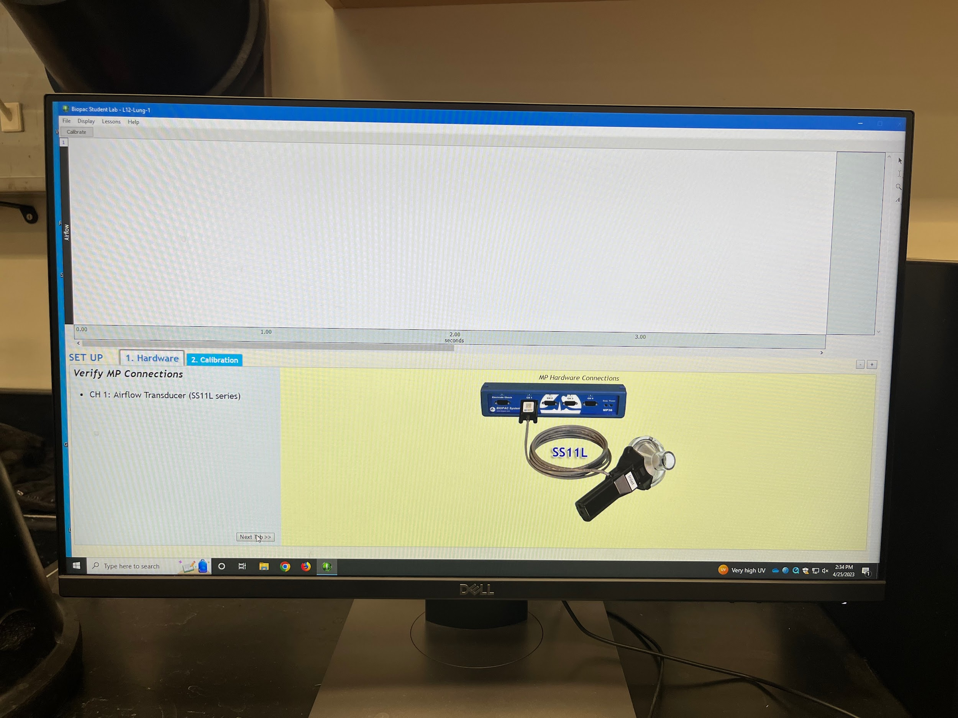
The next screen seen below should show the airflow transducer being held by a human hand. This step is to check that the airflow transducer is communicating with the flat, blue box. So, click ‘calibrate’. Watch a straight, flat line move across the screen twice. Do not blow into the airflow transducer. If the line that run across the screen is flat, horizontal and straight, move on to the next screen by clicking on [continue].
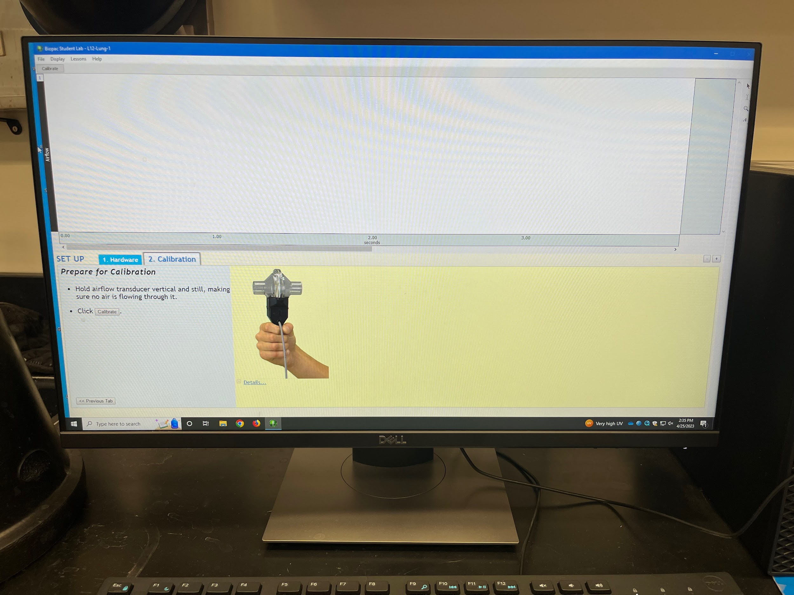
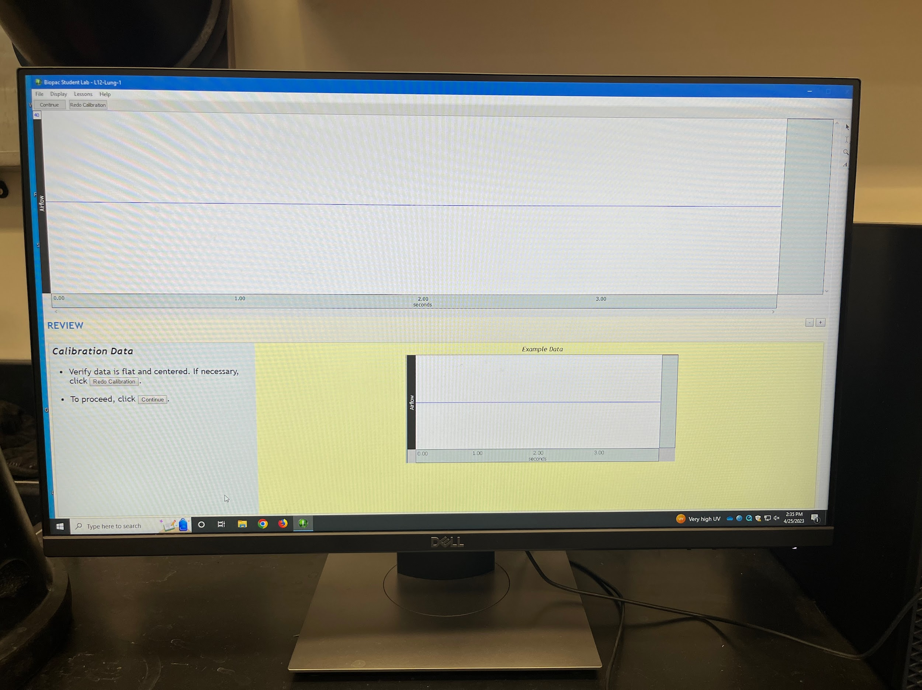
Now is the time for you to do something useful. Time to calibrate the machine using the white calibration syringe.

Simply now follow the instructions and diagrams shown on the following computer screens to do the calibration step. Make sure you have the apparatus assembled properly: ‘black transducer’ + ‘round air filter’ + ‘long white tube with plunger’.

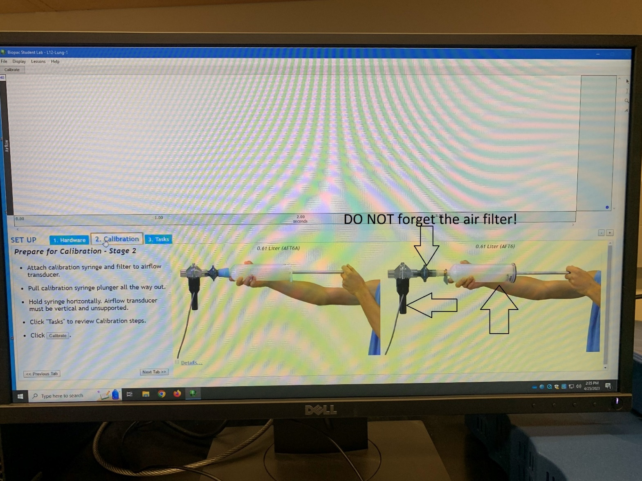
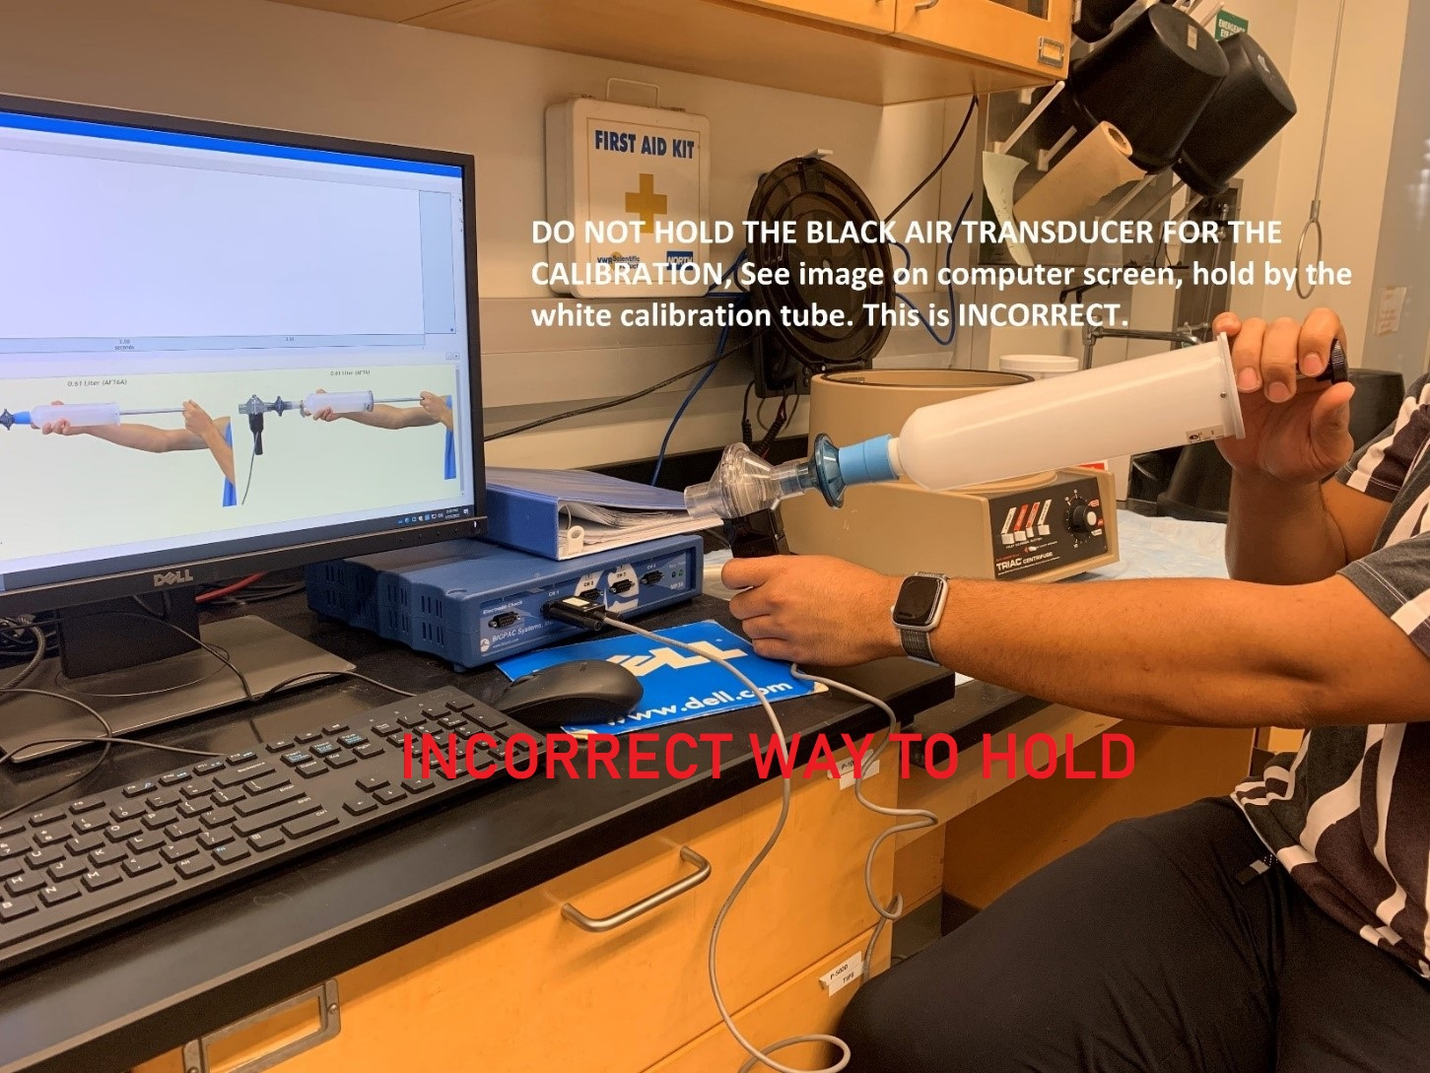
Attach calibration syringe and filter to airflow transducer.
Pull calibration syringe plunger all the way out.
Hold syringe horizontally.
Airflow transducer must be vertical and unsupported.
During calibration cycle, push evenly as possible the plunger in and out 5 times (10 total strokes), be sure and wait 2 seconds between each stroke.

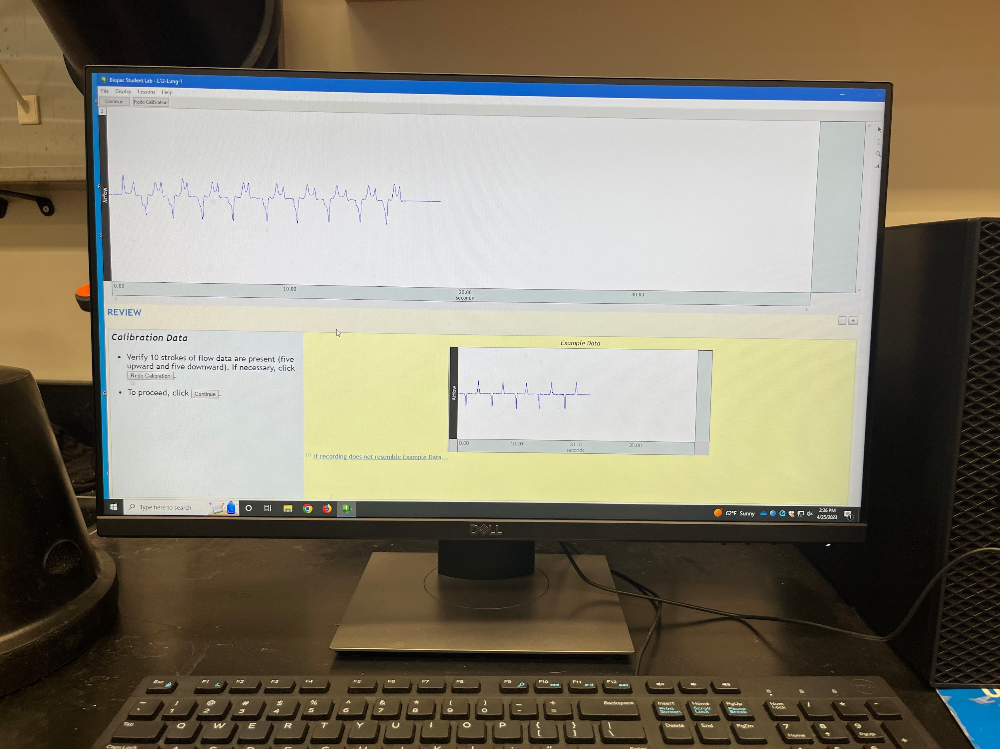
Does your graph look like the ‘example data’ graph? The ‘example graph’ is perfect. The one you will generate while pushing the calibration syringe in and out will not ever look that perfect but will have bumps in it. That’s OK. Move to the next step.
Following successful calibration, prepare the mouthpiece. Remove the calibration syringe carefully. Now you should have the black airflow transducer in your hand, attached directly to it is the round air filter and to the air filter is now attached the flat, white mouthpiece. See the diagram directly on the bottom of your computer screen. DO NOT forget the air filter. And do not forget to put on your nose clip before you start breathing into the apparatus.
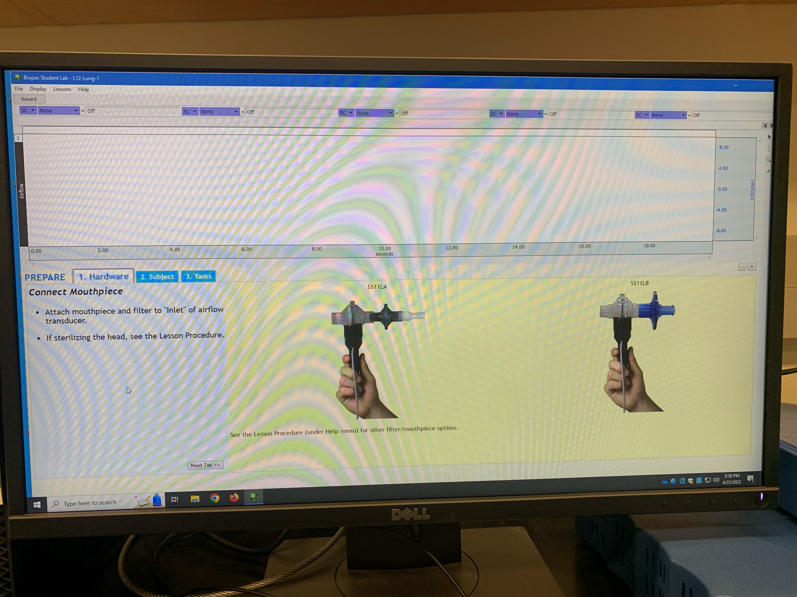
Click ‘Next Tab’ once you have the set-up complete: black airflow transducer + air filter + white mouthpiece.
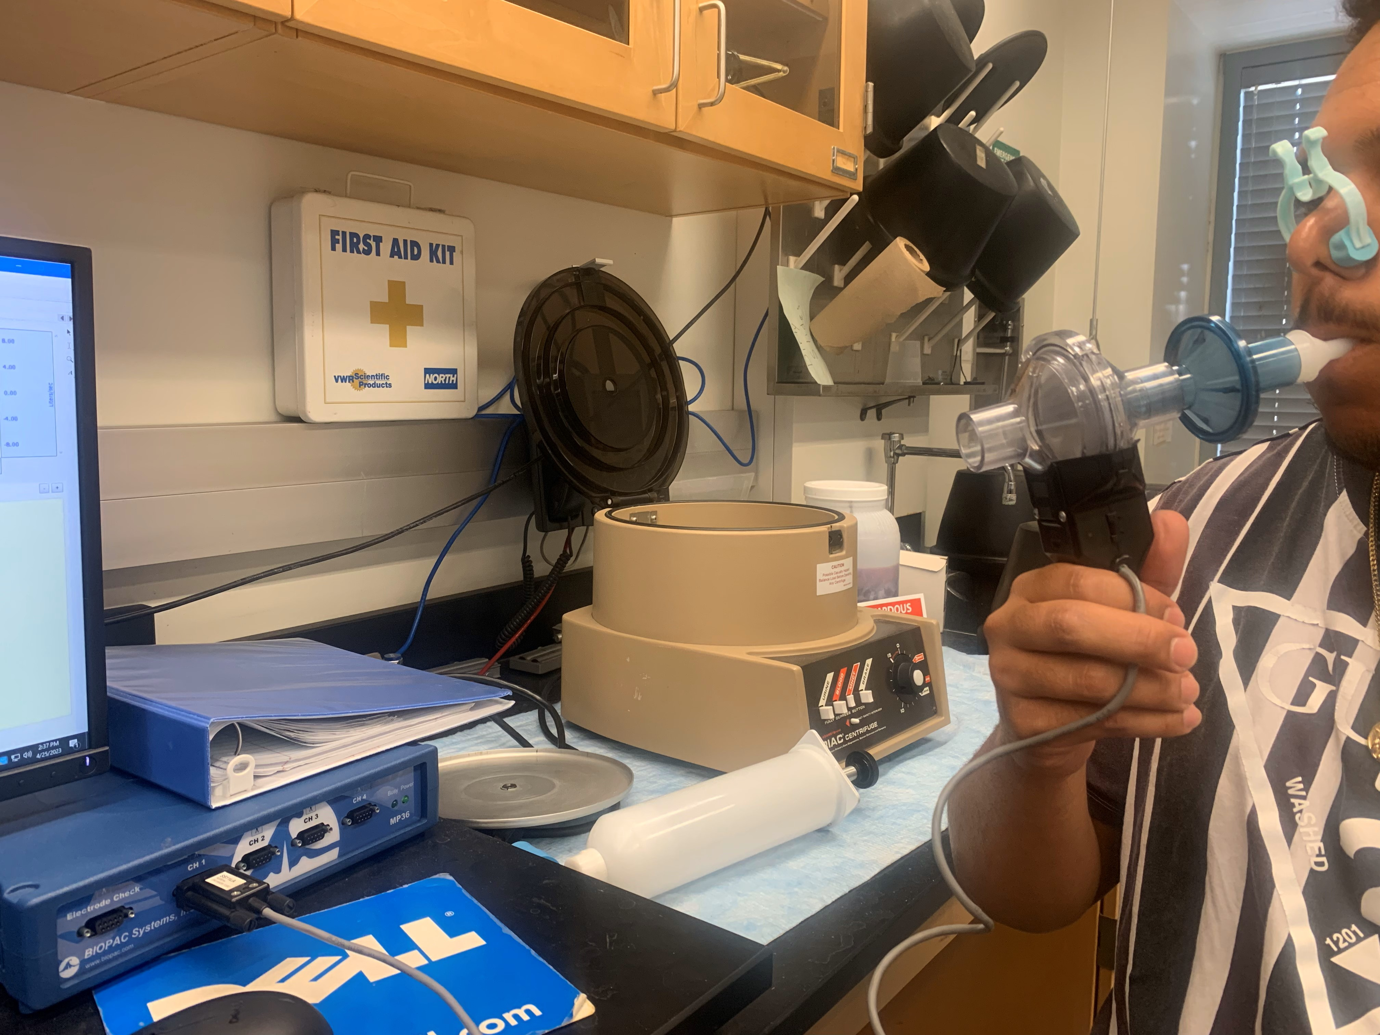

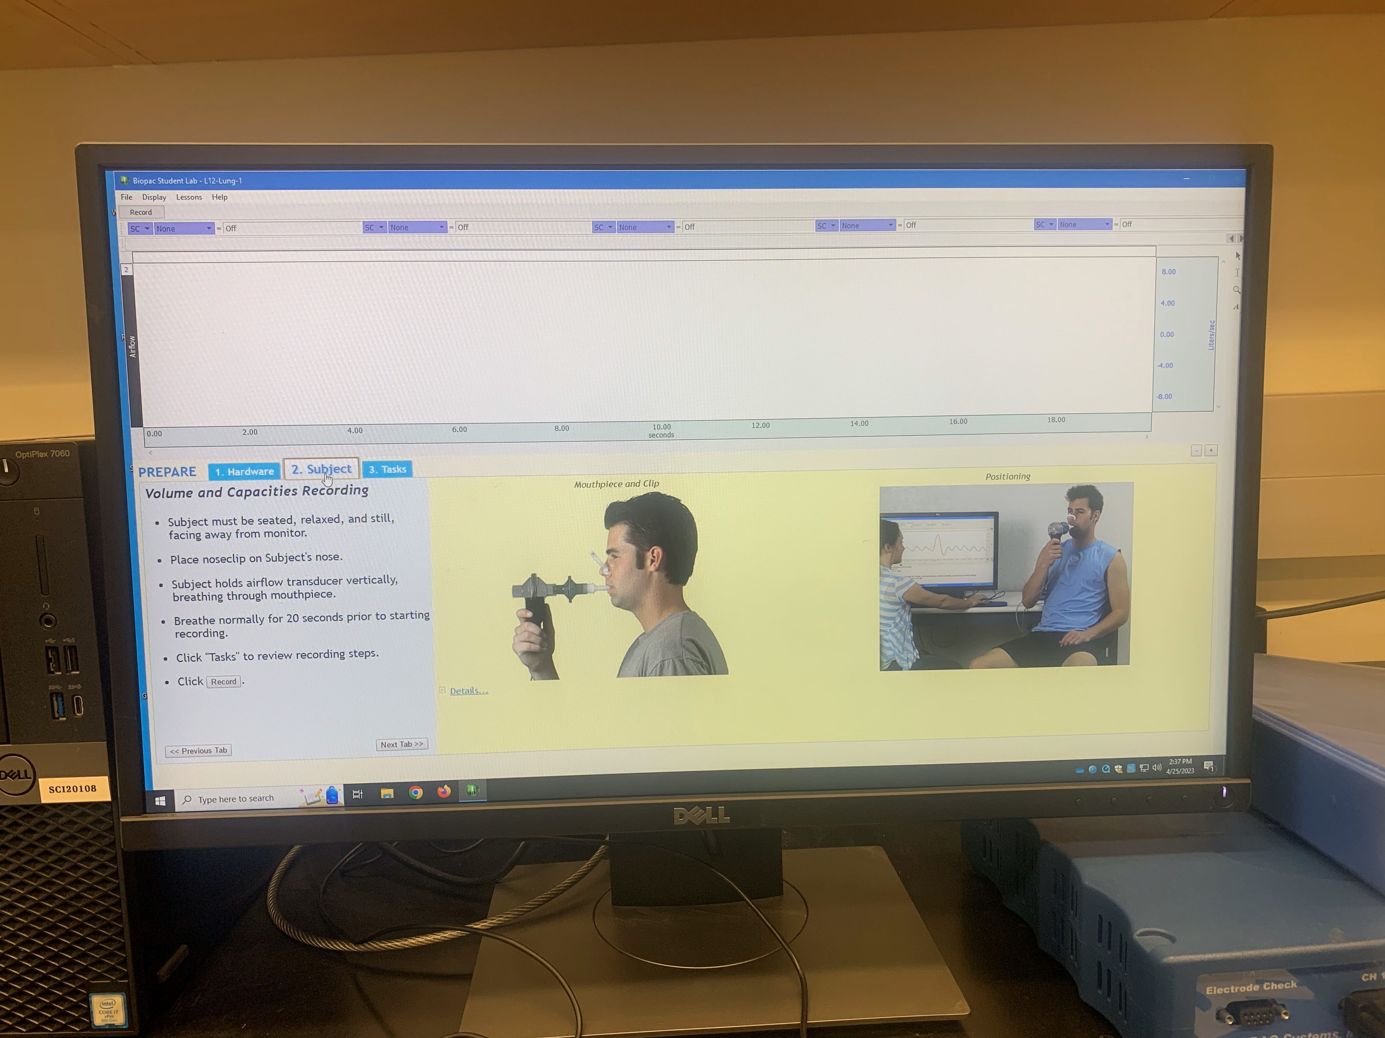
When the above screen appears, click on ‘Tasks’ highlighted in light blue near the left, middle of the computer screen. Follow these steps.
- Subject must be seated, relaxed, and still, facing away from the monitor
- Place nose clip on subject’s nose.
- Subject holds airflow transducer vertically, breathing through mouthpiece.
- Breath normally for 20 seconds prior to starting recording.
- Click “tasks” to review recording steps.
- Before recording, subject acclimates by breathing normally for 20 seconds.
- Breathe normally for 5 breaths.
- Inhale as deeply as possible, then exhale completely.
- Breath normally for five breaths.

Note that you are breathing into the mouthpiece with the nose clip on but you are not running the program. You have not yet hit the ‘record’ button so although you are breathing into the mouthpiece, nothing is being recorded yet.
From the ‘Tasks’ or the ‘Subject’ tab, now hit ‘record’ and follow the directions that appear on the screen now (5 normal breaths, breathe in as deeply as possible, then blow out all the air, exhaling as hard as you can, then breathing 5 more normal breaths). You will see the volumes being recorded on the screen.

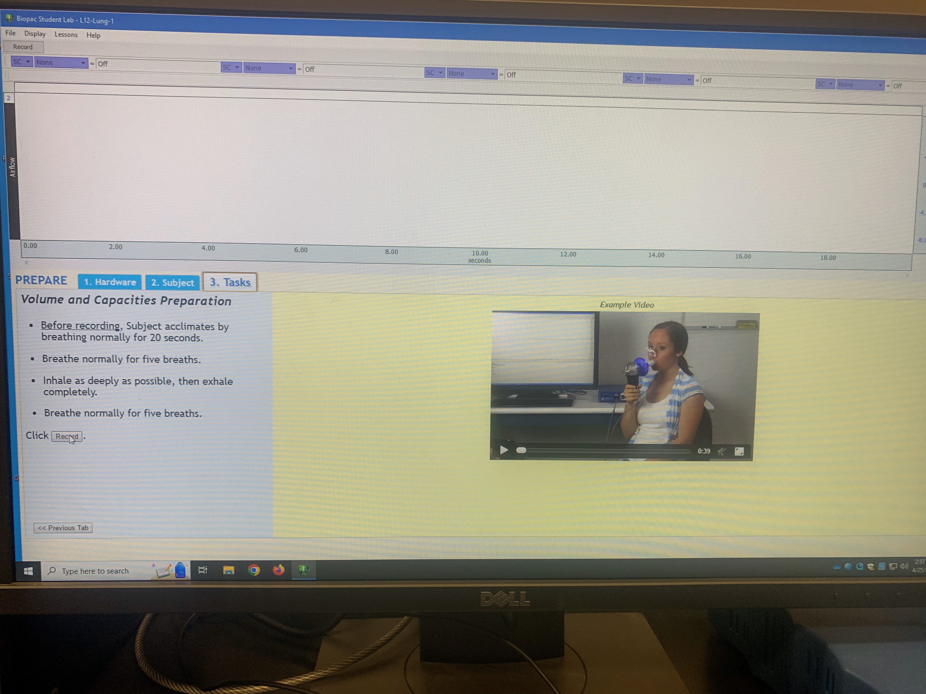

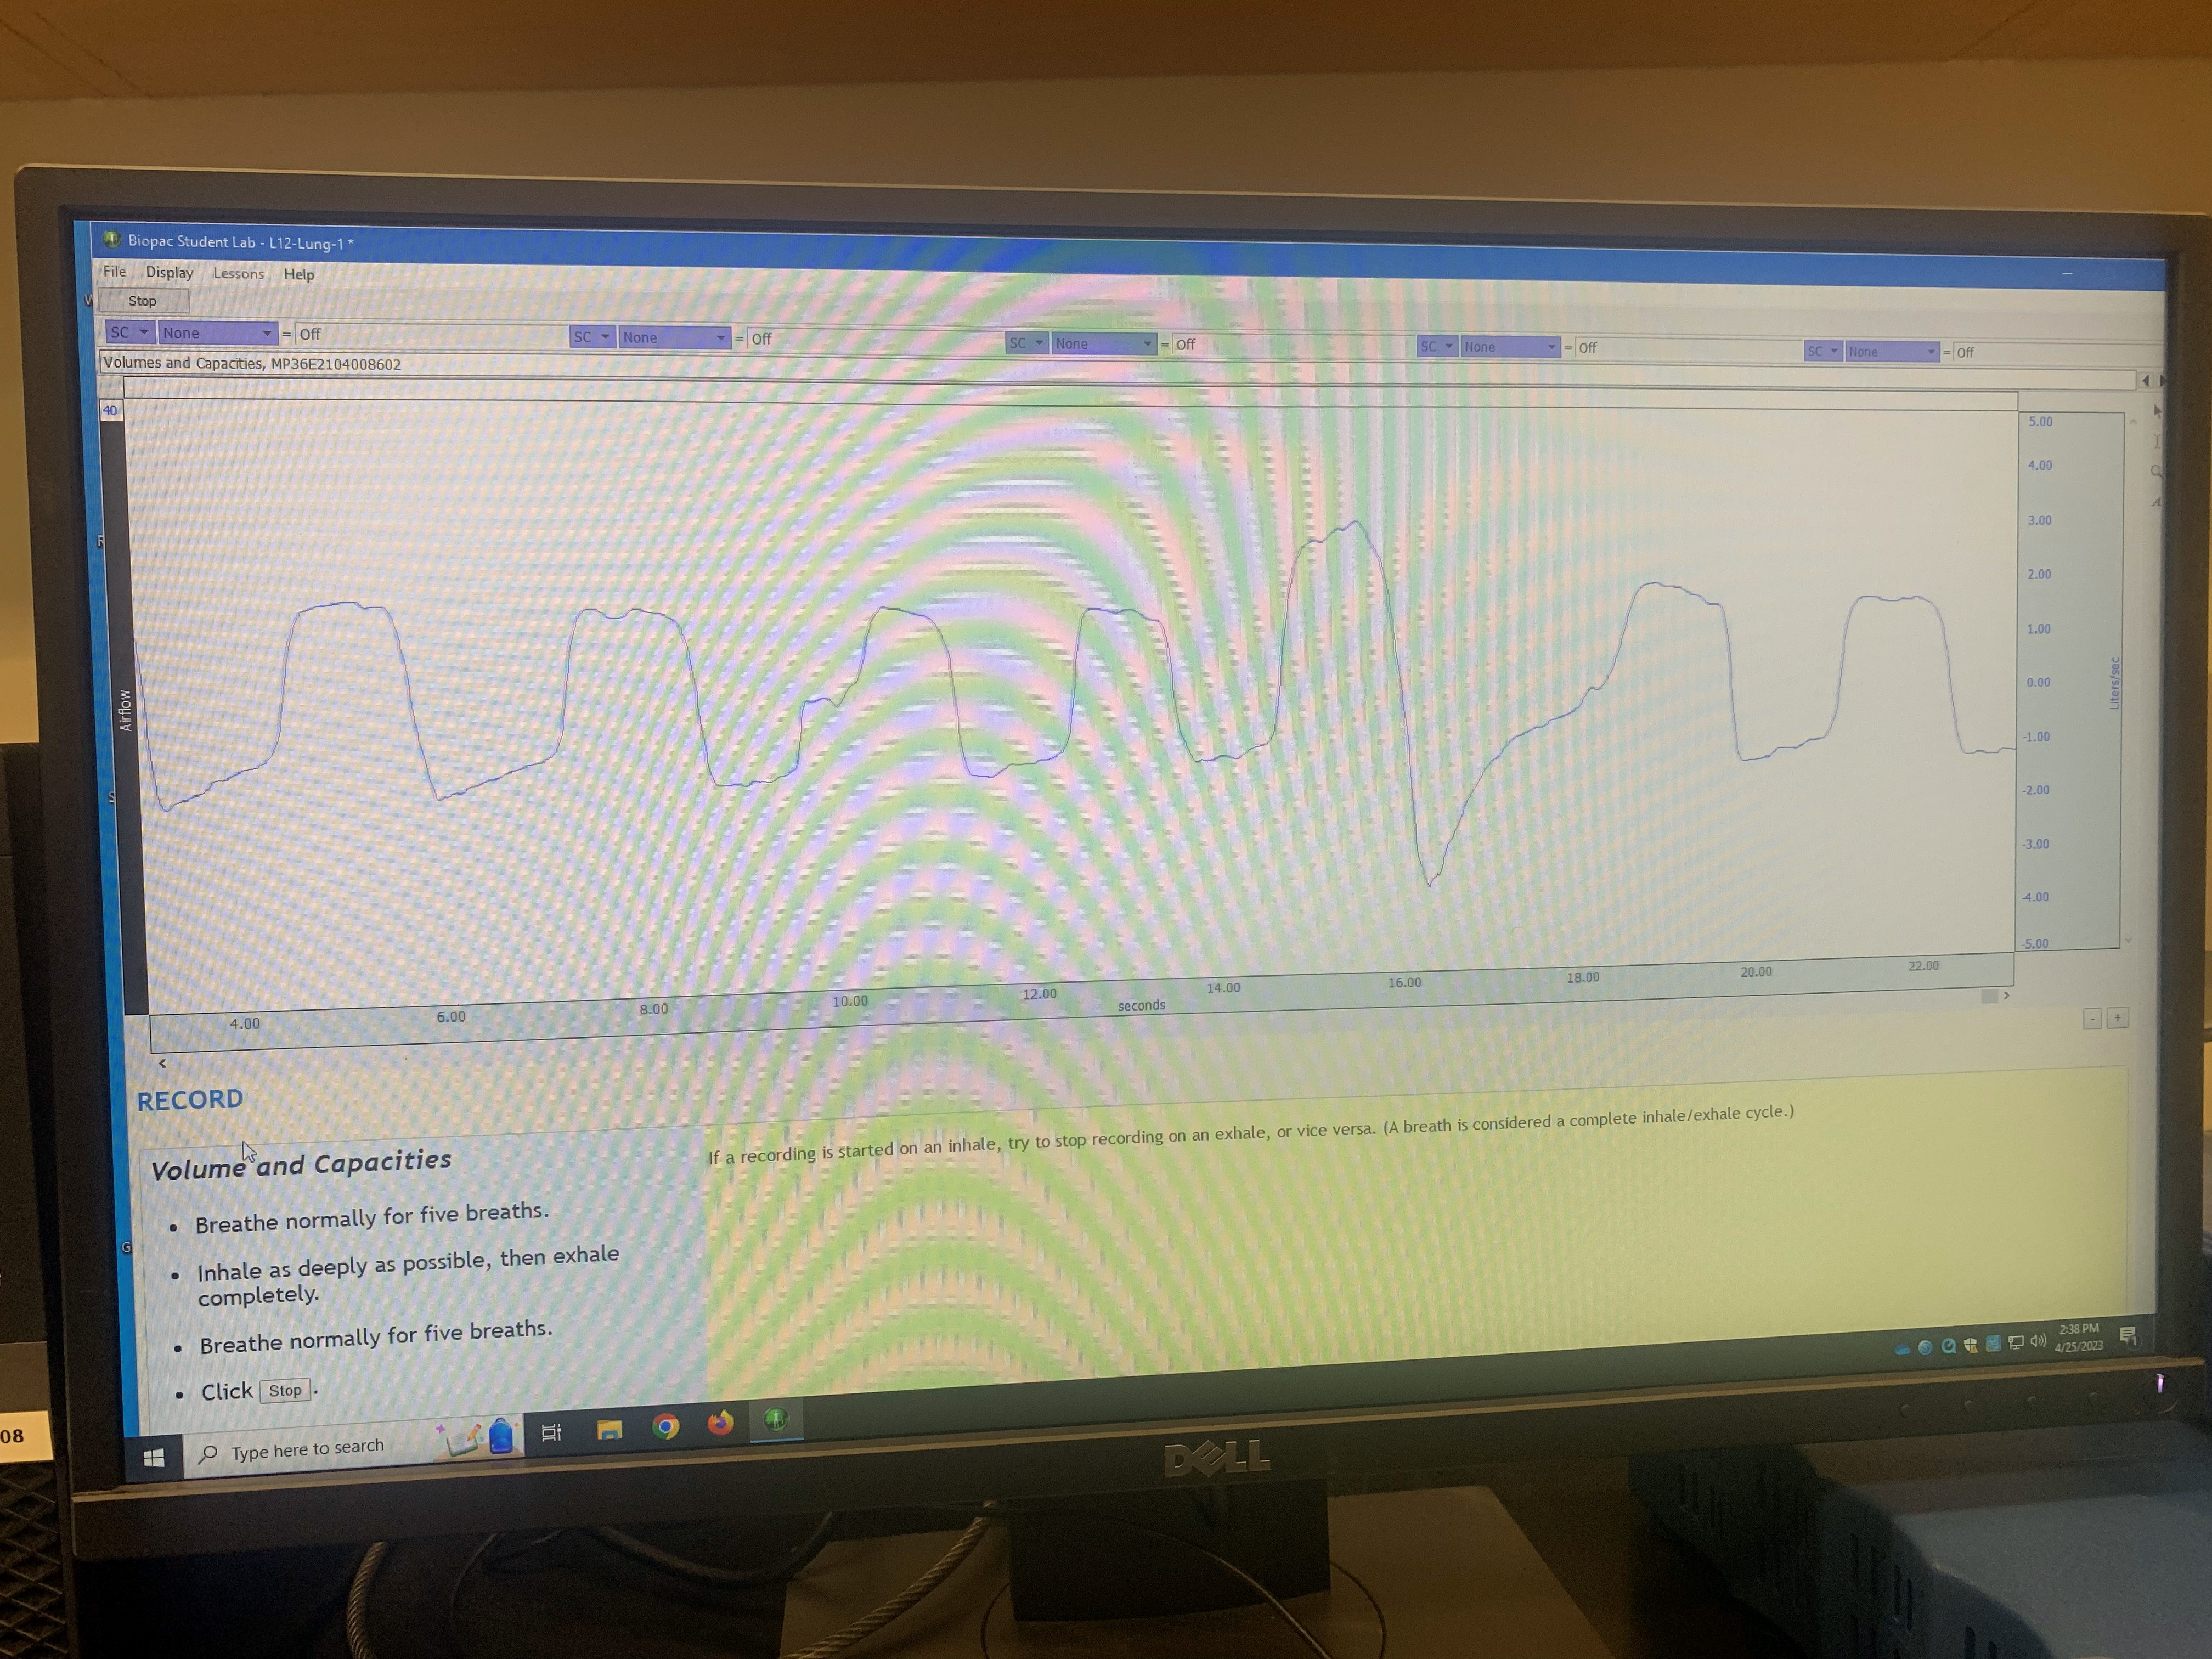
The above screen shows what the tracing looks like while you are breathing and it is recording.

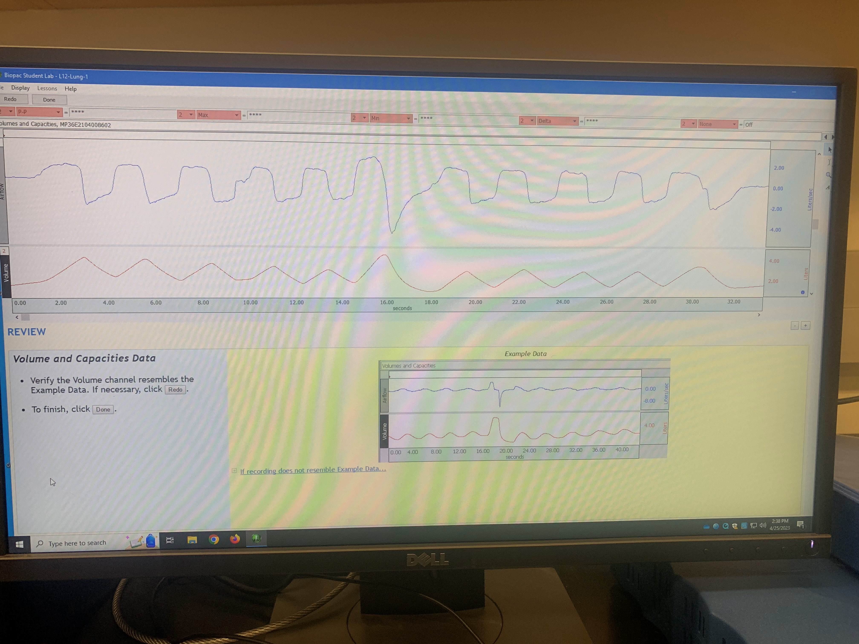
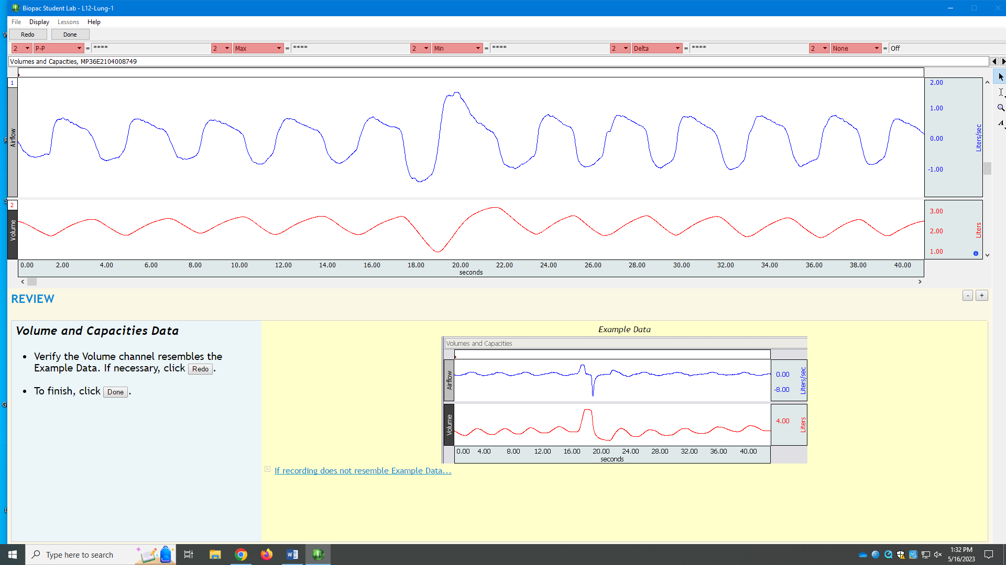
The two screens above both show the screen you should see after you hit the ‘stop’ tab. Let’s analyze what you see. First look at the lower, red tracing. That is volume of air in liters. Compare that with the lower, red line in their example in the yellow-shaded area. I hope you gave it your all and breathed in as deeply as you could and exhaled as hard as you could and that you had your nose clip on. Their example went as high as 4.0 liters. My data only shows a maximum volume barely up to 3.0 liters. I will go back, repeat, and do it again and try harder. The blue line shows how fast you were breathing in liters/sec. We are concerned only with the volumes in red.
Your entire breathing experiment is shown. Can you recognize the first 5 normal breaths? Then where you inhaled as much as you could and followed that by exhaling as hard as you could? Then the last 5 normal breaths?
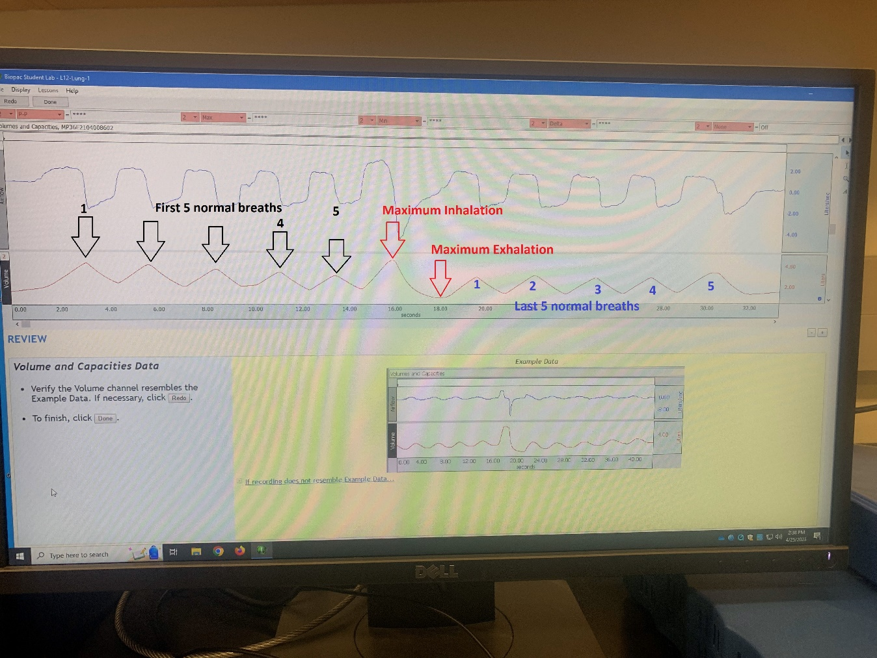
Now to get ‘the numbers’, to read the volumes in liters. You want to read the numbers to get your tidal volume, inspiratory reserve volume and the expiratory reserve volume. What you need to find is what Biopac calls the “I-Bar”.
See the red-highlighted rectangles near the top of the screen? They are circled in the picture below. Go ahead and click on the ‘down-arrow’ next to any one of these. When you click on the downward arrowhead, this list shaded in grey appears. Find ‘value’ and click on it please. The word ‘value’ should now appear in that red-shaded rectangle.
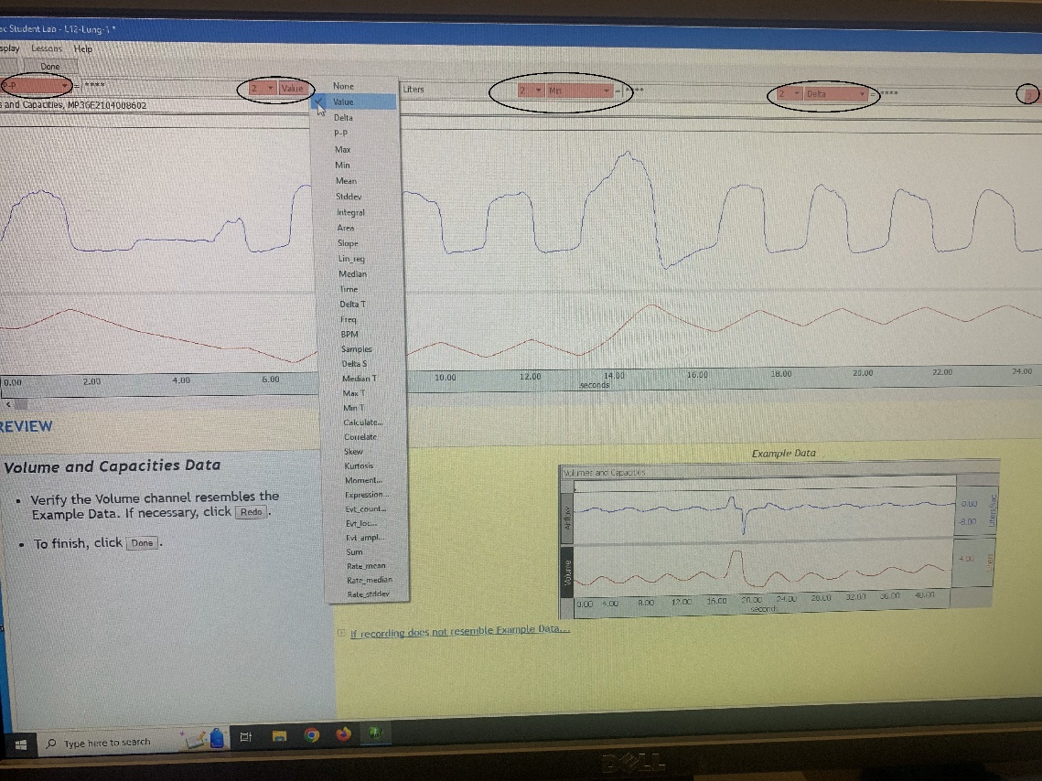

Avertissement
(OK, that’s ‘warning’ in French)

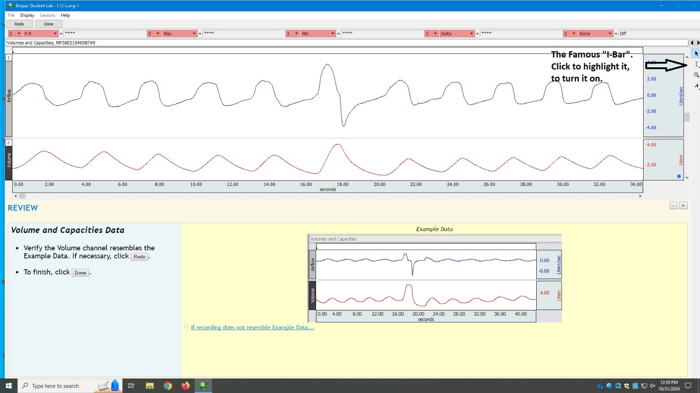
Before you can get your data from the computer, you need to make sure the “I-Bar” icon is highlighted.
Click on the “I-Bar” icon in the upper right as shown in the diagram above to highlight it. It might already be highlighted.)
End of Advertencia (warning in Spanish).

Let’s have some fun. Look at the picture below. I have moved the cursor to the top of the first normal breath (remember we are looking at the red line, not the blue one), then I right-click and HOLD IT for 3 seconds. Then a vertical line appears on the red graph and that value in liters on the graph appears in the red-highlighted rectangle.
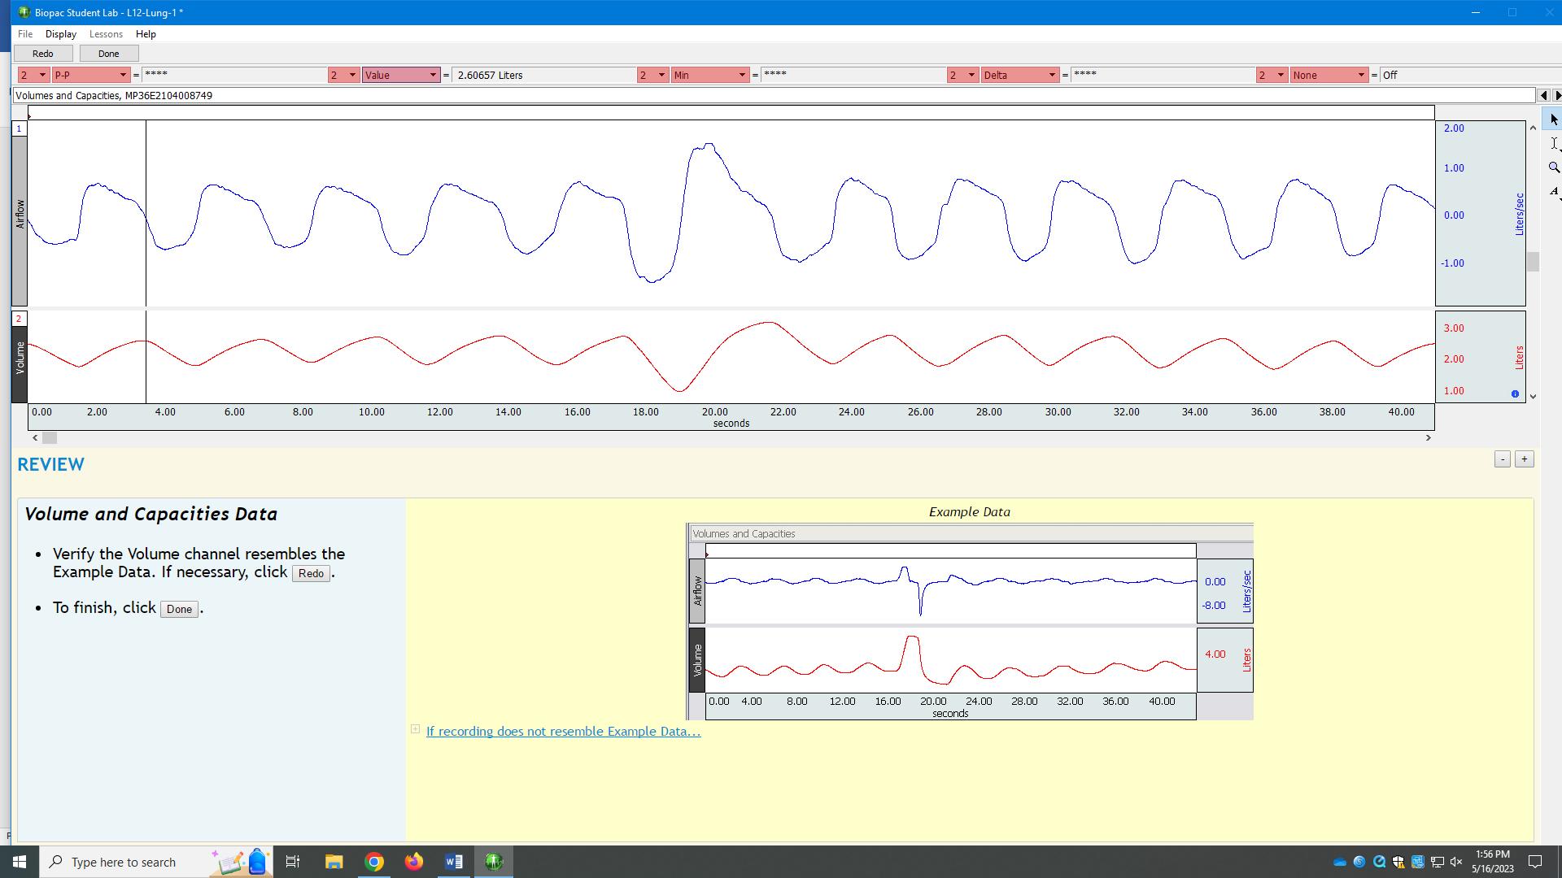
It is hard to read in the picture above, but the value is 2.60657 liters. That is the peak volume of that normal breath. Now I move the cursor to the bottom of that breath, right-click and HOLD IT for 3 seconds and the value appear in the red-shaded rectangle: 1.81098 liters. See the picture below.
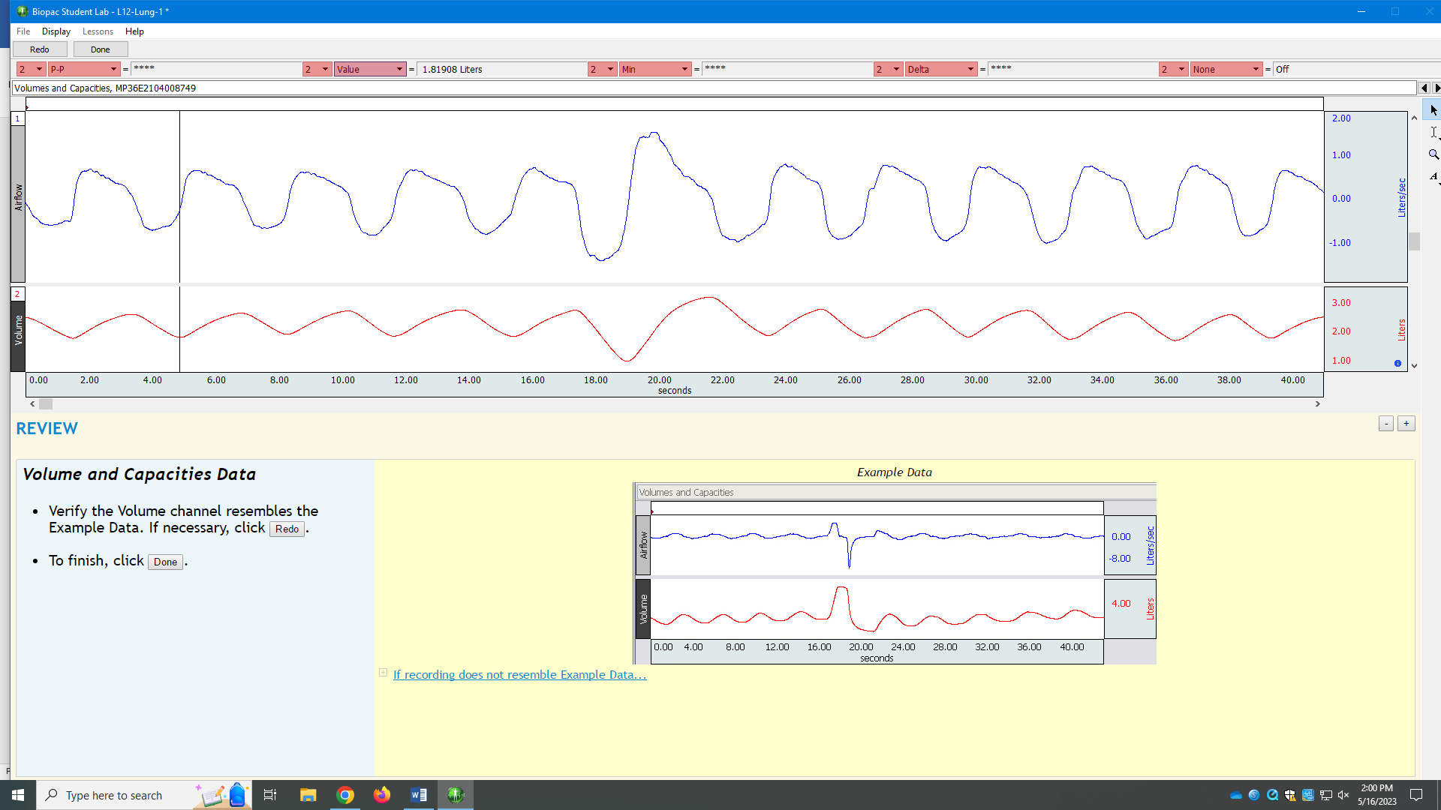
If I now subtract these, I have my tidal volume for that breath: 2.60657 – 1.81098 = .79559 liters !
So, you can measure and calculate the tidal volume of any of your normal breaths.
Let’s measure your inspiratory reserve volume. Remember that it is the volume above the peak tidal volume after you inhale maximally. So, watch where I click on the “I-BAR” for the values in the next two photographs below. I chose the peak of the normal breath right before my maximal inhalation (2.74828 liters). Then I click on the peak of the maximal inhalation (the second picture below). That value is 3.18888 liters. So the inspiratory reserve volume is: 3.18888 – 2.74828 = 0.4406 liters !
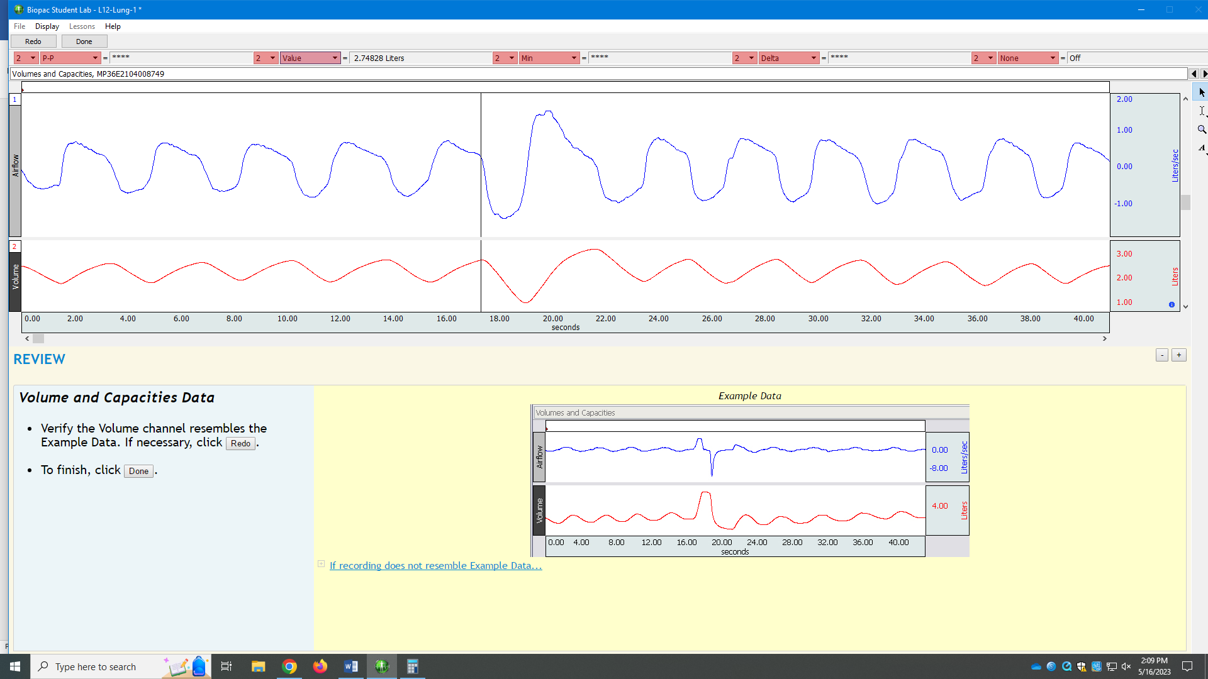
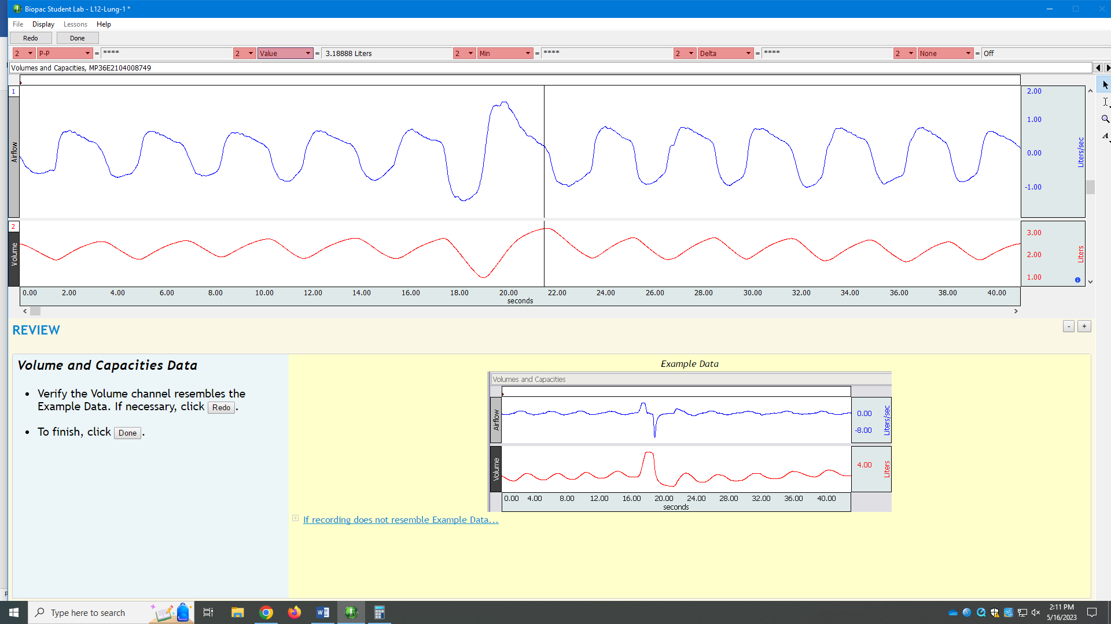
Next is to measure the expiratory reserve volume. This you will have to do yourself with your data. I did not breath out maximally and so my tracing is useless for this. Don’t forget to compare your tracing with the spirograms seen at the beginning of this lab. Are your numbers ‘real’? Did you really try hard enough? Are your numbers even compatible with life? Proceed to Lab 13.

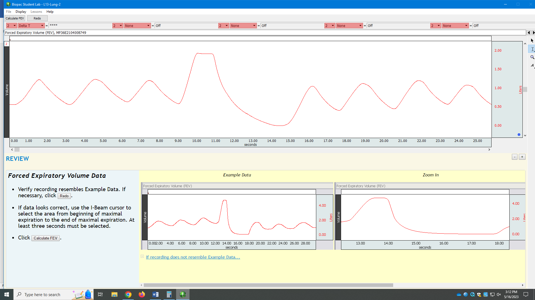

I now click on the “I-BAR” at the beginning of the downslope, when I began my forced expiration, see below:
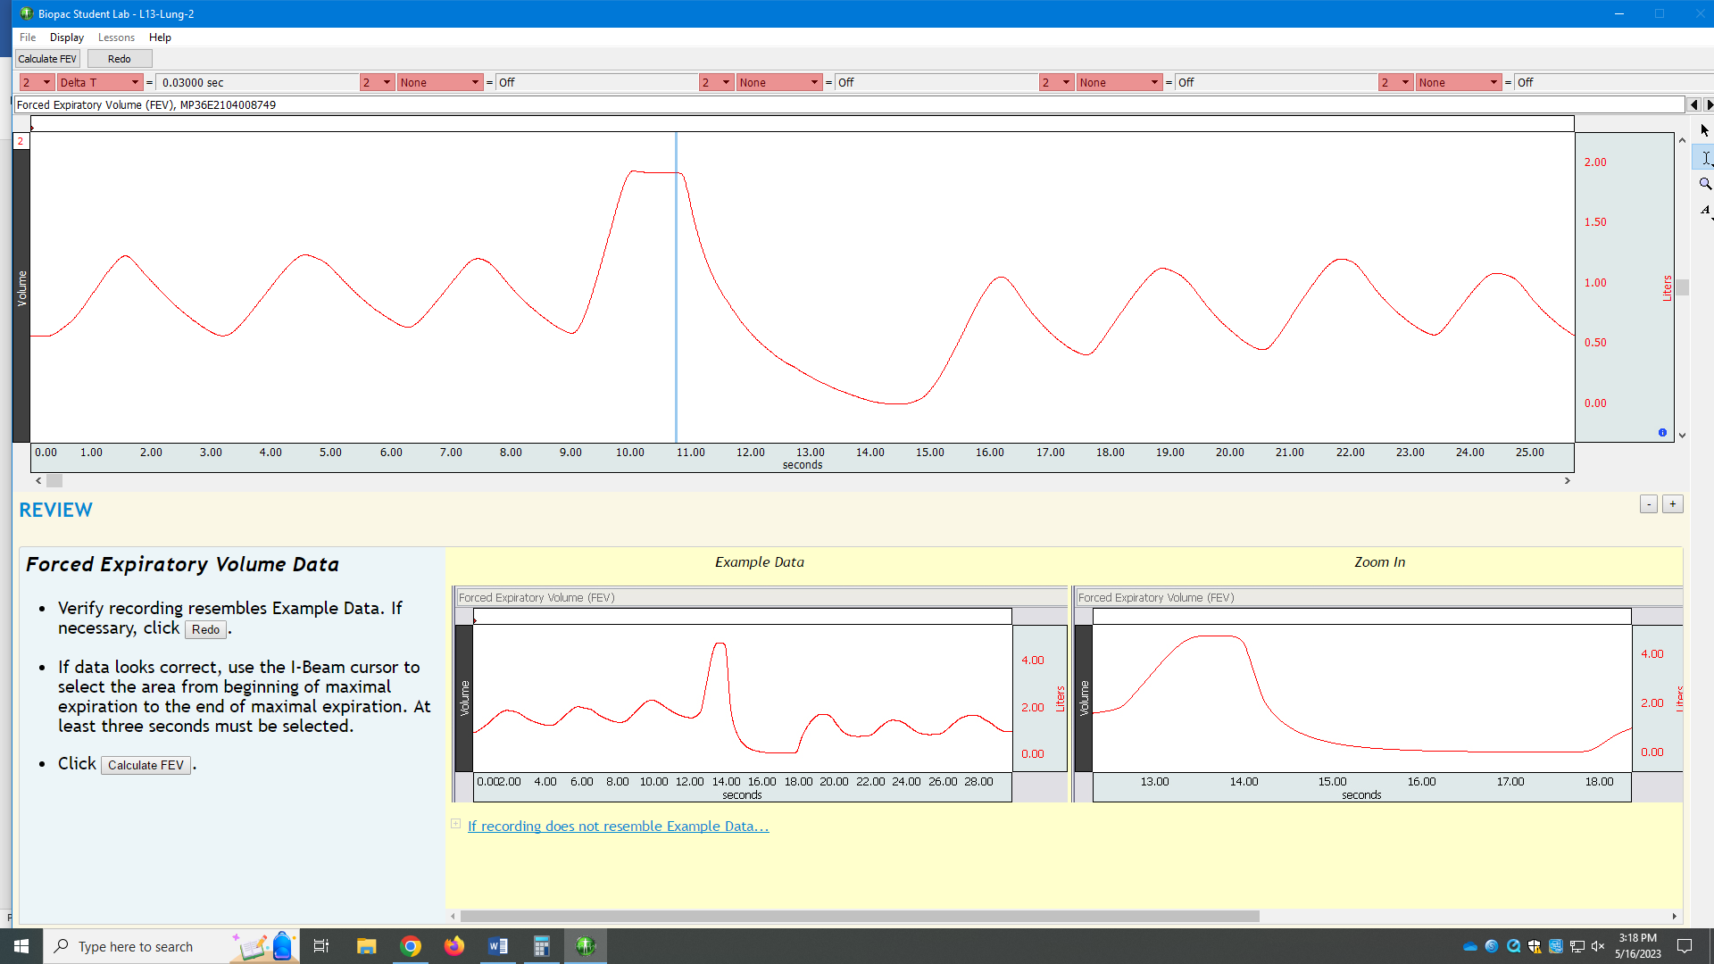
Now I click on at the beginning of the downslope AND drag the cursor to the bottom of the downslope, at least 3 seconds of time according to the seconds time scale on the bottom of the tracing. See this area of the downslope now highlighted, see below:
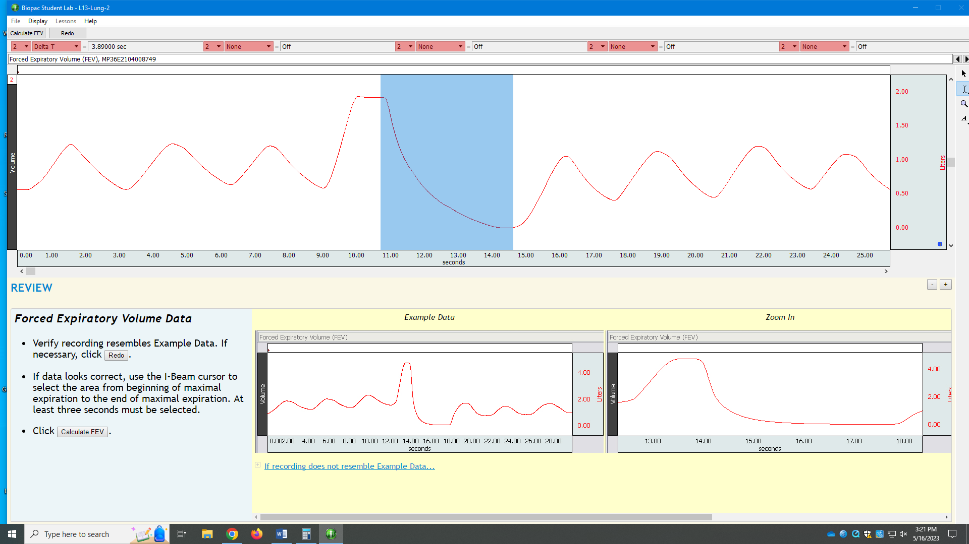
Then click on ‘Calculate FEV’.
You will now see a screen like this (see below):
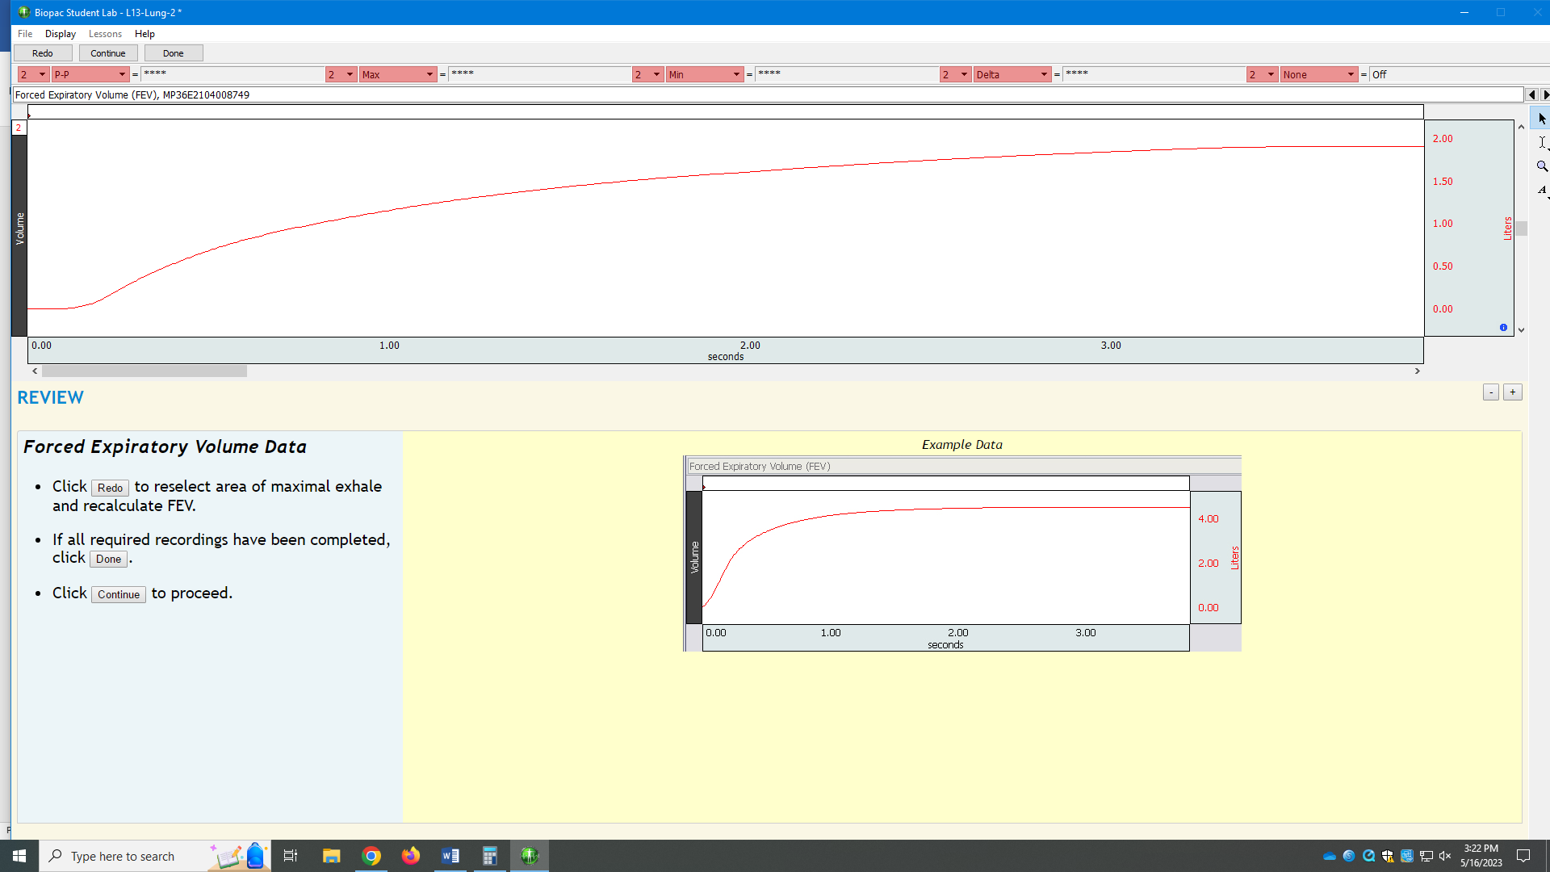
Click on one of the red-highlighted rectangles and choose ‘value’ like we did before for the previous lab. You want lung volumes at the beginning, at one second, at two seconds and at three seconds. Get those values.
In my example, they are: 0.00058 liters at 0.00 seconds (see below).
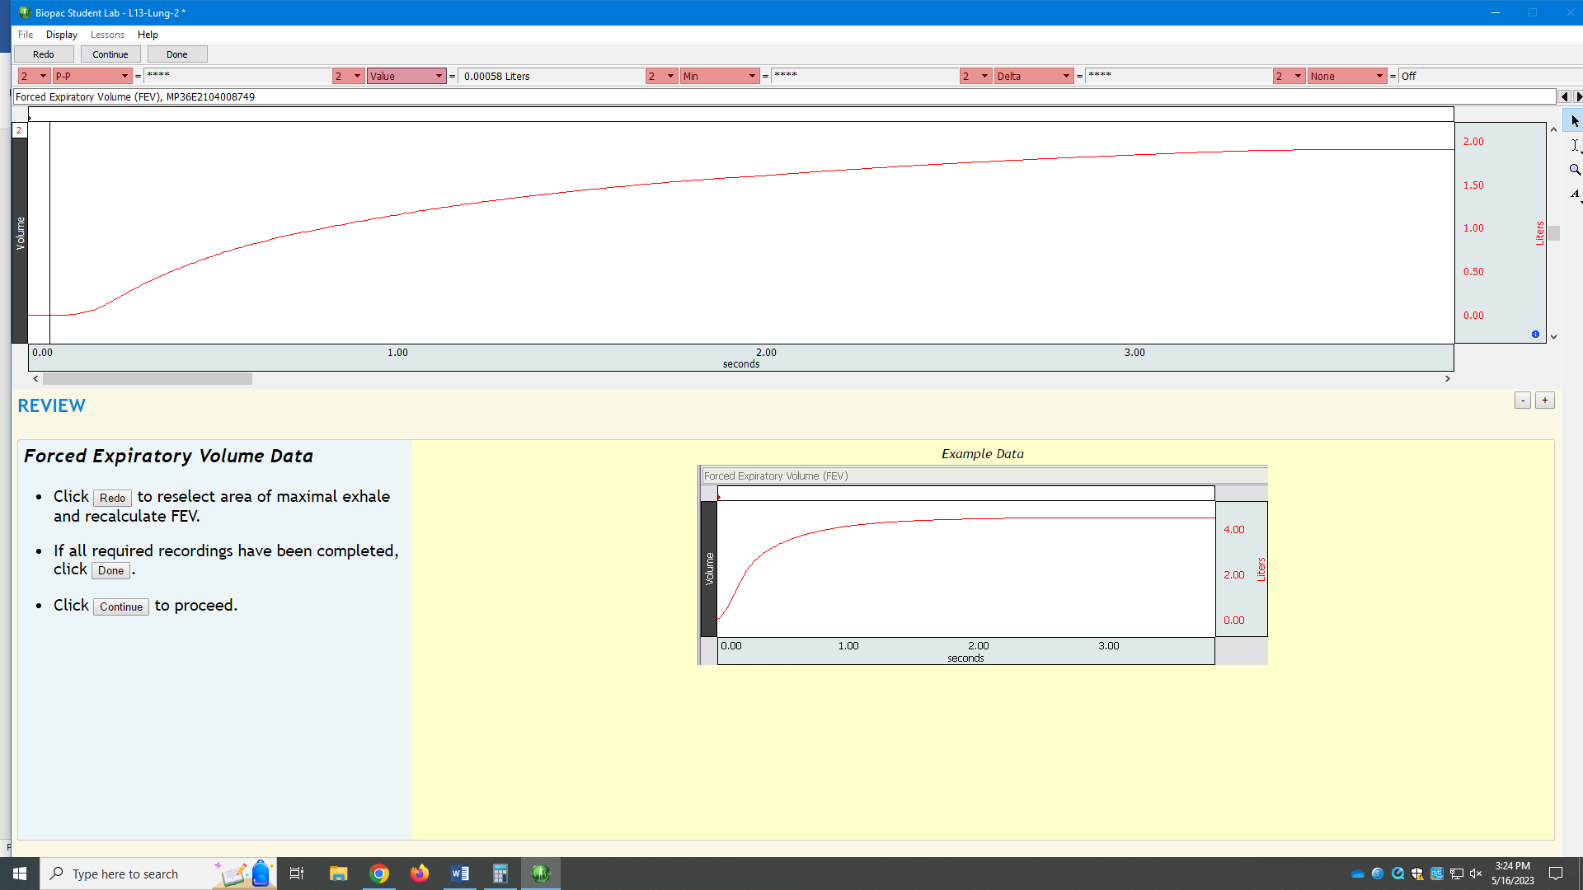
At one second (see below): 1.15487 liters
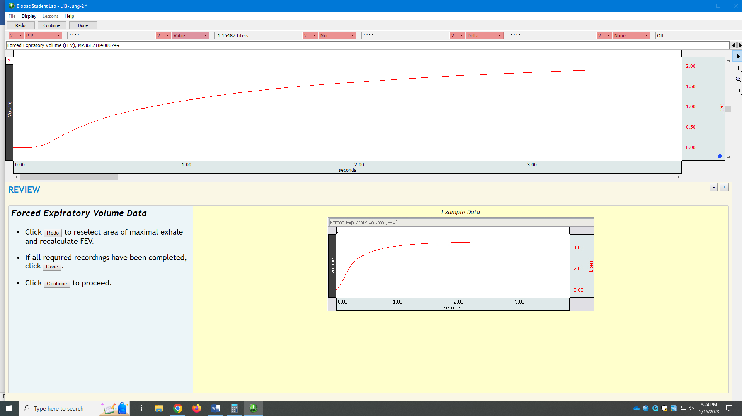
At two seconds: 1.61129 liters (see below):
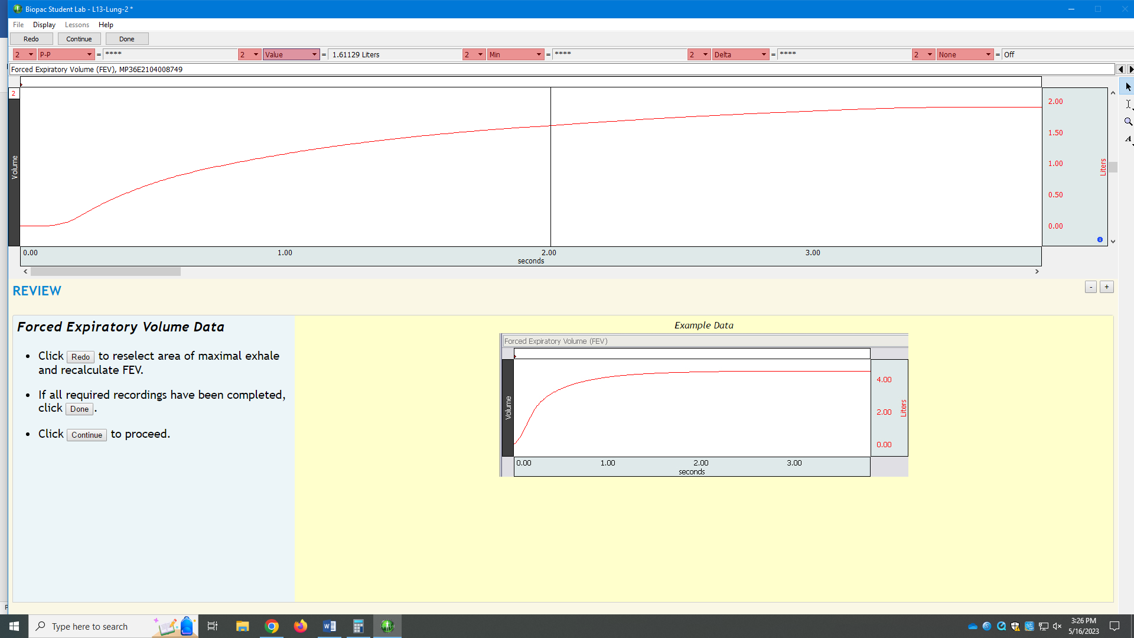
At three seconds: 1.84711 liters (see below):
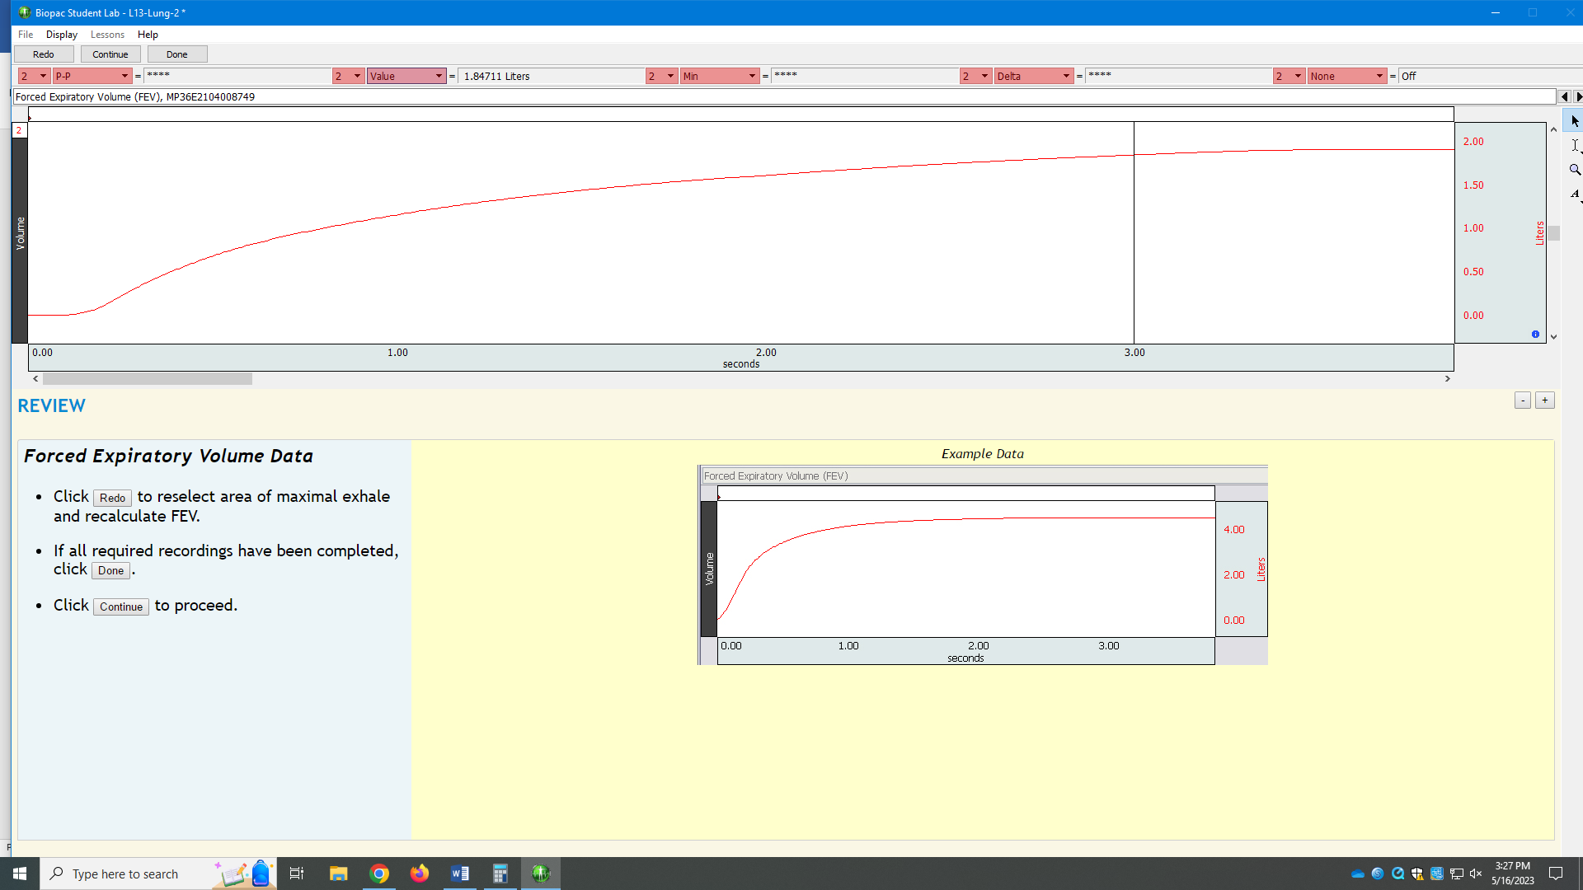
Notice how bad those values are. The example shows that by one second all the air has been blow out of the lungs. In my tracing, even after 3.0 seconds, the tracing still has not completely flattened out. What a normal lung can force out in less than one second takes my lungs a bit over three seconds. What do you think is the cause for this? (Think asthma).
The next experiment is to measure how much and how fast you can move air into and out of the lungs (MVV).
Rather than having you breathe as deep and as fast as you can for a minute (you might pass out), you can breathe as deep and as fast as you can for either 15 seconds and then multiply that by 4 to make it 60 seconds OR you breathe as fast and as deep as you can for 20 seconds and then multiply that by 3 to get to 60 seconds. MVV is measured in liters per minute.
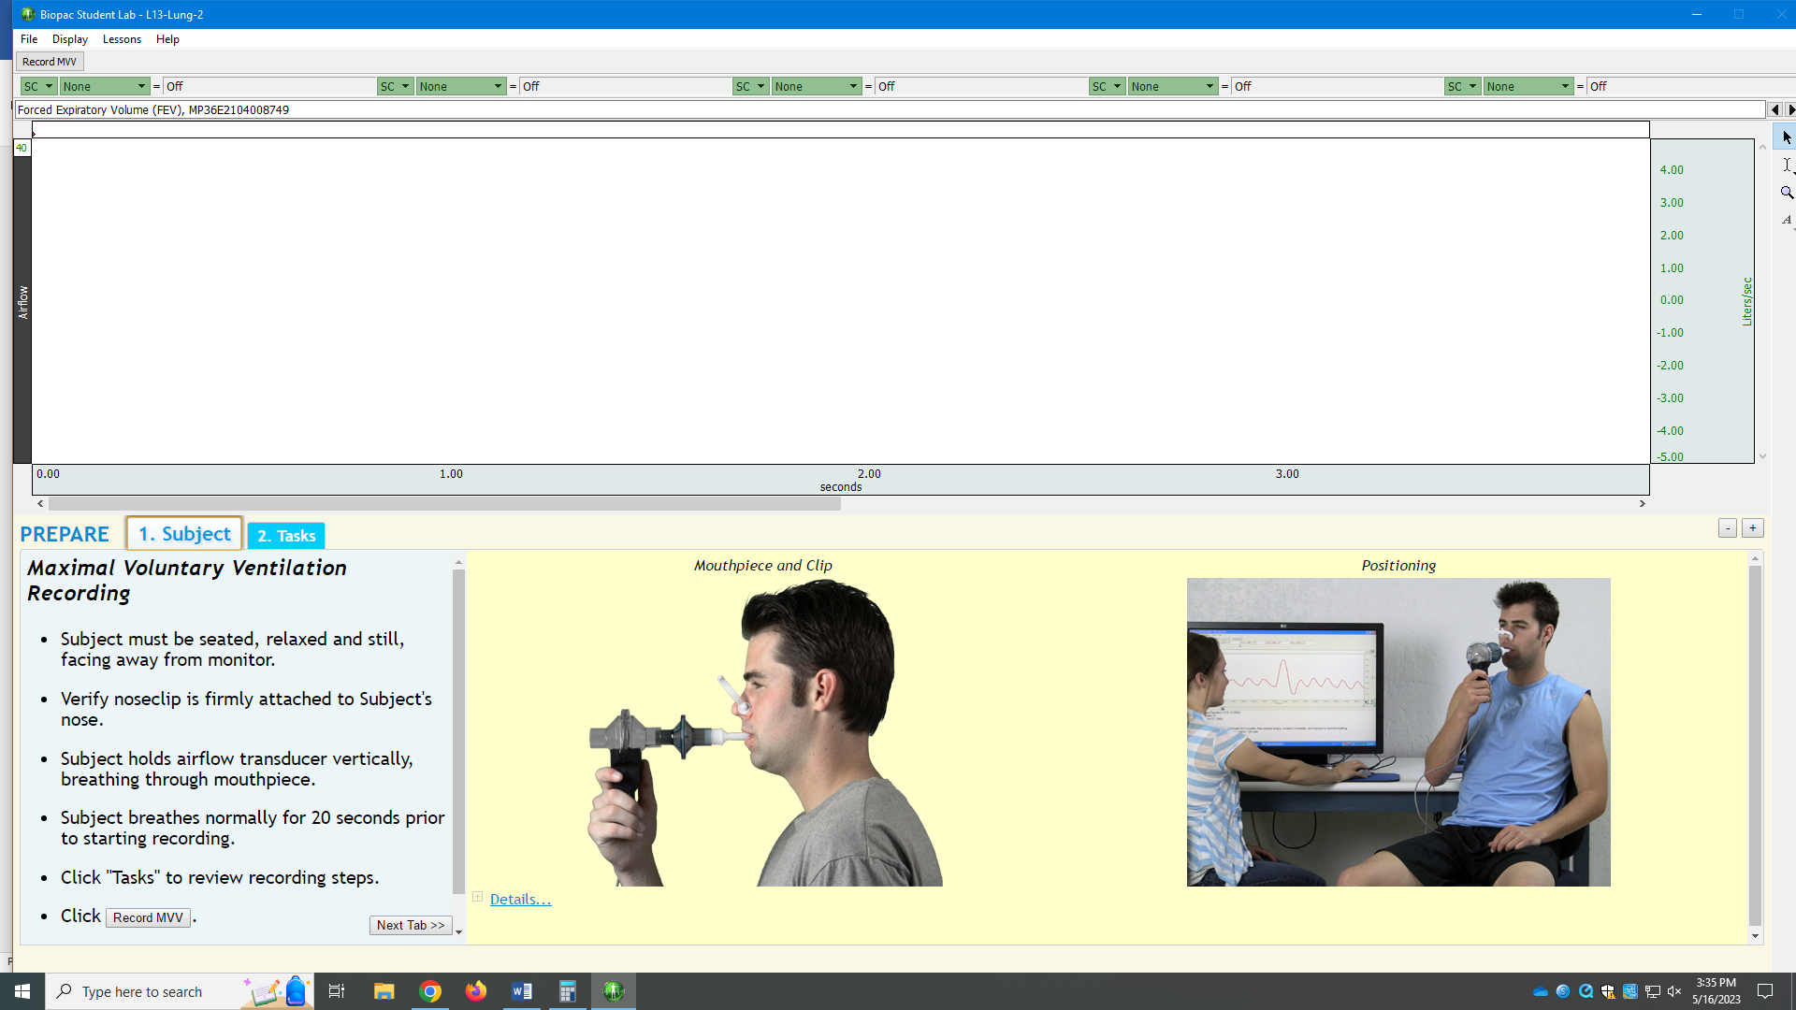
After you click on ‘Record MVV’, you will follow the directions and have a tracing that looks something like this (see below):
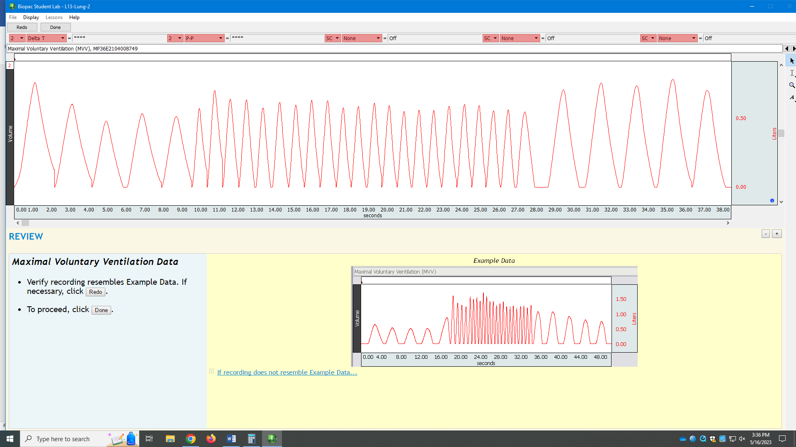
At the beginning and at the end you see your 5 normal breaths. In between you see your rapid, deep breaths. You will want to calculate the volume of each rapid breath for either 15 seconds (and multiply that by 4) or calculate the volume of each rapid breath for 20 seconds (and multiply that by 3). With the “I-BAR”, click on the bottom of a single rapid breath, get that value (for example: 0.04444 liters) and click on the value of the peak of that same breath (for example: 0.70474 liters). Do the subtraction and that is the volume for that single, rapid breath (0.70474 – 0.04444 = 0.6643 liters).
You will calculate the volume of each breath and add up all those volumes for either 15 seconds (and then multiply that volume by 4) OR add up all the individual volumes for 20 seconds (and then multiply that volume by 3). That will be your MVV in liters/min.

