**BioPac Lesson 13: PULMONARY FUNCTION II**

Pulmonary Flow Rates:

-Forced Expiratory Volume (FEV1,2,3) -Maximal Voluntary Ventilation (MVV)

Student’s Name: Date:

Student’s Height: Student’s Weight:

Student’s Age: Gender: Male / Female

Forced expiratory volume (FEV) refers to the air an individual can exhale during a forced breath in*“X”* seconds. It is usually represented as FEV, followed by a subscript that indicates the number of seconds of the measurement's duration. For instance, forced expiratory volume in 1 second (FEV1) (FEV1) is the maximum air the subject can forcibly expel during the first second following maximal inhalation. The subject inhales as much air as possible, then blows it all out as quickly as possible into the spirometer. Just that amount of air that is expired during the first second is the FEV1 (FEV1). Similarly, forced expiratory volume in 2 seconds (FEV2) (FEV2) is the volume of forcibly exhaled air measured during the first 2 seconds of this exhalation. And so FEV3 (FEV3) is the volume of forcibly exhaled air measured during the first 3 seconds of this exhalation. One long, strong exhalation into the spirometer, and the volume of air exhaled during the first second, volume of air exhaled during the first and second seconds, and the volume of air exhaled during the first, second and third seconds are your three values.

Vital Capacity is the sum of Tidal Volume + Inspiratory Reserve Volume + Expiratory Reserve Volume. **VC = TV + IRV + ERV.**

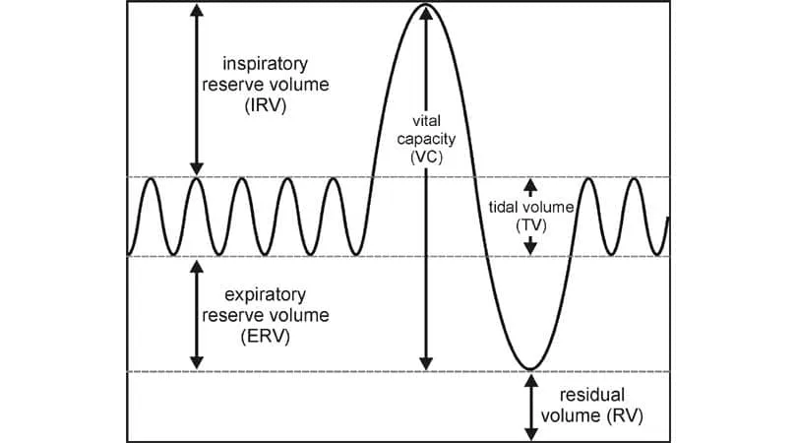

So, what if you inhaled as deeply as you could, then blew out all of the air that you could? That volume that you would blow out would also equal your vital capacity. So the Vital Capacity is a measurement of how much air the lungs can ‘move’, how much air the lungs can bring in and out. It is useful knowledge to also know how fast the lungs can blow out all of the air brought into the lungs after a deep inhalation. The FEV is a measure of how fast the air is exiting the lungs, how fast you can blow all of that air out. Since every person will have a slightly different Vital Capacity (VC) and FEV’s, if we were to make a ratio of these two numbers, that ratio can be compared between everyone.

On the graph below, the VC (vital capacity is where the line finally levels off, the maximal amount of air that you could blow out. Now since you are blowing out your vital capacity of air from the lungs as quickly as you can, this measurement (this volume) is called Forced Vital Capacity (FVC).

*Forced vital capacity (FVC). This is the amount of air breathed out forcefully and quickly after breathing in as much as you can.*

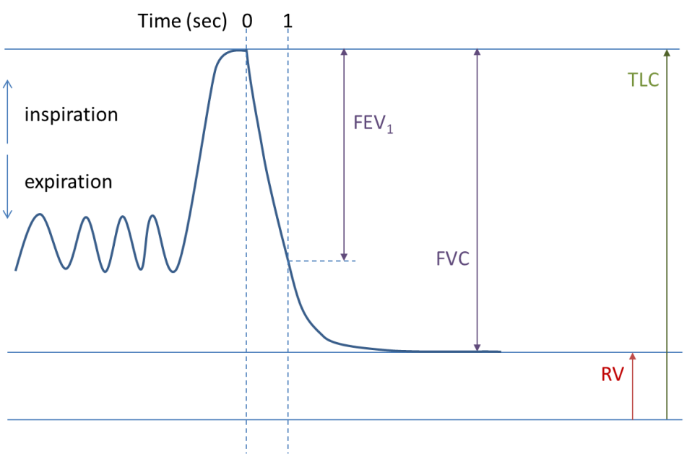

This graph above shows the line at 1.0 second. That volume would be the forced expiratory volume in one second = FEV1. Therefore, if the total amount of air expired after you have inhaled maximally is your vital capacity (forced vital capacity) (FVC on the graph above AND if the FEV1 is the amount of air expired in the first second of expiration, the ratio of the two shows you what percentage of the total air expired was blown out in the very first second. FEV/FVC.

Example: A reasonable number for FEV1 could be 3.0 liters. A reasonable number for FVC could be 3.7 liters. So the ratio: FEV/FVC = 3/3.7 = .81 or 81%. In other words, 81% of your total vital capacity should be expired in that first second of a forced expiration.

Notice on the first graph at the beginning of this lab report, by 2 seconds, FEV2, it is almost at the flat part of the downward slope, probably at 98% of FVC. And certainly by 3 seconds, FEV3, it will be at FVC, where FEV3 = FVC.

So that is what you are going to need to do with your tracing. Follow the directions, inhale maximally, blow out all of the air from you lungs as quickly as possible. Then obtain your FEV1, your FEV2, and FEV3 volumes as well as your FVC volume.

Place those numbers below:

|  |  |  |
| --- | --- | --- |
| FVC: | LEAVE THIS BLANK | LEAVE THIS BLANK |
| FEV1: | FEV1 / FVC: | FEV1/FVC*100= % |
| FEV2: | FEV2 / FVC: | FEV2/FVC*100= % |
| FEV3: | FEV3 / FVC: | FEV3/FVC*100= % |

“Normal” FEV1/FVC should be around 80%. FEV2/FVC should be close to 100%. FEV3/FVC should be 100%.

Would asthma cause the FEV1/FVC to increase or decrease and why?

Below is your answer.

I have asthma. Here is my reading/tracing:

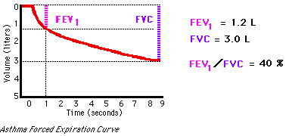

Why would an asthmatic (someone with narrowed and stiff airways) have an FEV1/FVC of only 40% when it should be around 80%?

**MVV Measurements:**

Before you start this part of the lab and you begin breathing a lot of breaths very fast, read all of this portion of the lab first. This is the sort of tracing you will be creating:

On the table below, fill in the values. Place the ‘high’ value for a breath in the second column and the ‘low’ value for that same breath in the third column. In the fourth (last) column, subtract the low number from the high number to obtain the volume of that breath. Remember, each ‘cycle’ is a complete breath.

Follow the directions and fill in this chart. You do not have to do all 15 cycles shown.

|  |  |  |  |
| --- | --- | --- | --- |
| Cycle number | Maximum Volume | Minimum Volume | Subtract to obtain total volume of that breath. |
| Cycle 1 |  |  |  |
| Cycle 2 |  |  |  |
| Cycle 3 |  |  |  |
| Cycle 4 |  |  |  |
| Cycle 5 |  |  |  |
| Cycle 6 |  |  |  |
| Cycle 7 |  |  |  |
| Cycle 8 |  |  |  |
| Cycle 9 |  |  |  |
| Cycle 10 |  |  |  |
| Cycle 11 |  |  |  |
| Cycle 12 |  |  |  |
| Cycle 13 |  |  |  |
| Cycle 14 |  |  |  |
| Cycle 15 |  |  |  |

You will want to calculate how much air you were able to move in and out of your lungs in ONE MINUTE.

Wait! Do not start breathing deeply and quickly into the spirometer. If you did this experiment, breathing as fast and as deep as you can for ONE MINUTE (60 seconds), you’d probably pass out from hyperventilation. So, you have two choices: Breathe as deep and as fast as you can for 15 seconds, add up all the breaths, then multiply by 4 (15 seconds X 4 = 60 seconds);

Or

Breathe as deep and as fast as possible for 12 seconds, add up all the volumes, then multiply by 5 (12 seconds X 5 = 60 seconds).

Place that MVV in liters per minute in the box below:

|  |
| --- |
|  |

Define Maximal Voluntary Ventilation (MVV):

What does MVV show you about lung volumes and flow of air through the airways?

How would asthma affect a person’s MVV?

How would emphysema affect a person’s FEV1/FVC?

How would emphysema affect a person’s Vital Capacity?

What is ‘lung perfusion’?

What is ‘lung ventilation’?

How are lung perfusion and lung ventilation different?