**Coagulation.**

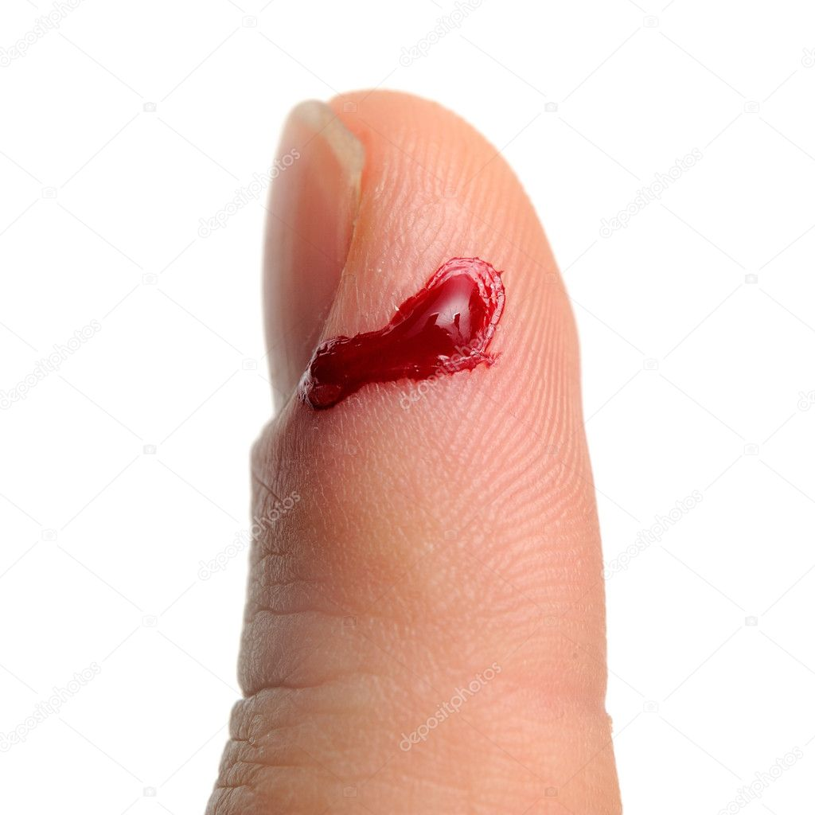

**Blood Clotting, Made Easy……no.**

**Blood Clotting, Made Simple……nope.**

**Blood Clotting 101……….no.**

**Blood Clotting for Dummies………..still no.**

I don’t like where this is going. The famous (or infamous) blood clotting diagram:  
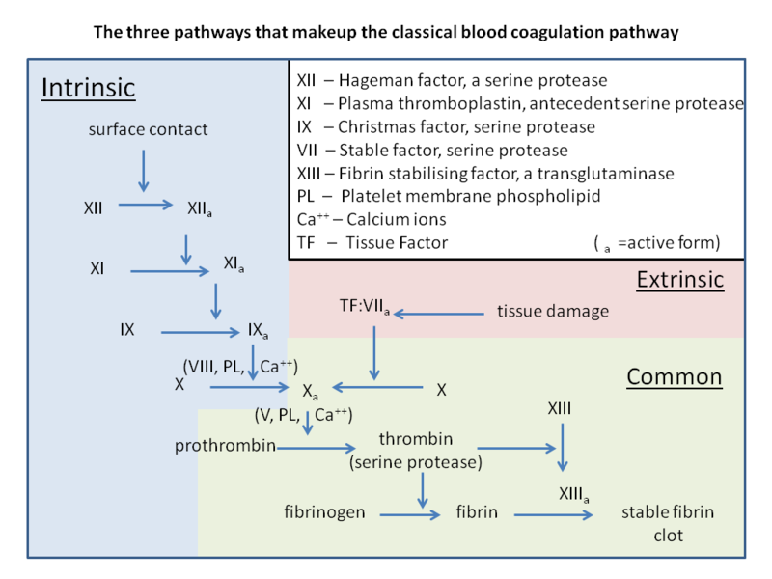

Are you about to tell me that I am going to have to learn all of those complicated clotting factors with their Roman Numerals and letters, who triggers who, what activates what, in what order, who’s Von Willebrand anyway, how hemophilia ties into all of this, glycoproteins, factors, receptors, zymogens, warfarin, heparin, serine proteases, extrinsic pathway, intrinsic pathway and why is it called Christmas factor?

That’s asking way too much of your students Wissmann. Give us a break.

Knowledge is a good thing. Relax and trust me and spend quality time ‘learning’ what I’m about to show you. After all, this class is called Human Physiology and to understand the processes of blood clotting is one of the very best physiological pathways to understand in life. We won’t even look at that above diagram until the very end. So relax, pay attention and follow me.

**Platelets + Fibrin = Blood Clot**

Simple, yes?

Let’s say it again: Blood Clot consists simply of a net of fibrin and sticky platelets (the book will call them ‘activated platelets’).

**Blood Clot = Platelets and Fibrin**

Where does the fibrin come from and how to get the platelets to go to the torn part of the blood vessel and stick? That takes some explaining.

**Blood clot: (notice the net-like (or sometimes described as a mesh-like) fibrin, red blood cells trapped in this net/mesh of fibrin and some smaller, oval platelets)**

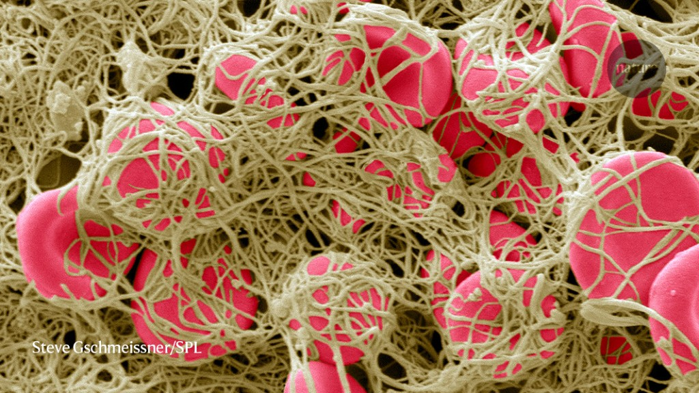

**Hemostasis** includes three steps that occur in a rapid sequence: (1) vascular spasm, or vasoconstriction, a brief and intense contraction of blood vessels triggered by chemicals released from ‘activated platelets’; (2) formation of a platelet plug where activated platelets adhere; and (3) blood clotting or coagulation, which reinforces the platelet plug with fibrin mesh that acts as a glue to hold the clot.

So let’s review. When a blood vessel is damaged a blood clot is quickly formed to stop the bleeding. What is found in this blood clot? You know the answer = fibrin and platelets. Well, and as the picture shows this clot will also have any blood cells that are trapped in the fibrin net, but remember what is put together to make the clot are fibrin (the net) and platelets (sticking and releasing chemicals). So as the above paragraph states, to stop the bleeding (hemostasis) platelets are activated (I’ll explain how that happens shortly) and these activated platelets release chemicals that cause that blood vessel to constrict (that’s a good thing); fibrin is assembled into a big net; and these activated platelets stick forming the platelet plug.

**Blood Clot = fibrin + platelets.**

But keep in mind the red blood cells are bleeding out of the wound and so also get stuck in the fibrin net. The red blood cells don’t form the clot but end up being trapped in the clot. What forms the clot are…. **Fibrin + Platelets**. Got it by now? Good.

**Below are the best two pictures ever to help explain a blood clot:**

**The blood vessel is damaged. It can be lightly or deeply scraped along the inside without puncturing the vessel wall or you can outright damage the vessel wall all the way through. Either way, a blood clot will be triggered to form.**

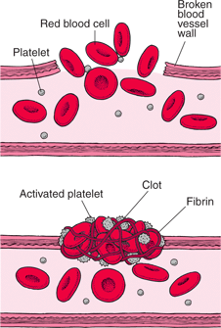 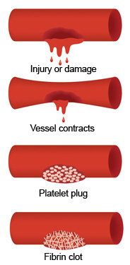

**And let me throw in one more excellent instructive illustration below just for fun:**

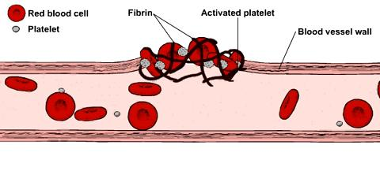

**Platelets + Fibrin = Blood Clot**

Where do the platelets come from? Well, they are preexisting, floating around in your blood, having been made in the bone marrow by the megakaryocytes (remember?).

And so then, where does the fibrin come from? Well, the fibrin (what looks like a big net in the blood clot) comes from its inactive form (does not look like a net yet) fibrinogen. And so where then does the fibrinogen come from and how is the fibrinogen converted into the net-like fibrin?

The inactive fibrinogen is made by the liver and released out into the blood stream. Oh, by the way, this fibrinogen is considered ‘clotting factor I’ (it was the first one discovered since it is found in the blood and turns into the ‘net’ of the clot, the fibrin). If this was an anatomy class all we’d have to do is memorize fibrin and platelet = blood clot and identify them. But since this is a physiology course, I guess we’ll have to learn the ‘process’ of how the inactive, liver produced fibrinogen is converted into the active, net-like fibrin found in a blood clot. So let me go ahead and explain what converts fibrinogen to fibrin.

When tissue damage results in bleeding, **fibrinogen** is converted at the wound into **fibrin** by the action of thrombin, a clotting enzyme. **Fibrin** molecules then combine to form long **fibrin** threads that entangle platelets, building up a spongy mass that gradually hardens and contracts to form the blood clot.

So there is your answer, THROMBIN, converts fibrinogen to fibrin at the wound. And where does the THROMBIN come from? You guessed it, it is converted from its inactive form ‘PROTHROMBIN’ into its active form THROMBIN. The PROTHROMBIN is made by the liver and placed out into the blood. THROMBIN must be an enzyme. In fact it is a serine protease type of enzyme. I’ll explain that a bit later.

A blood vessel is damaged so somehow the inactive prothrombin is converted into the active thrombin. This newly formed thrombin acts as an enzyme to convert inactive fibrinogen to active fibrin. As the below diagrams will show, these newly formed fibrins self-assemble and link together to form a net of fibrin.

It looks something like this:

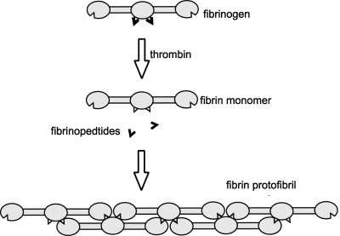 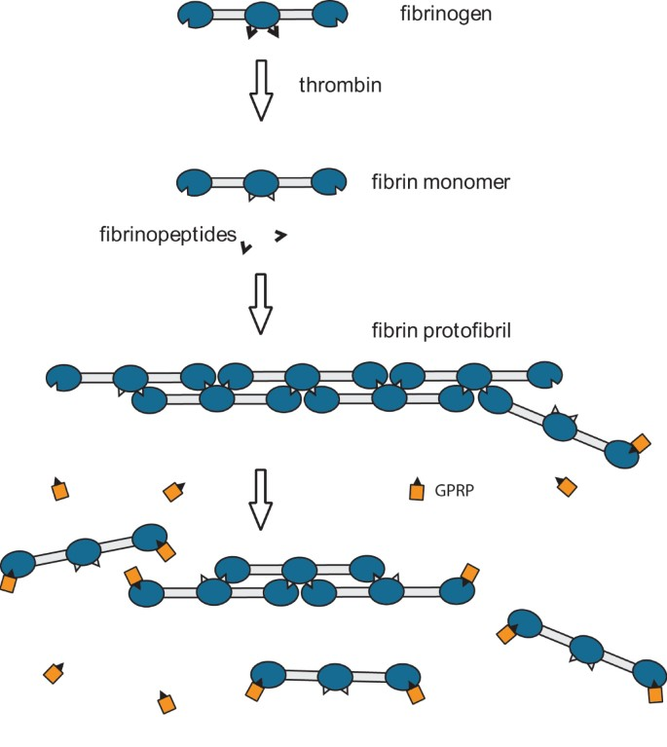

You are not responsible for knowing ‘fibrinopedtides (which by the way is misspelled-should be fibrinopeptides) and fibrin protofibril’. Just know that the individual fibrinogens are activated by THROMBIN to link into the net-like fibrin.

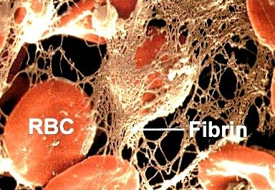

And let me add one more step to the formation of the fibrin mesh/net found in the clot. It is this mesh/net that traps RBC’s and platelets and molecules into the clot. So to strengthen this ‘mesh/net’ and help it to contract some to stop the bleeding, the linked fibrins are ‘**cross-linked’** as shown below (notice how the long, thin fibrins are cross-linked in the last step):

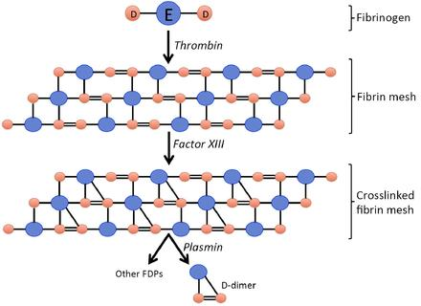

You can ignore for now ‘plasmin’ and ‘other FDPs’.

I should mention what molecule makes the cross-linking possible…..that molecule is called **clotting factor XIII** (lucky factor-13). Notice that in the diagram. Where does **Factor XIII** come from? The liver. **Factor XIII** is found floating in the blood. What triggers **Factor XIII** to now be able to build the cross links? **Factor XIII** is activated by THROMBIN also. So when the vessel is damaged, the inactive precursor PROTHROMBIN (from the liver, floating in the blood) is activated into THROMBIN and this activated THROMBIN activates **FACTOR XIII** to build cross links in the fibrin mesh/net and the fibrin came from THROMBIN converting the inactive fibrinogen into fibrin.

Now is as good a time as ever to mention something about the clotting factors and their Roman numerals. They are numbered in the order in which they were discovered. So the biggest, most obvious ones were the first ones discovered and numbered with the lowest Roman numerals. You’ve discovered that in most all cases, the clotting factor is in the blood in an inactive form and then gets converted into its active form. The inactive form has the Roman numeral while the active form also uses the Roman numeral and adds the letter ‘a’ after the Roman numeral. For example, we just learned about clotting factor XIII, which can also be called FXIII. In its inactive form it is called: FXIII. In its active form it is called: FXIIIa.

Let’s try another example. We are about to learn what molecule converts the inactive prothrombin into its active form thrombin. That molecule (an enzyme) is clotting factor X. So when clotting factor X is available in its active form, FXa, it will convert the inactive prothrombin to the active thrombin. So clotting factor goes from its inactive form, FX, to its active form, FXa.

We’re over ½ way through explaining the clotting series of reactions, the clotting cascade. Damage to blood vessel wall 🡪 something as of yet unexplained happens 🡪 clotting factor X 🡪 FXa 🡪 prothrombin to thrombin 🡪 fibrinogen to fibrin! (Don’t forget thrombin also converts lucky FXIII to FXIIIa to cross link the fibrins.)

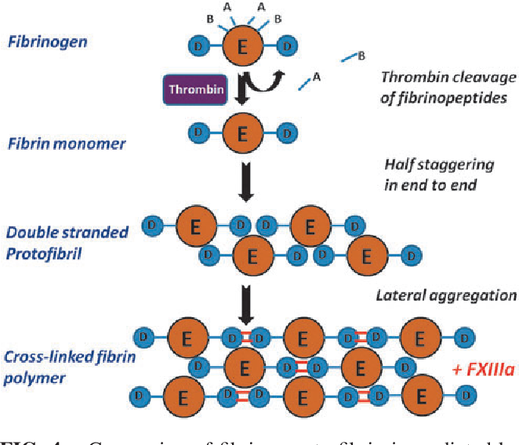

Below is a beautiful scanning electron micrograph (picture taken with a scanning electron microscope). Above: fibrin alone; Below: blood clot with RBCs and platelets trapped in the fibrin mesh/net.

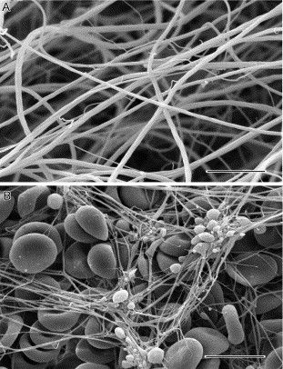

So now the below diagram makes sense. The liver makes the inactive Fibrinogen and the inactive Prothrombin. When a blood vessel is damaged, the inactive prothrombin is activated/converted into the active thrombin.

This thrombin does two things: (1)converts inactive fibrinogen into active fibrin and (2)activates lucky clotting factor XIII which in turn adds cross links to the growing fibrin mesh/net. Notice XIIIa means the active form of XIII. So thrombin must be an enzyme. It is a serine protease type of enzyme (we’ll discuss that later).  
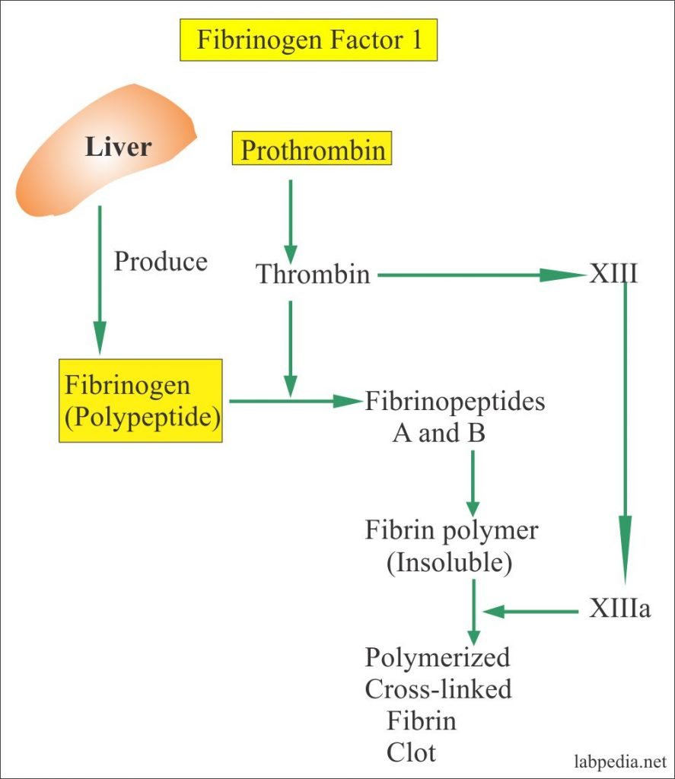

So that’s it, right? Blood Clot = platelets and fibrin. You’ve explained platelets and fibrin. So we’re done, right? Let’s grab our surfboards and hit the waves.

Well, before you go, let me take a very interesting tangent. Now that we know about prothrombin/thrombin and fibrinogen/fibrin, can that help us understand bleeding disorders and ‘drug thinning’ agents like the famous heparin?

**Prothrombin time** (**PT**) is a blood test that measures how long it takes blood to clot. A **prothrombin time** test can be used to check for bleeding problems. **PT** is also used to check whether a medicine to prevent blood clots is working.

The average time range for blood to clot is about 10 to 13 seconds. A number higher than that range means it takes blood longer than usual to clot. A number lower than that range means blood clots more quickly than normal.

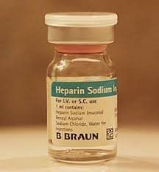

**Heparin famously prevents blood clots. How?**

I’ve been explaining how the blood can form a blood clot if a blood vessel is damaged. As you might guess, in the blood there is a way to prevent blood clots from happening. A ‘natural’ way for the blood to not form a blood clot in order to make sure minor trauma to a blood vessel will not cause too much clotting.

**Antithrombin III** is a protein in the blood that blocks abnormal blood clots from forming. It helps the body keep a healthy balance between clotting and not-clotting.  It blocks our blood clotting mechanism by inactivating the major clotting protein “thrombin.” It is, therefore, called “anti-thrombin.” Remember that thrombin is a critical molecule needed in the pathway to form a blood clot. If you block thrombin, well then, no blood clot. That is what antithrombin III normally does.

Antithrombin III is a [serpin](https://en.wikipedia.org/wiki/Serine_protease_inhibitor) (serine protease inhibitor). I won’t test on ‘serpin’, but it is worth knowing about. Remember most all of these clotting factors are enzymes. They exist in an inactive form, and then are converted into their active form. Well, the active form of an enzyme would have it enzymatically react with something. Most all of these clotting factor enzymes are ‘serine proteases’, enzymes that break proteins with a special serine amino acid at the binding site of the enzyme. Prothrombin is an inactive enzyme (specifically in the serine protease category). When converted to its active form thrombin, the inactive prothrombin was enzymatically broken by clotting factor Xa (itself a serine protease enzyme) into an active enzyme called thrombin. This active serine protease enzyme called thrombin specifically binds to the inactive fibrinogen and converts it into fibrin.

Since antithrombin III blocks the action of the enzyme thrombin, antithrombin III is a serine protease inhibitor.

Let’s get back to heparin now. So heparin produces its major anticoagulant effect by stimulating antithrombin III. If heparin stimulates antithrombin III, then antithrombin III will block thrombin more and prevent blood clotting. Remember also that thrombin activates lucky clotting factor XIII, the clotting factor involved in cross-linking the fibrin. Since heparin stimulates antithrombin III, with thrombin inactive, clotting factor XIII is not activated and fibrinogen is not converted into fibrin, hence, no clotting thanks to heparin. Antithrombin III’s activity is increased manyfold by the [anticoagulant](https://en.wikipedia.org/wiki/Anticoagulant) drug [heparin](https://en.wikipedia.org/wiki/Heparin), which enhances the binding of antithrombin III to [factor IIa](https://en.wikipedia.org/wiki/Thrombin) (Thrombin) and [factor Xa](https://en.wikipedia.org/wiki/Factor_X).

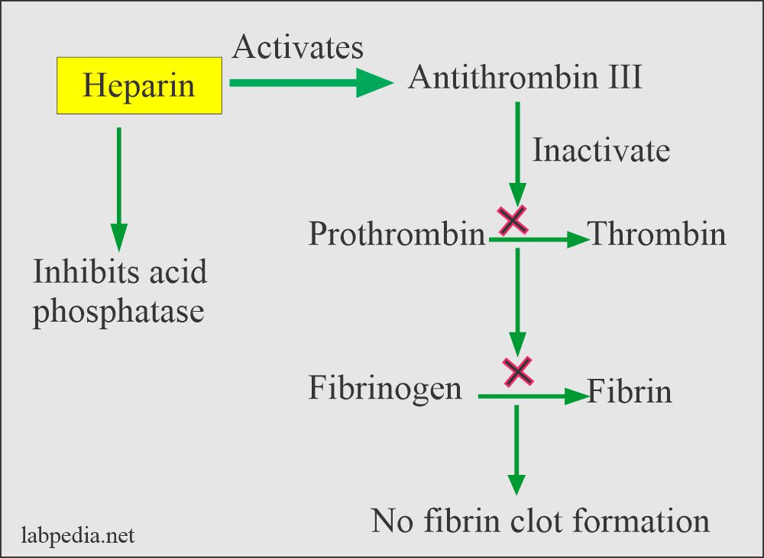

So my first tangent here was to explain something about ‘blood thinners’. My second tangent now is to talk about forming blood clots not in a torn blood vessel wall but when the inner lining of a blood vessel is scraped or damaged. If the inner lining of a blood vessel is damaged, without tearing all the way through the blood vessel wall, a blood clot will still be formed. But this can lead to trouble since this blood clot is forming inside the vessel, along the wall of that vessel. This blood clot inside the vessel is called a ‘thrombus’. And if this clot gets torn loose from the inner lining of the wall of that blood vessel, that blood clot can float downstream in the circulatory system and eventually get stuck in a smaller diameter blood vessel, completely blocking blood flow and that’s big trouble. If the blood clot is now a floating blood clot, it is called an ‘embolus’. Emboli are very dangerous.

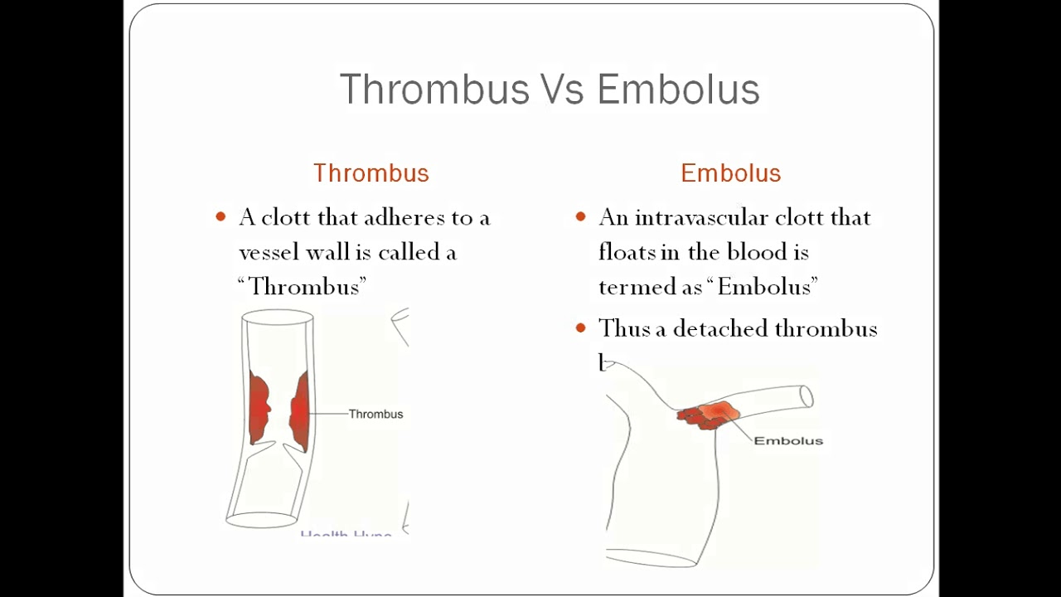

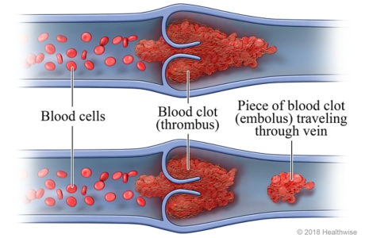

And one of the most common and most dangerous types of emboli come from “Deep Vein Thrombosus”.

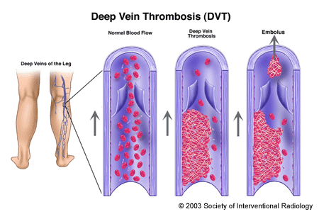

**Follow me.**  Blood clots called deep vein thrombi (DVT) often develop in the deep leg veins. If you sit for hours in a cramped airplane seat for example. Pulmonary embolism (PE) occurs when clots break off from vein walls and travel through the heart to the pulmonary arteries. So you develop a big clot in a large vein in a leg. That clot breaks loose (when you finally stand up for example). It is now a big thrombus. Anatomically it travels up the veins in your leg, up into the vena cava, will enter the right atrium, down into the right ventricle and enter the pulmonary arteries to the lungs. It is big and will block the pulmonary arteries. No blood flow through the pulmonary arteries and you die quickly. This becomes serious.

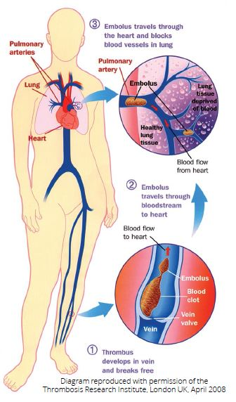 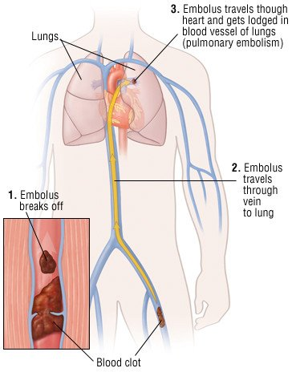

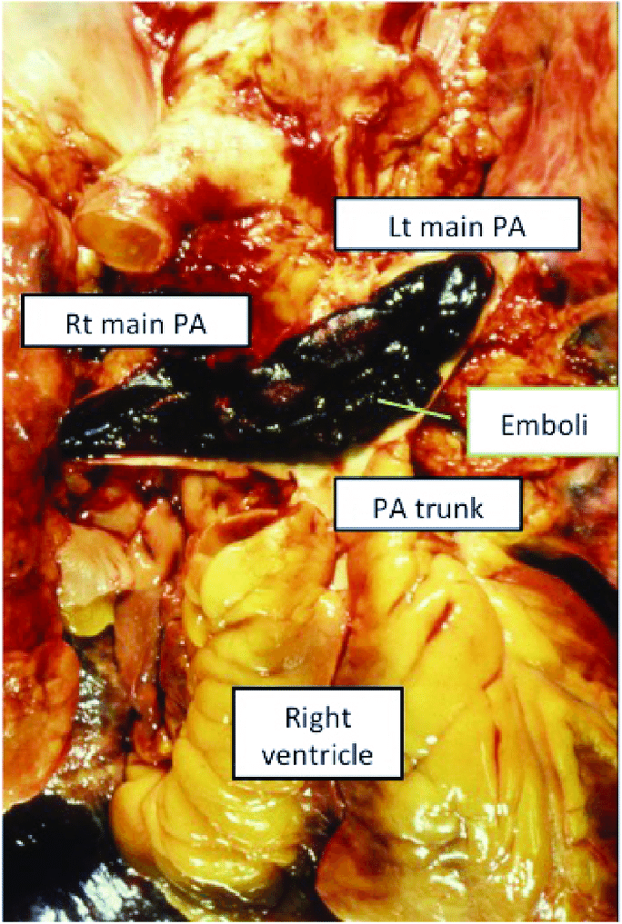

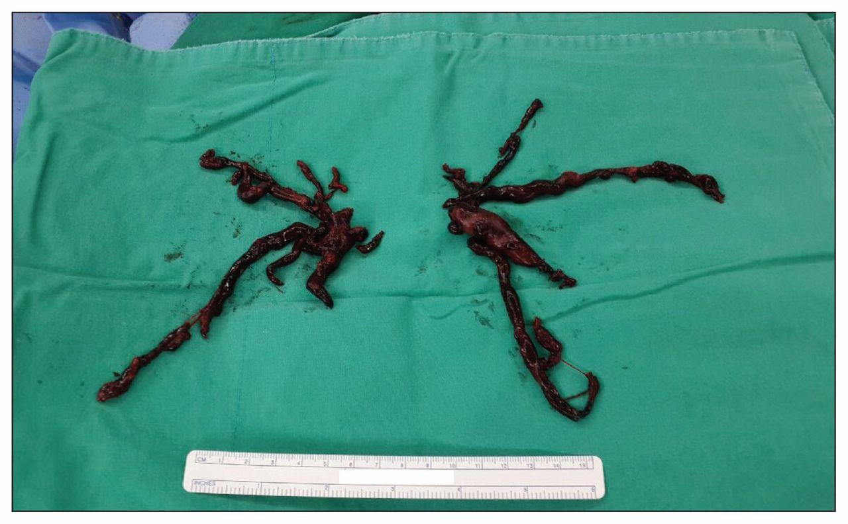

So maybe taking a ‘baby aspirin’ before a long airplane trip is a good idea. Why?

There are two main types of blood thinners. (1)**Anticoagulants** such as heparin or warfarin (also called Coumadin) slow down your body's process of making clots. (2)Antiplatelet drugs, such as **aspirin**, prevent blood cells called platelets from clumping together to form a clot.

Let’s spend some time talking about a thrombus. SMOKING will introduce toxic molecules into the bloodstream. These toxic molecules will be toxic to the cells lining the blood vessels and damage and kill these inner lining cells. Remember the inner lining of all of your blood vessels are simple squamous epithelium, the endothelium. Next is the middle layer of a blood vessel, the tunica media made up of smooth muscle fibers, elastic fibers and some collagen fibers.

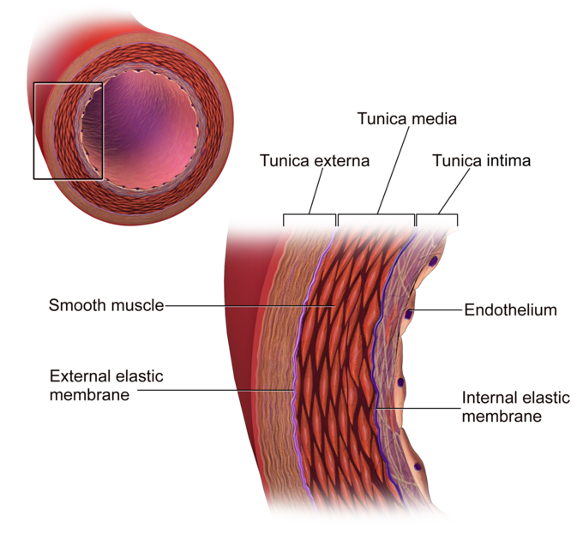

So if the tunica intima is gone the tunica media and tunica externa are now exposed to the blood. Platelets and specific clotting factors are exposed to COLLAGEN! Normally the platelets and clotting factors would never be in direct contact with COLLAGEN fibers. But if there is damage to the inner linings of blood vessels (due to say, atherosclerosis), the platelets will react to being in contact with collagen and specific clotting factors will respond to being now exposed to collagen fibers.

Firstly, the platelets when exposed to the collagen become ACTIVATED PLATELETS and will stick to the collagen. A blood protein that helps in anchoring the platelets here is a protein called von Willebrand Factor (which is not one of the Roman Numeral clotting proteins). So that von Willebrand’s Disease is a bleeding disorder due to a lack of platelet adherence to the damaged part of the vessel. Since it is genetic, it is a lifelong disorder where the patient has trouble forming blood clots. The von Willebrand Factor comes from the platelets and endothelial cells.

Blood Clot = Fibrin + Platelets

These platelets found at the wound and becoming part of the blood clot are ‘activated platelets’ because they’ve been in contact with collagen. These activated platelets now release von Willebrand’s factor (to help with sticking/adherence).

Let me simply add one more molecule called **“Tissue Factor”.** It is released from the damaged cells in the wall of the blood vessel. Also some of the **Tissue Factor** does not leave the vessel wall but stays in the vessel wall and can now come in contact with clotting factors floating in the blood. The **Tissue Factor** remaining in the wall of the blood vessel can also come in contact with platelets, activating these platelets. This released **Tissue Factor** and remaining **Tissue Factor** does two things: (1)converts inactive platelets to ‘activated platelets’ and (2)activates the inactive clotting **factor VII** into its active form (VII into VIIa).

Wait, you just said that when platelets are ‘exposed’ (come in contact with) collagen they become activated platelets. Now you’re saying that when platelets come in contact with Tissue Factor found in the wall of the damaged vessel they become activated platelets. Yes, both statements are correct. Both collagen and Tissue Factor will cause platelets to become activated platelets.

But don’t overlook the HUGE new fact presented. With TISSUE FACTOR now exposed, what was an inactive clotting factor called clotting **factor VII** can now bind to Tissue Factor and this combined FVII and TISSUE FACTOR molecule activates the clotting **factor X** in the blood!

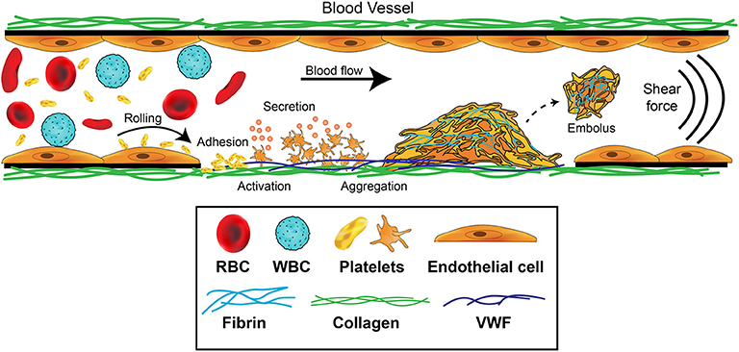

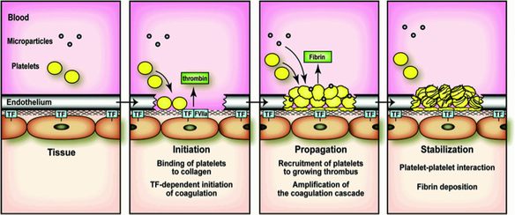

Now watch this. The activated factor VII (called VIIa) converts clotting factor X into its active form, clotting factor Xa.

And pay attention now, clotting factor Xa converts prothrombin into thrombin! Thrombin ‘blah-blah-blah’ to fibrin mesh/net!

Let’s regroup. Damage inner lining of blood vessel. Expose collagen and release of Tissue Factor along with Tissue Factor being exposed in the wall of the damaged blood vessel. Tissue Factor stimulates VII into VIIa. VIIa activates X into Xa, which turns prothrombin into thrombin. Thrombin converts fibrinogen into fibrin! And remember thrombin activates XIII for the cross-linking of fibrin.

Also, exposed collagen and released Tissue Factor activates platelets to firmly attach.

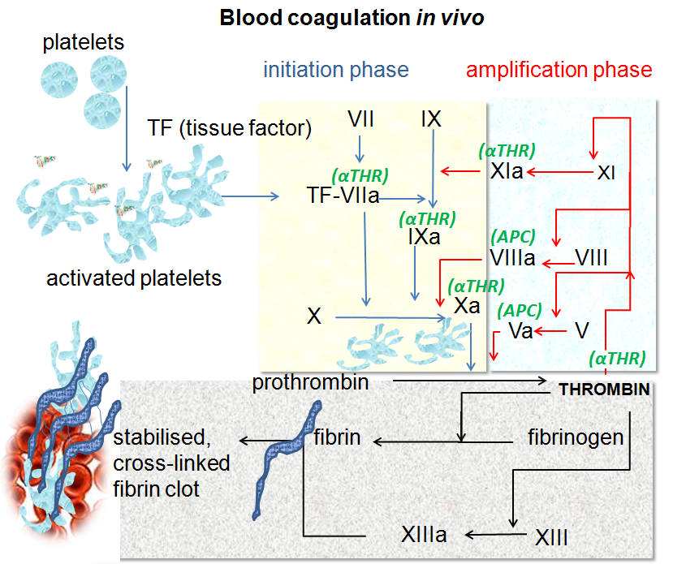

For now ignore clotting factors: V, VIII, and XI seen in red above.

This is not complicated at all. We know:

Prothrombin to thrombin 🡪 fibrinogen to fibrin

Thrombin 🡪 activates lucky factor XIII (FXIII) into FXIIIa for cross linking.

Now we’ve just connected the dots!

Damage to vessel wall. Tissue Factor exposed (as well as collagen). Clotting factor VII (FVII) binds to Tissue Factor.

The active form of FVII which is called FVIIa will convert inactive clotting factor X (FX) into its active form, active clotting factor X (FXa). And what does FXa do? It converts prothrombin to thrombin! Not complicated at all.

Say it with me. Damage to vessel wall. Expose Tissue Factor (TF). This binds and activates FVII. Activated VII turns on FX. Newly activated FX (FXa) converts prothrombin to thrombin. Thrombin converts fibrinogen to fibrin. Viola!

And don’t get von Willebrand’s factor confused. It is released by the activated platelets causing them to stick more, making the platelet plug. So von Willebrand’s factor is not one of the blood clotting factors and has no Roman numeral.

That leaves clotting factors XII, XI, and IX. Clotting factor XII is activated by exposure to collagen and also activated by exposure to negatively charged proteins in the wall of the vessel. Platelet release of chemicals may also aid in the conversion of XII into XIIa. XIIa converts inactive XI into active XIa. XIa converts IX into its active form IXa. Here it comes….the active IXa converts X to Xa and off we go again.



Good stuff.

You’ve noticed in your readings that the literature mentions that the so-called ‘intrinsic pathway’ (I don’t like those terms: intrinsic and extrinsic pathways) is triggered by glass. That’s a weird thing to say, right? So when does your circulating blood ever come into contact with glass? You cut or break a blood vessel and there is never, ever any glass inside the wall of a blood vessel or even in the surrounding tissues. So why mention that Factor XII is triggered by contact with glass of all things?

Well, I’ll tell ya. Your blood can come into contact with glass if a needle is inserted through your skin and someone draws blood out of you into a glass test-tube for your blood to be analyzed in a hospital laboratory. So in order for your blood to not clot when it is taken out of your body into a test-tube, the test-tube has to have the ability to not trigger Factor XII or some sort of anticoagulant must already be in the test-tube to immediately mix the blood with.

If you put **blood** into a **plain glass tube**, i.e. with no anticoagulant in it, when the **blood** touches the **glass** a plasma protein called Factor XII (also called "Hageman Factor") is activated. So why is factor XII called Hageman Factor? Why because it is named after John Hageman who worked on the railroads. John Hageman had prolonged clotting time in test tubes. In 1955, Drs. Oscar Ratnoff and Jane Colopy identified for the first time Factor XII and that John did not have it due to a genetic mutation. Those rare people who genetically lack Factor XII have Hageman’s disease and do not clot as well as others.

This factor initiates **clot** formation. In a **glass tube**, the **glass** causes the initiation of the **clotting** mechanism, most likely due to negative charges on the glass. As you can imagine, a lot of research has gone into finding ways to not make blood clot when drawn into a glass test-tube. So during all of that research, the molecules involved in this pathway were discovered (you know, clotting factors FXII, FXI, FIX). So this pathway is valid, does help in triggering the production of a blood clot but is the minor pathway compared to the pathway that involves Tissue Factor binding FVII, FVIIa activating FX into FXa which converts prothrombin to thrombin.

Now you physiology superstars may have noticed a molecule called ‘kallikrein’ mentioned, usually in relation to it being activated by Factor XII. There are more than one type of kallikrein and they do a lot of things in the body. So for our purposes just understand that when kallikrein is activated by Factor XII, kallikrein is involved in turning on the inflammatory response which makes sense since a broken blood vessel means possibly bacterial entry and at that site you’d need immune cells right away. But we won’t be tested on kallikrein.

Let’s take apart a ‘fancy’ definition but notice at the end of this ‘fancy’ definition it gets back to the basic facts: blood clot = platelets + fibrin:

*“The plasma coagulation system in mammalian blood consists of a cascade of enzyme activation events in which serine proteases activate the proteins (proenzymes and procofactors) in the next step of the cascade via limited proteolysis. The ultimate outcome is the polymerization of fibrin and the activation of platelets, leading to a blood clot.”*

First of all, what is a serine protease? They hydrolyze (break) proteins. They are a protein made up of many amino acids, some of which are the amino acid serine. But they all have one special serine amino acid that is part of the binding site where they attach to the protein they are going to break. So to be an effective protease, these serine proteases have a ‘special’ serine amino acid at its binding site (active site). And just in case you were interested, of the 699 proteases in humans, 178 of them are serine proteases. Most of the enzymes in this clotting cascade are serine proteases.

*“This process is protective, as it prevents excessive blood loss following injury (normal hemostasis). Unfortunately, the blood clotting system can also lead to unwanted blood clots inside blood vessels (pathologic thrombosis), which is a leading cause of disability and death in the developed world.”*

The unwanted blood clots mentioned are thrombi produced in atherosclerosis. They can break away and become emboli.

The coagulation cascade is classically divided into three pathways: the contact (also known as the intrinsic) pathway, the tissue factor (also known as the **extrinsic pathway**), and the common pathway. Both the contact pathway and the tissue factor feed into and activate the common pathway.

The EXTRINSIC pathway as many sources call it. It is easy: damage endothelial cells, blood and blood cells exposed to ‘tissue factor’ (TF) which is a protein found inside the wall of the blood vessel. TF will trigger (activate) clotting factor VII (FVII) into its active form, clotting factor VIIa (FVIIa). Platelets will stick (adhere) to the TF in the exposed wall and become ‘activated platelets’. More platelets stick. In fact the activated platelets will release more TF to activate more FVIIa. Remember this FVIIa will convert inactive clotting factor X into its active form, Xa. Xa converts prothrombin to active thrombin, and this thrombin converts inactive fibrinogens into fibrin! Platelets release lucky clotting factor XIII to cross link the fibrin. Platelets release von Willebrand’s factor for platelet sticking to make the platelet plug.

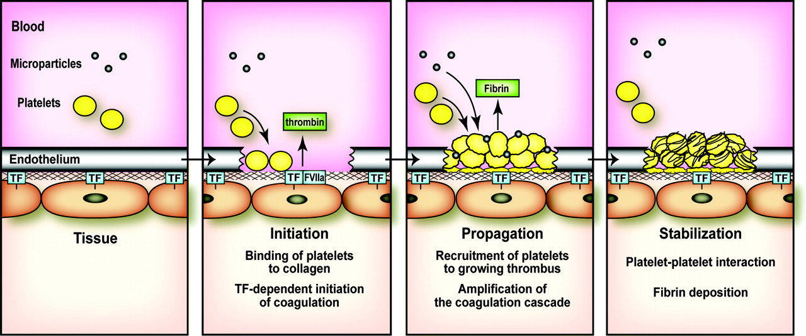

The INTRINSIC pathway. Despite its important role in clot formation in vitro (in a test-tube), contact activation (intrinsic pathway) appears to have little contribution to hemostasis in vivo (in the body/in tissue/ in cells). This conclusion comes from the fact that mice and humans (Hageman) lacking clotting factor XII have barely any bleeding tendencies. Rather, one of the functions of the contact pathway in vivo appears to be the generation of kallikrein to turn on the inflammatory response.

Intrinsic Pathway  
The intrinsic pathway is activated by trauma inside the vascular system, and is activated by platelets, exposed endothelium, chemicals, or collagen. This pathway is slower than the extrinsic pathway.  It involves factors XII, XI, IX, VIII. Can be considered a way to amplify the response initiated by the Tissue Factor pathway.

Let’s put it all together:

Common Pathway: FX 🡪 FXa 🡪 prothrombin to thrombin 🡪 fibrinogen to fibrin (and don’t forget lucky FXIIIa to cross link the fibrin).

Tissue Factor (extrinsic) pathway: exposed TF + FVII 🡪 FVIIa 🡪 FX to FXa 🡪 follow common pathway to blood clot and hemostasis.

Contact Pathway (intrinsic): FXIIa 🡪 FXIa 🡪 FIXa 🡪 FX into FXa and follow the common pathway to blood clot and hemostasis.

Tissue Factor is also referred to as clotting factor III.

Atherosclerosis can trigger either the contact pathway or the tissue factor pathway leading to thrombi.

Speaking of Vitamin-K:

Clotting factor VII is vitamin-K dependent. Also clotting factors II, IX and X are vitamin-K dependent. What is Vitamin-K? It is a *group* of vitamins. The “K” in vitamin-K comes from the German, “koagulation” since they were first identified in relation to blood clotting. There are three compounds that have the biological activity of vitamin-K:

1-phylloquinone (vitamin-K1): the normal dietary source found in green vegetables;

2-menaquinones (vitamin-K2): synthesized by intestinal bacteria;

3-menadione and menadiol diacetate: synthetic compounds that can be metabolized into phylloquinone.

Now you’ve read it, but you will not be responsible to know it for any quiz or exam. Interestingly vitamin-K is transported in the blood as a fat or cholesterol within chylomicrons and VLDL. That is why it is considered one of the 4 fat soluble vitamins (remember: A,D,E,K). The body stores very little vitamin-K and so it would be depleted quickly without regular dietary intake. But vitamin-K is recycled in the body via the ***vitamin-K cycle***. Again, not tested on but certainly interesting.

Vitamin-K dependent proteins rely on vitamin-K to aid in those same protein’s calcium binding functions. Remember several of the clotting factors use calcium as a co-factor and now we’ve learned that those clotting factors need vitamin-K in order to bind calcium. Clotting factors II, VII, IX and X require vitamin-K in order to successfully bind their cofactor calcium.

I am now finally getting to the point: ***Warfarin***. Warfarin blocks steps in the **vitamin-K cycle** creating a functional deficiency of vitamin-K. Thus, warfarin inhibits coagulation. It is a blood thinner. With warfarin present, less vitamin-K available, less binding of calcium to those clotting factors that require calcium as a cofactor and so no reacting as an enzyme and so no clotting. Warfarin would be a type of vitamin-K antagonist.

Who would get warfarin? Any patient that has a significant risk of developing a blood clot or already has pathological blood clotting (patient has deep vein thrombosis or acute ischemic stroke for example). So as you might guess, the major side effect of warfarin is bleeding. Or bleeding can occur in someone who is vitamin-K deficient in their diet. Now wasn’t the all interesting?

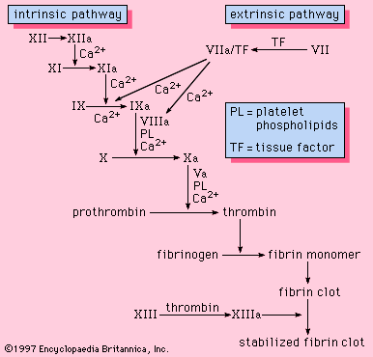

OK, since the clotting factors were numbered according to the order in which they were discovered, (clotting factors one through thirteen: FI – FXIII) it makes a whole lot of sense to imagine the first protein to be found in a blood clot was fibrin so obviously clotting factor I = fibrinogen.

Where did the fibrin come from? From fibrinogen (FI). How was fibrinogen converted into fibrin, by the second protein discovered in this clotting pathway, thrombin. So clotting factor II is prothrombin. I wasn’t there but it does make some sense to believe the next large protein involved in blood clotting to be discovered was the large, membrane protein that starts the whole process, Tissue Factor. So Tissue Factor is clotting factor III.

This is odd. The next thing necessary to create a blood clot that was isolated (discovered) was Calcium. Not a protein but the ion Ca++. So it was called clotting factor IV. In all of this, Ca++ acts as a co-factor to an enzyme. But actually, Ca++ acts as a co-factor to several enzymes in these pathways. That makes for some confusion since if you look at these pathways in detail, clotting factor IV is shown to ‘combine’ with other enzymes. But that is right, since what is called clotting factor IV is just the ion Calcium and is a co-factor it must combine with enzymes to make them functional.

Factors V and VI we are not going to worry about. Interestingly there is no clotting factor VI. What was named clotting factor VI turned out to be the active version of factor V (FVa). So the active version of factor V (FVa) was named clotting factor VI incorrectly and so there is not FVI.

The rest we know by their numbers very well by now.

The ‘subendothelial cell’ von Willebrand’s factor is just that, found in the tissue underneath the endothelial cells. When the inner lining of the vessel is damaged, von Willebrand’s factor is exposed and it attaches tightly to platelets helping to secure the platelet plug. Once activated, the platelets themselves will also release von Willebrand’s factor.

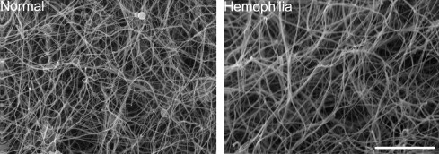

In factor **VIII** deficiency (hemophilia A), the body doesn't make enough factor **VIII** (factor 8), one of the substances the body needs to form a clot. If you look at that complicated complement cascade diagram, you’ll find FVIII acts as a cofactor for FIXa to convert the important step, FX into FXa. Without FXa, no clotting.

Type A, the most common type, is caused by a deficiency of factor VIII. This type is known as classic **hemophilia**.

Type **B hemophilia** is caused by a deficiency of factor IX. This type is also called Christmas disease.

The **disease** is **named** for Stephen **Christmas**, who was the first person diagnosed with the condition in 1952.

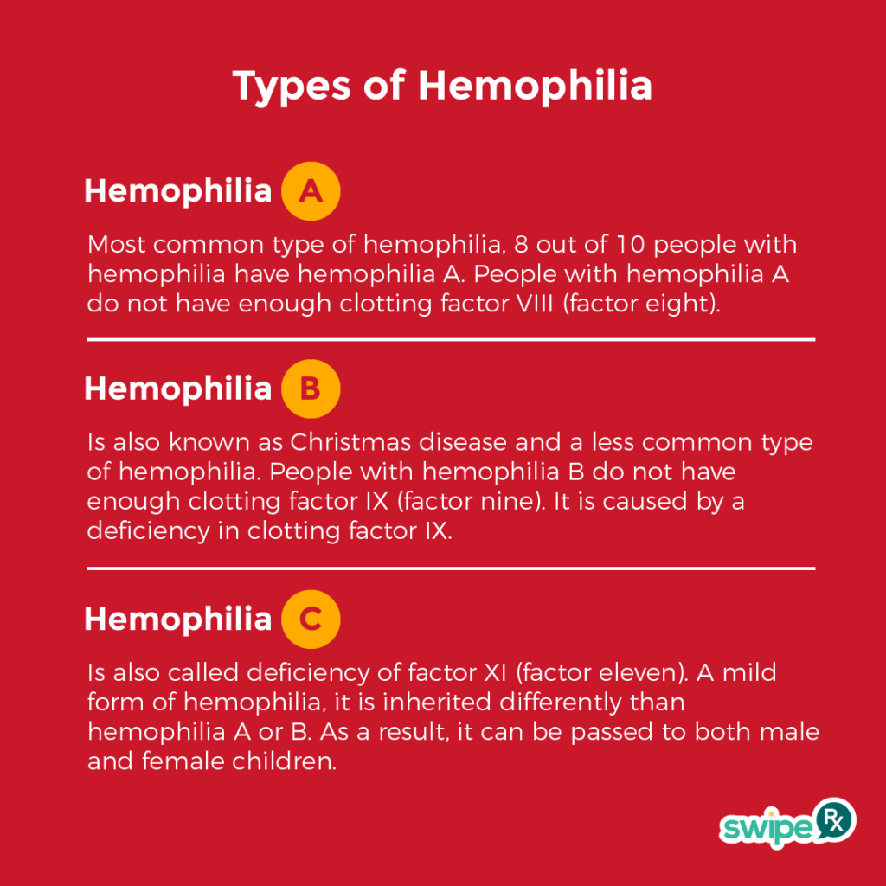

**Antithrombin III** is made in the liver.

**Antithrombin III** is a circulating plasma protein that functions as an important regulator of blood coagulation. It inactivates several enzymes of the coagulation cascade, in particular thrombin and factor Xa.

**Antithrombin III** is a protein in the blood that blocks abnormal blood clots from forming. It helps the body keep a healthy balance between clotting and not-clotting. So what does that mean, ‘helps the body keep a healthy balance between clotting and not-clotting’? When and why and how does antithrombin III turn on and block blood clotting? It is unknown. The regulator molecules that keep it off or activate it are not fully understood. So let me answer that question this way. If you have a person (or animal) that lacks antithrombin III, they form too many blood clots and have problems with thrombi. So it is known that antithrombin III is involved with preventing blood clotting, it is not fully known what activates it.

**Heparin** binds to **Antithrombin III** (AT) and amplifies its blocking of thrombin and FXa. Antithrombin III’s activity is increased manyfold by the [anticoagulant](https://en.wikipedia.org/wiki/Anticoagulant) drug [heparin](https://en.wikipedia.org/wiki/Heparin), which enhances the binding of antithrombin III to [factor IIa](https://en.wikipedia.org/wiki/Thrombin) (Thrombin) and [factor Xa](https://en.wikipedia.org/wiki/Factor_X).



Most coagulation factors were discovered in the 1940s and 1950s. Initially named after the first patients. The use of ROMAN NUMERALS was adopted in 1954 to simplify their nomenclature. Two independent teams propose the concept of the coagulation cascade.

The mechanism of clotting began to be studied by Buchanan (1838), who recognized thrombin; Hammarsten (1875), who purified fibrinogen; and Arthus (1890), who discovered the need for calcium. The fact that platelets existed and had a hemostatic function was developed in the 1800s.

Arthus discovered in 1890 that calcium was essential in coagulation. Platelets were identified in 1865, and their function was elucidated by Giulio Bizzozero in 1882. The theory that thrombin is generated by the presence of tissue factor was consolidated by Paul Morawitz in 1905.

Platelets have the following functions:

* Secrete vasoconstrictors which constrict blood vessels, causing vascular spasms in broken blood vessels.
* Form temporary platelet plugs to stop bleeding with the aid of von Willebrand’s factor.

[Prothrombin](https://www.sciencedirect.com/topics/pharmacology-toxicology-and-pharmaceutical-science/prothrombin) (clotting factor II), the [zymogen](https://www.sciencedirect.com/topics/pharmacology-toxicology-and-pharmaceutical-science/enzyme-precursor) of the plasma [procoagulant](https://www.sciencedirect.com/topics/pharmacology-toxicology-and-pharmaceutical-science/procoagulant" \o "Learn more about Procoagulant from ScienceDirect's AI-generated Topic Pages) thrombin, was the first protein shown to be dependent on [vitamin K](https://www.sciencedirect.com/topics/chemistry/vitamin-k). Plasma clotting factors VII, IX, and X were all initially identified in patients with hereditary bleeding disorders and were subsequently shown to be vitamin K dependent.

