Hemolysis: the destruction of RBC’s.

Here is a current article explaining that it is still unclear as to how and why ‘OLD’ red blood cells are burst while inside the spleen by macrophages found there…..

“Normal human red blood cells have an average life span of about 120 days in the circulation after which they are engulfed by macrophages. This is an extremely efficient process as macrophages phagocytose about 5 million erythrocytes every second without any significant release of hemoglobin in the circulation. Despite large number of investigations, the precise molecular mechanism by which macrophages recognize senescent red blood cells for clearance remains elusive. Red cells undergo several physicochemical changes as they age in the circulation. Several of these changes have been proposed as a recognition tag for macrophages. Most prevalent hypotheses for red cell clearance mechanism(s) are expression of neoantigens on red cell surface, exposure phosphatidylserine and decreased deformability.”

“The high density of macrophages in the red pulp results in contact with the red cells. Macrophages recognize damaged, deformed and senescent erythrocytes and remove them from circulation by phagocytosis.”

So our take-away lesson is that ‘old’ (senescent) RBC’s are recognized by macrophages in the spleen and burst while in the spleen. That sets up our discussion on what happens to their contents. Well, we all now know that their content consists of lots and lots of hemoglobin molecules.

Oh, by the way, did you think about what they say in the article? That 5,000,000 RBC’s are destroyed in the spleen every SECOND! I find that hard to imagine even.

First, here is just the Heme-group:

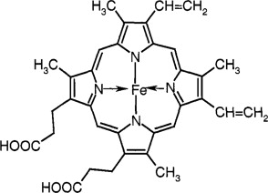 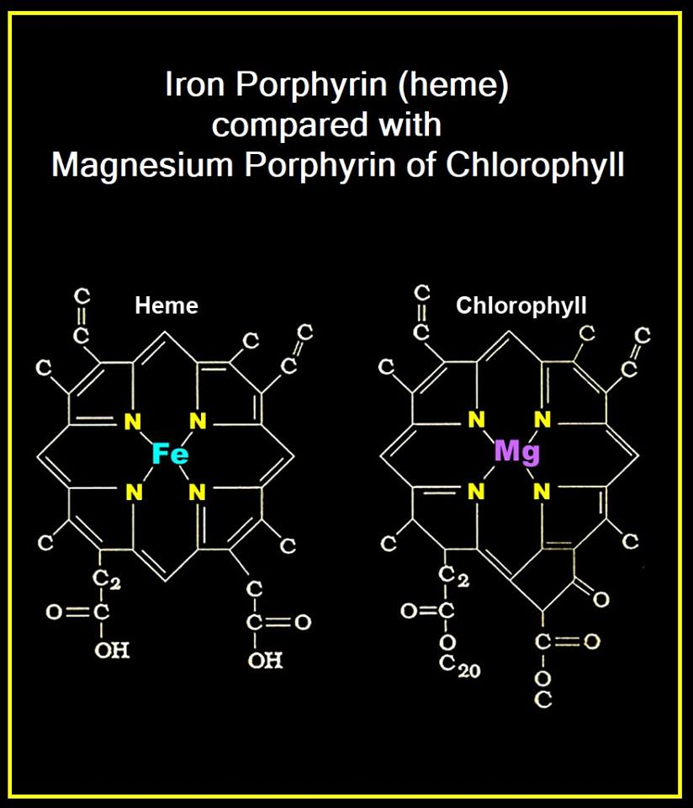

What is this “Heme” group? It is the Iron atom (Fe) at the center of the rings with nitrogens. The entire structure with the nitrogen containing rings is porphyrin. They are also referred to as ‘nitrogenous rings’. Notice in the diagram above, that chlorophyll that plant cells contain also use this porphyrin ring but instead of iron (Fe) the porphyrin ring in plants has magnesium (Mg) and that is what chlorophyll is. Interesting, yes? The point, the porphyrin ring is found occasionally in several molecules.

So as the growing biologist that you are, you should know about the porphyrin ring. Will you ever have to draw it, NO.

But you can certainly now recognize the porphyrin ring as containing the nitrogenous rings that surround the iron at the center of the Heme group in hemoglobin.

Now below is the entire Hb molecule, notice below, left that the two alpha chains in red the two beta chains in blue and the ‘heme’ groups with the iron at the center in green…hard to see, but look toward the center of the globin chains (diagram on the left). The diagram below on the right has the Heme groups in purple looking like little spaceships.

Keep in mind that the curly ribbons on the below left and the worm like curves on the below right diagrams are the alpha and beta globin chains which are simply strings of amino acids, hence the ‘protein’ portions of the hemoglobin molecule.

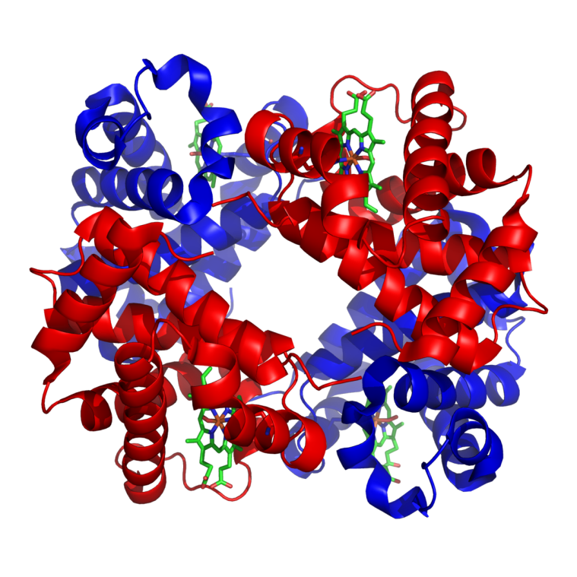 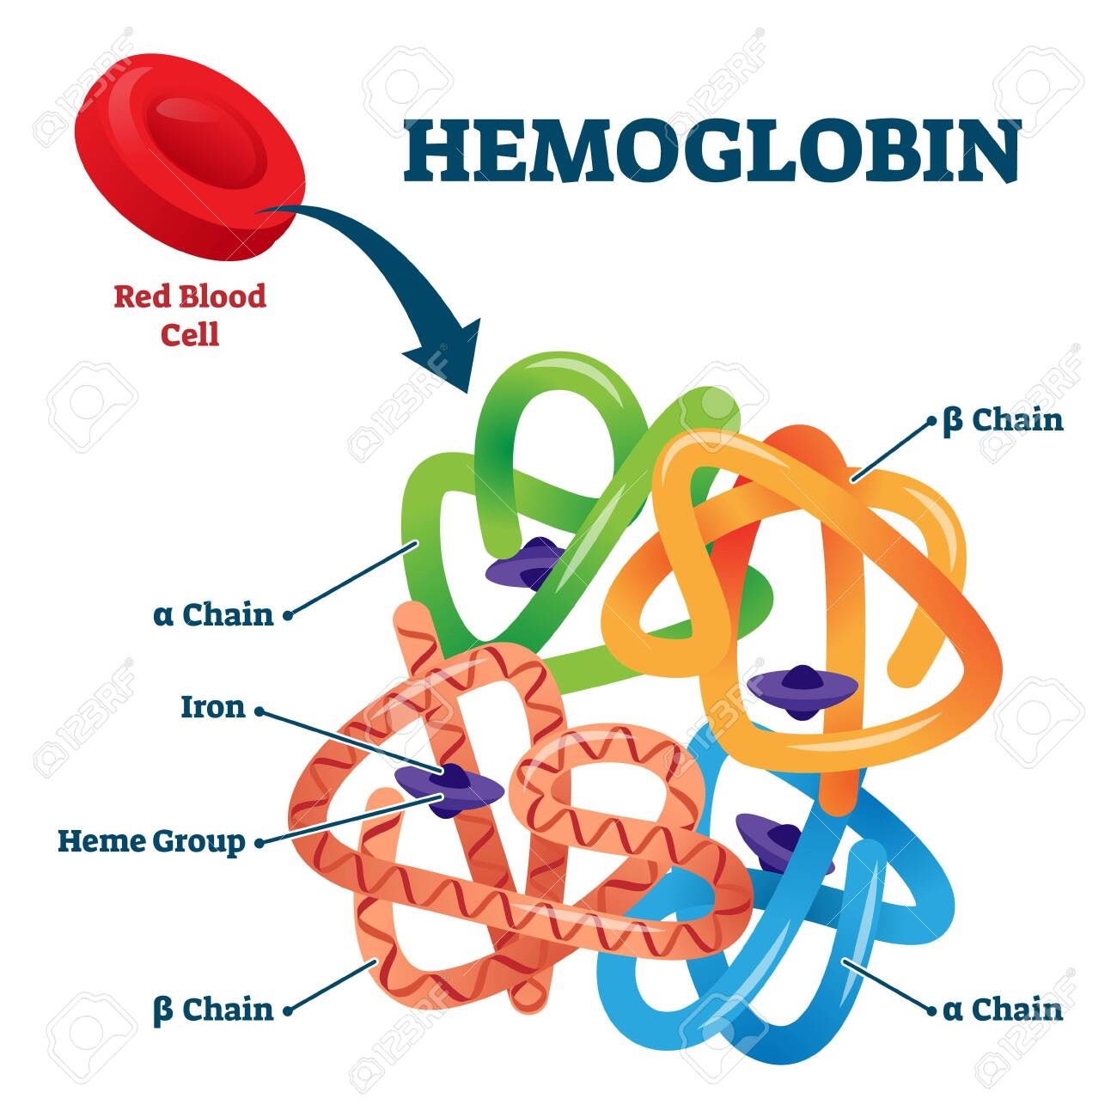

Note below: The oxygen binds to the iron (Fe) of the heme group of hemoglobin. As an interesting aside, notice on the right CN (cyanide) has bound to the iron of the heme group of hemoglobin. That is how cyanide kills, by blocking the binding of oxygen to Hb (cyanide also blocks the electron transport chain in mitochondria preventing ATP production).

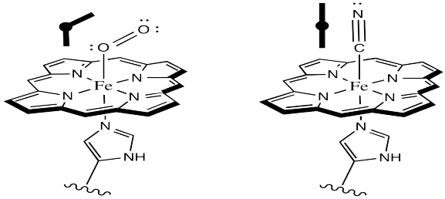

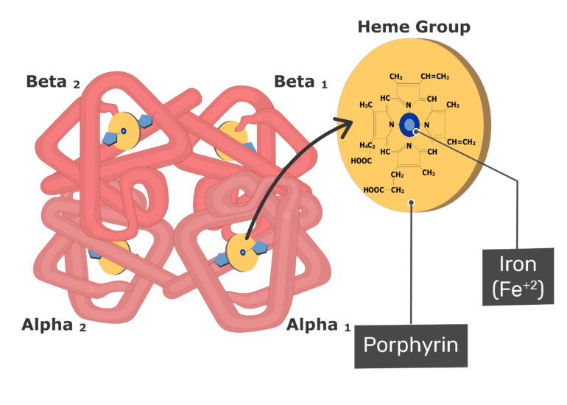

So now that we understand the structure of the hemoglobin molecule we can begin to follow the path of destruction of it. When it is released from the lysed RBC in the spleen it is separated into several components.

The stings of amino acids…the globin protein strings…..are separated from the Heme groups. Then the Heme group is separated into just the iron atom, Fe, and the porphyrin ring. Below left is the simplified diagram because it implies that the porphyrin ring immediately becomes bilirubin and this bilirubin is deposited into the blood coming out of the spleen.

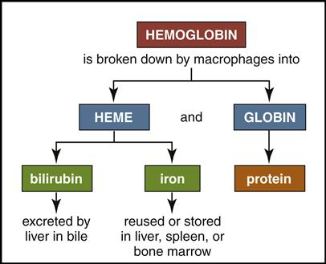 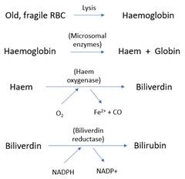

The biochemical truth is that the porphyrin ring is first converted in the spleen into biliverdin and this biliverdin is then converted into bilirubin (above right).

So look again at the diagram above left please. There are three products left over from the breakdown of Hb:

**(1)** **‘globin’**, a string of amino acids that can easily be recycled by the body. These protein strings are broken down into individual amino acids and recycled (What is the name of this reaction that breaks down a protein into its amino acids?)

**(2)Iron** (Fe). This iron does not travel well in the blood, it is insoluble in water which blood plasma mostly is. Since the iron is insoluble, it will clump up in the blood, NOT GOOD, so it is bound to a protein found in the blood for transport in the blood. That blood protein is ‘transferrin’.

“Greater than 95% of iron in plasma is bound to its circulating transport protein transferrin, which delivers most of its iron to erythrocyte precursors—i.e. erythroid progenitor cells of the bone marrow that differentiate into mature RBCs.”

Transferrin has a high affinity to ferric iron. Transferrin is made in the liver by the hepatocytes.

By the way, iron comes in 2 states: Fe++ (ferrous) and Fe+++ (ferric). I will never ask about that.

By the way, transferrin also transports iron to the bone marrow from the intestines after it is absorbed by the cells of the small intestine from your diet.

**(3)** **Bilirubin**. This bilirubin looks like this:

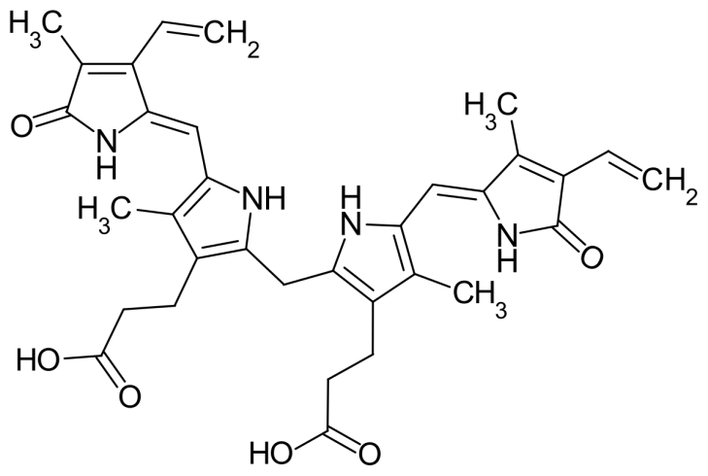NOTICE the nitrogenous rings of porphyrin? This bilirubin is just the porphyrin ring rearranged a bit into bilirubin without the iron atom. These nitrogenous rings are waste to the body. Just as the nitrogen group on an amino acids is waste to the body. These nitrogenous rings need to be eliminated from the body. So these nitrogenous rings in the form of bilirubin are leaving the spleen into the blood. To travel in the blood, this bilirubin is bound to a protein found in the blood….Albumin.

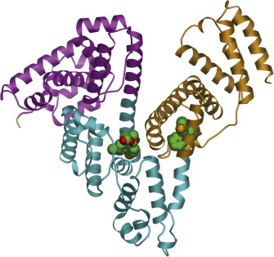 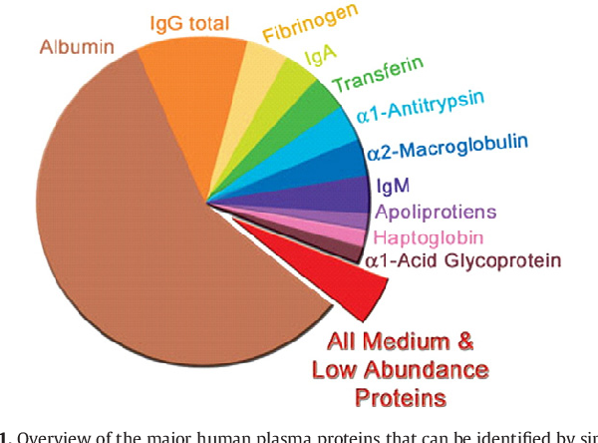

You are not required to recognize this structure of albumin, but I did want to introduce you to the most abundant protein in your blood…albumin. The most plentiful protein in your blood plasma by far. Let me then remind you of the term ‘plasma proteins’. It is used a lot, your ‘plasma proteins’. When it is introduced early on in any physiology course, it refers to all the proteins that happen to be floating in your blood plasma. They are almost all made in the liver and they provide ‘oncotic pressure’. Remember oncotic vs. hydrostatic pressure? The textbooks will tell you that albumin alone in the blood plasma provides 80% of the oncotic pressure pulling water back into the blood via osmosis. Along with binding and transporting bilirubin in the blood, albumin binds zinc, copper and calcium to transport those in the blood. Albumin will bind and transport certain medications (drugs) in the blood and in this way, prolonging their lifespan in the blood and in the body.

Well we are finally now putting a face onto each of these ‘plasma proteins’. The most abundant of these previously vaguely called ‘plasma proteins’ is albumin. Albumin binds and carries bilirubin in the blood from the spleen. Look again at the pie-graph at the upper right please. The second most abundant proteins in the blood are the antibody molecules. We’ll learn they come in four categories depending upon their structure. That is the IgG slice of the pie-graph. Next is fibrinogen which we know about regarding blood clotting. Next is the IgA, another type of antibody found floating in the blood. Next in abundance is the molecule we just talked about, transferrin (looks like it is misspelled in the pie-chart).

I think this very important because of my college-aged trauma. I was taught about these unidentified, nameless proteins that are found in the blood called ‘plasma proteins’. The ‘plasma proteins’ are responsible for this and that. I wanted to know what they were, what did they look like, which ones were they? It was never made clear to me what these ‘plasma proteins’ were. But you my dear students will not suffer such trauma. You now know personally the ones that make up a little over 75% of all of these circulating blood plasma proteins.

Back to albumin. The bilirubin bound to albumin in the blood coming out of the spleen will eventually float into the liver. The liver will remove the bilirubin from the albumin and attach it to glucuronic acid and that combination will be placed NOT back out into the blood! This bilirubin-glucuronide is added into the bile that the hepatocytes make. And the bile with bilirubin-glucuronide is transported with the bile to the gall bladder and eventually into the small intestine. Remember?

Bile made by hepatocytes, transported for storage in the gall bladder, with a meal the gall bladder contracts, bile travels from gall bladder to small intestine:

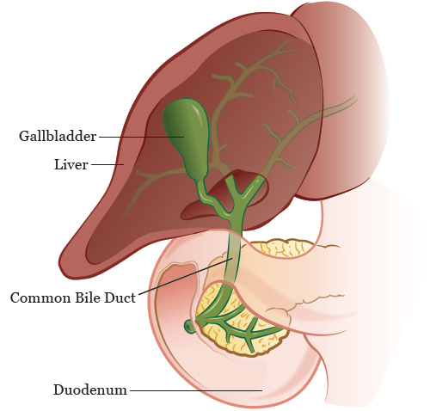

So the bilirubin-glucuronide will travel eventually to the small intestine. Remember that the body is trying to get rid of these nitrogenous rings and lookie-here, those nitrogenous rings are in the small intestine now, on their way out of the body with your poop (feces). Success.

Let me now mention that these nitrogenous rings travel from the spleen to the liver bound to albumin in the blood. Then they travel from the liver to the small intestine bound to glucuronic acid. To simplify the naming, when the nitrogenous rings are traveling as bilirubin bound to albumin in the blood from the spleen to the liver, they are called **unconjugated bilirubin**.

When the nitrogenous rings are traveling as bilirubin bound to glucuronic acid in the bile from the liver to the small intestine, they are called ‘**conjugated bilirubin’**.

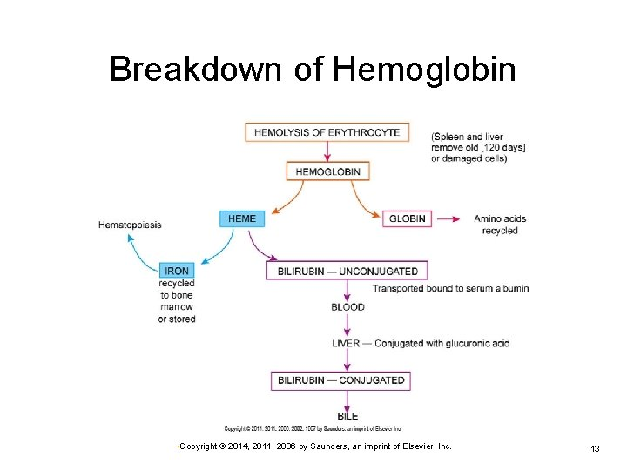

So from now on, everybody will talk to you about unconjugated bilirubin and conjugated bilirubin. And now you get it.

As a quick aside, you would expect to see an increase in ‘unconjugated bilirubin’ in a patient with a damaged liver (liver disease)? Yes, the diseased liver cannot convert the unconjugated bilirubin to conjugated bilirubin. This can lead to jaundice. What’s jaundice you ask?

“a medical condition with yellowing of the skin or whites of the eyes, arising from excess of the pigment bilirubin and typically caused by liver disease, or by excessive breakdown of red blood cells.”

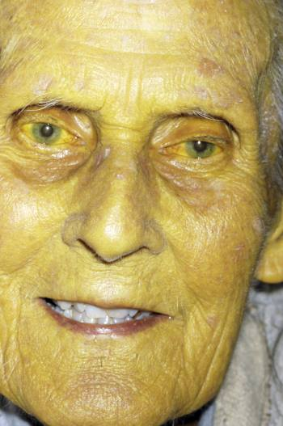 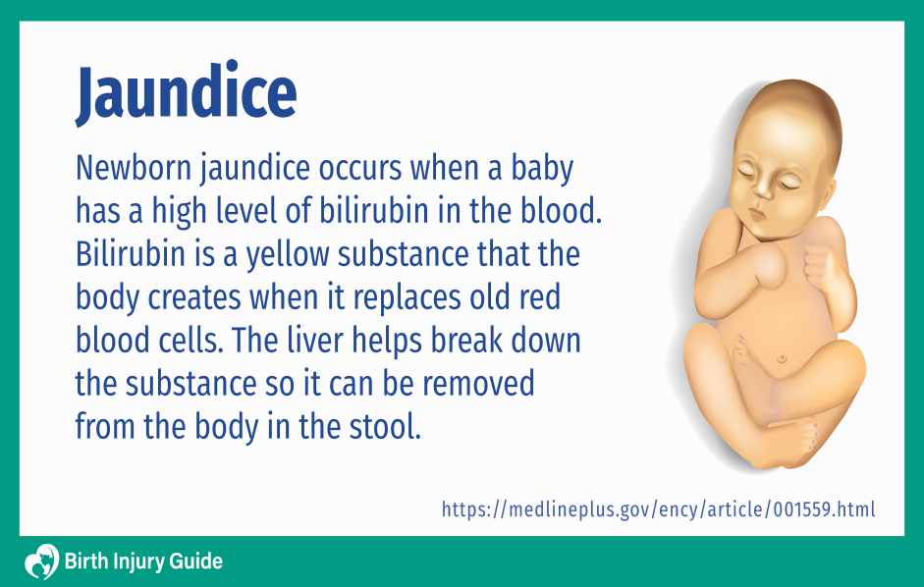

Yes, we need to understand jaundice.

OK, let’s pick up with the nitrogenous rings in the small intestine, the conjugated bilirubin. If you look at the diagram below you see that the conjugated bilirubin, the nitrogenous rings turns into urobilinogen. Simply the conjugated bilirubin has the glucuronic acid removed, it is de-conjugated in the small intestine by bacterial cells that live there and some can be de-conjugated by the mucosal cells lining the small intestine. This de-conjugated bilirubin is called urobilinogen. Some of the urobilinogen can be absorbed by the small and large intestine back into the blood. Exactly what we don’t want to do. But this form of bilirubin while in the blood can be filtered out of the blood by the kidneys and excreted by the body in the urine. This form is called urobilin and it is a molecule with a YELLOW pigment, hence the yellow pigment found in human urine!

The de-conjugated bilirubin, urobilinogen, that stays in the intestines can be used by the bacteria in the ‘gut’ for food and it is broken down into a molecule full of nitrogenous rings called stercobilin, which is a molecule with a BROWN pigment. Hence, why your poop is brown!

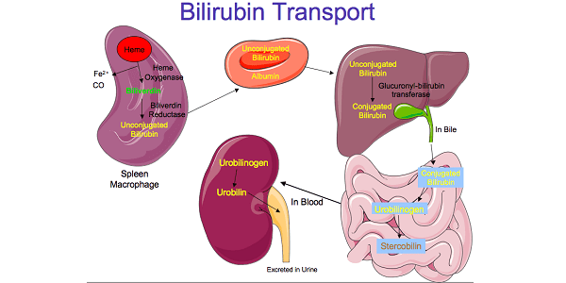

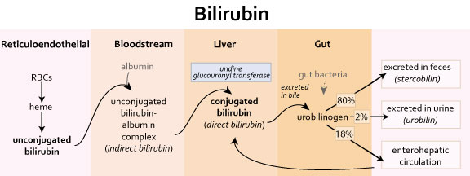

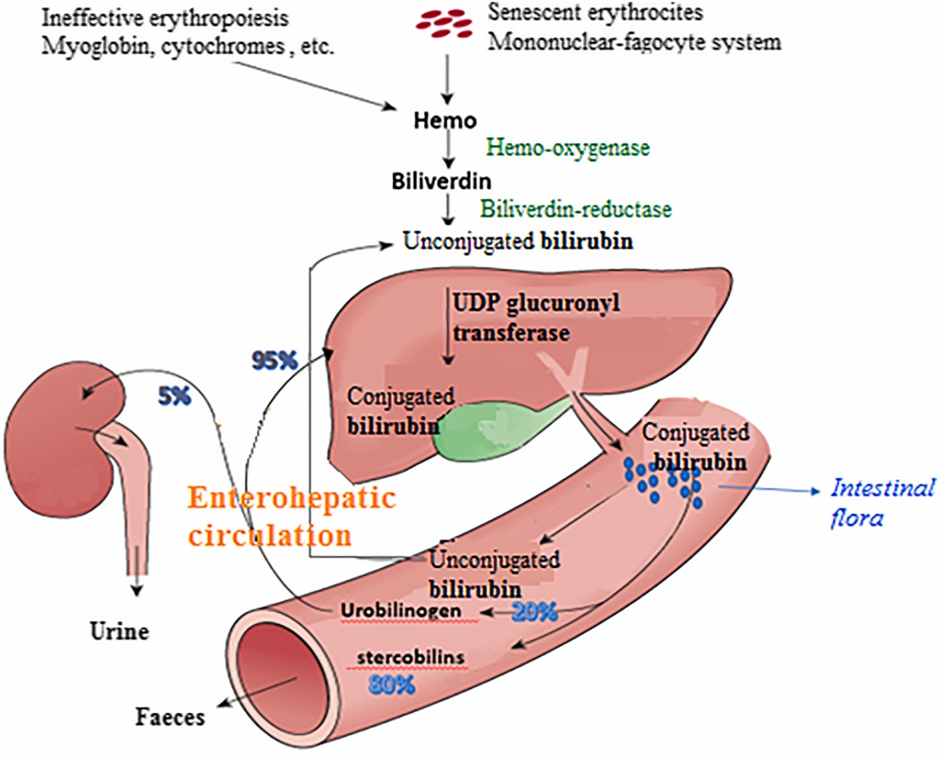

Structure of stercobilin on the left and urobilin on the right. See all those nitrogenous rings.

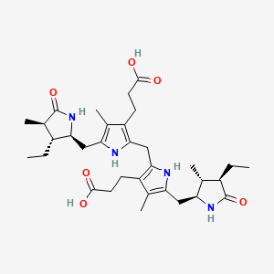 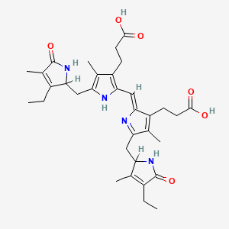

Some of you are probably looking really hard to see how they are structurally different. They look almost identical. Hint: all the nitrogens on the left have a single “H” attached, you cannot say the same for all the hydrogens on the right. Wow, small difference indeed. Yet one is brown and one is yellow. You’ll need to remember which is which, not their structure.

The end.