**Cholesterol and HMG-CoA reductase:**

You should limit how much cholesterol you eat. It is bad for you. Your body needs cholesterol to build healthy cells, but high levels of cholesterol can increase your risk of heart disease. With high cholesterol, you can develop fatty deposits in your blood vessels. Eventually, these deposits grow, making it difficult for enough blood to flow through your arteries. These ‘plaques’ are made up of triglycerides and cholesterol.

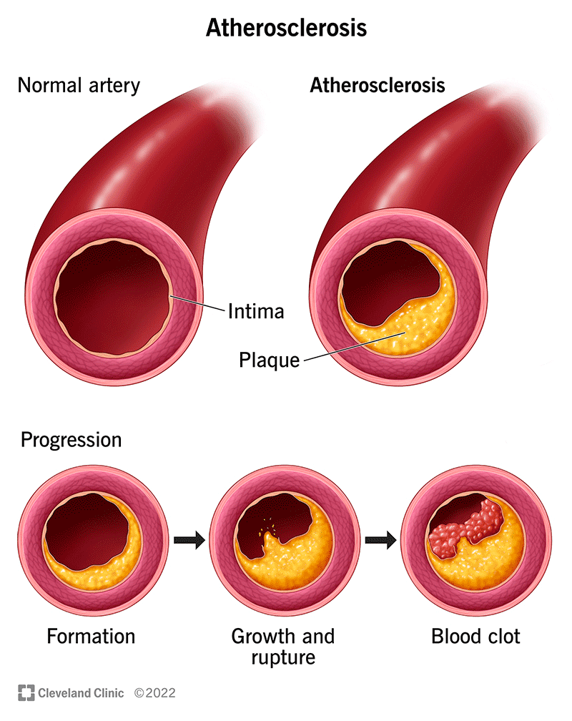 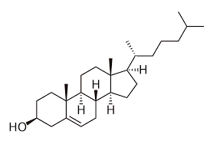

Your liver can produce cholesterol for the body using a series of chemical reactions using several enzymes. Cholesterol is synthesized via a cascade of enzymatic reactions known as the mevalonate pathway. This series of reactions is primarily regulated by a rate-limiting step involving the conversion of 3-hydroxyl-3-methylglutaryl-coenzyme A (HMG-CoA) into mevalonic acid. Take a look at the pathway but do not panic. We will not be responsible for memorizing this pathway.

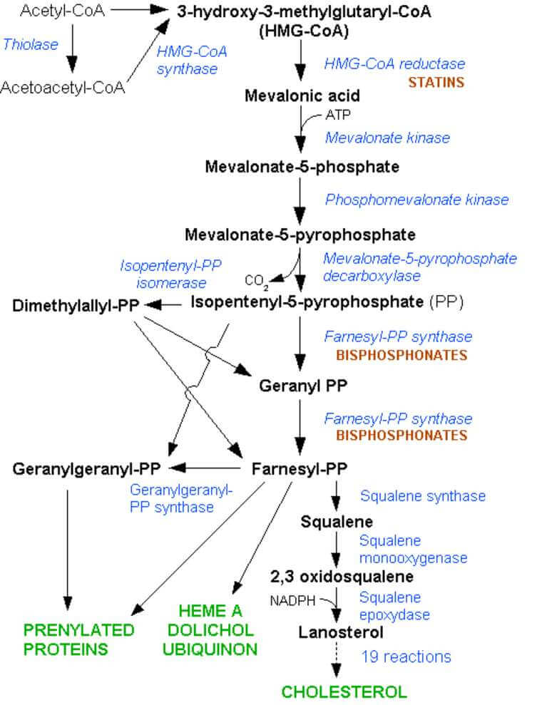

The important part of this pathway is to notice it starts with acetyl-CoA and ends with cholesterol. The second most important part of the pathway is to notice the enzyme called HMG-COA-reductase (3-hydroxy-3-methylglutaryl coenzyme A reductase). Below is a simplified diagram of the pathway.

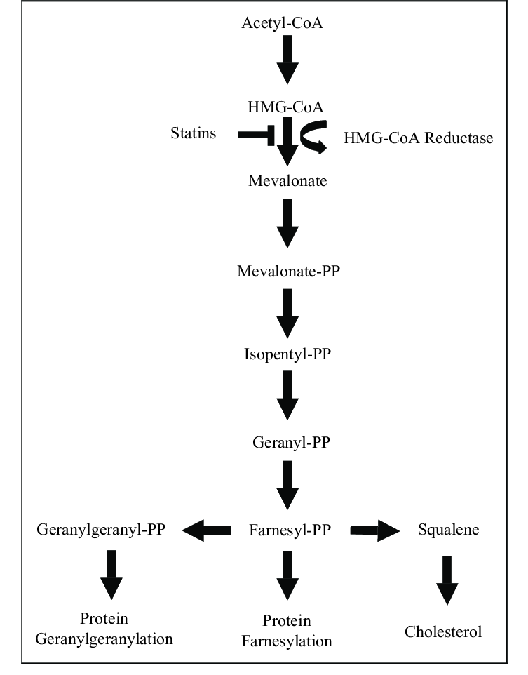

Notice that the drugs called ‘statins’ will block the enzyme HMG-CoA-reductase, hence blocking the synthesis of cholesterol by your own liver.  Because the liver isn't making so much cholesterol, it then takes cholesterol out of your blood to make bile with, so your blood cholesterol levels fall. There are several different kinds of ‘statins’ because some have fewer side effects, interact with foods differently, interact with other medications differently, and are tolerated differently by the patient.

Of course, along with taking ‘statins’, you’ll want to reduce how much cholesterol you eat.

So the take-home lessons:

1)do not memorize this pathway.

2)memorize HMG-CoA reductase as the enzyme involved in the liver’s synthesis of cholesterol. Dietary cholesterol is called "exogenous" cholesterol and the cholesterol synthesized by the liver is called endogenous cholesterol.

3)know that statins target this enzyme to lower blood cholesterol.

Bile / Bile Salts.

So why would the liver take cholesterol out of the blood because the liver is not making it by itself? Remember, taking a statin will inhibit the enzyme HMG-CoA reductase blocking cholesterol synthesis by the hepatocytes. So without its own production of cholesterol, the liver will remove cholesterol from the blood, thus lowering blood cholesterol as a result of taking the statin.

The liver needs cholesterol to make one of the main ingredients in the bile it produces. That ingredient in bile that requires cholesterol to make are the famous ‘bile salts’. What are ‘bile salts’?

The main bile salt is cholic acid.

Hey, I can see the skeleton of cholesterol in this cholic acid molecule. I can see that cholesterol is necessary to make this bile salt called cholic acid. An important ingredient in bile.

Let me explain it this way. The liver cells, the hepatocytes, make ‘BILE’. So what is BILE? What is in bile? What does bile consist of? If it was on the shelf at the grocery store, what would be listed in its ‘list of ingredients’?

Well.…..**Bile is made up of bile acids, cholesterol, phospholipids, bile pigments (such as bilirubin and biliverdin), electrolytes and water.**

OK, so that brings us back to what are bile salts? Are they the same as ‘bile acids’? I see both ‘bile salts’ and ‘bile acids’ listed in my readings about what is in bile.

Bile salts are made from cholesterol by the hepatocytes. So the hepatocytes need cholesterol to make the bile salts. And if a statin were to block the synthesis of cholesterol by the hepatocytes (the statin would block what enzyme?), the liver would need to remove cholesterol from the blood in order to make the necessary bile salts. The bile salts are important in allowing bile to emulsify fats.

Wait, this diagram above calls them ‘bile acids’, not bile salts. Is there a difference? Well, yes, a slight difference we won’t be tested on.

Bile acids are conjugated with taurine or glycine residues to give anions called bile salts. The hepatocytes need cholesterol to make cholic acid. The cholic acid is a bile acid. This cholic acid has taurine and glycine added to it to make it into two types of bile salts.

Bile salts aid in digestion by making cholesterol, fats, and fat-soluble vitamins easier to absorb from the intestine. Not to confuse bile salts with bilirubin. Bilirubin is the main pigment in bile. Bilirubin is a waste product that is formed from hemoglobin (the protein that carries oxygen in the blood) and is excreted in bile.

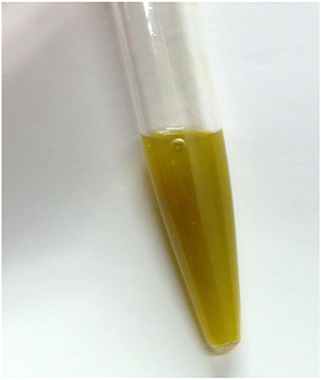

Bile.