**Fast-Twitch vs. Slow-Twitch (skeletal muscle fibers):**

Here is the very oversimplified but still accurate description. In any given skeletal muscle (i.e. biceps brachii or gluteus maximus), you will find two variations of the skeletal muscle fibers: fast-twitch and slow-twitch. A muscle of the arm or shoulder would have a slightly higher percentage of fast-twitch muscle fibers as compared to the number of slow-twitch muscle fibers in that muscle. Whereas, in a muscle running along side your vertebrae, a postural muscle, of all the skeletal muscle fibers in that muscle, there would be slightly more slow-twitch muscle fibers than fast-twitch muscle fibers.

Slow-twitch muscle fibers get their name from the fact that they do slightly contract more slowly than a fast-twitch muscle fiber. More importantly though is that slow-twitch muscle fibers contain a protein called **myoglobin**. Here come some myoglobin facts:

-It encodes a single polypeptide chain with one oxygen binding site.

-Myoglobin contains a heme group that can reversibly bind to oxygen (the same ‘heme’ group in hemoglobin). Hence, myoglobin stores oxygen in skeletal muscle cells.

-This extra source of oxygen allows slow-twitch muscle fibers to have this additional source of oxygen in order to make ATP even when the blood supply of oxygen is inadequate.

-So slow-twitch muscle fibers do not fatigue as quickly as a fast-twitch muscle fiber since fast-twitch muscle fibers do not contain myoglobin.

-The body uses it as an oxygen storage protein in muscle.

-Myoglobin is able to bind and release oxygen depending on the oxygen concentration in the cell.

-Its primary function, as a result, is to supply extra oxygen to slow-twitch muscle cells, and so more ATP.

-Myoglobin has a dark pigment to it. Myoglobin is the reason for the red color of the muscle (dark meat).

Those muscles in the body that need to stay contracted for long, long periods of time contain mostly slow-twitch muscle fibers. You can stand up for hours and hours if need be. Those muscles you would need to stay contracted for hours, the muscles of the legs and spine, are mostly slow-twitch muscle fibers.

Take a bird for example. Some can sleep standing up. Their leg muscles are almost all (in certain birds) slow-twitch muscle fibers. Lots of myoglobin containing muscle fibers, hence this is where you would find the ‘dark meat’ in a bird, say a turkey. The turkey leg is ‘dark meat’ due to the large majority of myoglobin containing slow-twitch muscle fibers.

Your academic life would not be complete without a picture of myoglobin. We will talk in detail about hemoglobin when we talk about red blood cells. Red blood cells, as you hopefully learned in anatomy, are a bag full of hemoglobin since hemoglobin binds oxygen, this is how the majority of oxygen is transported in the blood. Oxygen transport in the blood is by having oxygen enter the red blood cell and be bound by hemoglobin. Hemoglobin is famous for many reasons, one of these reasons is that it is a protein made up of 4 protein chain subunits (quaternary structure).

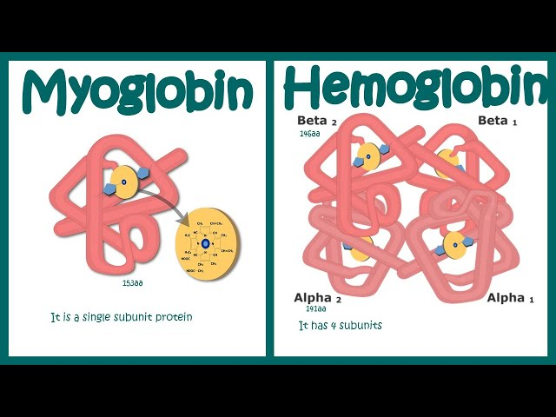

Fast-twitch muscle fibers do not contain myoglobin so they are the ‘white meat’ of a turkey. Fast-twitch muscles contract quickly and fatigue quickly. So, the flight muscles of a bird would be mostly fast-twitch muscles. A turkey’s ‘white meat’ would be the breast meat, the almost all fast-twitch containing flight muscles. In humans, the percentage of slow-twitch vs fast-twitch is very similar as you can see in the diagram below and so we humans do not have ‘dark meat’ and ‘white meat’.

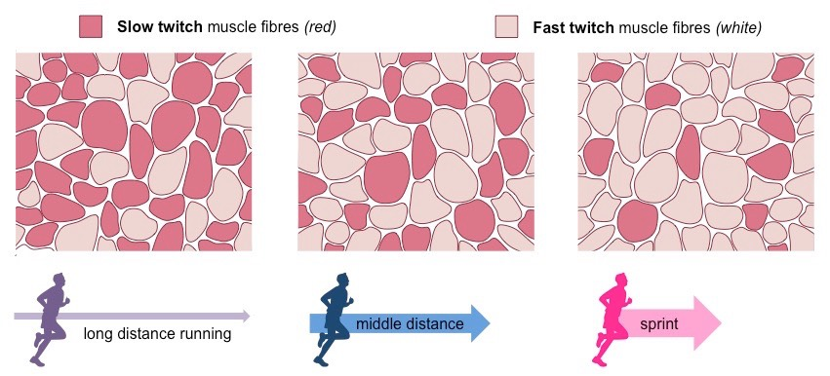

If you do end up doing any sort of Google searching on fast-twitch and/or slow-twitch muscle fibers, you will find a lot of information about how you can train each type and, in some cases, modify one type into the other. All you need to know for the exam is what is explained in this handout.

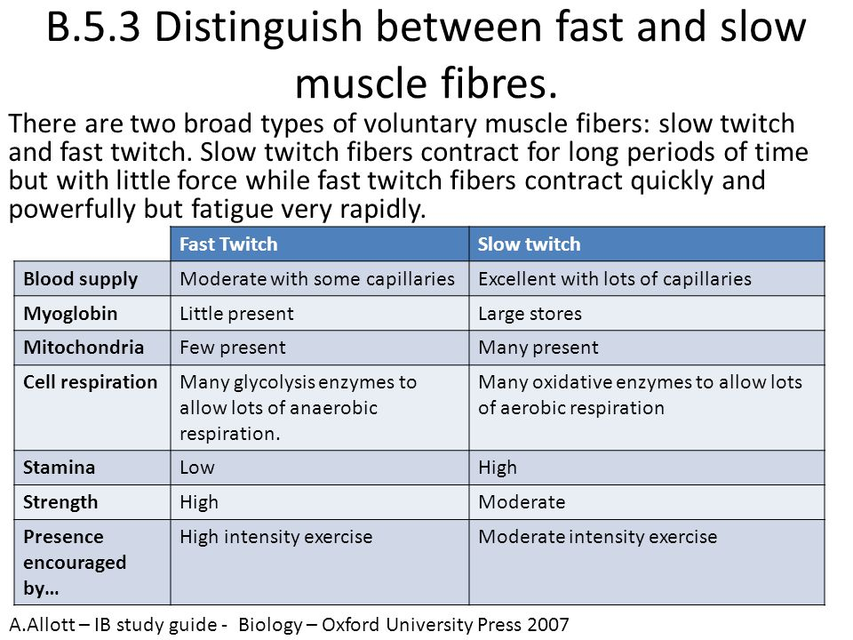

Ignore the ‘Cell respiration’ information in the above chart.