Fats You Need – Essential Fatty Acids
(from http://www.benbest.com/health/essfat.html)

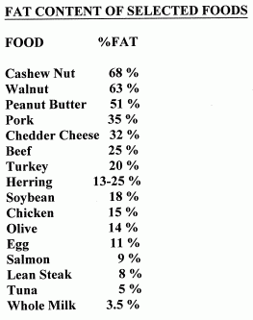
Your body needs fats to function properly. Nearly half of the dry weight of the brain is fat, and a quarter of this is cholesterol. Cholesterol is an essential part of sex hormones, bile acids, D vitamins and steroid hormones from the cortex of the adrenal gland -- among other important substances. Cholesterol does not need to be eaten, however, because the liver and other tissues can manufacture cholesterol from saturated fats. But too many saturated fats result in excessively high blood levels of cholesterol that can end up being deposited in atherosclerotic plaques on blood vessels, leading to cardiovascular disease.

The term blood cholesterol is actually a reference to HDL (High-Density Lipoprotein), LDL (Low-Density Lipoprotein) and VLDL (Very Low-Density Lipoprotein). "Lipo" means "lipid", a general term that refers to all biological fats and oils. HDL has been called "good cholesterol" because it can pick up excess fats and carry them back to the liver. LDL (and especially VLDL) has been called "bad cholesterol" because it can become so overloaded with fats that the fats are dropped on blood vessel walls rather than carried to the cells where they are needed. LDL could also be called "good", because LDL supplies cells with fats needed for structure and function.
Aside from cholesterol, most other fat in the body is constructed from what is known as fatty acids. A fatty acid is a long straight chain of carbon atoms (studded with hydrogen atoms) that has an acid group (carboxylic acid) at one end (the water-soluble end). The rest of the fatty acid is oil-soluble, with a methyl group at the other end. Fatty acids in the body usually exist unattached to any other molecule (free fatty acids), attached to glycerol in groups of three (triglycerides), or attached to phosphatidic acid molecules (phospholipids).
Fatty acids differ from one another not only by the number of carbons in their chain, but by the number of double-bonds between the carbon atoms. Fatty acids with only single-bonds are called saturated because they are "saturated" with as many hydrogen atoms as they can carry. Fatty acids with only one double-bond are called mono-unsaturated. And fatty acids with more than one double-bond are called poly-unsaturated.

Polyunsaturated fats have often been recommended to reduce coronary heart disease. But all saturated fats do not have the same effect on cholesterol synthesis in the liver. Only the saturated fats of chain-length 12, 14 and 16 (lauric acid, myristic acid and palmitic acid) have been shown to elevate blood cholesterol. Of these, myristic acid (high in coconut and palm oil) elevates cholesterol the most. Stearic acid (18-carbon, saturated) has been shown to lower cholesterol by 21% -- even more than oleic acid (18-carbon, mono-unsaturated) which lowers LDL by 15%.

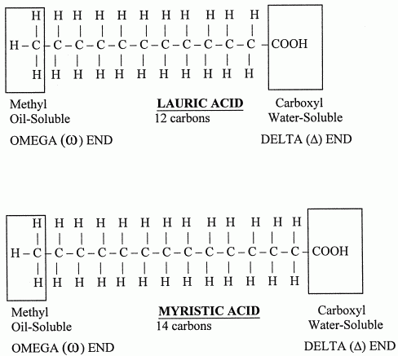

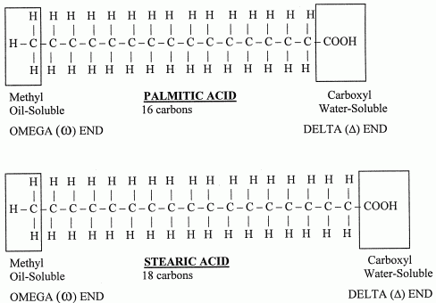

Fatty acid double-bonds come in two configurations known as cis (carbon chains on the same side of a double-bond) and trans (carbon chains on the opposite side of a double-bond). Most of the double-bonds made by biological systems have the cis configuration. It is the cis configuration of unsaturated fatty acids that prevents tight packing of fatty acids in membranes, and hence increases membrane fluidity.

Saturated fats (like butter or lard) and fatty acids with trans double-bonds (like margarine) tend to be solids at room temperature, whereas natural fatty acids with cis double-bonds (like vegetable oils) tend to be liquids. By artificially hydrogenating vegetable oils, the food processing industry reduces the number of double bonds and causes the formation of trans fatty acids. Hydrogenation results in margarines that are more solid and less vulnerable to rancidity. Hydrogenation results in peanut butter with a trans-fat-containing oil that does not separate from the peanut paste. But when trans fatty acids are incorporated into cell membranes, the membrane fluidity is reduced and the cells do not function as well. Not all trans fatty acids in the diet are due to food processing. For example, natural butter is 5% trans fat.
CIS ISOMER | TRANS ISOMER
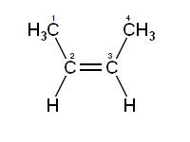 | 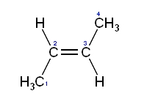

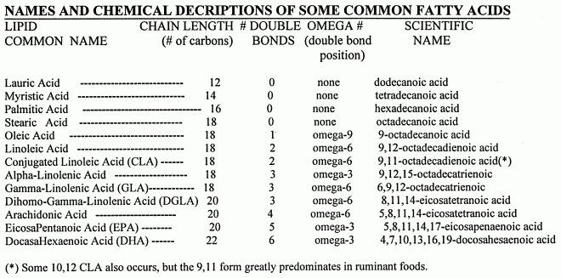

The human body can manufacture most of the fats it needs, including cholesterol, saturated fatty acids and unsaturated fatty acids. But there are two fatty acids which cannot be manufactured in the body, and which must be obtained from dietary sources: linoleic acid and alpha-linolenic acid. These are the essential fatty acids. Linoleic acid is an 18-carbon chain with 2 double-bonds, whereas alpha-linolenic acid is an 18-carbon chain with 3 double-bonds. The position of double-bonds in a fatty acid is critical to function, and this is especially true of double-bonds close to the methyl end. For long-chain fatty acids, the body's enzymes cannot add double-bonds near the methyl end.
A fatty acid has a carboxylic acid at one end and a methyl group at the other end. Carbon atoms in a fatty acid are identified by Greek letter on the basis of their distance from the carboxylic acid. The carbon atom closest to the to the carboxylic acid is the alpha (α) carbon, the next adjacent carbon is the beta (β) carbon, etc. In a long-chain fatty acid the carbon atom in the methyl group is called the omega (ω) carbon because omega is the last letter of the Greek alphabet. Because the closest double-bond to the methyl group in linoleic acid is 6 carbon atoms away from the methyl, linoleic acid is called an omega−6 (ω−6 or n−6) fatty acid. For alpha-linolenic acid, the double-bond closest to the methyl group is only 3 carbons away, so it is an omega−3 (ω−3 or n−3) ) fatty acid. The carbon next to the carboxylic acid is called the alpha carbon because alpha is the first letter of the Greek alphabet. But to confuse matters, the acid end of a fatty acid is called the delta (δ) end.
The configuration (geometry) at the double bond can be either cis (adjacent hydrogen atoms on the same side of the molecule) or trans (adjacent atoms on the opposite side). Unsaturated fatty acids in the trans configuration are more linear, more rigid and have a higher melting-point. The distinctiveness of cis & trans fatty acids merit unique names: cis-9-octadecanoic acid is oleic acid, whereas trans-9-octadecanoic acid is elaidic acid.

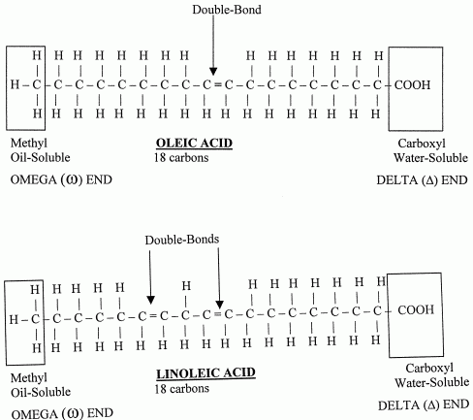

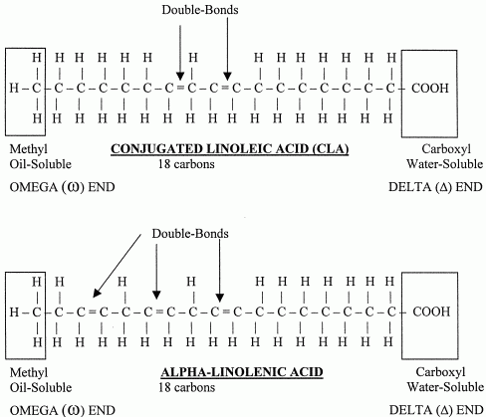

The body cannot make an omega−3 or omega−6 fatty acid because human metabolism cannot add a double-bond to a fatty acid that is more than 9 carbons away from the delta end. For the same reason, the body cannot convert an omega−3 to an omega−6 fatty acid, or vice-versa. But the body can make omega−9 fatty acids. And the body can add more double-bonds closer to the delta end of omega−3 and omega−6 fatty acids.
Two distinct families of essential fatty acids exist in the human body: the omega−3 family and omega−6 family. The omega−3 family comes from alpha-linolenic acid, and the omega−6 family comes from linoleic acid. Each family is the result of increasing chain length and of forming double-bonds from one of these two essential fatty acids. The two families compete for the same enzymes for forming double bonds (desaturase enzymes) and enzymes for lengthening the carbon chain (elongase enzymes). Elongase enzymes always add carbon atoms (in pairs) to the delta end of the fatty acid.
The primary source of omega−6 fatty acids in the diet is linoleic acid from the oils of seeds and grains. Sunflower, safflower and corn oil are particularly rich sources of linoleic acid, which is at the root of the omega−6 fatty-acid family. Evening primrose oil and borage oil are high not only in linoleic acid, but the omega−6 derivative gamma-linolenic acid (GLA). Avocado is 15-20% oil -- mainly monosaturated, but also high in linoleic acid. (Avocado has the highest fat content and the highest fiber content -- soluble as well as insoluble -- of any fruit.)

Phospholipids and cholesterol are the principal components of nearly all cell membranes. The backbone of a phospholipid is the same glycerol molecule that forms the backbone of triglycerides. But instead of 3 fatty acids attached to glycerol, a phospholipid consists of 2 fatty acids, a phosphate group and an alcohol. The most common alcohols are derived from serine, ethanolamine, choline and inositol. Thus, the most common phospholipids are phosphatidylcholine, phospatidylethanolamine, phosphatidylserine, and phosphatidylinositol. Phosphatidylcholine is also known as lecithin.

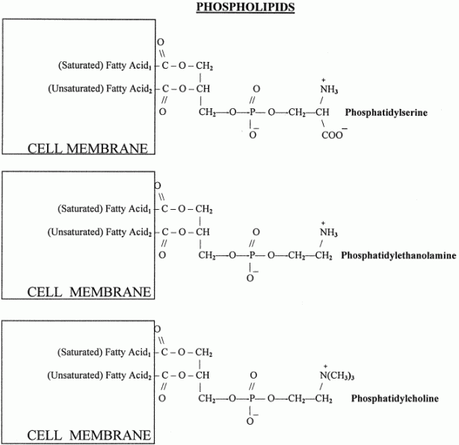
Phospholipids in Cell Membranes

Different cells have different quantities of phospholipid in their membranes. Gray matter in the brain is nearly 70% phospholipid, whereas brain white matter is less than half phospholipid because of high concentrations of glycolipid (sugar-fat). There is much variation in the amounts and kinds of phospholipid in membranes. Brain gray matter is 30% phosphatidylcholine whereas brain white matter is 10% phosphatidylcholine. The inner layer of neuron membranes primarily contain phosphatidylethanolamine & phosphatidylserine, whereas in the outer layer phosphatidylcholine & sphingomyelin predominate. Mitochondrial and endoplasmic reticulum membranes are both 40% phosphatidylcholine. But mitochondrial membranes are also 35% phosphatidylethanolamine, whereas endoplasmic reticulum membrane is about 17% phosphatidylethanolamine.

Each of the 3 groups attached to the glycerol backbone has a special enzyme that can separate the group from the backbone. Phospholipase A₁ enzyme attacks the attachment of the first fatty acid, Phospholipase A₂ attacks the attachment of the middle fatty acid and Phospholipase D attacks the alcohol attachment.

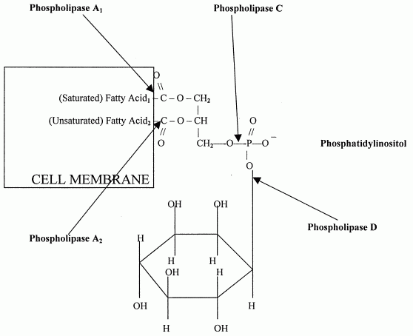

Another important product of linoleic acid is arachidonic acid. Arachidonic acid is a 20-carbon omega−6 fatty acid with 4 double-bonds. Arachidonic acid, in turn, gives rise to a whole group of 20-carbon, biologically-important substances known as the eicosanoids (eicosa- is Greek for "20"), including prostaglandins, thromboxanes, lipoxins and leukotrienes -- which affect immunity, inflammation and blood clotting (among other actions). But omega−3 fatty acids can also produce eicosanoids.
Noteworthy members of the omega−3 family of fatty acids manufactured from alpha-linolenic acid are EicosaPentaenoic Acid (EPA) and DocasaHexaenoic Acid (DHA). A pentaenoic acid has 5 double-bonds. A hexaenoic acid has 6 double-bonds. EPA is a 20-carbon chain fatty acid, whereas DHA is a 22-carbon chain fatty acid. Like arachidonic acid, EPA gives rise to its own class of eicosanoids. The EPA-generated eicosanoids are in the omega−3 family, as distinct from the omega−6 eicosanoids derived from arachidonic acid.
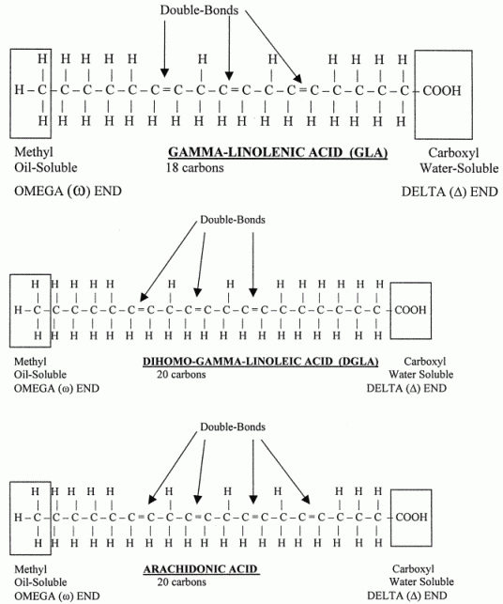

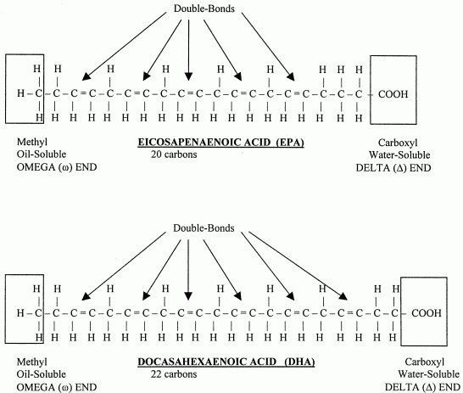

Frequently the unsaturated fatty acid stored in the second position of a cell membrane will be arachidonic acid, EPA or DHA (especially in the neurons). The release of arachidonic acid or EPA from cell membranes by Phospholipase A₂ allows the enzymes lipoxygenase and cyclooxygenase to form biologically active eicosanoids like prostaglandins (PGZs, first isolated in prostate gland), thromboxanes (TXZs, first isolated in thrombocytes) and leucotrienes (LTZs, first isolated in leucocytes). These eicosanoids can be compared to hormones, except that unlike hormones they are destroyed by local enzymes within seconds or minutes after formation. This limits the activities of eicosanoids to the area where they were released.
Having cell membranes contain fatty acids that can form the hormone-like eicosanoids gives the body the capacity to produce quick, localized action in almost any tissue or organ. The most general need for rapid, local action is the response to trauma. Therefore, eicosanoids are most often concerned with clotting, inflammation and the initiation of immune defense.
Some membrane phospholipids, such as the phosphatidylinositols, function to convert activity at cell surface G-protein-coupled receptors into intracellular signals. Hydrolysis by phospholipase C and phospholipase D produce the second messengers (intracellular messengers) DiAcylGlycerol (DAG) [which stimulates Protein Kinase C (PKC)] and Inositol triPhosphate (IP₃) [which causes intracellular release of calcium]. Activated PKC concentrates in the plasma membrane where it phosphorylates membrane proteins of receptors and ion-channels to inhibit their function (negative feedback).

