I’ve got an interesting story for you so listen up.

What kind of story?

An interesting story. The first character you need to be introduced to is a protein.

Ah, not a dramatic story with humans and emotions but a story about molecules. Rats.

Anyway, let me introduce you to the first character in this ‘molecular’ story. It is a protein called……G-protein.

Huh, the protein is actually called ‘G-protein’. That’s not very imaginative, but OK, that makes it easy to remember. It is a protein called the G-protein.

And it is located in the membrane, within the phospholipid bilayer.

OK, it is called G-protein and is a membrane protein. What cells’ membranes is it in? Which cells in the body have this G-protein their membrane?

I’ll get to that.

Why the letter “G”?

It stands for ‘guanine nucleotide-binding protein’, but everyone calls it G-protein.

Are you ever going to show it to me?

Not yet. Let me first tell you that this G-protein can come apart into fragments. As the books would say, it will dissociate into subunits.

OK, how many pieces does it break into when it ‘dissociates’?

Three.

That’s not bad.

Can you guess what the three fragments, or subunits, are called?

Hmmm, let me think. I bet they are named after the first three letters in the Greek alphabet, Alpha, Beta and I don’t know the third letter of the Greek alphabet.

The third letter is gamma:

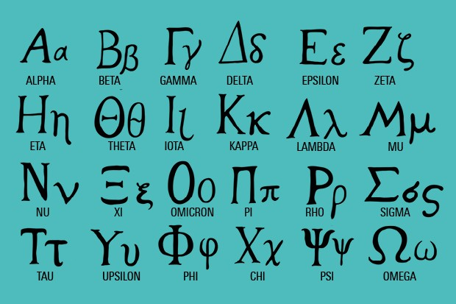

(You may have heard the expression, ‘from alpha to omega’, now you see where that comes from.)

But anyway, you’re RIGHT! The 3 subunits are called alpha, beta and gamma.

So after all this, you’re story begins with the G-protein, which is a membrane protein, and it can come apart, dissociate into three subunits, alpha, beta and gamma. This is taking a long time. Now can I see a picture of this G-protein?

Nope, not yet.

Come on.

Let me introduce you to another molecule in this story.

Fine.

This second molecule sits next to the G-protein in the membrane. And this second molecule can bind to things on the outside of the membrane. And check out the structure of this second molecule.

Wait, you’re going to show me the structure of the second molecule in this story before you show me the structure of the G-protein?

Yes, I am. The second molecule has 7, yes, SEVEN stretches of this long membrane protein that zig and zag across the membrane. It has SEVEN transmembrane domains as the books would say. It spans, goes back and forth within the membrane SEVEN times. Here, take a look at this cartoon depiction:

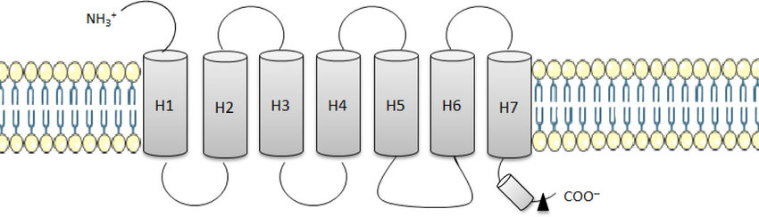

Take a look at it in color:  
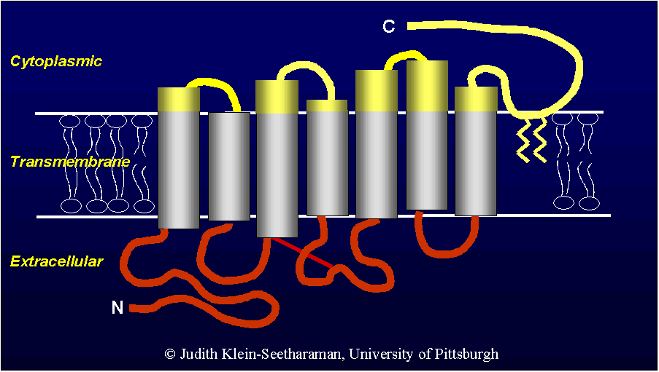

Actually in its natural shape within the membrane it is more rounded:

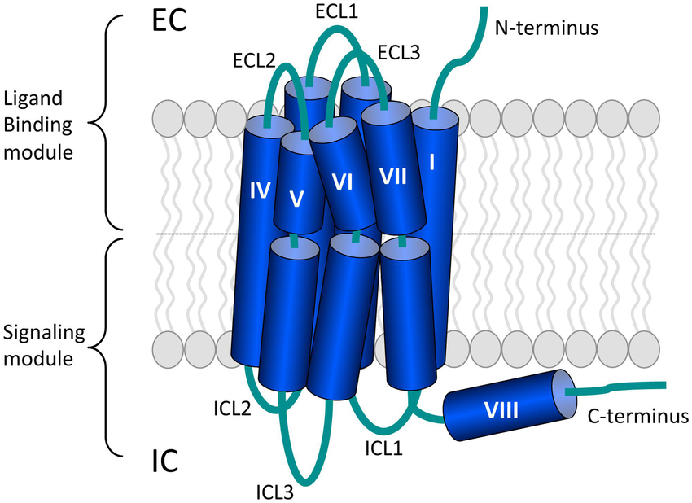

And did I mention that this big-o-membrane protein binds to things on the outside, extracellular, end. What the picture above calls the ‘ligand binding module’. It is a type of receptor, this huge protein.

Hold on now, you’re telling me the G-protein, which by the way I haven’t even seen yet, sits next to a ‘receptor’? We’ve seen this story before, a receptor with some sort of ‘chemical-dependent gate’ next to it. Is the G-protein some sort of chemical dependent Na+ gate, or chemical dependent K+ gate, or something like that?

No. The G-protein is not a chemical dependent gate. The G-protein does not ‘open’ when something binds to the receptor that has 7 transmembrane domains.

How about you tell me that name of this second molecule in your story, this receptor that has 7 transmembrane domains?

OK, it is called the ‘G-protein coupled receptor’. Get it, the G-protein is next to it, they are coupled. Now I will show you a picture of the G-protein next to the ‘G-protein coupled receptor’, both sitting in a membrane. In fact, the diagram below shows what happens when something binds to the ‘G-protein coupled receptor (GPCR)’, the G protein comes apart….dissociates.

But notice that when the G protein comes apart, dissociates, it does not break apart into all 3 fragments, subunits, but it breaks apart into the alpha subunit and a second fragment, the beta and gamma subunits still attached.

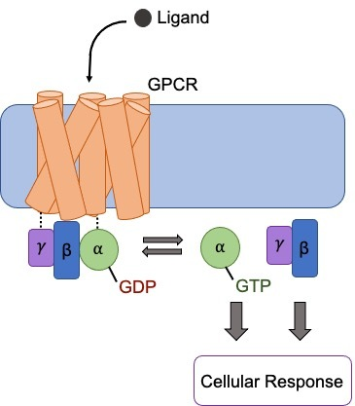

You’ve spent all this time to tell me that there are 2 membrane proteins, next to each other in the membrane of certain cells and simply when the ‘ligand’ binds to the receptor which is called the G-protein coupled receptor (GPCR), the G protein itself comes apart into a free alpha subunit and a combined beta/gamma subunit? That’s the story so far. Can we move along a bit faster with this story, you’re taking too long to tell it. Remember you’re communicating with the “texting/tic-tock/Instagram” generation. Get on with it will ya.

OK, well, the alpha subunit moves on to react and the combined beta/gamma subunit also goes on to react inside the cell. The alpha subunit will trigger a chain reaction.

The End.

__________________________________________________________________________________________

The sequel begins.

Your sequel better be much more interesting that the original story.

It is. Let me now introduce you to a molecule called Adenylate Cyclase (also called Adenylyl Cyclase). That’s a mouthful. As you can tell from the last 3 letters of its name, …ase, Adenylate Cyclase is an enzyme. It will catalyze the conversion of one molecule into another. What is enzymatically converts is ATP into cAMP (called cyclic AMP, don’t call it ‘camp’).

Adenylate Cyclase converts adenosine triphosphate into cyclic adenosine monophosphate.

Not that you have to memorize the diagram below, but just so you can see what is happening:

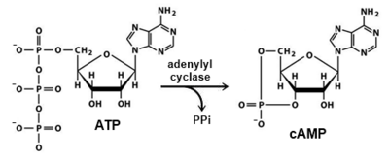

See the ‘cyclic’ part of cAMP, how the phosphate group is connecting in a ring to adenosine?

Now we have cAMP. This happens inside the cell. So now we have cAMP inside the cell. And what does cAMP do?

Many things. The newly formed cAMP can activate a molecule called Protein Kinase which then can carry out further reactions inside the cell. The newly formed cAMP can travel inside the cell to cause gates to open. It is a famous ‘second messenger’ within the cell. This ‘second messenger’ cAMP is a powerful signaling molecule inside the cell.

Here comes the drama. Remember that cAMP comes from ATP by the enzyme adenylate cyclase. How is adenylate cyclase turned on? Adenylate Cyclase is activated by…….G-protein Alpha subunit!

Whoa.

See how all these pieces come together. A molecule binds to the receptor, GPCR. That causes the G-protein to dissociate. The alpha subunit travels down the membrane to activate adenylate cyclase. The active adenylate cyclase converts ATP to cAMP. And now the cAMP triggers lots of reactions within the cell.

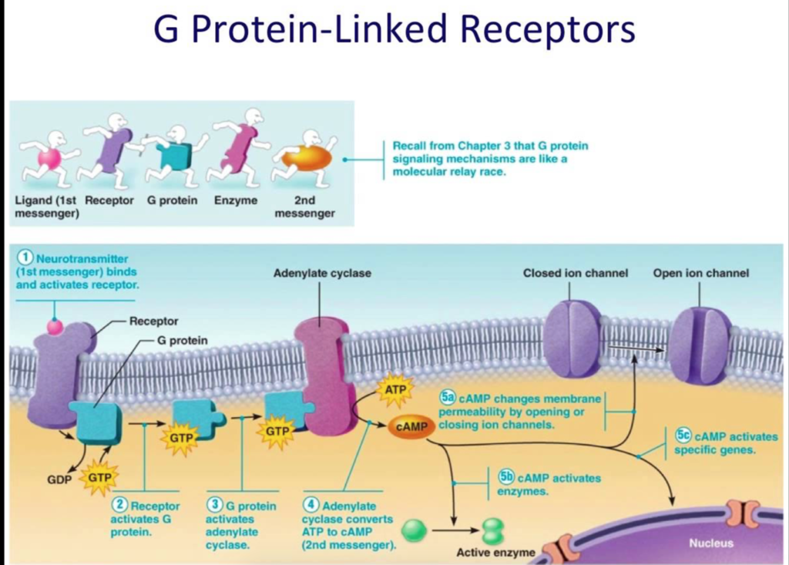

I know what you’re thinking. You think this is soooo cool, so very physiology.

This is so cool you want to know more. OK, I’ll give you a tad bit more information. When the receptor, GPCR, is bound by its ‘ligand’, a GDP part of the G protein is replaced by GTP on the G protein. See that in the above diagram.

The alpha subunit has GDP as part of it before the ligand binds to the GPCR. When the ligand binds to the GPCR, the GDP in the alpha subunit is replaced by GTP and the alpha subunit comes off. This replacement of GDP with GTP allows the free alpha subunit to convert an inactive enzyme adenylate cyclase found in the membrane to its active form.

The now activated Adenylate Cyclase (also called Adenylyl Cyclase) can convert ATP into the powerful cAMP.

The mighty second messenger, cAMP.

Notice that adenylate cyclase will convert ATP to cAMP and this cAMP can go on to trigger many reactions inside the cell. One of which is to activate Protein Kinase A. An example is shown below:

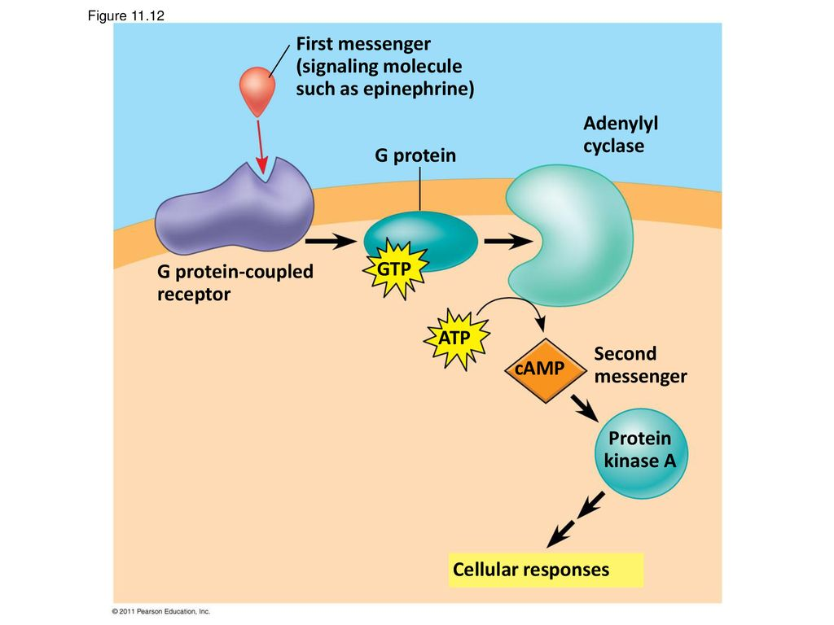

Got it. A simple chain reaction.

OK, here’s the BIG FINISH! Take a look at the diagram below…..

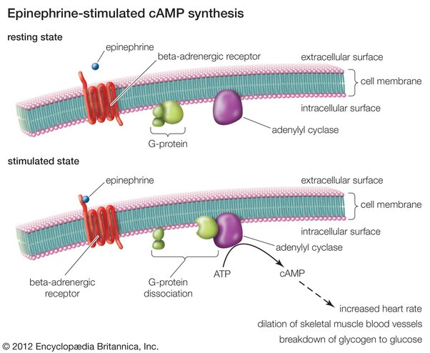

Remember that epinephrine would cause the heart to increase heart rate. The above diagram shows how that happens!

Epinephrine binds to our new friend, GPCR, which causes GDP to come off of the G protein and GTP takes its place. With that happening, the alpha subunit comes off. This alpha subunit will activate in the membrane adenylate cyclase (also called adenylyl cyclase). This activated adenylate cyclase converts ATP to cAMP and the powerful second messenger cAMP triggers the pacemaker cells of the heart in the SA node to fire faster. How does cAMP cause the pacemaker cells of the heart to depolarize faster is to have cAMP open gates to let in positive charges (Na+ and Ca++):

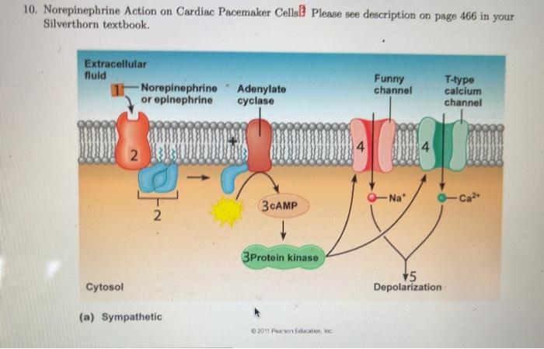

Epinephrine is the neurotransmitter released from the sympathetic postganglionic neuron. Epinephrine is the ‘fight of flight’ neurotransmitter. This neurotransmitter is released to stimulate the heart to beat faster. And notice that epinephrine does not cause the pacemakers cells in the SA node to depolarize by triggering the opening of gates with chemical dependent gates, but epinephrine uses the “G-Protein” pathway. Not ‘Ion-channels’.

AWESOME. Awesome that we can understand it. And useful because this will help you in nursing school understand how lots of cardiac medications work.

Remember that ACh causes the heart to slow down its heart rate. We already know that when you release ACh into the synapse from the parasympathetic neuron to the cardiac pacemaker cells causes ‘inhibition’, ‘hyperpolarization’.

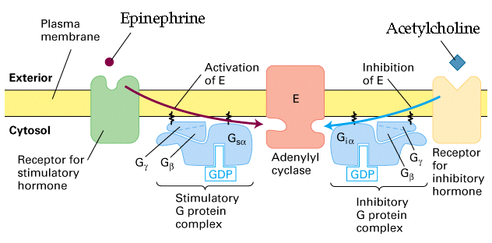

And ACh’s G protein action eventually activates cAMP which opens K+ gate, allowing K+ to diffuse OUT, leaving the inside less positive (more negative), inhibiting the action potential, slowing the heart rate.

WOW. I didn’t see that coming. These newly described G-protein pathways, which by the way are not that hard to memorize, are how ACh can slow heart rate and how epinephrine can increase heart rate inside the pacemaker cells within the SA node of the heart. Here’s a review question, is the sympathetic or parasympathetic signal travel along the Vagus cranial nerve?

So here’s a question. We’ve already learned that nerve to nerve transmission of an action potential or even nerve to skeletal muscle fiber transmission of an action potential does not involve these G proteins, but our good old friends, chemical dependent gates and voltage dependent gates. Once the pacemaker cells of the SA node depolarize, then they send their action potentials from cell to cell through the gap junctions using what we already know, opening voltage dependent gates.

Here's something useful. Remember that the ACh receptors also bind nicotine and muscarine, hence there are two types of ACh receptors: nicotinic and muscarinic.

Check this out: the nicotinic ACh receptors are the ones found at the neuromuscular junctions, they use chemical dependent gates and voltage dependent gates.

But the muscarinic ACh receptors are the ones found in the heart and use G proteins!

So to sound fancy, the muscarinic receptors in the cardiac muscle fibers are GPCR’s and when bound activate the alpha subunit of the G protein which **inhibits** adenylate cyclase which will decrease cAMP acting to block the action potential AND the alpha subunit opens K+ gates to decrease the resting membrane potential. ACh is the parasympathetic signal to slow heart rate.

Atropine increases the heart rate and improves the atrioventricular conduction by blocking the parasympathetic influences on the heart. Atropine binds to the GPCR, hence blocking the muscarinic ACh receptor.

The End.

_______________________________________________________________________________________

Later on during this semester we will learn that **hormones** that bind to their receptors trigger their target cells to respond by activating G proteins. Let me introduce another major pathway just so you can see it:

There are tricky names, but very memoizable.

Let’s take a look. Ligand binds to GPCR, this activates G protein, releasing the alpha subunit. The alpha subunit activates an enzyme phospholipase C. This phospholipase C converts PIP2, phosphatidylinositol bisphosphate into two molecules which are diacylglycerol (DAG) and inositol trisphosphate (IP3). DAG and IP3 can go on to trigger other cellular responses within the cell. Famous second messengers: DAG and IP3. See below. No worries for now, we’ll have to memorize this pathway later on when we talk about the endocrine system.

