The Role of Inositol Triphosphate and Diacylglycerol in intracellular signaling:
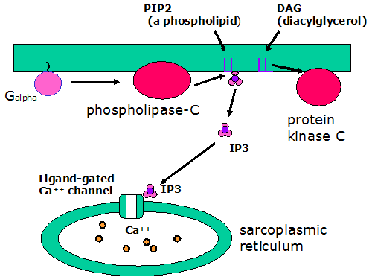

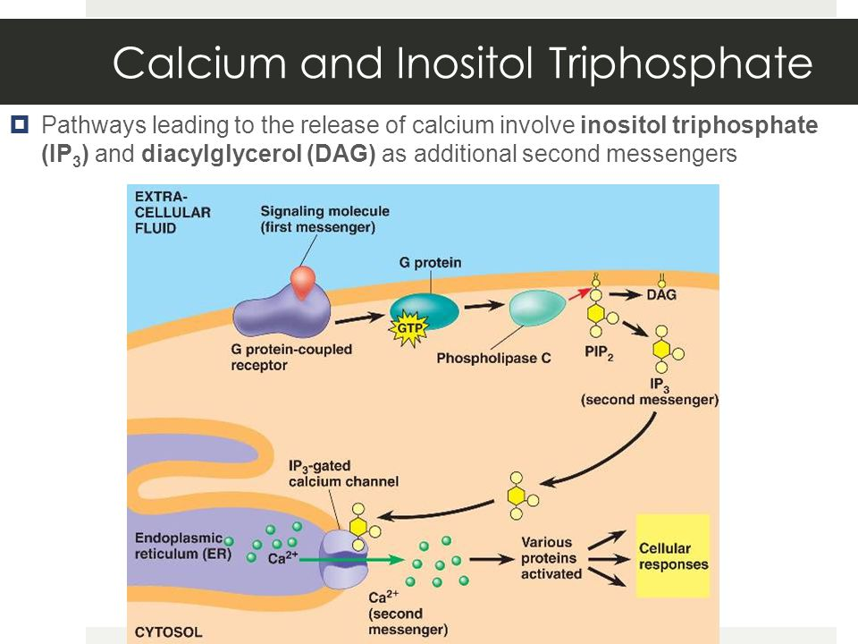
https://www.youtube.com/watch?v=VMVdVnDX5jM

