**Knee-Jerk Reflex:**

Why is it done? What does it show? How is it done?

2-minute neuroscience:

<https://www.youtube.com/watch?v=c-dD0N53QRg>

If you have ever been to a primary care physician, they have almost certainly used a little hammer to tap your knee to test for your knee-jerk reflex. In response to this tap, your leg likely jerked a little, hence the name of the reflex. This simple test is used to assure that everything is working correctly in your spinal cord.

A diminished reflex response can be associated with peripheral nervous system disorders such as sensory polyneuropathies, neuromuscular junction disorders, and others, while hyper-reflexive response is related to central nervous system disorders.

It is important to note that an absence of the reflex in response to a tap does not necessarily mean that an individual has a disease, as the test is not 100% accurate.

The knee-jerk reflex is not just used to test your neurological state when you are at the doctor’s office. It is used in everyday life, even if you don’t notice it.

Before we talk about when the reflex is used, it is important to understand what a reflex is in general, and how the knee-jerk reflex specifically works. A reflex is a fast, automatic response to a stimulus, requiring no input from the brain.

Reflexes are crucial in that they allow us to react fast to a potentially dangerous stimulus, such as a hot surface.  Not only do reflexes keep us safe from harm, but they also are involved in daily activities, such as balancing when we walk. The reflex that helps us not fall down on our faces when we trip as we are walking is the knee-jerk reflex. The knee-jerk reflex falls under the category of muscle stretch reflexes, where tapping a tendon leads to the activation of a muscle spindle, leading to nerve fiber activation in the spinal cord, which further leads to a response through a motor neuron.

The knee-jerk reflex is also known as the patellar reflex. The name of the reflex comes from the patellar tendon, a tendon that attaches the bottom of the patella to the top of the tibia, and it is the tendon that the doctor taps when they test for the knee-jerk reflex.

The knee-jerk reflex is a deep tendon reflex that is mediated by the nerves in the L2, L3, and L4 of the spinal cord. This reflex is a monosynaptic reflex, meaning that one neuron synapses onto a second neuron, leading to a response in the muscle. This monosynaptic connection is part of why the knee-jerk reflex is so fast. Additionally, the reflex only goes to the lumbar region of the spinal cord, instead of getting feedback from the brain first, increasing its speed. So, what exactly happens when your patellar tendon is hit with the hammer?

1. The stretch of the tendon is detected through stretch receptors in the muscle spindle in the quadriceps muscle.
2. The muscle spindle then stimulates the sensory neurons which travel to the lumbar region of the spinal cord.
3. In the gray matter of the spinal cord, the sensory neurons synapse on a motor neuron (this is the monosynaptic reflex).
4. The motor neuron projects to the muscle spindle in the quadriceps contracting the muscle.

These are the basic steps of how the knee jerk reflex works. However, when one muscle contracts, the opposing muscle needs to relax to allow for movement. Therefore, the knee jerk reflex, like any other reflex, has additional, non-monosynaptic, steps that lead to the relaxation of the hamstring.

1. When the sensory neuron reaches the spinal cord, in addition to synapsing on a motor neuron, it also synapses on an inhibitory interneuron.
2. This inhibitory interneuron then synapses on a different motor neuron.
3. This second motor neuron travels to the hamstring muscle, relaxing it.

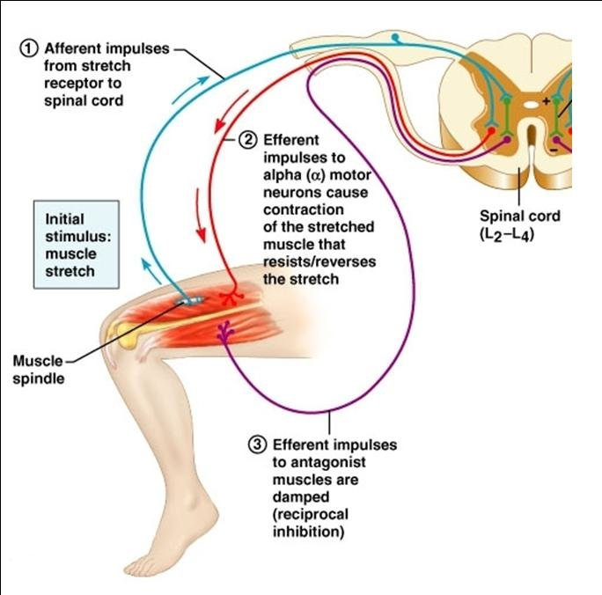

In summary, striking of the [patellar tendon](https://en.wikipedia.org/wiki/Patellar_tendon) with a [reflex hammer](https://en.wikipedia.org/wiki/Reflex_hammer) just below the [patella](https://en.wikipedia.org/wiki/Patella) stretches the [muscle spindle](https://en.wikipedia.org/wiki/Muscle_spindle) in the [quadriceps muscle](https://en.wikipedia.org/wiki/Quadriceps_muscle). This produces a signal which travels back to the spinal cord and synapses (without interneurons) at the level of L3 or L4 in the spinal cord, completely independent of the brain.

From there, an [alpha motor neuron](https://en.wikipedia.org/wiki/Alpha_motor_neuron) conducts an efferent impulse back to the [quadriceps femoris muscle](https://en.wikipedia.org/wiki/Quadriceps_femoris_muscle), triggering contraction. This contraction, coordinated with the relaxation of the antagonistic flexor hamstring muscles causes the leg to kick. There is a latency of around 18 [ms](https://en.wikipedia.org/wiki/Millisecond" \o "Millisecond) between stretch of the patellar tendon and the beginning of contraction of the quadriceps femoris muscle.

This is a reflex of [proprioception](https://en.wikipedia.org/wiki/Proprioception) which helps maintain [posture](https://en.wikipedia.org/wiki/Neutral_spine) and [balance](https://en.wikipedia.org/wiki/Balance_(ability)), allowing to keep one's balance with little effort or conscious thought.

The patellar reflex is a clinical and classic example of the monosynaptic [reflex arc](https://en.wikipedia.org/wiki/Reflex_arc). There is no [interneuron](https://en.wikipedia.org/wiki/Interneuron) in the pathway leading to contraction of the quadriceps muscle. Instead, the sensory neuron synapses directly on a motor neuron in the spinal cord. However, there *is* an inhibitory interneuron used to relax the antagonistic hamstring muscle.

[Wilhelm Heinrich Erb](https://en.wikipedia.org/wiki/Wilhelm_Heinrich_Erb) (1840–1921) and [Carl Friedrich Westphal](https://en.wikipedia.org/w/index.php?title=Carl_Friedrich_Westphal&action=edit&redlink=1) (1833–1890) simultaneously reported the patellar tendon or knee reflex in 1875. The term *knee-jerk* was recorded by Sir [Michael Foster](https://en.wikipedia.org/wiki/Michael_Foster_(physiologist)) in his Textbook of [physiology](https://en.wikipedia.org/wiki/Physiology) in 1877: "Striking the tendon below the patella gives rise to a sudden extension of the leg, known as the knee-jerk.

Hyperreflexia happens when your skeletal muscles have an increased or overactive reflex response. Damage to your motor neurons (nerve cells) that transmit signals from your brain to your spinal cord causes hyperreflexia. This is called an upper motor neuron (UMN) lesion. But other non-neurological conditions, like anxiety and hyperthyroidism, can cause hyperreflexia, too.

UMN damage leads to a characteristic set of symptoms known as upper motor neuron syndrome. The symptoms of hyperreflexia include:

-muscle weakness -spasticity (when certain muscles contract all at once)

-clonus (involuntary and rhythmic muscle contractions.

If you have hyperreflexia, your leg will kick out more briskly and forcefully than normal.

Several conditions can lead to UMN damage and hyperreflexia:

-amyotrophic lateral sclerosis (ALS); -encephalitis (brain infection;

-multiple sclerosis (MS); -Parkinson’s disease; -traumatic brain injury.

Also, anxiety disorders, like generalized anxiety disorder or panic disorder trigger your ‘flight or fight’ response (sympathetic n.s.). This causes your muscles and reflexes to be extra sensitive. So ‘stress’ can temporarily cause hyperreflexia.

Hyporeflexia is a symptom in which your skeletal muscles have a decreased or absent reflex response. It results from damage to any part of your reflex arc (the sensory part; the central part; the motor part). If the damage is to the motor nerves, it is called a lower motor neuron lesion. So hyporeflexia is the opposite of hyperreflexia.

Damage anywhere along the reflex arc can cause hyporeflexia (sensory neuron / spinal cord / motor neurons).

The Knee Jerk Reflex also known as the Patellar Reflex:

How is it done? Why is it done? What does it show?

First let’s review the anatomy:

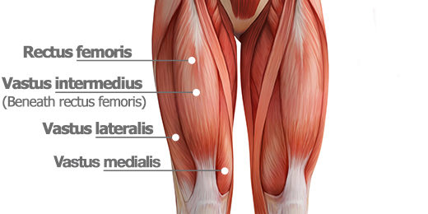

The quadriceps are a group of muscles present on the front of the thigh. They consist of four distinct muscles: the rectus femoris, the vastus lateralis, the vastus intermedius, and the vastus medialis.

The origin of the rectus femoris is the anterior, superior iliac spine on the pelvis. The origins of the vastus lateralis, vastus medialis and vastus intermedius are from the femur. All insert onto the tibial tuberosity of the tibia.

Built into these muscles are muscle spindles that are sensitive to stretch (stretch receptors). That sensory information, that the muscle has been stretched, is sent up to the spinal cord and arrives there in the L3 and L4 regions.

Immediately that sensory nerve synapses with a motor neuron within the spinal cord and that motor neuron will travel back to the quadriceps, branching quite a lot, and cause all the heads to contract, pulling on the tibial tuberosity, extending at the knee (lifting the lower leg to make it more toward a ‘more straight’ position although the knee jerk reflex is not strong enough to cause the leg to become completely straight.

So to elicit this knee jerk response, the kicking out of the lower leg, one must stretch the quadriceps muscles.

How to stretch the quadriceps?

-detach the knee joint and pull the tibia away from the femur? Would work but quite painful and destructive.

-poke your finger or a metal hook through the skin, wrapping your finger or this hook around the quadriceps and pulling the quadriceps out, away from the bones? Again, OUCH!

-what if you simply push in on the quadriceps? Instead of reaching around it and pulling it out, just push it in. And the narrowest part of this entire muscle would be the tendon right before it inserts at the tibial tuberosity. Push that tendon in, not pull it out since pulling it out would require you to cut through the skin. Pushing in on that tendon is what is done with that little hammer. Hitting that tendon is stretching the length, from origins to insertion, of this muscle. So, it reflexively contracts, kicking the lower leg out.

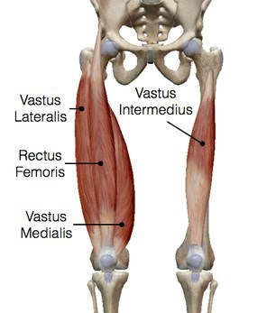 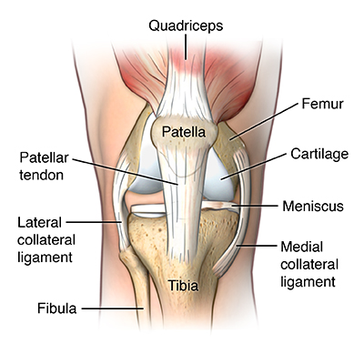

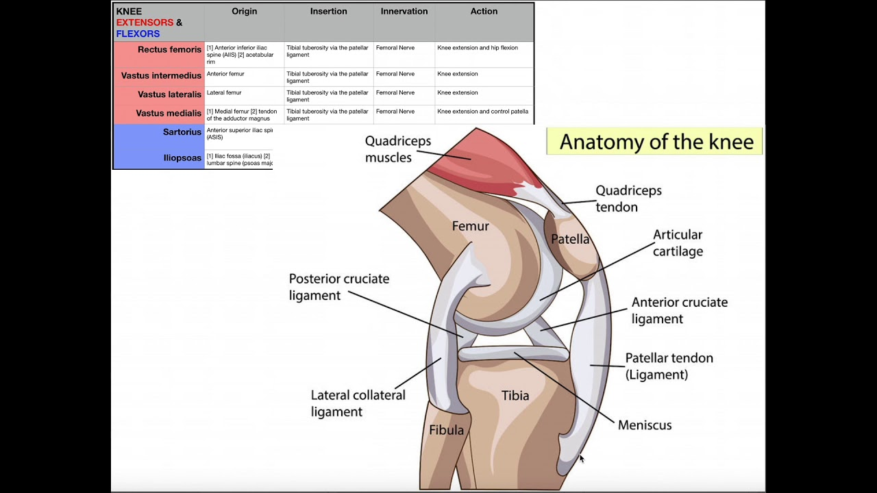

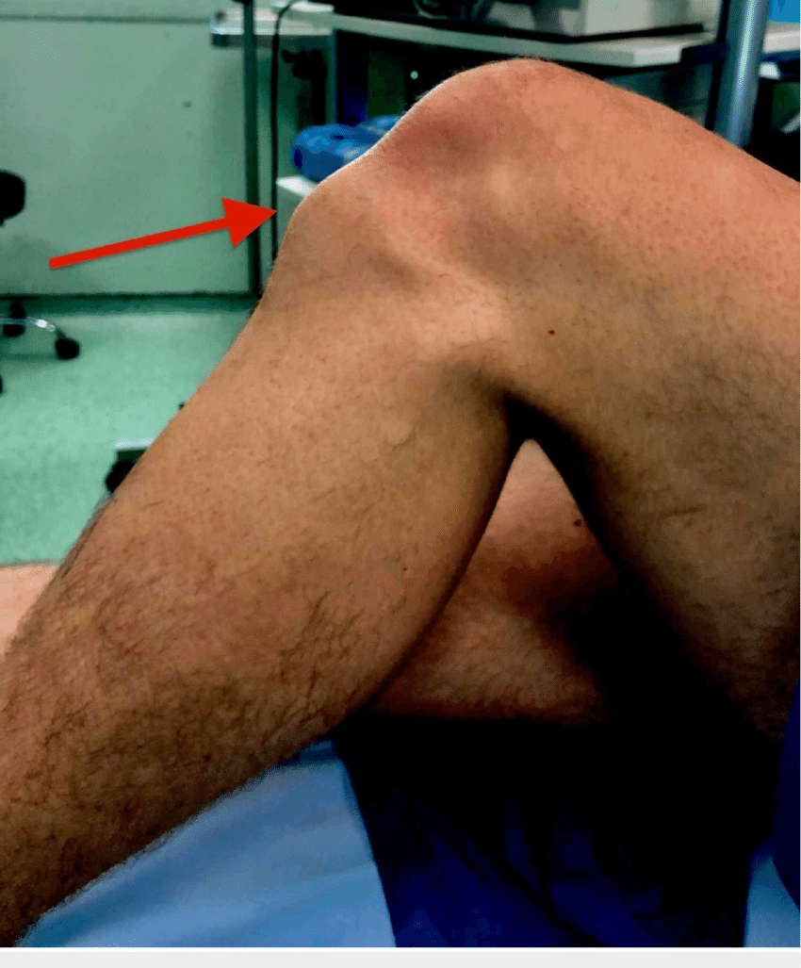 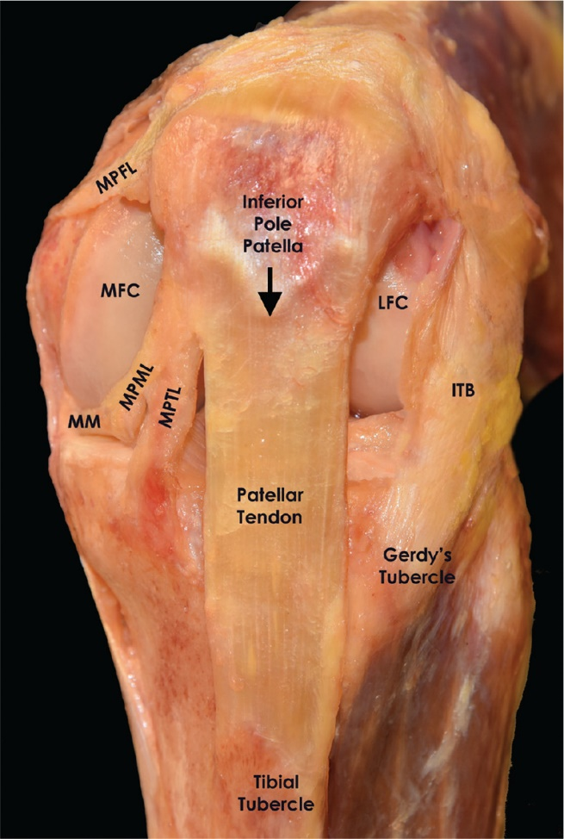

So, with that cute, little hammer you are to strike (hit) the patellar tendon, stretching the entire quadriceps muscles. That stretching of them will send motor signals back to it to contract back to its original position. If the lower leg is not touching the ground, contracting the quadriceps will cause the lower leg to kick out. Why does this reflex exist? Image you are standing up and start to tilt backwards. That would stretch the quadriceps and this ‘reflex’ action would contract the quadriceps bringing you back upright.

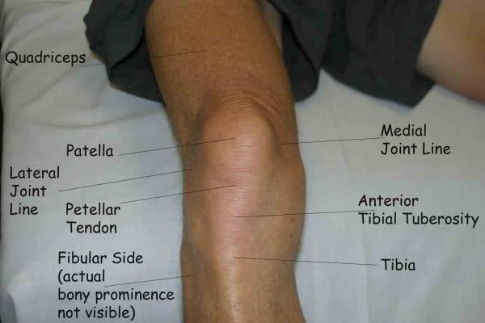

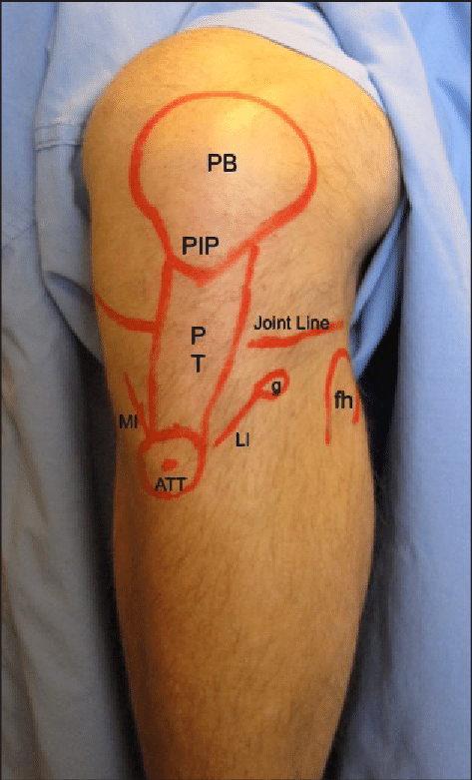 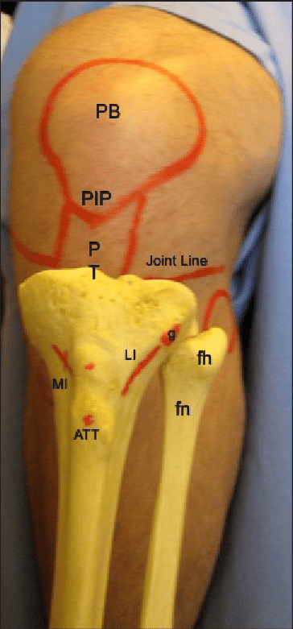

After viewing all these nice images, you should now be able to find and ‘hit’ the patellar tendon with that cute, little hammer.

2-minute neuroscience:

<https://www.youtube.com/watch?v=c-dD0N53QRg>

A reflex is a fast, automatic response to a stimulus, requiring no input from the brain.

The knee-jerk reflex is a deep tendon reflex that is mediated by the nerves in the L2, L3, and L4 of the spinal cord. This reflex is a monosynaptic reflex, meaning that one neuron synapses onto a second neuron, leading to a response in the muscle. This monosynaptic connection is part of why the knee-jerk reflex is so fast. Additionally, the reflex only goes to the lumbar region of the spinal cord, instead of getting feedback from the brain first, increasing its speed.

So with a gentle, little tap of the patellar tendon a health care provider (or physiology classmate) can test for hyporeflexia or hyperreflexia. If either one or the other of these are seen, then testing for peripheral neuron disorders or upper motor neuron dysfunction can begin. You will NOT be tested on what these disorders are (as listed above).

So why would damage to neurons in the brain or upper spinal cord cause the knee jerk reflex to be too strong, hyperreflexia? I understand that damage to the neurons in the reflex pathway themselves would slow or lessen the ‘kick’, hyporeflexia. And since the knee jerk reflex is monosynaptic, it does not rely on the brain. So why would damage to certain parts of the brain or upper spinal cord cause hyperreflexia?

Let’s think about what mostly causes the quadriceps muscles to contract. Well, like any skeletal muscle, that’s the precentral gyrus of the brain. From a small contraction, to a maximal contraction of the quadriceps, it is the neurons in the brain controlling that. The brain then also regulates the ‘tone’ of the quadriceps, how contracted it is at rest. If there is damage to these neurons from the brain, or in the spinal cord, there is less ‘tone’ being maintained in the quadriceps. In this way, when the monosynaptic knee jerk reflex happens without the brain knowing, there is less tone to interfere with the knee jerk response and so now the quadriceps will contract stronger, with a higher/stronger kick = hyperreflexia.