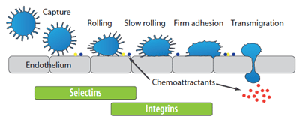

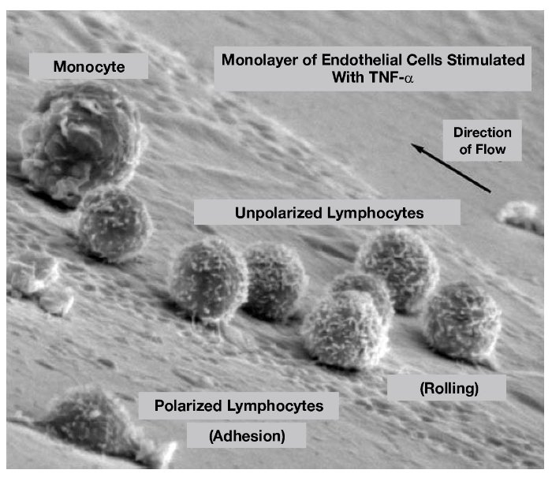

Diapedesis - Medical Animation
https://www.youtube.com/watch?v=R8VzquHdwZw
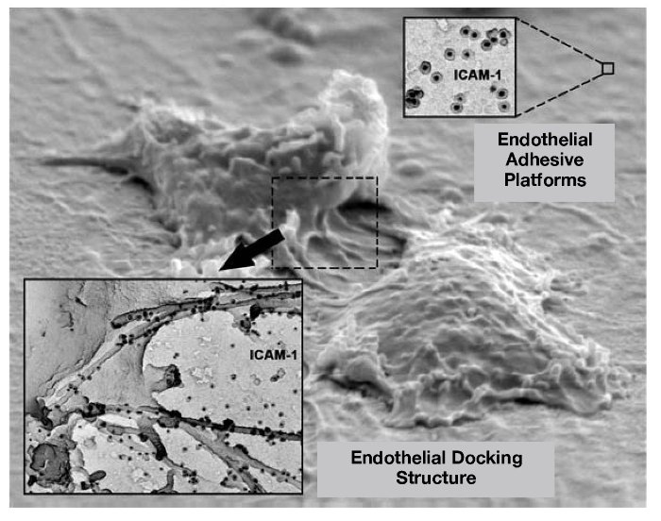

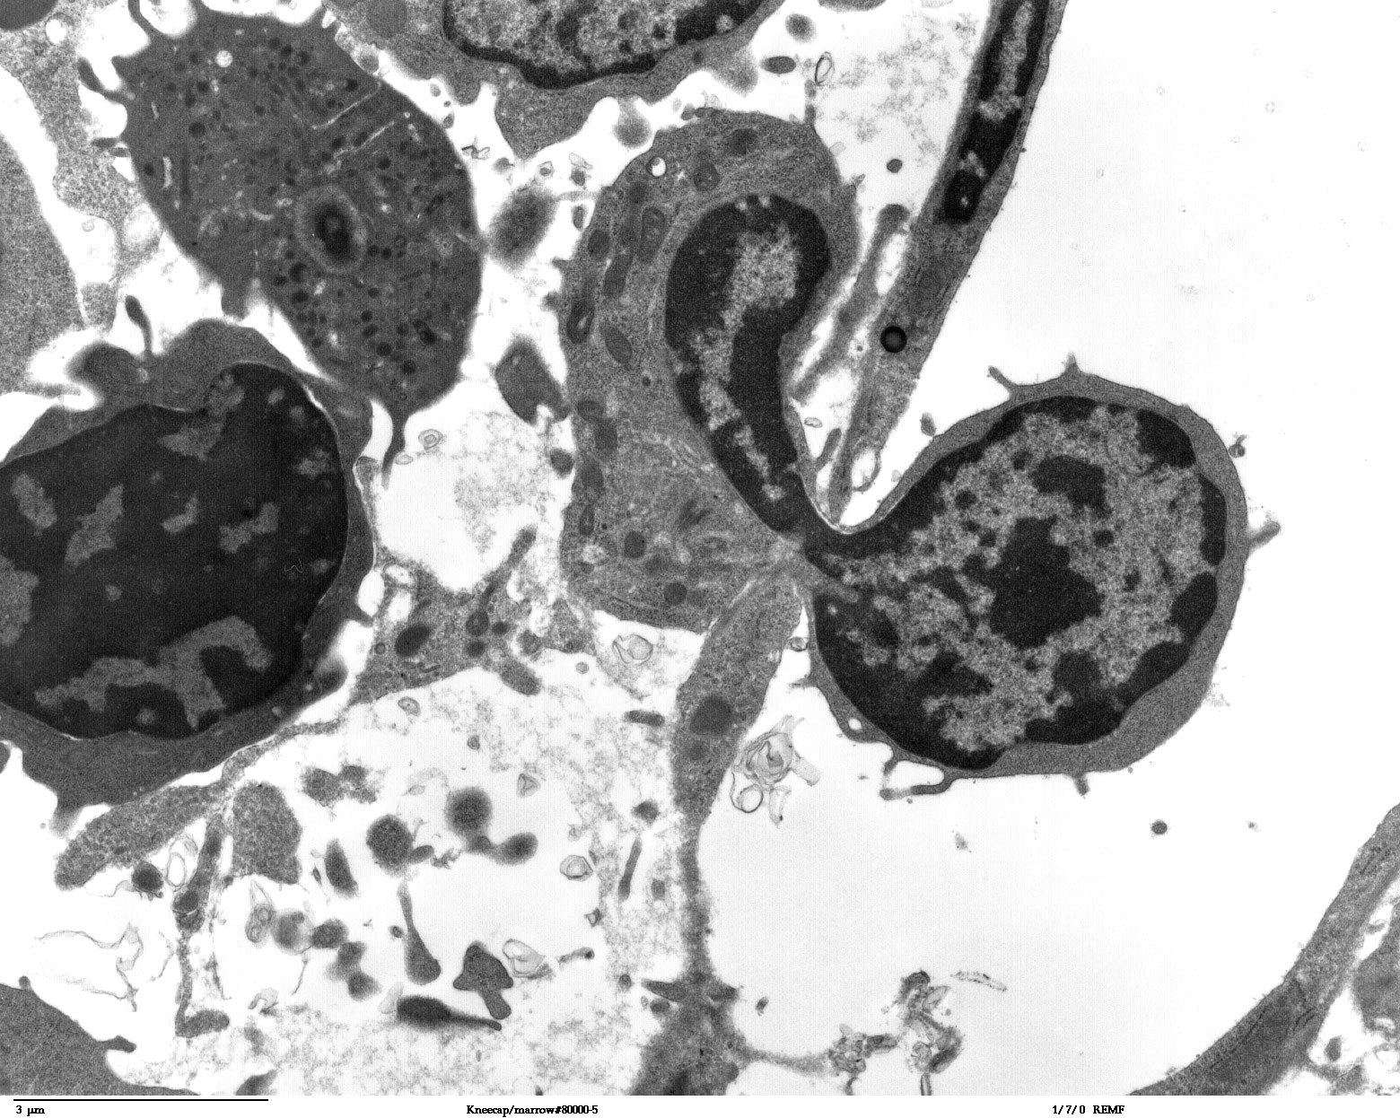

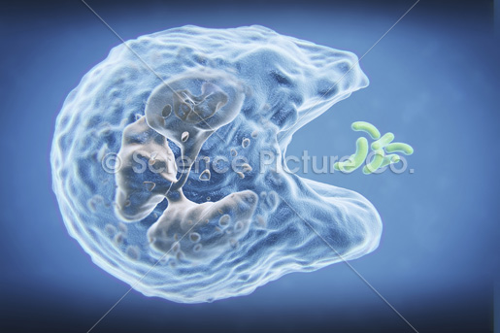

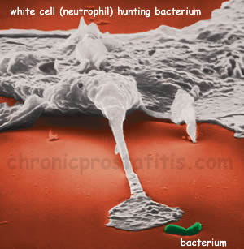
Bacterial phagocytosis by neutrophils
http://www.youtube.com/watch?v=ygkvXT1BmaA

Neutrophil Phagocytosis –
White Blood Cell Eats Staphylococcus Aureus Bacteria
http://www.youtube.com/watch?v=Z_mXDvZQ6dU

Margination
http://www.youtube.com/watch?v=XylVhCRQATk

Leukocyte Extravasation with explanation
http://www.youtube.com/watch?v=297HcgDxb7k

Diapedesis / Extravasation Made Simple!
http://www.youtube.com/watch?v=ULJkPCCp6gc

Neutrophils accumulation and extravasation
http://www.youtube.com/watch?v=qRoE1jSIKxs

ACUTE INFLAMMATION
https://www.youtube.com/watch?v=suCKm97yvyk

