**Lipid bilayer**

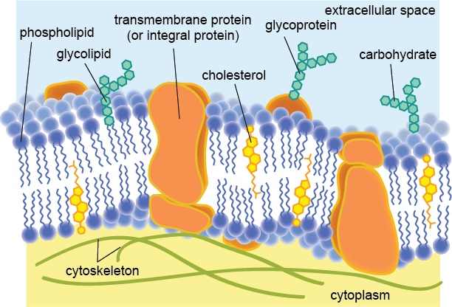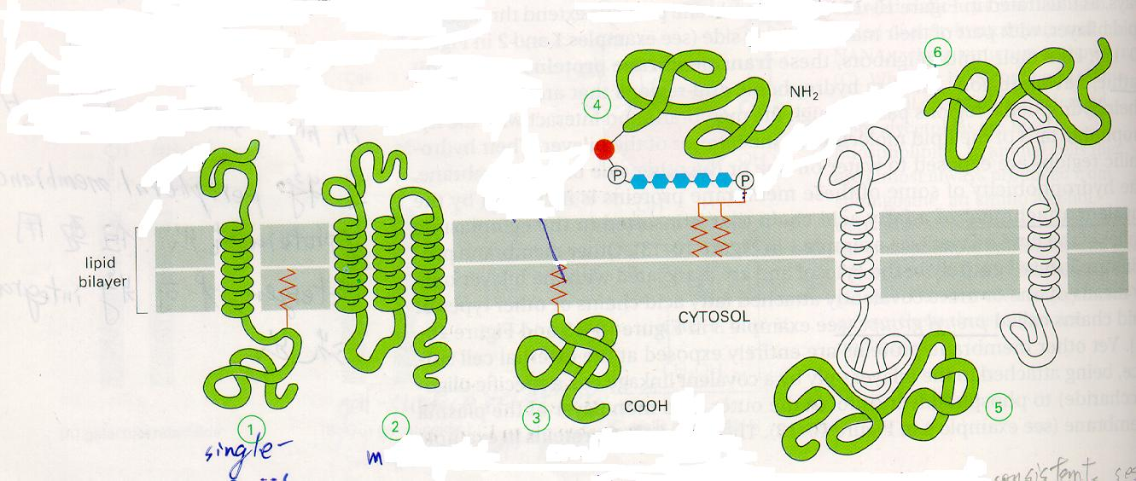The lipid bilayer is made of two layers of lipid molecules. These membranes are flat sheets that form a continuous barrier around cells. The cell membrane of almost all living organisms is made of a lipid bilayer, as are the membranes surrounding the cell nucleus and other sub-cellular structures. The lipid bilayer is the barrier that keeps ions, proteins and other molecules where they are needed and prevents them from diffusing into areas where they should not be. Lipid bilayers are ideally suited to this role because, even though they are only a few nanometers in width, they are impermeable to most water-soluble (hydrophilic) molecules. Bilayers are particularly impermeable to ions, which allows cells to regulate salt concentrations and pH by pumping ions across their membranes using proteins called ion pumps. Because lipid bilayers are quite fragile and are so thin that they are invisible in a traditional microscope, bilayers are very challenging to study. Biological membranes typically include several types of lipids other than phospholipids. A particularly important example in animal cells is cholesterol, which helps strengthen the bilayer and decrease its permeability. Cholesterol also helps regulate the activity of certain integral membrane proteins. Integral membrane proteins (also called trans-membrane proteins) extend completely across the lipid bilayer with the amino acids facing the inside and outside of the bilayer (the intracellularly and extracellularly exposed amino acids) having charged side groups (R-groups with charge) while the amino acids found within the bilayer have uncharged side groups. Trans membrane proteins extend across bilayer by helices. It can be further classified into single pass (1) or multipass (2). (50 lipid molecule : 1 protein molecule) Peripheral proteins are not inserted into the hydrophobic interior of the membrane. How are they associated with it? Indirectly associated through protein-protein ionic bond interactions. To what are the intracellular portions of membrane proteins usually bound? Cytoskeletal components, like actin.

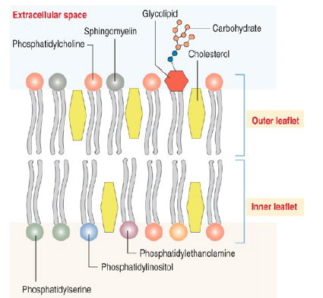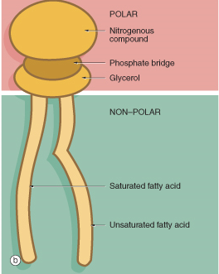While lipid tails primarily modulate bilayer phase behavior, it is the headgroup (containing nitrogen) that determines the bilayer surface chemistry. Most natural bilayers are composed primarily of phospholipids, although sphingolipids such as sphingomyelin and sterols such as cholesterol are also important components. Of the phospholipids, the most common headgroup is phosphatidylcholine (PC), accounting for about half the phospholipids in most mammalian cells. PC is a zwitterionic headgroup, as it has a negative charge on the phosphate group and a positive charge on the amine but, because these local charges balance, no net charge.

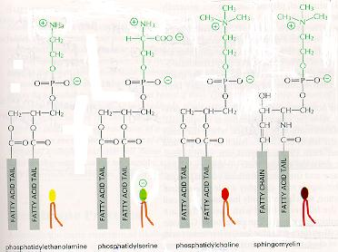In many naturally occurring bilayers, the compositions of the inner and outer membrane leaflets are different. In human red blood cells, the inner (cytoplasmic) leaflet is composed mostly of phosphatidylethanolamine, phosphatidylserine and phosphatidylinositol and its phosphorylated derivatives. By contrast, the outer (extracellular) leaflet is based on phosphatidylcholine, sphingomyelin and a variety of glycolipids. In some cases, this asymmetry is based on where the lipids are made in the cell and reflects their initial orientation. Lipid asymmetry arises, at least in part, from the fact that most phospholipids are synthesized and initially inserted into the inner monolayer: those that constitute the outer monolayer are then transported from the inner monolayer by a class of enzymes called flippases. Other lipids, such as sphingomyelin, appear to be synthesized at the external leaflet. Flippases are members of a larger family of lipid transport molecules that also includes floppases, which transfer lipids in the opposite direction, and scramblases, which randomize lipid distribution across lipid bilayers. In any case, once lipid asymmetry is established, it does not normally dissipate quickly because spontaneous flip-flop of lipids between leaflets is extremely slow.

Phosphatidylethanolamine Phosphatidylserine Phosphatidylcholine Sphingomyelin (The first two molecules are present in the innersphere of the membrane. The third and the fourth are present in the outer sphere of the membrane)

Other headgroups are also present to varying degrees and can include phosphatidylserine (PS), phosphatidylethanolamine (PE) and phosphatidylglycerol (PG). These alternate headgroups often confer specific biological functionality. Unlike PC, some of the other headgroups carry a net charge, which can alter the electrostatic interactions of small molecules with the bilayer.

Glycolipids

Present in the extracellular portion of lipid bilayer

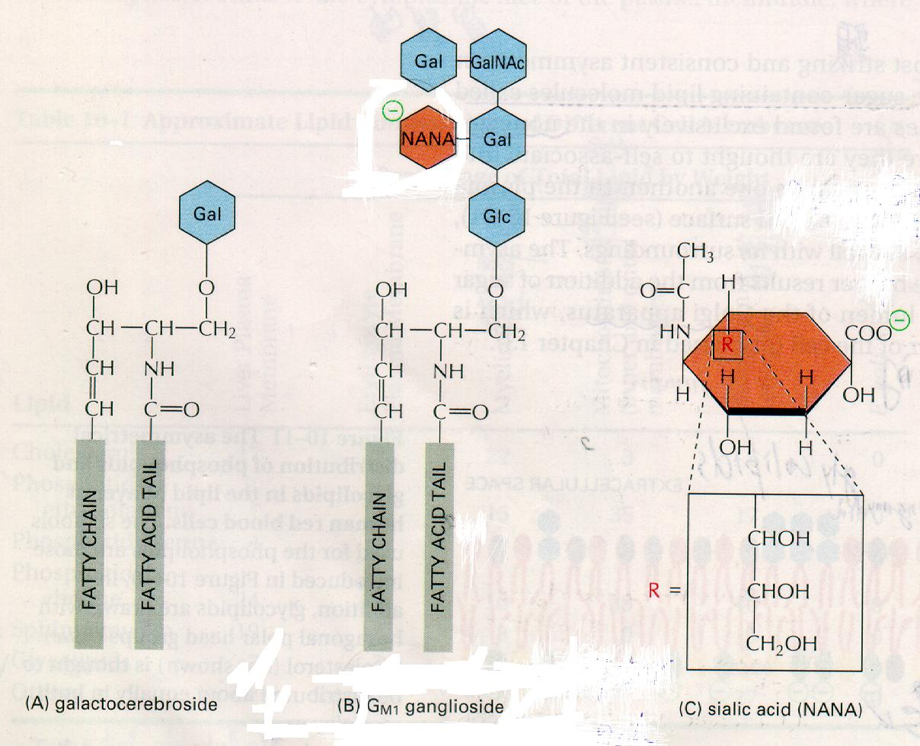

Galactocerebroside GM1 ganglioside Sialic acid (NANA)

Glycolipids constitutes 5% of total cell plasma membrane

Gangliosides are very important and complicated

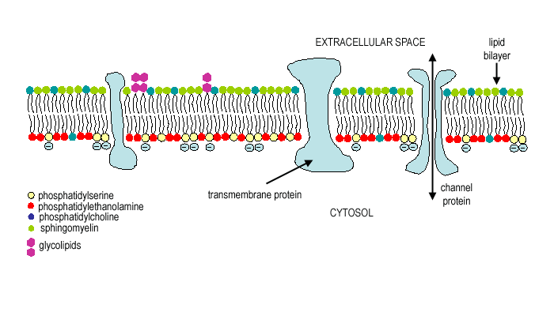

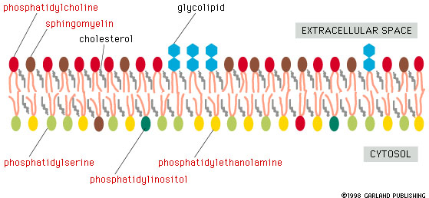

The two diagrams above show the constituents of the plasma membrane and their different distributions between the inside of the membrane (the cytosolic facing side of the phospholipid bilayer) and the outside of the membrane that faces the extracellular space. The extracellular facing side of the bilayer has mostly: phosphatidylcholine & sphingomyelin & glycolipids. Whereas the cytosolic facing side of the bilayer mostly has phosphatidylserine & phosphatidylinositol & phosphatidylethanolamine.

The lipid bilayer of plasma membranes is composed of phospholipids, glycolipids, and cholesterol.

What are the 4 major phospholipids in the plasma membrane?

- Phosphatidylcholine  
- Phosphatidylethanolamine  
- Phosphatidylserine  
- Sphingomyelin

Which phospholipids are present mainly in the outer leaflet?

- Phosphatidylcholine  
- Sphingomyelin

Which phospholipids are present mainly in the inner leaflet?

- Phosphatidylserine  
- Phosphatidylinositol  
- Phosphatidylethanolamine

T/F: Glycolipids are found only in the inner leaflet.

False; glycolipids are found only in the outer leaflet.

Why does the cytosolic face of the plasma membrane have a net negative charge?

The inner leaflet contains phosphatidylserine and phosphatidylinositol, both of which are negatively charged.

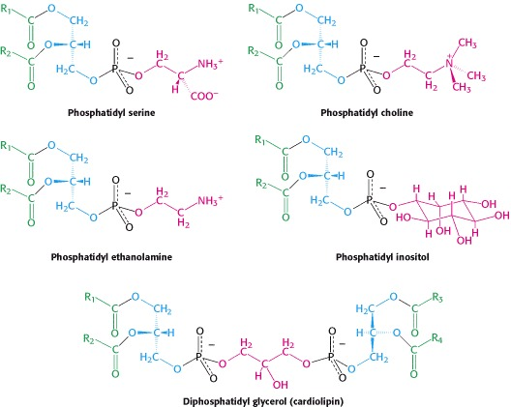

End of required material.

Continue to read my non-required tangent on ‘lysosomal storage diseases’ below:

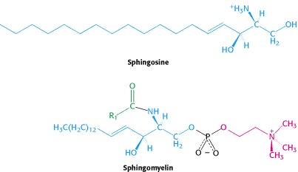

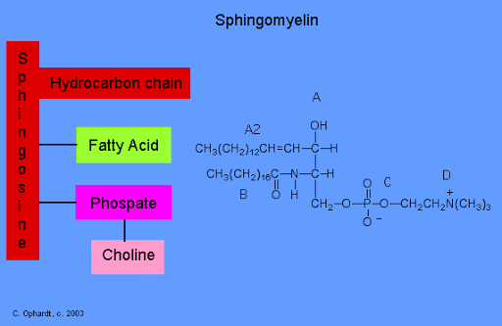

Sphingomyelin found in the membranes of neurons (up to 20% of all membrane lipids in neurons).

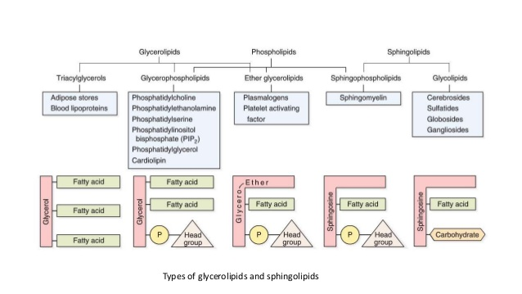

The diagram above is just here to show you how similar these types of molecules are. You do not need to memorize all of the types, just appreciate that they are all very similar structurally and related.

Several famous diseases are due to the accumulation of these molecules. Tay-Sachs disease is a rare inherited disorder that progressively destroys nerve cells in the brain and spinal cord.

The most common form of Tay-Sachs disease becomes apparent in infancy. Infants with this disorder typically appear normal until the age of 3 to 6 months, when their development slows and muscles used for movement weaken. Affected infants lose motor skills such as turning over, sitting, and crawling. Children with this severe infantile form of Tay-Sachs disease usually live only into early childhood.

Mutations in the [*HEXA*](https://ghr.nlm.nih.gov/gene/HEXA) gene cause Tay-Sachs disease. The *HEXA* gene provides instructions for making part of an enzyme called beta-hexosaminidase-A, which plays a critical role in the brain and spinal cord. This enzyme is located in [lysosomes](https://ghr.nlm.nih.gov/art/large/celllysosomes.jpeg), which are structures in cells that break down toxic substances and act as recycling centers.

Within lysosomes, beta-hexosaminidase-A helps break down a fatty substance called **GM2 ganglioside**. You can see in the diagram above that gangliosides are a type of sphingolipid and thus fall into the category of membrane lipids. Notice also GM2 ganglioside has the framework of a phospholipid but also has a carbohydrate group added.

Mutations in the *HEXA* gene disrupt the activity of beta-hexosaminidase-A, which prevents the enzyme from breaking down GM2 ganglioside. As a result, this substance accumulates to toxic levels, particularly in the lysosomes of [neurons](https://ghr.nlm.nih.gov/art/large/nerve-cell.jpeg) in the brain and spinal cord. Progressive damage caused by the buildup of GM2 ganglioside leads to the destruction of these neurons, which causes the signs and symptoms of Tay-Sachs disease.

Because Tay-Sachs disease impairs the function of a lysosomal enzyme and involves the buildup of GM2 ganglioside, this condition is sometimes referred to as a **lysosomal storage disorder** or a GM2-gangliosidosis.

This allows me to introduce to you the category of ‘lysosomal storage diseases’. Gaucher disease is one of the most common lysosomal storage disorders (LSDs). LSDs are inherited disorders resulting from a lack of specific lysosomal enzymes that break down certain lipids (fats) or carbohydrates (sugars) in the body cells.

If a person does not have enough of one of these enzymes, the body cannot break down the fat or carbohydrate targeted by enzymes for recycling. These fats or sugars accumulate in cell lysosomes where enzymes are active, disrupting normal function and causing lysosomal storage disorders.

The cell is constantly making these large lipids and carbohydrates and then breaking down old, wornout, broken ones (they do ‘wear out’ in time after all, as you can imagine the larger, more complex the molecule, the more frequently it breaks) and sending the broken molecules to the lysosome to be further broken down so that the atoms can be reused by the cell (recycling).

Each one of these molecules requires specific lysosomal enzymes to break it completely apart. If any one of these enzymes is missing due to a genetic mutation in the gene coding for that enzyme then the broken, large lipids and carbohydrates will accumulate in the lysosome and eventually damage that cell.

The scientific community has identified more than 40 types of lysosomal storage diseases, and that number keeps growing. I have moved off onto a tangent from the required information at the beginning of this handout on membrane phospholipids. But look at the diagram below. The pink line shows that the enzyme to carry out this step in recycling of the larger molecule back into the small, building-block ceramide is missing, thus causing the accumulation of that molecule that exists right before the missing enzymatic step causing the disease listed (ie. Tay-Sachs: Missing the enzyme hexosaminidase-A leading the accumulation of GM2-ganglioside). Notice in the diagram below that all the arrows are leading to the breakdown of the larger molecule into the basic building block ceramide. Once the ceramide is made inside the lysosome, this ceramide can then be used to build new, large lipids and carbohydrates.

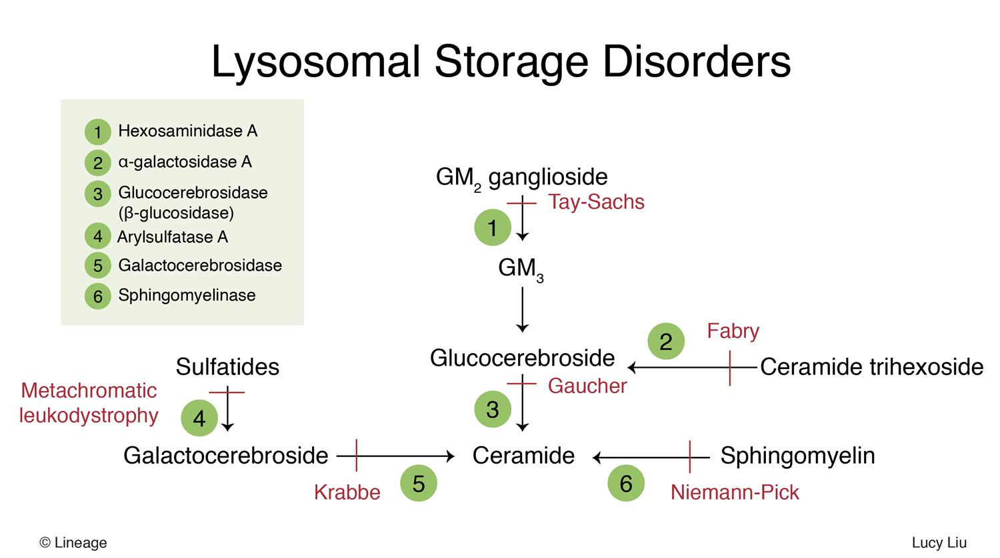

Notice in the diagram below that ceramide is used to build these much larger, more complex molecules needed by the cell. Looking at the diagram below, imagine a ganglioside or a cerebroside having been damaged inside of a cell. It is sent to the lysosome for degradation (recycling). In some people they are missing the specific enzyme needed to break it down and so the lysosome accumulates that molecule causing the lysosomal storage disease.

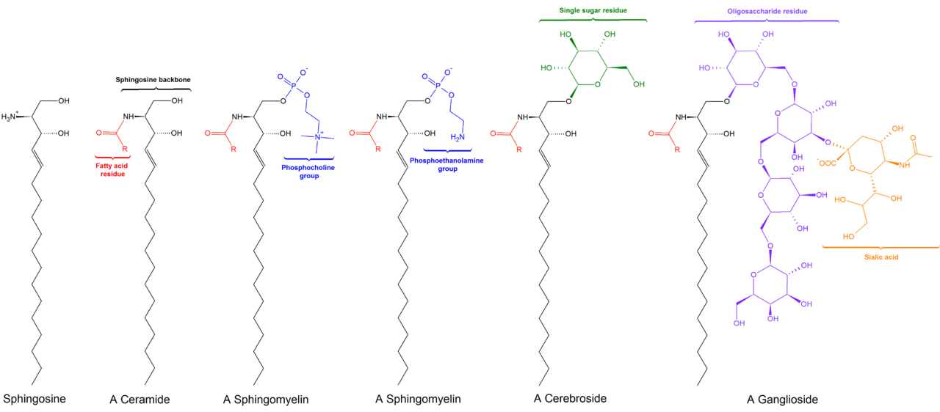

In the diagram below, you can see that “Cer” (the ceramide) molecule is used as the basic building block to construct all these other more complex lipids and carbohydrates inside the cell.

Don’t let me confuse you.

The cell will use ceramide as the basic building block to assemble many types of large molecules inside the cell, branching lipids and branching carbohydrates. If one of these molecules were to ‘wear-out’, it needs to be enzymatically broken back down to the basic building block framework of ceramide inside the lysosome using specific lysosomal enzymes. So these charts show the construction of these large lipids and carbohydrates and the destruction of the large lipids and carbohydrates back into ceramide.

Let’s take “Niemann-Pick disease” for an example.

In the diagram above, you see “Cer” (ceramide) is converted into sphingomyelin by adding the ‘blue’ phosphocholine group. Now if that sphingomyelin molecule were to be damaged inside the cell, it would have to be recycled by taking the damaged sphingomyelin molecule to the lysosome and have the lysosome with its lysosomal enzymes degrade it back to ceramide. That would only require one enzymatic step, the one enzyme to break off the phosphocholine group.

That enzyme is sphingomyelinase. If a person had a genetic defect in the gene for sphingomyelinase, they would lack that lysosomal enzyme and the damaged sphingomyelin molecule would not be broken down and all the damaged sphingomyelin molecules over time would accumulate inside all of the lysosomes causing damage and the disease named ‘Niemann-Pick disease’.

Give a glance at these last three diagrams.

Two diagrams above you see Niemann-Pick disease due to the lack of the enzyme labeled 6 in the diagram, sphingomyelinase, so sphingomyelin cannot be broken back down to ceramide. Nieman-Pick disease due to the accumulation of sphingomyelin inside the lysosomes of that person’s cells.

The diagram directly above shows how ceramide and sphingomyelin are related, just take a ceramide and add the phosphocholine group. To recycle a damaged sphingomyelin, use the enzyme sphingomyelinase to remove the phosphocholine group. If you lack that enzyme, sphingomyelin accumulates inside the lysosomes.

You again see the same idea in the diagram below. These lysosomal storage diseases are not that uncommon and you will most likely in your lifetime know of someone who has been affected by a lysosomal storage disease. They are some of the most complicated disorders to understand so I wanted to show you how ‘not complicated’ they really are if you understand molecular structures and building and deconstruction (for recycling) of those larger than average, branching molecules.

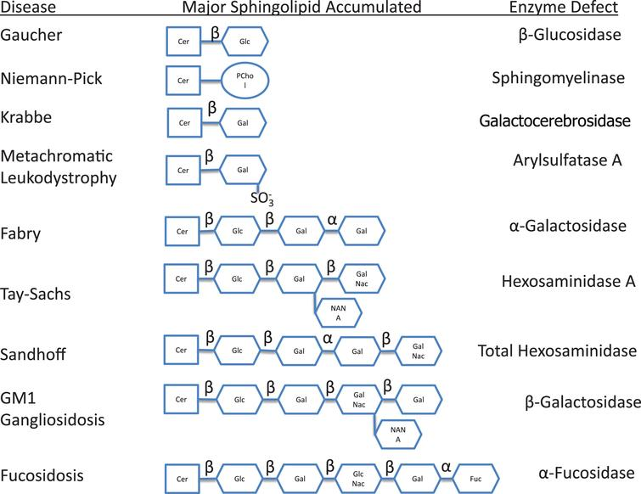

The end.