NAD and NADH, two good friends of yours. We learned about them when we learned about the Krebs Cycle and the electron transport chain. How many ATP can you get from one NADH? Good, you remember.

But what I didn’t stress, and I’m sorry I didn’t, in fact I’m so sorry I didn’t I’m writing this to you now, was the actual name of NAD. Did you learn it on your own? If you didn’t, well, here it is: **Nicotinamide adenine dinucleotide** (abbreviated as **NAD**). That is confusing, so before we go any further, let me make learning this name so much easier by actually showing you the structure of it (don’t panic, I’m helping):

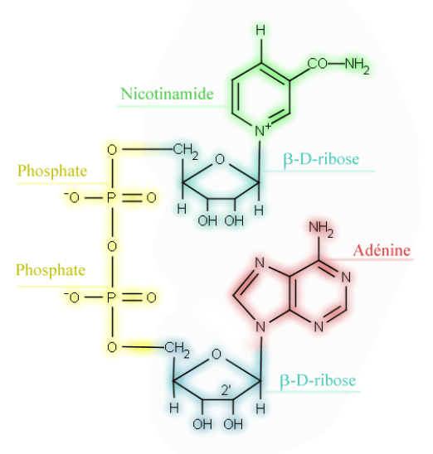

See the base ‘adenine’ in red? Good ol’ adenine. That’s a familiar structure to us all. Remember what a nucleotide is? Remember what the difference between a nucleotide and a nucleoside is? Well, let’s remind ourselves. DNA (and RNA) are made up of …. ‘nucleotides’! Here’s a perfect image to remind you:

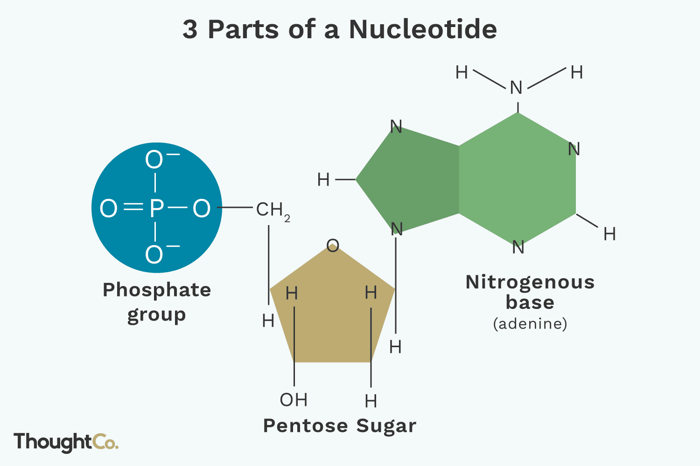

In fact, this nucleotide uses adenine as its base. A nucleotide has one of the bases (A, G, C, T or don’t forget U) along with the 5-carbon deoxyribose sugar and the phosphate group. Simple. If you link them together you have a strand of DNA (or RNA):

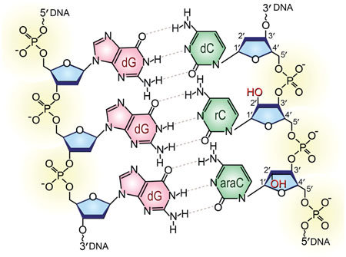

This image above I found actually shows two strands of DNA ‘base pairing’ in the middle to form DS-DNA = Chromosome! But see the red highlighted bases (G’s and C’s) attached to their 5-carbon deoxyribose sugars and their phosphate groups linking to the next nucleotide and so on. The building block is this triplet of: base + deoxyribose + phosphate group.

Got it. Nucleotide.

Now if you go back and look at the original image showing NAD, there is the base adenine in red. OK, got it. It is attached to the 5-carbon deoxyribose sugar. So why does the second image call it a ‘pentose’ sugar? Well, this definition will make that clear: ‘The 5-carbon pentose sugar in DNA is deoxyribose while the 5-carbon sugar in RNA is ribose’. Get it, you can be any 5-carbon sugar and be considered a pentose sugar. But there are specific examples of these pentose sugars like ribose and deoxyribose. OK, so the first image, the one of NAD has ribose as its pentose sugar. OK, got it.

So why does the first image of NAD call it beta-D-ribose? Remember the ‘D-‘ vs. ‘L-‘ configurations of sugars (and amino acids too)? It has to do with their three-dimensional arrangement of -OH’s and -H’s attached. We don’t have to worry about that since almost all sugars found in nature are the ‘D-‘ configuration. (For those still curious, if the –OH group attached to the bottom-most asymmetric center (the carbon that is second from the bottom) is on the right, then, the compound is a D- sugar. If the –OH group is on the left, then, the compound is a L-sugar. I won’t ask.)

And you remember the difference between the ‘alpha’ vs ‘beta’ forms (-OH group ‘up’=beta; -OH group ‘down’=alpha):

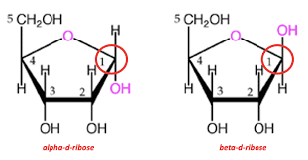

Wait. Something makes sense. As I look at the first image, the one of NAD, the bond connecting the adenine base to the beta-ribose means that the -OH on the ribose is taken away to make this bond and what was removed from the ‘N’ in adenine? It must have been a ‘-H’ so that -H and -OH were removed to make this bond and be left over with water as a byproduct (dehydration synthesis reaction). Nice.

OK, nucleotide = base (adenine in this case) + deoxyribose + phosphate. So what would be a ‘di-nucleotide’? Well, two nucleotides linked together of course. Oh, I see, your getting back to NAD, nicotinamide adenine dinucleotide. So we simply add a second nucleotide to the nucleotide that has adenine, and we link them as you saw in the first image via the phosphate groups. An interesting connection indeed. What is the second nucleotide in this di-nucleotide? A nucleotide we have not yet met before with a bit of an awkward name….nicotinamide. It is a pyrimidine because it contains nitrogen at positions 1 and 3 in the ring.

Part of the reason we are focusing on the naming of NAD is the nicotinamide back-story. Here is that back-story.

Our new friend, nicotinamide has some very closely related molecules, one of which is very famous. Structurally nicotinamide is similar to nicotinic acid and nicotinamide riboside. Nicotinic acid is famous by its other name, the vitamin ‘niacin’! All three molecules are easily interconverted in the cells of the body. Commonly the vitamin ‘niacin’ is called vitamin B-3. But actually there is the family of vitamin B-3 molecules: nicotinic acid (niacin); nicotinamide and nicotinamide riboside.

Not so long ago in Europe and other parts of the world people did not get enough niacin in their diets and they developed the disease pellagra which has a long list of symptoms, one of which is very noticeable and characteristic changes to a person’s skin (you can Google-search images of pellagra if you like). Around 1937 it was discovered that nicotinic acid would cure pellagra. By the 1940’s flour had nicotinic acid added to it to prevent pellagra. The general population didn’t like this idea since they thought nicotinic acid was the same a nicotine found in tobacco and known even back then as dangerous to one’s health. So a better name for nicotinic acid was devised…niacin = ***ni****cotinic****ac****id* + *vitam****in***. So your niacin, or vitamin-B-3 is good for you although if you eat right you shouldn’t need to take niacin. The cells of the body can make ‘niacin’ from the amino acid tryptophan enzymatically.

Not to scare you, but if you are like me, seeing is believing and seeing structures helps:

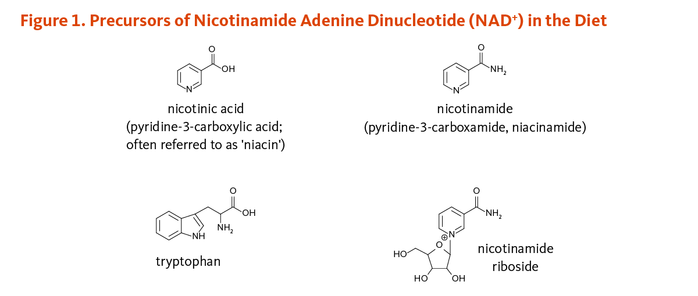

So, I need NAD in order to make ATP. Does the NAD come from dietary ‘niacin’? Yes. The cells of the body use the ‘niacin’ (vitamin-B-3) (nicotinic acid) (nicotinamide) to make ‘nicotinamide adenine dinucleotide’!

Cool!

Please go to the next page to look at and appreciate the structure of ATP!

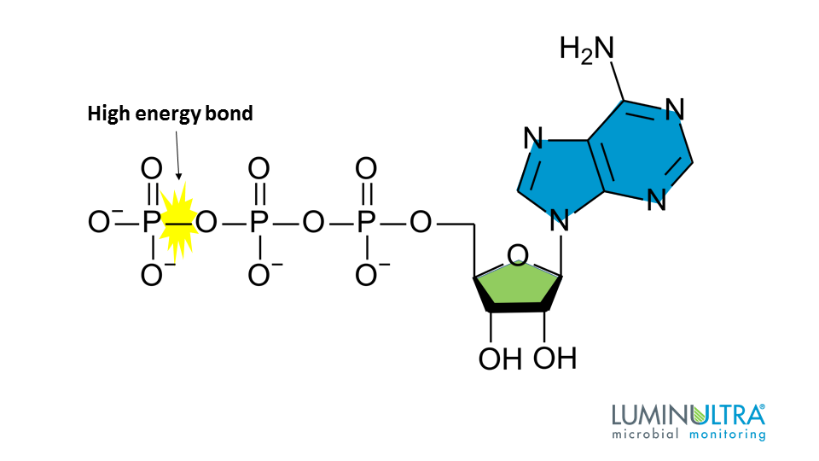

Does ATP use deoxyribose or regular ribose?

Does the ribose shown above have 5 carbons? I only see 4 inside the ring (hint: the 5th carbon is at the corner).

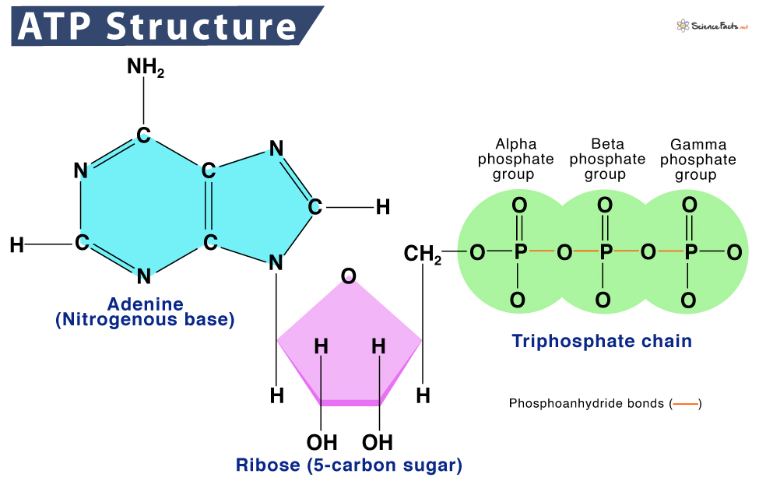

And here is ADP:

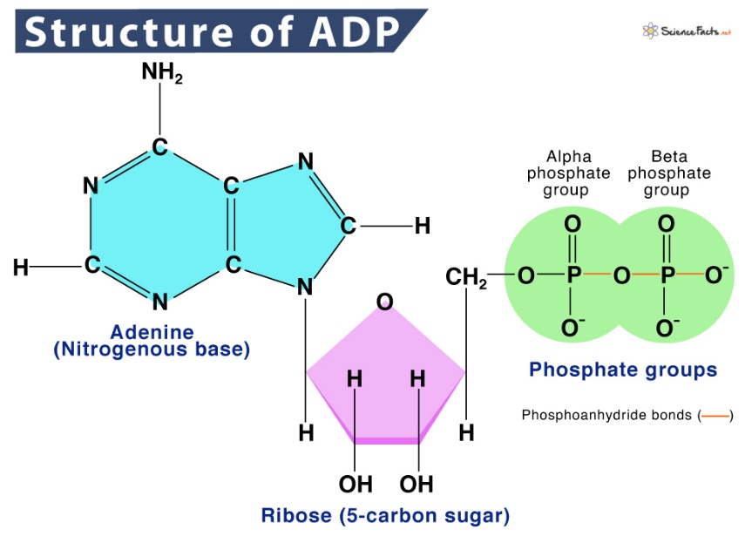

So what did we learn today? Well, let’s start with this approach, the ‘BIG’ picture. There are molecules. They come in varying collections of atoms, varying shapes and sizes. The chemists, bless their hearts, have done a very good job organizing them into groups or categories. Unfortunately, the groups and categories and names of the molecules themselves becomes awkward. Regardless, we courageously march on to learn about biochemistry, especially the biochemistry of our human body.

So there are ‘pyrimidines’ and ‘purines’:

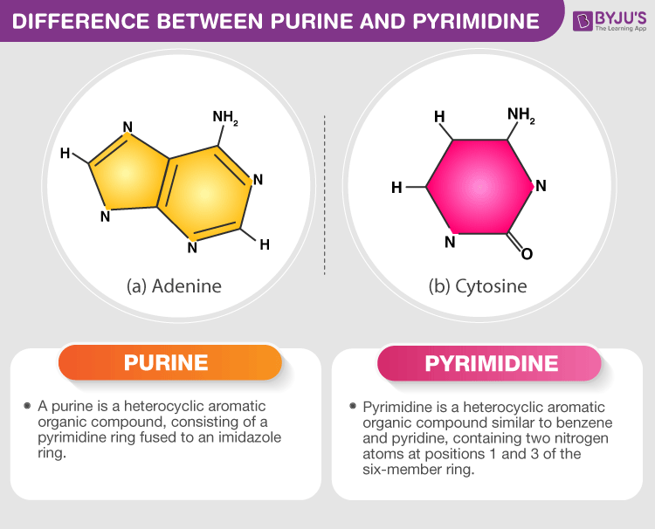

A molecule can fall into either category depending upon its structure. There are purines and pyrimidines found in our human bodies. The most famous purines are the purines that end up in DNA…..the molecules ‘adenine’ and ‘guanine’.

The famous pyrimidines that end up being used in DNA are ‘cytosine’ and ‘thymine’. Another pyrimidine used by the body is the pyrimidine ‘uracil’ and remember that is used in RNA molecules.

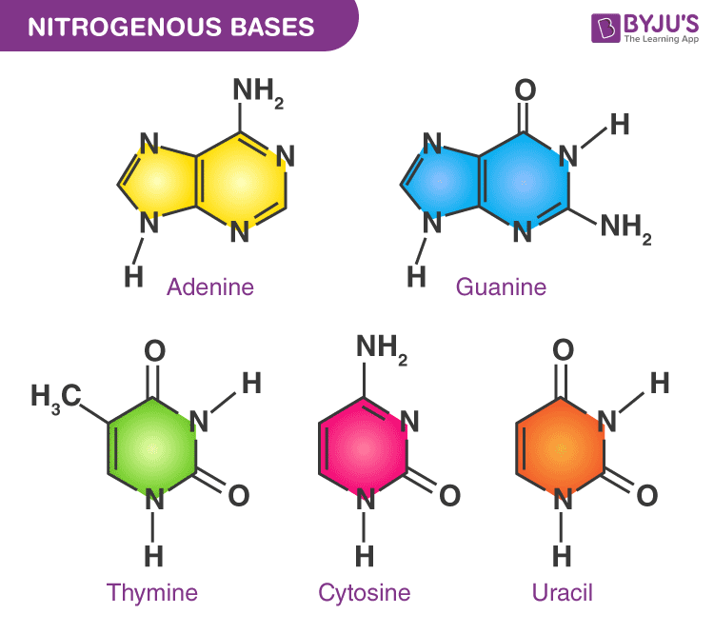

What we learned today is that there is another pyrimidine molecule, nicotinamide. It is used in a big way as a part of NADH. Take the pyrimidine nicotinamide and link it to adenine with phosphates and you have nicotinamide adenine dinucleotide. The dinucleotide in the name reminds you it has the ribose sugars.

As an aside, you may now be wondering ‘what is a base’? The famous 4 bases in DNA. Well, the famous 4 bases in DNA are just four of several pyrimidines and purines you can find in the body that exclusively are part of the DNA strand. But now we know, there are other purines and pyrimidines in the body that are not part of DNA but also very important.

Tell me more please. Explain to me about FADH2. Make it easy just like you did for NADH please.

Well….

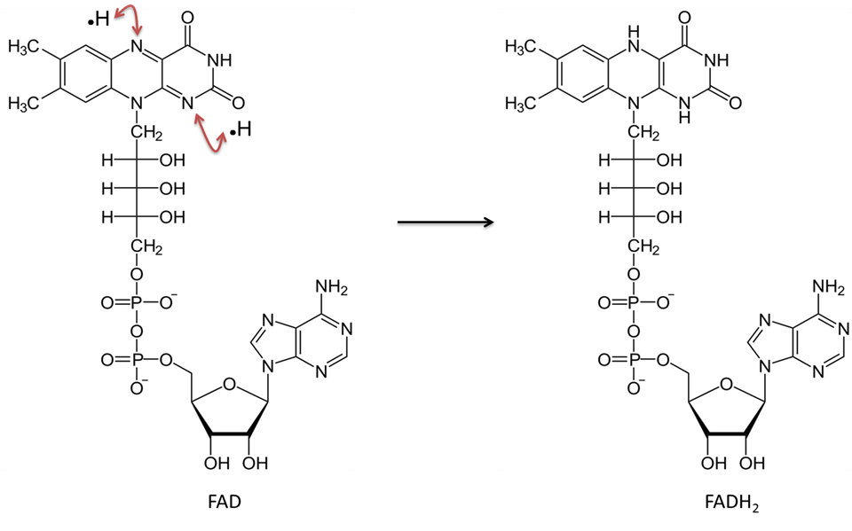

Start at the bottom, see the adenine base? And see the ribose sugar? And see the phosphates? Good.

Now look at the top, that structure with the 3-rings is FLAVIN. Hence, flavin adenine dinucleotide. Flavin is derived from riboflavin (Vitamin B-2). Do you remember what Vitamin B-3 was? We talked about it above, niacin, the relative of nicotinamide. As you can see, Flavin is neither a purine or a pyrimidine. It is used in the internal structure of many molecules, mainly enzymes, in the human body. A ‘nucleotide’ is a “Base + Sugar + Phosphate”. There certainly is a nucleotide at the bottom of FADH (adenine base + ribose sugar + the famous phosphate group). But flavin is not a base and there is no sugar (ribose) attached to it so technically this is not a ‘dinucleotide’. But that’s OK with us, right? That’s all we’ll need to know.

You do NOT have to know the chart below, just useful information:

