Botulinum toxin (BTX) is a neurotoxic protein produced by the bacterium Clostridium botulinum and related species. It prevents the release of the neurotransmitter acetylcholine from axon endings at the neuromuscular junction and thus causes flaccid paralysis. Infection with the bacterium causes the disease botulism. The toxin is also used commercially in medicine, cosmetics and research. Botulinum toxin produced by Clostridium botulinum is the cause of botulism. Humans most commonly ingest the toxin from eating improperly-canned foods in which C. botulinum has grown. However, the toxin can also be introduced through an infected wound. Botulinum toxin exerts its effect by cleaving key proteins required for nerve activation. First, the toxin binds specifically to nerves which use the neurotransmitter acetylcholine. Once bound to the nerve terminal, the neuron takes up the toxin into a vesicle. As the vesicle moves farther into the cell, it acidifies, activating a portion of the toxin which triggers it to push across the vesicle membrane and into the cell cytoplasm. Once inside the cytoplasm, the toxin cleaves SNARE proteins preventing the cell from releasing vesicles of neurotransmitter. This stops nerve signaling, leading to paralysis. 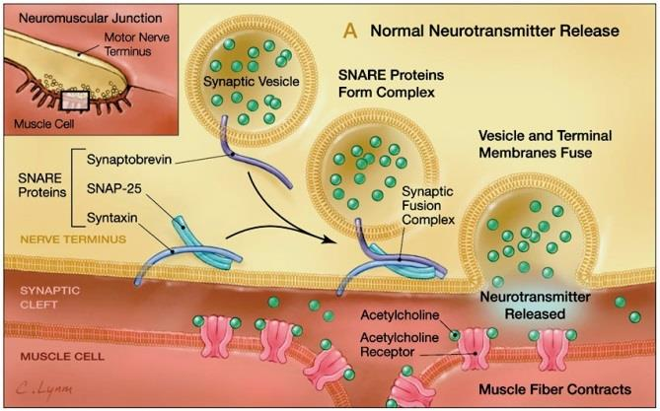
You do not need to know about the ‘SNARE’ proteins. Just note the synaptic vesicle merging with the cell membrane and releasing neurotransmitters.
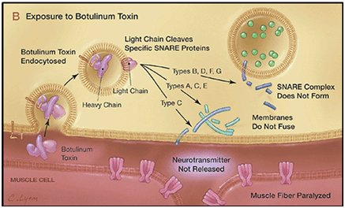
Now just note how the Botulinum toxin disrupts these SNARE proteins and the membranes do not fuse.

Sarin is a highly toxic synthetic organophosphorus compound. A colorless, odorless liquid, it is used as a chemical weapon due to its extreme potency as a nerve agent. Exposure is lethal even at very low concentrations, where death can occur within one to ten minutes after direct inhalation of a lethal dose due to suffocation from lung muscle paralysis, unless antidotes are quickly administered. People who absorb a non-lethal dose, but do not receive immediate medical treatment, may suffer permanent neurological damage. Like some other nerve agents that affect the neurotransmitter acetylcholine, Sarin attacks the nervous system by interfering with the degradation of the neurotransmitter acetylcholine at neuromuscular junctions. Death will usually occur as a result of asphyxia due to the inability to control the muscles involved in breathing. Specifically, Sarin is a potent inhibitor of acetylcholinesterase, an enzyme that degrades the neurotransmitter acetylcholine after it is released into the synaptic cleft.
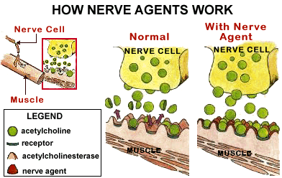

Lidocaine, also known as xylocaine, is a medication used to numb tissue in a specific area (local anesthetic). Lidocaine is one of the most commonly used local anesthetics in dentistry. Lidocaine alters signal conduction in neurons by prolonging the inactivation of the fast voltage-gated Na⁺ channels in the neuronal cell membrane responsible for action potential propagation. With sufficient blockage, the voltage-gated sodium channels will not open and an action potential will not be generated.
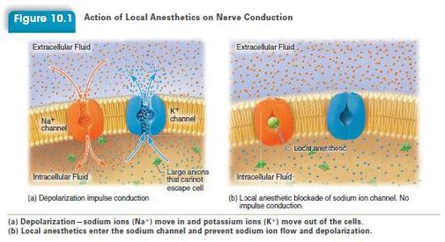
Novocaine acts mainly by inhibiting sodium influx through voltage gated sodium channels in the neuronal cell membrane of peripheral nerves. When the influx of sodium is interrupted, an action potential cannot arise and signal conduction is thus inhibited.
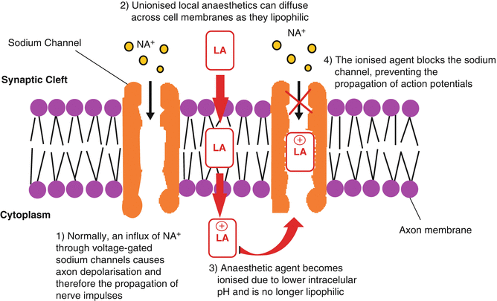

Myasthenia gravis (MG) is an autoantibody-mediated disease generally caused by antibodies to the muscle form of the nicotinic acetylcholine receptor, leading to its loss from the postsynaptic membrane. Myasthenia gravis (MG) is a relatively rare autoimmune disorder in which antibodies form against nicotinic acetylcholine (ACh) postsynaptic receptors at the neuromuscular junction (NMJ) of the skeletal muscles.
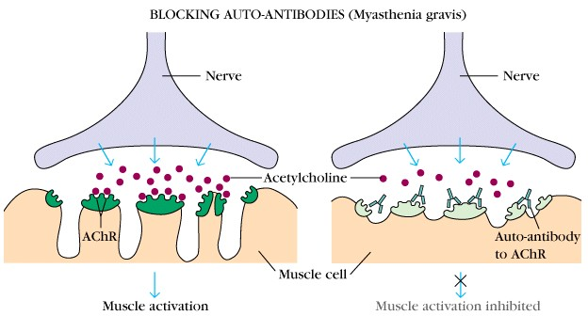
Myasthenia gravis is generally treated with medications known as acetylcholinesterase inhibitors such as neostigmine and pyridostigmine. Why would inhibiting acetylcholinesterase help with MG?

Inflammation is part of the complex biological response of body tissues to harmful stimuli, such as pathogens, damaged cells, or irritants, and is a protective response involving immune cells, blood vessels, and molecular mediators. The function of inflammation is to eliminate the initial cause of cell injury, clear out necrotic cells and tissues damaged from the original insult and the inflammatory process, and initiate tissue repair. The five classical signs of inflammation are heat, pain, redness, swelling, and loss of function (Latin calor, dolor, rubor, tumor, and functio laesa).

The cardinal signs of inflammation include: pain, heat, redness, swelling, and loss of function. Some of these indicators can be seen here due to an allergic reaction. There are many contributors to the inflammatory process, and prostaglandins are one of the more significant ones. Prostaglandins are one of the more potent mediators that cause increased blood flow, chemotaxis (chemical signals that summon white blood cells), and subsequent dysfunction of tissues and organs.
The enzymes that produce prostaglandins are called cyclooxygenase (COX). There are two types of COX enzymes, COX-1 and COX-2. Both enzymes produce prostaglandins that promote inflammation, pain, and fever; however, only COX-1 produces prostaglandins that protect the stomach and intestinal lining.
The synthesis of prostaglandins begins with the molecule arachidonic acid: a polyunsaturated fatty acid present in animal fats. It is important in metabolism, especially in the synthesis of prostaglandins and leukotrienes, and is an essential constituent of the diet. Arachidonic acid in the human body usually comes from dietary animal sources (meat, eggs) or is synthesized from linoleic acid.
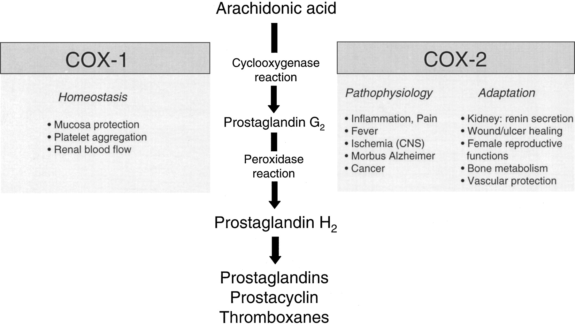
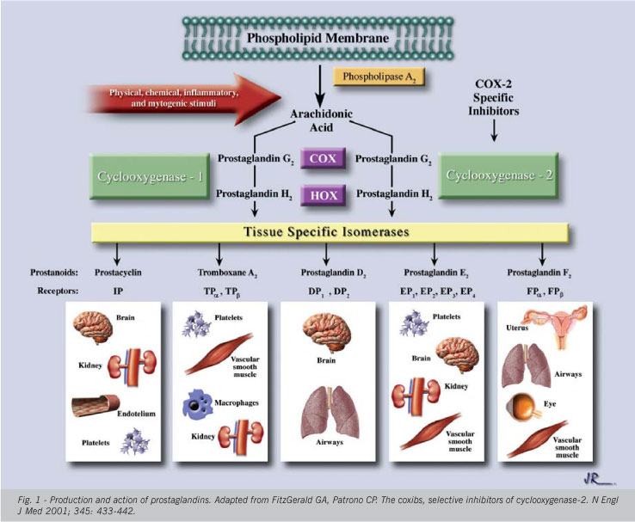

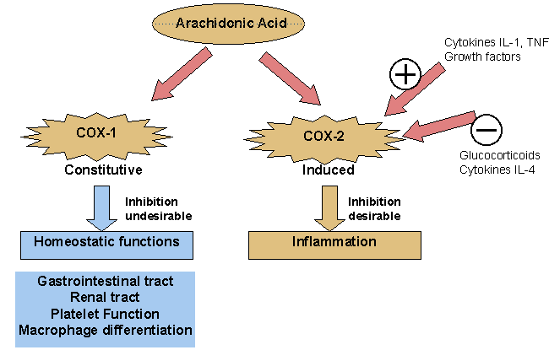
Selective COX-2 inhibitors are a type of nonsteroidal anti-inflammatory drug (NSAID) that directly targets cyclooxygenase-2, COX-2, an enzyme responsible for inflammation and pain. Targeting selectivity for COX-2 reduces the risk of peptic ulceration. After several COX-2 inhibiting drugs were approved for marketing, data from clinical trials revealed that COX-2 inhibitors caused a significant increase in heart attacks and strokes. Rofecoxib (commonly known as Vioxx) was taken off the market in 2004 because of these concerns and celecoxib and traditional NSAIDs received boxed warnings on their labels. Many COX-2-specific inhibitors have been removed from the U.S. market. As of December 2011, only Celebrex (generic name is celecoxib) is still available for purchase in the United States.
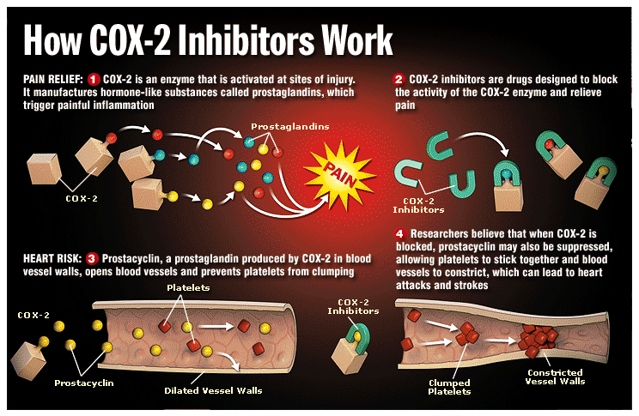

Parkinson’s Disease. Gradual degeneration and loss of dopaminergic neurons in the substantia nigra and subsequent reduction of dopamine levels from those neurons in the brain are associated with motor deficits that characterize Parkinson’s disease (PD). As the substantia nigra degenerates in Parkinson's disease (PD), the nigrostriatal pathway is disrupted, reducing dopamine and producing PD symptoms. Although dopamine does not readily cross the blood-brain barrier, its precursor, levodopa, does. Levodopa is absorbed in the small bowel and is used as a treatment for the symptoms of PD.
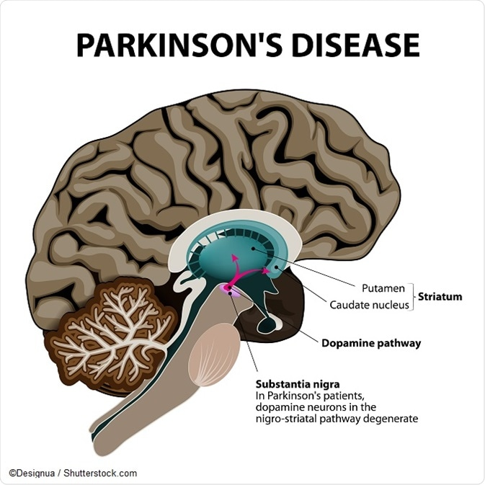

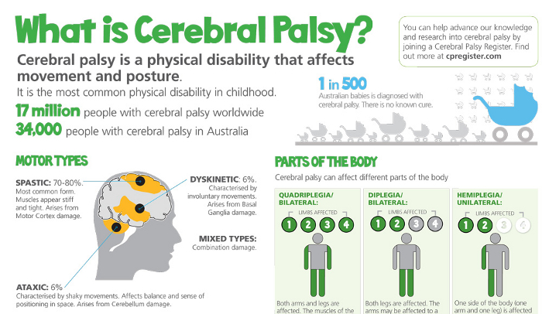

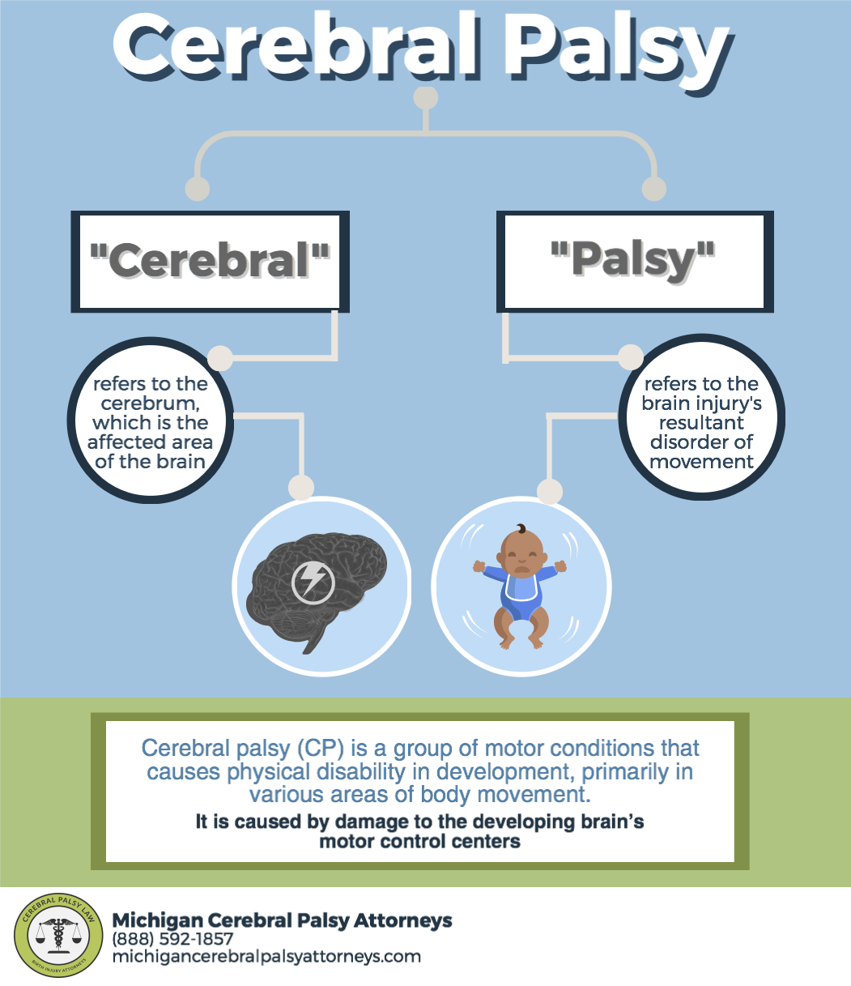

Huntington's disease is an inherited disease that causes the progressive breakdown (degeneration) of nerve cells in the brain. Huntington's disease has a broad impact on a person's functional abilities and usually results in movement, thinking (cognitive) and psychiatric disorders. Most people with Huntington's disease develop signs and symptoms in their 30s or 40s. But the disease may emerge earlier or later in life. The movement disorders associated with Huntington's disease can include both involuntary movement problems and impairments in voluntary movements, such as:
- Involuntary jerking or writhing movements (chorea)
- Muscle problems, such as rigidity or muscle contracture (dystonia)
- Slow or abnormal eye movements
- Impaired gait, posture and balance
- Difficulty with the physical production of speech or swallowing
Impairments in voluntary movements — rather than the involuntary movements — may have a greater impact on a person's ability to work, perform daily activities, communicate and remain independent.
Huntington's disease (HD), also known as Huntington's chorea, is an inherited disorder that results in death of brain cells. The earliest symptoms are often subtle problems with mood or mental abilities. A general lack of coordination and an unsteady gait often follow. As the disease advances, uncoordinated, jerky body movements become more apparent. Physical abilities gradually worsen until coordinated movement becomes difficult and the person is unable to talk. Mental abilities generally decline into dementia. The disease is caused by an autosomal dominant mutation in either of an individual's two copies of a gene called Huntingtin. This means a child of an affected person typically has a 50% chance of inheriting the disease. The Huntingtin gene provides the genetic information for a protein that is also called "huntingtin". Expansion of CAG (cytosine-adenine-guanine) triplet repeats in the gene coding for the Huntingtin protein results in an abnormal protein, which gradually damages cells in the brain, through mechanisms that are not fully understood. All humans have two copies of the Huntingtin gene (HTT), which codes for the protein Huntingtin (HTT). Part of this gene is a repeated section called a trinucleotide repeat, which varies in length between individuals and may change length between generations. If the repeat is present in a healthy gene, a dynamic mutation may increase the repeat count and result in a defective gene. The differing functions of these proteins are the cause of pathological changes which in turn cause the disease symptoms. HD is one of several trinucleotide repeat disorders which are caused by the length of a repeated section of a gene exceeding a normal range. HTT contains a sequence of three DNA bases—cytosine-adenine-guanine (CAG)—repeated multiple times (i.e. ... CAGCAGCAG ...), known as a trinucleotide repeat. CAG is the 3-letter genetic code (codon) for the amino acid glutamine, so a series of them results in the production of a chain of glutamine known as a polyglutamine tract (or polyQ tract), and the repeated part of the gene, the PolyQ region.
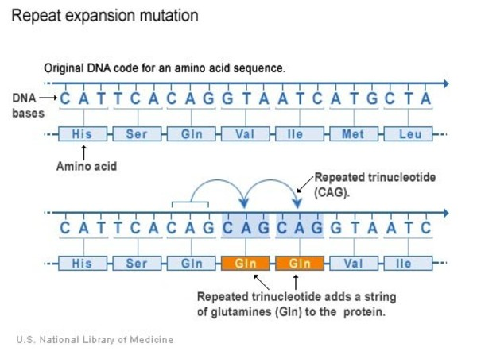
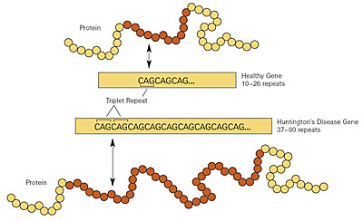
Cannabis, also known as marijuana among other names, is a psychoactive drug from the Cannabis plant used for medical or recreational purposes. The main psychoactive part of cannabis is tetrahydrocannabinol (THC), one of 483 known compounds in the plant including at least 65 other cannabinoids. Cannabis can be used by smoking, vaporizing, within food, or as an extract.
Cannabis has mental and physical effects such as creating a "high" or "stoned" feeling, a general change in perception, heightened mood, and an increase in appetite. Onset of effects is within minutes when smoked, and about 30 to 60 minutes when cooked and eaten. They last for between two and six hours. Short-term side effects may include a decrease in short-term memory, dry mouth, impaired motor skills, red eyes, and feelings of paranoia or anxiety. Long-term side effects may include addiction, decreased mental ability in those who started as teenagers, and behavioral problems in children whose mothers used cannabis during pregnancy. Studies have found a strong relation between cannabis use and the risk of psychosis.
The high lipid-solubility of cannabinoids results in their persisting in the body for long periods of time. Even after a single administration of THC, detectable levels of THC can be found in the body for weeks or longer (depending on the amount administered and the sensitivity of the assessment method). A number of investigators have suggested that this is an important factor in marijuana's effects, perhaps because cannabinoids may accumulate in the body, particularly in the lipid membranes of neurons.
Researchers have subsequently confirmed that THC exerts its most prominent effects via its actions on two types of cannabinoid receptors, the CB₁ receptor and the CB₂ receptor. The CB₁ receptor is found primarily in the brain as well as in some peripheral tissues, and the CB₂ receptor is found primarily in peripheral tissues, but is also expressed in neuroglial cells. Cannabinoid receptors, located throughout the body, are part of the endocannabinoid system, which is involved in a variety of physiological processes including appetite, pain-sensation, mood, and memory.

Muscle Relaxers: Rocuronium bromide is an aminosteroid non-depolarizing neuromuscular blocker or muscle relaxant used in modern anesthesia to facilitate tracheal intubation by providing skeletal muscle relaxation, most commonly required for surgery or mechanical ventilation.

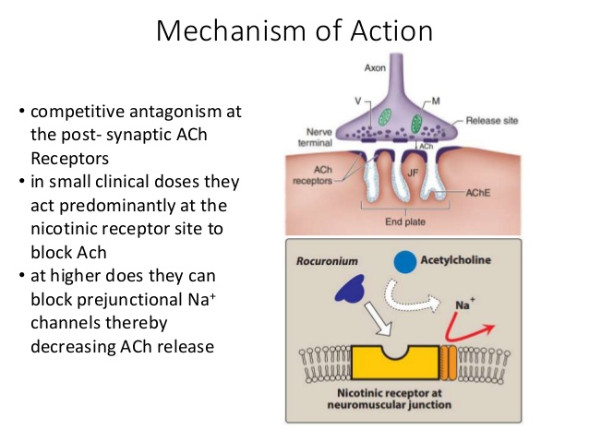
An antiemetic is a drug that is effective against vomiting and nausea. Antiemetics are typically used to treat motion sickness and the side effects of opioid analgesics, general anesthetics, and chemotherapy directed against cancer. The other name for serotonin is 5-hydroxytryptamine or 5-HT. Serotonin or 5-hydroxytryptamine (5-HT) is a monoamine neurotransmitter. The 5-HT and 5-HT₃ receptors are serotonin receptors. Antiemetics may be used for severe cases of gastroenteritis, especially if the patient is dehydrated. One type are the 5-HT₃ receptor antagonists which block serotonin receptors in the central nervous system and gastrointestinal tract. As such, they can be used to treat post-operative and cytotoxic drug nausea & vomiting.
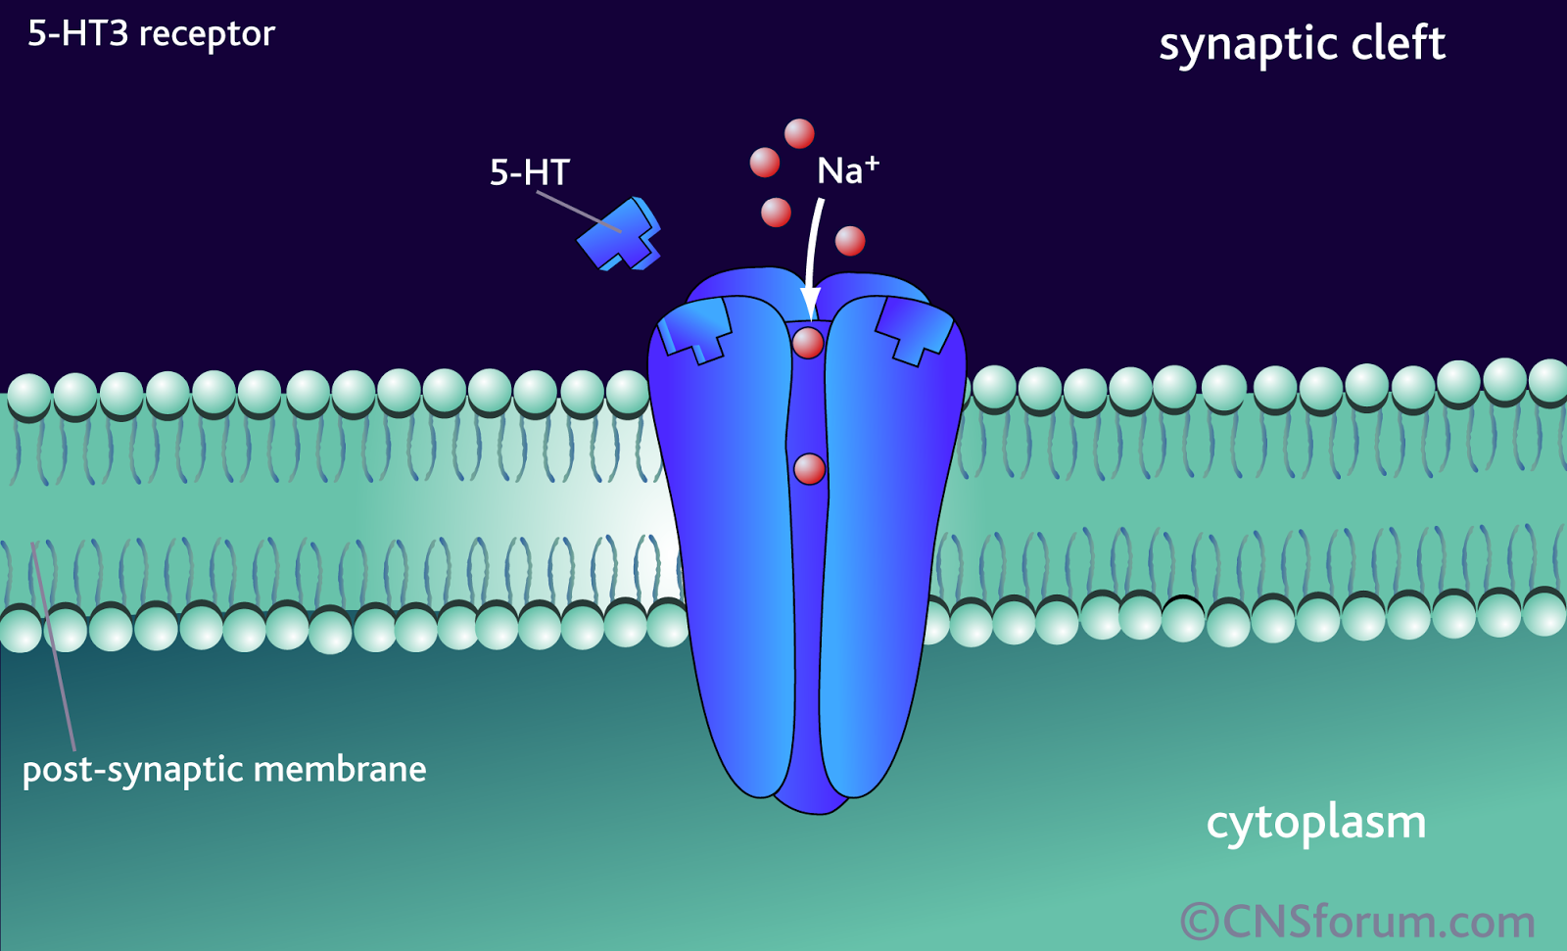
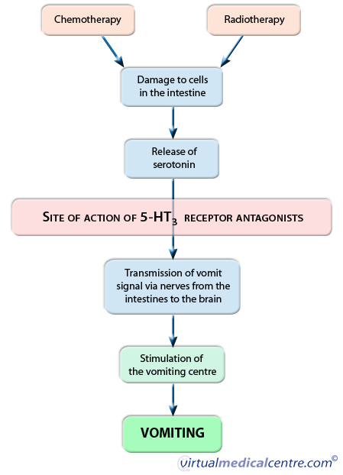
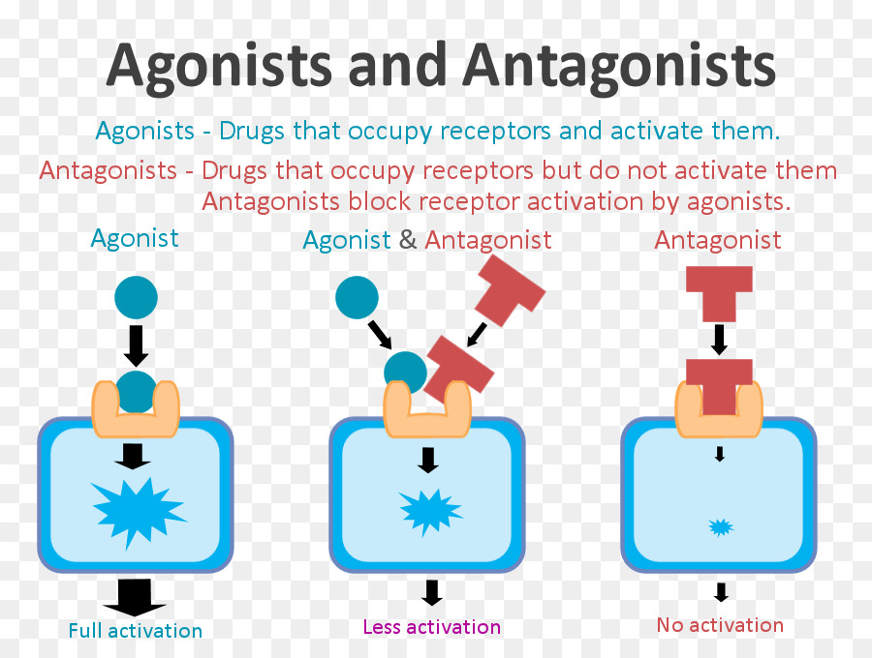
Corticosteroids (cortisone-like medicines) are used to provide relief for inflamed areas of the body. They lessen swelling, redness, itching, and allergic reactions. They are often used as part of the treatment for a number of different diseases, such as severe allergies or skin problems, asthma, or arthritis. The conversion of phospholipids to arachidonic acid is critical to the formation of various prostaglandins. This initial step is facilitated by the enzymatic action of phospholipase A2. Corticosteroids inhibit the action of phospholipase A2 and thus prevent the formation of arachidonic acid and subsequently prostaglandins.
Antianxiety medications: (SSRIs): Some medications reduce anxiety by stimulating serotonin and dopamine receptors on nerves, thereby altering the chemical messages that nerves receive. Benzodiazepines reduce symptoms of anxiety by increasing the action of a brain chemical called gamma-aminobutyric acid (GABA). An anxiolytic (also antipanic or antianxiety agent) is a medication or other intervention that inhibits anxiety. This effect is in contrast to anxiogenic agents, which increase anxiety. Anxiolytic medications have been used for the treatment of anxiety disorder and its related psychological and physical symptoms. Selective serotonin reuptake inhibitors or serotonin-specific reuptake inhibitors (SSRIs) are a class of compounds typically used in the treatment of depression, anxiety disorders, OCD and some personality disorders. Primarily classified as antidepressants, most SSRIs have anxiolytic effects.
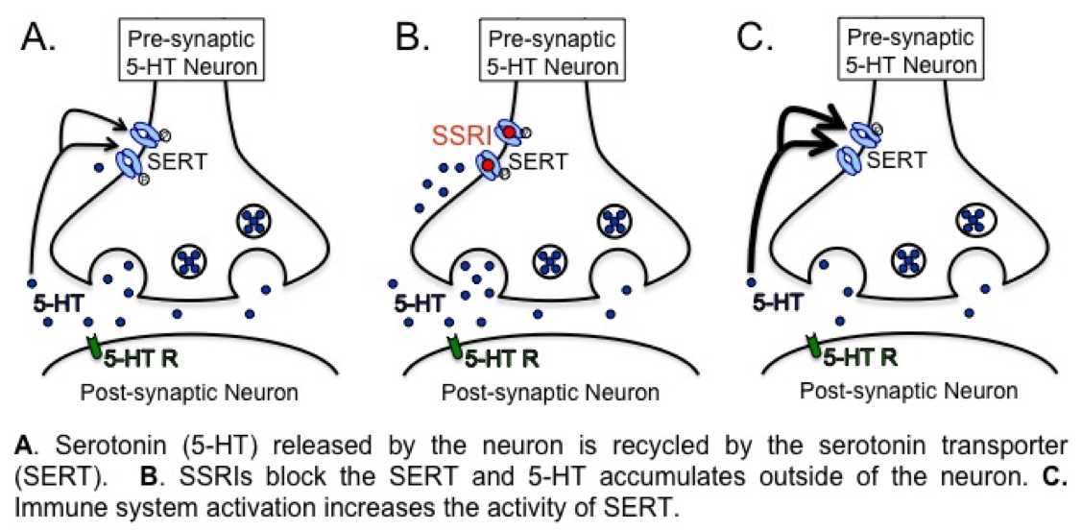

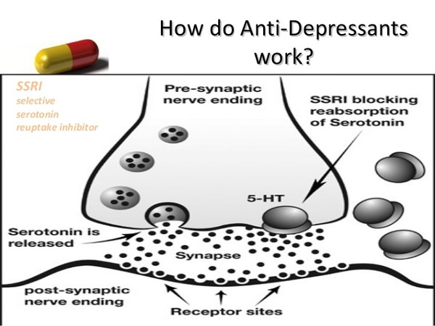

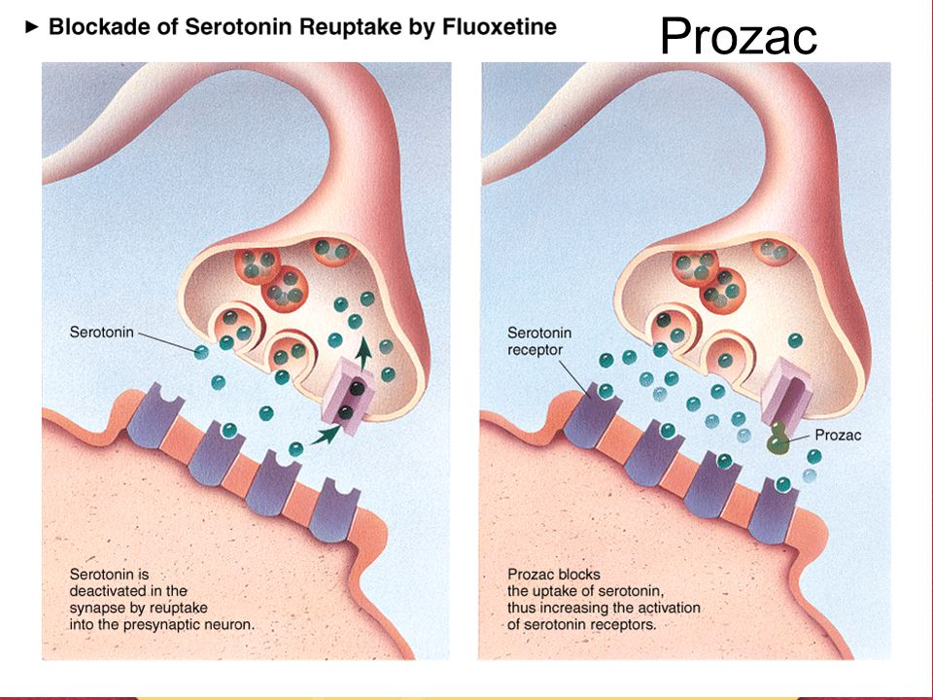

NSAIDS Prostaglandins are a family of chemicals that are produced by the cells of the body and have several important functions. Nonsteroidal anti-inflammatory drugs (NSAIDs) block both of the COX enzymes and reduce prostaglandins throughout the body. As a consequence, ongoing inflammation, pain, and fever are reduced. Common side effects of NSAIDs include:
- Stomach pain and heartburn.
- Stomach ulcers.

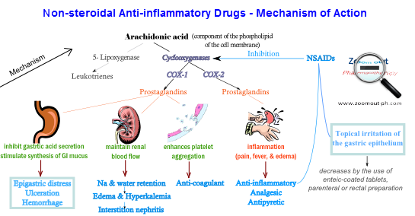

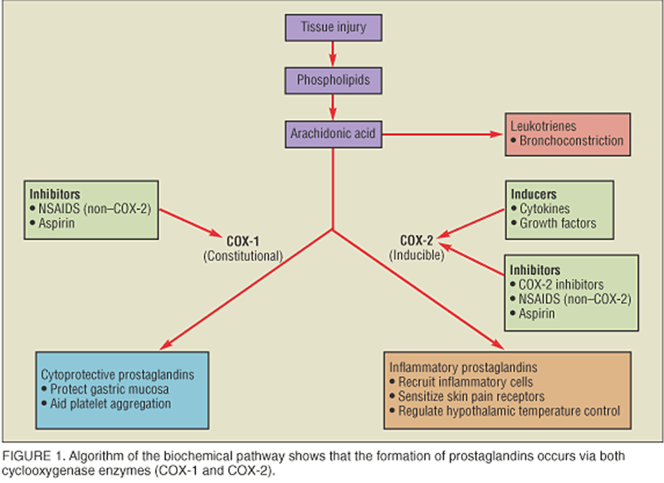
Opiate is a term classically used in pharmacology to mean a drug derived from opium. Opioid, a more modern term, is used to designate all narcotics, both natural and synthetic, that bind to opioid receptors in the brain. Opiates are alkaloid compounds naturally found in the opium poppy plant Papaver somniferum. The psychoactive compounds found in the opium plant include morphine and codeine. Heroin (diacetylmorphine) is a morphine prodrug; it is metabolized by the liver into morphine after administration.
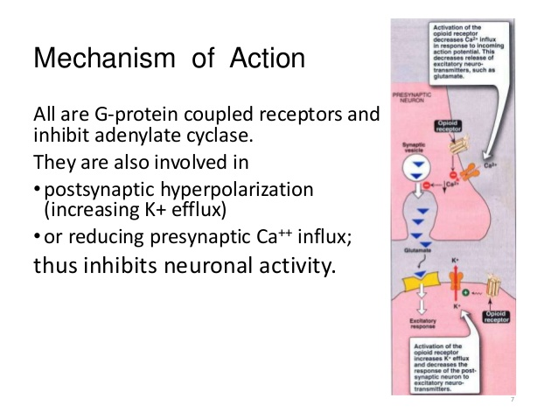
Tricyclic antidepressants (TCAs) are a class of medications that are used primarily as antidepressants. TCAs were discovered in the early 1950s and were marketed later in the decade. They are named after their chemical structure, which contains three rings of atoms.
Although TCAs are sometimes prescribed for depressive disorders, they have been largely replaced in clinical use in most parts of the world by newer antidepressants such as selective serotonin reuptake inhibitors (SSRIs), serotonin–norepinephrine reuptake inhibitors(SNRIs) and norepinephrine reuptake inhibitors (NRIs). Adverse effects have been found to be of a similar level between TCAs and SSRIs.
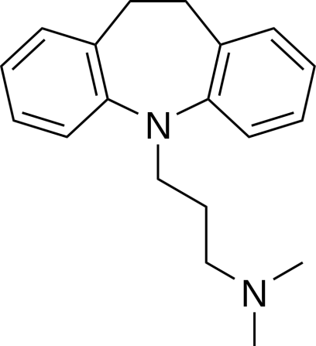
Chemical structure of the prototypical and first marketed tricyclic antidepressant imipramine. Notice its three rings.
The majority of the TCAs act primarily as SNRIs by blocking the serotonin transporter (SERT) and the norepinephrine transporter (NET), respectively, which results in an elevation of the synaptic concentrations of both of these neurotransmitters, and therefore an enhancement of neurotransmission.
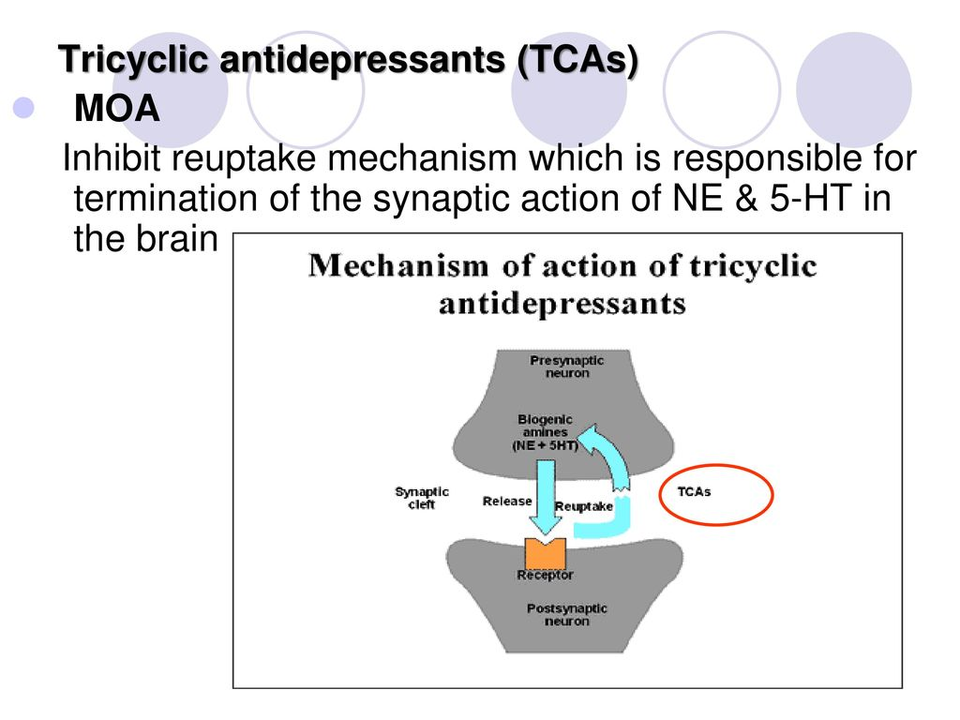

Antipsychotics, also known as neuroleptics or major tranquilizers, are a class of medication primarily used to manage psychosis (including delusions, hallucinations, paranoia or disordered thought), principally in schizophrenia and bipolar disorder. They are increasingly being used in the management of non-psychotic disorders. Antipsychotics are usually effective in relieving symptoms of psychosis in the short term. Antipsychotic drugs such as haloperidol tend to block dopamine D₂ receptors in the dopaminergic pathways of the brain. This means that dopamine released in these pathways has less effect. Excess release of dopamine in the mesolimbic pathway has been linked to psychotic experiences. Decreased dopamine release in the prefrontal cortex, and excess dopamine release in other pathways, are associated with psychotic episodes in schizophrenia and bipolar disorder.
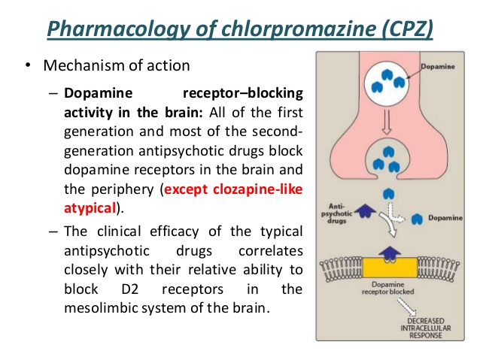
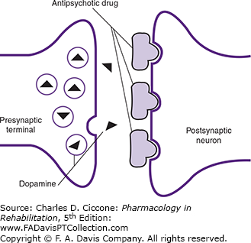

Antipyretics are substances that reduce fever. Antipyretics cause the hypothalamus to override a prostaglandin-induced increase in temperature. The body then works to lower the temperature, which results in a reduction in fever. Most antipyretic medications have other purposes. The most common antipyretics in the United States are ibuprofen and aspirin, which are nonsteroidal anti-inflammatory drugs (NSAIDs) used primarily as analgesics (pain relievers), but which also have antipyretic properties.
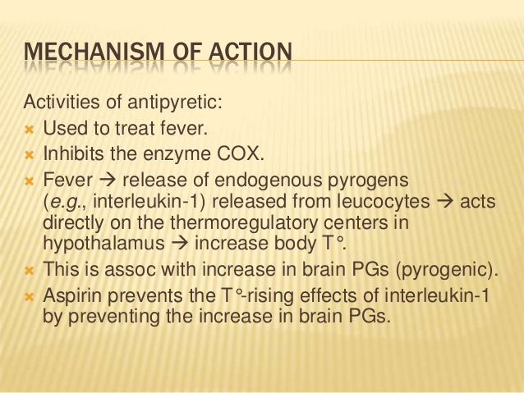

Anticonvulsants (also commonly known as antiepileptic drugs or as antiseizure drugs) are a diverse group of pharmacological agents used in the treatment of epileptic seizures. Anticonvulsants are also increasingly being used in the treatment of bipolar disorder and borderline personality disorder, since many seem to act as mood stabilizers. Anticonvulsants suppress the excessive rapid firing of neurons during seizures. Anticonvulsants also prevent the spread of the seizure within the brain. Conventional antiepileptic drugs may block sodium channels or enhance γ-aminobutyric acid (GABA) function.

GABA: (gamma-aminobutyric acid) is an inhibitory neurotransmitter Neurons that produce GABA as their neurotransmitter are called GABAergic neurons, and have chiefly inhibitory action at receptors. This binding causes the opening of ion channels to allow the flow of either negatively charged chloride ions into the cell or positively charged potassium ions out of the cell. This action results in a negative change in the transmembrane potential, usually causing hyperpolarization. GABA occurs in 30-40% of all synapses. Only glutamate is more widely distributed. Neurons in every region of the brain use GABA to fine-tune neurotransmission. Increasing GABA at the neuronal synapse inhibits the generation of the action potential of the neuron, thereby making it less likely to excite nearby neurons.
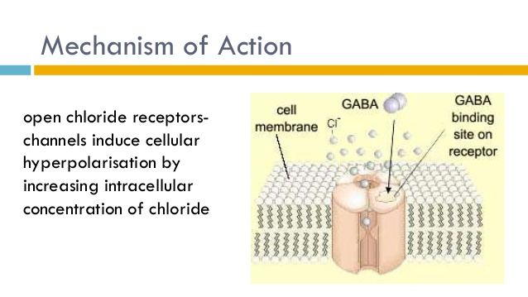

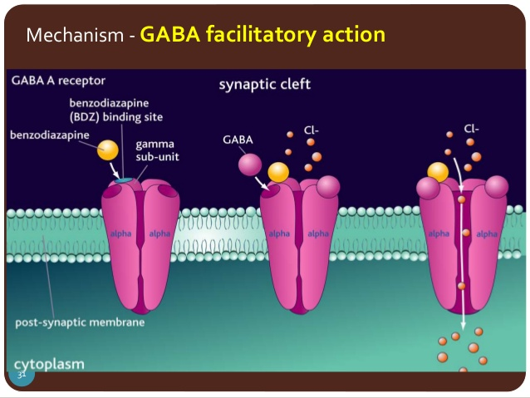

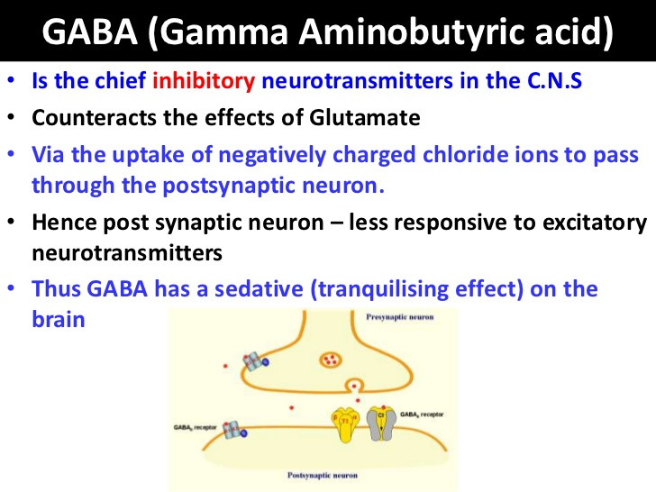
A tic is a nonvoluntary body movement or vocal sound that is made repeatedly, rapidly, and suddenly. It has a stereotyped but nonrhythmic character. The disorders are distinguished from one another according to three criteria: the child's age at onset; the duration of the disorder; and the number and variety of tics.
Tics are classified as either motor or phonic, and simple or complex.

Motor or phonic
Motor tics are movement-based tics affecting discrete muscle groups.
Phonic tics are involuntary sounds produced by moving air through the nose, mouth, or throat. They may be alternately referred to as verbal tics or vocal tics, but most diagnosticians prefer the term phonic tics to reflect the notion that the vocal cords are not involved in all tics that produce sound.

Simple or complex
Simple motor tics are typically sudden, brief, meaningless movements that usually involve only one group of muscles, such as eye blinking, head jerking, or shoulder shrugging.Motor tics can be of an endless variety and may include such movements as hand clapping, neck stretching, mouth movements, head, arm or leg jerks, and facial grimacing.
A simple phonic tic can be almost any sound or noise, with common vocal tics being throat clearing, sniffing, or grunting.
Complex motor tics are typically more purposeful-appearing and of a longer nature. They may involve a cluster of movements and appear coordinated. Examples of complex motor tics are pulling at clothes, touching people, touching objects, echopraxia (repeating or imitating another person's actions) and copropraxia (involuntarily performing obscene or forbidden gestures).
Complex phonic tics include echolalia (repeating words just spoken by someone else), palilalia (repeating one's own previously spoken words), lexilalia (repeating words after reading them), and coprolalia (the spontaneous utterance of socially objectionable or taboo words or phrases). Coprolalia is a highly publicized symptom of Tourette syndrome; however, only about 10% of TS patients exhibit coprolalia. No need to memorize each type.

