**Useful facts about DNA and Chromosomes (and RNA too) (and of course some classwork).**

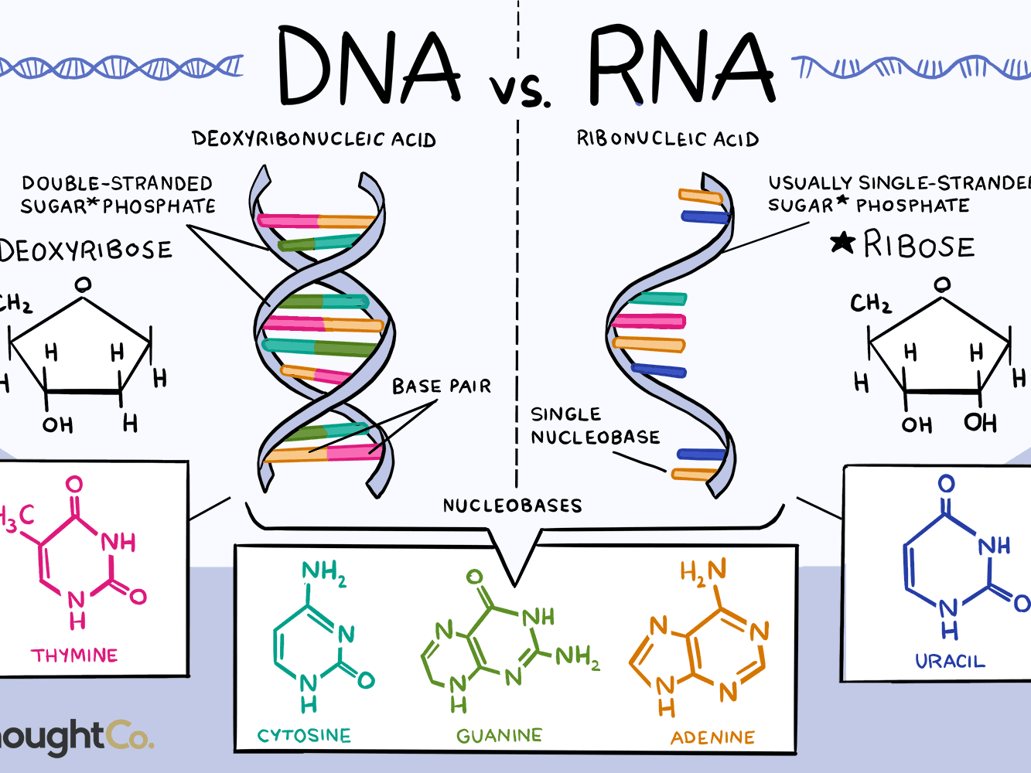

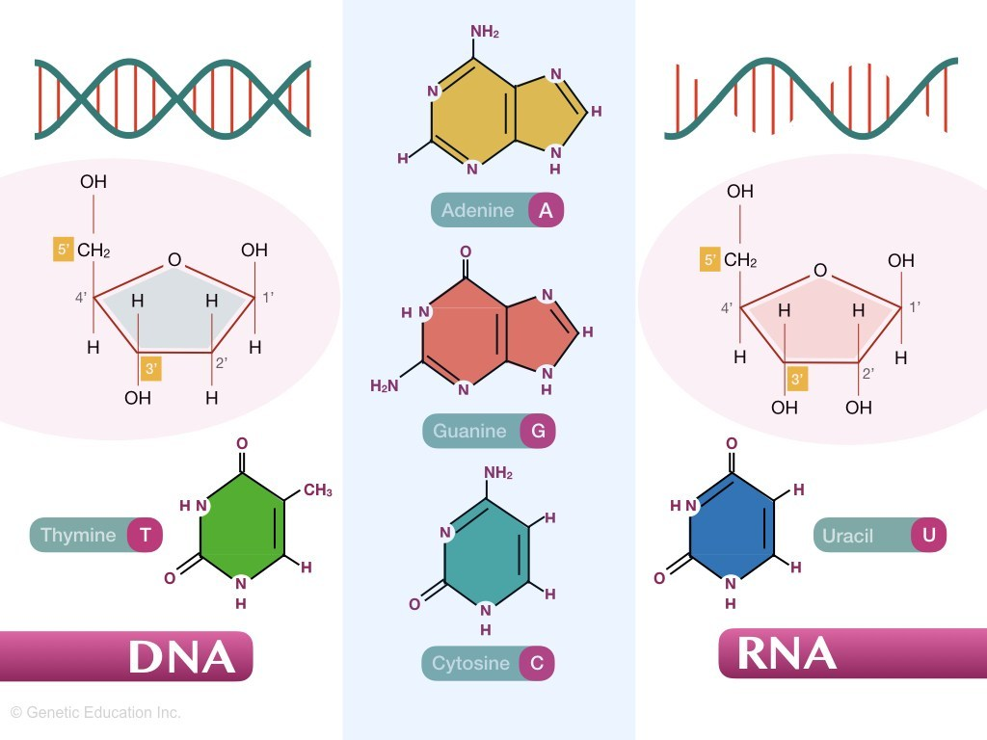

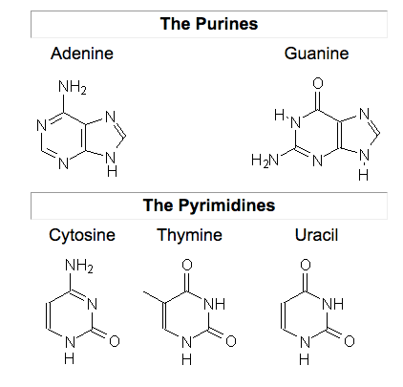

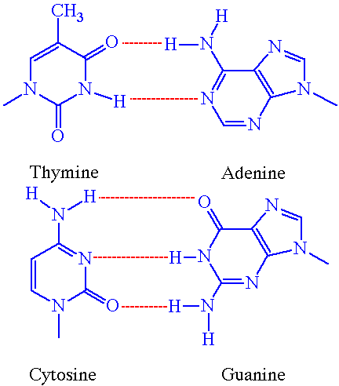

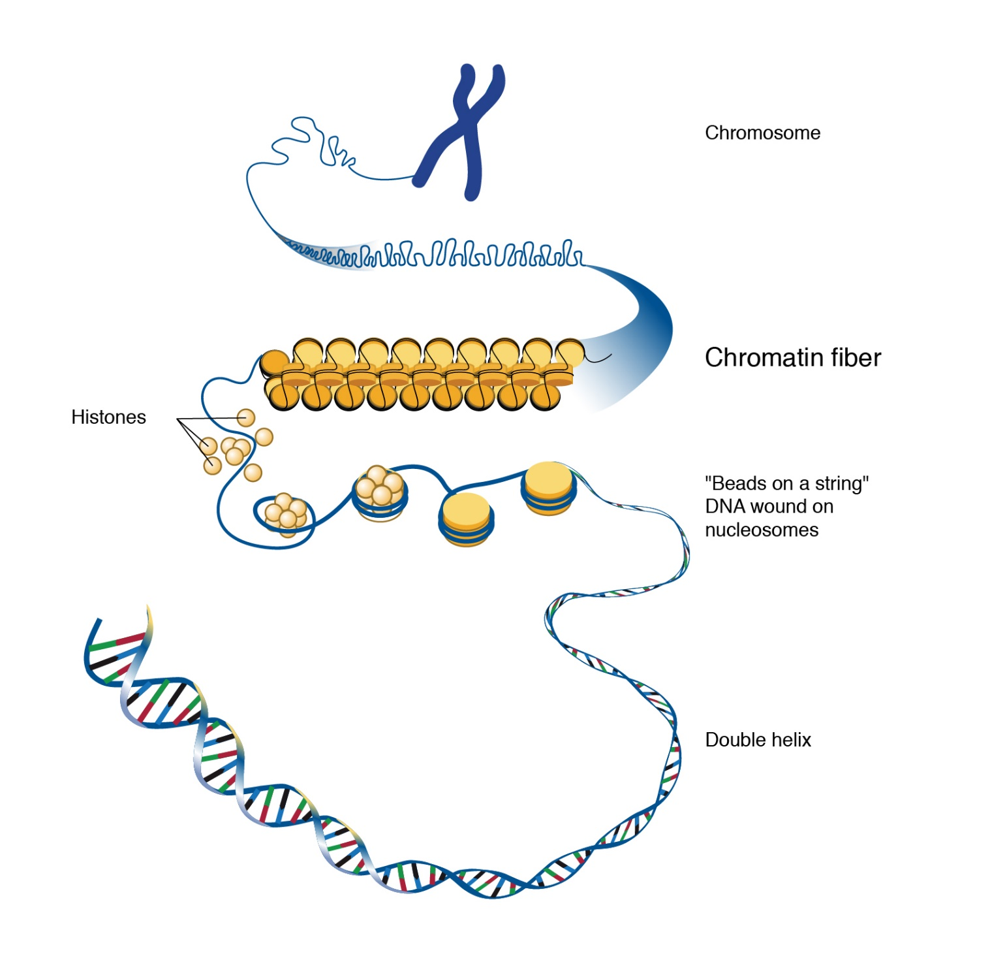

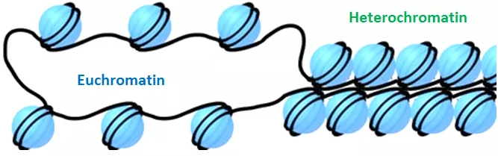

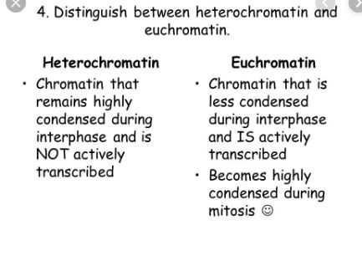

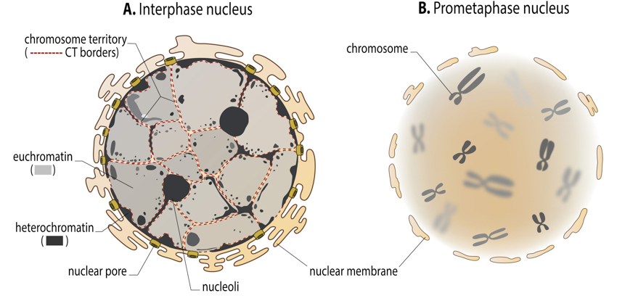

**DNA polymerase** is an enzyme that synthesizes **DNA** molecules from nucleoside triphosphates, the molecular precursors of **DNA**. These enzymes are essential for **DNA** replication and usually work in groups to create two identical **DNA** duplexes from a single original **DNA** duplex.

**RNA polymerase**, is an enzyme that synthesizes **RNA** from a DNA template. RNAP locally opens the double-stranded DNA so that one strand of the exposed nucleotides can be used as a template for the synthesis of **RNA**, a process called transcription.

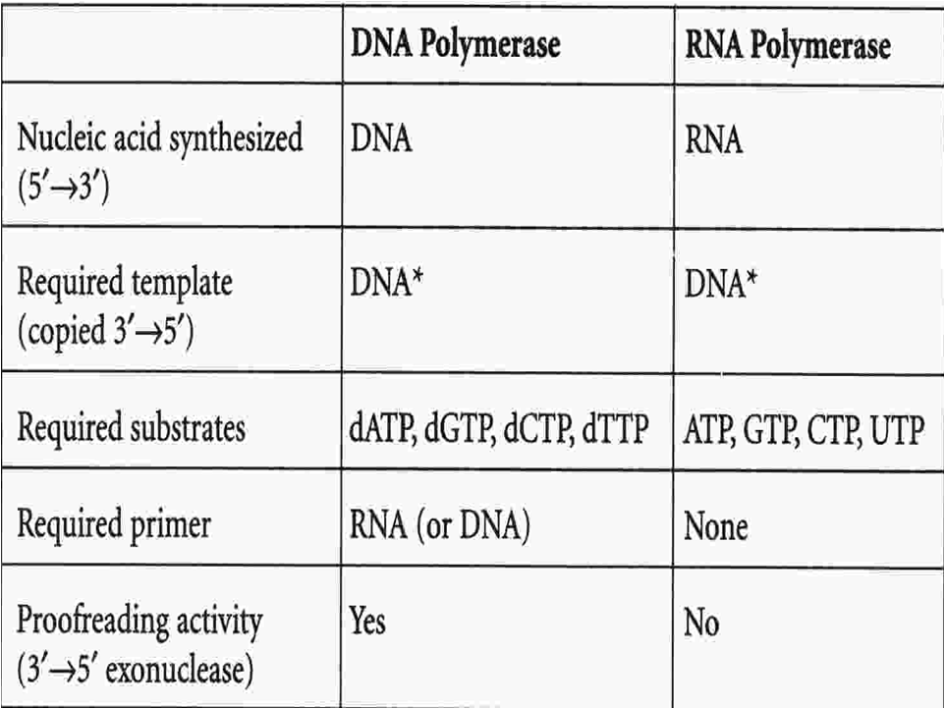

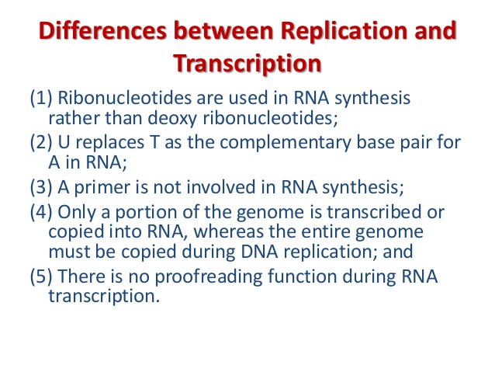

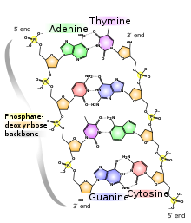

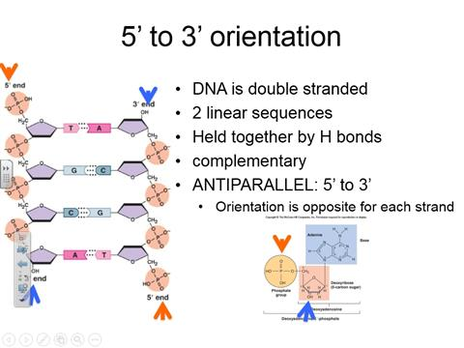

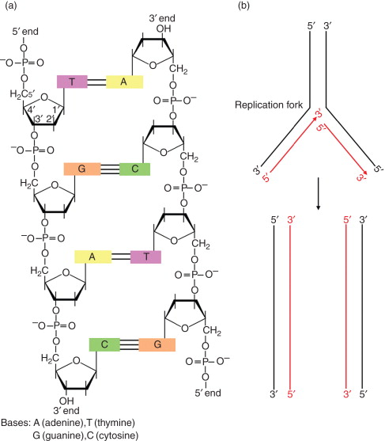

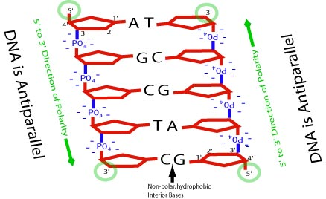

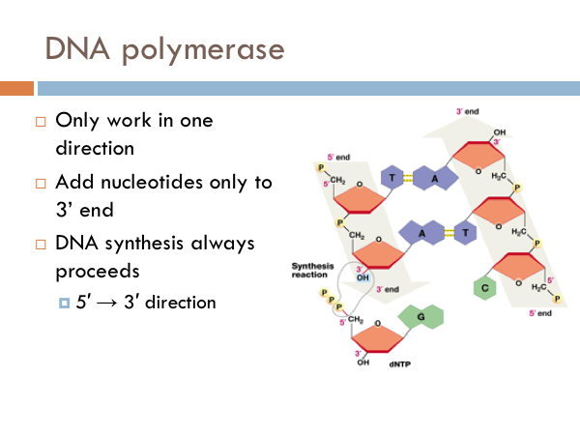

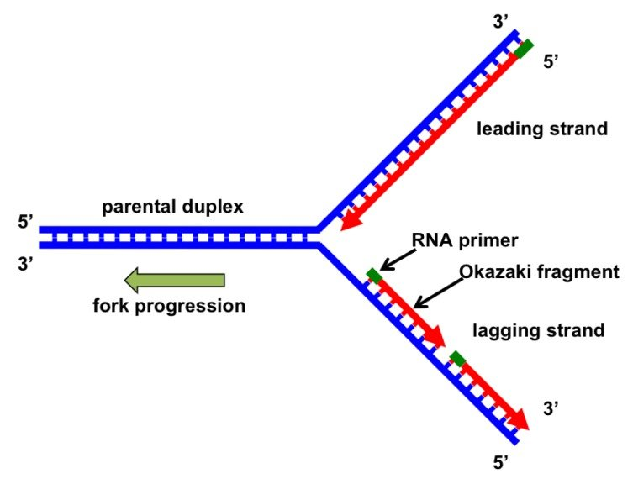

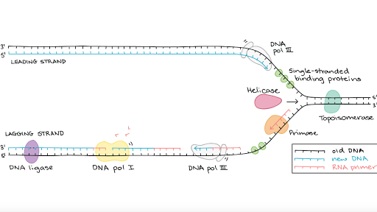

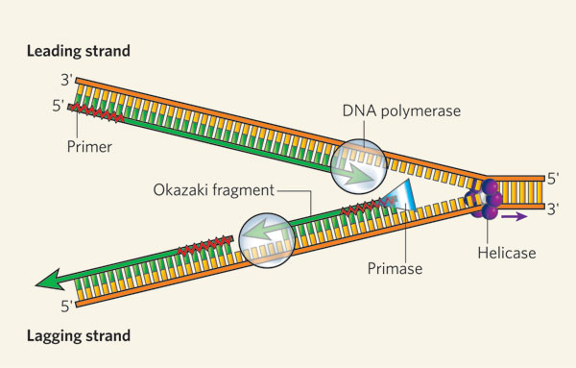

**RNA splicing**, in molecular biology, is a form of **RNA** processing in which a newly made precursor messenger **RNA** (pre-mRNA) transcript is transformed into a mature messenger **RNA** (mRNA). During **splicing**, introns (Non-coding regions) are removed and exons (Coding Regions) are joined together.

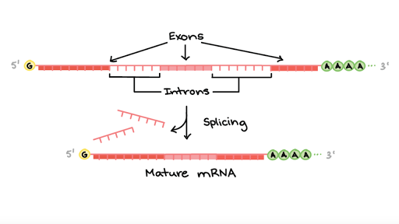

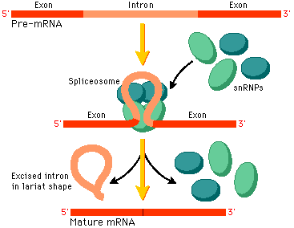

We are not responsible for learning the ‘snRNPs’ and the ‘spliceosome’.

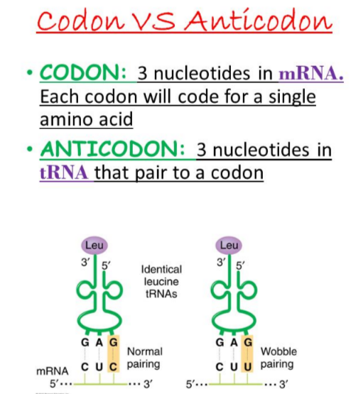

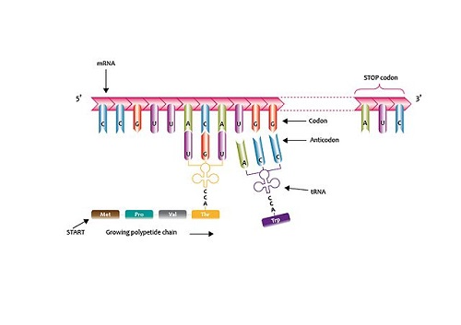

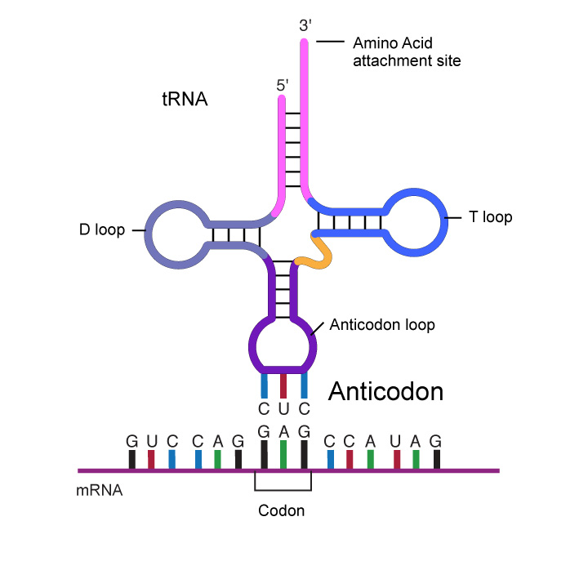

<https://www.youtube.com/watch?v=5f8yuvlmSyo>

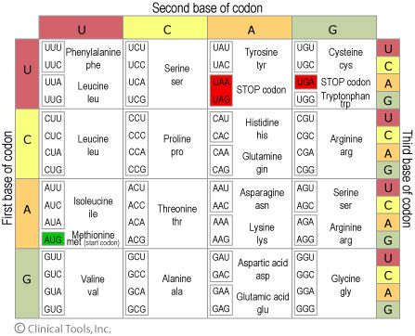

Now time for you to do some research on your own. Look up the answers to these questions and perform the following tasks.

-Using the codon table above, write down the amino acid sequence of this strand of RNA:

…..GUUGAUAAUACUAUUCGUUCUUUUUGA.

-What are restriction enzymes (also called restriction endonucleases)?

-Where do the originally come from naturally? (ie. Don’t answer they come from a biotech company.)

-What do they do in their natural state? What is their purpose in their natural state?

-How are they used by molecular biologists?

-Which restriction endonuclease cleaves this sequence (below)? What kind of cut is made? What organism naturally contains this restriction enzyme?

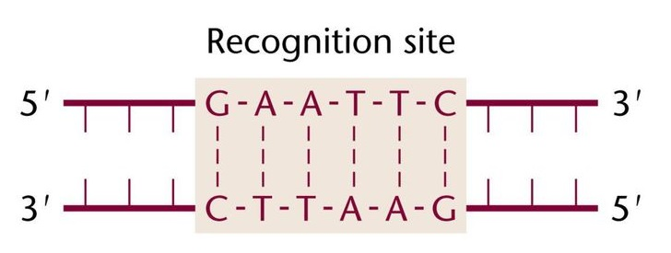

Time for PCR! Look it up on the interwebs. Nice site right here:

<https://www.khanacademy.org/science/biology/biotech-dna-technology/dna-sequencing-pcr-electrophoresis/a/polymerase-chain-reaction-pcr>

and watch the videos on the class website.

-What does PCR stand for?

-Why is it so useful/powerful?

-Grab a couple of full-size sheets of paper and draw it out for 3 cycles.

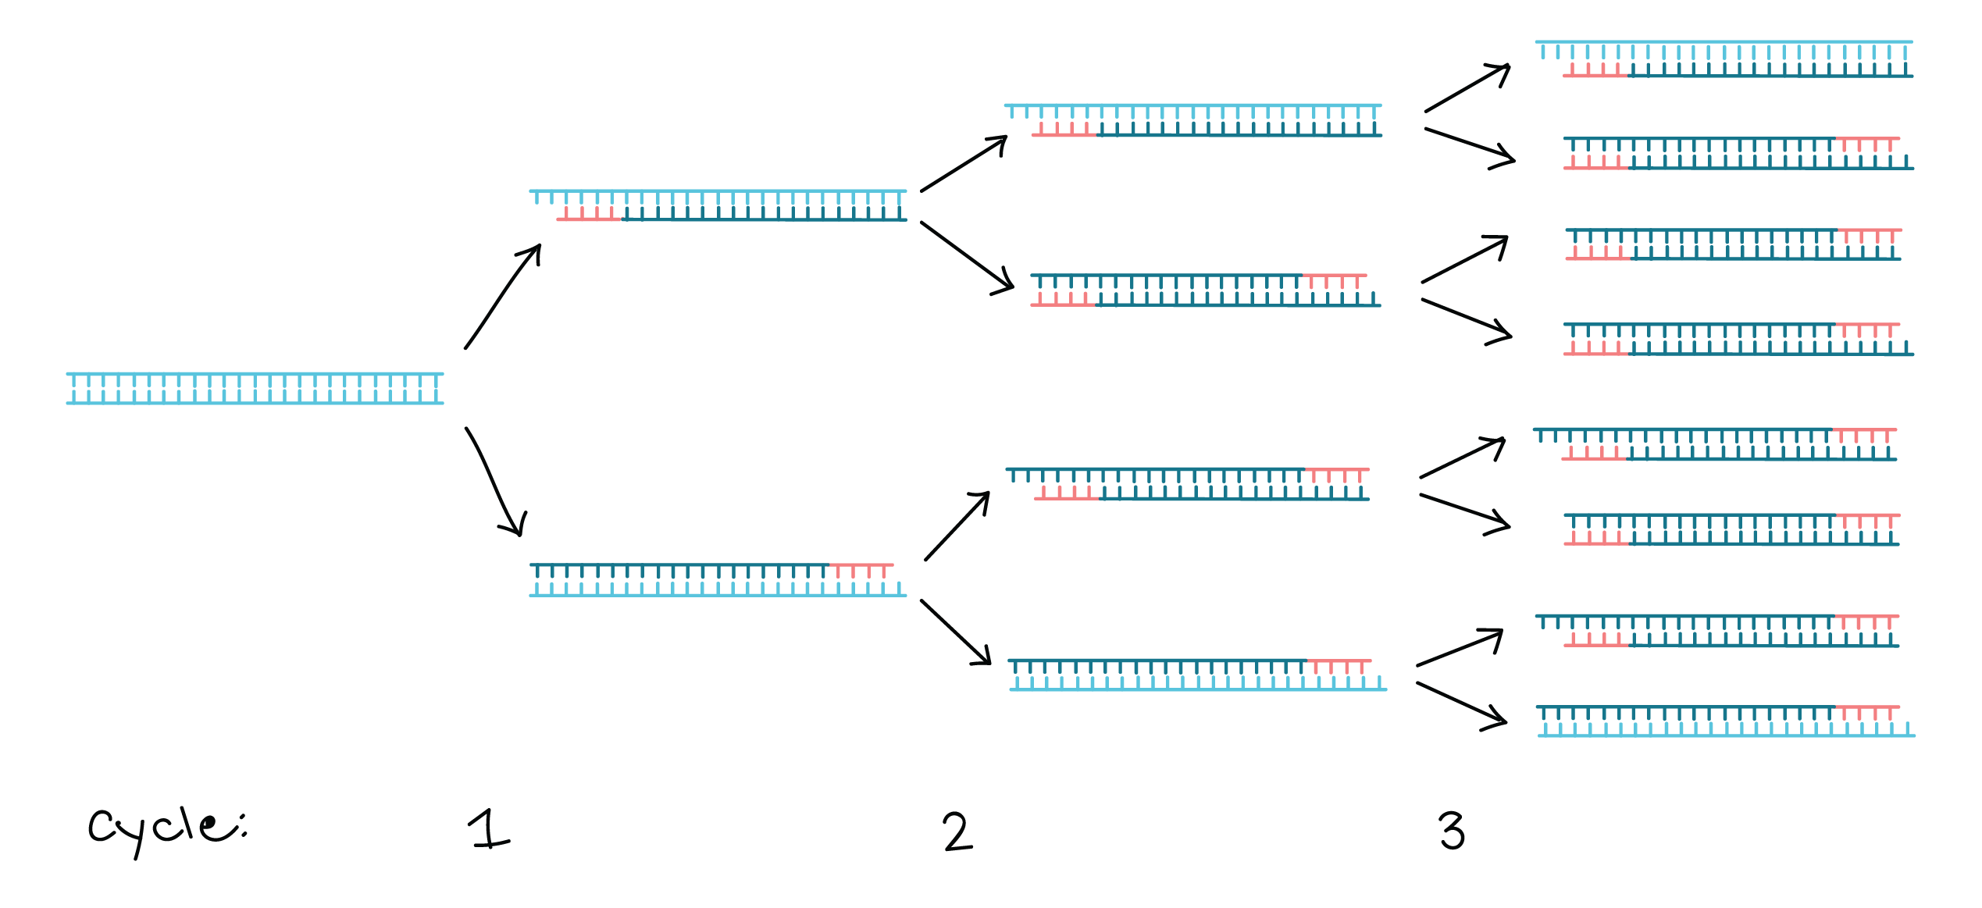

Then circle the complete double stranded fragments of the exact length you are trying to amplify.

-Explain what a tumor suppressor gene is.

-Explain what an oncogene and what a proto-oncogene is.

Done.