Welcome to Human Physiology.

You’ve successfully completed Ana-1. You have a working knowledge of human anatomy which is required to learn human physiology. If you did not learn enough human anatomy in your Anatomy class, you will struggle very much in this class. You are also required to take the chemistry pre-requisite in order to enroll in this class and for good reason. That brings me to the point of my introduction to this course. To understand how the body works, you will need to learn about how the organs and organ systems work. How does an organ, any organ, in the body work? Well, it is the cells of that organ that do the work. What do the cells of an organ do? They carry out reactions and move molecules around. They carry out biochemical reactions and transport molecules. Molecules made up of atoms. All of physiology is based on the interactions of atoms and molecules……BIOCHEMISTRY!

Lots of biochemistry in this class. Wonderful biochemistry because to understand the biochemistry of your cells is to understand truly how your body works. Only then can you try to fix it when it is broken or diseased. I am sorry I will not be having you in my classroom, to be able to talk and rant to you in person about the ‘molecules and their structures and their interactions’. That brings me to my second major point. Taking a class like this ALL ONLINE will require you to work that much harder. And to combine that with this being a short Summer session, boy-oh-boy, you’re in for a very demanding time academically.

Introduction to physiology:

<https://www.youtube.com/watch?v=6qk_LTVXZ2w>

Worth watching but we will not be tested on it:

<https://www.youtube.com/watch?v=RHW-KDDKypo>

Since physiology is a lot of biochemistry, let’s talk about biomolecules or just plain molecules that you find in your body. Wait, we can even begin with something even more basic and that would be to begin with atoms since atoms make up our molecules. If we begin with atoms, and you all are very familiar with atoms since you learned all about them in your chemistry pre-requisite class, I can just give a basic review here. Just reviewing the parts of chemistry that are relevant to us in physiology. When talking about atoms, one needs to introduce the Periodic Table.

<https://www.youtube.com/watch?v=0RRVV4Diomg>

Protons, Neutrons, Electrons:

<https://www.youtube.com/watch?v=e9GuJUaX0UM>

The electron configurations:

<https://www.youtube.com/watch?v=tc9tEUqUmKw>

Atomic Structure:

<https://www.youtube.com/watch?v=EMDrb2LqL7E>

Brief History (worth watching, no test questions from these 2 videos):  
<https://www.youtube.com/watch?v=kBgIMRV895w>

<https://www.youtube.com/watch?v=thnDxFdkzZs>

Atomic Structure meets the Periodic Table:

<https://www.youtube.com/watch?v=3_FJIpKgdV4>

Now let’s focus on four important atoms: Hydrogen, Oxygen, Nitrogen and Carbon.

See where they are in the periodic table:

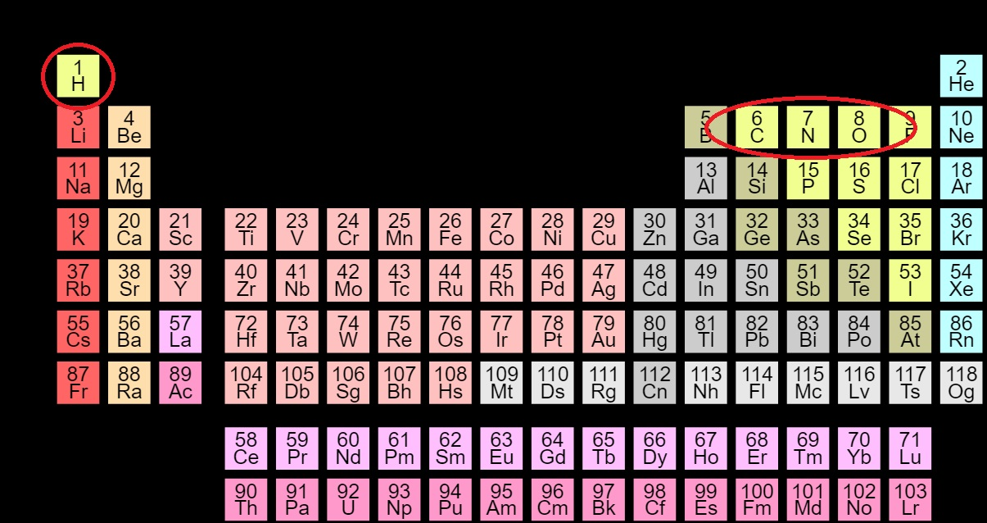

Look at Carbon:

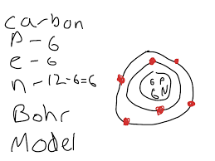 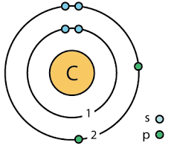

Remember that the second orbital can hold 8 electrons. I’ll call those ‘holes’ where an electron could go. Carbon has 8 holes in its second orbital (Carbon would have 2 holes in its first orbital). So Carbon being Carbon has how many total electrons? Well, because it is Carbon it has 6 electrons and where do those 6 electrons go? Well, 2 into the first orbital and 4 into the second orbital. But in its second orbital it has room for 8 electrons. So in its second orbital it has 8 holes but only 4 electrons to fill those holes. It can share an electron with 4 other possible atoms in order to fill those 4 holes and make it stable. Take Hydrogen. It is atomic number 1, so it has 1 proton in its nucleus and 1 electron circling that nucleus. Its first orbital has room for 2 electrons but it only has 1 electron. Hydrogen has one hole in its first orbital. It can share its electron with a hole in carbon’s second orbital and an electron from carbon’s second orbital can share (fill) the hole hydrogen has so that now hydrogen is stable, all of its two holes are filled and we’ve added one hydrogen atom to carbon. We can repeat that now three more times to have four hydrogens filling the four holes that carbon has in its second orbital. These shared electrons are called ‘covalent bonds’.

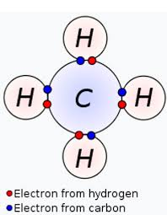

With everyone’s orbitals filled, it is in a stable configuration exists as CH4.

What about nitrogen? Atomic number 7. So 7 protons and 7 electrons. Where are the 7 electrons? The first 2 fill the first orbital, that leaves 5 in the second orbital. The second orbital has room for 8 electrons, so there are 3 holes. Nitrogen can fill those 3 holes by sharing electrons and holes with 3 hydrogens making NH3, or ammonia.

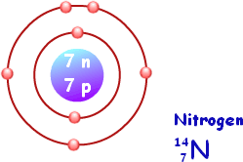

Covalent bonds for the big-4:

<https://www.youtube.com/watch?v=G9K6PMGt4LM>

Sorry you have to watch this video but it amuses me to no end, it cracks me up so learn from it please:

<https://www.youtube.com/watch?v=LkAykOv1foc>

In summary, carbon can make 4 covalent bonds; nitrogen can make 3 covalent bonds, oxygen can make 2 covalent bonds and hydrogen can make one covalent bond.

Speaking of atoms, write out the answer to this question: ‘What is an isotope?’ AND ‘List a famous isotope found in humans.’

‘What is deuterium?’ ‘What is tritium?’

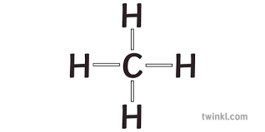 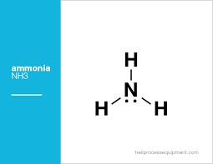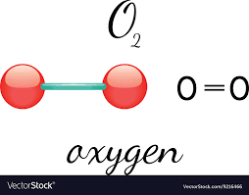

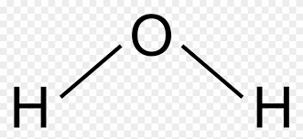 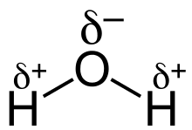

[Notice that in the water molecule on the right it is shown with the oxygen having small negative charge while the two hydrogens having small positive charges. Water is a polar molecule.]

Or in other words, when looking at diagrams of molecular structures, “C” will always have 4 lines associated with it; “N” will have 3 lines going to it; “O” will have 2 lines coming and going from it; and “H” will always have one line with it.

Following these rules for the formation of numbers of covalent bonds for atoms, you can connect any of these molecules together as long as you obey the rules (C=4; N=3; O=2; H=1).

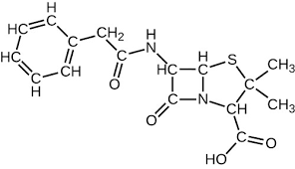 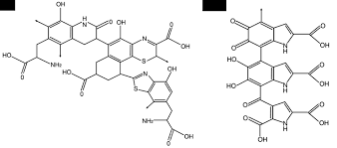

You’ll notice that “C” can use 2 of its 4 covalent bonds to make a double bond and that you don’t always have to write out the “C” when showing carbons.

Here’s a question. Research the answer, type it out and turn it in to me. The question is: ‘how many covalent bonds does sulfur usually form?’ Hint, you will find the answer in the answer to the next question: ‘What is the difference between cysteine and cystine?’

Of all the possible molecules there are, or could be, for us to learn, all we’re going to be concerned with learning are the molecules, large and small, that one finds in the human body. That’s good. So where do we start? We’ll first have to divide all of the molecules we find in our bodies into different structural (and functional) groups. The biochemists have already done that for us. These four groups of molecules are the:

Sugars (carbohydrates) Proteins (polypeptides) Fats/Lipids (triglycerides) Nucleic Acids (DNA/RNA)

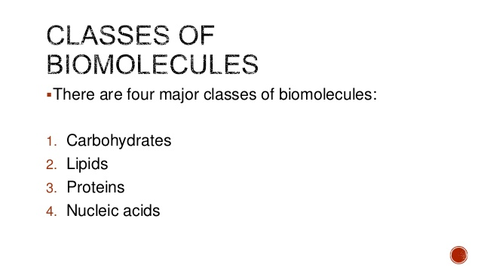

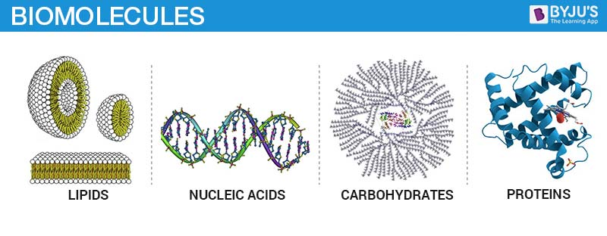

4 types of Biomolecules:

<https://www.youtube.com/watch?v=YO244P1e9QM>

<https://www.youtube.com/watch?v=H8WJ2KENlK0>

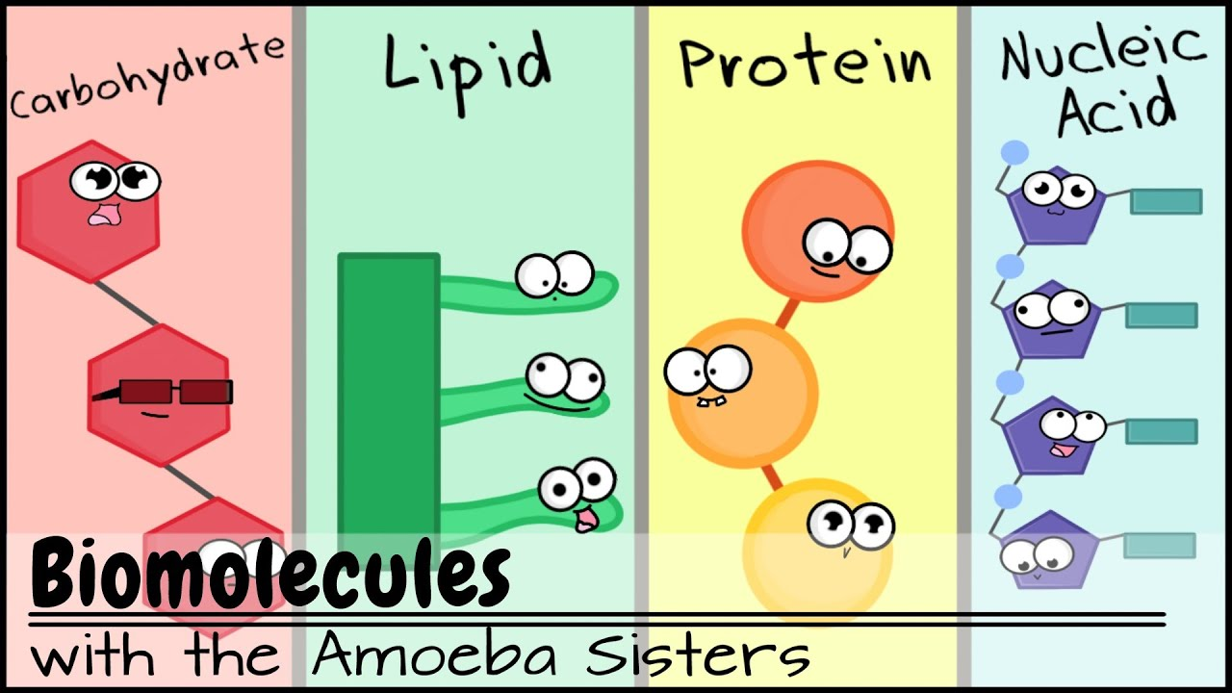

You may well be overwhelmed by these videos so you’ll want to go back and watch them once we’ve discussed all of this.

Lots of references to sugar (glucose) providing us with ‘energy’. Well you remember the ‘energy’ in the body comes from ATP, and ATP is made in the mitochondria. We will fortunately learn exactly how the mitochondria make ATP from glucose after the first exam. So for now, we’ll go with this standard diagram:

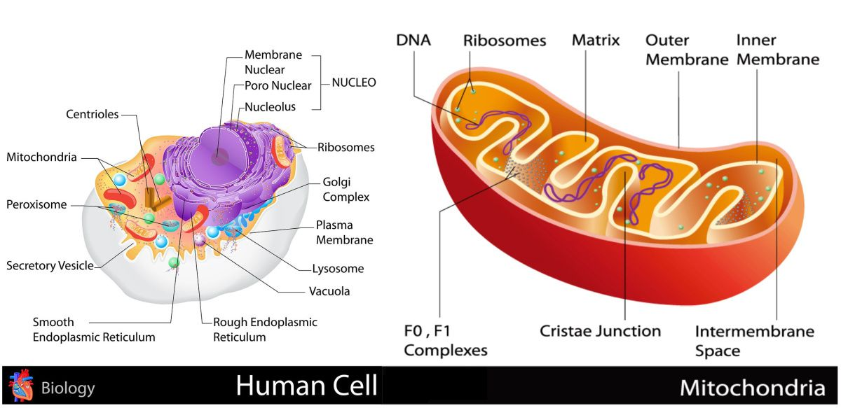

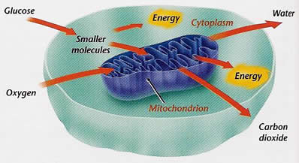

Of course, the word ‘energy’ above really means ATP, as shown below.

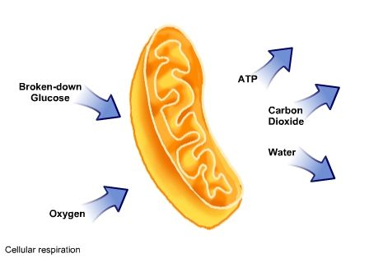

So glucose is important. We need to memorize its structure.

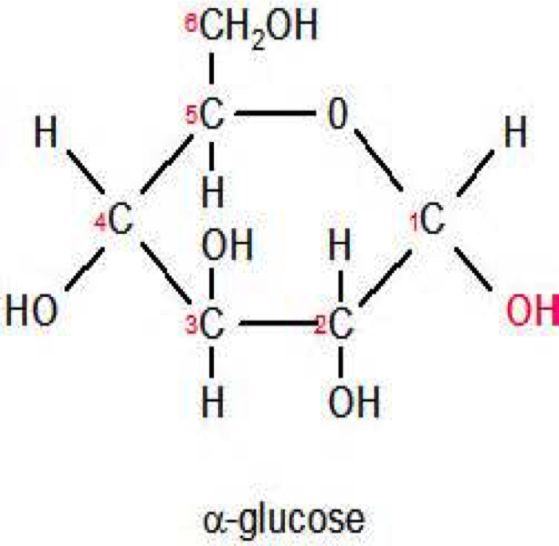 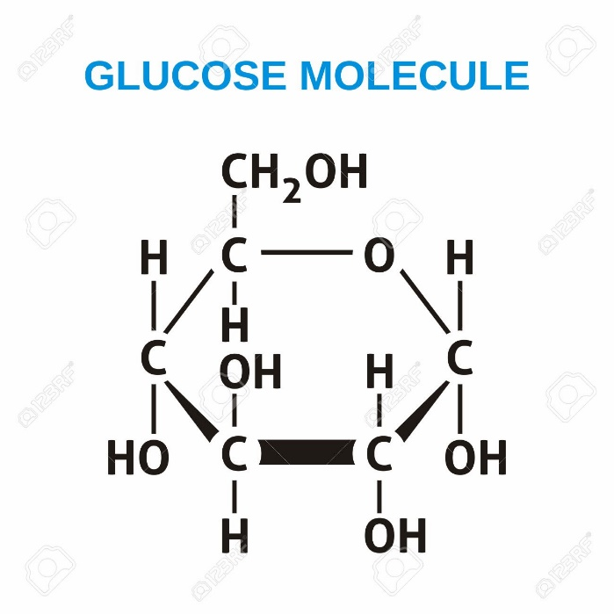

Notice that each of the 6 carbons is numbered: 1…2…3…4…5…6, starting on the left and moving clockwise. Poor carbon #6 is outside of the loop. ☹

This ring structure, cyclic structure, of glucose is the way it will always appear in your cells, in your body. There is a straight, linear form but that will never happen biologically in us. Draw the glucose shown above. You will be required to draw it. You must know how to draw it. There is symmetry. Each carbon has an -H and -OH attached to it (well, sort of, not carbon #5). The first two -OH’s off carbons 1 and 2 both points down, then the -OH off of carbon 3 points up, then back to carbon 4 having its -OH pointing down. Don’t forget the -H on carbon 5 (I always do) and carbon 6 has the -H and -OH groups attached but since carbon 6 is a carbon it must have 4 covalent bonds so make the 4th covalent bond just a simple -H. Carbon 6 has the -H and the -OH and an additional -H which can be shortened to what you see written: carbon 6 + H2OH.

I used to say that glucose was the KING of all sugars, but that is a very sexist thing to say now-a-days, although I did not create the idea of Kings and how they oversaw everything in their kingdoms which made them very influential and powerful and important so to say the important and influential and powerful molecule glucose is like a King is really just a reference to a bygone era and not actually a sexist remark at all.

Let me get this out early in our class. What defines ‘Life’ is molecules and cells doing ‘stuff’ (reacting). If the molecules or cells are not having reactions happen, they are essentially dead, non-living. And where does the energy to make all these reactions come from? In what form does the energy to allow all of life in the universe to exist come in? In the form of ATP. And those ATPs are made in the mitochondria and require GLUCOSE (the King of all sugars, or some might even say, the King of all molecules).

Your body will never willingly get rid of any glucose once it is eaten. You will never find a single glucose in your feces or urine (unless there is something wrong with you physiologically, like being a diabetic). So what happens to the glucose that you eat? You store it for later use by linking the glucoses together to make glycogen. Or that excess sugar can be converted into fat (glucose into triglyceride). Why convert glucose into triglyceride? Well, we’ll eventually learn that your body can turn triglyceride into ATP also. So fat (triglyceride) is a storage form of energy.

The plants take individual glucoses and link them together. One glucose plus one glucose would make a disaccharide (each single glucose being a monosaccharide). If another glucose is added to a disaccharide then you have obviously a trisaccharide. After that you would not necessarily have a ‘quadrasaccharide’ (that’s not a real word) but they would be called polysaccharides. Polysaccharides are long chains of glucoses made by the plants. Also called complex carbohydrates.

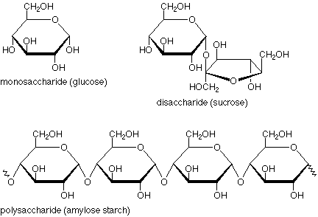

Remember glucose has the ‘-OH’s on carbons 1, 2, 3 and 4 = down, down, up, down.

This is as good a time as any to mention that although GLUCOSE is the King of all sugars, there are other 6-carbon sugars we need to introduce ourselves to. They are fructose and galactose. And by the way, did you remember that in the book they use this formula to define a sugar: CnH2nOn, where n=integer. So for example, glucose with 6 carbons would be: C6H12O6 replacing the ‘n’ in the formula with the number ‘6’. A famous 5-carbon sugar, ribose, would then be C5H10O5. Below are the three famous disaccharides: maltose (two glucoses); lactose (glucose + galactose); and sucrose (glucose + fructose).

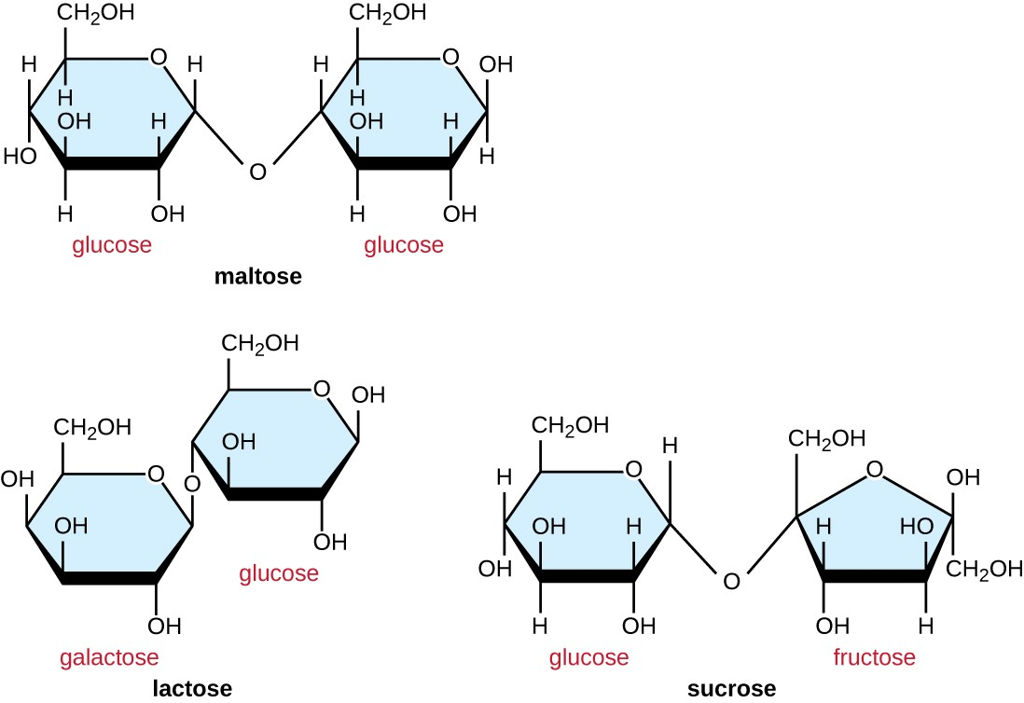

Yes? You have your hand up? You have a question? Ah, a good question. Let me repeat it for the entire class to hear. You asked how are galactose and fructose different from glucose if they both have 6 carbons and also follow the CnH2nOn rule? For galactose, look closely at the ‘up’ and ‘down’ of the attached -OH’s compared to the ‘down, down, up, down’ pattern of the -OH’s in glucose.

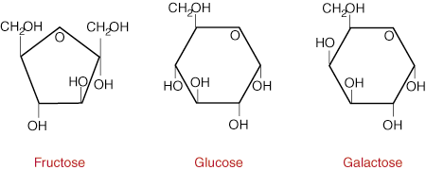

For galactose, the up/down pattern of the -OHs on carbons 1, 2, 3 and 4 is different than the pattern for glucose. For glucose remember, for carbons 1, 2, 3 and 4 the attached -OHs was down, down, up, down. For galactose for carbons 1 – 4 the pattern of the attached -OHs is down, down, up, up. Now for fructose, notice that if you start with glucose and move the carbon 5 attachment via “O” instead of going to carbon 1, this link goes to carbon 2. See the fructose diagram below. In red all I have done is move the existing link from carbon 5 to carbon 2. Fructose is just glucose but instead the link from carbon 5 is now to carbon 2, leaving carbon 1 out of the loop. That’s it. But to make the structure look more symmetrical, ALL of the textbooks will draw fructose the way you see it above and below.

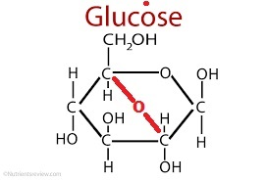 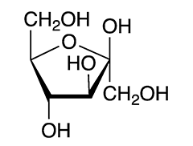

Above: glucose converted into fructose Above: fructose, notice carbons 1 and 6 are outside of the ring.

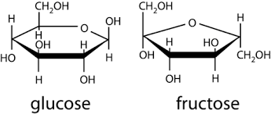

How to link glucoses or fructoses or galactoses together to make polysaccharides? Let’s take a look. Its easy. Notice the by product is harmless water, H2O. You remove an -OH group from carbon 4 on one glucose and remove an -H from the -OH on carbon 1 of the neighboring glucose, combine that into harmless water and the two broken bonds on the two glucoses will join in order to make them stable again (to fill empty holes).

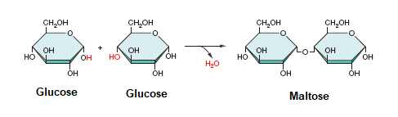

<https://www.youtube.com/watch?v=FEAXI5XeJ4M>

These strings of glucoses made by the plants, or by us to store glucose for later use, can be linear or branched.

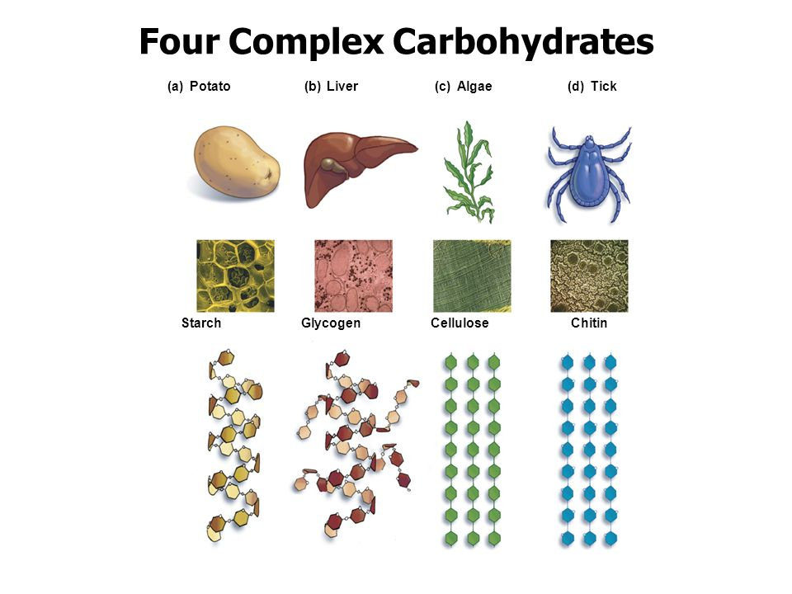

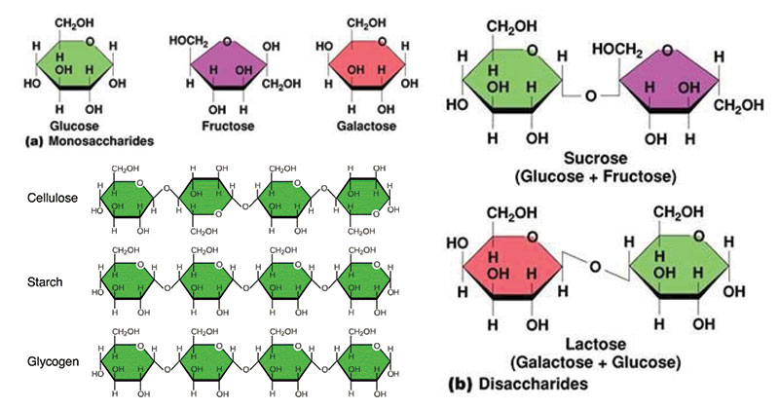

We cannot digest cellulose because we do not have enzymes to digest beta glycosidic linkages in Cellulose.

So ‘how can we humans break the beta glycosidic linkages in lactose?’

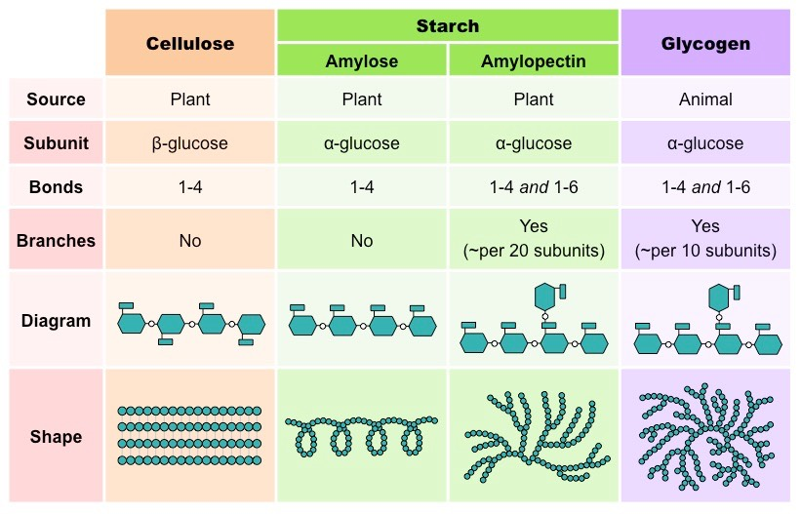

Above, you eat the starch. The only difference between amylose and amylopectin is that amylose is a straight line of connected glucoses (that may wrap in circles as seen above) and amylopectin is branched glucoses.

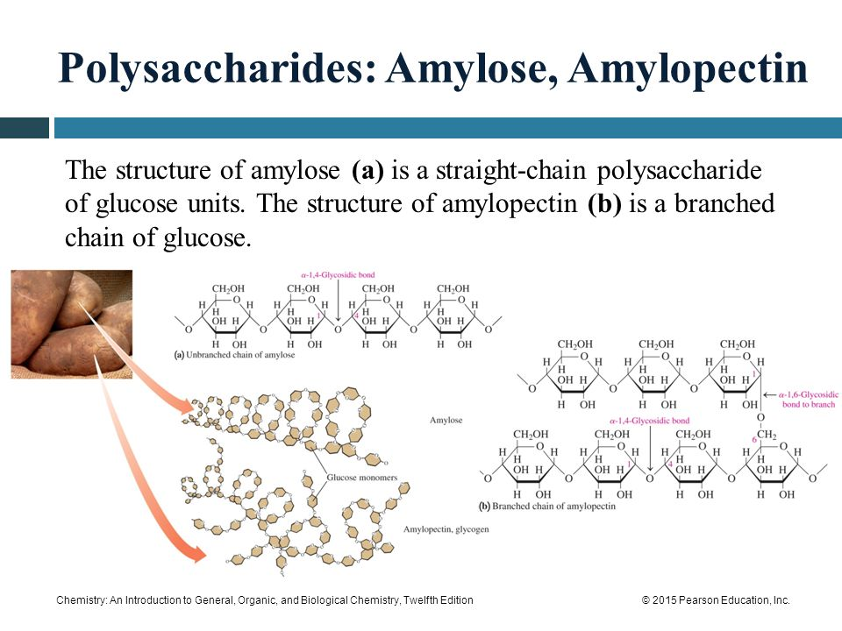

Cellulose: [Cellulose is the main substance found in plant cell walls and helps the plant to remain stiff and strong. Humans cannot digest cellulose, but it is important in the diet as a source of fiber. Cellulose is a [polysaccharide](https://en.wikipedia.org/wiki/Polysaccharide) consisting of a linear chain of several hundred to many thousands of [β(1→4) linked](https://en.wikipedia.org/wiki/Glycosidic_bond) [D-glucose](https://en.wikipedia.org/wiki/Glucose) units. Cellulose is an important structural component of the primary [cell wall](https://en.wikipedia.org/wiki/Cell_wall) of [green plants](https://en.wikipedia.org/wiki/Green_plants). Cellulose is the most abundant [organic polymer](https://en.wikipedia.org/wiki/Biopolymer) on Earth. The cellulose content of [cotton](https://en.wikipedia.org/wiki/Cotton) fiber is 90%, that of [wood](https://en.wikipedia.org/wiki/Wood) is 40–50%. Cellulose is mainly used to produce [paperboard](https://en.wikipedia.org/wiki/Paperboard) and [paper](https://en.wikipedia.org/wiki/Paper). Some animals, particularly [ruminants](https://en.wikipedia.org/wiki/Ruminant) and [termites](https://en.wikipedia.org/wiki/Termite), can [digest](https://en.wikipedia.org/wiki/Digestion) cellulose with the help of [symbiotic](https://en.wikipedia.org/wiki/Symbiosis) micro-organisms that live in their guts. In [human nutrition](https://en.wikipedia.org/wiki/Human_nutrition), cellulose is a non-digestible constituent of [insoluble](https://en.wikipedia.org/wiki/Insoluble) [dietary fiber](https://en.wikipedia.org/wiki/Dietary_fiber), acting as a [hydrophilic](https://en.wikipedia.org/wiki/Hydrophilic) [bulking agent](https://en.wikipedia.org/wiki/Bulking_agent) for [feces](https://en.wikipedia.org/wiki/Feces) and potentially aiding in [defecation](https://en.wikipedia.org/wiki/Defecation).]

The cellulose in the plant is the part that you cannot digest. So let’s ask, ‘why can’t you break apart cellulose (digest cellulose) when it is a chain of glucose monosaccharides?” Because the glucoses in cellulose are connected differently than how the glucoses are connected in starch (or glycogen). Take a look. In the diagram below labeled ‘maltose’ is two glucose monosaccharides side by side. They have been connected. The glucose on the right has had the -OH removed from its carbon 4 and the glucose on the left has had its -H removed from its carbon 1. What has been removed are the -OH and a -H which can combine to form……H2O, harmless water as a byproduct of this reaction and now the two glucose monosaccharides are connected in a 1, 4 – linkage (see why it is called a 1, 4 -linkage because it is between carbon 1 and carbon 4). These two glucoses are linked with the “O” still there because in order to make H2O as a byproduct, we needed to remove an -OH and a -H, leaving behind the “O” of the -OH. This reaction is called a ‘dehydration synthesis’. We removed water so ‘dehydration’. We synthesized a longer chain of glucose monosaccharides so ‘synthesis’.

In the lower part of the diagram below, you also see a 1, 4 – linkage between two 6 carbon sugars. These is still a “O” between them. But the direction of the bond goes up and down. This bond is squiggly. When the bonds both go down with the “O” between them, then it is considered an ‘alpha’ linkage. If the bond has one bond going up and the other going down (all squiggly), that is called a ‘beta’ linkage.

Starch has the alpha linkage. Cellulose has the beta linkage. I like to picture it all this way. If I have my left hand with the thumb pointed up in front of me. I pretend my hand is a glucose molecule with my thumb being carbon 6. If I had more left hands in line with the original one, I could link all these left hands together with a dehydration synthesis reaction and make a polysaccharide. Yes? Yes! These would all be alpha linkages. But now picture next to my original left hand another left hand but this left hand is upside down compared to the original left hand. An ‘upside right’ left hand next to an ’upside-down’ left hand. An ‘upside right’ glucose next to an ‘upside down’ glucose. They can still be attached to each other with a dehydration synthesis reaction at carbon 4 and carbon 1 but unlike starch with all the glucoses upside right all in a row and all connected, for cellulose they are upside right and upside down glucoses, glucoses with beta linkages. The digestive enzyme that has to fit onto this polysaccharide in order to digest it will only fit if all the hands/glucoses are all upside right, all in alpha linkages. The digestive enzymes you make in your body will not fit onto an upside right next to an upside down pair of glucoses, the beta linkage, and so if you do not possess any enzymes that can fit onto glucoses with beta linkages, you unfortunately cannot digest that. As you read in the above Wikipedia definition of cellulose, the only way any animal can digest glucoses with the beta linkages, cows for instance, is to have multiple stomachs and use the symbiotic bacteria in their gut to use their bacterial enzymes to digest it.

As an aside, and if we were in class together, you’d get a nice little rant about the myths of wheat grass. You’d get my cute little story about how flabbergasted I was once upon a time while in a Jamba Juice seeing the person in front of me getting wheat grass in his drink. Then seeing a whole, thick book with some goof-ball’s picture on the cover exclaiming all the health benefits of wheat grass. No way in the world can or does it improve immune function. No reproducible, scientific evidence to support such a claim. You can’t digest it, its grass. Sure it has some vitamins, but lots and lots of stuff have vitamins. It is ‘ruffage’ and so helps with keeping you regular but lettuce or any vegetable will do that. Come on now, its grass.

<https://www.youtube.com/watch?v=TYU-XS8dUMg>

Very informative, I dare you to not tap your foot, and I like the 1, 6 bonds the best:

<https://www.youtube.com/watch?v=TYU-XS8dUMg>

You do not need to worry about the ‘keto’ and ‘aldo’ parts, but you do need to know where all this vocabulary comes from (The D- configuration for example).

<https://www.youtube.com/watch?v=doe_zZDjU5c>

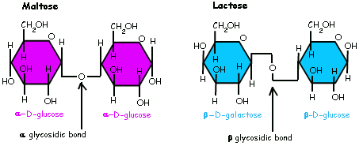

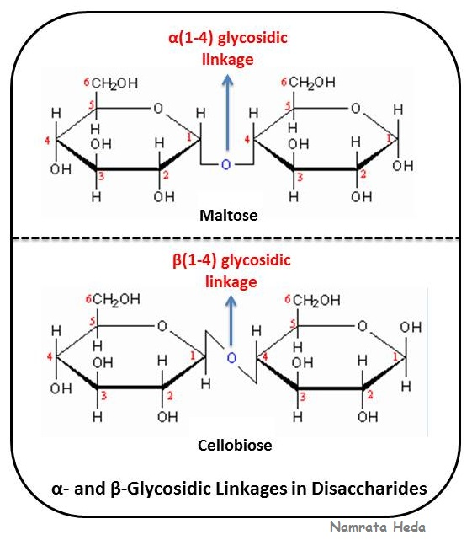

Alpha vs. beta linkage video below:

<https://www.youtube.com/watch?v=XwBE47fwPoM>

<https://www.youtube.com/watch?v=Ddjvp8wUTC8>

Hydrolysis and Dehydration Synthesis:

<https://www.youtube.com/watch?v=PYH63o10iTE>

So, plants make polysaccharides. We eat the polysaccharides (maybe a little too much). We then digest the polysaccharides. How? Where? How are they absorbed? You’d better review from your Ana-1 textbook ‘cause you’ll need to know. In detail.

In order to break apart the polysaccharide, digest it, we need to systematically break it apart into individual glucoses. A misconception is that digestion of foods is simply breaking the molecules apart into all their bits and pieces, letting individual carbons and hydrogens and oxygens come flying away. This is not how digestion in your gut works. An enzyme that fits over the alpha linkage will break apart the 1, 4 – linkage, liberating the glucoses.

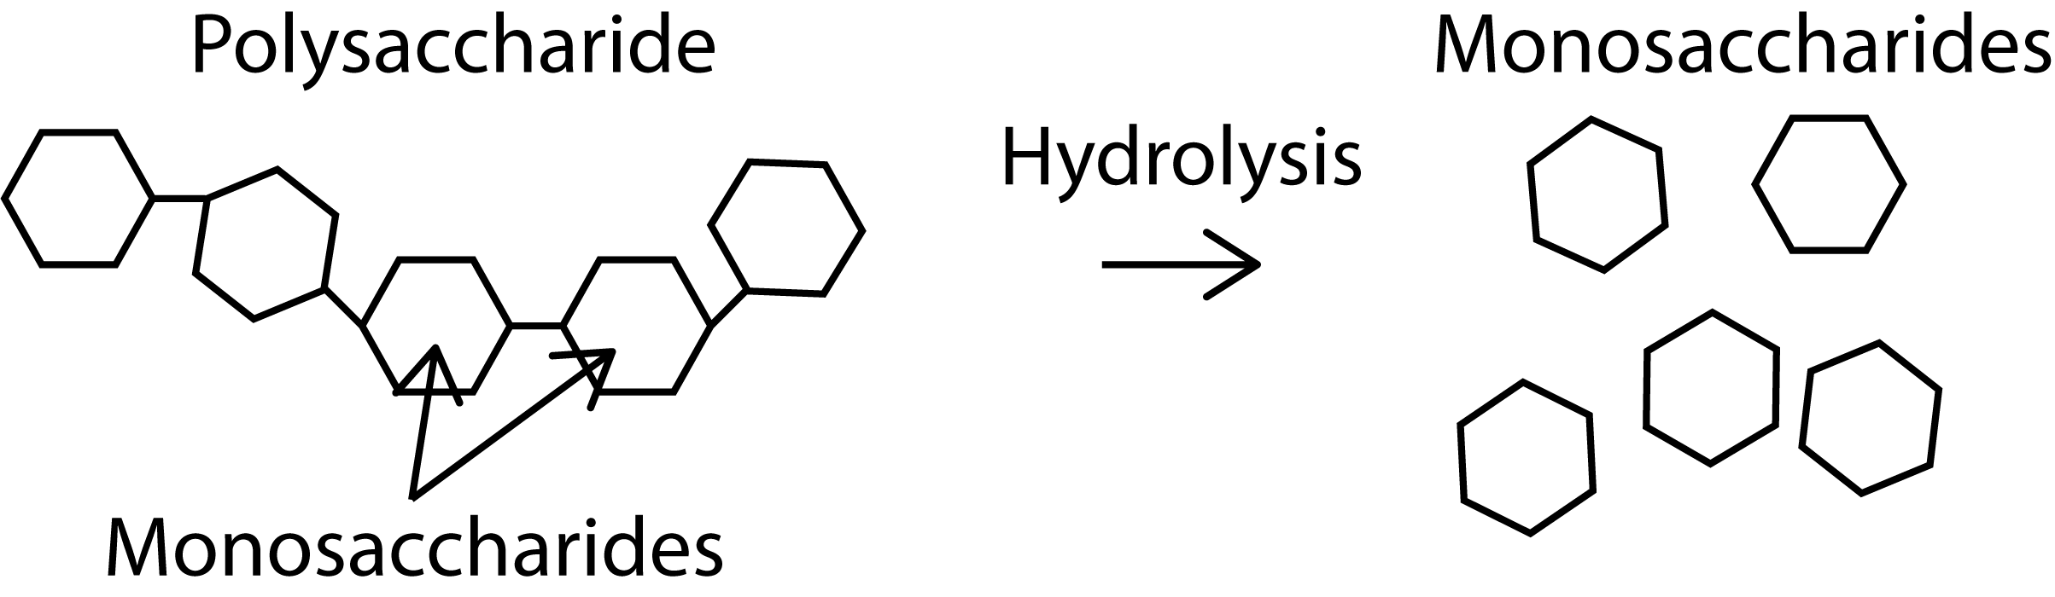

What has to happen is that the 1, 4 – linkage is broken (by a specific enzyme, using ATP energy) and a water molecule, H2O, is also broken into a -H and a -OH. As the diagram below shows, the free -H goes onto the “O” that is part of carbon 4 and the -OH goes onto the carbon 1. Those two broken bonds are sealed up with the -H and the -OH and now everything is balanced and stable and the bond is broken freeing the glucose.

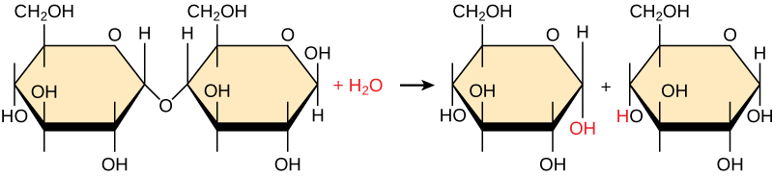

This reaction is called the ‘hydrolysis’ reaction. ‘hydro’ = water; ‘lysis’ = breaking…..breaking apart water in order to use the two fragments to plug the two broken bonds on the glucoses. It is the opposite of dehydration synthesis.

<https://www.youtube.com/watch?v=oIPE7OJIKV0>

<https://www.youtube.com/watch?v=SOQyiM6V3RQ>

Well that was good, clean fun. Let’s move on to our next group of molecules, the proteins. For that, you’ll need to click on the next lecture notes link. But before you go, check out the two diagrams below. They show our 4 major groups of molecules. In the first diagram it shows that proteins are made up of amino acids; that nucleic acids are made up of adenine (and other bases that we’ll learn); that fats (triglycerides) are made up from palmitic acid by the body; and that glucose is used to make disaccharides and complex carbohydrates.

In the very bottom diagram we see that (1)amino acids are used to make proteins (2)fatty acids (fats/triglycerides) can be combined with a short type of sugar called glycerol to make the very important and plentiful phospholipids (3)carbohydrates to make polysaccharides and (4)nucleobases (weirdest term yet for the 4 bases) to make first nucleotides and then DNA/RNA. Before we can advance on to learn about how the body works, the biochemistry of the body, we need to have a complete understanding of all of these molecules and their derivatives. Yep, a lot of memorization of molecules. All ‘Good Stuff’.

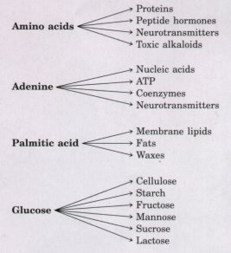

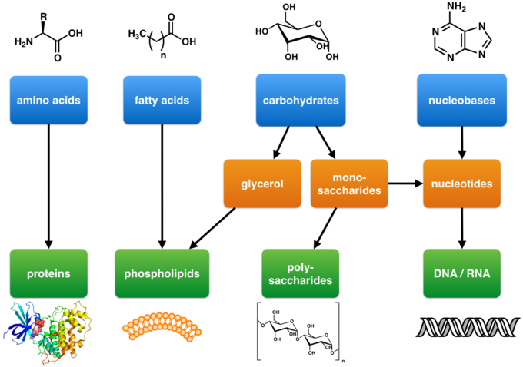

Now you’re walking along a beautiful beach with that certain someone. A lovely sunset. A lovely moment. You two come across a empty lobster shell. Your certain special someone leans down and picks it up. Examining it they tell you that the lobster must have molted this one since the lobster shell, its hard exoskeleton, cannot grow with the lobster and so the lobster sheds its small one and grows a newer, larger one. You chime in that the shell is made of chitin which is made up of glucose derivatives called N-acetylglucosamine which are modified glucose monosaccharides that simply have an amine group and an acetyl group added to it. And although it is made up of precious, useful glucose molecules it is useless to us for energy because of the bonding between these useful glucoses. Your certain someone special looks happy to know this. So, you continue by drawing the beta-linkage in the sand and explaining how you looked into it on your own after your physiology instructor introduced it in class. The beginning of a budding, lasting relationship indeed.