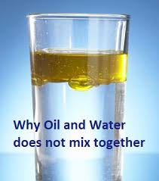 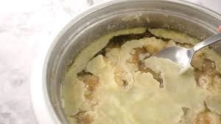

**FAT FLOATS.**

Come to think of it, **OIL FLOATS.**

Are they the same? Let’s do a google search: ‘is fat the same as oil’.

This is the first thing that comes up: ‘**Fats** and **oils** are totally different from each other. In simple terms, **fats** are animal **fats** whereas **oils** are vegetable **oils**. The other difference **is fats** tend to be solids at room temperature; on the other hand, **oils** tend to be liquid at room temperature’.

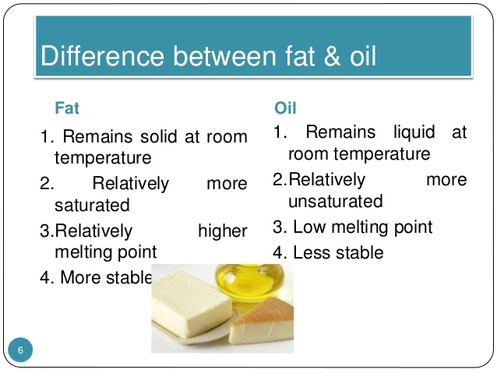

**“Liar, liar, pants on fire”**

Google is lying, again.

* Explain why fats and oils are referred to as triglycerides.
* Structures of Fats and Oils
* Fats and oils are called triglycerides because they are esters composed of three fatty acid units joined to *glycerol*:
* 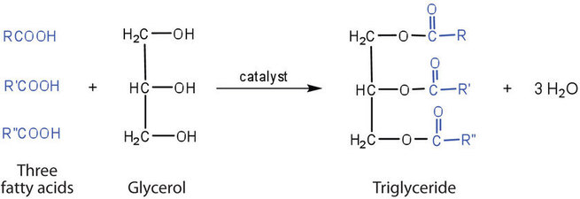
* If all three OH groups on the glycerol molecule are esterified with the same fatty acid, the resulting ester is called a *simple triglyceride*. Although simple triglycerides have been synthesized in the laboratory, they rarely occur in nature. Instead, a typical triglyceride obtained from naturally occurring fats and oils contains two or three different fatty acid components and is thus termed a *mixed triglyceride*.
* 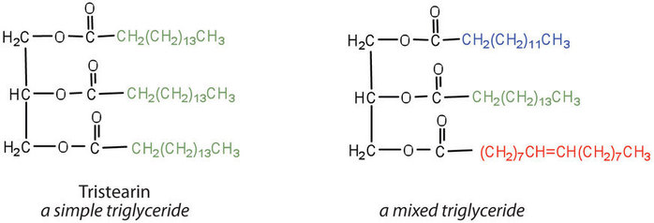
* A triglyceride is called a fat if it is a solid at 25°C; it is called an oil if it is a liquid at that temperature. These differences in melting points reflect differences in the degree of unsaturation and number of carbon atoms in the constituent fatty acids. Triglycerides obtained from animal sources are usually solids, while those of plant origin are generally oils. Therefore, we commonly speak of animal fats and vegetable oils.

So structurally both FATS and OILS are types of triglycerides. Why bring this up? Because we are about to talk about how your body ‘processes’ the FATS and OILS that you eat. How does your body digest and utilize the tasty fat and oil that you eat?

Since they are triglycerides, a lipase will cut them apart with three cuts, cutting a fatty acid carbon tail off resulting in a free fatty acid and the remining diglyceride. Then the lipase cuts off another fatty acid so now you have two free fatty acids and the remaining monoglyceride. And one last cut by the lipase to completely digest the triglyceride into three free fatty acids and the glycerol backbone. That happens in the digestive tube. Details for all of this I will leave for the textbook. We’ve got bigger fish to fry. Other things to focus on right now. Once digested into its four pieces, these are absorbed by the absorptive cells lining the small intestine. Once inside these absorptive cells the triglyceride is actually reassembled. Since you were wondering, they are reassembled in the SER.

Here come one of my many important points I’d like to make today. How does this reassembled triglyceride get from the small intestine absorptive cell to all the cells of the body? Yep, through the blood stream. After absorbing your ‘meal’ you distribute all the amino acids from your digested proteins and the monosaccharides from your digested complex carbohydrates and your triglycerides via the blood stream because we all remember all these absorbed molecules enter the blood vessels surrounding the intestines.

BACKGROUD INFO: Do remember the all important ‘Hepatic Portal’ system of vessels. There is a set of blood vessels that travel directly from the intestines (and stomach) straight to the liver.

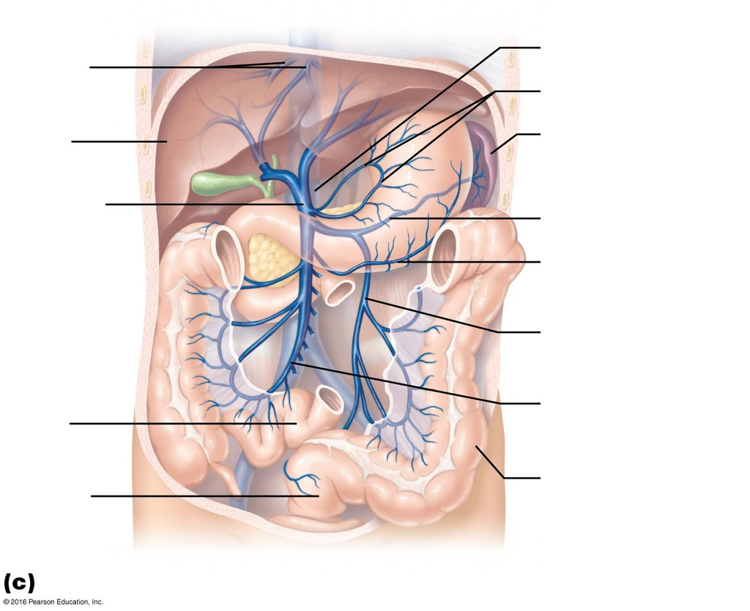

The above blue vessels represent the hepatic portal veins traveling from the digestive tube organs directly to the liver.

Everything that enters the body through the digestive system enters these vessels and travels straight to the liver so that the liver cells, the hepatocytes, can take a look at what ever those molecules are and process them. If there is glucose in those vessels and that glucose goes first straight to the liver the hepatocytes can store some of that glucose for later use and act to decrease the amount of glucose that continues out to the rest of the body. The liver ‘sees’ everything that comes in through the digestive tube first before it gets out to the rest of the body.

If you ingest a toxin, say you eat poisonous mushrooms, that toxin would travel first to the liver. The hepatocytes, heroically, will have enzymes to break that toxin so that it is no longer a toxin. The liver detoxifies this way. But it was a toxin when it arrived at the liver and so some liver cells will die. The liver is one of the few organs that can regenerate. So some surviving hepatocytes will go through mitosis and replace the dead ones.

As an aside, alcohol is toxic to human cells and so when you drink alcohol those toxic alcohol molecules travel through the hepatic portal veins straight to the liver cells, killing some of them. Those dead ones are replaced by scar tissue and new healthy hepatocytes. If you do this a lot, binging on alcohol, your liver will become an ugly mass of retracted scar tissue and little and big nodules of newly grown hepatocytes. This is called cirrhosis. Never pretty. Never healthy. Always preventable from alcohol.

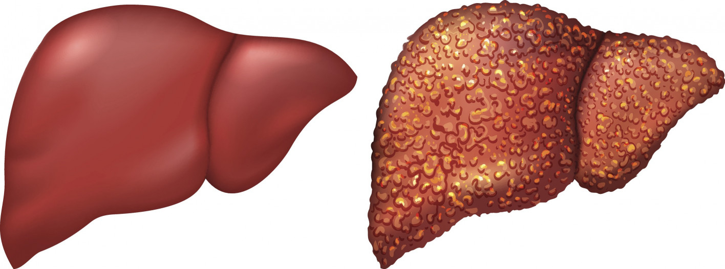

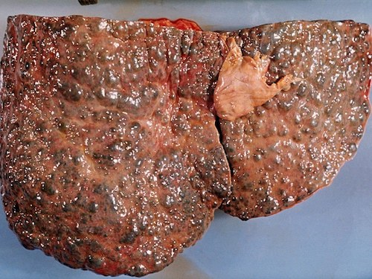

Sorry to be a ‘Debbie Downer’, but 5 (count ‘em 5) cancers related to alcohol use:

<https://www.cancer.gov/about-cancer/causes-prevention/risk/alcohol/alcohol-fact-sheet>

<https://www.cancer.org/cancer/cancer-causes/diet-physical-activity/alcohol-use-and-cancer.html>

<https://www.ncbi.nlm.nih.gov/pmc/articles/PMC3391950/>

But let me get back to my point, back to moving triglycerides from the absorptive cells of the small intestine to the cells of the body via the blood stream. If you digest the triglyceride with lipase, absorb the 4 components, reassemble them in the SER of the absorptive cell, then put them into the blood vessels surrounding the intestines that triglyceride molecule has entered the hepatic portal veins and is headed directly to the liver. Just simple anatomy. But here is a question that gets back to the beginning of all of this. Fat floats. This triglyceride molecule, and all the others, do not mix in water. What water? The water of your blood plasma. Your blood is mostly water. So if you are going to add ‘fat’ (triglycerides) to this water based blood the fat is not going to mix or dissolve and it will form large clumps/globs of fat just like you would see in the unwashed pots and pans in your kitchen sink.

Let’s think about this. Protein is digested into amino acids. Protein will dissolve in water. Sugars dissolve in water. So the protein and carbohydrate that you eat and absorb will travel easily in the hepatic portal veins since these two types of molecules dissolve in water and your blood is mostly water. But fats/triglycerides is a very different story. They will always clump up in blood. In fact, what happens after the liver? The hepatic portal veins bring the blood to the liver and then what? Well, the blood leaves the liver and enters the vena cava and travels to the whole body delivering amino acids and monosaccharides and the triglycerides. Well, yes for the amino acids and monosaccharides but from the liver out to all the cells of the body is again a problem since the triglycerides will clump up in the blood.

We have a delivery problem getting fat molecules (triglycerides) delivered to all of the cells of the body via the blood stream.

How are we going to do this? Do what? Move triglycerides through the blood from the small intestine to the liver and again moving the triglycerides from the liver to all of the cells of the body.

We will package these triglycerides. We will create small, little, round transport bags to package the triglycerides through the blood. A small bag-o-triglycerides.

Let’s see, to transport the triglycerides from the absorptive cells of the small intestine to the liver via the hepatic portal veins we’ll need to build a small bag-o-fat. So the absorptive cells do the following: (1)absorb the 4 components; (2)reassemble the triglyceride; (3)place those reassembled triglycerides into a small bag-o-fat. What does this bag-o-fat look like? It is just an empty vesicle that the cell fills with triglycerides. Like any vesicle it is a sphere with an outer membrane made up of phospholipid. Let me at this time mention cholesterol. Cholesterol as you remember does not look anything like a triglyceride but cholesterol acts chemically like a triglyceride. Cholesterol also clumps up in water and so would also clump up in the blood. So the cells treat cholesterol like it does triglyceride. The cell will take the absorbed cholesterol and package it with the triglycerides into this bag-o-fat. Notice that cholesterol is not chemically digested.

Enough talk, show me this bag-o-fat made by the absorptive cells of the small intestine in order to transport triglycerides and cholesterol from the small intestine to the liver through the hepatic portal veins. What is it really called?

It is called a chylomicron.

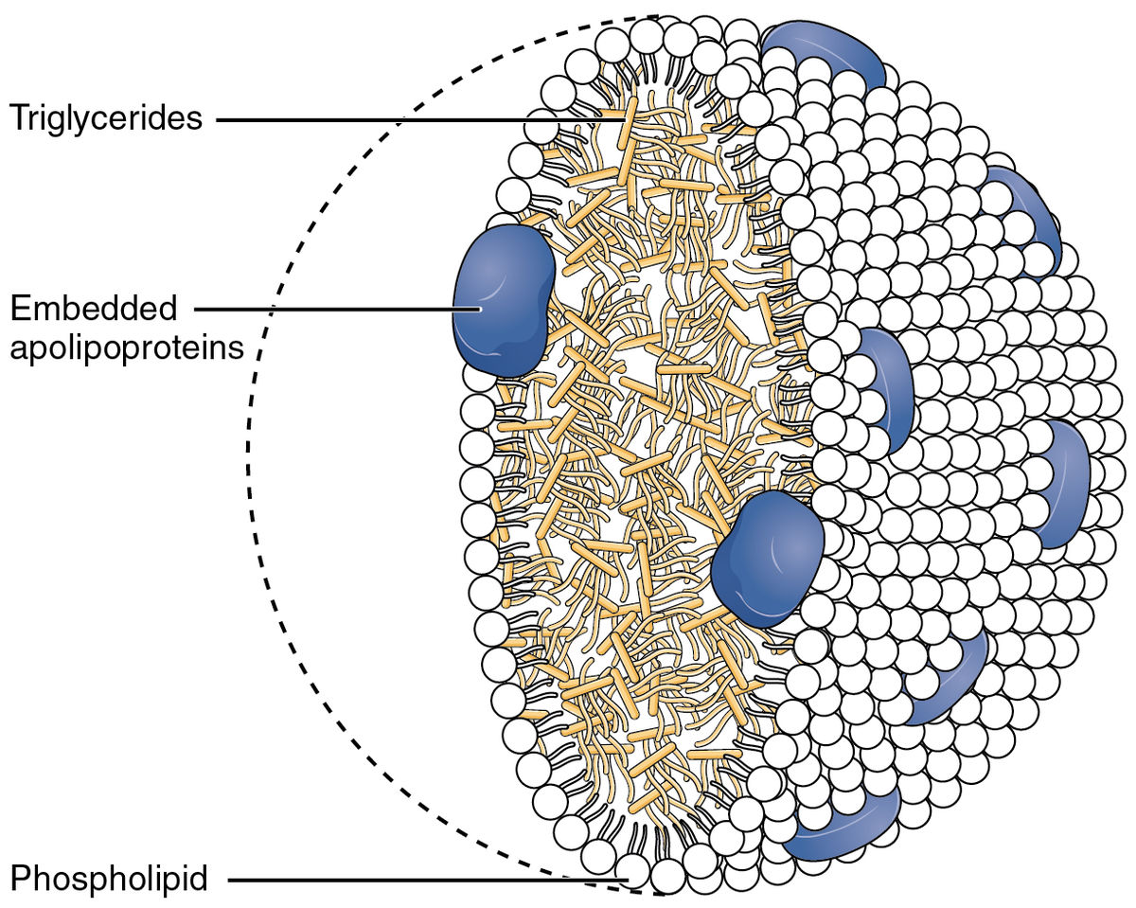

Well I’ll be, it looks just like what you described Paul. A bag-o-triglycerides (and cholesterols).

Shouldn’t the outer membrane be a phospholipid bilayer? Well since it is full of triglycerides (which are very closely related to phospholipids) it does not need the inner lining of phospholipids. What’s with the blue things? Those are proteins that are located in the membrane. These proteins are called apolipoproteins. Chylomicron = outer membrane + apolipoproteins + triglycerides and cholesterols inside. That is how they are moved through the blood so the individual triglycerides and cholesterols do not clump up in the blood and make big globules of fat in the blood.

Small intestine-> absorptive cells -> triglycerides packaged into chylomicrons-> dumped into hepatic portal veins -> liver.

So next the liver takes the chylomicrons out of the blood that will circulate through the hepatic sinusoids into the hepatocytes. The liver takes the chylomicrons out of the blood so that coming out of the liver there are no more chylomicrons.

Next step. To deliver these triglyceride molecules out to all of the cells of the body. The liver cells, the hepatocytes, will destroy the chylomicrons that they have taken in and repackage the triglycerides (and cholesterols) into their very own ‘Made in Hepatocytes’ bag-o-fat. This ‘Made in Hepatocytes’ bag-o-fat will be released by the hepatocytes out into the vena cava. Using this ‘Made in Hepatocytes’ bag-o-fat is how the triglycerides will be distributed triglycerides and cholesterol to all the cells of the body. Any cell in the body that needs a triglyceride (or cholesterol) molecule will bind onto the passing by in the blood ‘Made in Hepatocytes’ bag-o-fat and remove triglyceride and/or cholesterol from it.

As you can imagine, as this ‘Made in Hepatocytes’ bag-o-fat continues to flow through the blood stream it is having triglycerides removed and is slowly being emptied of its contents, its triglycerides and cholesterols. It is getting smaller and emptier.

Here is a tricky part. Huh? What are you asking me? I know, give me a minute. I’ll tell you the real name of the ‘Made in Hepatocytes’ bag-o-fat. First a tricky concept. The ‘Made in Hepatocyte’ bag-o-fat is full of triglycerides and cholesterol and made by the liver. It is similar to the chylomicron. Very similar. How are they different in fact?

-chylomicron: the name of the bag-o-fat made by the absorptive cells of small intestine.

-‘Made by Hepatocytes’ bag-o-fat: made by liver, delivered into entire blood circulatory system, but structurally the same as a chylomicron. Just like the picture above: membrane of phospholipids with some proteins embedded.

If you were to grab some chylomicrons and put them in a glass of water, would they float or sink? Easy, the chylomicron is a bag-o-fat and I remember, fat floats, so the chylomicrons will float on the top of the water. That is true. The only real weight the chylomicron has to possibly make it sink in the water would be the protein embedded in the membrane. But that protein is not going to make it sink at all because it is filled with fat (triglycerides).

Same thing holds true for the ‘Made by Hepatocytes’ bag-o-fat. It structurally is the same as the chylomicron so it too floats. The only weight it would have to possibly make it sink would be the embedded apolipoproteins it has in its membrane. But again, it is a bag-o-fat and the protein has no chance of making it sink.

But remember back to what I was saying a few paragraphs ago. The ‘Made by Hepatocytes’ bag-o-fat is slowly being emptied as it passes through all the blood vessels of the body. Being emptied of triglycerides which would make it sink in water from the weight of the proteins. By the way, the number of proteins will always stay the same. So at some point it will become emptied of enough triglycerides that the weight of its embedded proteins (the apolipoproteins) would allow it to start to sink if placed into a glass of water.

Picture two glasses of water. The one on the left has freshly made ‘Made by Hepatocytes bag-o-fats floating on the top of the water. The glass on the left has ‘old’ Made by Hepatocyte bag-o-fats that have been circulating for a while in the blood and have been emptied of a lot of their triglycerides. In this glass of water these bags-o-fat would not be floating on the top of the water but might have sunken down into the water a bit.

Something that is dense will sink. Something that is less dense will not sink as much and float more. The bag-o-fats in the glass on the left would be considered less dense compared to the bag-o-fats in the glass on the right. The bag-o-fats in the glass on the right would be considered more dense because they sink a bit. Hard to consider a bag of fat that floats being more or less dense but that’s what we are considering. The more triglycerides inside, the less dense. The fewer triglycerides inside, the more dense because the weight of the proteins embedded in the membrane now have a effect and can pull it down.

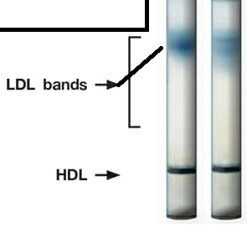

If you draw some blood and look for these areas where the bags of fat either float or sink, you can see them above. Notice the dark band at the bottom of the tube labeled ‘HDL’ must be high density lipoproteins, the ‘old’ bags of fat that have little fat left allowing the proteins to weight it down so that it sinks. The ‘new’ bags of fat are full of fat and float the best. They are not dense, the labeled ‘LDL’; low density lipoproteins seen higher up.

There I finally said it. These ‘Made in Hepatocyte’ bag-o-fats are called **‘lipoproteins’**. The liver makes lipoproteins. The small intestine makes chylomicrons. Chylomicrons travel from small intestine to liver. The triglycerides and cholesterol from the chylomicrons are removed by the hepatocytes and repackaged into the liver cell made lipoproteins. These lipoproteins made by the liver are released out into the general circulation. They are emptied of their triglycerides and cholesterols and as they get emptier and emptier of ‘fat’, they will have the ability to sink more and more, becoming higher density lipoproteins.

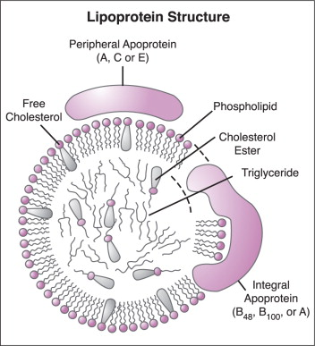 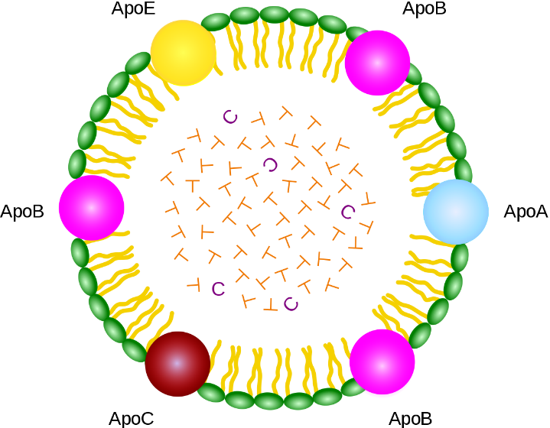

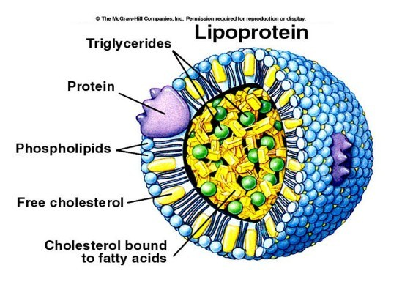

So the lipoproteins from the liver start out being very ‘floaty’, very low density and over time become higher density. Over time they will have the ability to sink more due to the unchanging number of proteins they always have. So if some experimenter was to look at people’s blood for these levels of lipoproteins, that researcher might see different levels depending on how full or empty the lipoproteins are with triglycerides. They’d most likely see additional bands of bags-o-fat. That is the case.

What if the experimenter found a floating band of bags-o-fat above the LDL band? What to call it? Well, it floats better than the LDL. It is less dense that the already very floaty LDL layer of lipoproteins. So it is even less dense than the LDL (low density lipoprotein). Less dense than the ‘low density lipoprotein’? OK, we’ll call it ‘very-low density lipoprotein or VLDL.

Take a look? <https://www.paulsclassinformation.com/physiologytextbook/OnlinePhys/LDLhandout.htm>

Take a minute to think about this. This newly identified VLDL is more floaty than the first discovered and first named LDL. How do you get more floaty (less dense)? You have even more triglycerides in you than the LDL. How do you get even more triglycerides inside of you than the LDL’s? You are newer. You’ve just come right out of the liver and have not had a chance to have any of your triglycerides taken out yet. Drum roll please…….the VLDL must be the lipoproteins that are first released from the liver!

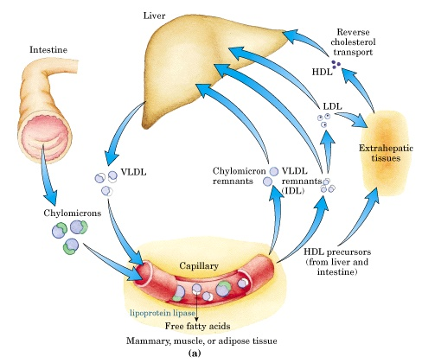

Focus on the liver. Coming out of the liver are the VLDL’s. That’s right! They are the floatiest, very low density, the opposite of the ‘sinkiest’ high density. They are freshly filled with the most triglycerides and cholesterols. As these VLDL’s float through the blood stream and the cells of the body remove triglycerides and cholesterols they start to have more density due to the proteins they have embedded in their membranes. The VLDL’s would transition to something less floaty, sink a bit more and be called then the LDL. As these LDL’s move through the blood stream, they will eventually enter the liver. Once the LDL’s enter the liver, the liver cells, the hepatocytes will take the LDL in, add more triglycerides and cholesterols into it (essentially fill up back up), and send it back out into the blood stream as a freshly packed VLDL. And so it goes.

VLDL exits the liver to go to the cells of the body. As it empties the LDL would be taken back into the liver cells, refilled and released again as VLDL.

Add to this the one way path of triglycerides and cholesterol from the small intestine via the chylomicrons and the hepatic portal veins.

So what’s all the talk about HDL? I’m guessing that stands for high density lipoproteins. Where do they come from?

NOT THE LIVER.

NOT THE SMALL INTESTINE.

Where then?

Remember that all of these lipoproteins and the chylomicrons are ways to transport triglycerides and cholesterols since we cannot have them floating free in the blood. They clump up into globules of fat and plug everything up. So any triglyceride or cholesterol needs to be carried in the blood in bag o fat, a lipoprotein or chylomicron.

So let’s consider a single cell. A neuron. It is always busy biochemically. At some point it will have generated waste triglycerides and/or cholesterols. That single cell cannot dump the individual triglyceride into the blood. Too many of those free triglycerides from other cells and again they will clump up. So the triglyceride waste from a single cell must be packaged into a tiny, little lipoprotein. Those are the HDL’s. Of course they are the highest density since from their beginning they have very little triglyceride in them. How much triglyceride waste can a single cell have after all? The membrane of the HDL still has to have apolipoproteins to weigh it down. So in the diagram you see HDL’s coming from ‘extrahepatic tissues’. What they mean by that is that the HDL’s come from all the cells of the body that are not the liver. And where to the HDL’s take their waste triglyceride and waste cholesterols to? The liver. Once the HDL’s enter the liver, the hepatocytes take in the HDL’s, destroy the HDL and package the triglycerides and cholesterol into VLDLs. See how clever that it. The liver cells pick up the waste triglycerides and cholesterols from each cell by taking up the HDL’s and recycle the triglycerides and cholesterols by putting them into the VLDL’s that the liver cells make. Those waste triglycerides and cholesterols from all the individual cells is now being recycled since they are now being sent out to the body inside the VLDL’s.

So THREE pathways to transport triglycerides in the body, In the blood. Why special pathways? Because fat floats.

1-From Small Intestine to Liver via chylomicrons;

2-From Liver to all the cells of the body via VLDL’s and LDL’s;

3-From each cell in the body (that isn’t a liver cell) back to the liver for recycling via HDL.

Clinical relevance. Studies have been done looking at people with atherosclerosis (and heart attacks) and comparing those that have had heart attacks with those who are ‘healthy’. Comparing specifically the amount of HDL and LDL in these groups. The observations have been that those with ‘healthy’ hearts have higher levels of HDL and those that have had heart attacks had more of the LDL’s. Why? People still trying to exactly determine that. But the observations are real.

<https://www.cdc.gov/cholesterol/ldl_hdl.htm>

There is more interesting stuff to the story. Those of you that know some of this already or those of you that are interested and will read ahead will know that I too am a:

**Liar, liar, pants on fire  
Your nose is longer than a telephone wire.**

But I’ll explain next time.

A huge contribution to mankind by ingenuity, hard work and good science:  
<https://www.nobelprize.org/prizes/medicine/1985/press-release/>

For any nerds out there, an interesting site that we would not be tested on:

<https://chem.libretexts.org/Bookshelves/Introductory_Chemistry/Book%3A_The_Basics_of_GOB_Chemistry_(Ball_et_al.)/17%3A_Lipids/17.2%3A_Fats_and_Oils>