**Lipoproteins – Part II:**

So why did Paul leave his nice discussion on lipoproteins and moving ‘fat’ around the bloodstream in such a weird way. He sort of relished in the fact that he was lying to us. Admitted to it in bold and a larger font. He’s all about the ‘truth’ of reproducible science. Well, if Paul were to be put in front of a judge and asked, ‘Why? Why Paul would you intentionally lie to your precious students?” Paul would give that age-old excuse that ‘it was for their own good’.

I think it time Paul did some fast talking to get himself out of all this ‘misinformation’.

Or not.

He wants you all to find his lies.

That is today’s assignment. You work together. You email me explanations for the following:

1-actually this one has nothing to do with lies and deceit but simply include in your email to me the biochemical explanation as to how your own body actually makes cholesterol. Doesn’t seem logical. Everything we read and hear about is concerned with us eating too much cholesterol and cutting down on cholesterol levels in the blood. But cholesterol is a critically important molecule used to make a bunch of hormones and other important molecules in the body. So the body does need a way (a biochemical pathway with enzymes and intermediates) to make cholesterol.

2-And since we’re talking about it, send me the pathway on how the body eliminates cholesterol from the body.

3-You are going to have to prove to me that you remember everything there is to know about “Bile”. Talk to me about bile in great detail.

4-Now to the lying. I just might have some clues at the bottom of this document. List for me all of my lies. Stuff I did not mention regarding those three pathways or things about those three pathways that were out-right untrue.

You are all to work together but I do need an individual email from each one of you. When is it due? I’ll announce that time to you right now. If I forget, remind me.

**Clues:**



Why in the world are the lymphatic vessels involved?

What is a micelle anyway?

What’s this talk about long-chain and short-chain fatty acids? Are they somehow treated differently during digestion and transport?

My goodness, Wissmann didn’t tell us about a lot of stuff. Why’s he making us do all this research? Isn’t he supposed to be the teacher and telling us this stuff? How unfair.

What’s a lacteal and what do they have to do with transporting ‘fats’?

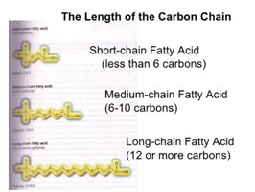

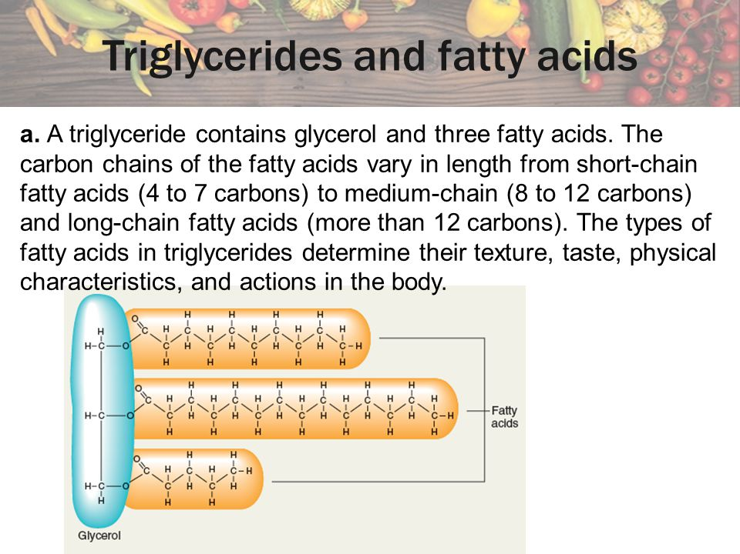

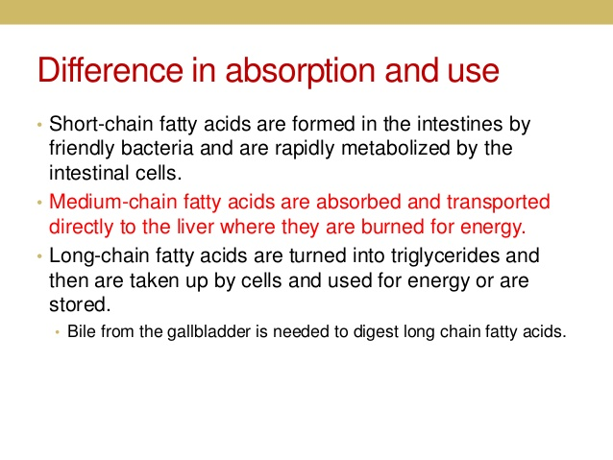

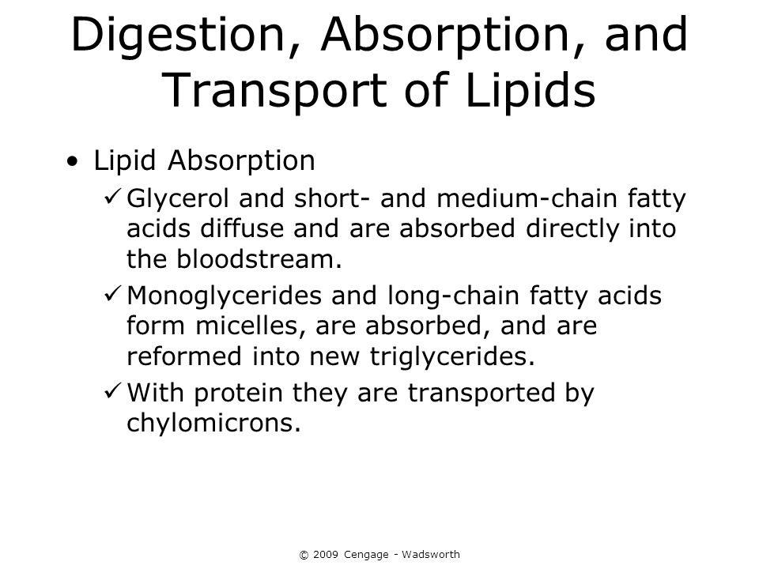

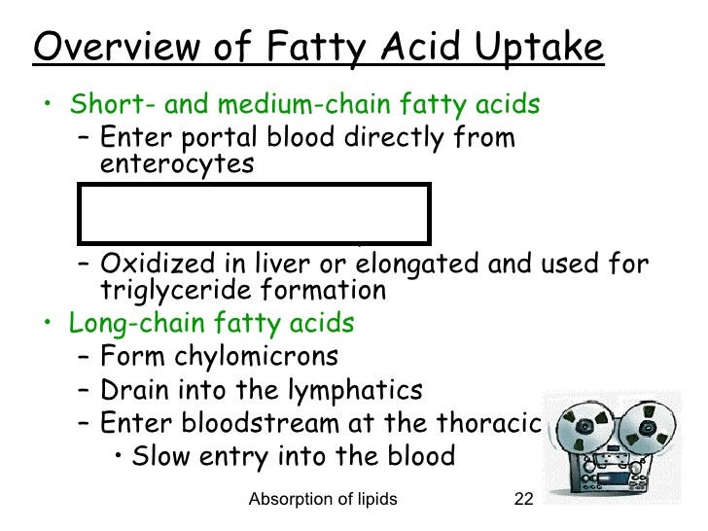

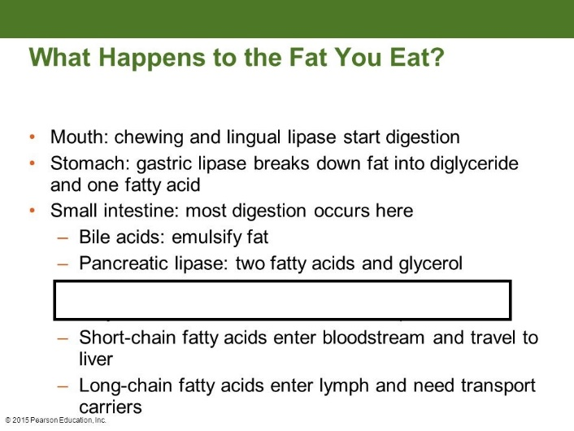

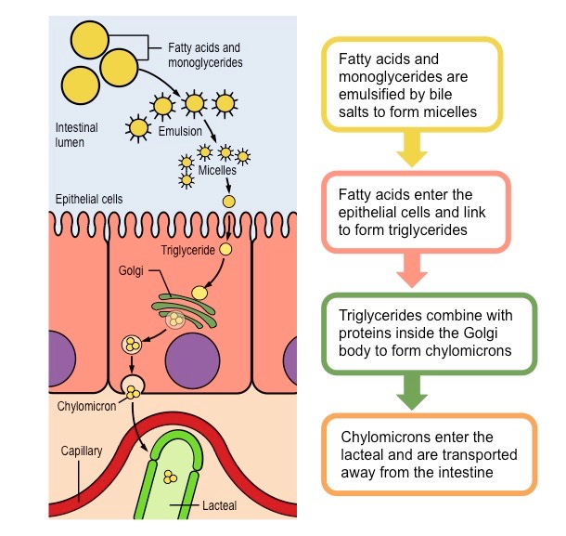

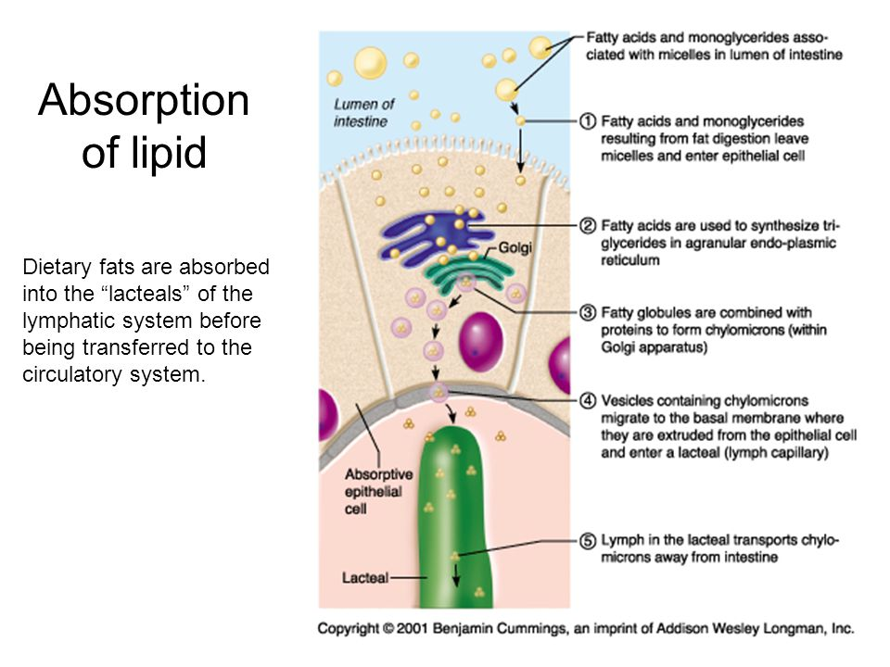

The End.