Nucleic Acids:

We’ve discussed (1) carbohydrates; (2) proteins; (3) triglycerides.

Now we get to discuss the 4th group of molecules, nucleic acids.

What is a nucleic acid? It is monotonous and boring. Draw a sugar and then draw the phosphate group attached to it, then draw a sugar connected to the phosphate group and then add to that second sugar another phosphate group, then add a sugar and a phosphate group, then add a sugar and then add a phosphate group and then keep going adding sugar and phosphate group. That is what a nucleic acid is….a repeating sequence of ‘sugar-phosphate group’ over and over again.

We already know all we need to know about the phosphate group. What about the sugar? What kind of sugar is it? We know there are several types of monosaccharides, which one is it? Well, let’s burst open one of your human cells and extract the nucleic acid and analyze what the sugar it has. The sugar is a 5-carbon sugar. So it is not glucose or one of the other 6-carbon (hexose) sugars. It is a 5-carbon sugar. Let me ask you, what is the formula then?

Hint: CnH2nOn = H5H10O5.

A six-carbon sugar (like glucose) is a hexose. A 5-carbon sugar is a ribose sugar. So the nucleic acid taken from your cells is a repeating sequence of ‘ribose-phosphate group’ over and over again.

But wait, when the laboratory analyzed the sugar that they removed from the nucleic acid taken from your cells they made a mistake. It was a 5-carbon sugar but it was missing an oxygen. Each sugar should have an -OH and an -H attached but this 5-carbon sugar they found in your cell’s nucleic acid had one carbon that did not have -OH and -H attached but at one carbon it was missing the oxygen so that one carbon has -H and -H attached.

Take a look at ribose the ribose they found inside your cells that is missing an oxygen and therefore is called deoxyribose.

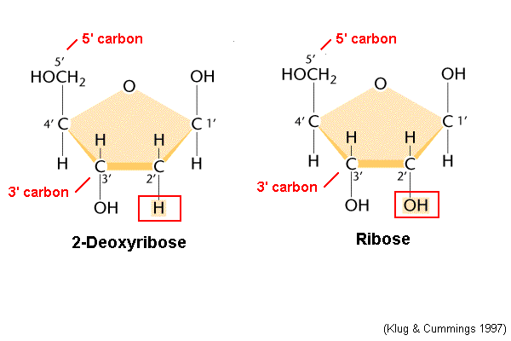

So the nucleic acid taken from your cells is a repeating sequence of ‘deoxyribose + phosphate group’ over and over again. OK, you’re right Paul, it is boring and monotonous. So here’s something interesting about nucleic acid. Each sugar has something attached to it. Yay. Tell us, what are attached to the sugars? Each one of the sugars has one of four molecules attached to it. Only 4 choices. These four choices are the four ‘bases’ that can be possibly attached to the sugars. These four bases are: adenine; guanine; cytosine; and thymine. You’ll notice in the diagram that each 5-carbon deoxyribose has one of these four possible bases attached. A nucleic acid that uses deoxyribose as it sugar is then called just that: Deoxy-ribo-nucleic-acid = DNA! That’s what DNA is, a boring, monotonous molecule. The only real interesting thing about it is the order, or sequence, of the bases if we wanted to try to keep track of their order. Since a strand of DNA can be quite long, that would be a very long sequence of bases and hard to determine and very hard to keep track of.

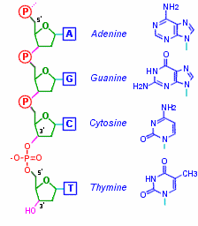 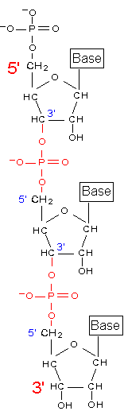 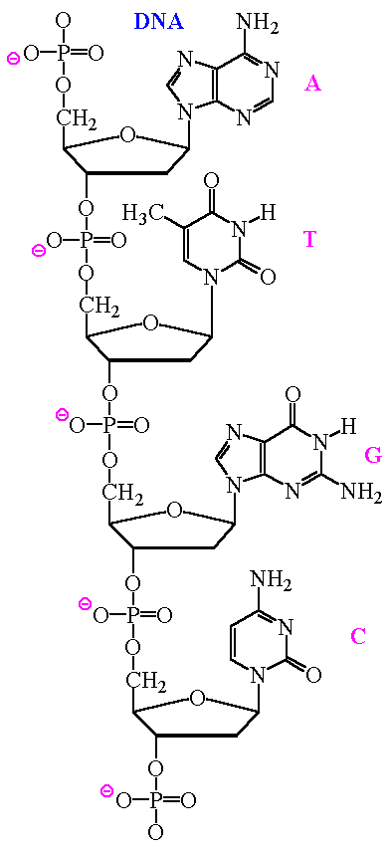

See, sort of boring, 5-carbon sugar (deoxyribose) attached to the phosphate group and then another 5-carbon deoxyribose sugar and another phosphate group and so on and so on. Attached to each 5-carbon sugar is one of the four bases (A, G, C, or T).

There you have it.

So I am your friend. You can trust me. I brought to your attention the sugars, carbohydrates, and how easy it is to learn the structure of the glucose molecule and how easy it is to connect these monosaccharides together, just take off an OH and an H to make sure it’ll add up to water and then connect the broken bonds. Not that bad.

I had you accept into your life amino acids which was not a hard thing to do at all since all an amino acid is …. Is an ‘amino’ plus an ‘acid’ connected to a central carbon atom. Not difficult to understand at all.

Then I reassured you about triglycerides. If you were to come up to one you might think it too complicated to understand but once you recognize that all it is made up of is the simple 3-carbon glycerol on the top and three fatty acid chains of carbons hanging down, one fatty acid chain of carbons for each of the three carbons of glycerol. And to put one together, a triglyceride that is, you use that same dehydration synthesis reaction we used for carbohydrates and proteins by removing an OH and an H (make sure it always adds up to water, H2O) and connect the broken bonds.

And to digest any one of these, a polysaccharide, a protein (polypeptide), or snip-snip-snip to digest off the three fatty acids from glycerol all you need to do is the hydrolysis reaction.

And now you showed me how boring and monotonous a single strand of nucleic acid, DNA is. So is that it for DNA?

Well….NO!

Another interesting thing about DNA are the 4 bases. They can pair up if you push them together in the right orientation. They will weakly bind and structurally fit together if brought together in the correct position. It turns out the A-base will pair up with the T-base. Adenine and Thymine pair up. Lots of ways the textbooks say this. The A and T will base pair. That the A and the T base are complementary. They can be pulled apart without much work for the cell so it is not as if they are covalently bonded together. But they do ‘pair up’. Likewise for the C and G bases. Cytosine will base pair with Guanine.

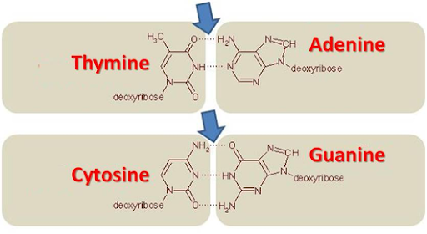

Now is a good time to tell you that chemically the T and the C bases are called pyrimidines while the A and the G bases are called purines. I had a student who had gone to U. C. Davis and they are the Aggies. And they consider themselves wholesome and good people. So she was taught while there that the Aggies are pure. This works for me, the A and G bases are the purines.



That leaves the T and C bases as the pyrimidines.

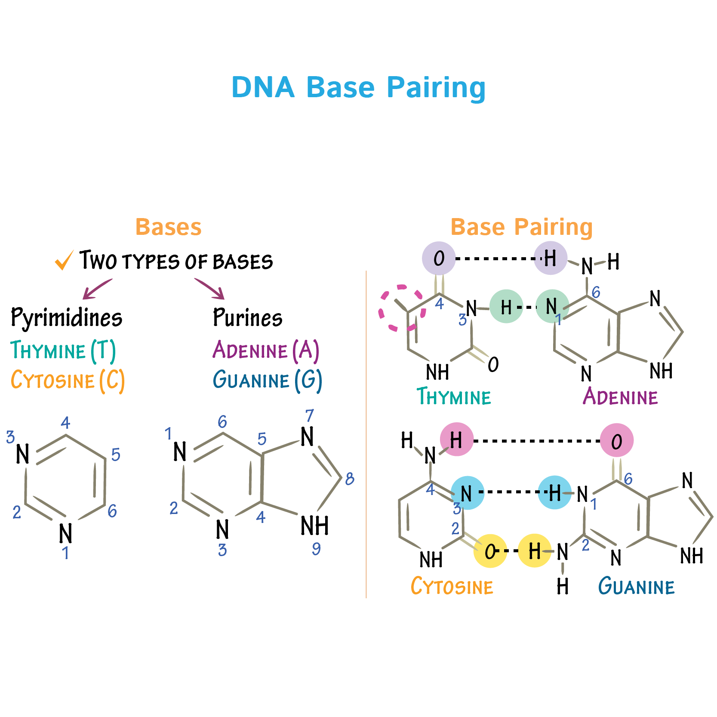

This base pairing allows for something special. Imagine I have a single strand of DNA. ‘Sugar-Phospate group’ over and over again. Each deoxyribose sugar has either an A or a T or a C or a G base attached. Just like you saw a few diagrams above.

Now imagine a second, separate strand of DNA. And I line up next to each other these two separate strands of DNA. And imagine that at every sugar position it just so happens that the base on the one strand is the perfect match to the base on the strand right next to it now. Imagine these two separate strands of DNA laying next to each other, one above the lower strand. On the top strand, there is an A base and on the lower strand right next to the A base above is a T base. They naturally will pair up and form two weak bonds that will want to keep the A and T bases together. And at the next position, the very next set of sugar with its base, the upper strand has a C base and the lower strand has a G base. They will base pair with three weak bonds and so they will want to remain base paired. And imagine that happens for every position on these two separate strands of DNA. Every T on the top strand has an A base below it and for every C base in the top strand, right there below it on the second strand of DNA is a G base. All the bases happen to base pair. These two separate strands of DNA will stay together since all the bases happen to pair up. You now have a ‘double strand’ of DNA. Double stranded DNA.

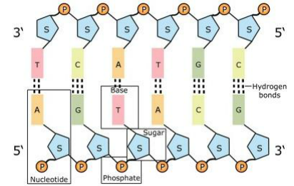

Take a look at the above diagram. The T above on the left is paired with an A base on the lower strand on the left. And as you march along the length of these two separate strands, each base has it pair. Notice also this diagram defines a useful term, the ‘nucleotide’. What is a nucleotide? And I’ve seen the term nucleoside, what’s that? Will this be confusing? Or will Paul help me out again? (fingers crossed for good luck)

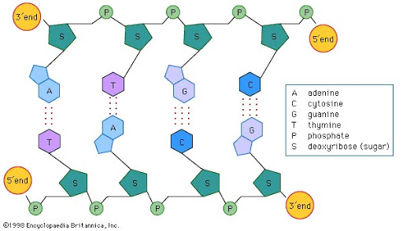

Notice below the difference between the nucleotide and the nucleoside.

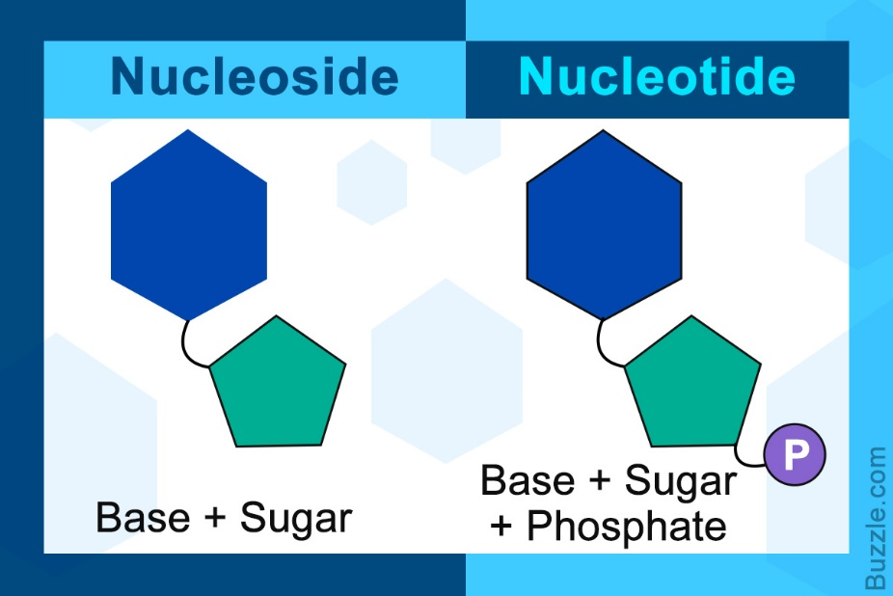

Remember that ‘s’ comes before ‘t’ in the alphabet. The nucleoside only has the sugar and its base, while the nucleotide has the sugar plus its base AND the phosphate group.

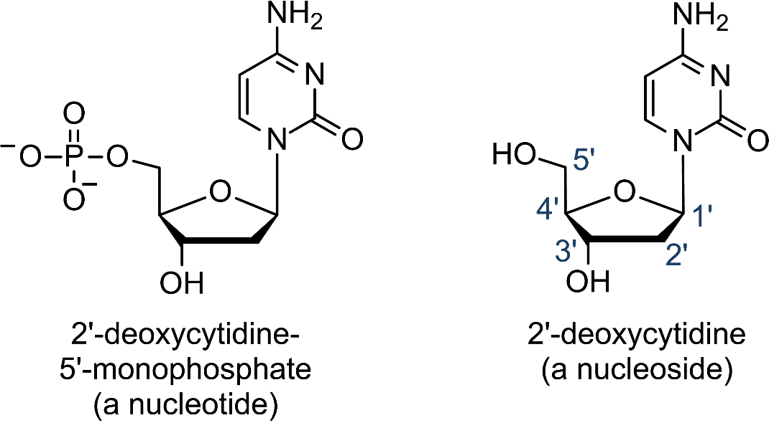

We won’t need to know that the nucleoside that has C as its base is called 2’-deoxycytidine, but notice the nucleoside on the right and if you add the phosphate group you have the nucleotide version.

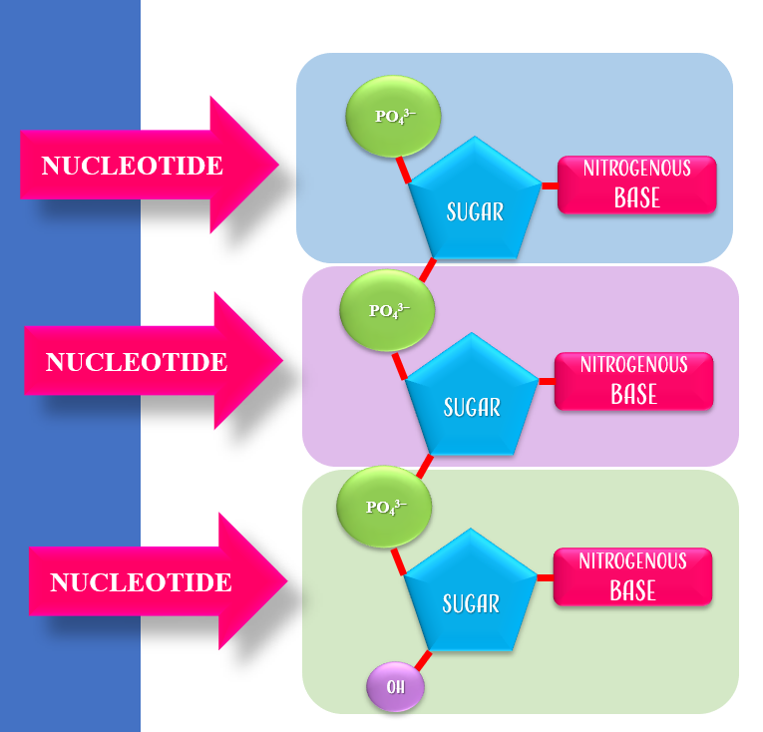

Again, in the diagram below, we see lots of atoms and bonds but we can recognize what we’re looking at.

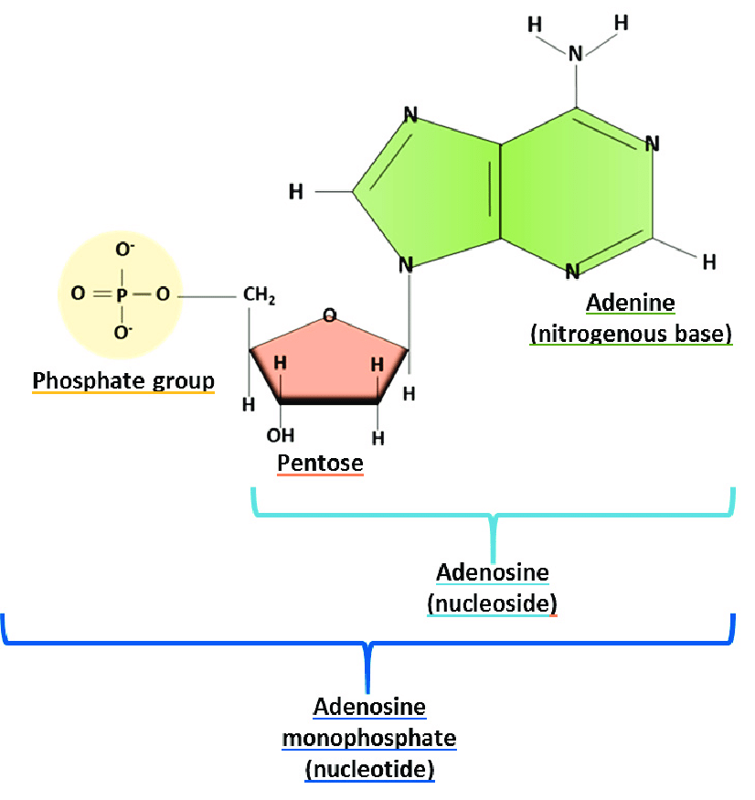

Above I recognize the nucleoside (Adenine base plus its sugar, I even notice the missing oxygen at carbon 2, they call it pentose, we know it as deoxyribose). When you add the phosphate group, it becomes a nucleotide. We’re here to learn. I’m seeing that the chemical name of this nucleotide is ‘adenosine monophosphate’ because the base is adenine and, well, it has one phosphate. What else would you call it?

Look at the diagram below. The top structure is what we just saw, the nucleotide with adenine as the base and its one phosphate = adenosine monophosphate. What do you think you call the second structure, the one in the middle below? Well it has two phosphates, so I’m guessing adenosine diphosphate? And the bottom structure with 3 phosphate groups attached? I guess it’ll be called adenosine tri-phosphate? WAIT! You made me say ‘adenosine tri-phosphate’. That’s ATP.

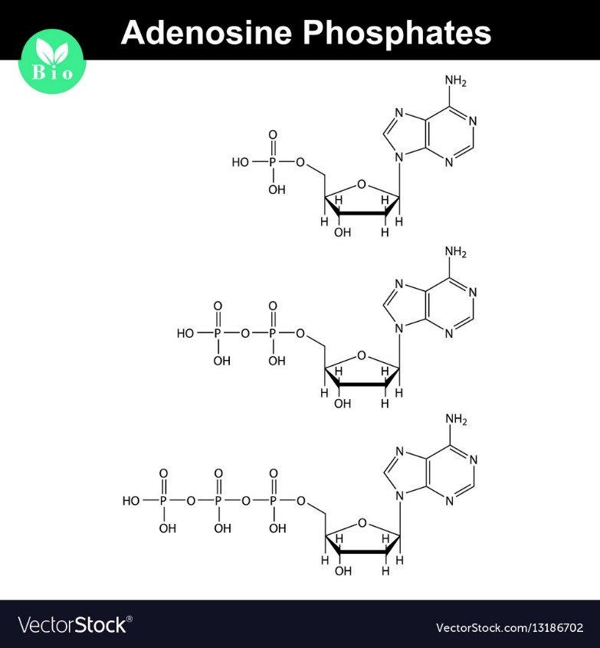

Is the last structure in the diagram above really ATP? Is ATP almost the same as the nucleotide that uses the A base in DNA? That’s just weird. The nucleotide in DNA that has A as its base has only one phosphate. Agreed. But if you add two more phosphates onto it and make it a triphosphate, is that really ATP?

Well, if you look closely, no. See the diagram below and look at the 5-carbon sugar. In the nucleotide that uses the A base in DNA you will always have as the sugar deoxyribose, where the oxygen is missing from carbon 2 of the 5-carbon sugar. But in ATP, the 5-carbon sugar is good old regular ribose. See the slight difference.

In the diagram below, on the right is the nucleotide you’d use in making DNA, they call it in the diagram dAMP. On the left is ATP with ribose as its sugar, not deoxyribose.

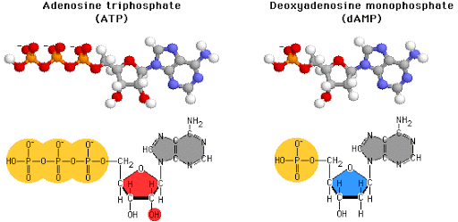

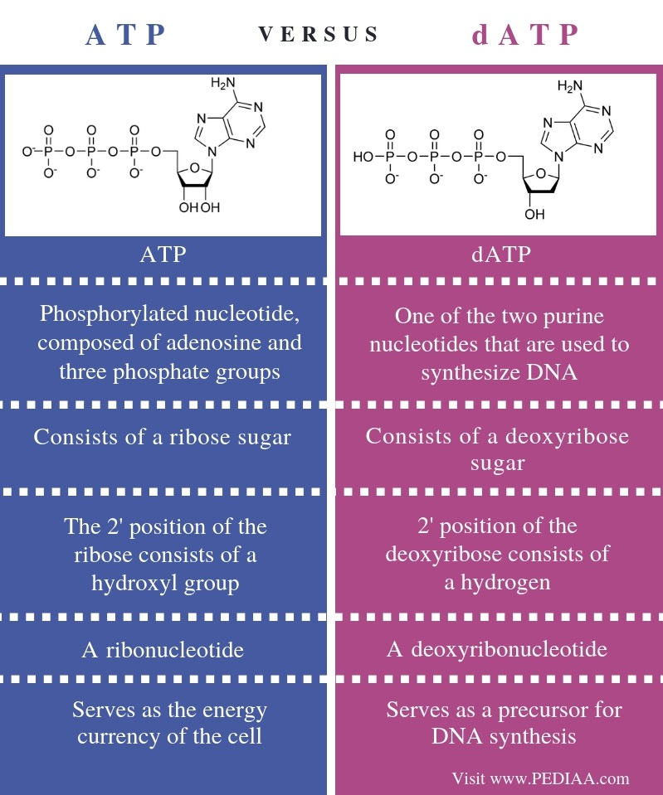

Now what was I saying about DNA before we went off on that interesting tangent? Oh yes, we had made a HUGE discovery. That two strands of DNA can become a double stranded molecule if all the bases pair up. Right now it looks like a ladder laying on its side. Remember this diagram. The rungs of the ladder are the base pairs and the sides of the ladder are the sugar-phosphate backbone, never changing, running along the outer sides of the double stranded DNA. The only thing that changes are the bases and their sequence.



**THIS DOUBLE STRANDED DNA IS CALLED A……**

**CHROMOSOME!!!!**

We’ve discovered what these famous chromosomes actually look like. And they are not complicated.

So why does everyone talk about them as being complicated? Well, they can be very, very long. What if I asked you to determine and write down the order, or sequence, of all the A, G, C and T bases for a chromosome and that chromosome was 10,000 bases long. That is cumbersome. That’s what makes chromosomes complicated. But their structure in simple (and monotonous).

Another thing to mention. Image the double stranded DNA, the chromosome, as being a flexible ladder so that you could twist it. Chromosomes have that twist. To the biochemists, the twist is called an alpha-helix. Now that make recognizing what we are looking at a bit trickier.

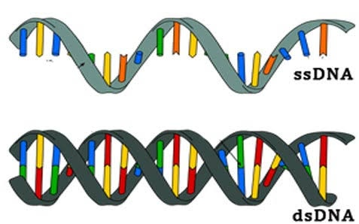

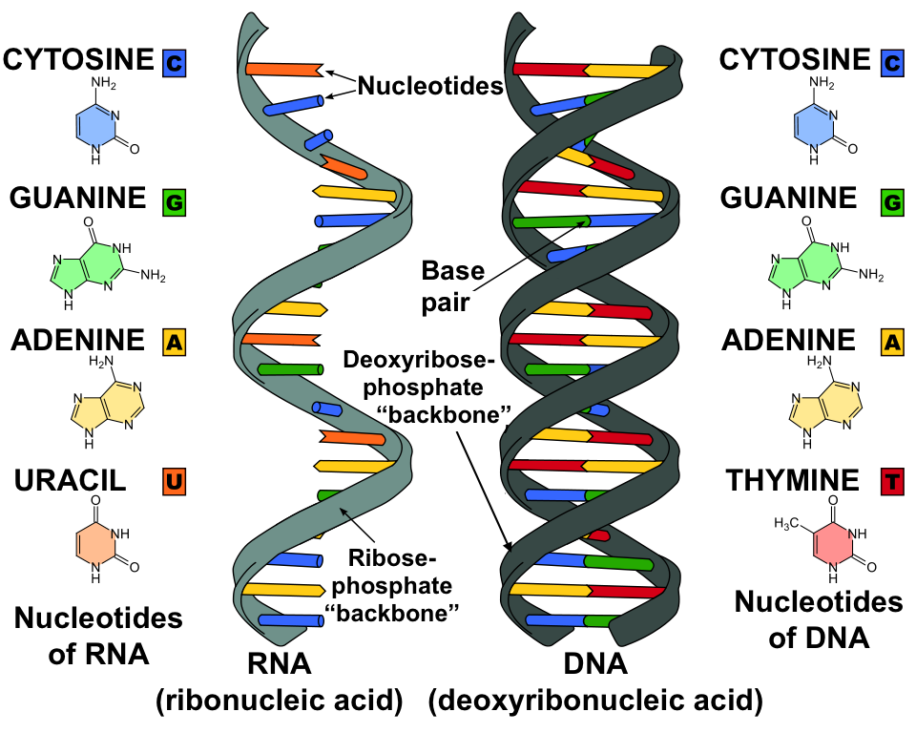

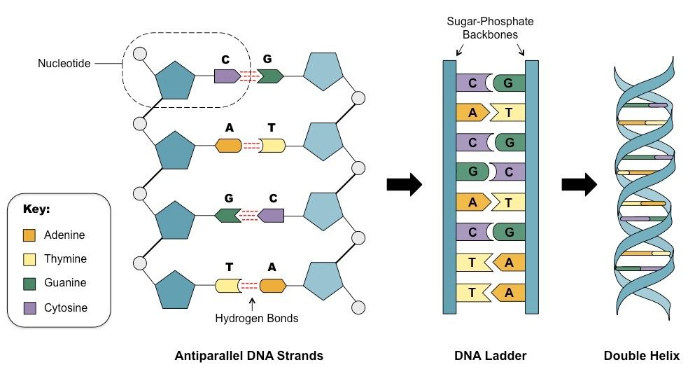

Several years ago our department got some money and we purchased a couple of models. We faculty met after our classes to put one together. Wow. We do really know the structure of a chromosome and DNA. We’re Ph.D.’s after all, some of us focusing on molecular biology and stuff. It took us days to put just one together.

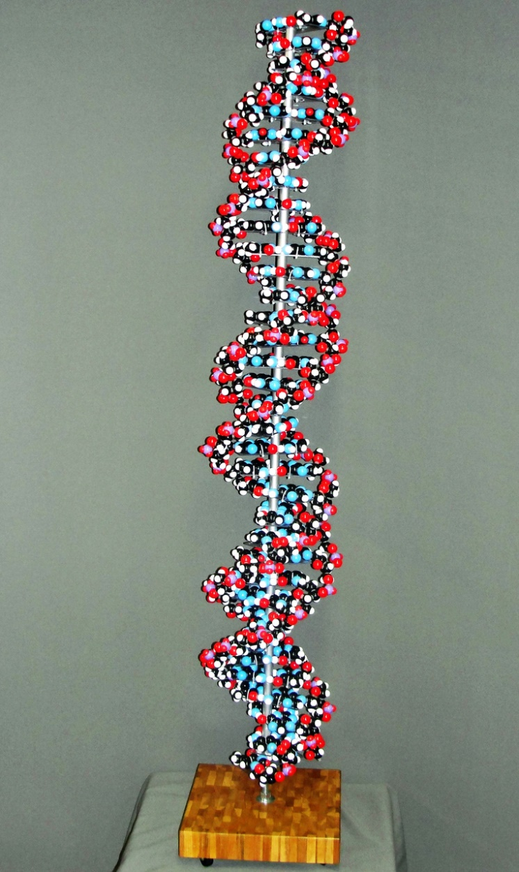

But you all now know the structure of a chromosome. Mostly. Still some more to add.

Chromosomes are very, very long. So the double stranded DNA, the chromosome, is coiled up and wrapped around a protein called a histone protein.

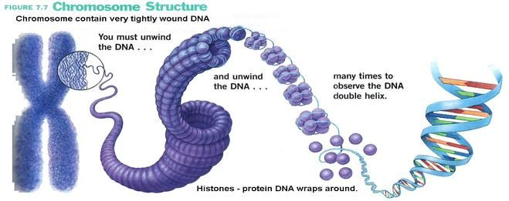

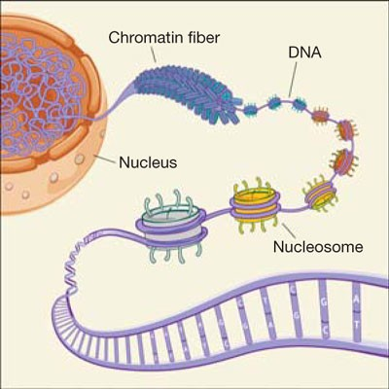

So what is a nucleosome? And what is chromatin? I’ll let you look that up.

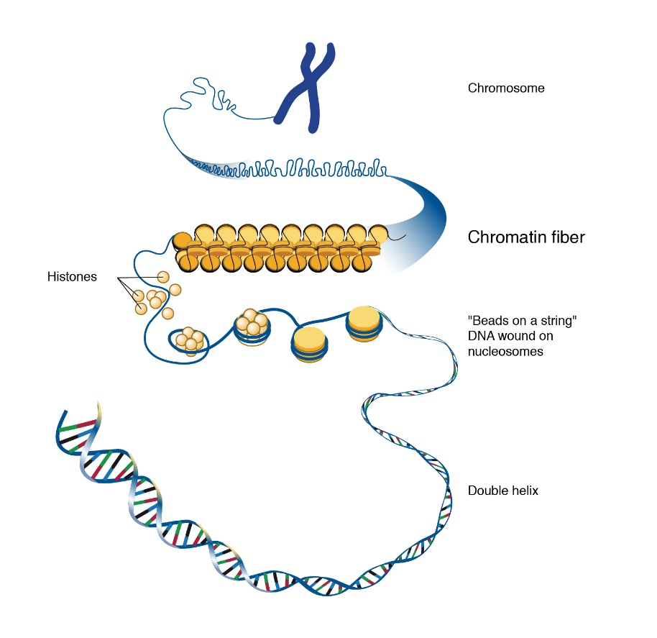

<https://www.youtube.com/watch?v=C1CRrtkWwu0>

<https://www.youtube.com/watch?v=o_-6JXLYS-k>

You now know about anti-parallel strands, right?

<https://www.youtube.com/watch?v=_POdWsii7AI>

<https://www.youtube.com/watch?v=V6bKn34nSbk>

<https://www.youtube.com/watch?v=V6bKn34nSbk>

Even more impressive, after finishing her work on DNA, Franklin led pioneering work at Birkbeck College on the molecular structures of viruses. Her team member [Aaron Klug](https://en.wikipedia.org/wiki/Aaron_Klug) continued her research, winning the Nobel Prize in Chemistry in 1982. In her short career she provided data that would lead to two Nobel awards in two very different fields.

OK, so we understand the structure of nucleic acids and a specific nucleic acid that uses deoxyribose as its sugar, DNA, and double strands of DNA making it a chromosome. Now what?

What do chromosomes do?

Actually before we talk about the purpose of chromosomes let’s first talk about something very important that happens to chromosomes. And that is, when a cell undergoes cell division, cell replication, MITOSIS, this dividing cell must duplicate a lot of its organelles (twice as many mitochondria, lysosomes, and such right before it splits into two daughter cells). And the same is true for all of the chromosomes. All of a cells chromosomes have to divide prior to this cell that is dividing have to duplicate themselves, and duplicate themselves perfectly. Each base, each A and T and C and G has to be identical in their position, in their sequence.

This DNA replication needs to be explained. That’ll be fun because at the end of the explanation we’ll see that it is a beautifully clever way to make two copies of a chromosome. So lets duplicate the cell’s chromosome, let’s do DNA replication. Hold on there, did you say let’s duplicate the cell’s chromosome? Hey there buddy, your human cells do not have just ‘a chromosome’. Your human cells have many chromosomes. How many you may ask? Let’s burst open a cell and burst open its nucleus, stain the DNA with a chemical that specifically binds to DNA and look and count.

With some practice you take one of your human cells, place it into a drop of liquid and drop that drop of liquid containing your human cell down onto a clear, glass microscopic slide. The practice helps you determine from what height you drop the drop of liquid in order to get the cell and the nucleus to burst open leaving all the chromosomes scattered on the clear, glass microscopic slide. You put the slide under the microscope and take a look and start counting chromosomes.

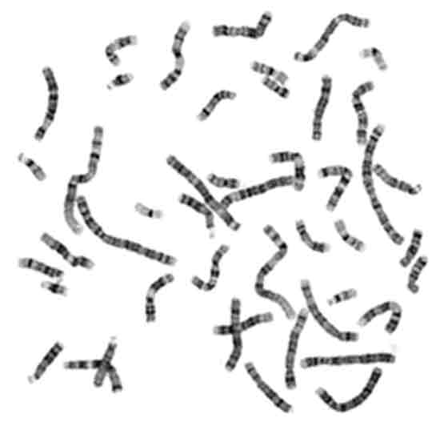

This is what you might see. It is very hard to count all these chromosome since they are being seen in the lens of your microscope, you can’t mark the ones you’ve already counted and it is very easy to not be sure if you’ve counted that one before. A tricky and frustrating task. So the clever lab technician decided on a better way. She took a picture of this image with the microscope camera. Then she cut out each chromosome from the picture and lined them all up and counted them. Brilliant idea. Now computers do it, but what the lab will return to us is an organized list of the chromosomes. The lab technician just decided to order them starting with the longest ones since as you can see above, your chromosomes come in different lengths. Longest to shortest she ordered them and immediately she discovered that for everyone she found, there is another one just as long. Each chromosome has its pair. The total count of chromosomes is 46 chromosomes. All of your human cells (by and large, some are different for good reasons as we will see eventually) have 46 chromosomes in their nuclei. The diagram below I just thought was cut showing them paired up with colors. No way would they ever have splatted onto the microscopic slide paired this way.

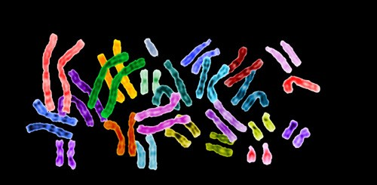

The early technologists and now computers find them on the microscopic slide, or in the drop of liquid directly, make an image of each one and lines them up pairwise starting with the longest pair. So they are numbered, chromosome pairs 1 through 23. This is called a karyotype.

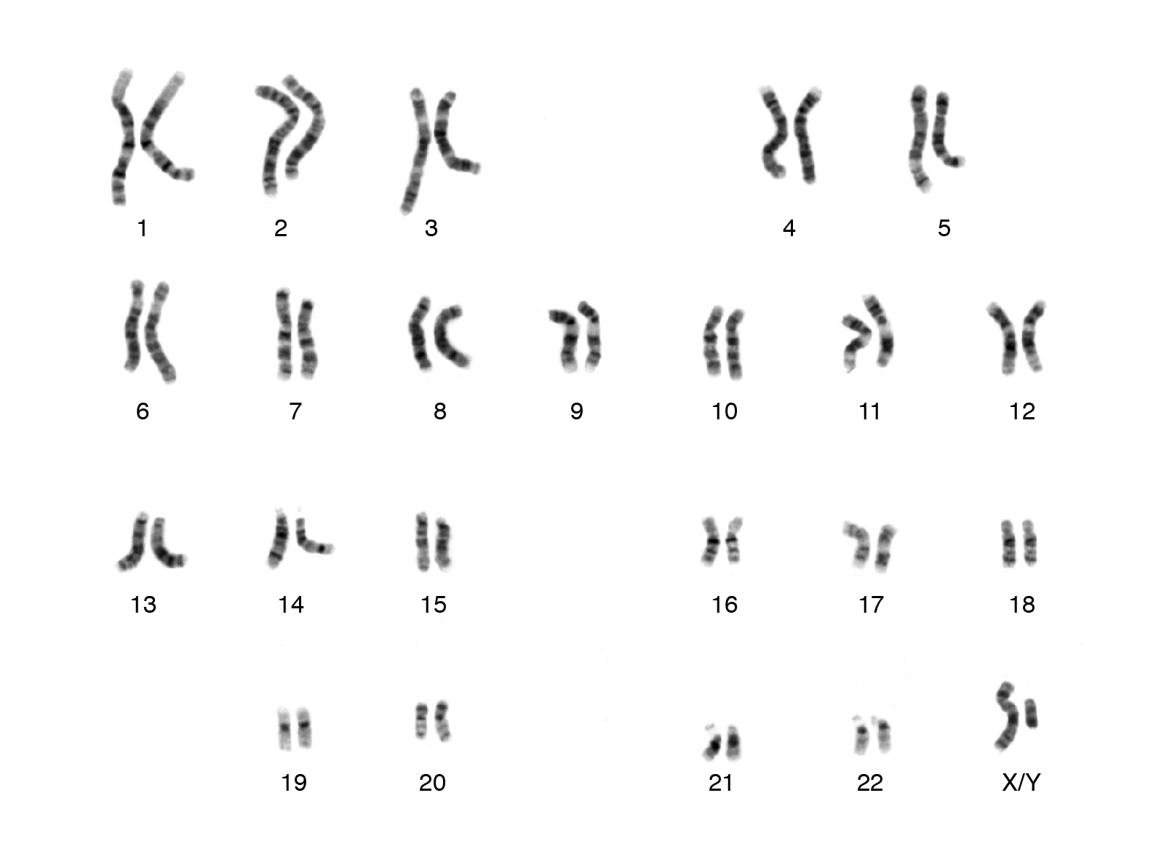

We will learn that a single chromosome turns on the production of testosterone and when testosterone is present that fetus, that person, will develop male reproductive organs and be a reproductive male. The chromosome that turns on testosterone production is a short chromosome called the Y-chromosome. It is considered a ‘sex-chromosome’ since it determines the reproductive sex of that individual. Without the Y-chromosome, with no testosterone production early in development, that individual will develop female reproductive organs and be a reproductive female. The chromosome that does pair up with the Y-chromosome is much longer than the Y-chromosome and is called the X-chromosome. So by convention, the very last pair of chromosomes, pair 23, are called the sex chromosomes and are either XY for a genetic male and XX for a genetic female. Can you tell me why there can’t ever be a YY individual? In the karyotype above, what genetic sex is this person?

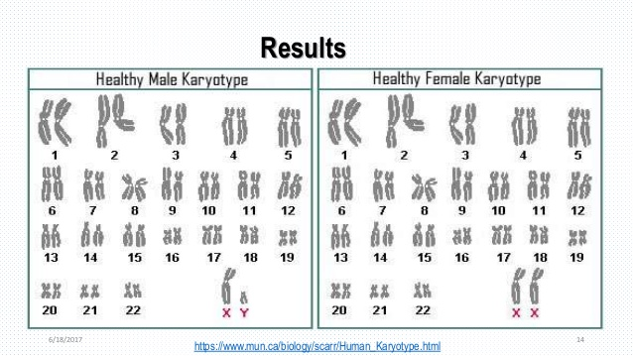

Once it was seen that each chromosome has its pair, it made perfect logical sense to be that way since you inherit half of your genetic traits, half of your genes from genetic mom and half from genetic dad. So one complete set of 23 chromosomes came from your genetic mom and a complete set of 23 chromosomes came from your genetic dad. Oh, yeah, dad’s sperm had 23 of his chromosomes and mom’s egg has 23 of her chromosomes.

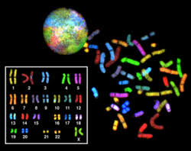

We’ve established now that your human cells have 23 pairs of chromosomes in their nuclei. Back to DNA replication. How do we replicate all 46 of them?

<https://www.youtube.com/watch?v=wTabIb9vIkw>

A very basic video (explanation) but that’s what happens. Now if you realize that both ‘top’ and ‘bottom’ strands of the DNA making up the chromosome are both copied base by base, when you are done filling in the matching bases on both the separated top and bottom strands of the original chromosome, you end up with two double strands of DNA, TWO NEW CHROMOSOMES, that have to identical to the original because you used the original strands to make the two new strands. Genius! Way to go evolution.

<https://www.youtube.com/watch?v=lSvF5-rBRGQ>

<https://www.youtube.com/watch?v=tVoKhlg0WkY>

<https://www.youtube.com/watch?v=dKubyIRiN84>