**Ophthalmoscope:**

**(impress your friends, lean how to spell it)**

Fundoscopy: <https://www.youtube.com/watch?v=AzxNGz1cjgI>

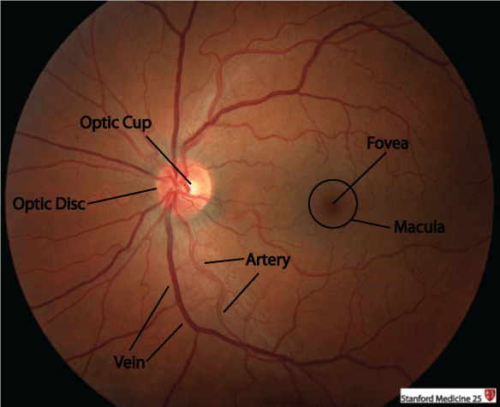

Normal anatomy of the retina seen with ophthalmoscope above. Know this normal anatomy.

Below shows pathologic changes with diabetes. We are not responsible for knowing below diagram’s information.

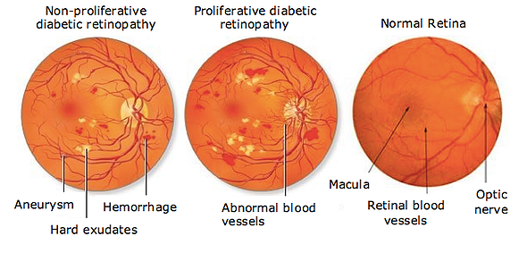

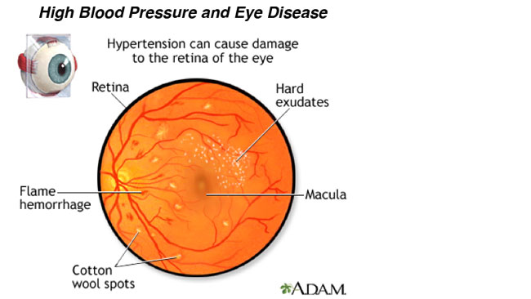

Again, we are not responsible for knowing about hypertension and cytomegalovirus changes to retina. Just interesting to see.

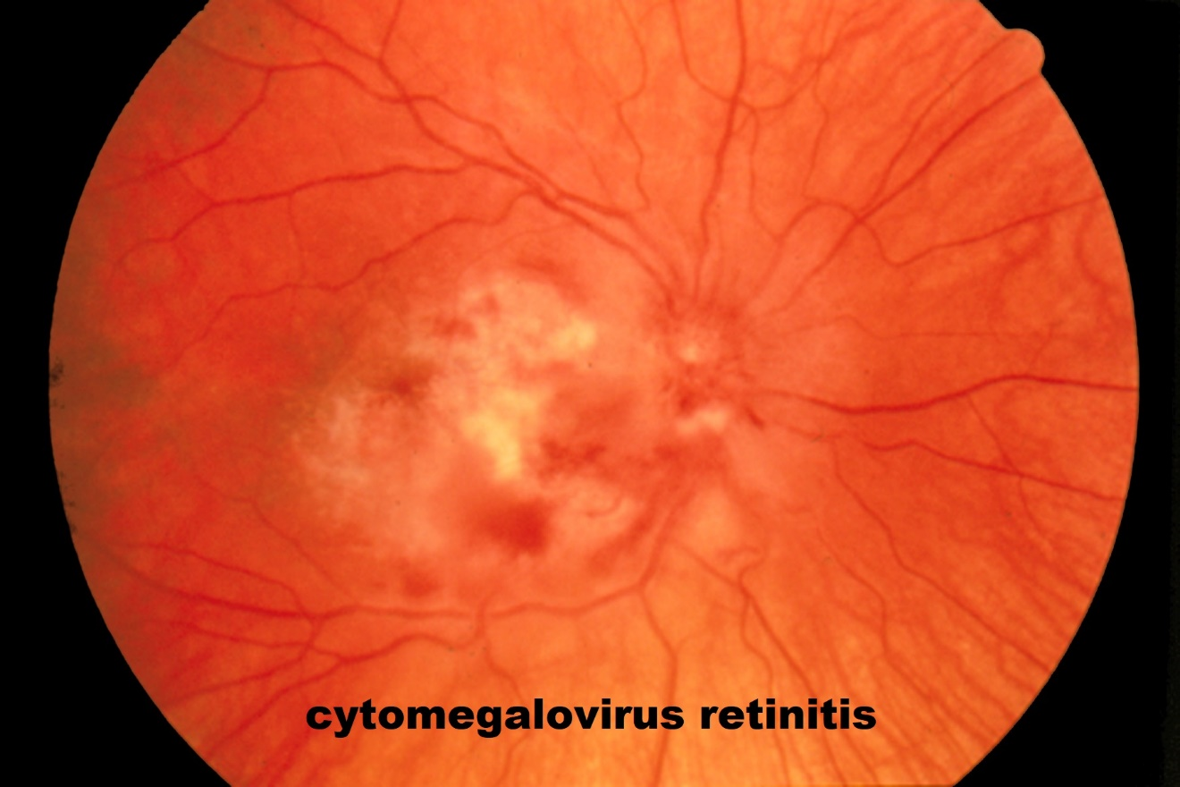

We are not responsible for any of the conditions shown above. Just to give you an idea of what can be found.

You are responsible to know just the definition but not the pathology for the following:

-macular degeneration -glaucoma -cataract surgery.

You do not have to know these images, but interesting to see:

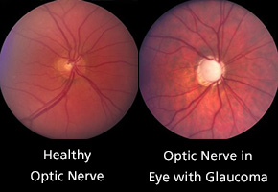

Disk cupping in glaucoma: above and below.

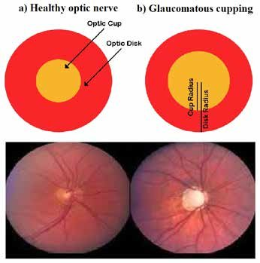

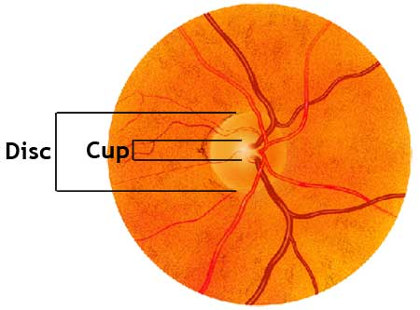

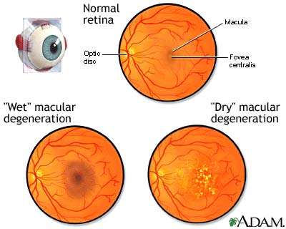

**otoscope**

<https://www.youtube.com/watch?v=7R7lKEVBFaQ>

<https://www.youtube.com/watch?v=qgTEUn-5UqQ>

<https://www.youtube.com/watch?v=08IV03zDRXk>

<https://www.youtube.com/watch?v=IYWzH2LC6gw> or

<https://www.youtube.com/watch?v=IYWzH2LC6gw&has_verified=1>

<https://www.youtube.com/watch?v=QuTtxZ_D3m8>

<https://www.youtube.com/watch?v=TiSpjfuQxXM>

All you are required to know is the normal view of the inner ear with the otoscope and define otitis media.