Proteins:

So what’s a protein? We now know what a sugar or carbohydrate is. What is this thing you and the book are calling a protein? Well, first an example or two. Many of your hormones are proteins. Now you may not know much about your hormones but let’s take growth hormone or insulin. Those hormones you’ve heard about and you know they have a big impact on your body. They are proteins. Your Achille’s tendon at the back of your ankle. It is made up of long, thin fibers called collagen. These famous collagen fibers are protein. OK, so what is a protein? Let me begin by saying all of your proteins are simply a linear chain of amino acids. And before you ask what’s an amino acid, let me get this out. There are 20 different amino acids to choose from. So 20 different amino acid molecules and you can string them together in different orders and in different lengths to make all of your proteins.

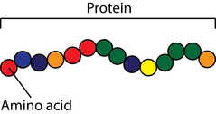

I do need to talk more about what these amino acids are. Well, their structure is very simple. Yes, you will have to know the structure of an amino acid. ‘DO WE HAVE TO KNOW THE STRUCTURE OF ALL 20 AMINO ACIDS?’ No, but just wait and listen. All 20 amino acids have the same structure with only one part of each of the 20 amino acids that is different. Let me continue. An amino acid is an ‘amino’ group and a ‘acid’ group connected to a carbon atom in the middle. Ammonia is NH3 and is stable as NH3 because nitrogen will always form 3 covalent bonds. So if you wanted to bind ammonia to something you’d have to remove a hydrogen leaving that broken bond available to bond something. In this case it will bond to a carbon atom in the middle of every amino acid. On the other side of this central carbon will be the ‘acid’ group. You learned about the ‘acid’ group in chemistry: carbon double bonded to an oxygen and also bonded to the -OH group. Put the amino group and the acid group onto the central carbon and there you have it, the structure of all of the 20 amino acids.

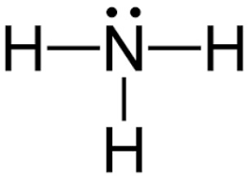 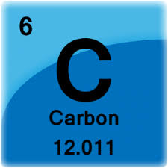 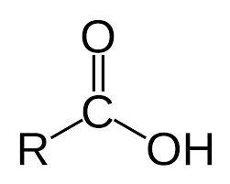

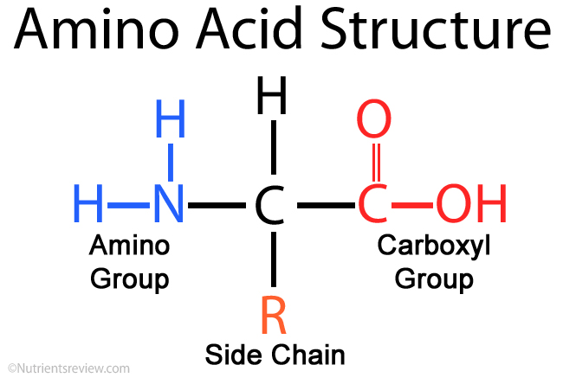

Remember that carbon will always form 4 covalent bonds. Two are now taken, one for the amino group and one for the acid group. That leaves the central carbon with two more bonds to fill. The top bond is easy, just add a hydrogen atom. The bottom bond can have 20 different things attached there. That explains how this common backbone of the central carbon + the amino group + the acid group (with a hydrogen on top) can have 20 different forms, because there are 20 different things that can be attached to the bottom of the central carbon. So to keep things simple, generally, like the diagram above shows, the bottom of the central carbon bond is shown to have the “R-group” meaning that depending upon that amino acid, there can be 1-20 different things attached there. For example, there is an amino acid that has as its ‘R-group’ just a hydrogen, “glycine”.

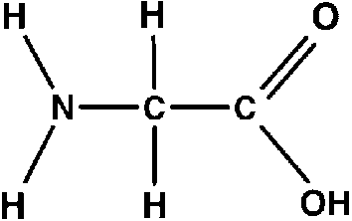 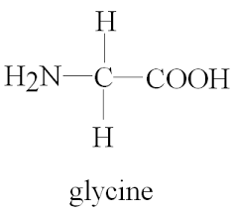

Just to warn you, you may come across a drawing that looks like the one below on the left. It still is glycine but I hate it. It is hard to recognize all the atoms. Even worse would be the diagram shown below on the right. Why do they do these things?

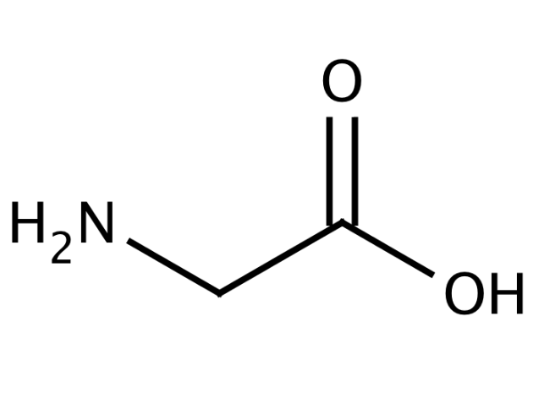 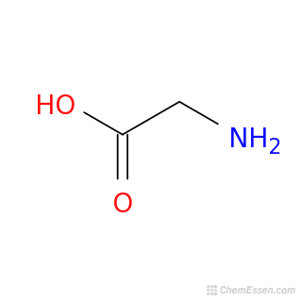

Another simple example, for the ‘R-group’ you just find an -CH3 group rather than just a -H like you saw in glycine. The amino acid with just a -CH3 group attached is alanine.

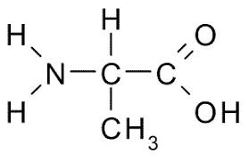

Is there an amino acid that has added at the ‘R-group’ position a -CH2-CH3 group? Let’s look:  
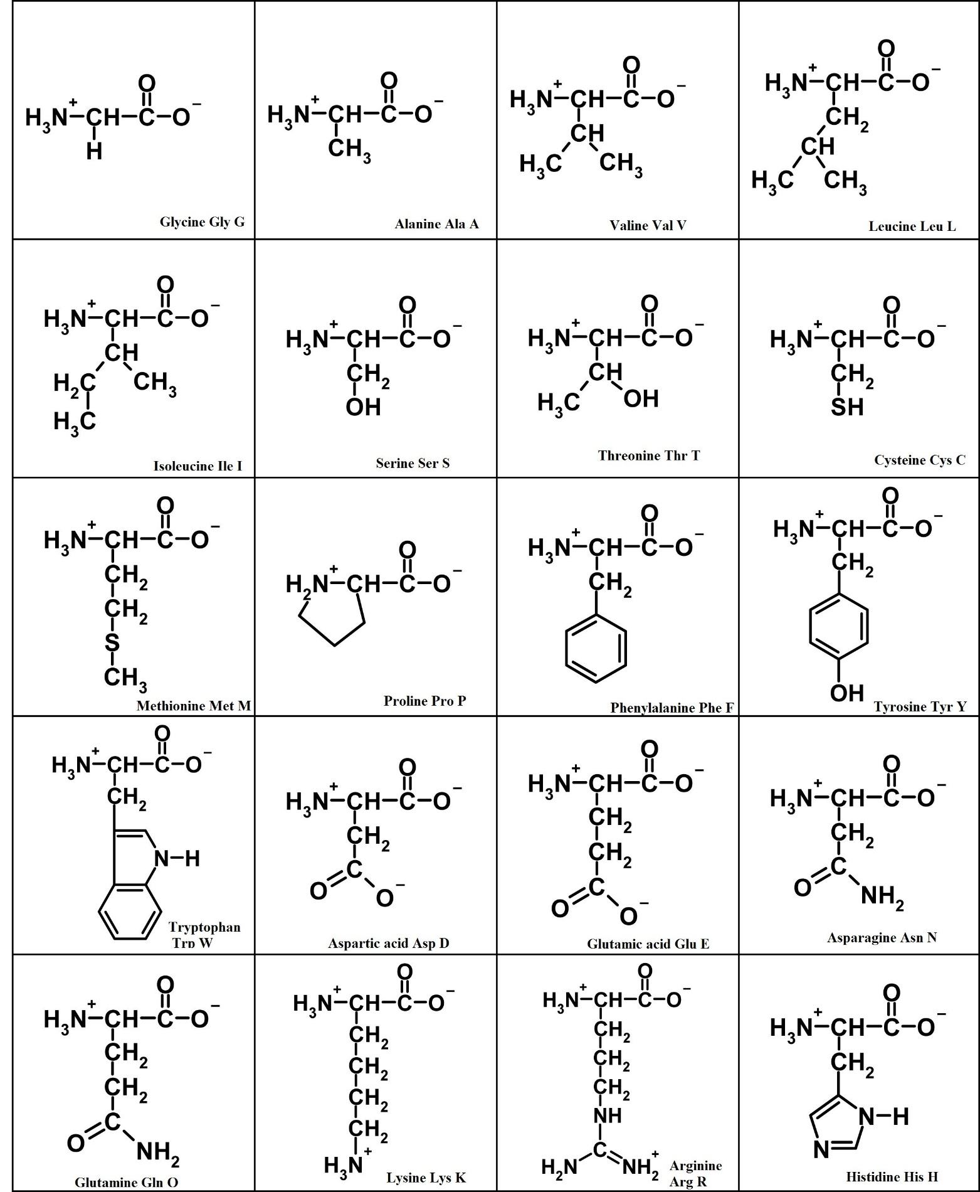

There I did it. I got you to look at the table of all 20 amino acids. I don’t think I see an amino acid that has -CH2-CH3 attached to the bottom of the central carbon. There is an amino acid with -CH2-OH attached (serine). How about the amino acid that has -CH2-SH attached? That one is cysteine. That’s an important one. But as you can see, it is not a complicated one. Why is cysteine important in the world of amino acids? Two of them can bind. Take a look below.

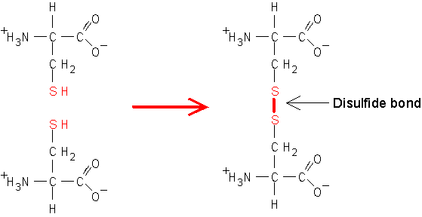

So if you have two (or more) cysteines in a single protein chain of amino acids, this same protein chain of amino acids can loop back on itself and bond at this disulfide bond.

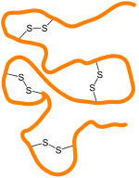 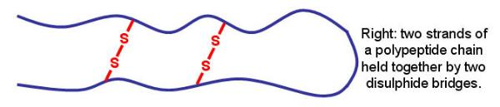

Or this disulfide bond can bind two separate protein chains together.

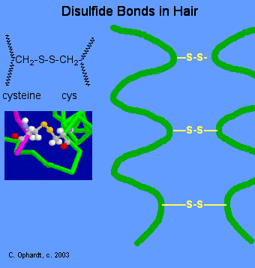 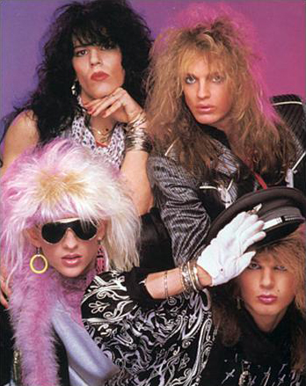

<http://chemistry.elmhurst.edu/vchembook/568hairwave.html>

Cysteine an important amino acid.

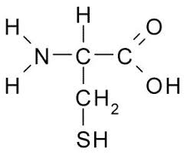

Go ahead and scroll back up to that nice table of the 20 amino acids. Take a look at tyrosine. See how pretty it is. Trouble is, with such a large ‘R-group’ attached, it is never drawn as seen below on the left in such a way where we’d recognize it immediately. But unfortunately it is drawn as seen below on the right.

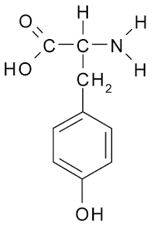 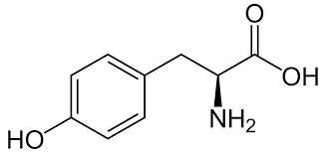

You’ll have to know tyrosine’s structure because so many things are made from it. What you ask? Well, how about the very important neurotransmitters epinephrine and norepinephrine and dopamine.

Back when I was your age, when dinosaurs roamed the earth, I was required to know all 20 amino acids and their chemical properties. So once upon a time, way back in the olden days I too expected my students to know the chemical properties of all 20 amino acids. But students complained. I got called into a ‘meeting’ with administration. Those meeting are never good news. I was asked why have my students learn so much detailed information? Couldn’t they just look it up on the internet (you see this was back when the internet was just beginning)? I sheepishly said I did it back in my day and they could do it too. Well, I was told not to have my students learn the chemical properties of all 20 amino acids. But before I left that meeting I remembered something my buddy Lloyd told me, ‘everything is negotiable’. And that’s good advice to you all even now. So before leaving the meeting I asked, ‘how about I have my students learn just 3 amino acids?’ I got the administrator to agree. So for all these years I get to have you learn these three amino acids:

Glycine; Alanine; and Tryptophan.

Let me get back to discussing proteins. Hopefully now you get it though. A protein, every protein is just a string of these 20 amino acids. Below is the amino acid sequence for human growth hormone. Nice. But once the order of the amino acids is known, it is important to know what this, or any, protein really looks like in the blood or in the body. The final working version of any protein is not a long, string of spaghetti noodle. It is folded into an exact 3-dimensional shape. It is the 3-dimensional shape of every protein that determines what it will do. What it reacts with, what it will bind to, you get the picture. So below this image of the order, or sequence, of the amino acids of human growth hormone is the way it is folded, its 3-dimensional shape, its working shape.

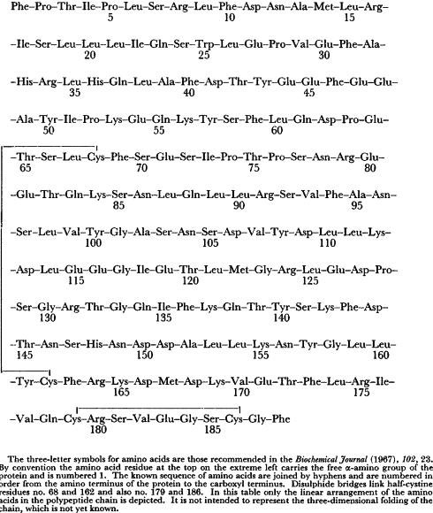

Below is human growth hormone folded into its working, functional, shape.

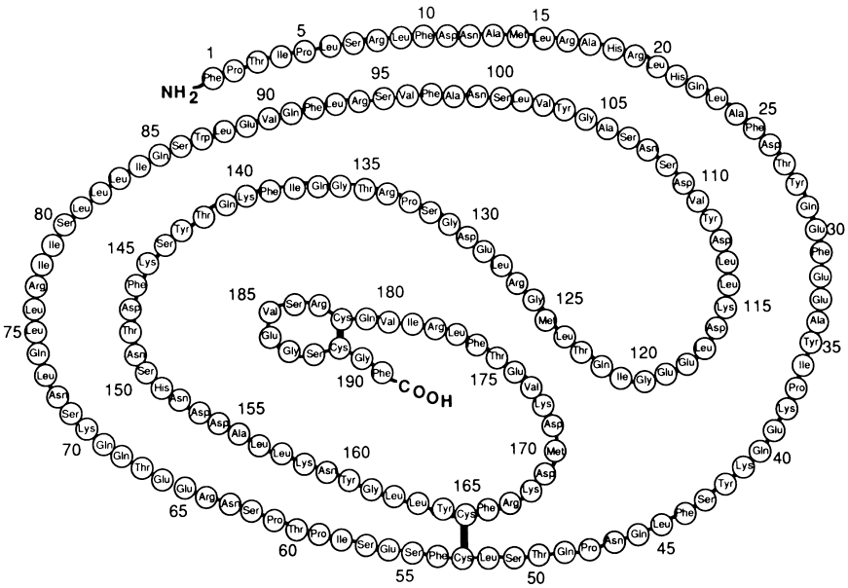

Hey, hey, hey! Look! Look! Look! I see spots where the loops of human growth hormone interconnect. Do you see them too. The thick black lines. One part of the strand is attached to another part of the strand after it loop back on itself. And if you look closely, the amino acids that form those thick, black lines of attachment, those cross-links, are Cys with their disulfide bonds! Ah, we know so much already.

Yep, I’ll have us look at insulin also.

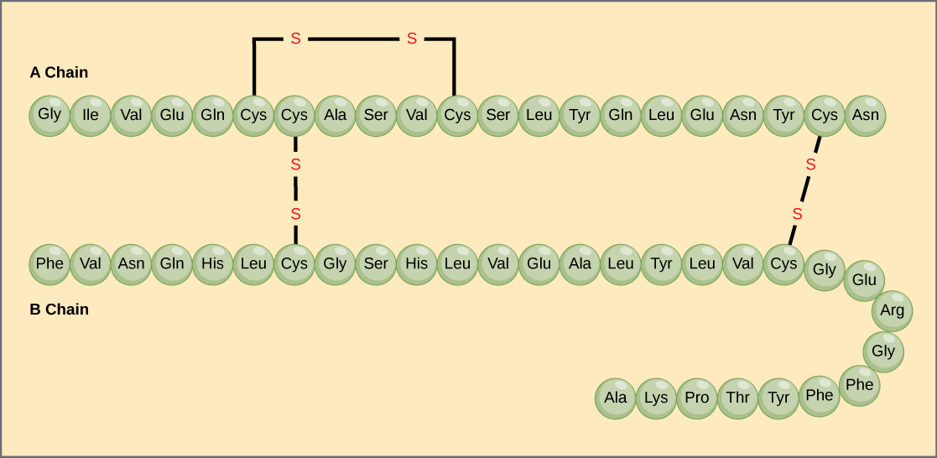

Looks to me that insulin has two chains of amino acids interconnected with those disulfide bonds made by cysteines. The one protein is the A-chain and the second protein is the B-chain. Where do the two protein chains, the A-chain and the B-chain, come from? Well, I guess they are made from two separate genes. mRNAs are transcribed from the two genes, that mRNA is translated by ribosomes into the two protein chains. Now if you don’t know about mRNAs or transcription or translation you can read this part again after we explain in later. But my point is right now an interesting fact about how the A-chain and the B-chain of insulin are made. There is just one single insulin gene, transcribing one mRNA which is translated into one string of amino acids in order to make the insulin protein. Take a look to see that the one single string of amino acids is folded and cut to ‘assemble’ the final insulin hormone. Follow along looking at the diagram below. A single insulin gene transcribes a single mRNA that is translated into a single strand of protein, a single string of amino acids. Now that strand is folded back on itself you see on the upper left. Once it is folded back on itself some of our new BFFs, the disulfide bonds from the amino acid cysteine, form holding the strand into its new coiled shape. Once those disulfide bonds are formed, a piece of the strand is just cut out (cleaved away). You see that the cleaved portion is colored in beige inside the endoplasmic reticulum of the cell (what cell of the pancreas?) So now you have the molecule on the upper right of the diagram below. Now the green portion is cut away leaving the A-chain and B-chain connected and oriented just the right way, just in the right positions. Very cleaver of the cell! Everything has to have a name. The final product, the nicely aligned A-chain and B-chain connected is ‘insulin’. The molecule right before it in this step by step process is ‘proinsulin’ and you see labeled the molecule for proinsulin in this step by step process is preproinsulin. Good Stuff! Right?

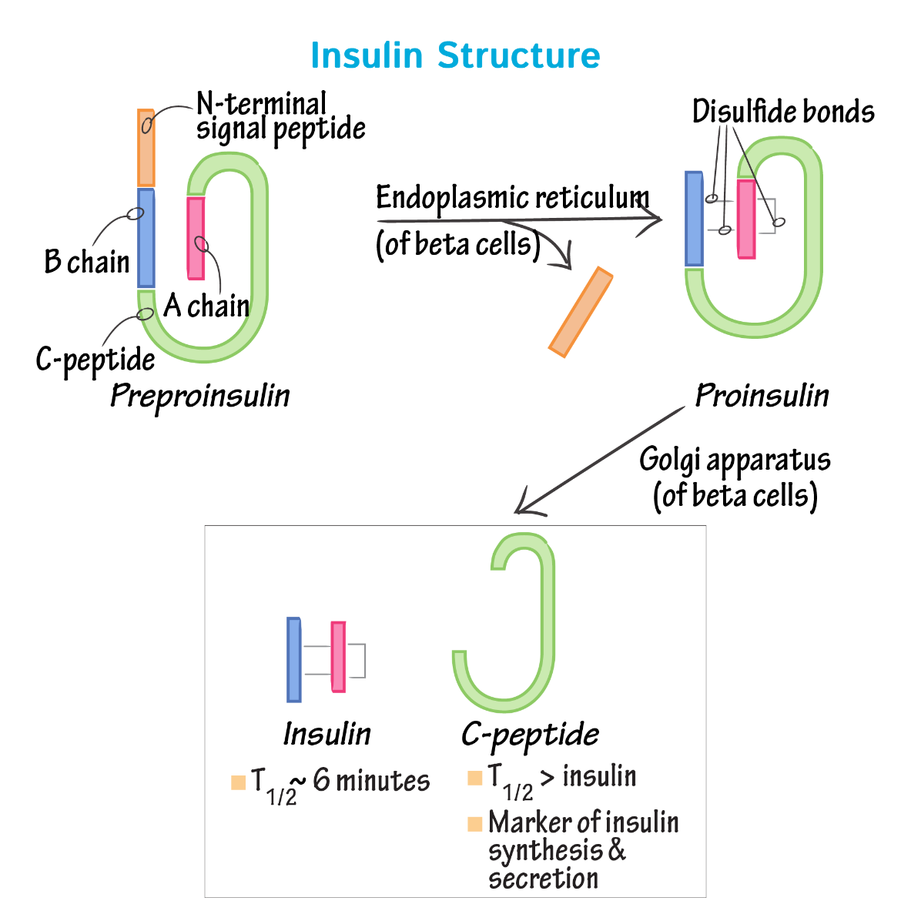

Let me just mention that the cleaved green fragment, labeled ‘C-peptide’, is also a functional molecule. Very efficient.

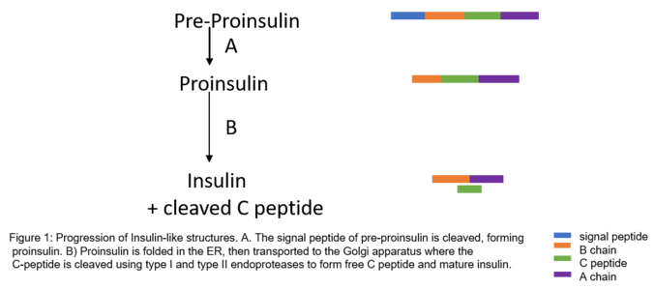

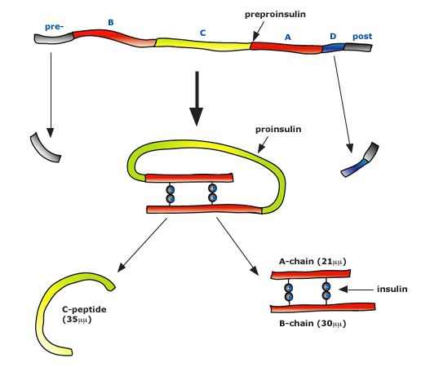

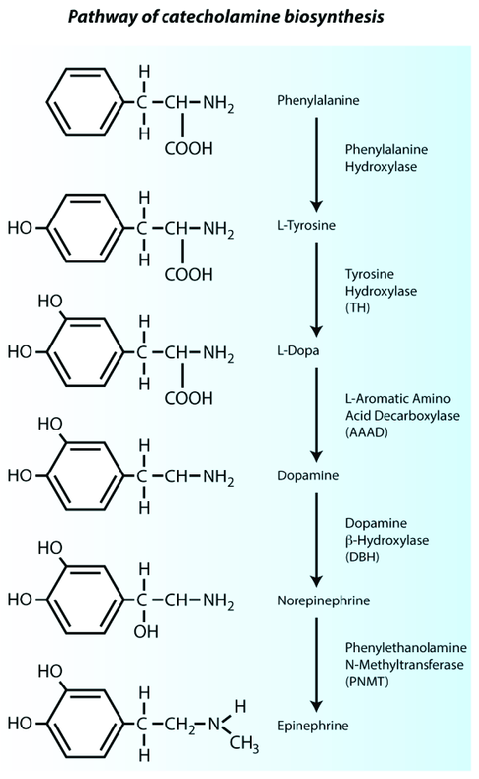

And next look at tryptophan. It is the precursor in the synthesis of the important neurotransmitter serotonin (5-hydroxytryptamine, 5-HT. Its structure is a bit complicated so we won’t have to know its structure, but it will be important to remember its role in the synthesis of serotonin.

Did someone mention collagen? The protein collagen?

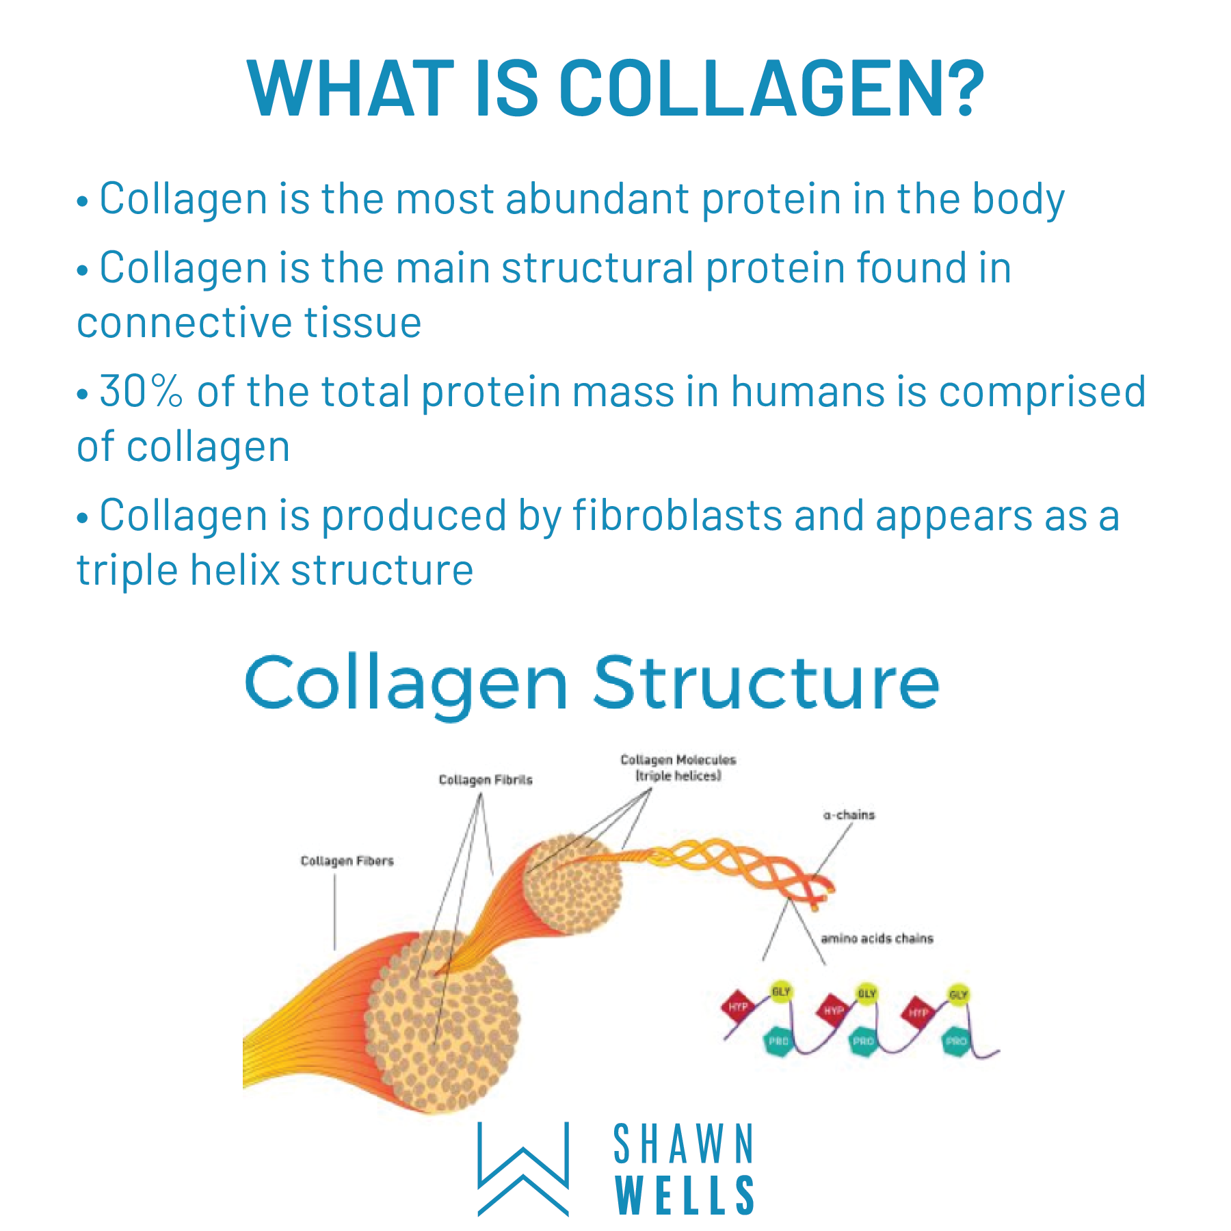

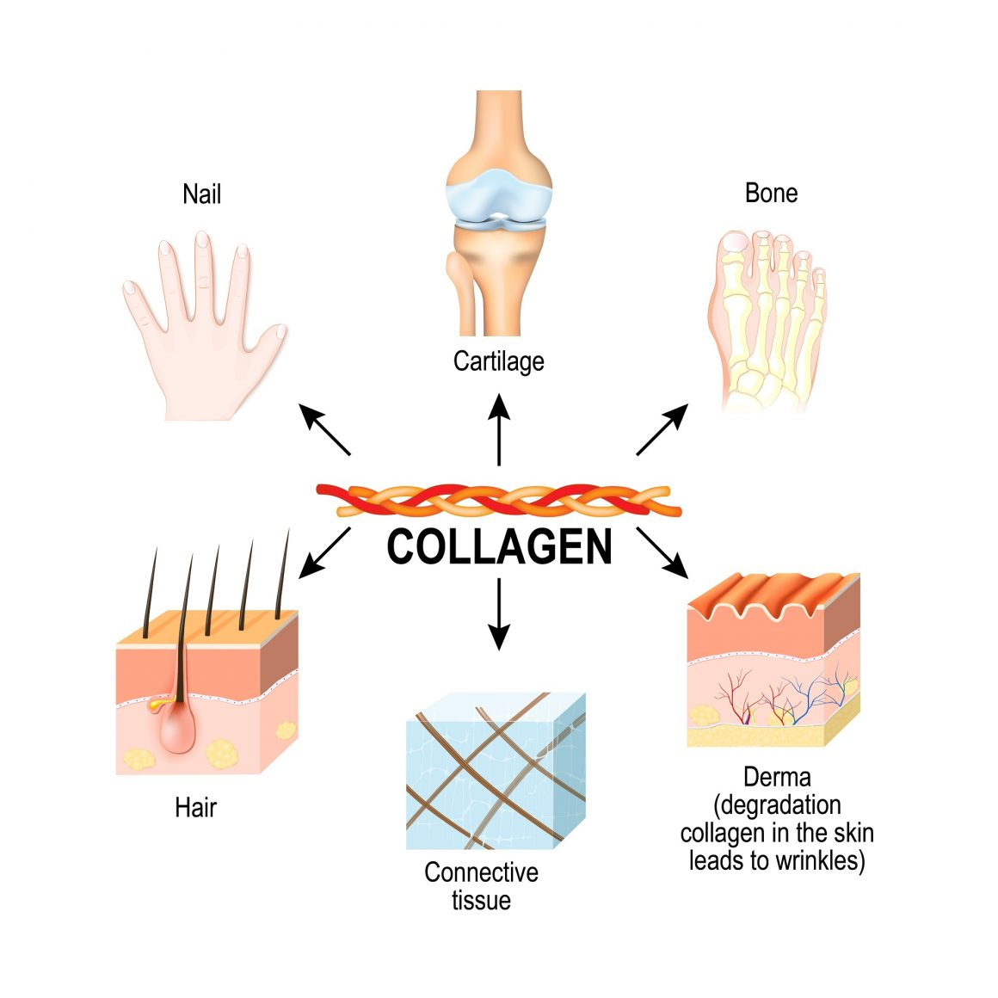

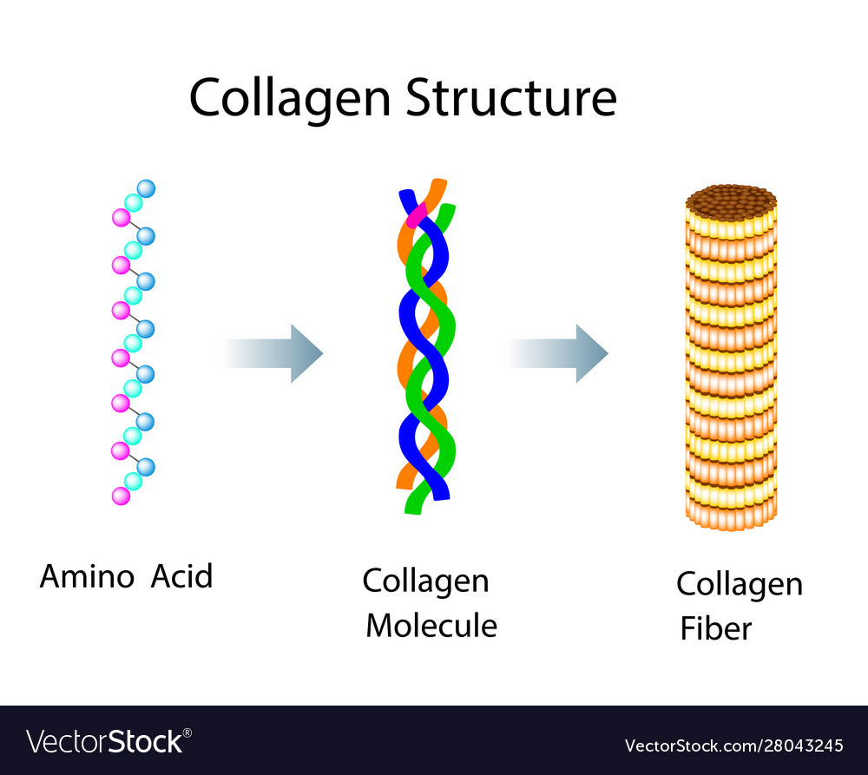

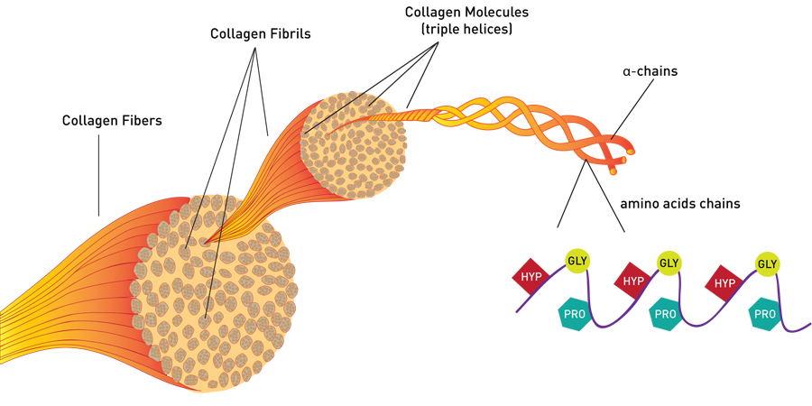

To make the collagen fiber you have to start by making the amino acid sequences, protein strands, for two proteins: the alpha-1 protein and the alpha-2 protein. Take two of the alpha-1 proteins and one of the alpha-2 proteins and wrap them up. They make a triple helix. This triple helix has the loose ends clipped off making the final version called tropocollagen. These tropocollagens are packaged together to make the thick, strong collagen fibril. Bundles of these collagen fibrils are then wrapped together to make the Achilles tendon.

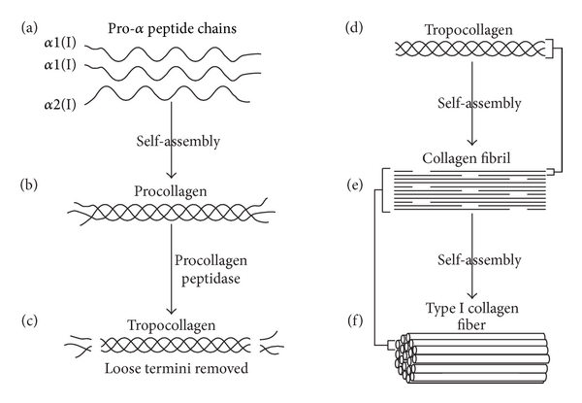

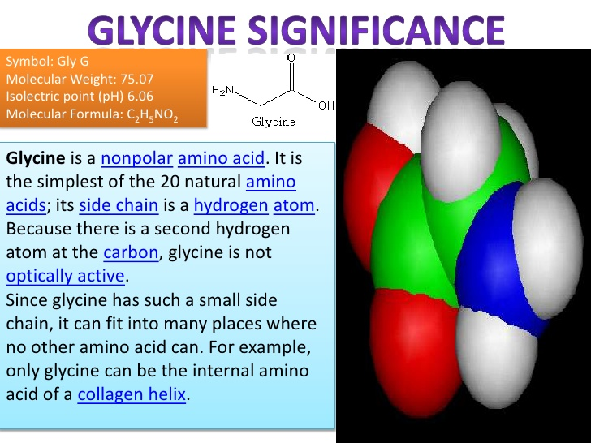

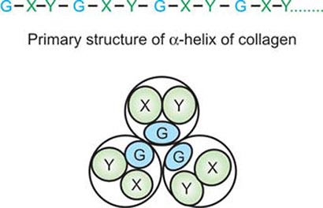

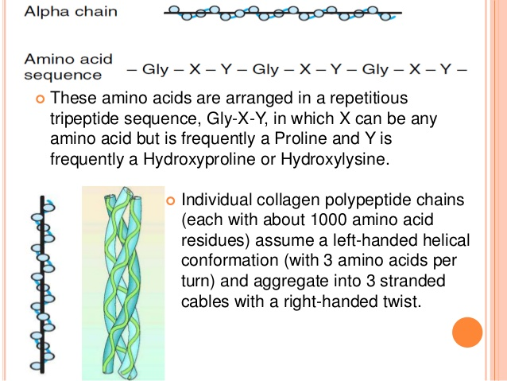

By the way, Vitamin-C is necessary for the enzymes that allow the three fibers to be stable as a triple helix. A deficiency in Vit-C causes scurvy.

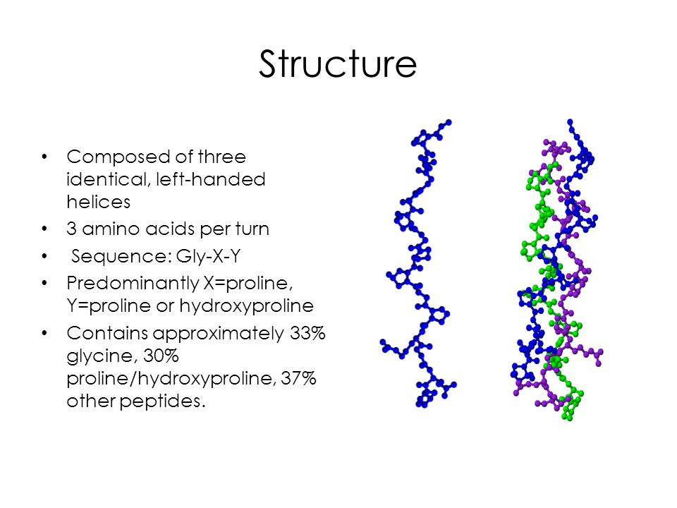

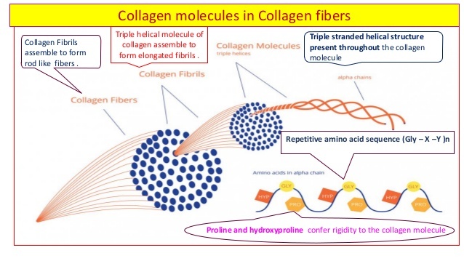

One more thing to mention about proteins. They are made as a linear string of amino acids. But then they must be folded or paired up with other protein strands. It is this final 3-dimensional shape that gives the protein its function. It is the 3-dimensional shape of the growth hormone protein that allows it to work. So the final, 3-dimensional shape of all proteins that allow them to ‘work’ in the body. So we need to describe what each protein looks like in its 3-dimensional shape. That’s not easy. How do you describe anything’s 3-dimensional shape with just words. You see, biochemists have been doing this way before the advent of the internet and cell phone cameras. How would you, using an old fashioned land line telephone, describe to me with just words what an apple with a bit out of it looks like….exactly? That would be difficult. In order to do this, biochemists have made up a series of ‘rules’ on how to describe a protein’s 3-dimensional shape. They are a protein’s: (1) primary structure; (2) secondary structure; (3) tertiary structure; (4) quaternary structure.

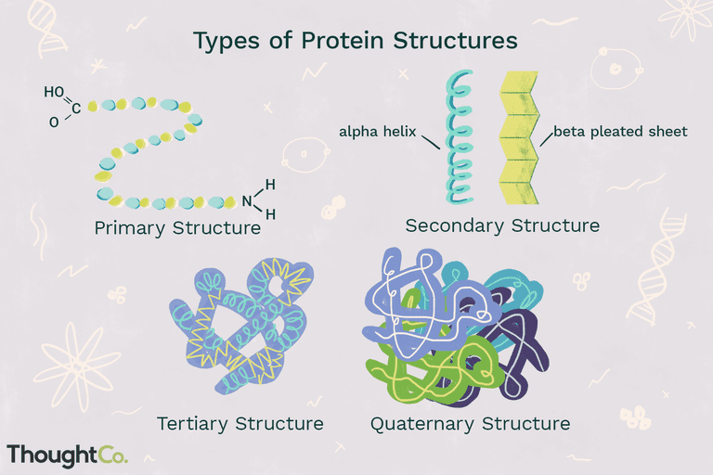

The ‘primary structure’ is simply to state in words the sequence of the amino acids in that protein.

The ‘secondary structure’ is to describe any ‘small’ curves or loops. You can read about the alpha helixes and beta-pleated sheets.

The ‘tertiary structure’ is to describe large curves or angles.

The ‘quaternary structure’ is to describe if that protein happens to have more than one protein strand in it.

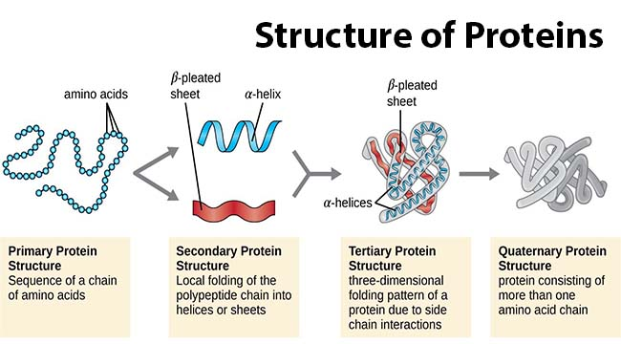

<https://www.youtube.com/watch?v=hok2hyED9go>

<https://www.youtube.com/watch?v=O5gN-IK6uKs>

How do you connect individual amino acids to make a protein strand anyway?

<https://www.youtube.com/watch?v=Bsk9hvXDJp8>

Just like we did in order to link together glucoses to make a polysaccharide, the dehydration synthesis. We remove a -OH and an -H to form water and we then link the two broken bonds between the two amino acids.

<https://www.youtube.com/watch?v=2Jgb_DpaQhM>

What allows a protein to ‘work’ is its 3-dimensional shape. If you were to change or disrupt the protein’s 3-dimensional shape it will not ‘work’. To change a protein’s 3-dimensional shape is to denaturation a protein. Notice, denaturation will destroy a protein’s quaternary, tertiary and secondary structure. But denaturation will not break the protein strand apart. Denaturation will not destroy or break a protein’s primary structure. One of my favorite multiple choice questions.

Denaturation:

<https://www.youtube.com/watch?v=3IL_Df5ouUc>

<https://www.youtube.com/watch?v=gEycDKQn93Y>

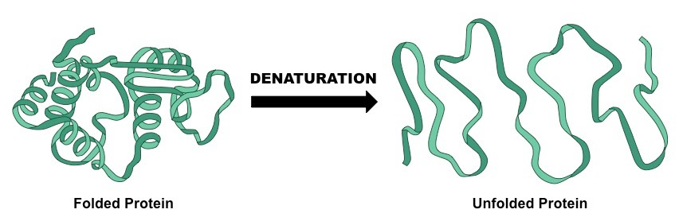

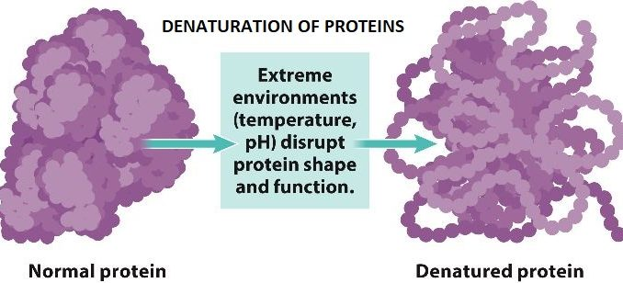

The End.

<https://www.youtube.com/watch?v=PmbcA1Sav7s>

<https://www.youtube.com/watch?v=1peFJ_-N7V8>