**Be able to draw:**

GLUCOSE;

DEHYDRATION SYNTHESIS AND HYDROLYSIS REACTIONS INVOLVING TWO GLUCOSE MONOSACCHARIDES;

An AMINO ACID;

DEHYDRATION SYNTHESIS AND HYDROLYSIS REACTIONS INVOLVING TWO AMNO ACIDS AND A DIPEPTIDE;

**Be able to recognize the following molecules:**

-glucose

-ribose;

-deoxyribose;

-fructose;

-galactose;

-cholesterol;

-the phosphate group;

-a phospholipid;

-the amino acid= valine;

-the amino acid= cysteine;

-cytosine;

-thymine;

-uracil;

-adenine;

-guanine;

-maltose;

-sucrose (see below);

-lactose;

-A=T base paired together;

-G=C base paired together;

-a saturated triglyceride;

-an unsaturated triglyceride.

Sucrose, the disaccharide of glucose plus fructose. But it is drawn two different ways in the textbooks and on the interwebs. Sometimes sucrose is drawn with glucose and fructose side-by-side and sometimes sucrose is drawn with glucose above fructose (as it is in our textbook).

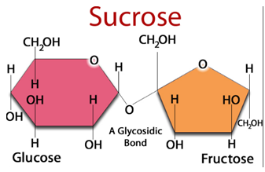 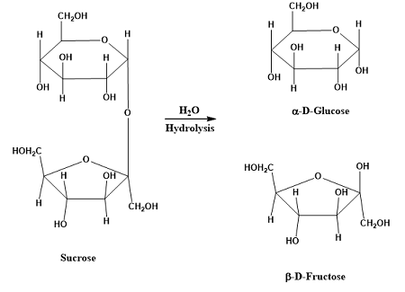

So let me tell you why both of these depictions exist. Let’s remind ourselves of the numbered carbons in both glucose and fructose. Directly below is glucose, with carbons #1-6 labeled. Below to the right is fructose with its carbons labeled.

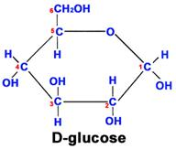 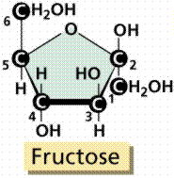

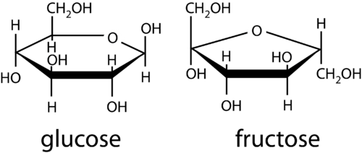

Notice that both glucose and fructose have carbon #6 ‘outside of the ring’. Fructose is different because carbon #1 is also ‘outside of the ring. Fructose has two carbons (#1 and #6) outside of the ring.

If we were going to link two glucoses together to make the disaccharide maltose, we’d create a bond between carbon #1 of the glucose on the left and carbon #4 of the glucose on the right, an ‘alpha’ 1,4 linkage:

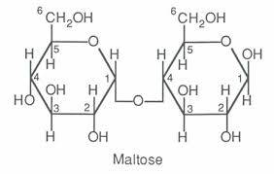

Here’s the interesting part of sucrose. **The linkage is a 1,2 linkage**. Carbon #1 from glucose but carbon #2 of fructose. So how to draw this? One way is to have glucose’s carbon #1 above fructose and its bond moving straight down to reach carbon #2 of fructose:

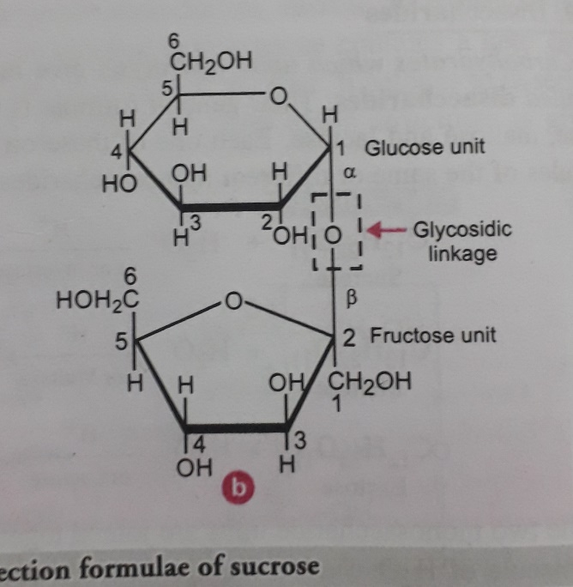

So remember sucrose has a 1,2 linkage. Here is something a lot of diagrams of the structure of sucrose will do. They will number the carbons on fructose BACKWARDS! By numbering the carbons on fructose backwards, you can have glucose and fructose side by side, see below and notice the numbering of the carbons:

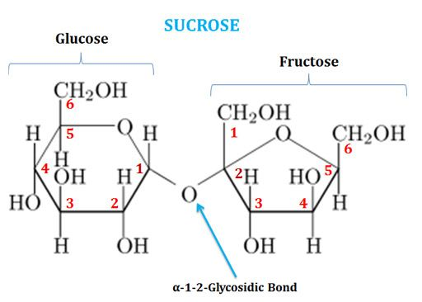

So there it is, explanations for why you will find sucrose drawn two different ways structurally.