Triglycerides (Fats):

Welcome to fat. Is ‘Fat’ the same as a ‘Triglyceride’? Let’s see what the interwebs say about triglycerides.

**Triglycerides** are a type of fat (lipid) found in your blood. When you eat, your body converts any calories it doesn't need to use right away into **triglycerides**. The **triglycerides** are stored in your fat cells. Later, hormones release **triglycerides** for energy between meals.

A triglyceride (TG, triacylglycerol, TAG, or triacylglyceride) is an [ester](https://en.wikipedia.org/wiki/Ester) derived from [glycerol](https://en.wikipedia.org/wiki/Glycerol) and three [fatty acids](https://en.wikipedia.org/wiki/Fatty_acids) (from [*tri-*](https://en.wiktionary.org/wiki/tri-#Prefix) and [*glyceride*](https://en.wikipedia.org/wiki/Glyceride)). Triglycerides are the main constituents of [body fat](https://en.wikipedia.org/wiki/Body_fat) in humans and other vertebrates.

Good and bad [cholesterol](https://www.webmd.com/cholesterol-management/default.htm). Saturated and unsaturated fat. Sometimes it seems like you need a program to keep track of all the fat players in the story of [heart disease](https://www.webmd.com/heart-disease/default.htm).

Triglycerides may be the easiest to understand.

Simply put, they are fat in the blood. They are used to give energy to your body. If you have extras, they are stored in different places in case they are needed later.

A high level has been linked to a greater chance for heart disease.

You and your doctor have ways to lower your level if it is running high.

**What Are Triglycerides?**

They are important to life and are the main form of fat – they are sometimes called “lipids” -- in the body. When you think of fat developing and being stored in your hips or belly, you're thinking of triglycerides.

They are the end product of digesting and breaking down fats in food. Some are made in the body from other energy sources, such as carbohydrates. When you’re between meals and need more energy, your body’s hormones release them so you tap those unused calories.

**How They’re Measured**

Your doctor may give you a common test called a [**lipid panel**](https://www.webmd.com/cholesterol-management/guide/tests-for-high-cholesterol-lipid-panel). It checks for different types of cholesterol, including the levels of the "good" kind and the "bad" kind. The American Heart Association recommends that everyone 21 and older get a lipid panel at least every 5 years.

The levels are checked after an overnight fast. Fat from a recent meal can muddy the picture.

These tests are important because you rarely have any symptoms when your triglycerides are high, unlike with many other conditions.

Elevated levels may lead to heart disease, especially in people with low levels of "good" cholesterol and high levels of "bad" cholesterol.

[Cholesterol](https://www.webmd.com/cholesterol-management/video/bernstein-test-cholesterol-levels) is a form of fat we need. It helps make the outer membranes of our bodies' cells stable. But for decades, doctors have known that people with high total [cholesterol levels](https://www.webmd.com/cholesterol-management/guide/understanding-numbers) are [more likely to get heart disease](https://www.webmd.com/heart-disease/understanding-heart-disease-prevention). More recently, they've found the different forms of [cholesterol](https://www.webmd.com/cholesterol-management/default.htm) ("good" and "bad") also play a role. High total cholesterol, high bad cholesterol, or low good cholesterol could raise your chances.

For example, [LDL](https://www.webmd.com/cholesterol-management/ss/slideshow-cholesterol-lowering-foods), or "bad," cholesterol can stick to [blood](https://www.webmd.com/heart/anatomy-picture-of-blood) vessel walls. Over years, it can play a role in clogging [arteries](https://www.webmd.com/heart/picture-of-the-arteries) in a process called [atherosclerosis](https://www.webmd.com/heart-disease/what-is-atherosclerosis). Narrowed arteries in your [heart](https://www.webmd.com/heart-disease/rm-quiz-know-heart) can then develop sudden [blood clots](https://www.webmd.com/dvt/blood-clots), causing [heart attacks](https://www.webmd.com/heart-disease/guide/heart-disease-heart-attacks).

The American [Heart](https://www.webmd.com/heart/picture-of-the-heart) Association recommends that everyone over age 20 get a [cholesterol test](https://www.webmd.com/cholesterol-management/ss/slideshow-cholesterol-overview) so you know what your levels are and can do something about them if you need to.

**Cholesterol Tests: The Good, the Bad, and the Fatty**

The different kinds of cholesterol and other fats in your blood are together called lipids. Doctors measure and diagnose lipid problems with a simple blood test. You'll probably have to [fast](https://www.webmd.com/diet/fasting) for 9 to 12 hours before it to make sure it's not affected by any food you recently ate.

A lipid profile usually gives results for four different types:

* Total cholesterol
* [LDL](https://www.webmd.com/cholesterol-management/video/bernstein-ldl-cholesterol-level-strive) (low-density lipoprotein), the "bad cholesterol"
* HDL (high-density lipoprotein), the "good cholesterol"
* [Triglycerides](https://www.webmd.com/cholesterol-management/lowering-triglyceride-levels), another form of fat

Some lipid panels can give even more detailed information, like the presence and sizes of various fat particles in your blood.

High [triglycerides](https://www.webmd.com/cholesterol-management/high-triglycerides-treatment-12/slideshow-triglycerides-tips) (150 mg/dL or greater) also raise the odds for heart disease.

OK, no more ‘cut and paste’ stuff from the interwebs. You know Paul, the above ‘cut and pasted’ stuff didn’t real add any clarity to any of this.

Firstly, let me tell cholesterol to just ‘butt out’. Right now we’re talking about triglycerides. But once you begin the topic of blood levels of triglycerides, cholesterol has to take over the conversation. I do like the way cholesterol looks, 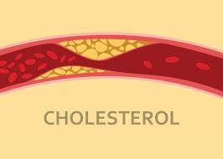, WAIT, that’s unhealthy, having cholesterol deposits lining and blocking your blood vessels, I don’t like that look at all. I meant I like the way cholesterol looks structurally: 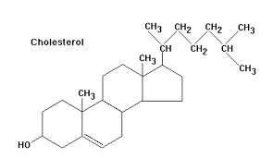

The neat set of rings, 3 with 6 corners and the upper one with 5 corners. One day you’ll look at the structure of testosterone and estrogen and you’ll recognize cholesterol in their structures. And just ‘cool your jets’ cholesterol. I know, the big deal about ‘good cholesterol’ and ‘bad cholesterol’.

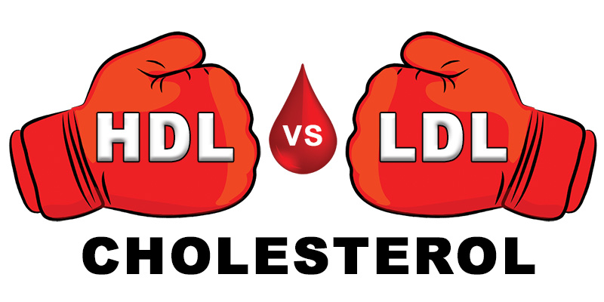

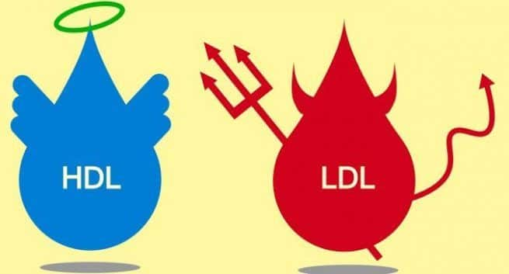

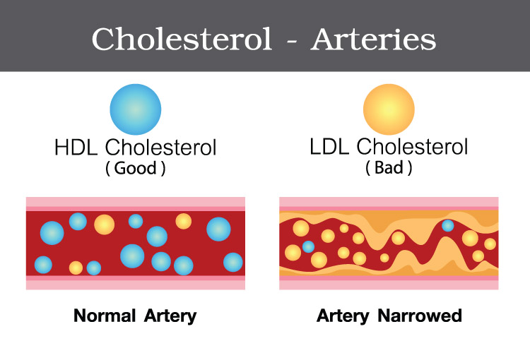

So let’s take a sample of your blood and measure you ‘fat’ level in your blood. Actually there are several things that the lab will measure, one of which is ‘triglyceride’ level. But once you start talking about the ‘lipid panel’ and your blood test results for ‘fats’, immediately everyone focuses on cholesterol. Jeez, cholesterol, you always dominate every conversation. So I mean it, get lost! You’ll get your turn later in the course. I want very much right now to talk about triglycerides thank you very much.

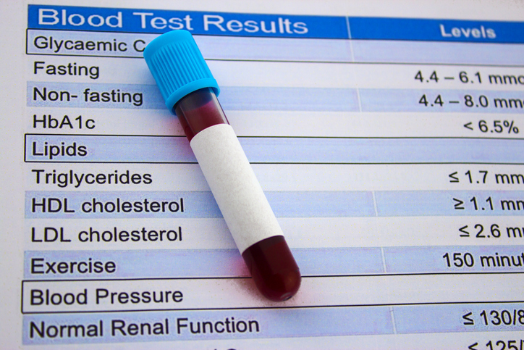

So let me start my discussion on triglycerides by saying that triglycerides are similar to phospholipids. One (the triglycerides) have three tails and the other (phospholipids) have two tails. Oddly, cholesterol is included when talking about triglycerides because cholesterols chemically act like triglycerides (cholesterol and triglyceride have very similar chemical properties) although as your noticing cholesterol looks nothing like a triglyceride. So all three of these type of molecules are called “Lipids”. “Lipids” is the overarching title for all three of these types of molecules.

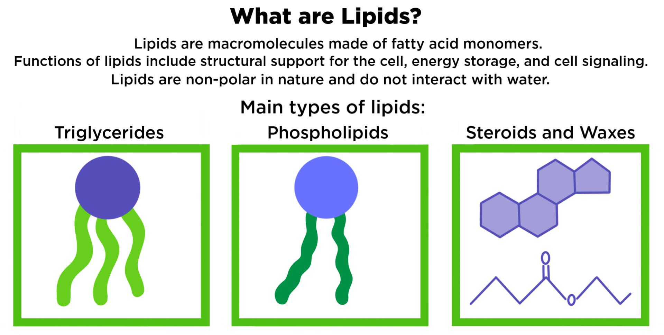

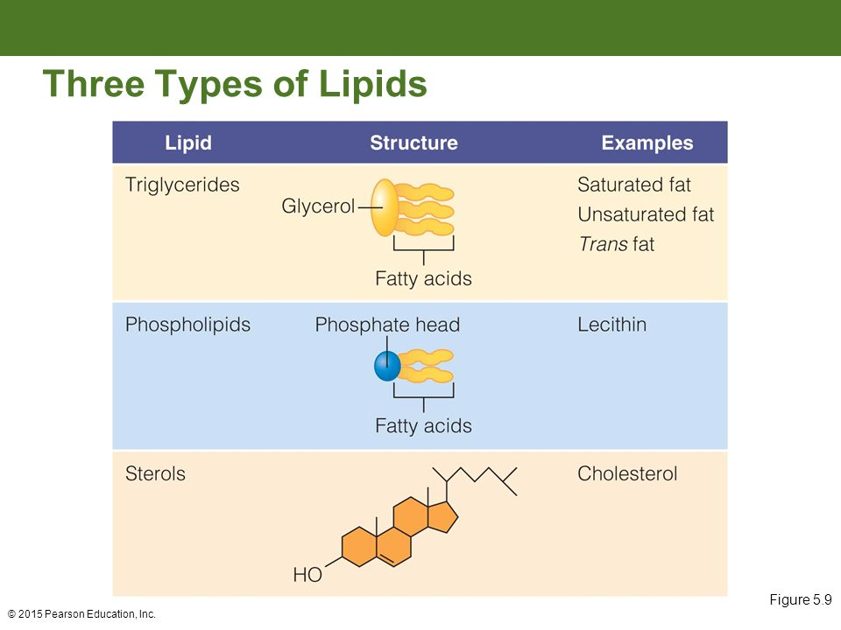

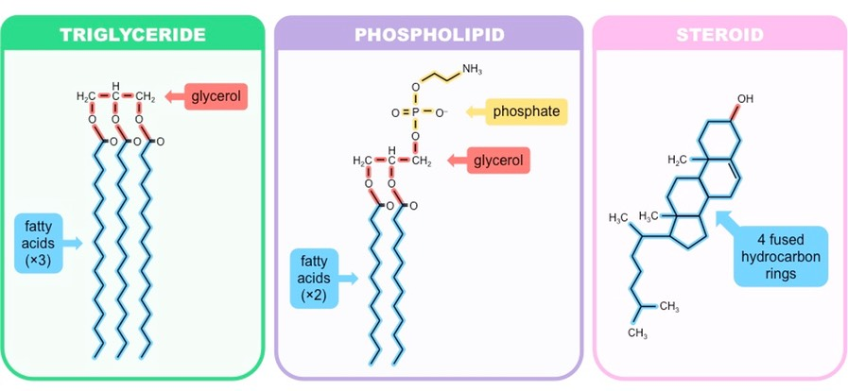

OK, so we got off to a confusing start. But I get it now. We should have started this whole discussion by titling it ‘lipids’ and then moved into triglycerides. Triglycerides are one of three types of lipids. One other type of lipid is cholesterol with its cool structural shape. So we can skip cholesterol for now. Now it is clear in my head. If you ask me on a quiz or an exam I can list the three types of lipids. Can we now finally start to talk about triglycerides?

Easy.

If I handed you one carbon atom you’d ask, “What do I do with this? It doesn’t even have a name. It is just a carbon atom.”

If I handed you two carbon atoms you’d ask, “Can I covalently bond them together, It’d be easier to carry them that way.”

If I handed you three carbon atoms and you went ahead and bonded them together, that would not be a complicated molecule at all. Just a 3 carbon molecule. Then I’d ask you to fill up the rest of the covalent bonds with an -OH and an -H on each of the three carbons. Any left over covalent bonds just fill ‘em up with a hydrogen.

This is what that very, very simple 3-carbon molecule would look like and it would be called glycerol:

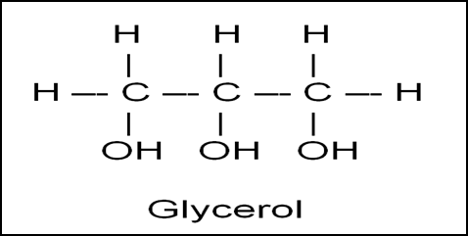

What if I drew its structure like this? Still a simple molecule:

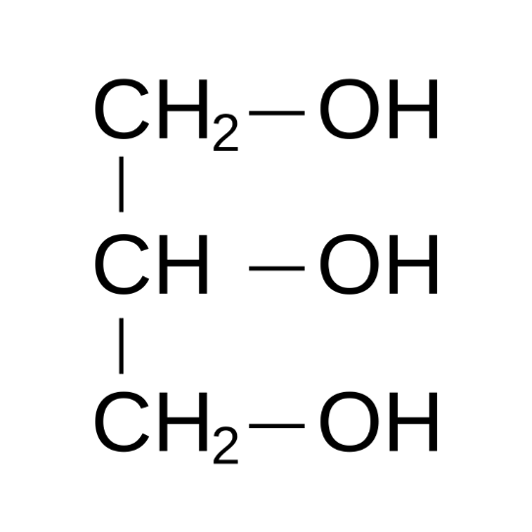

And this? If I drew it like this, you’d still be able to recognize it as glycerol: 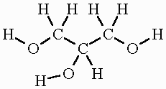

So there is glycerol. A very, very simple 3-carbon molecule where each carbon has an -OH and an -H attached with the left over bonds having an -H attached.

Now let me show you and define what a fatty acid is. First off, you know what the ‘acid’ group is. You learned it in chemistry. The ‘acid’ group looks like this:

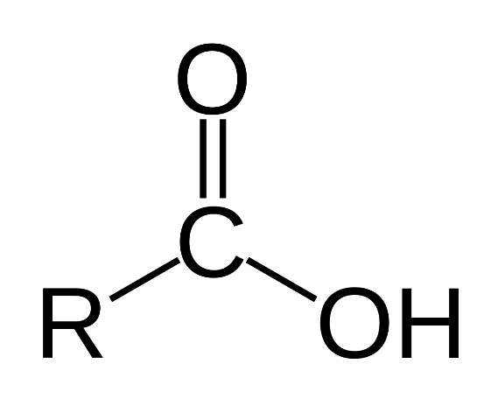

Wait a minute. We’ve done this already. I showed you the acid group when we defined the structure of the amino acids. The amino group plus the acid group attached to the central carbon. So let me take the acid group, -COOH, and add it to something very simple. How about I add this acid group onto a short or even a long string of carbons. That would be a very simple molecule, acid group at one end and extending down from this acid group is a string of carbon atoms. The additional covalent bonds the carbons have are simply filled up with hydrogen atoms. Take a look. Sure it is long, but a very simple molecule. And by the way, it would be considered a type of fatty acid.

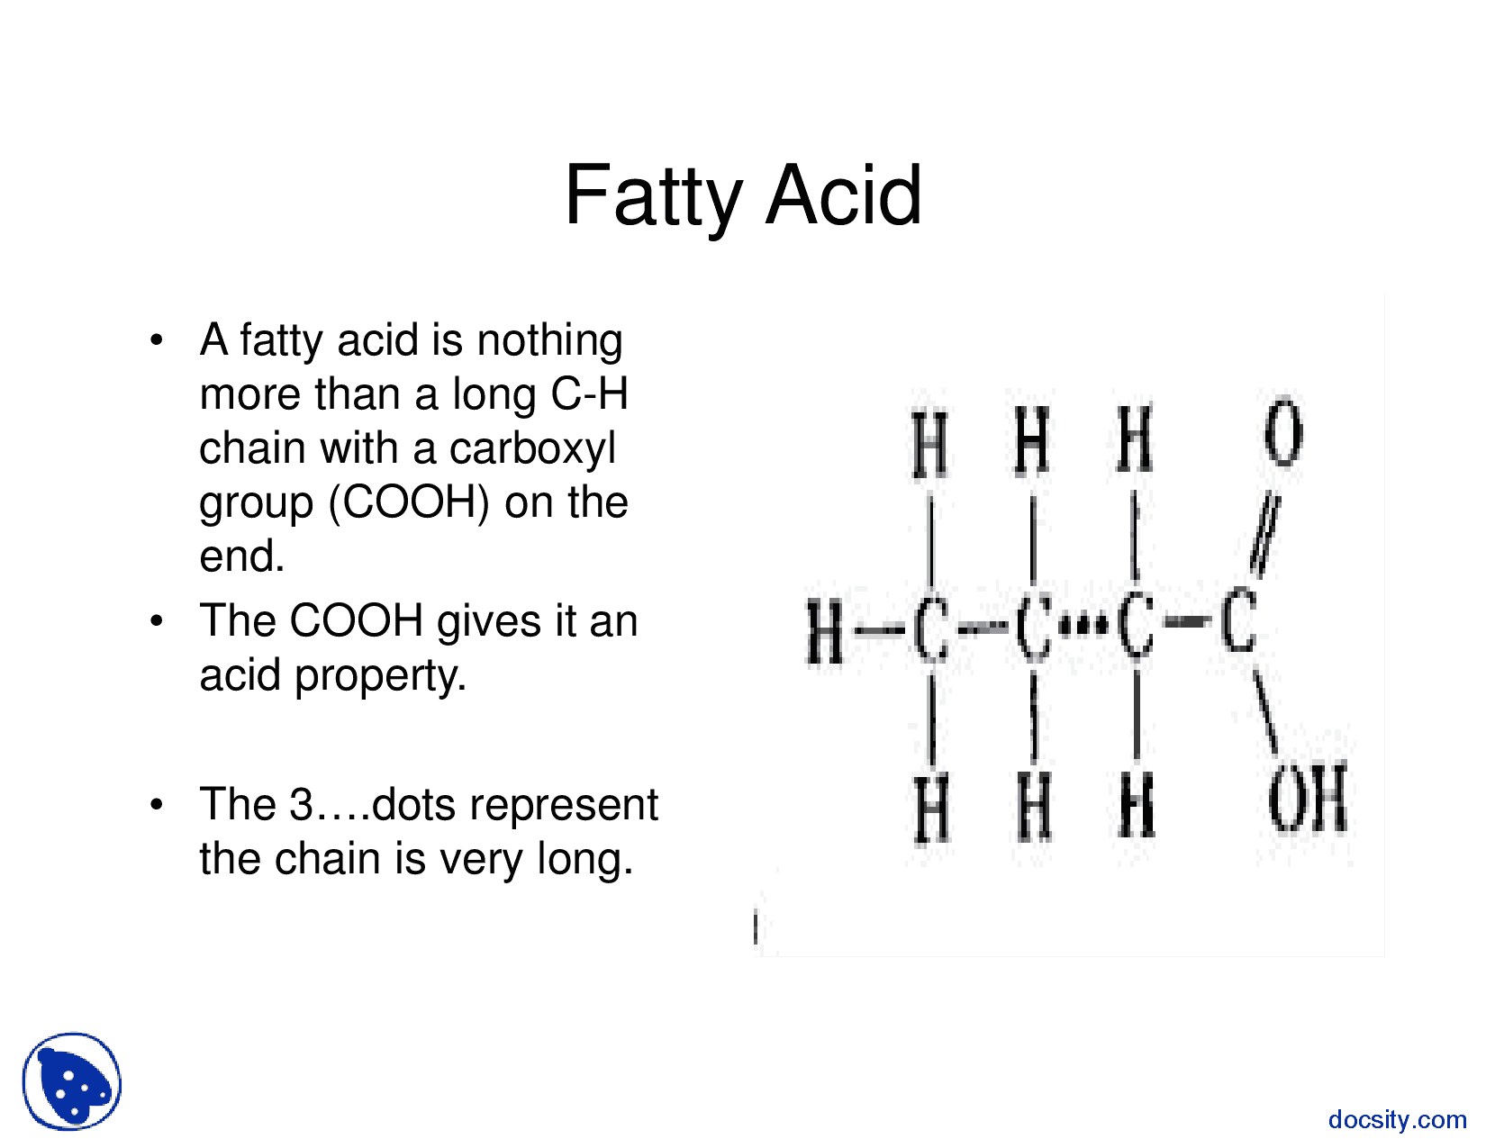

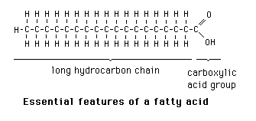

Simple molecule? Yes, we all agree. It is considered a ‘type’ of fatty acid because there can be many different fatty acids in the world depending upon how many carbons are in the tail. If you had a fatty acid with only 4 carbons, that would be a fatty acid with a specific chemical name. If there were 6 carbons in the tail, again it would be a type of fatty acid but it would have its own unique chemical name. If it had 22 carbons in its tail it would still be a type of fatty acid but would have its chemical name. So the fatty acid is simple, but what can freak people out is that when you end up looking them up, you find tables of fatty acids, all with their intimidating chemical names and that’s scary.

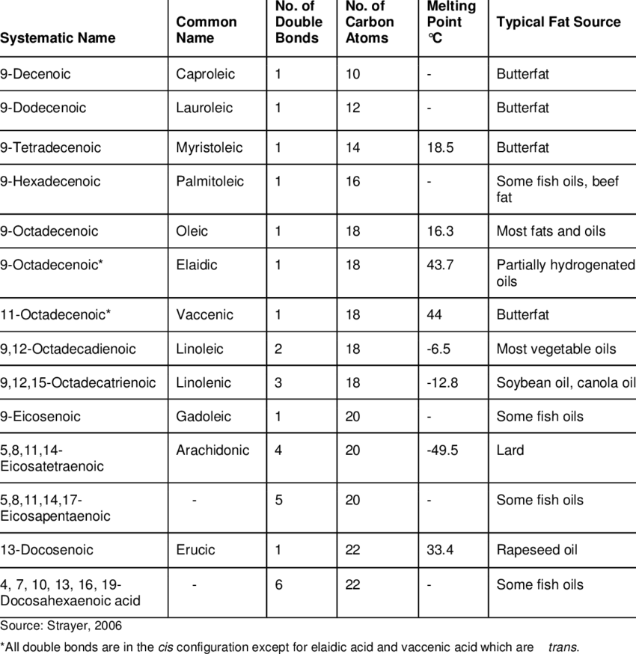

See what I mean. We won’t have to worry about learning the names of each fatty acid. We just have to agree on what a fatty acid is. You’ve heard these terms used before, so I’ll quickly define them. The carbon tails can have two carbons attached to each carbon (except the last carbon, it gets 3 hydrogens attached). That type of fatty acid is considered ‘saturated’ with hydrogens and so that fatty acid is called a saturated fat. Just that simple. Some carbons in the tail of carbons might happen to have a double bond between carbons and that would reduce the number of hydrogens attached to each one of those carbons. If the fatty acid has double bonds in it, then that fatty acid is considered an unsaturated fat. More than one double bond, you have a polyunsaturated fat.

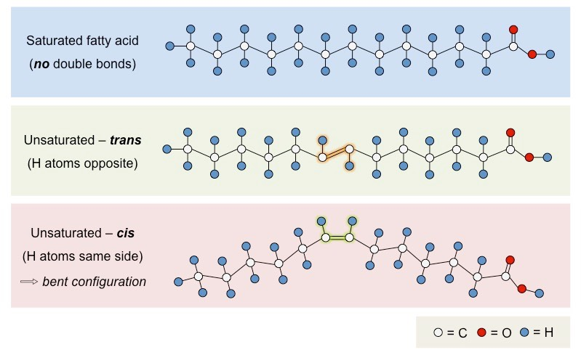

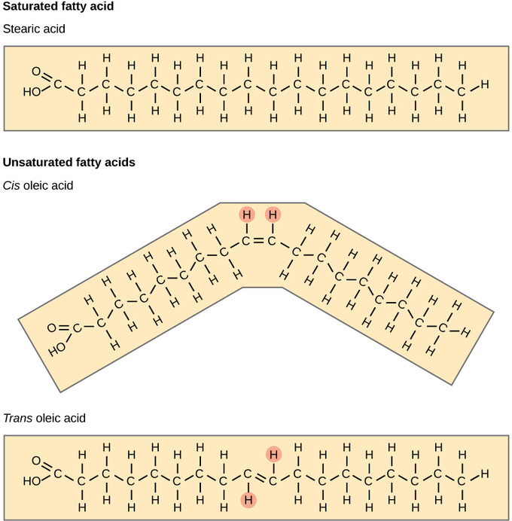

Let’s now attached three fatty acids to the three carbons in the glycerol to make a triglyceride.

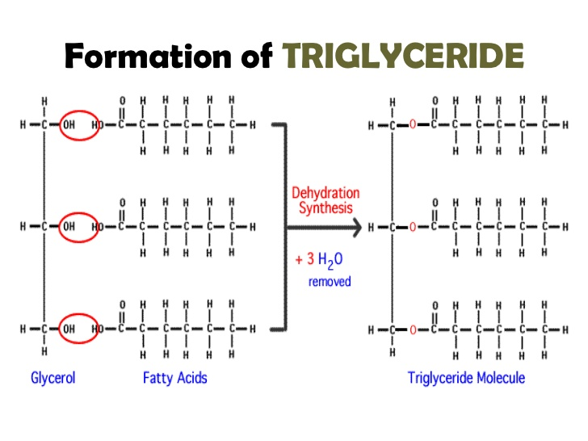

<https://www.youtube.com/watch?v=htHmxjEh4SQ>

<https://www.youtube.com/watch?v=VGHD9e3yRIU>

<https://www.youtube.com/watch?v=xIfIEKaKb04>

Big moment. Linking together monosaccharides, linking together amino acids, linking together 3 fatty acids onto the glycerol backbone are all done by dehydration synthesis with water as the byproduct. And the reverse for all three examples is the hydrolysis reaction.

Let me introduce you to a close cousin of the triglycerides. That relative to the triglycerides is the phospholipid. You can immediately see why. The triglyceride has three fatty acid tails hanging off of the glycerol backbone. The phospholipids have two fatty acid tails.

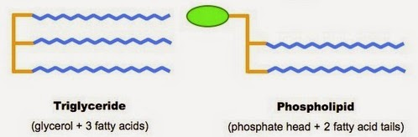

Same glycerol. Same two fatty acids attached. But to turn a triglyceride into a phospholipid all you need to do is remove of the fatty acid tails and replace it with a ‘phosphate group’. What’s a ‘phosphate group’? It is phosphate surrounded by oxygens. Phosphate that you find on your periodic table of the elements would not exist in your body (blood, cytoplasm, tissue spaces). If you have phosphate in the body, it ends up as a phosphate atom surrounded by oxygen atoms, making it the ‘phosphate group’.

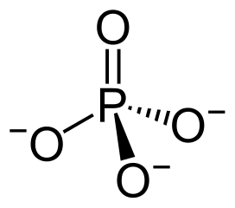 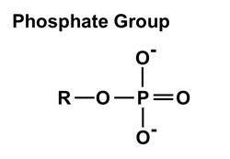

The phosphate group has a double bonded oxygen attached to the central phosphate and two other oxygens attached to the central phosphate, each of which has a negative charge associated with it. The 4th oxygen is attaching this phosphate group to some molecule, in our case attaching the phosphate group to glycerol. This makes the phospholipid.

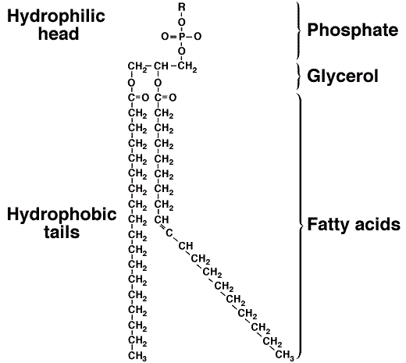

As large and as scary as this molecule appears, it is neither of those two things. We see glycerol (the backbone). We see the two tails of fatty acids. We see the third carbon of glycerol now has the famous phosphate group attached. Notice also that attached to the phosphate group is the “R”. The “R” represents something attached there. The phospholipids can have something attached to the phosphate group. Remember this diagram, that something that can be attached to the phosphate group of the phospholipid is shown as the green oval.



The phosphate group has negative charges on it. The fatty acid tails have no charge. We all understand the idea of charge. The (+) and (-) ends, or poles, of a battery have charge. We could talk very easily about things being charged and other things being uncharged. But to the chemists, they don’t use the word ‘charged’. They say ‘polar’. Something we could called charged they insist (quite strongly) we call ‘’polar”. If something has a charge, they insist quite forcefully that we say it has polarity. Water, simple water, the H2O molecule, has small charges on it. The chemists yell at us to call it a polar molecule, it has polarity. Since the central oxygen of a water molecule is larger than the tiny hydrogens the electrons are pulled in toward the oxygen and so the charged electrons are unequally distributed over the molecule and hence the central oxygen is ever so slightly negatively charged and the two hydrogens are ever so slightly positively charged. The water molecule is polar.

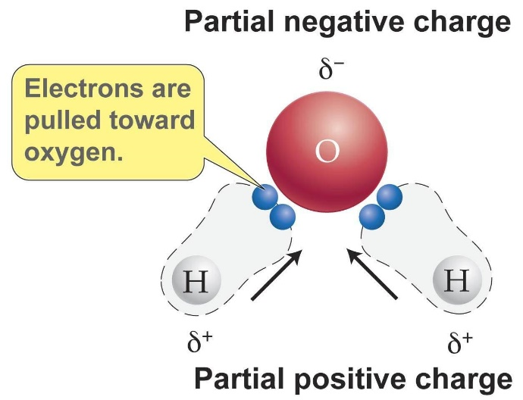

And now we’ve discovered that the phospholipid molecule is polar, but only where the charged phosphate group is located. The long tails are not charged, they are not polar. So that makes the phospholipid very interesting, part of it is polar, and another part of it is non-polar. The phosphate group (the charged part of the molecule) is right next to the glycerol backbone where everything is attached. So the glycerol backbone is considered the ‘head’ of the phospholipid and the tails are called….’tails’. The head is charged….Ooops, sorry chemists, the head is polar. The tails are non-polar.

Water is polar. The head of the phospholipid is polar. They are attracted. The small negative charges on a phospholipid head are attracted to the small positive charges in water molecules. The non-polar tails are not attracted to water because the non-polar tails have no charge to be attracted to anything. The head of the phospholipid is attracted to water and that is called being hydrophilic. The tails are not attracted to water an so are called hydrophobic.

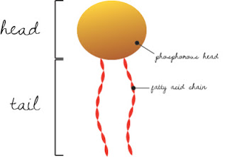 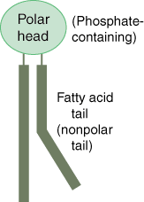 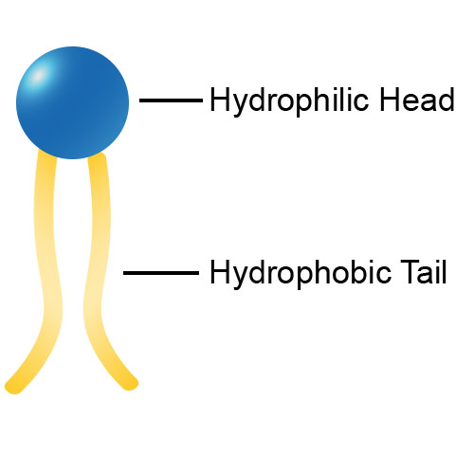

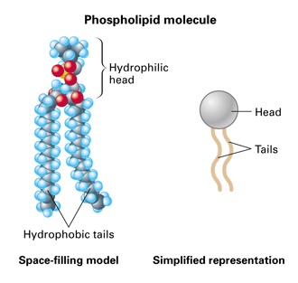

This is HUGE! Amazing and useful. If you put a bunch of phospholipids into water the phospholipids will spontaneously just line up and look like the picture below because the polar heads point outward towards the polar water molecules and the hydrophobic tails line up together in the middle.

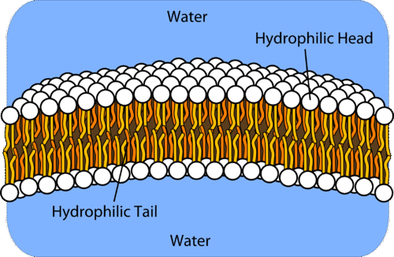

By doing nothing at all but just putting phospholipids into water, into an aqueous environment, the phospholipids will spontaneously just line up to form this phospholipid bilayer. They are not bond to each other, they are just aggregated next to each other and are banging around back and forth, even sometimes flipping between one side and the other. If one pops out of the lipid bilayer it will immediately pop back in due to its charges. Sort of like magnets.

Why this is so HUGE is because this phospholipid bilayer is exactly what the cell membrane that surrounds all of your cells is made up of!

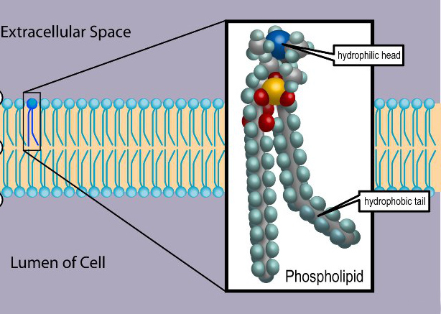

Give that a minute to sink in.

Intermixed with all these phospholipids you can find other molecules in your cell membranes. This phospholipid membrane is what makes up your lysosomal membrane, mitochondrial membrane, nuclear membrane, all membranes. You are required to know everything that has to do with membranes from Ana-1. I will be testing you on the Ana-1 material pertaining to membranes. At the end of this section is a supplement that has that information in case your Ana-1 course did not cover it. Scroll down to find it.

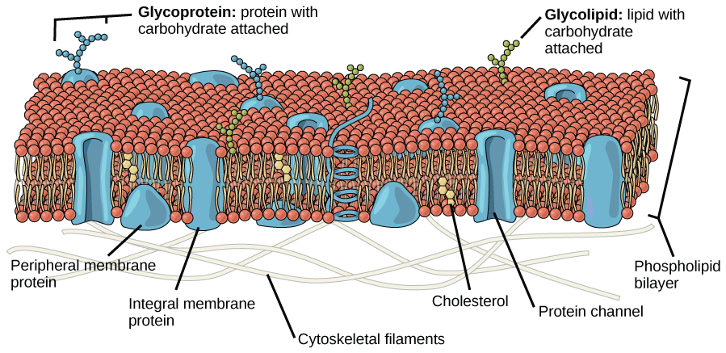

<https://www.youtube.com/watch?v=gh4ciqmXLsU>

<https://www.youtube.com/watch?v=UPSLsc6G31Q>

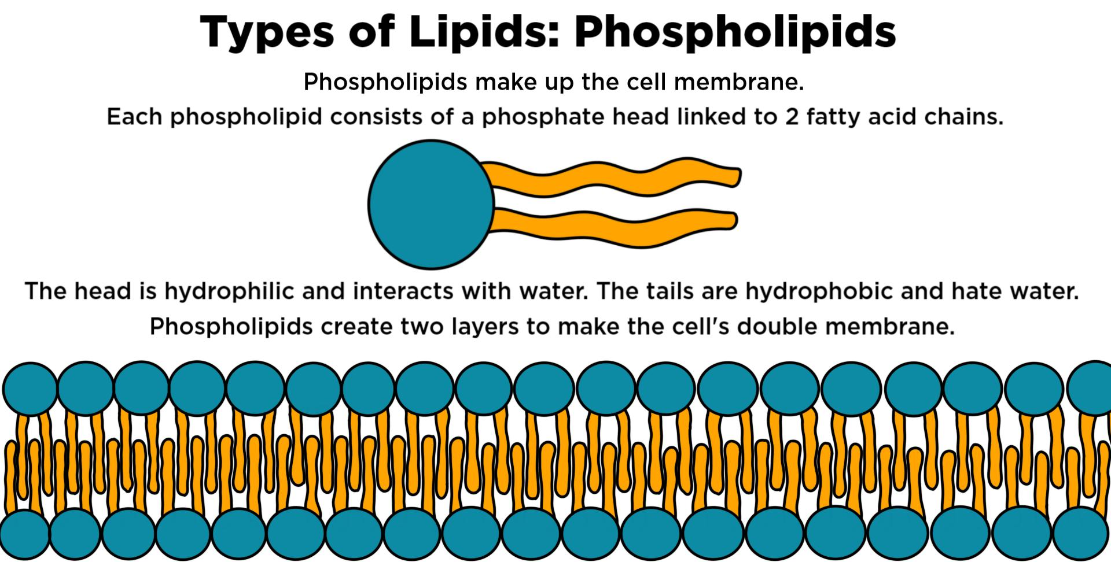



Notice in the diagram below that the phosphate group in the phospholipid has something attached to it. Yep, phospholipids have different things attached to the phosphate group making different types of phospholipids.

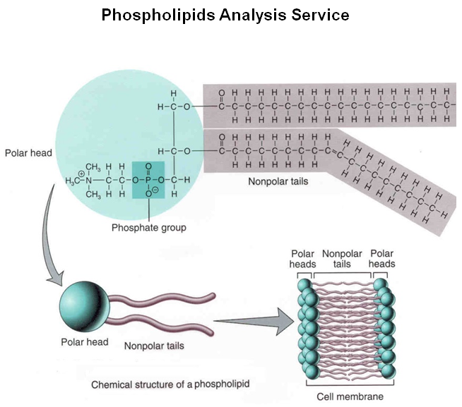

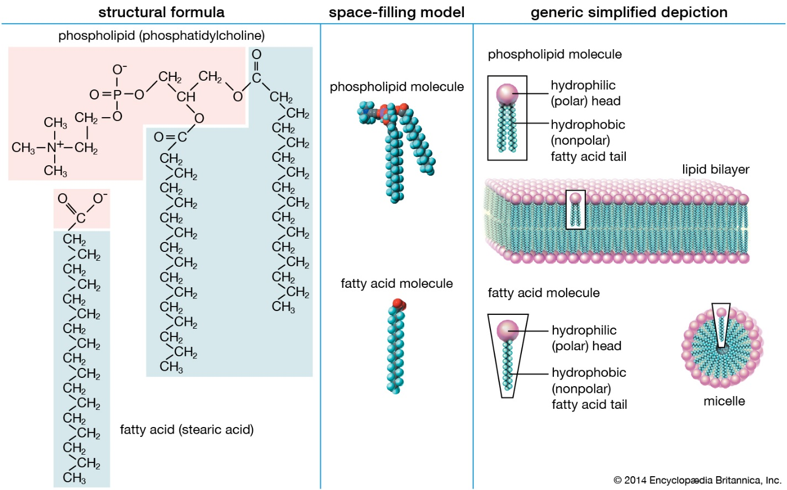

In the diagram directly above you see shaded in pink a molecule attached to the phosphate group of the phospholipid on the left. Find the phosphate group. Its easy, it is a phosphate atom surrounded by oxygens. Then branching off to the left of the phosphate group is a molecule with CH3 groups and a nitrogen at the center. That molecule is called ‘choline’ and so the name of this specific phospholipid is phosphatidylcholine. Really, not that complicated. Another membrane phospholipid is phosphatidylserine.

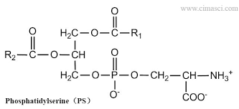

See the three carbons in a row, top to bottom, those are the three carbons of glycerol. The uppermost carbon has a fatty acid chain attached (the repeating carbons represented with the “R1”). The second carbon in the middle also has a fatty acid attached shown with the carbon tail represented as the “R2”. And the bottom, third, carbon has the recognizable phosphate group and branching to the right of the phosphate group is ‘serine’. Hence, phosphatidylserine.

So unlike all the cartoons of phospholipids with them all looking like an oval for the head and two lines for the tails, there happens to be something attached to the head portion to make it an individual phospholipid.

See the link on the class website.

**Osmosis / Crenation / Hemolysis:**

<https://www.youtube.com/watch?v=n3iNP_zwcWg>

<https://www.youtube.com/watch?v=rMa9MzP19zI>

<https://www.youtube.com/watch?v=FU9xE8rxnOo>

<https://www.youtube.com/watch?v=7-QJ-UUX0iY>

<https://www.youtube.com/watch?v=a7zaXNppbXo>

Supplement to this section: Anatomy to know: (taken from Openstax A&P textbook:

By the end of this section, you will be able to:

* Describe the molecular components that make up the cell membrane
* Explain the major features and properties of the cell membrane
* Differentiate between materials that can and cannot diffuse through the lipid bilayer
* Compare and contrast different types of passive transport with active transport, providing examples of each

Despite differences in structure and function, all living cells in multicellular organisms have a surrounding cell membrane. As the outer layer of your skin separates your body from its environment, the cell membrane (also known as the plasma membrane) separates the inner contents of a cell from its exterior environment. This cell membrane provides a protective barrier around the cell and regulates which materials can pass in or out.

### Structure and Composition of the Cell Membrane

The **cell membrane** is an extremely pliable structure composed primarily of back-to-back phospholipids (a “bilayer”). Cholesterol is also present, which contributes to the fluidity of the membrane, and there are various proteins embedded within the membrane that have a variety of functions.

A single phospholipid molecule has a phosphate group on one end, called the “head,” and two side-by-side chains of fatty acids that make up the lipid tails ([Figure 3.2](https://openstax.org/books/anatomy-and-physiology/pages/3-1-the-cell-membrane#fig-ch03_01_01)). The phosphate group is negatively charged, making the head polar and hydrophilic—or “water loving.” A **hydrophilic** molecule (or region of a molecule) is one that is attracted to water. The phosphate heads are thus attracted to the water molecules of both the extracellular and intracellular environments. The lipid tails, on the other hand, are uncharged, or nonpolar, and are hydrophobic—or “water fearing.” A **hydrophobic** molecule (or region of a molecule) repels and is repelled by water. Some lipid tails consist of saturated fatty acids and some contain unsaturated fatty acids. This combination adds to the fluidity of the tails that are constantly in motion. Phospholipids are thus amphipathic molecules. An **amphipathic** molecule is one that contains both a hydrophilic and a hydrophobic region. In fact, soap works to remove oil and grease stains because it has amphipathic properties. The hydrophilic portion can dissolve in water while the hydrophobic portion can trap grease in micelles that then can be washed away.

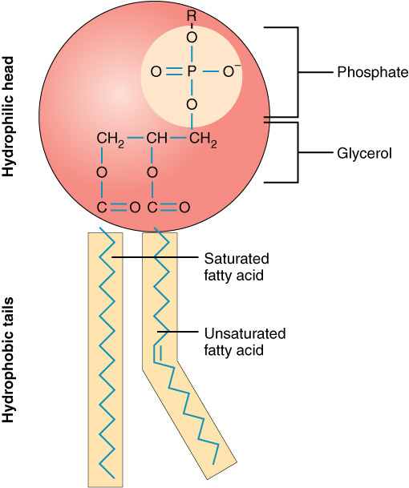

**Figure 3.2** **Phospholipid Structure**A phospholipid molecule consists of a polar phosphate “head,” which is hydrophilic and a non-polar lipid “tail,” which is hydrophobic. Unsaturated fatty acids result in kinks in the hydrophobic tails.

The cell membrane consists of two adjacent layers of phospholipids. The lipid tails of one layer face the lipid tails of the other layer, meeting at the interface of the two layers. The phospholipid heads face outward, one layer exposed to the interior of the cell and one layer exposed to the exterior ([Figure 3.3](https://openstax.org/books/anatomy-and-physiology/pages/3-1-the-cell-membrane#fig-ch03_01_02)). Because the phosphate groups are polar and hydrophilic, they are attracted to water in the intracellular fluid. **Intracellular fluid (ICF)** is the fluid interior of the cell. The phosphate groups are also attracted to the extracellular fluid. **Extracellular fluid (ECF)** is the fluid environment outside the enclosure of the cell membrane. **Interstitial fluid (IF)** is the term given to extracellular fluid not contained within blood vessels. Because the lipid tails are hydrophobic, they meet in the inner region of the membrane, excluding watery intracellular and extracellular fluid from this space. The cell membrane has many proteins, as well as other lipids (such as cholesterol), that are associated with the phospholipid bilayer. An important feature of the membrane is that it remains fluid; the lipids and proteins in the cell membrane are not rigidly locked in place.

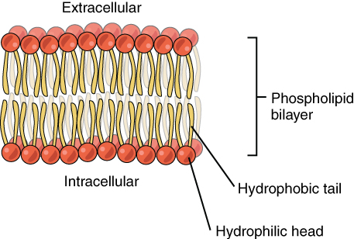

**Figure 3.3** **Phospolipid Bilayer** The phospholipid bilayer consists of two adjacent sheets of phospholipids, arranged tail to tail. The hydrophobic tails associate with one another, forming the interior of the membrane. The polar heads contact the fluid inside and outside of the cell.

### Membrane Proteins

The lipid bilayer forms the basis of the cell membrane, but it is peppered throughout with various proteins. Two different types of proteins that are commonly associated with the cell membrane are the integral proteins and peripheral protein ([Figure 3.4](https://openstax.org/books/anatomy-and-physiology/pages/3-1-the-cell-membrane#fig-ch03_01_03)). As its name suggests, an **integral protein** is a protein that is embedded in the membrane. A **channel protein** is an example of an integral protein that selectively allows particular materials, such as certain ions, to pass into or out of the cell.

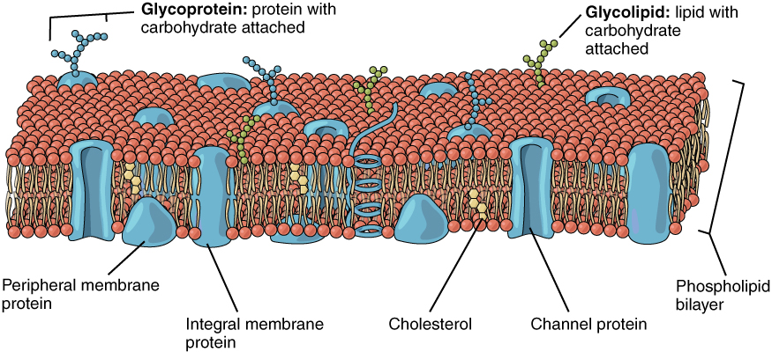

**Figure 3.4** **Cell Membrane** The cell membrane of the cell is a phospholipid bilayer containing many different molecular components, including proteins and cholesterol, some with carbohydrate groups attached.

Another important group of integral proteins are cell recognition proteins, which serve to mark a cell’s identity so that it can be recognized by other cells. A **receptor** is a type of recognition protein that can selectively bind a specific molecule outside the cell, and this binding induces a chemical reaction within the cell. A **ligand** is the specific molecule that binds to and activates a receptor. Some integral proteins serve dual roles as both a receptor and an ion channel. One example of a receptor-ligand interaction is the receptors on nerve cells that bind neurotransmitters, such as dopamine. When a dopamine molecule binds to a dopamine receptor protein, a channel within the transmembrane protein opens to allow certain ions to flow into the cell.

Some integral membrane proteins are glycoproteins. A **glycoprotein** is a protein that has carbohydrate molecules attached, which extend into the extracellular matrix. The attached carbohydrate tags on glycoproteins aid in cell recognition. The carbohydrates that extend from membrane proteins and even from some membrane lipids collectively form the glycocalyx. The **glycocalyx** is a fuzzy-appearing coating around the cell formed from glycoproteins and other carbohydrates attached to the cell membrane. The glycocalyx can have various roles. For example, it may have molecules that allow the cell to bind to another cell, it may contain receptors for hormones, or it might have enzymes to break down nutrients. The glycocalyces found in a person’s body are products of that person’s genetic makeup. They give each of the individual’s trillions of cells the “identity” of belonging in the person’s body. This identity is the primary way that a person’s immune defense cells “know” not to attack the person’s own body cells, but it also is the reason organs donated by another person might be rejected.

**Peripheral proteins** are typically found on the inner or outer surface of the lipid bilayer but can also be attached to the internal or external surface of an integral protein. These proteins typically perform a specific function for the cell. Some peripheral proteins on the surface of intestinal cells, for example, act as digestive enzymes to break down nutrients to sizes that can pass through the cells and into the bloodstream.

### Transport across the Cell Membrane

One of the great wonders of the cell membrane is its ability to regulate the concentration of substances inside the cell. These substances include ions such as Ca++, Na+, K+, and Cl–; nutrients including sugars, fatty acids, and amino acids; and waste products, particularly carbon dioxide (CO2), which must leave the cell.

The membrane’s lipid bilayer structure provides the first level of control. The phospholipids are tightly packed together, and the membrane has a hydrophobic interior. This structure causes the membrane to be selectively permeable. A membrane that has **selective permeability** allows only substances meeting certain criteria to pass through it unaided. In the case of the cell membrane, only relatively small, nonpolar materials can move through the lipid bilayer (remember, the lipid tails of the membrane are nonpolar). Some examples of these are other lipids, oxygen and carbon dioxide gases, and alcohol. However, water-soluble materials—like glucose, amino acids, and electrolytes—need some assistance to cross the membrane because they are repelled by the hydrophobic tails of the phospholipid bilayer. All substances that move through the membrane do so by one of two general methods, which are categorized based on whether or not energy is required. **Passive transport** is the movement of substances across the membrane without the expenditure of cellular energy. In contrast, **active transport** is the movement of substances across the membrane using energy from adenosine triphosphate (ATP).

#### Passive Transport

In order to understand how substances move passively across a cell membrane, it is necessary to understand concentration gradients and diffusion. A **concentration gradient** is the difference in concentration of a substance across a space. Molecules (or ions) will spread/diffuse from where they are more concentrated to where they are less concentrated until they are equally distributed in that space. (When molecules move in this way, they are said to move down their concentration gradient.) **Diffusion** is the movement of particles from an area of higher concentration to an area of lower concentration. A couple of common examples will help to illustrate this concept. Imagine being inside a closed bathroom. If a bottle of perfume were sprayed, the scent molecules would naturally diffuse from the spot where they left the bottle to all corners of the bathroom, and this diffusion would go on until no more concentration gradient remains. Another example is a spoonful of sugar placed in a cup of tea. Eventually the sugar will diffuse throughout the tea until no concentration gradient remains. In both cases, if the room is warmer or the tea hotter, diffusion occurs even faster as the molecules are bumping into each other and spreading out faster than at cooler temperatures. Having an internal body temperature around 98.6°F thus also aids in diffusion of particles within the body.

Whenever a substance exists in greater concentration on one side of a semipermeable membrane, such as the cell membranes, any substance that can move down its concentration gradient across the membrane will do so. Consider substances that can easily diffuse through the lipid bilayer of the cell membrane, such as the gases oxygen (O2) and CO2. O2 generally diffuses into cells because it is more concentrated outside of them, and CO2 typically diffuses out of cells because it is more concentrated inside of them. Neither of these examples requires any energy on the part of the cell, and therefore they use passive transport to move across the membrane.

Before moving on, you need to review the gases that can diffuse across a cell membrane. Because cells rapidly use up oxygen during metabolism, there is typically a lower concentration of O2 inside the cell than outside. As a result, oxygen will diffuse from the interstitial fluid directly through the lipid bilayer of the membrane and into the cytoplasm within the cell. On the other hand, because cells produce CO2 as a byproduct of metabolism, CO2 concentrations rise within the cytoplasm; therefore, CO2 will move from the cell through the lipid bilayer and into the interstitial fluid, where its concentration is lower. This mechanism of molecules moving across a cell membrane from the side where they are more concentrated to the side where they are less concentrated is a form of passive transport called simple diffusion ([Figure 3.5](https://openstax.org/books/anatomy-and-physiology/pages/3-1-the-cell-membrane#fig-ch03_01_04)).

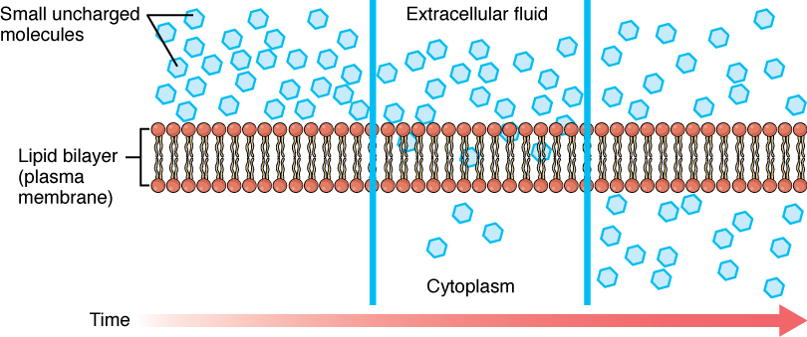

**Figure 3.5** **Simple Diffusion across the Cell (Plasma) Membrane** The structure of the lipid bilayer allows small, uncharged substances such as oxygen and carbon dioxide, and hydrophobic molecules such as lipids, to pass through the cell membrane, down their concentration gradient, by simple diffusion.

Large polar or ionic molecules, which are hydrophilic, cannot easily cross the phospholipid bilayer. Very small polar molecules, such as water, can cross via simple diffusion due to their small size. Charged atoms or molecules of any size cannot cross the cell membrane via simple diffusion as the charges are repelled by the hydrophobic tails in the interior of the phospholipid bilayer. Solutes dissolved in water on either side of the cell membrane will tend to diffuse down their concentration gradients, but because most substances cannot pass freely through the lipid bilayer of the cell membrane, their movement is restricted to protein channels and specialized transport mechanisms in the membrane. **Facilitated diffusion** is the diffusion process used for those substances that cannot cross the lipid bilayer due to their size, charge, and/or polarity ([Figure 3.6](https://openstax.org/books/anatomy-and-physiology/pages/3-1-the-cell-membrane#fig-ch03_01_05)). A common example of facilitated diffusion is the movement of glucose into the cell, where it is used to make ATP. Although glucose can be more concentrated outside of a cell, it cannot cross the lipid bilayer via simple diffusion because it is both large and polar. To resolve this, a specialized carrier protein called the glucose transporter will transfer glucose molecules into the cell to facilitate its inward diffusion.

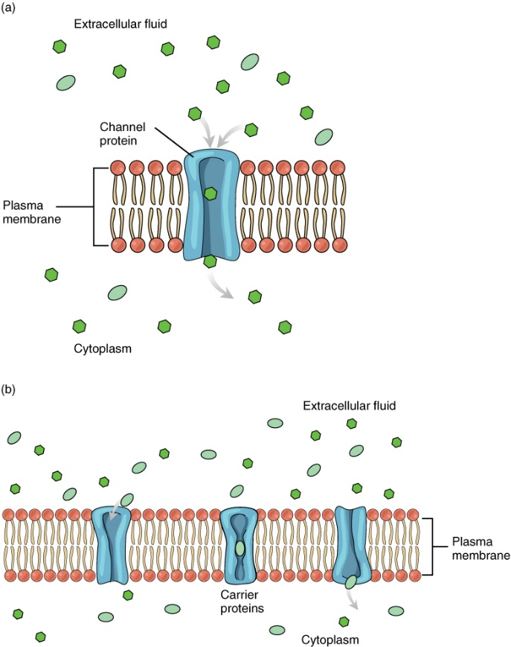

**Figure 3.6** **Facilitated Diffusion** (a) Facilitated diffusion of substances crossing the cell (plasma) membrane takes place with the help of proteins such as channel proteins and carrier proteins. Channel proteins are less selective than carrier proteins, and usually mildly discriminate between their cargo based on size and charge. (b) Carrier proteins are more selective, often only allowing one particular type of molecule to cross.

As an example, even though sodium ions (Na+) are highly concentrated outside of cells, these electrolytes are charged and cannot pass through the nonpolar lipid bilayer of the membrane. Their diffusion is facilitated by membrane proteins that form sodium channels (or “pores”), so that Na+ ions can move down their concentration gradient from outside the cells to inside the cells. There are many other solutes that must undergo facilitated diffusion to move into a cell, such as amino acids, or to move out of a cell, such as wastes. Because facilitated diffusion is a passive process, it does not require energy expenditure by the cell.

Water also can move freely across the cell membrane of all cells, either through protein channels or by slipping between the lipid tails of the membrane itself. **Osmosis** is the diffusion of water through a semipermeable membrane ([Figure 3.7](https://openstax.org/books/anatomy-and-physiology/pages/3-1-the-cell-membrane#fig-ch03_01_06)).

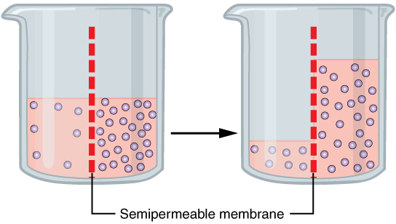

**Figure 3.7** **Osmosis** Osmosis is the diffusion of water through a semipermeable membrane down its concentration gradient. If a membrane is permeable to water, though not to a solute, water will equalize its own concentration by diffusing to the side of lower water concentration (and thus the side of higher solute concentration). In the beaker on the left, the solution on the right side of the membrane is hypertonic.

The movement of water molecules is not itself regulated by cells, so it is important that cells are exposed to an environment in which the concentration of solutes outside of the cells (in the extracellular fluid) is equal to the concentration of solutes inside the cells (in the cytoplasm). Two solutions that have the same concentration of solutes are said to be **isotonic** (equal tension). When cells and their extracellular environments are isotonic, the concentration of water molecules is the same outside and inside the cells, and the cells maintain their normal shape (and function).

Osmosis occurs when there is an imbalance of solutes outside of a cell versus inside the cell. A solution that has a higher concentration of solutes than another solution is said to be **hypertonic**, and water molecules tend to diffuse into a hypertonic solution ([Figure 3.8](https://openstax.org/books/anatomy-and-physiology/pages/3-1-the-cell-membrane#fig-ch03_01_07)). Cells in a hypertonic solution will shrivel as water leaves the cell via osmosis. In contrast, a solution that has a lower concentration of solutes than another solution is said to be **hypotonic**, and water molecules tend to diffuse out of a hypotonic solution. Cells in a hypotonic solution will take on too much water and swell, with the risk of eventually bursting. A critical aspect of homeostasis in living things is to create an internal environment in which all of the body’s cells are in an isotonic solution. Various organ systems, particularly the kidneys, work to maintain this homeostasis.

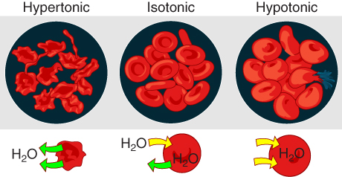

**Figure 3.8** **Concentration of Solutions** A hypertonic solution has a solute concentration higher than another solution. An isotonic solution has a solute concentration equal to another solution. A hypotonic solution has a solute concentration lower than another solution.

Another mechanism besides diffusion to passively transport materials between compartments is filtration. Unlike diffusion of a substance from where it is more concentrated to less concentrated, filtration uses a hydrostatic pressure gradient that pushes the fluid—and the solutes within it—from a higher pressure area to a lower pressure area. Filtration is an extremely important process in the body. For example, the circulatory system uses filtration to move plasma and substances across the endothelial lining of capillaries and into surrounding tissues, supplying cells with the nutrients. Filtration pressure in the kidneys provides the mechanism to remove wastes from the bloodstream.

#### Active Transport

For all of the transport methods described above, the cell expends no energy. Membrane proteins that aid in the passive transport of substances do so without the use of ATP. During active transport, ATP is required to move a substance across a membrane, often with the help of protein carriers, and usually against its concentration gradient.

One of the most common types of active transport involves proteins that serve as pumps. The word “pump” probably conjures up thoughts of using energy to pump up the tire of a bicycle or a basketball. Similarly, energy from ATP is required for these membrane proteins to transport substances—molecules or ions—across the membrane, usually against their concentration gradients (from an area of low concentration to an area of high concentration).

The **sodium-potassium pump**, which is also called Na+/K+ ATPase, transports sodium out of a cell while moving potassium into the cell. The Na+/K+ pump is an important ion pump found in the membranes of many types of cells. These pumps are particularly abundant in nerve cells, which are constantly pumping out sodium ions and pulling in potassium ions to maintain an electrical gradient across their cell membranes. An **electrical gradient** is a difference in electrical charge across a space. In the case of nerve cells, for example, the electrical gradient exists between the inside and outside of the cell, with the inside being negatively-charged (at around -70 mV) relative to the outside. The negative electrical gradient is maintained because each Na+/K+ pump moves three Na+ ions out of the cell and two K+ ions into the cell for each ATP molecule that is used ([Figure 3.9](https://openstax.org/books/anatomy-and-physiology/pages/3-1-the-cell-membrane#fig-ch03_01_08)). This process is so important for nerve cells that it accounts for the majority of their ATP usage.

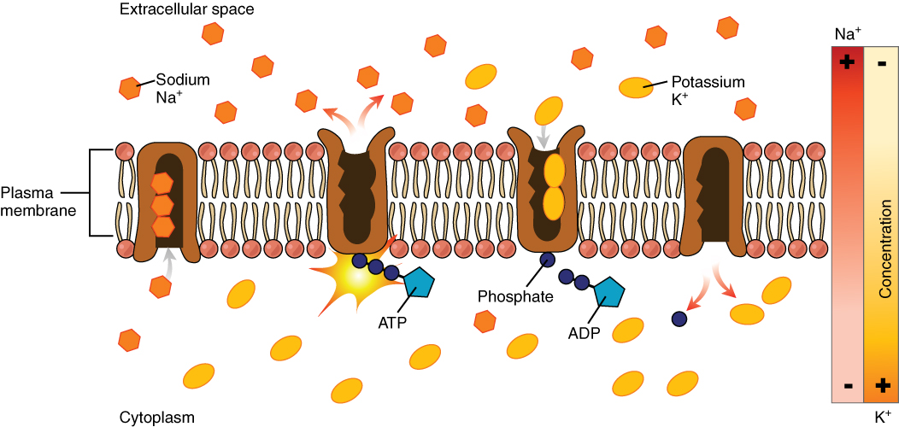

**Figure 3.9** **Sodium-Potassium Pump** The sodium-potassium pump is found in many cell (plasma) membranes. Powered by ATP, the pump moves sodium and potassium ions in opposite directions, each against its concentration gradient. In a single cycle of the pump, three sodium ions are extruded from and two potassium ions are imported into the cell.

Active transport pumps can also work together with other active or passive transport systems to move substances across the membrane. For example, the sodium-potassium pump maintains a high concentration of sodium ions outside of the cell. Therefore, if the cell needs sodium ions, all it has to do is open a passive sodium channel, as the concentration gradient of the sodium ions will drive them to diffuse into the cell. In this way, the action of an active transport pump (the sodium-potassium pump) powers the passive transport of sodium ions by creating a concentration gradient. When active transport powers the transport of another substance in this way, it is called secondary active transport.

Symporters are secondary active transporters that move two substances in the same direction. For example, the sodium-glucose symporter uses sodium ions to “pull” glucose molecules into the cell. Because cells store glucose for energy, glucose is typically at a higher concentration inside of the cell than outside. However, due to the action of the sodium-potassium pump, sodium ions will easily diffuse into the cell when the symporter is opened. The flood of sodium ions through the symporter provides the energy that allows glucose to move through the symporter and into the cell, against its concentration gradient.

Conversely, antiporters are secondary active transport systems that transport substances in opposite directions. For example, the sodium-hydrogen ion antiporter uses the energy from the inward flood of sodium ions to move hydrogen ions (H+) out of the cell. The sodium-hydrogen antiporter is used to maintain the pH of the cell's interior.

Other forms of active transport do not involve membrane carriers. **Endocytosis** (bringing “into the cell”) is the process of a cell ingesting material by enveloping it in a portion of its cell membrane, and then pinching off that portion of membrane ([Figure 3.10](https://openstax.org/books/anatomy-and-physiology/pages/3-1-the-cell-membrane#fig-ch03_01_09)). Once pinched off, the portion of membrane and its contents becomes an independent, intracellular vesicle. A **vesicle** is a membranous sac—a spherical and hollow organelle bounded by a lipid bilayer membrane. Endocytosis often brings materials into the cell that must to be broken down or digested. **Phagocytosis** (“cell eating”) is the endocytosis of large particles. Many immune cells engage in phagocytosis of invading pathogens. Like little Pac-men, their job is to patrol body tissues for unwanted matter, such as invading bacterial cells, phagocytize them, and digest them. In contrast to phagocytosis, **pinocytosis** (“cell drinking”) brings fluid containing dissolved substances into a cell through membrane vesicles.

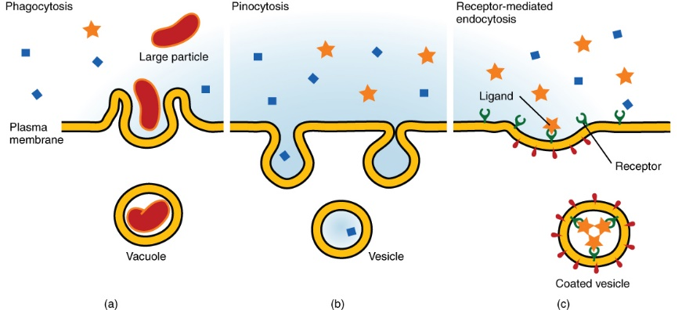

**Figure 3.10** **Three Forms of Endocytosis** Endocytosis is a form of active transport in which a cell envelopes extracellular materials using its cell membrane. (a) In phagocytosis, which is relatively nonselective, the cell takes in a large particle. (b) In pinocytosis, the cell takes in small particles in fluid. (c) In contrast, receptor-mediated endocytosis is quite selective. When external receptors bind a specific ligand, the cell responds by endocytosing the ligand.

Phagocytosis and pinocytosis take in large portions of extracellular material, and they are typically not highly selective in the substances they bring in. Cells regulate the endocytosis of specific substances via receptor-mediated endocytosis. **Receptor-mediated endocytosis** is endocytosis by a portion of the cell membrane that contains many receptors that are specific for a certain substance. Once the surface receptors have bound sufficient amounts of the specific substance (the receptor’s ligand), the cell will endocytose the part of the cell membrane containing the receptor-ligand complexes. Iron, a required component of hemoglobin, is endocytosed by red blood cells in this way. Iron is bound to a protein called transferrin in the blood. Specific transferrin receptors on red blood cell surfaces bind the iron-transferrin molecules, and the cell endocytoses the receptor-ligand complexes.

In contrast with endocytosis, **exocytosis** (taking “out of the cell”) is the process of a cell exporting material using vesicular transport ([Figure 3.11](https://openstax.org/books/anatomy-and-physiology/pages/3-1-the-cell-membrane#fig-ch03_01_10)). Many cells manufacture substances that must be secreted, like a factory manufacturing a product for export. These substances are typically packaged into membrane-bound vesicles within the cell. When the vesicle membrane fuses with the cell membrane, the vesicle releases it contents into the interstitial fluid. The vesicle membrane then becomes part of the cell membrane. Cells of the stomach and pancreas produce and secrete digestive enzymes through exocytosis ([Figure 3.12](https://openstax.org/books/anatomy-and-physiology/pages/3-1-the-cell-membrane#fig-ch03_01_11)). Endocrine cells produce and secrete hormones that are sent throughout the body, and certain immune cells produce and secrete large amounts of histamine, a chemical important for immune responses.

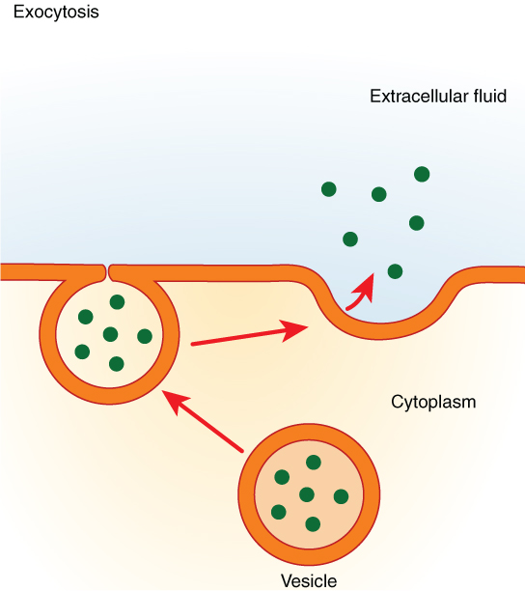

**Figure 3.11** **Exocytosis** Exocytosis is much like endocytosis in reverse. Material destined for export is packaged into a vesicle inside the cell. The membrane of the vesicle fuses with the cell membrane, and the contents are released into the extracellular space.

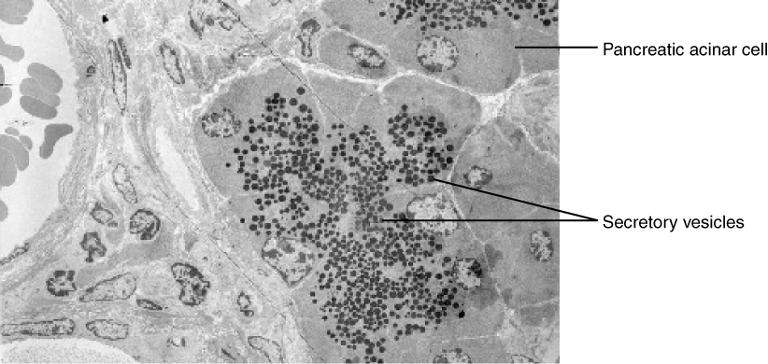

**Figure 3.12** **Pancreatic Cells' Enzyme Products** The pancreatic acinar cells produce and secrete many enzymes that digest food. The tiny black granules in this electron micrograph are secretory vesicles filled with enzymes that will be exported from the cells via exocytosis. LM × 2900. (Micrograph provided by the Regents of University of Michigan Medical School © 2012)

End of supplement.