Picture this:

**A cup.**

**Then fill it with water.**

**Then pour the water out.**

**Done.**

The ‘cup’ is your left ventricle. It fills with blood and then empties the blood out into the aorta.

When does the left ventricle (or for that matter, the entire heart) fill with blood? During diastole, while the heart is not contracting. When does the left ventricle (of for that matter, all four heart chambers) empty their blood? During systole, while the heart is contracting. During diastole all four chambers fill (first the two ventricles fill, then the two atria fill), during systole all four chambers empty, first the two atria squirt their atrial blood volume into the already filled ventricles (which overfills the two ventricles, stretching them a bit with that extra atrial blood) and then during the end of this same systole the two ventricles pump their blood out. But we’re looking just at the left ventricle. It fills and then it empties. But consider this. After the left ventricle has contracted and is now ‘empty’, there has to be some little bit of blood still inside the left ventricle. It cannot pump out every little last drop of blood after systole is over now can it? In fact, it is not as if the left ventricle is pumping its blood out into an empty aorta. The aorta has blood in it so there is some chance some of the blood that is being ejected into the aorta from the left ventricle won’t make it out in time before the aortic semilunar valve closes.

<https://www.youtube.com/watch?v=jBt5jZSWhMI>

<https://www.youtube.com/watch?v=oHMmtqKgs50>

There is always some blood left in the left ventricle after it has contracted and pumped its blood out, yes?

So, the left ventricle fills, pumps the blood out and there is a tiny bit still left behind in the left ventricle. OK.

Let’s add the confusing terminology. The left ventricle fills during diastole. When is the left ventricle completely filled to its maximum amount of blood it is going to be filled with during this one heartbeat? Well, of course, at the end of diastole. Diastole ends when systole begins and when systole begins the heart is contracting and blood is exiting the left ventricle. So, the maximum amount of blood in the left ventricle is the amount of blood that was put into the left ventricle up until the point in time when diastole switches to systole, at the very, very end of diastole. This is called ‘End Diastolic Volume’ (EDV). EDV is the maximum amount of blood placed into the left ventricle.

Go back to the top of this page. **A cup**. **Then fill it with water**. **Then pour the water out**. The amount of water you filled the cup with, or the amount of blood you filled the left ventricle with = EDV. **Then pour the water out** = left ventricular contraction = systole. At the end of systole = **Done**. So how much blood was pumped out of the left ventricle? Was ALL the blood that had filled the left ventricle pumped out with this single heartbeat? No, not all the blood that had filled the left ventricle was pumped out since, remember that is impossible, there will always have to be a small bit of blood that didn’t get pumped out – that stuck to the inner walls of the left ventricle; that just didn’t make it out in time before the valve closed. You can image not every single last drop didn’t get out during systole. So, what should we call this tiny little bit of blood that doesn’t get out of the left ventricle after systole is over? How about the ‘End Systolic Volume’ (ESV). The ESV is that volume of blood that remains within the left ventricle after the left ventricle is done contracting, at the end of systole.

Cardiac Output. That’s an important measurement. The amount of blood the heart is pumping out. And since that is all the heart ever has to do is pump out blood, I guess that about sums up how well the heart is doing its job. Cardiac Output (C.O. ml/min). Two things can effect (or it is ‘affect’, I never know) C.O. are: how fast the heart is beating (heart rate in beats/minute) and regardless of how fast the heart is beating, how much blood is being ejected per heartbeat which is called the ‘Stroke Volume’ (S.V. in ml/beat). So,

**C.O. ml/min = H.R. beats/min X S.V. ml/beat**

Think about the possible variations. The faster the heart beats, high heart rate, the more blood it is going to be pumped out every minute if the S.V. stays the same (which it should, no reason it shouldn’t) so C.O. increases. If H.R. decreases, then C.O. decreases. If the amount of blood in every beat were to increase and H.R. stayed the same well then C.O. would increase also. These two independent variables both influence C.O.

Let’s focus for right now on stroke volume. How much blood is ejected during a single beat of the heart. Let’s get back to the left ventricle and EDV and ESV. If every single drop of blood that filled the left ventricle were to be pumped out with that beat of the heart, then the stroke volume would equal the EDV (the volume of blood that filled the left ventricle). But remember that is impossible because some of the blood is left behind in the left ventricle after it is done contracting. The amount of blood that is ejected out of the left ventricle has to be the amount of blood that filled the left ventricle minus that amount of blood that does not get ejected (the amount of blood that gets left behind after systole is over). Let’s do simple math.

**A cup.**

**Then fill it with water. (Let’s say 10.0 ml)**

**Then pour the water out. (After you’re done pouring the water out you notice some water still left in the cup. You measure 8.0 ml was actually poured out of the cup and that 2.0 ml remained in the cup. That makes sense, you filled the cup with 10.0 ml, poured out 8.0 ml and 2.0 ml was left behind. TEN = EIGHT + TWO; or EIGHT = TEN – TWO. EIGHT (the amount that was poured out of the cup) = TEN (the amount you originally filled it with) – TWO (the amount that got stuck in the cup and didn’t pour out).**

**Done.**

8 = 10 – 2.

‘8’ = the amount that actually was poured out of the cup. In this case, for the left ventricle this would be the amount that is actually ejected from the left ventricle which is called the ‘stroke volume’, the amount of blood ejected in one beat. ‘10’ = the amount we filled the left ventricle with at the beginning of all of this which is ‘EDV’. Right, the maximum amount of blood in the left ventricle for this single beat of the heart is how much blood gets into the left ventricle during diastole up until the very end of diastole. ‘2’ = the amount of blood that did not get ejected. It was part of the volume we originally filled it with, but it just didn’t get ejected out of the left ventricle during this heartbeat. This is the ‘ESV’, right? So, this is always confusing but very simple math, just awkward symbols:

8 = 10 – 2 or **S.V. = E.D.V. - E.S.V.**

If you won’t believe me, maybe you’ll believe the internet:

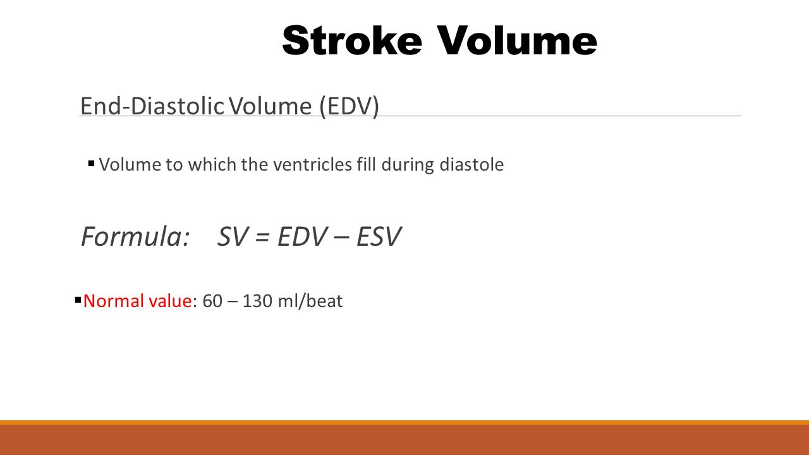

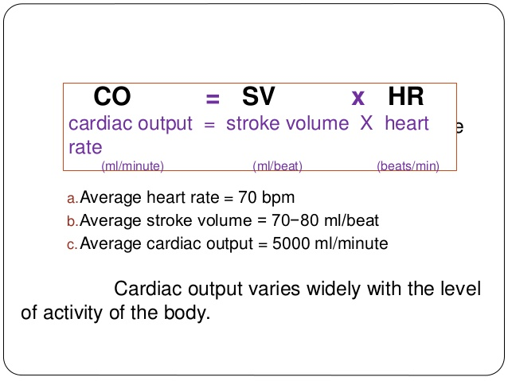

So, we’ve come up with two easy equations. C.O. = S.V. X H. R. and S.V. = E.D.V. – E.S.V.

What if we do that math-thing where we can substitute, in this case we substitute S.V. into the C.O. equation:

C.O. = (E.D.V. – E.S.V.) X H.R.

Very intimidating equation, but since we can easily derive it, we can always just write out the two separate equations and substitute.

Since cardiac output is a big deal in determining if the heart is working correctly or not, what sorts of things can affect (or effect?) C.O.?

Well, let’s be systematic with the variables in our equations.

C.O. depends on: Heart rate/ E.D.V. / E.S.V. or H.R. and S.V.

So, let’s simply list some things that can affect H.R. and E.D.V. and E.S.V. or S.V.

Well, heart rate is controlled by the nervous system so that seems straightforward enough. Sympathetic and parasympathetic nervous control can increase or decrease heart rate. But here’s an interesting thing about sympathetic and parasympathetic control of heart rate. The heart will beat on its own. Like Hollywood likes to show us, you can rip a heart right out of someone’s chest and have it continue to beat. Well, the rip it right out of someone’s chest is the part I don’t go along with anatomically – really? Rip right thru the sternum and ribs and pericardium, somehow get your evil hand around the slippery heart, just with the power of your evil grip tear it loose from the vena cava and aorta – come on now, ain’t gonna happen Wes Craven. But the part I do agree with is the part about the heart continuing to beat even though it is not connected to the nervous system anymore. If you could provide the heart with oxygenated blood, it would continue to beat on its own.

<https://www.youtube.com/watch?v=Bjn3TwMr4xs>

<https://www.youtube.com/watch?v=BqzW9Jq-OVA>

The videos show human cardiac muscle fibers (cardiac myocytes) beating without a nervous system attached. Wow.

Now in a fully developed human heart in a human chest and without going into details it is known that without any signals from the sympathetic or parasympathetic nervous systems that the heart cells will begin a fully functional heartbeat on their own in the SA-node the way a heart is suppose to. A human heart in a human chest will beat on its own spontaneously when not receiving action potentials from either a sympathetic or parasympathetic nerve pathway. In fact, it will beat quickly at about 100 beats per minute on its own. This is the heart’s ‘intrinsic heart rate’. (Not to be tested on but the intrinsic heart rate decreases with age and that is thought to contribute to a decreasing maximum heart rate with age.)

Sympathetic, fight or flight, signals will cause the heart to increase heart rate. We all know that. And parasympathetic nerve impulses will cause the heart to decrease heart rate. But since the heart will beat spontaneously on its own at about 100 bpm, if you want your resting heart rate to be around 60 bpm, you will actually have to send parasympathetic nerve impulses to slow it down from its natural 100 bpm rate. Think about it, as you sit here reading this you are sending parasympathetic nerve impulses to slow heart rate down to 60 bpm. Now think about this, if you want to increase heart rate from 60 bpm to 75 bpm by walking up stairs, you actually decrease the amount of parasympathetic nerve impulses. Remember also that the parasympathetic signals travel along the vagus cranial nerve. You are pushing the heart to be at 60 bpm with a strong parasympathetic set of signals. To increase your heart rate to 75 bpm you decrease the parasympathetic set of signals. To increase your heart rate to 90 bpm, you decrease the parasympathetic signals even more. If you turn off completely the parasympathetic signals then the heart is left to beat on its own at 100 bpm which is a fast heart rate.

So, I do not use the sympathetic system to increase my heart rate from resting 60 bpm to 90 bpm. Nope, just turning off the parasympathetic system. Now if you want to increase your heart rate above 100 bpm, then you would begin to stimulate the SA-node with sympathetic nerve impulses.

Remember, the vagus nerve stimulates certain muscles in the heart that help to slow heart rate. When it overreacts, it can cause a sudden drop in heart rate and blood pressure, resulting in fainting. This is known as vasovagal syncope.

This intrinsic firing rate decreases with age. Heart rate is decreased below the intrinsic rate primarily by activation of the vagus nerve innervating the SA node. Normally, at rest, there is significant vagal tone on the SA node so that the resting heart rate is between 60 and 80 beats/min.

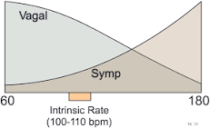

**Preload and Afterload:**

<https://www.youtube.com/watch?v=LqOd4Sqc9Ts>

Frank Starling Curve:

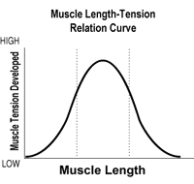

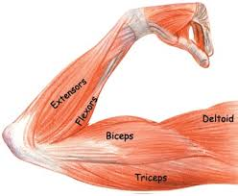 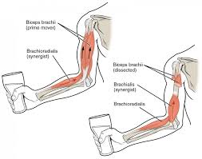 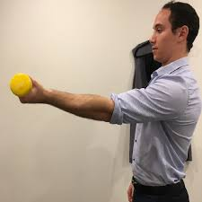

You already know this. It depends how much your elbow is bent (flexed) when you start your contraction as to how much strength you’ll have with that contraction. If you start your contraction of your biceps with your arm straight at the elbow (shown in the right hand picture of the nice fellow in the blue shirt), you cannot generate very much strength. Your biceps is not very strong when trying to bend at the elbow. If you begin the contraction of your biceps with the elbow at 90 degrees seen in the middle diagram above, you can lift a whole lot more weight, it is a stronger force of contraction just by having your biceps beginning at the 90 degree position that having the biceps in the position on the far right picture of the gentleman. Likewise, if the elbow is already flexed ‘too much’ as seen in the left diagram above. If you position the biceps as in the left diagram and then begin to contract the biceps, it will not produce very much force of contraction. The graph above these three diagrams shows this. The left hand 1/3 of the graph represents the force of the biceps contraction if you begin to contract the biceps with the elbow angle small, the hand almost touching the shoulder. The middle third of the graph shows the greater force you can generate with the biceps if you begin the contraction with the elbow at 90 degrees. And the right third of the graph shows the low force of contraction you can generate if you start with the biceps stretched and the arm straight as shown by the fellow in the blue shirt.

Same biceps. Same signal to contract. But different strengths of contraction just because you begin the contractions with the biceps in different positions. Stretch the biceps too much (as seen with the fellow in the blue shirt) and begin contraction and you do not generate much force of contraction. If the biceps is too short (as seen with the arm diagram on the left) and you begin contraction again it does not generate as much strength. But if you have the biceps stretched to just the right length, with the elbow at 90 degrees, then this same biceps will contract with much more force.

The same is true for all muscles. To get the greatest force of contraction out of a muscle you should begin that contraction with that muscle stretched to that perfect starting length to get the maximum ‘pull’. That maximum ‘pull’ comes from all the myosin heads binding F-actins. The fellow in the blue shirt has stretched the muscle fibers too much and there is not much overlap of the myosins and F-actins to do much ‘pulling’. At the other end, if the muscle is too short (as seen in the diagram on the left), again there is not as much ‘pull’ from the overlapping myosins and F-actins. Only when you preposition the myosins and F-actins to have their maximum overlap and then begin the contraction will you get the maximum ‘pull’ and contraction. This applies to the walls of the ventricles. If you gently fill the left ventricle with blood, the cardiac muscle fibers in the wall of the left ventricle are in the ‘too short’ position like the diagram on the left shows. Not much overlap of myosin heads and F-actins and if you begin the signal for contraction the walls of the left ventricle will not generate much force of contraction. So, to just quietly fill the left ventricle and then signal it to contract will not generate much of a ‘squirt’ of blood, a weak force of contraction. If you were to stretch the walls of the left ventricle (and right ventricle too) a bit you would have stretched the muscle fibers into the perfect overlap of myosins and F-actins so that if you now send the signal to contact it will contract with the maximum possible force, a much stronger ‘squirt’ of blood. You do stretch the walls of the ventricles by overfilling them with atrial blood. When the heart contracts in systole, the already filled ventricle is overfilled with the atrial blood. That serves an important function of stretching the already filled ventricle walls to this perfect length for maximum force of contraction. This overfilling of the already filled ventricle with atrial blood is the ‘PRELOAD’. The ‘preload’ of additional blood stretches the cardiac muscle fibers to begin their contraction at the best possible length with the most overlap to generate the strongest force of contraction to eject the blood as strong as possible for those muscle fibers. Get it?

Too much ‘preload’, overfilling, of the ventricles and they are stretched too far, like the biceps in the arm of the man with the blue shirt, and if you begin contraction in that position those muscle fibers will not contract with as much force and a weaker ejection of blood. Preload effects (affects?) stroke volume.

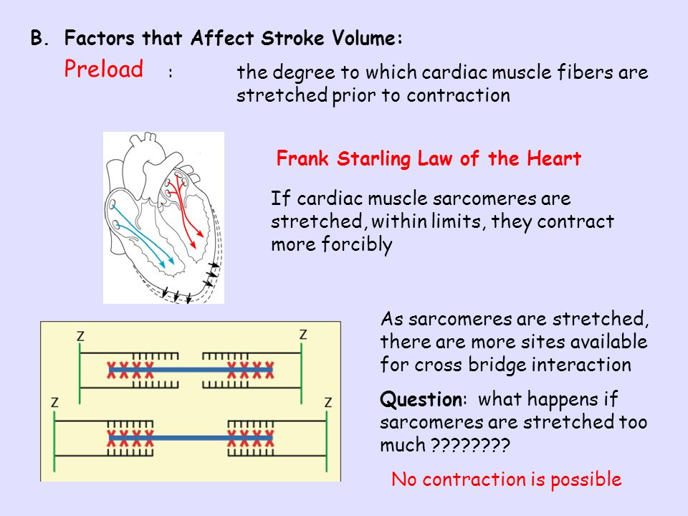

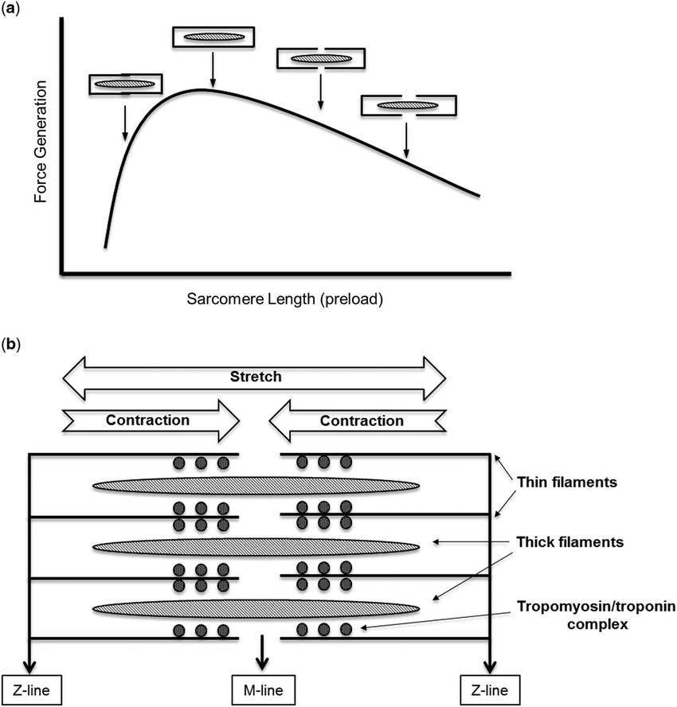

So have some clever researches tried to figure out how much preload overfilling of blood is just the right amount for maximum force of contraction? You don’t want zero preload (no overfilling). You don’t want too much preload (too much overfilling). How can researchers show how much preload is just the right amount. That is what Frank and Starling did. It at first glance is a confusing graph but it is showing too little preload giving a weak contraction, perfect preload giving maximum contraction and too much preload giving again weak contraction. By the way, this ‘strength of contraction’ or ‘force of contraction’ that we are talking about is commonly referred to as ‘contractility’.

Here comes the very complicated textbook-type definition:

*The Frank-Starling Law is the description of cardiac hemodynamics as it relates to myocyte stretch and contractility. The Frank-Starling Law states that the stroke volume of the left ventricle will increase as the left ventricular volume increases due to the myocyte stretch causing a more forceful systolic contraction.*

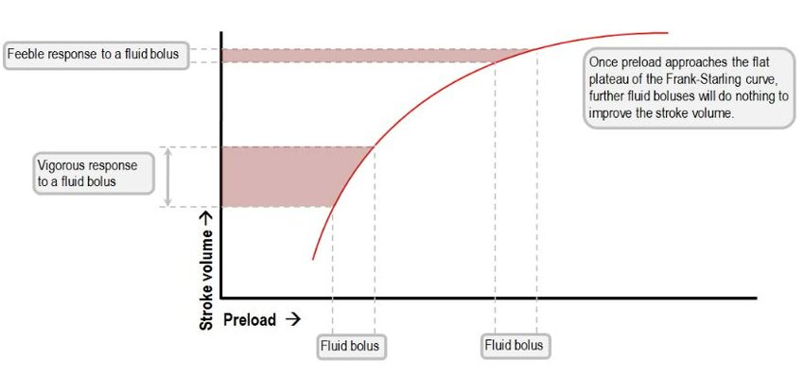

So what exactly is preload? What units is it measure in? Well, it is a volume. The volume of blood you overfill a ventricle with. Let me mention all this holds true for the right ventricle also.

<https://www.youtube.com/watch?v=hpQFToprlH8>

Wow, did I get off on a tangent. I was trying to talk about things (factors) that can affect (or is it effect?) cardiac output.

Well, preload can. The amount of preload directly effects (affects?) stroke volume by influencing directly the strength of that contraction. Too much or too little preload will decrease contractility while just the right amount of ventricular overfilling (the right amount of preload) will maximize contractility.

**C.O. = H.R. X S. V. and S.V. = E.D.V – E.S.V.**

So, what if you increase end systolic volume (E.S.V.)? Well, from the above equation that would decrease C.O.

An increase in E.S.V. means more blood left in the left ventricle after it is done contracting and ejecting its blood. How might that happen? Well, let’s make up an example. Case 1: Normal heart beating with normal stroke volume and hence normal cardiac output. Case 2: Patient with atherosclerosis and narrowing of blood vessels in circulatory system. Same heartbeat but squirting against narrowed blood vessels downstream from the left ventricle. So, with these narrowed blood vessels it is harder to push blood through them. In Case 2, the poor left ventricle is pumping against more resistance. Let’s assume we do not increase the force of contraction to compensate against this increased resistance of blood flow. So, with same heartbeat less blood is going to be ejected due to this resistance downstream from the left ventricle. Less blood ejected means more blood left behind in the left ventricle after the contraction is completed. Ah ha, an increase in E.S.V. Instead of the ‘normal’ example I gave before, 8=10-2, we now have 7=10-3 because E.S.V. increased from 2 to 3 due to the increased resistance of blood leaving the left ventricle. We’ve discovered that what the heart is pumping into matters. Let’s look at it this way. We are the heart. In fact, we are the left ventricle. We pump blood out to the body. We pump into the aorta. We are just the heart. We have no way of knowing what lies beyond the aorta. We just pump into the aorta. If the downstream circulatory system is healthy and not obstructed or narrowed we can pump our blood with no problems. Our cardiac output is fine. We are a happy heart keeping our host human alive. Now if the blood we are pumping comes up against resistance? What if when we try to pump our left ventricular blood out into the aorta it does not flow as easily and it is harder to pump the blood out into the aorta? We are just a heart. We have no knowledge of what lies beyond the aorta. We don’t know if our host human has atherosclerosis or diabetes or hypertension. All we know as the heart is that it is harder to pump out the same amount of blood as before and my cardiac output is going to be decreased because not as much is getting pumped out as before with every heartbeat. Due to this increased resistance there is more blood left in my left ventricle after systole. My E.S.V. is increased causing my S.V. to decrease and subsequently decreasing my cardiac output. I say all this because I am about to introduce a vague term. That term is ‘afterload’. What is ‘afterload’? It is this increased resistance the left (or right) ventricle sees when trying to pump its blood. The heart does not call it atherosclerosis or due to hypertension or diabetes, to the heart pumping into the aorta it is just an increased resistance called the ‘afterload’. This increased afterload can affect (effect?) cardiac output. The cardiologist will see a heart not doing its job with its decreased cardiac output due to an increased afterload. It is up to another doctor to decide what the cause of this afterload is.

<https://www.youtube.com/watch?v=fH-HtX7i0HA>

<https://www.youtube.com/watch?v=vFRkSB46bl8>

Can the right ventricle also have an increased afterload? Sure. What would directly cause an increased ‘afterload’ to the right ventricle? THE LUNGS! Something called ‘pulmonary hypertension’. It is when blood vessels in your lungs are narrowed, blocked or destroyed. The damage slows blood flow through your lungs, and blood pressure in the lung arteries rises. Your heart must work harder to pump blood through your lungs. The extra effort eventually causes your heart muscle to become weak and fail.

**Afterload** is the pressure the heart must work against to eject blood during systole (**ventricular** contraction).

Ah, and I thought you weren’t going to ask. Their first names are Otto Frank and Ernest Henry Starling. They, and other physiologists, proposed the principles and theories over 122 years ago.

The Frank–Starling law of the [heart](https://en.wikipedia.org/wiki/Human_heart) (also known as Starling's law and the Frank–Starling mechanism) represents the relationship between [stroke volume](https://en.wikipedia.org/wiki/Stroke_volume) and [end diastolic volume](https://en.wikipedia.org/wiki/End-diastolic_volume). The law states that the stroke volume of the heart increases in response to an increase in the volume of blood in the [ventricles](https://en.wikipedia.org/wiki/Ventricle_(heart)), before contraction (the end diastolic volume), when all other factors remain constant. As a larger volume of blood flows into the ventricle, the blood stretches the cardiac muscle fibers, leading to an increase in the force of contraction.

Read it and marvel at how you can now understand the textbook explanations (you will not need to remember the 2.2 micrometers part):

*The Frank-Starling mechanism occurs as the result of the length-tension relationship observed in striated muscle, including for example*[*skeletal muscles*](https://en.wikipedia.org/wiki/Skeletal_muscle)*and*[*cardiac (heart) muscle*](https://en.wikipedia.org/wiki/Cardiac_muscle)*. As a muscle fiber is stretched, active tension is created by altering the overlap of thick and thin filaments. The greatest isometric active tension is developed when a muscle is at its optimal length. In most relaxed skeletal muscle fibers, passive elastic properties maintain the muscle fibers length near optimal, as determined usually by the fixed distance between the attachment points of tendons to the bones at either end of the muscle. In contrast, the relaxed sarcomere length of cardiac muscle cells, in a resting ventricle, is lower than the optimal length for contraction. There is no bone to fix sarcomere length in the heart (of any animal) so sarcomere length is very variable and depends directly upon blood filling and thereby expanding the heart chambers. In the human heart, maximal force is generated with an initial sarcomere length of 2.2 micrometers, a length which is rarely exceeded in a normal heart. Initial lengths larger or smaller than this optimal value will decrease the force the muscle can achieve. For longer sarcomere lengths, this is the result of there being less overlap of the thin and thick filaments; for shorter sarcomere lengths, the cause is the decreased sensitivity for calcium by the*[*myofilaments*](https://en.wikipedia.org/wiki/Myofilament)*. An increase in filling of the ventricle increases the load experienced by each cardiac muscle fiber, stretching the fibers toward their optimal length.*