**Introduction to the Endocrine Glands and their Hormones.**

You’ve taken Ana-1 and so have some understanding of the endocrine glands and the hormones they release. In fact, when learning the anatomy of the endocrine glands you discovered how easy and tidy it was. It was very flash-card friendly. Make a flash-card for the endocrine gland and put on that card: name of endocrine gland; location in body; what it looks like grossly; its microscopic features (including its parts if any); what hormone(s) it releases; what those hormones do; what hormones it is stimulated by (if any). So, for anatomy all one needs to learn are those facts. Very manageable. I’ll be assuming you all enter into physiology possessing that knowledge. I’ve posted a nice anatomy review but you may also need to consult our Ana-1 textbook to review, relearn or learn for the first time all that useful information.

Now let’s set the stage for learning the physiology of these endocrine glands and their hormones. That means we delve into biochemistry. No way to avoid it, hormone interactions involve biochemical interactions. And since your hormones rule your body, like it or not, everyone needs to know these biochemical interactions which means for us learning some very cool biochemical pathways.

I agree it can get confusing and a bit tangled, so I’ll give some overview initially.

Lot’s of hormones. How to group them? How to make sense of so many of them? Easy, divide them initially into two groups. Those that are made from cholesterol and those that are not made from cholesterol. If some are not made from cholesterol, then what are they made from? Well, how about amino acids. These would be small and large protein hormones.

There you have it for starters: ‘steroid hormones’ (made from cholesterol) and ‘non-steroid hormones’ (made from amino acids).

If we start with the steroid hormones, you know what comes next. THAT diagram. Really, don’t panic. It is a great reference and you do need to be able to read and interpret it quickly so you do need to study it but you do not need to memorize it (unless you want to join me in my nerd world). The ‘takeaway’ from ‘THAT’ diagram seen below. Testosterone, estradiol, progesterone, cortisol and aldosterone are made from cholesterol. The steroid hormones. They pass freely through the phospholipid bilayer and so enter their target cells, bind to their receptor and that newly constructed molecule is a DNA binding protein.

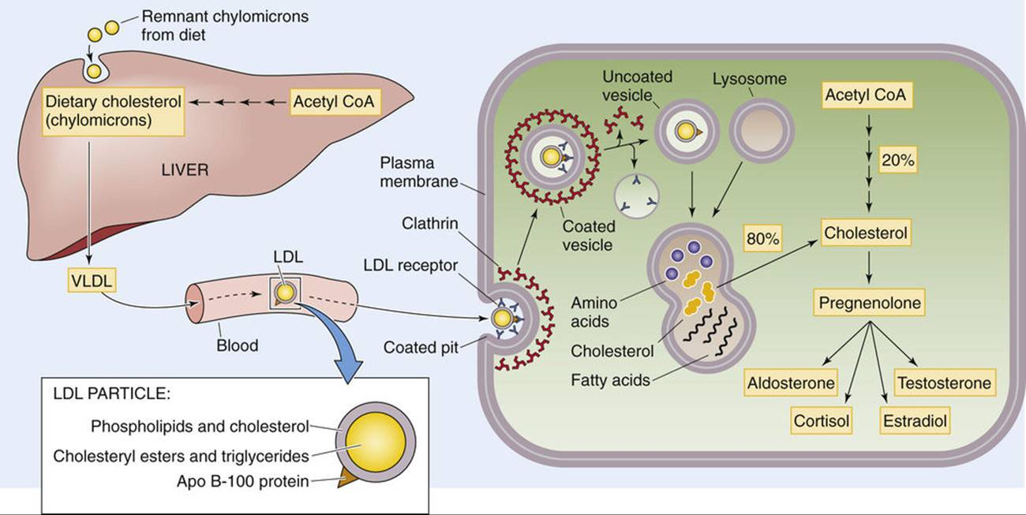

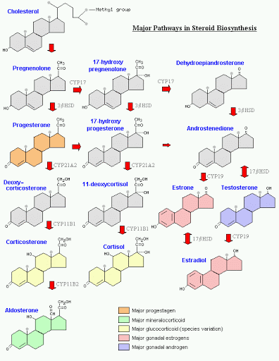

And don’t forget vitamin D (calcitriol). It too is made from cholesterol. See the website pathway. So why isn’t vitamin D included in the two above diagrams?

That simply leaves the ‘not-made-from-cholesterol’ hormones. The ‘non-steroidal’ hormones. The hormones that use second messengers. All the hormones that are not: testosterone, estradiol, progesterone, cortisol, aldosterone, Vit-D. The second messenger pathways are complicated, but there are two significant ones and those are the two we will be learning. One involved cAMP and the other involves ‘IP3 and DAG’.

You’ll need to read/study/learn the link from the class website on hormones.

<https://www.youtube.com/watch?v=9Bq6qHJaSJs>

<https://www.youtube.com/watch?v=erHdQ6cCu_s>

OK, a bit self-indulgent of me to include this video but it is useful to watch:

<https://www.youtube.com/watch?v=PzA5Z3DXfrQ>

A nice video that goes into detail so you can actually know what’s up but we won’t be responsible for all those details:

<https://www.youtube.com/watch?v=3qR9B2JCT_s>

Now I suggest you try this in order to learn the material. You’ll need to create a table and in that table, you’ll list:

-name of endocrine gland

-picture of where it is located in the human body

-picture showing its gross appearance (you know I mean ‘gross’ as in what it looks like with the naked eye, not ‘gross’ as in unsightly or ugly, right?)

-a pretty histological view of that gland; could be a labeled image, or not

-a discussion of all of its histological features

-a separate line in the table listed each hormone it releases and what that hormone does

-whether that hormone when acting on its target cell acts as a steroid hormone or uses a second messenger pathway and if it uses a second messenger pathway, what second messenger pathway it uses

-if any hormone stimulates this endocrine gland with specifics

That’s it. Very tidy. Very comprehensive. Will give you much joy to study with.

If you would to impress me and get on my ‘good side’, here is something to consider doing. As you read over my posted endocrine system link found on the class website you will find one error. There is ‘planted’ in that document one mistake on how one hormone works. Simply tell me which hormone is wrong and what it is supposed to be.

Another thing to consider is explaining what’s the big deal over something described as having 7-transmembrane proteins.

The end.

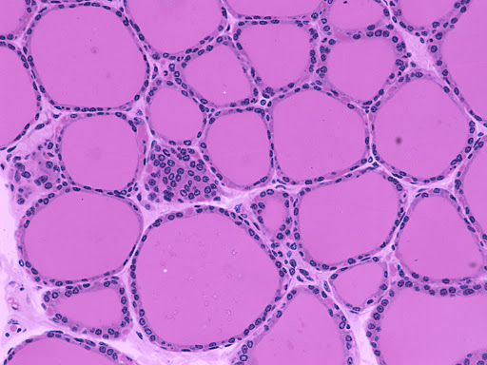

**The histology of the human thyroid gland taken with a light microscope, H & E staining, circa 2015.**

This type of artwork can be considered to be realism. There isn’t an actual background scene in this image. This work of art is solely the view of the cells of this gland. The follicles are the focus point of this work of art. My first impression of the artwork is that the shapes and colors offer both symmetry and geometry at the same time. Curves dominate the micrograph: small nuclei darkly stained graduating to larger ovals of the cells with a slightly granular cytoplasm and then attracting your eyes to the largest of the circles, the brightly, uniformly, vibrant pinks of the colloid found at the centers of the follicles. Astounding how much emotion can be conveyed by using only a two-color stain. But the emotive strength of this simple yet strong image is undeniable. The mood and visual effect that this image portrays is one of hope and beauty. The subtle vibrance brings the viewer to an elevated state of contentment and appreciation. The interconnectivity of the curves and ovals and circles reminds the viewer of the power and beauty of life and leaves the audience with a lasting want and need to know more and more about this microscopic world known as the human body.