Female reproductive system.
Now that we have a clear understanding of the male reproductive systems, let’s take a look at the female reproductive system. Below you see the ovaries where the eggs (ova=plural; ovum=singular) are made and released from. When an egg is released it is called ovulation. This ovulated egg is now available to be fertilized by a sperm. Notice in the next diagram below, that if this process of sexual reproduction is to work correctly the sperm actually fertilized the ovulated egg right outside of the ovary, right at the beginning of the Fallopian tube (also known as the uterine tube). Once the egg is fertilized it is now a zygote and is the very first cell of the new person. It will begin its divisions and continue its divisions as it moves along the Fallopian tube towards the uterus where it will eventually implant into the inner lining of the uterus (called the endometrium). Once implanted it can draw nutrients and molecules from the mother’s tissues and begin to grow in size. It is in the uterus (womb) where it will stay for the rest of the pregnancy.
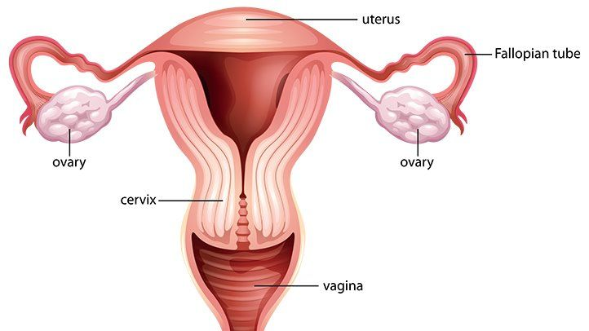

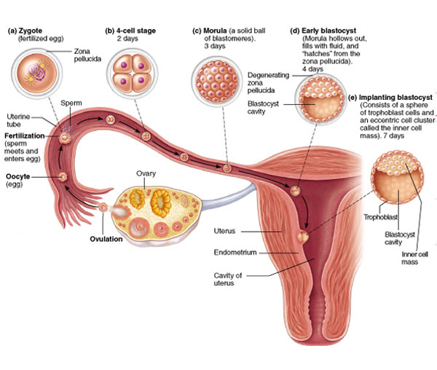
We will not go into the details of pregnancy but from an anatomical perspective, the embryo/fetus/baby will expand the uterus tremendously pushing the intestines and diaphragm upwards and constricting the lungs and this expanding uterus with a growing baby inside sits right on top of the female bladder explaining why a pregnant woman needs to urinate often.
[What’s a Zygote? Fertilization is a process that usually happens within a few hours of ovulation. It’s that critical point in reproduction when the sperm meets the newly released egg. At this meeting, 23 male and 23 female chromosomes mix together to create a single cell embryo called a zygote.
Embryo vs. Fetus? In human pregnancies, a baby-to-be isn’t considered a fetus until the 9th week after conception, or week 11 after your last menstrual period (LMP). The embryonic period is all about the formation of important systems of the body. Think of it as your baby’s basic foundation and framework. The fetal period, on the other hand, is more about growth and development so your baby can survive in the outside world.]

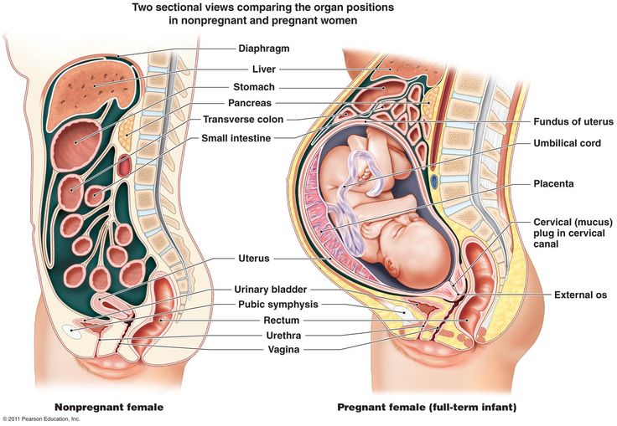
So, getting back to the basic female anatomy of the reproductive system, the ovaries are where the eggs come from. The uterus is where the ‘baby’ grows. The Fallopian tubes connect the ovaries with the uterus. How the sperm enter the female reproductive system is the vagina. Notice the small opening connecting the vagina to the uterus is the ‘external os’. The external os is a small opening at the center of the dome-shaped transition from vagina to uterus called the cervix. Let me go ahead and mention now an interesting anatomical fact about the cervix and os of the cervix. The vagina is lined with the same type of epithelium as the outside skin. They are sort of continuous. I say sort of because the external skin outside the vagina is keratinized stratified squamous epithelium whereas the epithelium lining the vagina is a mucous membrane and so is not keratinized…..but this ‘skin’ lining the inside of the vagina is still stratified squamous epithelium and will look like the ‘skin’ microscopic slide you’ve seen before in anatomy, just not keratinized. So, the epithelium lining the vagina is non-keratinized stratified squamous epithelium. But at the os, at that tiny opening there is an abrupt change in epithelial type. As you proceed up from the vagina through the os into the uterus the type of epithelium lining the uterus is simple columnar epithelium. And you see this abrupt change right at the os. Note in the diagram below this transition from vagina up into the uterus, the small opening you would see if you were to look up into the vagina is the external os.
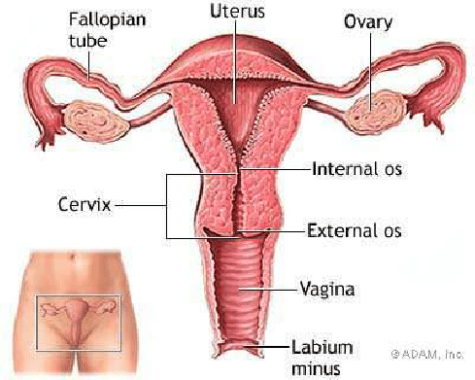
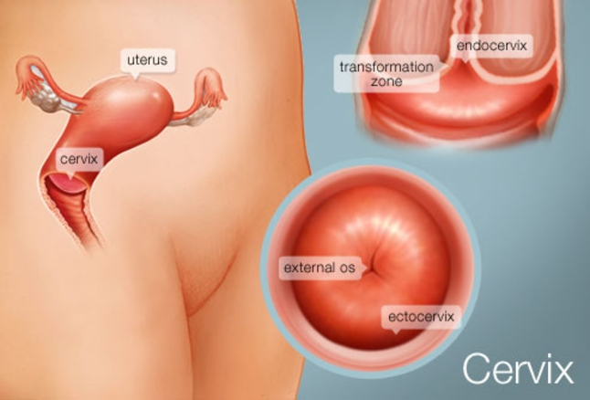
Why it is important to focus on all of this anatomy is that a very common cancer in women, young and old, is cervical cancer. Cancer of these epithelial cells.
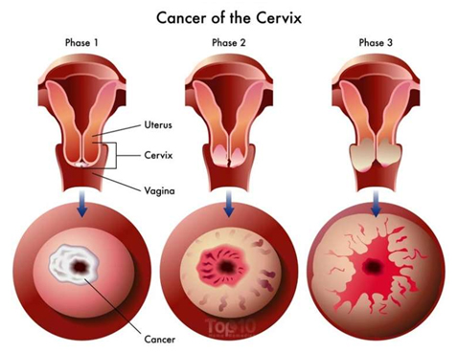
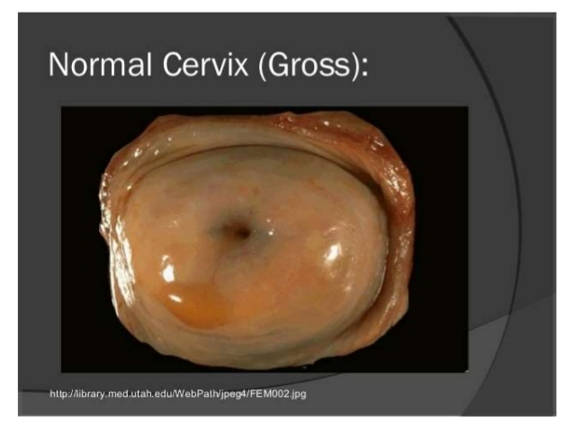
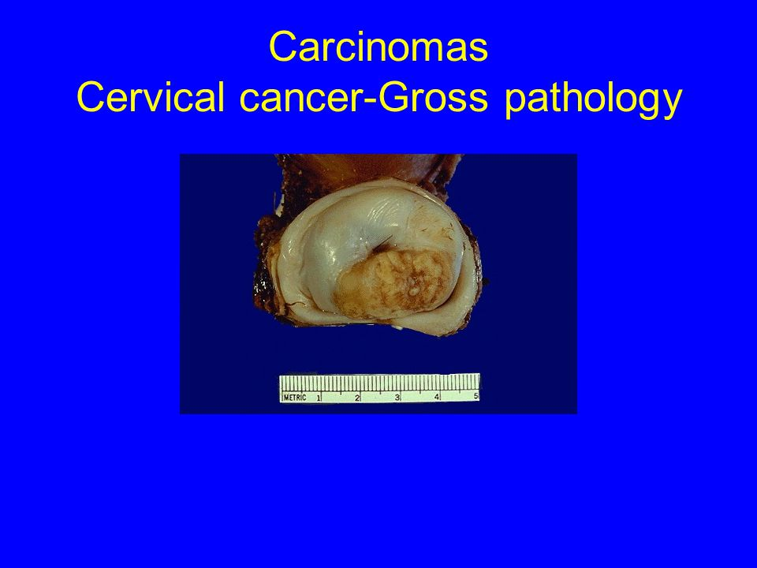
It is vitally important that all women get routine pelvic exams and Pap smears. As I was mentioning, lining the vaginal side is stratified squamous epithelium while lining the uterine side is simple columnar epithelium. And the abrupt transition is at the external os. Take a look:
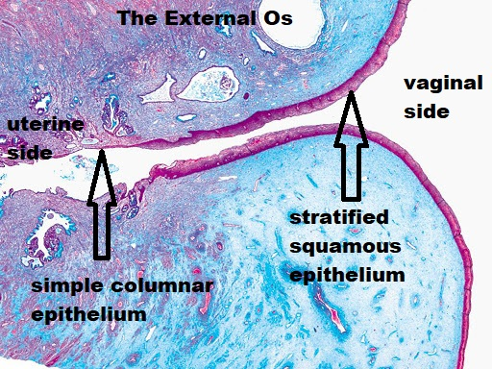
I agree, in the above low power histological view of the external os it is impossible to see what type of epithelium is there. But even with low power you can begin to tell the difference in epithelial types.
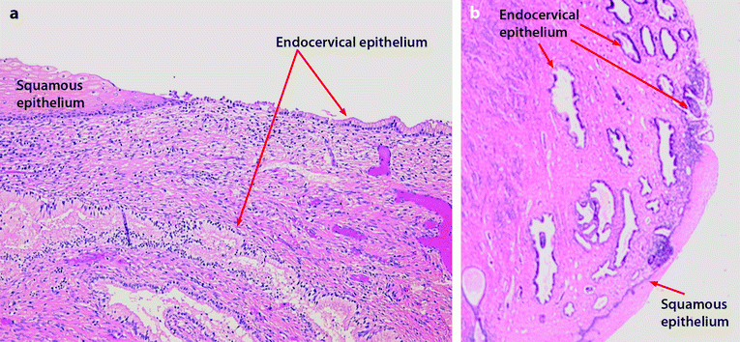
In the above images, with a bit higher power magnification you can begin to definitely see the differences in epithelial types. And below with even higher power you can see the abrupt change in epithelial cell types between the vaginal side of the os and the uterine side of the os. The vaginal side of the cervix is called the ectocervix and the uterine side of the cervix is called the endocervix. Ectocervical cells are stratified squamous epithelium. Endocervical cells are simple columnar epithelium.
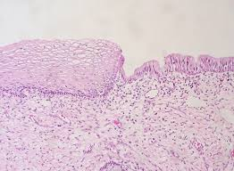
Can you tell which is the vaginal side half and which is the uterine half? (OK, the vaginal half in the above image is the left half because it obviously is stratified squamous epithelium whereas the right half of the image seen above is simple columnar epithelium which must be uterus. A Pap smear is to go in and take a sample of both types of epithelium and examine them to see if they look normal.
[A Pap smear, also called a Pap test, is a screening procedure for cervical cancer. It tests for the presence of precancerous or cancerous cells on your cervix. The cervix is the opening of the uterus. During the routine procedure, cells from your cervix are gently scraped away and examined for abnormal growth.]
https://www.webmd.com/women/guide/pap-smear#1
https://www.cancer.gov/publications/dictionaries/cancer-terms/def/pap-smear
https://www.mayoclinic.org/diseases-conditions/cervical-cancer/symptoms-causes/syc-20352501
It will be important to look microscopically at the ovary since that is where the eggs are found.
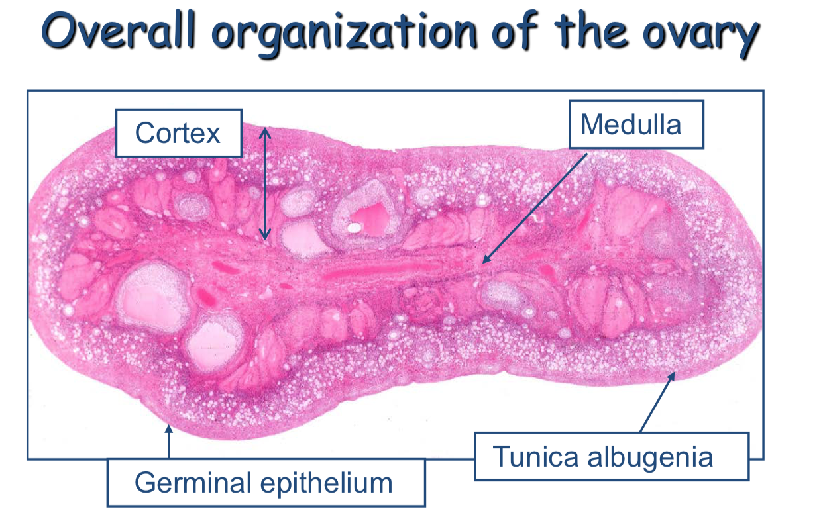
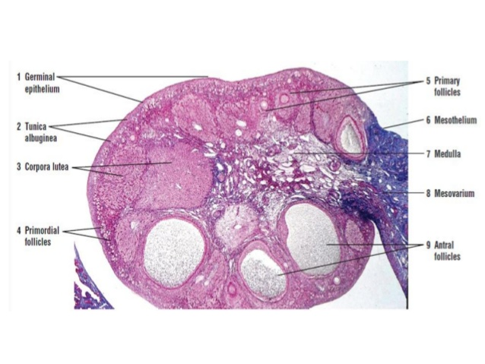
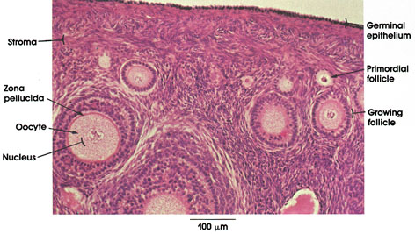
Notice that inside the round ovarian follicles are the eggs.

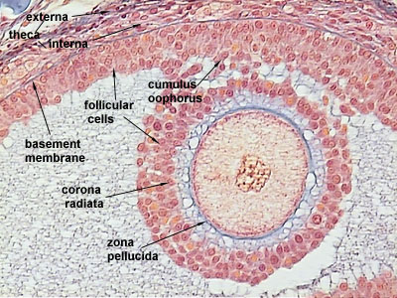

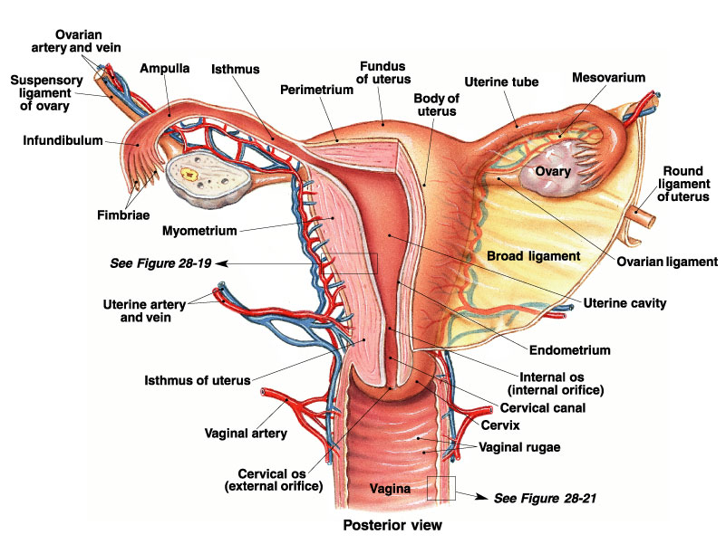

https://www.youtube.com/watch?v=AREHaMls9Y4
https://www.youtube.com/watch?v=ZZEsPUQ1gG4
https://www.youtube.com/watch?v=RFDatCchpus

And if you’re interested, a nice review of male reproduction: https://www.youtube.com/watch?v=2xErC-tnbG4
https://www.youtube.com/watch?v=-XQcnO4iX_U
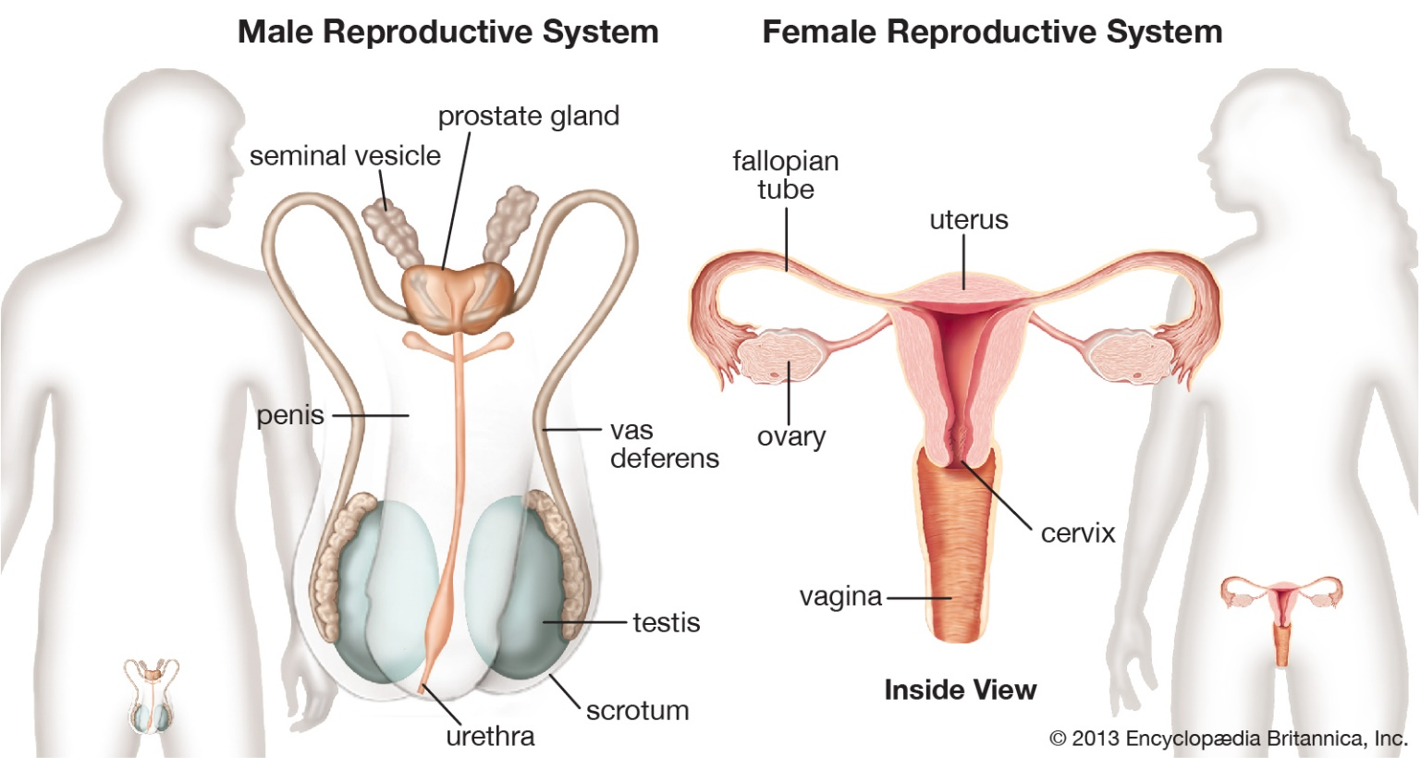
I’ve been putting it off but now let’s get to it. Let’s explain oogenesis. We explained spermatogenesis. Oogenesis should be the same thing since what we are after is to take a diploid regular female human cell that has 46 chromosomes and turn it into a haploid gamete with only 23 chromosomes, the egg or ovum. Well, oogenesis will be similar to spermatogenesis but in some ways it has to be different. One way oogenesis is different from spermatogenesis is that the eggs in the female are all made before she is even born. Huh? What? Let me explain. Remember that sperm are being continuously produced after puberty in the male. Every day (well, every minute) brand new sperm are being produced in the male by the thousands starting at puberty.
However, in the female, the eggs that are going to be in both ovaries and made by meiosis are made before that female herself is even born. So, picture a female fetus inside her mother’s womb (uterus). I’ll call her Maggie. Unborn Maggie has a little fetal heart beating blood into little fetal blood vessels. She’s got a little fetal liver and a little fetal brain. She has little arm buds and little leg buds. She has little ovaries that are very busy undergoing meiosis making thousands of eggs while she is still a fetus. So when the time comes and Maggie is born, on the day of her birth, day 1 of her existence outside of her mother’s uterus, all of the eggs she will ever have or need are already made and waiting inside both of her ovaries. Very unlike the male and spermatogenesis. One thing to then mention about Maggie’s eggs. When Maggie is 22 and ovulates and that released egg is fertilized, that egg itself is 22 years old. That explains one reason for more complications to the baby if the mother is ‘older’. The egg is as old as the mother and if the egg is 35 or 40 or 60 years old, there is statistically a higher likelihood of something bad having happened to that egg compared to an egg that might be only 21 years old in a 21 year old mother. A quick google search tells me that the oldest natural pregnancy was a British woman at 53. A report of a Chinese woman who naturally got pregnant at 67. And the artificially inseminated Indian woman who gave birth at 74 years old.
How this information may relate to you and how to study for our exam would be the fact that in the chart of meiosis for the male, the very, very first step was actually ‘mitosis’ before you even began meiosis. Remember so the male would have back-up spermatogonial cells to continuously make more sperm throughout his life. That initial ‘mitosis’ step does not occur in the female. In the female ovaries we begin egg production with the first step of meiosis.
Step 1 of oogenesis: DNA replication. Identical to what we did in the male for spermatogenesis. Doubling all the chromosomes with the new copy attached to the original chromosome. Ending up with double chromosomes in the nucleus. This cell that was produced in spermatogenesis was called the ‘primary spermatocyte’. So, in the female ovaries this cell following DNA replication is called the ‘primary oocyte’.
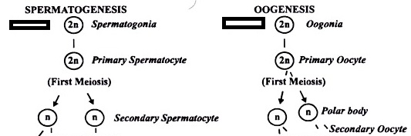
So, in oogenesis, the oogonial cell (the oogonium) undergoes step 1 of meiosis, DNA replication producing the primary oocyte. Just like we saw with spermatogenesis. Now we begin steps 2 and 3, the two division steps. Remember the first division step, step 2 of meiosis, is called meiosis I. And the second division step, step 3 of meiosis, is called meiosis II. In the male, we start the first division step (step 2 of meiosis) with the primary spermatocyte dividing ‘even-steven’ into two secondary spermatocytes. Likewise, in the female ovary. The second step of meiosis, the first division step, has the primary oocyte dividing ‘NOT even-steven’ into ‘NOT two secondary oocytes’. Huh? Why not? After all that ‘even-steven’ this and that with the male reproductive system, now we don’t do the ‘even-steven’ song with the female reproductive system? Why not? I was just getting to tolerate it. Notice I didn’t say I was just getting used to it, just to tolerate it. But now, no more ‘even-steven’ divisions? OK Paul, go ahead and explain.
Glad I made my point. Yes, in the male both of the division steps, steps 2 and 3 of meiosis, are easy to keep track of the chromosomes because you simply divide them ‘even-steven’ down the middle. In fact the whole division of the cell is ‘even-steven’ down the middle. But not so with oogenesis. Let’s explain why.
Let’s think about what happens after the egg is made. I know that is getting ahead of ourselves since we are right now trying to explain how the egg is made using meiosis. But let’s jump to after the egg is made and what happens next. Well the interesting story would be that the finished egg is released, ovulated, and a sperm fertilizes this egg and that fertilized egg immediately is a zygote, the first new human cell of that person. Then what?
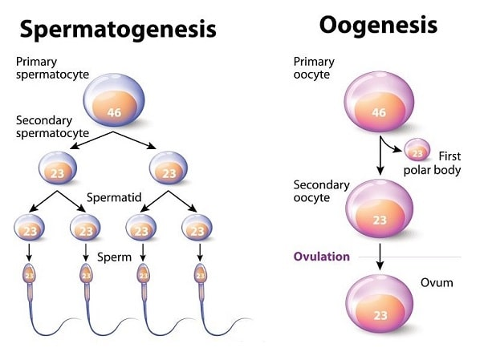
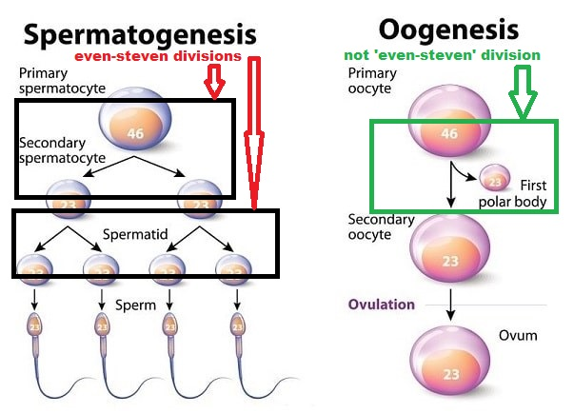
What do you mean, then what? Well, then what happens to this zygote? Well, we know it begins to travel along the Fallopian tube on its way to the uterus. Once it arrives at the uterus it has divided enough times to have grown large enough to have the ability to release enzymes and attach and digest its way into the inner lining of the uterus, the endometrial layer of the uterus (the endometrium). This is called implantation. This ball of cells, the blastocyst, has implanted into the endometrium of the uterus and now is directly connected to the mother. It can now finally start to grow in size. It is now for the first time ever connected to a supply of nutrients. Prior to implantation it was floating all by itself, alone, along the Fallopian tube. Sure it was dividing but never growing in size or increasing its volume since how could it grow in size, it was not connected to anything.
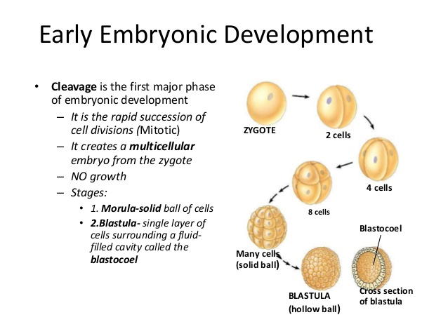
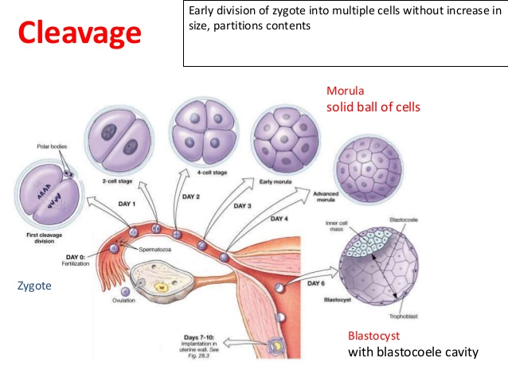
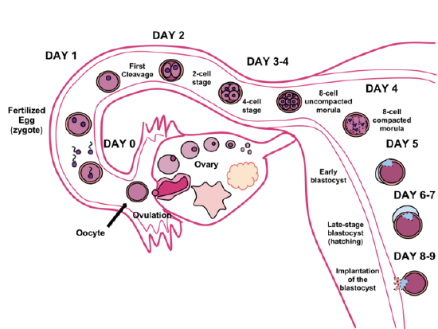
Notice in the diagram directly above, the time from fertilization to implantation can be from 6-8 days. About a week. You are a week old before you are actually connected to mom’s uterus. How can the zygote survive for a week all by itself, all alone, floating in the Fallopian tube? The zygote needs a week’s worth of supplies. The zygote needs a lot of stored ‘stuff’ in its cytoplasm. The zygote needs a lot of stored sugars (glycogen), proteins, nucleic acids at the beginning of this busy trip along the Fallopian tube. Where does the zygote get all these molecules?
Good question. Well, the zygote was, right before it was fertilized by that tiny sperm, an egg. Where did the egg come from? Meiosis of an oogonial cell, a regular female human cell. So as we step through the 3 steps of meiosis transforming an oogonial cell into a ovum (egg) we need to supply that cell with plenty of molecules so that this same cell can survive for a week traveling along the Fallopian tube if this ovum (egg) were to be ovulated and fertilized. The zygote has a week’s worth of supplies because it is directly derived from the ovum which is derived from the oogonial cell and the oogonial cell has a week’s worth of stored molecules inside of it.
So, in the conversion of an oogonial cell into an ovum, when performing the 3 steps of meiosis, we need to make darn sure that each cell in this 3-step process gets as many molecules stored away as possible. So, in the first division step, step 2 of meiosis, the cell divides. But we cannot afford to have the primary oocyte divide ‘even-steven’ into two identically sized cells because that would cut in half the stored supplies we need. Instead, as you see in the diagrams, when the primary oocyte carries out its first division step, one of the daughter cells retains all of the cytoplasm and all the molecules stored in that cytoplasm whereas the other daughter cell does not get any cytoplasm. In this way the first daughter cell retains all of the stored molecules and none of the stored molecules travel into the other daughter cell. The second daughter cell that gets none of the cytoplasm and so none of the stored cytoplasmic molecules is called a polar body. All the polar body contains is half of the chromosomes. This is NOT an ‘even-steven’ division of the cell.
The primary oocyte divides but in a very unequal way. One daughter cell gets half the chromosomes and all of the cytoplasm and all the cytoplasmic contents. The other daughter cell gets none of the cytoplasm, none of the cytoplasmic contents but it does get half of the chromosomes. We’ve conserved all the cytoplasmic contents into the secondary oocyte (so the egg derived from it can survive for a week) and sent off half the chromosomes into the other daughter cell, the polar body which is just a shriveled up ball of half the chromosomes. Notice below how small this polar body is.
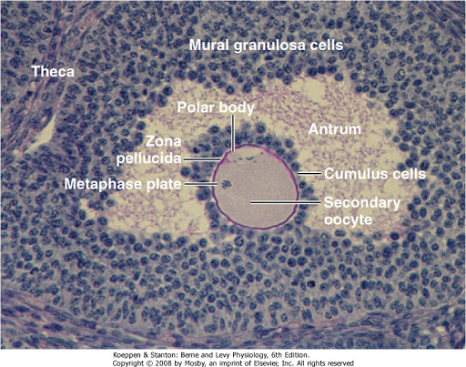
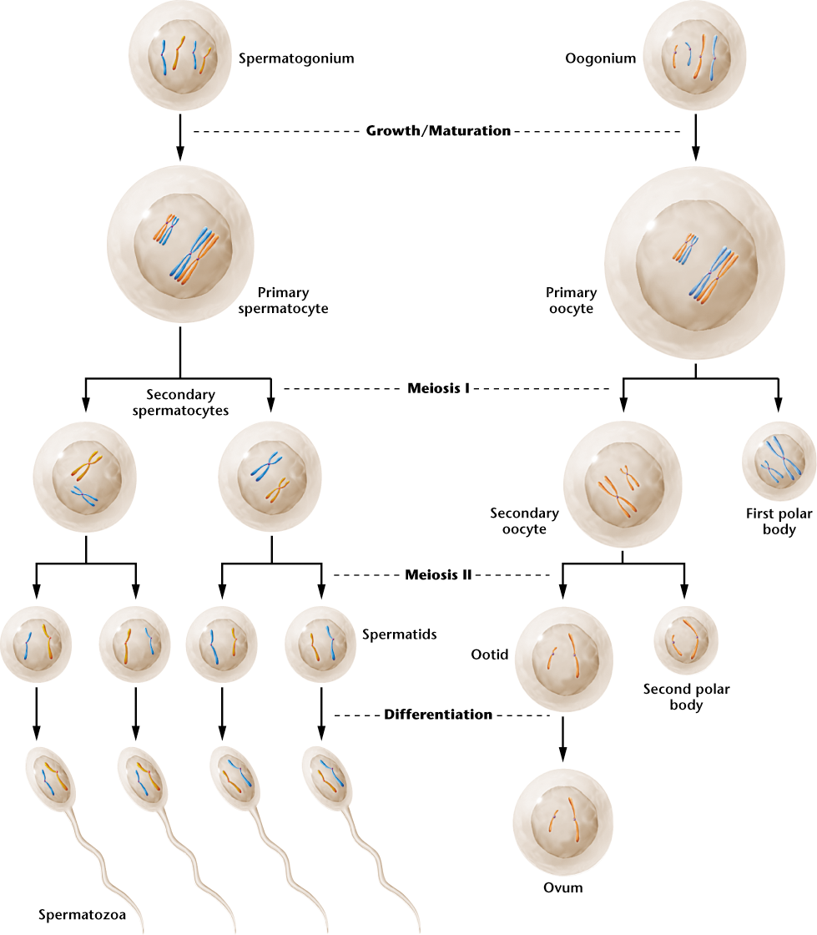
Notice on the right, the primary oocyte divides into a full-sized secondary oocyte and the tiny little first polar body. Why? Because in this way the secondary oocyte has all the cytoplasm and cytoplasmic contents to last a week. This first polar body is just a way to get rid of half of the chromosomes without sacrificing any cytoplasm. That is all this first polar body contains, half the chromosomes. And now the secondary oocyte must go through the second division step, step 3 of meiosis. Notice with this division step, it is NOT ‘even-steven’ either. Again, in order to retain all of the cytoplasm and cytoplasmic contents one daughter cell keeps all the cytoplasm and the other daughter cell gets none of the cytoplasm. This ‘full-sized’ daughter cell is the ovum or egg and the other daughter cell that only has half the chromosomes but none of the cytoplasm is also called a polar body, the second polar body.
Let me mention that sometimes, but not always, the first polar body will divide into two other polar bodies. In fact, since the first polar body has no cytoplasm to start with, the two daughter cells must also not have any cytoplasm and so these two daughter cells are just as small as the original first polar body and so also called polar bodies. That is why you will sometimes see the diagram below showing 3 polar bodies. This is not often the case but I do like the lower diagram since it shows some symmetry with spermatogenesis. Spermatogenesis produces 4 sperm that could fertilize an ovum (egg). Oogenesis though produces only one fertilizable ovum (egg) and three useless polar bodies.
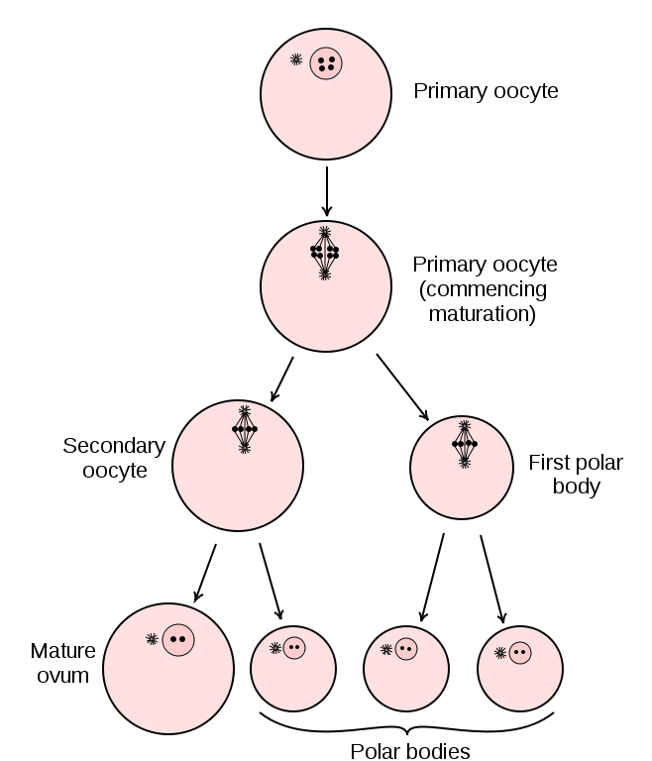
Now this single fertilizable ovum (egg) has retained all of the cytoplasm and cytoplasmic contents from the original oogonial cell and can, if fertilized, survive for a week on its way through the Fallopian tube to the uterus.
One last thing to mention. And this will blow your young minds. An interesting fact about oogenesis but has big ramifications. There is no egg! Nope, it is not an egg. What is ovulated is a ‘secondary oocyte’. This is because meiosis in the ovaries stops in the middle. Meiosis does not go to completion in the female ovaries. Meiosis starts and thousands of secondary oocytes are produced but all of these secondary oocytes do not finish meiosis. Meiosis in the female ovaries begins but stops at the secondary oocyte step. Step 3 of meiosis does not happen.
OK, so meiosis in the ovaries stops at the secondary oocyte stage. So, when does meiosis finish? Meiosis does go to completion and does step 3 only when the secondary oocyte is fertilized. The secondary oocyte is ovulated. It technically is not an ovum (egg) at the time of ovulation. You’ll notice in all of the anatomy and physiology textbooks it is called a secondary oocyte, not an egg.
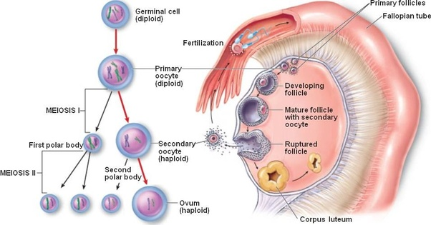
My point, notice that what is released from the rupturing follicle is a secondary oocyte, not an ovum (egg). And what is fertilized by the sperm right there in the Fallopian tube close to the ovary is the secondary oocyte.
Secondary Oocyte.
Secondary Oocyte.
Secondary Oocyte.
Secondary Oocyte.

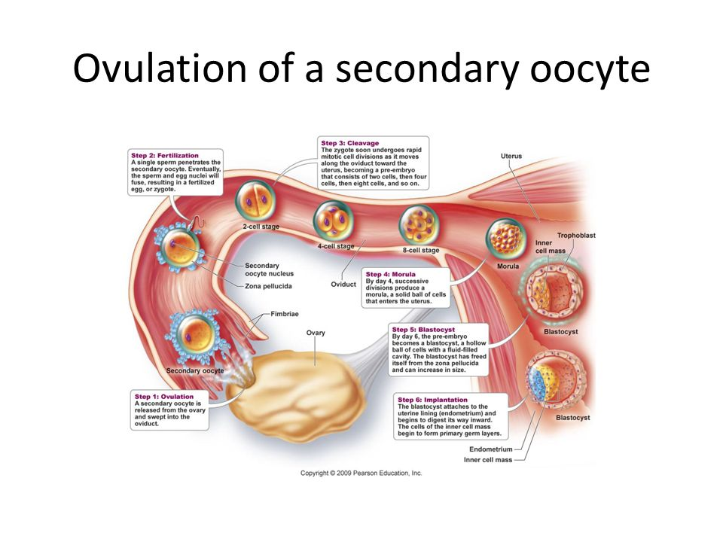
The instant the secondary oocyte is fertilized by the sperm, the secondary oocyte completes meiosis step 3 and that produces as we know the ovum (egg). BUT WAIT. The fact that the sperm has fertilized the secondary oocyte means that it is now a ‘zygote’.
-Sperm fertilize an egg to produce the zygote. UNTRUE.
-Sperm fertilize a secondary oocyte to produce a zygote. True.
So where is the ovum or egg? There never is an ‘egg’. The only way to produce the ovum, the egg, is to complete meiosis and have the secondary oocyte undergo its division into the egg and polar body. The only way to trigger the secondary oocyte to complete step 3 of meiosis and undergo its last division step is to have sperm fertilize the secondary oocyte which means you’ve created the zygote.
So as much as everyone calls them eggs, even fertility doctors, they are never really eggs. Let’s step through the options. If the secondary oocyte is ovulated and is never fertilized it never completes meiosis and never becomes an ovum (egg) and polar body and it certainly never becomes a zygote.
If the secondary oocyte is fertilized, then it is immediately a zygote. It will at this time complete step 3 of meiosis and shed half of the chromosomes but it is not an egg, it is a zygote.
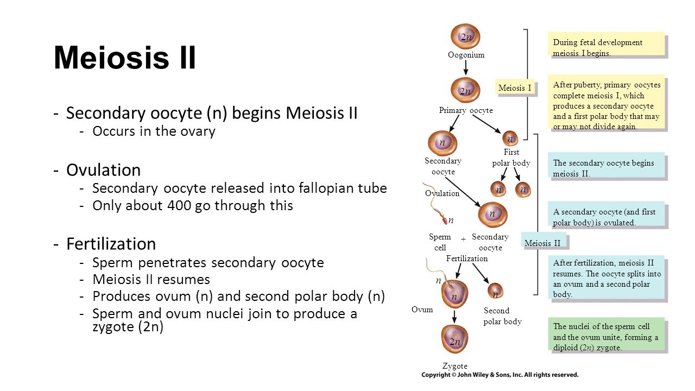
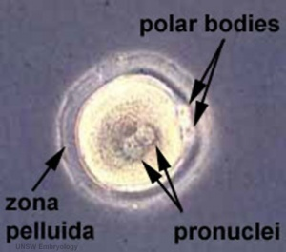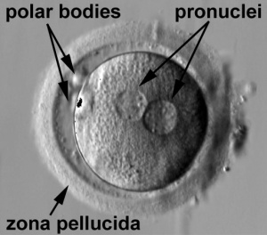
Let’s discuss the above photographs. Following the first division step in oogenesis, the primary oocyte divides into the secondary oocyte and the first polar body. Remember that polar body has no cytoplasm, just half of the chromosomes so the polar body is as small as a nucleus of a cell. If this secondary oocyte is fertilized, then it completes the last division step producing the second polar body (about the size of a nucleus) and this secondary oocyte now has the 23 male chromosomes inside of it. So, the double chromosomes are now separated, one set stays in the center of the cell as a ‘pronucleus’ and the other set of chromosomes migrate to the side of this cell and become the second polar body. The chromosomes from the sperm become the second pronucleus. So, looking at the diagram above, there are two pronuclei (one from the sperm’s 23 chromosomes; one from the set of 23 chromosomes from the original oogonial cell) and two polar bodies, the first polar body and the second polar body. Within seconds the two pronuclei will join into one single nucleus and that’ll be the zygote!

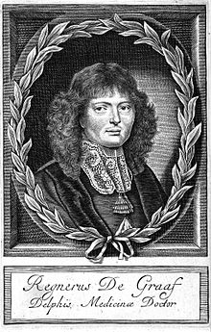
Gabrielis Fallopius who described the uterine tubes for the first time. Reinier De Graaf was probably the first to understand their true function.
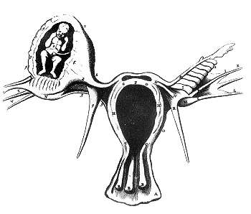
Ectopic pregnancy by Reinier de Graaf.

Two major female reproductive organs, the ovaries and the uterus. All the ovaries will ever do is ‘ovulate’. The uterus is there ready to receive the fertilized secondary oocyte. These two organs have to be in sync. The uterus must be ready to allow for implantation of the fertilized secondary oocyte which would actually be a blastocyst by the time it gets to the uterus. So there are two cycles: (1)The ovarian cycle: the growth of the follicle and the release of the secondary oocyte; (2)The uterine cycle, the growth and shedding of the inner lining of the uterus, the endometrium, about every 28 days.
What controls the ovaries? Two hormones from the brain: Follicle Stimulating Hormone and Luteinizing Hormone (FSH and LH). These two hormones are released from the brain (actually the anterior pituitary gland), travel through the blood and stimulate the ovaries to eventually carry out ovulation.
What controls the uterus to keep it in sync with ovulation from the ovaries. Two hormones released from the ovaries: Estrogen and Progesterone. These two hormones act on the uterus (the endometrium) to grow and shed this endometrial lining every 28 days or so.
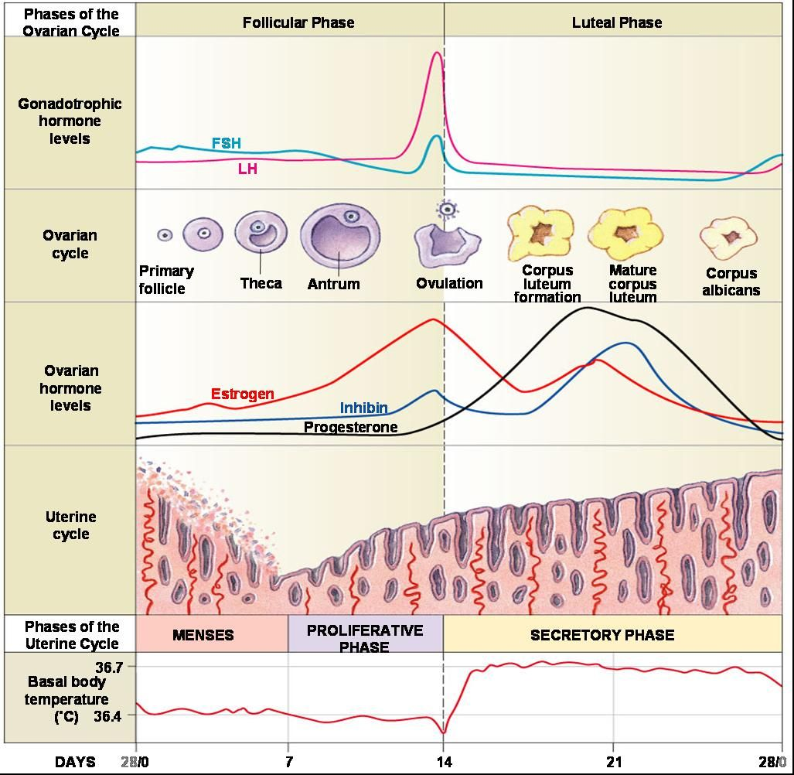
Simply divide this busy diagram into an upper half and a lower half. The upper half of this diagram shows the brain (anterior pituitary gland releasing into the blood over the 28 day cycle the different levels of FSH and LH. It is the peaks and valleys of these two hormones that trigger the growth of follicles in the ovaries and the eventual release of a secondary oocyte (ovulation to happen around day 14 of the 28 day cycle). End of upper half of diagram.
The lower half of the diagram shows the ovaries releasing their ovarian hormones into the blood to affect the uterus and the growth and shedding of the inner lining of the uterus, the endometrium. The peaks and valleys of estrogen and progesterone over the 28 day cycle controls the uterine cycle and menstruation (the menstrual cycle).
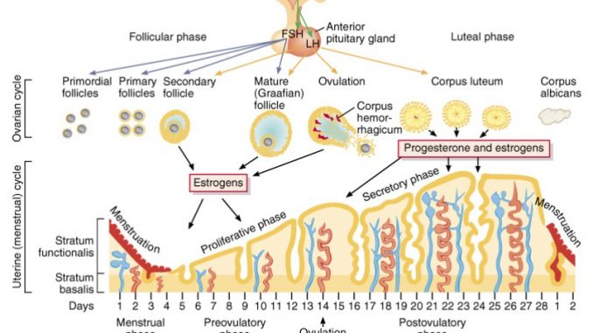
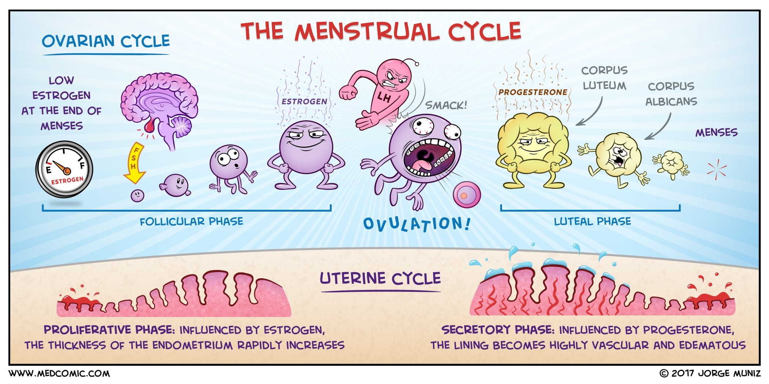
Not that I find this comic depiction of the menstrual cycle funny but it does illustrate some nice points in a way that differs from all the same ol’ diagrams like you see two diagrams above.
https://www.youtube.com/watch?v=SQNSGvfvhqM
https://www.youtube.com/watch?v=tOluxtc3Cpw
Visit Draw-It-To-Know-It Anatomical Overview of the Female Reproductive System

And another thing. This is interesting. All of us, when we are fetuses, have both sets of reproductive organs. Let me explain and as you’ll see in the diagram below. Every human fetus will have the tissues that will become the male reproductive organs as well has having the tissues that will become the female reproductive organs. Both sets of tubules (what could become male and what could become female) exist in every fetus, including you and me. If the hormone testosterone is present in the fetus then the tissues that will turn into the entire male reproductive system continue to grow and develop while the tissues that would have become the female reproductive organs disappears. If there is no testosterone, then, by default, by doing nothing at all, the tissues that will become the female reproductive organs continue to grow and develop and the tissues that could become the male reproductive organs disappears.
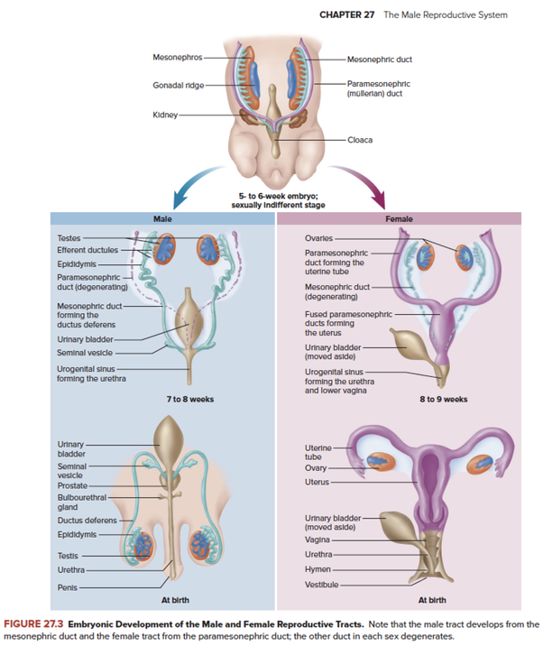
So how is testosterone introduced into the body in order for the male reproductive organs to develop and the female ones to disappear? There is a gene for testosterone and a gene that makes a protein that turns on the gene that makes testosterone. On the Y-chromosome there is a gene that when transcribed and translated makes a protein and that protein will do several things, one of which is turning the production of testosterone. With testosterone present, the male reproductive organs continue their development and the tissues that would have become the female reproductive organs disappear.
[The SRY gene provides instructions for making a protein called the sex-determining region Y protein. This protein is involved in male sexual development, which is usually determined by the chromosomes an individual has. People usually have 46 chromosomes in each cell. Two of the 46 chromosomes, known as X and Y, are called sex chromosomes because they help determine whether a person will develop male or female sex characteristics. Girls and women typically have two X chromosomes (46,XX karyotype), while boys and men usually have one X chromosome and one Y chromosome (46,XY karyotype).
The SRY gene is found on the Y chromosome. The sex-determining region Y protein produced from this gene acts as a transcription factor, which means it attaches (binds) to specific regions of DNA and helps control the activity of particular genes. This protein starts processes that cause a fetus to develop male gonads (testes) and prevent the development of female reproductive structures (uterus and fallopian tubes).]
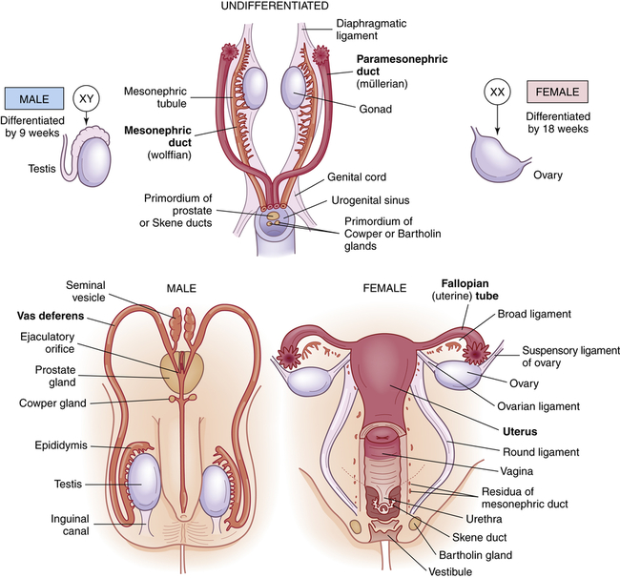
So, the presence of the Y-chromosome leads to the production of testosterone and that will lead to the continued development of the male reproductive system and the disappearance of the female reproductive system.
If there is no Y-chromosome, just two X-chromosomes, then that person is genetically ‘female’, having two X-chromosomes and by NOT having testosterone (not having a Y-chromosome) the female reproductive organs will continue their development and the male reproductive organs will disappear.
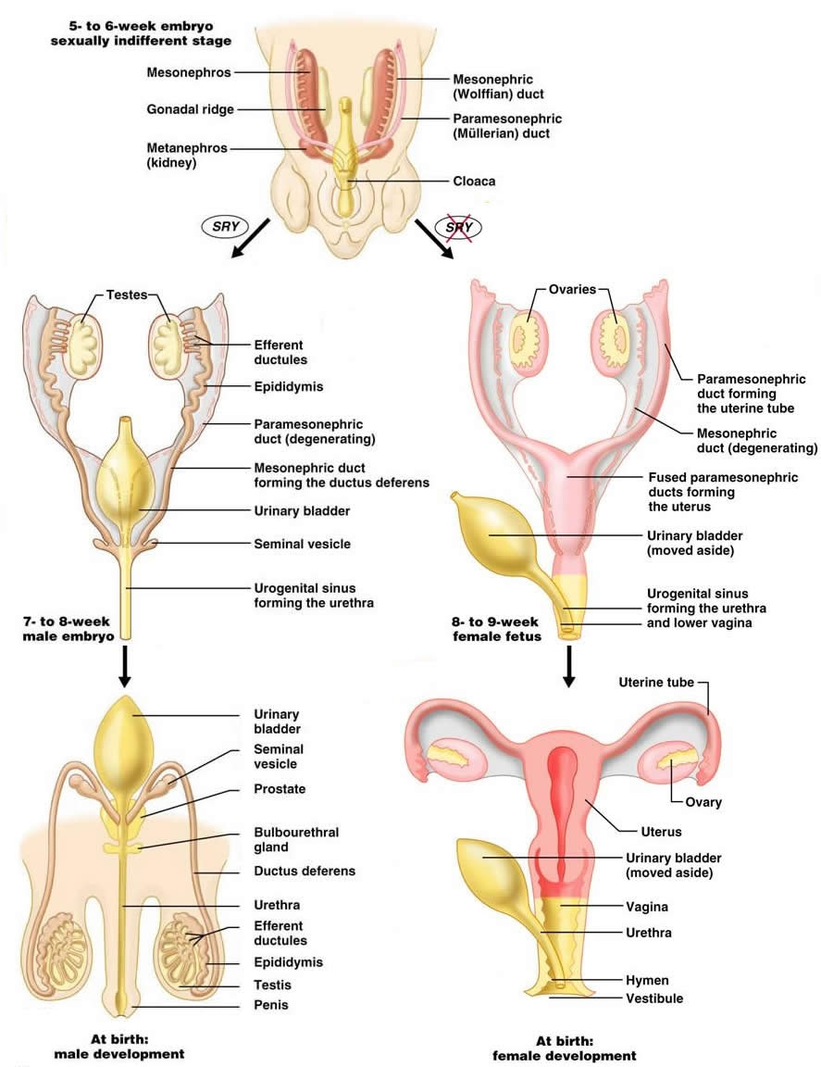
https://www.youtube.com/watch?v=VKQLtgBWQ9Q
AND, the same thing holds true for the development of the external reproductive organs, the external genitalia. A genetic male is called a genetic male because he would have a Y-chromosome (XY) which would turn on testosterone production and lead to the continued development of the male reproductive organs and the male external genitalia. A genetic female is called a genetic female because she does not have a Y-chromosome (XX) and so without testosterone the female reproductive organs will develop to completion as well as the female external genitalia and the male reproductive tissues will disappear.
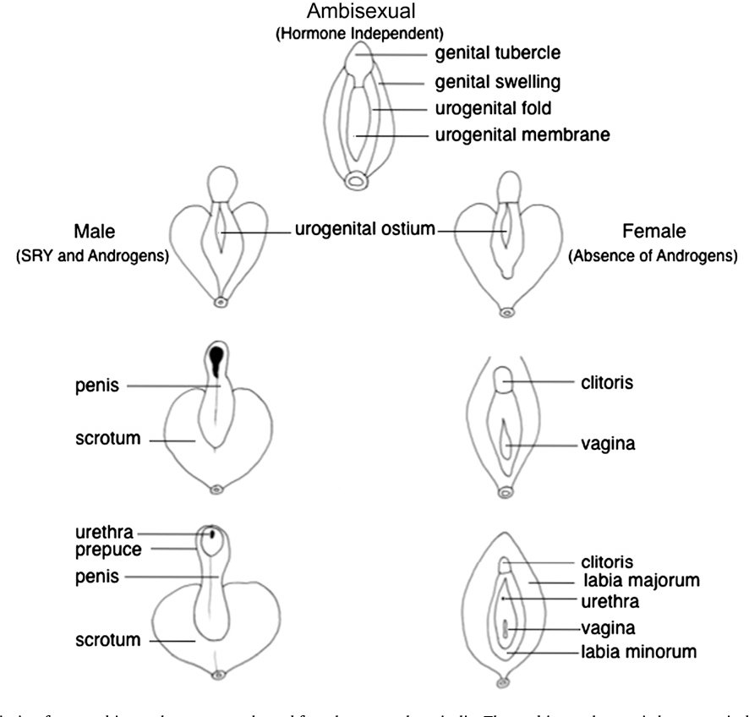
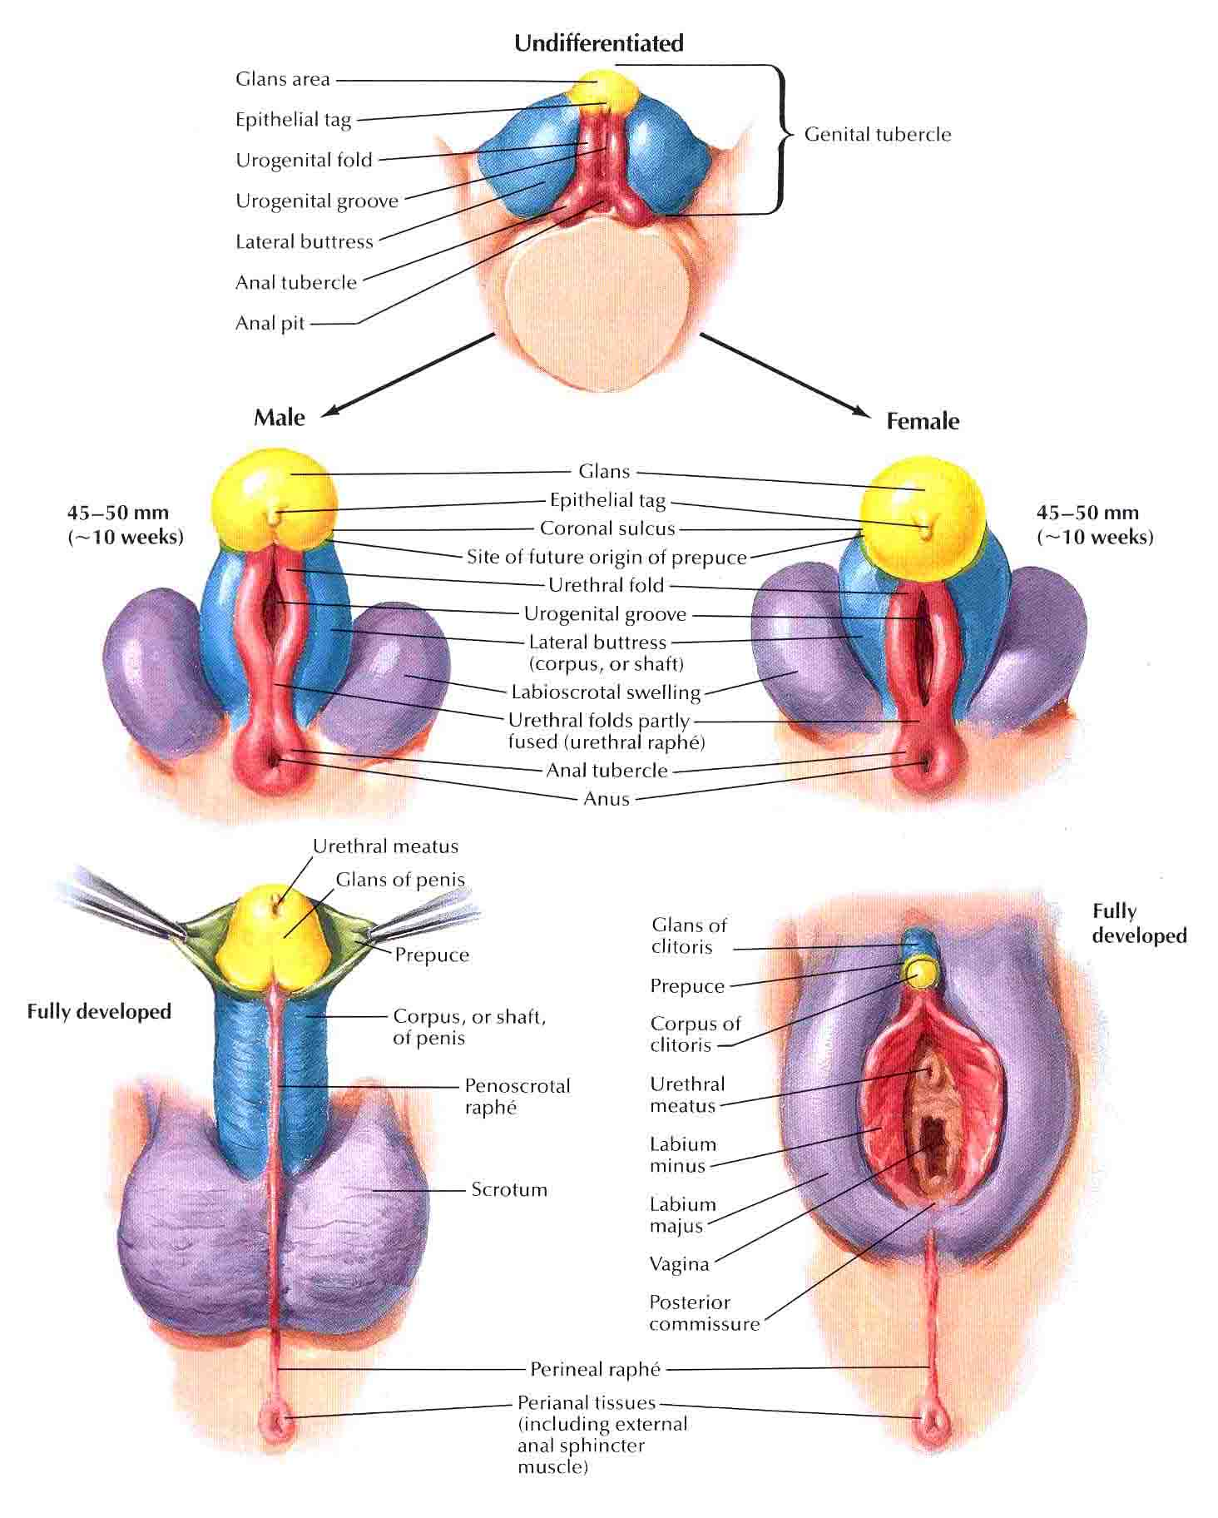
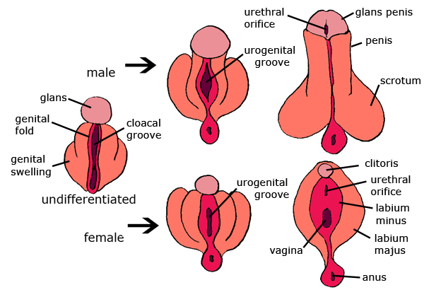
There is a medical term called ‘ambiguous genitalia’.
[The external genitalia of males and females develop from the same fetal tissue. The same tissue that becomes a penis in a male becomes a clitoris in a female. The main factor controlling the next step is testosterone. The presence of testosterone causes male organs to develop and the absence of testosterone causes female organs to develop.
Without enough male hormones, a genetic male will develop ambiguous genitalia. Likewise, a genetic female will develop ambiguous genitalia if male hormone is present.]

Know the histology of:
-testes; -penis in cross section; -ovary; -uterus; -Fallopian tube.

The Pap smear, also called the Pap technique was developed by and named after George Papanicolaou (1883-1962), a Greek-born physician and scientist who moved to the U.S. In 1923, while looking at vaginal smears from women with cervical cancer, Papanicolaou saw cancer cells.
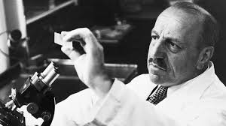
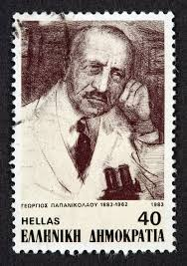
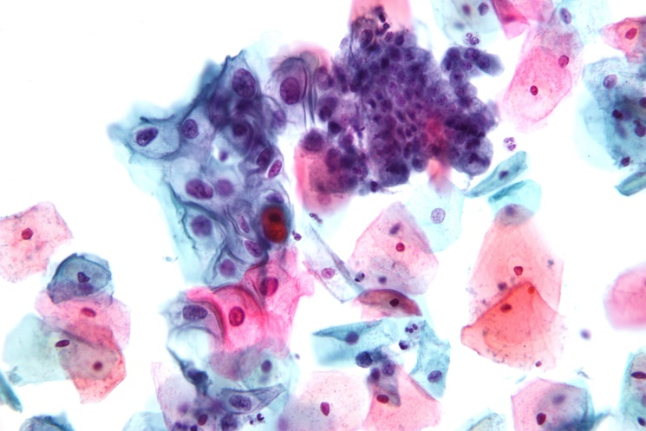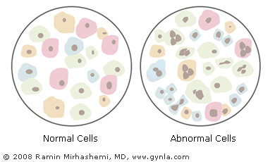

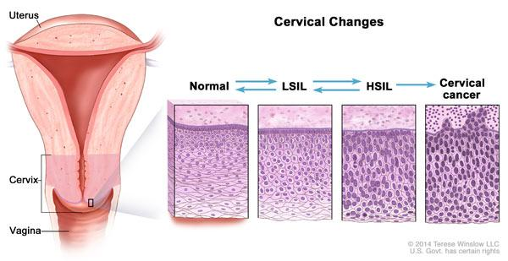
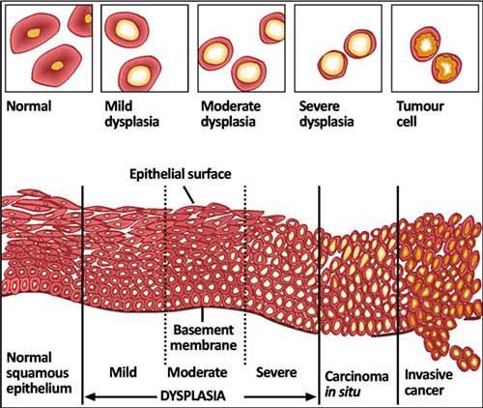

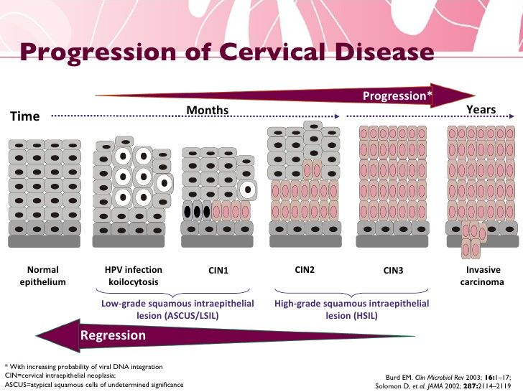
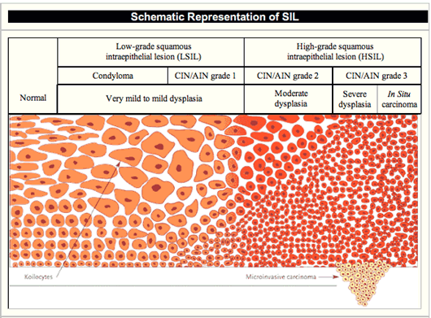
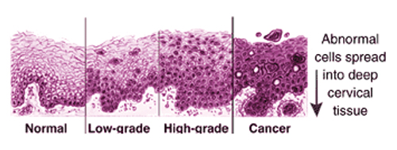
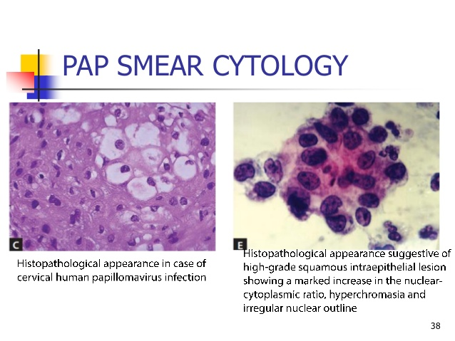
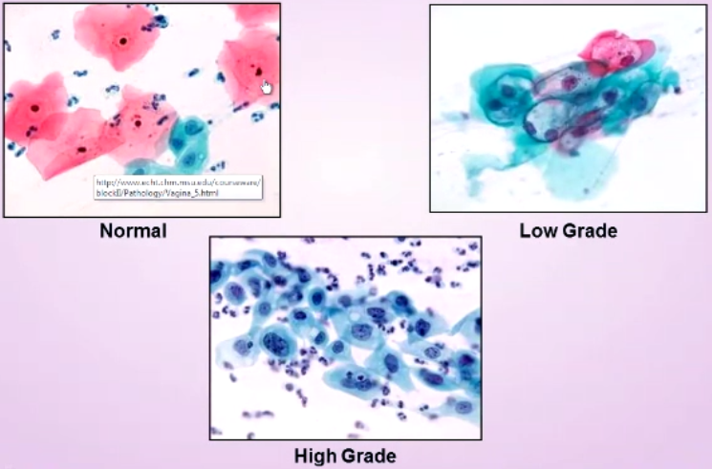
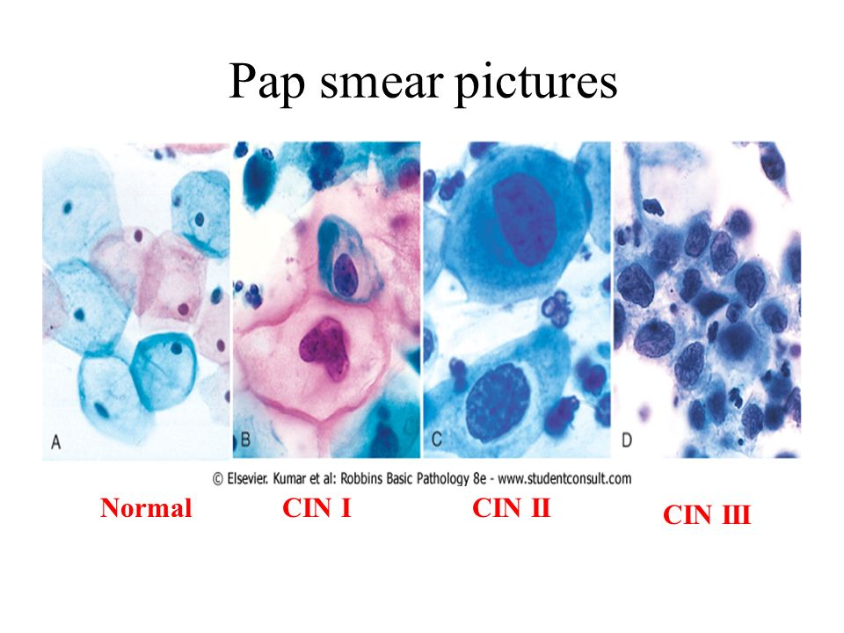
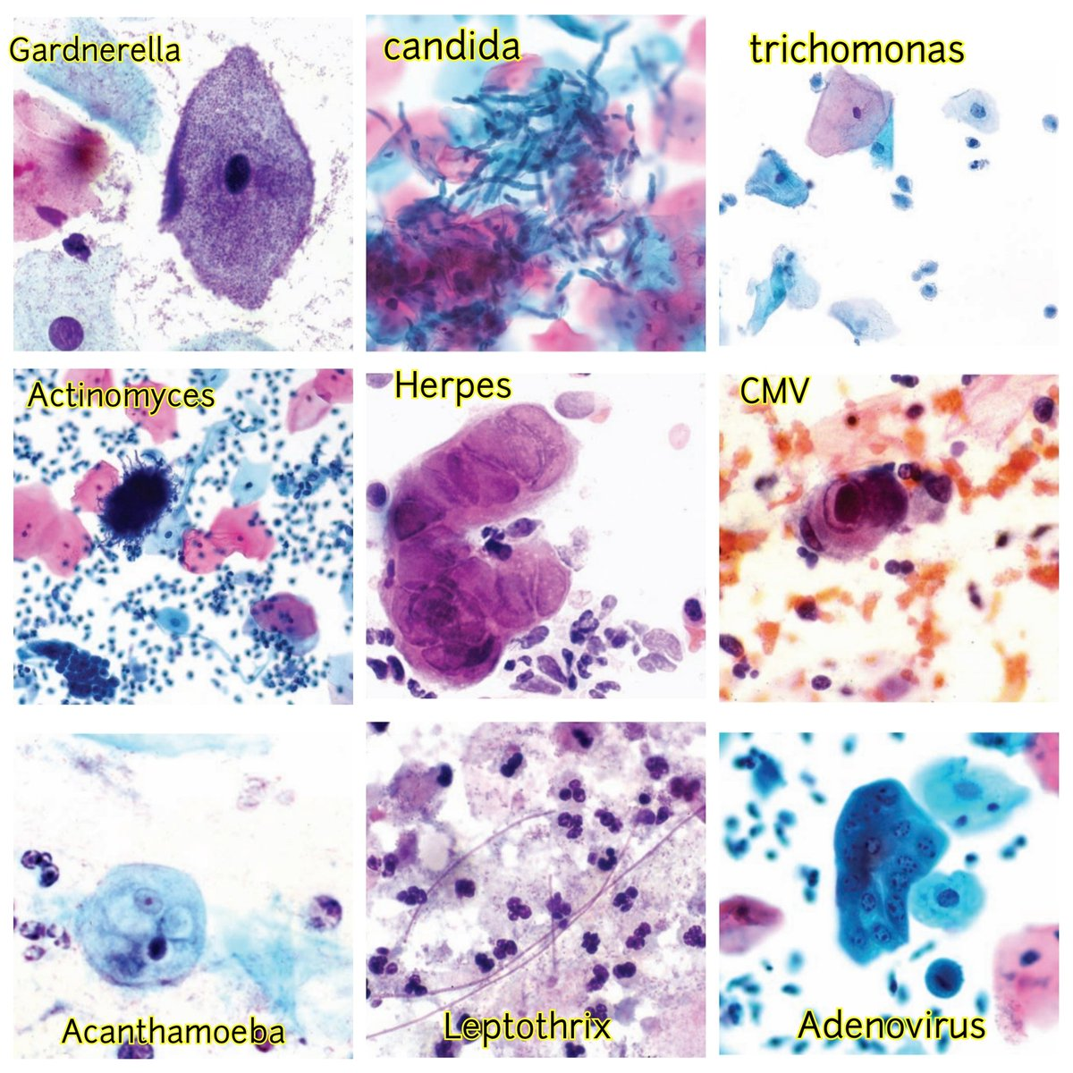

https://www.youtube.com/watch?v=i2YZYUYqjEY
https://www.youtube.com/watch?v=9m-EpupYkRg
https://www.youtube.com/watch?v=5KEAnfLj1pE
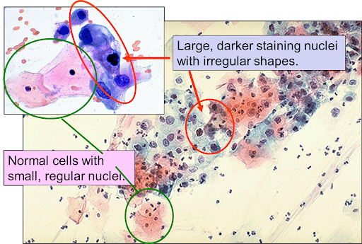
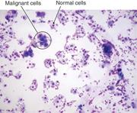
https://www.healthcentral.com/condition/condyloma
https://health.clevelandclinic.org/abnormal-pap-smear-what-an-lsil-result-might-mean-for-you/
https://my.clevelandclinic.org/health/diseases/15678-cervical-intraepithelial-neoplasia-cin
-What is HPV and why am I asking about it now?
-What is LSIL?
-What is CIN 1, CIN 2 and CIN 3?
-Now I am confused. One of the images above show CMV and Herpes. Those are not HPV. What is the difference between: Human papillomavirus (HPV), Herpes Simples (HSV), Epstein Barr Virus (EBV), and Human
Cytomegalovirus (CMV) infections AND how do they all relate to the cervix and cervical cells?

THE END.

