Human Heart Anatomy:

4 Chambers. 4 Valves. 4 Vessels.

Fibrous Skeleton:

The heart is made up of cardiac muscle fibers. They depolarize. They have intercalated discs that contain gap junctions. The gap junctions allow the depolarization to spread directly from one cardiac myocyte to the neighboring one and so on to spread that initial nervous signal. These nervous signals arrive at the Sino-Atrial Node. From the SA-node two things happen simultaneously. One of those is that this signal travels along the ‘conduction system of the heart’. From the SA-node to the AV-node, bundle of His, right and left bundle branches, and to the Purkinje fibers located in the walls of the ventricles.

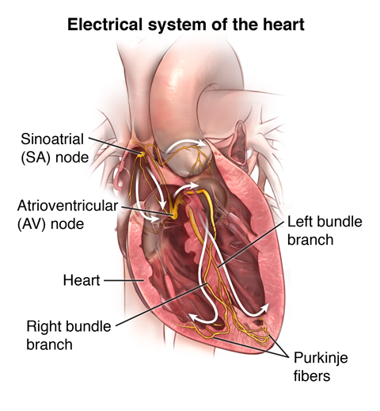

<https://www.youtube.com/watch?v=RYZ4daFwMa8>

Hopefully we all remember that. Remind yourself that all muscle fibers depolarize including the cardiac myocytes. So this conduction system works very much like a nervous pathway which would simply require these cardiac myocytes to become more nerve-like and less muscle-like which is not a difficult thing to happen since these cardiac fibers depolarize already. Why do we need this conduction system. Think about blood flow in the heart. With the beginning of systole, the atria contract first squirting their atrial blood down into the already filled ventricles. The atria contract down into the ventricles. But when the atria are done contracting, they relax and now the ventricles contract but the ventricles need to contract their blood up into the aorta and pulmonary artery. Atria contract downward into ventricles, but ventricles contract up into the arteries. This conduction system allows for that. Nice.

The second thing that is happening along side the conduction of this nerve signal running though the conduction system of the heart is this same nerve signal is spreading from cardiac muscle fiber (cardiac myocyte) to cardiac muscle fiber through the gap junctions contained in the intercalated discs. These gap junctions are very small but directly connect neighboring cardiac myocytes so that one initial nervous signal can spread from muscle fiber to muscle fiber. In this way the atria have each and every fiber contract one after the next generating their wave of contraction down into the ventricles.

<https://www.youtube.com/watch?v=7K2icszdxQc>

Skip Bachmann’s bundle, we don’t need to know that part. But notice the orange lines showing the depolarization signal for the atria to contract. Why doesn’t this wave of orange line depolarization continue to spread from the atria directly into the ventricles? First of all, that would ruin everything. We need the ventricles to contract from the bottom up. That’s what the conduction system makes sure happens. So we need to stop the orange line wave of atrial muscle fibers contracting to stop at the border of atria and ventricles. We can’t allow the orange line atrial depolarization to move directly from the atrial muscle fibers into the ventricular muscle fibers. That would have the ventricular muscle fibers to contract from the top down and squirt the blood nowhere into the bottom of the ventricles. This wave of depolarization is stopped dead at the border of the atrial and ventricles. How? At the border of the atrial and ventricles is a layer of fibrous connective tissue. Connective tissue will never depolarize. Also this layer of connective tissue can help to support the AV-valves located there. This is the fibrous skeleton.

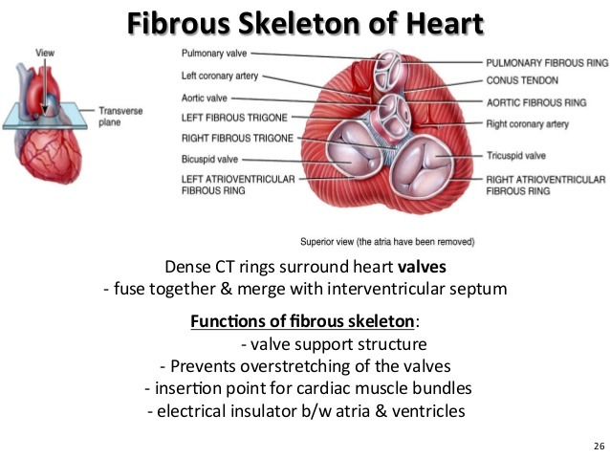

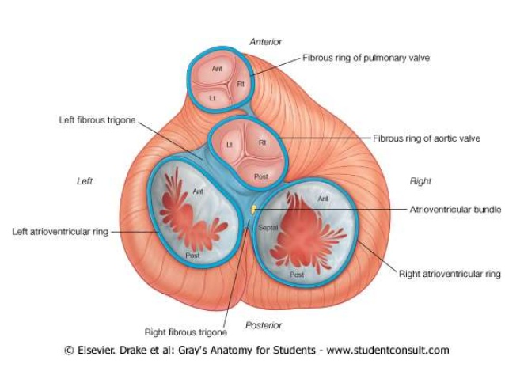

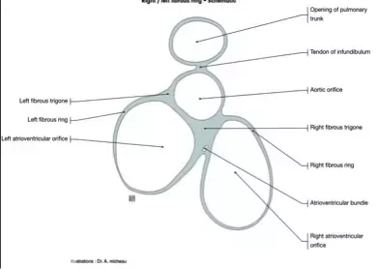

So again, two signals running through the heart at the same time, the black arrows and the red arrows shown below:

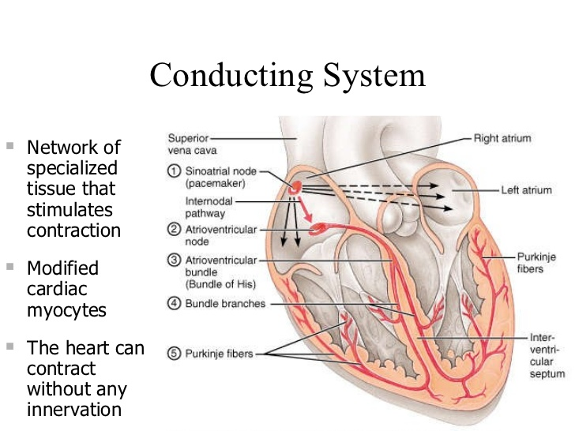

Are you ready to dissect Wigger’s Diagram (Carl J. Wigger):

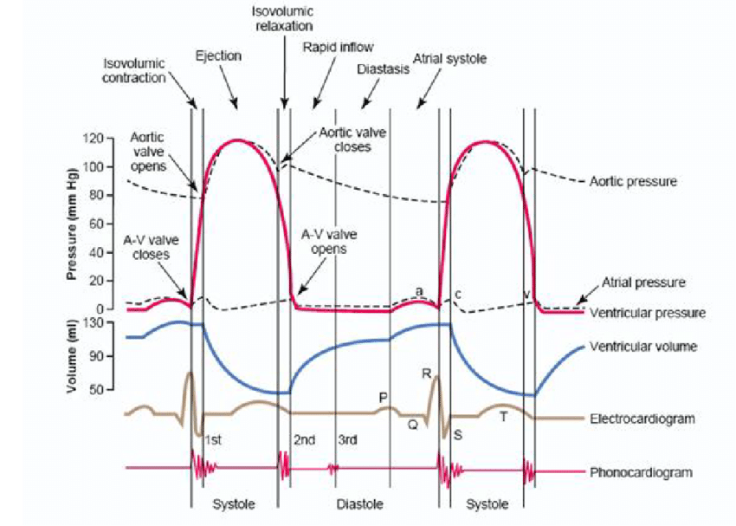

Start at the bottom and work your way up and we’ll talk about it later but you can figure it out.