**Heart Information:**

How does the blood flow? Not like a river. It travels in huge pressure waves. Well, huge if you were riding in the blood. Coming out of the almighty powerful left ventricle the blood enters the aorta. But how does the blood from the powerful left ventricle (and to a lesser extent from the right ventricle) exactly enter the aorta. How much blood leaves the left ventricle? How much is an average stroke volume? Let’s say 70 ml.

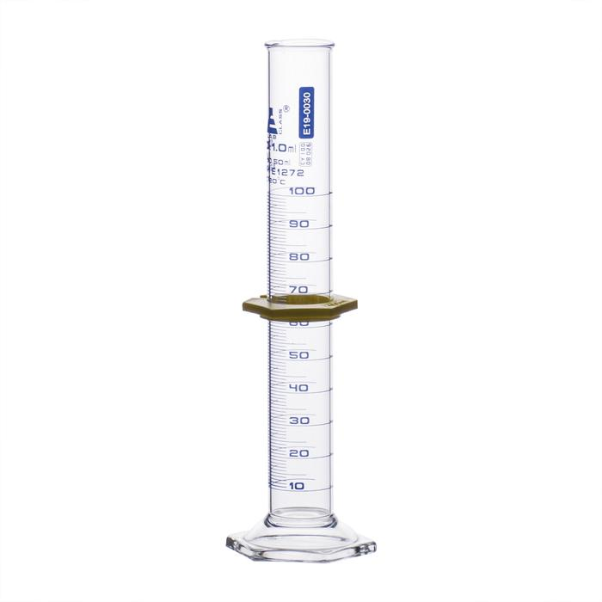

And how fast does this 70 ml completely leave the left ventricle and enter the aorta? Well, I guess at the speed of a heartbeat. And how fast is a heartbeat? Well, at rest, maybe 60 beats/minute so 1 beat per second. So, look at that volume and image that entire volume leaving the left ventricle in only ONE SECOND! My point is that the blood does not ‘flow’ out of the left ventricle into the aorta, that would take way, way too long. If your heart rate were even a bit elevated from walking up stairs (70-80 beats/minute) you’d be ejecting that 70 ml (or so) of blood in less than one second. In a fraction of a second all that blood is out of the left ventricle and into the aorta. So, if we were to film the blood leaving the left ventricle in super slow motion we would not see the blood ‘flowing’ out.

This is what has to occur since so much blood has to leave in such a short period of time. The blood in the left ventricle is being compressed when the left ventricle is contracting. Compressed more, compressed more until the blood looks and acts like a compressed ball of blood. This is called a ‘bolus’ of blood. That compressed ball of blood, around 70 ml, is in a fraction of a second dumped into the aorta. One fraction of a second this ball o blood is in the left ventricle, a fraction of a second later that ball o blood, looking and acting like a ball o blood, is not squirted but plopped into the aorta. As soon as that bolus of blood is in the aorta, the left ventricle is empty (except for the ESV) and the aortic semilunar valve is closed, slammed closed. Slammed so hard you can hear the leaflets of the valve slam shut (second heart sound, right?).

Let’s look inside the aorta now. Aortic semilunar valve is closed and a big, compressed (pressurized) ball (bolus) of blood is there wanting to now expand. It expands stretching the walls of the aorta and mostly moving to the path of least resistance downstream in the aorta. But imagine this pressurized ball of blood expanding in every direction once it gets outside the aortic semilunar valve. I would draw this ball o blood with little arrows pointing out from it in all directions: arrows pointing downstream, arrows pointing up against the walls of the aorta and arrows pointing backwards toward the closed aortic semilunar valve. Eventually the ball expands and moves downstream as a ‘pulse’ of blood in our arteries. You can see that expanding pressure wave of blood hitting the closed aortic valve from the aorta side as the dicrotic notch on the wonderful Wiggers diagram. It is shown on the second Wiggers diagram below labeled “C”. Ah, the sadness of not lecturing, I don’t get to say, ‘Wiggers’. Fun to say, fun to learn, right?

Follow the red ‘aortic pressure’ line and watch as the pressure in the aorta naturally goes up as this ball o blood is dumped from the left ventricle into the aorta and right when the aortic valve closes the expanding ball o blood hits the closed aortic valve leaflets and bouncing back to move downstream. This little ‘bump’ of pressurized blood hitting the closed aortic valve causes that little uptick in aortic pressure when the aortic valve closes, the dicrotic notch.

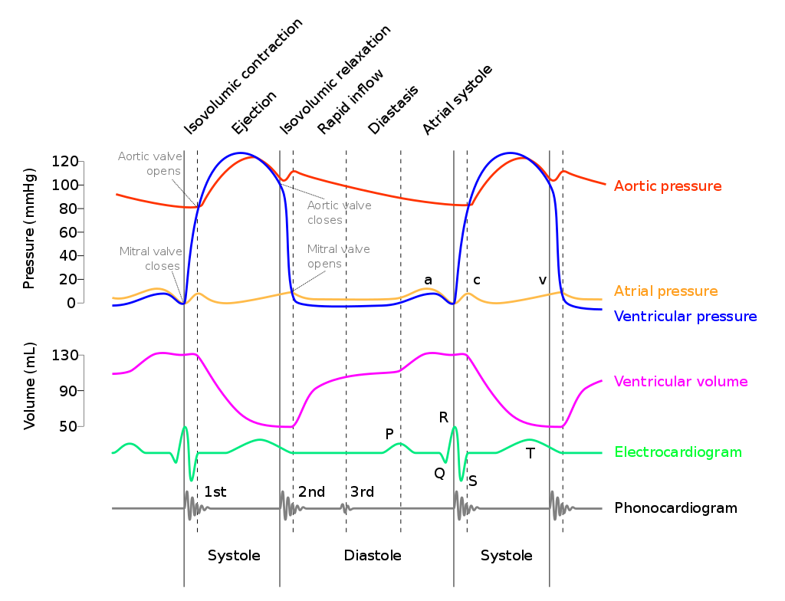

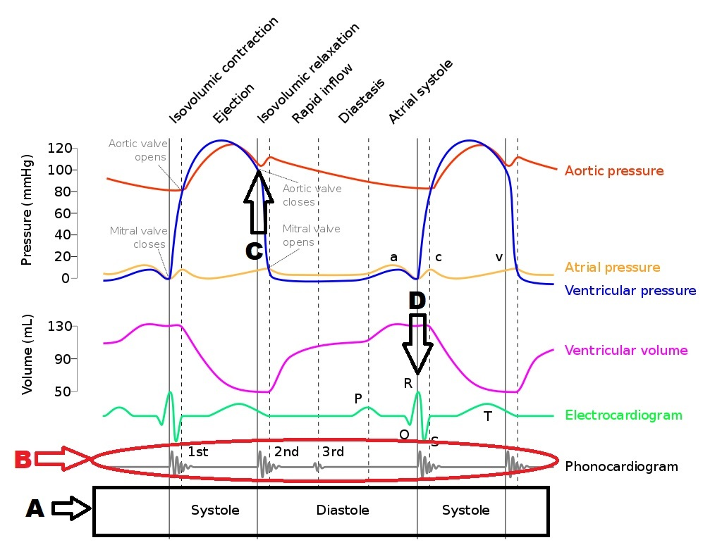

Well, since we’ve got the Wiggers diagram out, let’s talk about how clever, useful and easy it actually is. We’ll start at the bottom. Bracketed in black, labeled “A” simply shows what we understand very well, the periods of diastole and systole. Diastole is when the heart is relaxed and filling with blood. Systole is when the heart contracts and ejects (its ball o blood into the aorta and the pulmonary artery). WAIT! I’m confused. That is not what Wiggers shows. I look at the ECG tracing and I see that the P-wave is solidly within diastole. The P-wave is when the atria depolarize and contract. The P-wave should begin systole, shouldn’t it? Well, there are two definitions out there. The ‘teaching anatomy and physiology’ definition and the ‘clinical nursing/doctoring’ definition. The ‘teaching A&P’ definition generally is the one I mentioned above: diastole is when the heart is relaxed and filling with blood; systole is when the heart contracts and ejects blood generating the systolic blood pressure and this definition can place atrial contraction within systole.

The ‘clinical nursing/doctoring’ definition is more concerned with ventricular contraction generating systolic blood pressure and defines systole as beginning with ventricular depolarization and contraction. That’s what you see on Wiggers (“D”). Notice the defining line between diastole and systole is the QRS complex, the depolarization and contraction of the ventricles.

So, let’s get back to dissecting (pronounced: ‘dis-sec-ting’. NOT ‘d-eye-sec-ting’) the Wiggers diagram. Look at the red circled “B”, the heart sounds. You can always remember what valves close and when if you just trace the path of blood through the heart with one hearbeat. When the heart is relaxed and filling both ventricles and atria fill. To begin a heartbeat the atria depolarize/contract first squirting their atrial blood into the already filled ventricles and the two AV-vales are open. Once that is completed and the ventricles start to contract (QRS) the two AV valves have to shut. These are the first valves to close and so must produce the first heart sound, the Lupp of the Lupp-Dupp and you see on the diagram. The second heart sound as you follow the blood through the heart must be the closing of the semilunar valves after the blood has left the ventricles and both the pulmonary artery and the aorta have theses balls o blood inside them with the two semilunar valves now shut tight. You see on the diagram that the second heart sound, the Dupp of the Lupp-Dupp, lines up with the aortic valve closing on the top red line as well as matching the lowest value for ventricular volume (the purple line). Ventricular volume makes perfect sense. The QRS is ventricular contraction and as you see it matches the beginning of the decrease of ventricular volume. Notice also at the QRS the ventricular pressure begins its rise.

Now ‘isovolumic contraction’ at the very top is fun. As the name implies it is that short period of time when the ventricles are contracting but not ejecting blood yet. So, the top of the QRS complex begins isovolumic contraction where the ventricles begin to contract in full and you see on the purple line (ventricular volume) that it stays the same. The volume of the ventricles is staying the same while the ventricle is contracting and compressing the blood into its ball o blood. See the blue line (ventricular pressure) during isovolumic contraction. It is rising dramatically. See that during isovolumic contraction we are watching the blood in the ventricles rise and rise until …… what? When will the blood in the ventricle actually be able to leave the left ventricle and enter the aorta? When the pressure in the left ventricle is higher than the pressure of the blood in the aorta. Find that on Wiggers. Where the blue line and the red line intersect for the first time on the diagram is where the blood pressure in the left ventricle is finally greater than the blood pressure in the aorta and now blood leaves the left ventricle and enters the aorta and you see ventricular volume begin to drop. Nice.

<https://www.youtube.com/watch?v=zcNTx8AC_Ro>

OK, now what is Mean Arterial Pressure (MAP)? MAP, or **mean arterial pressure**, is defined as the average **pressure** in a patient's **arteries** during one cardiac cycle. It is considered a better indicator of perfusion to vital organs than systolic **blood pressure** (SBP). Normally blood flows in the arteries jumping between systolic and diastolic pressure. What if you just wanted to know ‘what is the average blood pressure’? Sure the patient’s blood systolic pressure might be too high or too low or maybe the patient’s diastolic blood pressure is jumping around between being too high or too low, can I just get a good measurement number of the average blood pressure the organs of the body are seeing? That is what the MAP provides. Now why can’t I just average the systolic and diastolic blood pressures to get this ‘mean’ arterial pressure? The rule for normal blood pressure is 120/80. So, if I just average them [ (120 + 80) / 2 = 100 mmHg].

But that is not accurate because of the time the blood spends in systole compared to the time the blood spends in diastole. If you were to observe the blood very little time is spent in systole and most of the time is spent in diastole. In other words most of the time you spend floating in the blood is spent under diastolic pressure and for just a little bit of time you get hit with a brief wave of systolic pressure. So, you cannot just average 120 and 80. The MAP equation allows for this.

There are two equations to calculate MAP:

1. MAP = diastolic pressure + (pulse pressure/3); where pulse pressure is systolic pressure – diastolic pressure.

Example: Blood pressure is 120/80. Pulse pressure is 120-80=40, so MAP = 80 + (40/3) = 93.3 mmHg.

1. MAP = [ 2(diastolic pressure) + (systolic pressure) ] / 3.

Example: Blood pressure is 120/80. [ 2(80) + 120 ] / 3 = 93.3 mmHg.

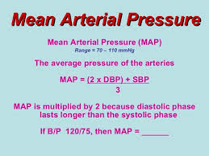

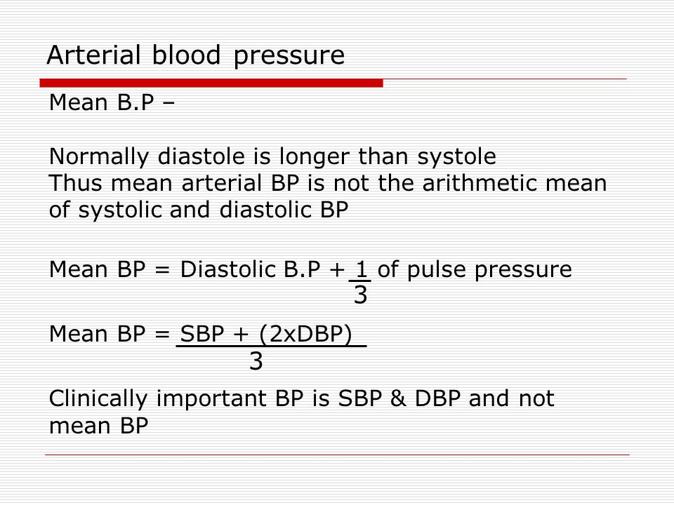

<https://www.youtube.com/watch?v=XiVpku0vjLU>

She’s so perky. But she neglected to point out why MAP is important. Mean arterial pressure is significant because it measures the pressure necessary for adequate perfusion of the organs of the body. ... It is vital to have a MAP of at least 60 mmHg to provide enough blood to the coronary arteries, kidneys, and brain. The normal MAP range is between 70 and 100 mmHg.

Related to blood pressure and how hard the heart has to work to pump blood into the circulatory system, what sorts of things effect (affect?) total peripheral resistance to blood flow? What sorts of things can make it easier or harder to pump blood into a system of vessels? One such thing would be the viscosity of the blood. How thick the blood is. You know, water vs. syrup. That should not vary too much, the viscosity of your blood. But what could change the viscosity of your blood? The number of blood cells you have could. How could you ever make or have so many ‘extra’ blood cells to effect (affect?) the blood viscosity. How about if as part of a cancerous overgrowth of just your blood cells all those cancerous extra blood cells overpopulated the blood circulatory system? A leukemia possibly. A cancer where there is an overproduction of certain types of white blood cells.

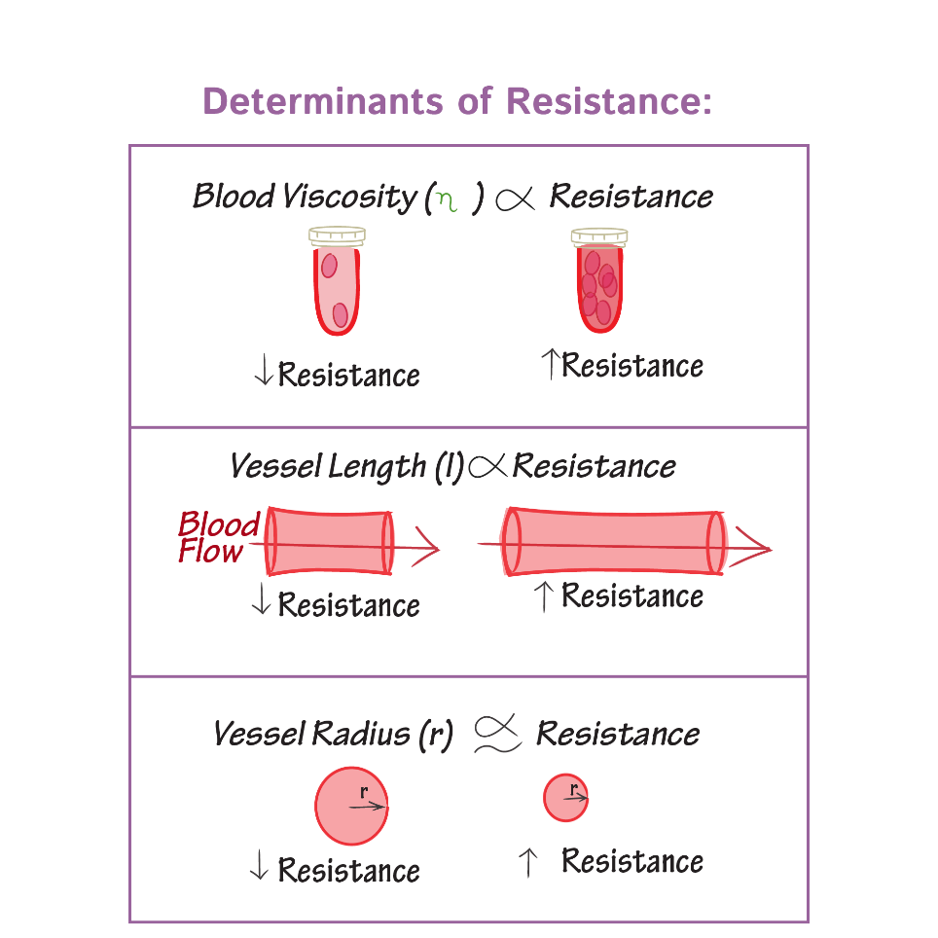

Another factor that might influence total peripheral resistance to blood flow in the blood vessels would be ‘vessel length’. Just how long all the blood vessels add up to be. Easier to pump through 10 feet of pipe rather than 100 feet of pipe. How can a person develop too many blood vessels expanding the overall length of the circulatory system? By having extra fat. More fatty tissue, more blood vessels to supply that tissue, the harder the heart would have to work to pump blood.

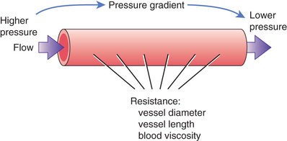

But the factor that is the most important factor in determining total peripheral resistance is blood vessel diameter. How open or closed the blood vessel is. Obviously the larger the opening for a blood vessel the more blood can pass along it and the easier the blood flows, the least resistance. The smaller the opening of a blood vessel (the smaller the lumen) the more resistance to blood flow. But from physics, this relationship is powerful. Resistance = 1/(radius of vessel opening)4. In other words, when ever you change the radius (or diameter) of a blood vessel (or any tube) you are altering the resistance to the 4th power. Example: blood vessel with a radius of 1 cm. I plug that into the equation and get resistance of 1/(1)4 = 1. But increase the radius to 2 cm. The new resistance is 1/(2)4 = 1/16. Doubling the radius changes the resistance 16-fold! So, if you do this math backwards, constricting a vessel’s radius from 2 cm to 1 cm (cutting the radius by ½) you get a 16-times increase in resistance. So, vessel diameter has a huge impact on resistance to blood flow.

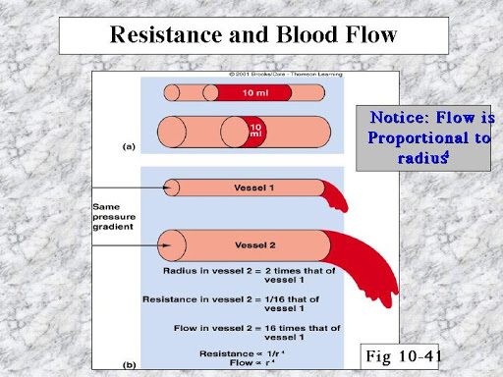

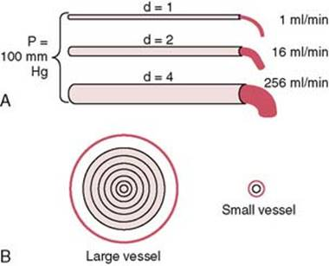

Now, let’s see that it makes sense that the volume of blood ejected from the left ventricle must equal the volume of blood ejected by the right ventricle so the ‘rule’ is that the left and right ventricles hold the same volume, that the left and right ventricles are the same size. Well, first of all, all of our hearts are not the same anatomically (and I guess poetically). And even within the same person there will be differences between the volume that person’s right and left ventricles eject out. I had remembered that imagining studies had shown that generally a person’s left ventricle was slightly larger than the right ventricle but when looking that up recently found an article showing in infants and adolescents that the right ventricle was larger. Now these are imaging studies, measuring the size of the ventricles, so hard to misinterpret that type of data. But let me get back to the point. Generally, and we’ll see why, the two ventricles must put out the same amount of blood per beat. Left ventricular stroke volume = right ventricular stoke volume.

Let’s look at the diagram below. Coming out of the left ventricle is the blood going to the body, the systemic pathway and my arrows show that in green. The pulmonary circulation is shown in orange.

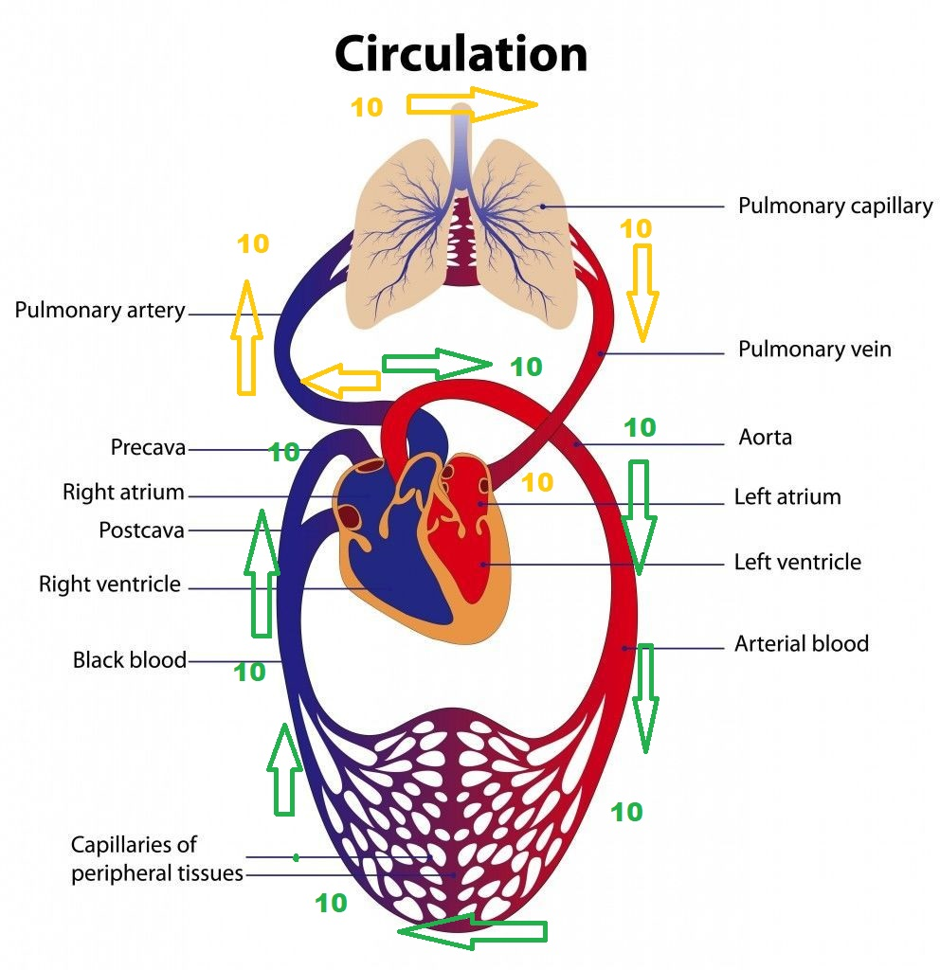

So, let’s just use some hypothetical numbers, numbers that are not real but easy to understand. Let’s say that the left ventricle just pumped out in one heartbeat 10 ml of blood. I use 10 because it is a nice round number (do you remember what an average stroke volume would be?). So, coming out of the left ventricle is 10 ml of blood shown with the ‘10’ and following the green arrowheads. That 10 ml that came out pushed on the blood that was already in the arteries. So the 10 ml that came out of the left ventricle pushes on 10 ml that was just outside the left ventricle and that 10 ml pushed on the 10 ml that is in front of it and that 10 ml pushed on the 10 ml that is in front of it and so on and so on. So finally the last 10 ml in green is pushed into the right atrium. Since the arteries are all full of blood (the left ventricle does not pump out into an empty space), when the left ventricle pumps out its stroke volume, we’re using 10 ml in our example, that 10 ml pushes on the 10 ml already in the blood vessels and all the way around the systemic circulatory system pushing 10 ml into the right atrium.

When 10 ml enters the right atrium, it enters the right ventricle and then 10 ml must be pumped out of the right ventricle into the pulmonary artery. This 10 ml pumped out of the right ventricle pushes on the 10 ml already in the pulmonary artery which pushes on the next 10 ml and so on and so on until after passing through the lungs and returning to the heart 10 ml is pushed into the left ventricle.

That is why the amount of blood ejected from the left ventricle must be the same as the amount of blood pumped out of the right ventricle. Let’s take an example if the volumes do not match. Let’s say the person has a weakened left ventricle. So instead of pumping out 10 ml this weakened left ventricle pumps out 9.0 ml. This 9.0 ml then pushes on 9.0 ml already in the aorta and that 9.0 ml pushes on the next 9.0 ml and so on and so on eventually pushes 9.0 ml into the right atrium. But this person’s right ventricle is perfectly fine and strong so the right ventricle pumps out 10 ml and that 10 ml pushes on the 10 ml already in the pulmonary artery which pushes on the 10 ml in front if it and so on and so on until 10 ml is pushed into the left atrium. Let’s look at the left side of the heart. 10 ml being pumped into the left atrium but only 9.0 ml being pumped out of the left ventricle. The amounts do not match. 10 ml coming into the left side but only 9.0 ml being pumped out. There has to be a backup. A weakened left ventricle will result in a backup of 1.0 ml behind the left side of the heart. With each hearbeat 9.0 ml goes out from the left side of the heart but 10 ml is showing up to the left side of the heart so 1.0 ml backs up behind the left atrium. This backup will eventually go back to the lungs. The blood that should be running through the lungs is now not flowing. A backup of blood in the lungs. It becomes stagnated and under high pressure allowing blood plasma to leak into the air sacs, the alveoli. With fluid filling the alveoli there is reduced gas exchange and big trouble.

Just watch the first 4:00: <https://www.youtube.com/watch?v=quYdjm_s-38>

What about the opposite? A patient with right-sided heart failure? So, the left ventricle pumps out 10 ml because it is healthy. But the right ventricle is weakened and so only pumps out 9.0 ml. Where is the backup of that 1.0 ml now? 10 ml out of the left ventricle, pushes 10 ml and so on all the way through the systemic circulatory system and pushing 10 ml into the right side of the heart but only 9.0 ml is pumped out of the right ventricle. So, the 1.0 ml backup occurs in the vena cava. So, what organ(s) are the first to be victims of the backup of stagnating, high pressure blood, this congestion?

<https://www.youtube.com/watch?v=TTh0VDG7M7E>

Now keep in mind, my numbers are made up by me to illustrate my point. But even if the difference between input and output were only a fraction of a milliliter, if you get that small backup with every heartbeat, that would add up fast. So the slightest mismatch in stroke volume between the left ventricle and the right ventricle will cause congestion.

I wonder what a google search for these keywords would reveal?

“hepatic congestion right sided heart failure”