**The Immune System:**

Not much introduction needed. You understand that your body has many different ways to protect itself from bacteria, viruses, parasites, opportunistic fungi, you name it, lots of things would like to use us as a food source and a home.

Many of the protective systems are self-evident. Your skin for example. It is a very important barrier. How do we know? Remove some and watch how quickly and catastrophically the infections set in. The best examples are burn victims. Remove the skin as a protective barrier and they run a huge risk of dying from the subsequent infection. Even a tiny bee sting. The epidermis is compromised, bacteria get in past the epidermis and it is not uncommon for a fast growing, quickly spreading infection to set in.

Also the immune cells. We learned about them when we leaned about the cardiovascular system and all the different blood cells. There were the 5 types of leukocytes: neutrophils; eosinophils; basophils; monocyte/macrophages; and lymphocytes (B-cells and T-cells). Each plays its own role in what turns out to be a very complicated system. I do not need to go into details here since the textbook does a nice job. But what you do need to watch is phagocytosis. You can search the Youtubes and find some nice videos of phagocytosis. Quite a remarkable thing for a human cell to do. The other thing well worth watching is chemotaxis and diapedesis. How can a WBC that is not necessarily floating in the blood….floating is much too calm a term….but is flying through the blood being carried by the current of the flowing blood able to get out of that blood vessel? The monocyte (for example) needs to migrate out of the blood and into the tissue spaces. How can it even slow down enough to somehow squeeze its way out of a blood vessel? This WBC must get itself to the wall of the blood vessel where the current of the blood is slowest. Once there, it will tumble along the inner surface of that blood vessel and eventually slow down and stop. There must be receptors on the surface of this monocyte that bind to proteins on the endothelial cells. Once the WBC stops, like an octopus, it squeezes itself in between endothelial cells to exit this blood vessel.

<https://www.youtube.com/watch?v=949eYdEz3Es>

Amazing video listed below:

<https://www.youtube.com/watch?v=LB9FYAo7SJU>

Remember that the B-cells make antibodies. All human cells have cell surface proteins. All bacterial cells have their bacterial cell surface proteins. Even a viral particle has a protein coat on its surface. It is these surface proteins that the antibodies would recognize as either being ‘self’ and belonging to that person or ‘non-self’ and thereby being foreign and the Ab will attach, signaling other immune responses. With Ab attached, the complement cascade will become involved. We do not need to memorize all the steps of the complement cascade (complement fixation) because as you’ll notice, they do not bind in numerical order. That is because they were named with a number in the order in which they were discovered and they were not all discovered at the same time and certainly not in their exact order of activation. But you are required to know the last complement proteins and what they do as part of the immune response.

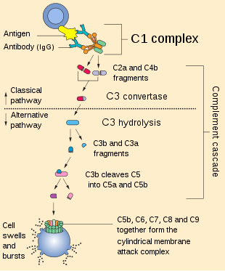

The complement system, also known as complement cascade, is a part of the [immune system](https://en.wikipedia.org/wiki/Immune_system) that enhances (complements) the ability of [antibodies](https://en.wikipedia.org/wiki/Antibody) and [phagocytic](https://en.wikipedia.org/wiki/Phagocytic) cells to clear [microbes](https://en.wikipedia.org/wiki/Microbes) and damaged cells from an organism, promote inflammation, and attack the pathogen's [cell membrane](https://en.wikipedia.org/wiki/Cell_membrane). The complement system consists of a number of small proteins that are synthesized by the [liver](https://en.wikipedia.org/wiki/Liver), and circulate in the blood as inactive [precursors](https://en.wikipedia.org/wiki/Protein_precursor). When stimulated by one of several triggers, [proteases](https://en.wikipedia.org/wiki/Protease) in the system cleave specific proteins to release [cytokines](https://en.wikipedia.org/wiki/Cytokine) and initiate an amplifying cascade of further cleavages. The end result of this *complement activation* or *complement fixation* cascade is stimulation of [phagocytes](https://en.wikipedia.org/wiki/Phagocyte) to clear foreign and damaged material, [inflammation](https://en.wikipedia.org/wiki/Inflammation) to attract additional phagocytes, and [activation](https://en.wikipedia.org/wiki/Activation) of the cell-killing [membrane attack complex](https://en.wikipedia.org/wiki/Complement_membrane_attack_complex). Over 30 proteins and protein fragments make up the complement system, including [serum proteins](https://en.wikipedia.org/wiki/Blood_proteins), and [cell membrane receptors](https://en.wikipedia.org/wiki/Cell_surface_receptor). They account for about 10% of the [globulin](https://en.wikipedia.org/wiki/Globulin) fraction of blood serum.

_________________________________________________________________

This is historic and famous so let’s memorize it. The four parts of inflammation:

-redness (rubor);

-warmth (calor);

-pain (dolor);

-swelling (tumor).

Calor, dolor, rubor, and [tumor](https://www.rxlist.com/tumor_grade/article.htm) (Latin): Heat, [pain](https://www.rxlist.com/pain_management/article.htm), redness, and swelling. The four classical signs of [inflammation](https://www.rxlist.com/script/main/art.asp?articlekey=3979), originally recorded [in](https://www.rxlist.com/script/main/art.asp?articlekey=3950) the 1st century A.D.

<https://www.youtube.com/watch?v=FKG9rqC9IPE>

<https://www.youtube.com/watch?v=FXSuEIMrPQk>

<https://www.youtube.com/watch?v=Fbzb75HA9M8>

<https://www.youtube.com/watch?v=qCpWXPSMBIY>

I will only be asking exam questions from the material presented in our textbook. Some of the included videos in this lecture have information we will not be required to learn (interesting, but not tested on).

Note that the T-cells have several types that include the T-suppressor cells. These actually turn ‘down’ the immune reaction. Think of it this way. You get a small cut on the back of your hand. Of course bacteria get into your body there. You activate your immune cells and basophils would release chemicals to recruit more and more immune cells to the scene. Cells are phagocytosing, complement is being activated, cells (both human and bacterial) are dying releasing their contents. You would not want to recruit every immune cell in your circulatory system to kill off just a few hundred bacterial cells. If you did bring in too many of your own immune cells you would actually cause destruction of the normal surrounding tissue with an overblown immune response. It is referred to as ‘the bystander effect’. Innocent bystander human cells would be killed or damaged by too much of an immune reaction. So once discovered, the T-suppressor cells made sense, that the immune system must have a way to modulate how big and how small the response is.

Now here come the most complicated and important part of this chapter. There is a handout on the webpage about it.

Fact #1: All cells of the body have one protein on their surface that they all share. This one protein can be found on each and every cell of your body. OK. Here is the bad part, its name. This protein that is found on each and every cell in your body is called the ‘**MHC Class I’** protein. An odd and awkward name yes, but there it is.

Fact #2: Your macrophages and your B-cells have a common protein. This protein is found only on all of your B-cells and all of your macrophages. OK. Here is the bad part, its name. This protein that is found on each and every B-cell and macrophage in your body is called the ‘**MHC Class II’** protein.

Let’s say you are infected with a virus. That virus will invade some of your cells. It will duplicate itself and bud off of that infected cell and spread to other cells, infecting them. Your T-cytotoxic cells will try to stop that viral infection by identifying the infected cells that house the viruses and destroy that infected cell. So how do the T-cytotoxic cells identify your infected human cells? The T-cytotoxic cells will recognize the budding viral particles. They are protein on their surface and foreign. Here is the odd and interesting fact about how T-cytotoxic cells recognize the infected human cell. The T-cytotoxic cells will only bind and destroy anything if the T-cytotoxic cell can bind to (recognize) BOTH the MHC Class I protein and the budding viral particle. The T-cytotoxic cells needs to bind to both. T-cytotoxic cells must bind to [MHC Class I + foreign protein of budding virus] in order to kill.

In a similar way, T-helper cells and T-suppressor cells must see two things before they can bind and do what they do. The T-helper and T-suppressor cells need to bind to (recognize) BOTH MHC Class II and foreign protein.

Remember the B-cells have the MHC Class II protein on their surface. The B-cell will also bind foreign bacteria. So the B-cell can have a foreign bacterial cell bound to its surface. And since it is a B-cell, it will have the MHC Class II protein. The T-helper and T-suppressor cells need to see (recognize) (bind to) both: [MHC Class II + foreign bacterial protein].

Here is an interesting fact about macrophages. Once a macrophage phagocytoses a bacterial cell, it will move that bacterial cell to its lysosome and the enzymes in that lysosome will digest the bacterial cell apart into fragments. But that doesn’t end it. The macrophage will then move those fragments of the bacterial cell onto its own cell surface. Macrophages display on their surface’s fragments of digested bacterial cells. That will now allow the T-helper and T-suppressor cells to become active. The T-helper and T-suppressor cells recognize (bind to) BOTH MHC Class II protein + the foreign bacterial protein they have displayed.

Because the T-helper and T-suppressor cells need the macrophage or the B-cell in order to become activated, the macrophage and the B-cell are called ‘antigen presenting cells’ (APC). You will see labeled in many diagrams a cell with the ‘APC’ label. The macrophage and the B-cell have to ‘present’ to the T-helper and T-suppressor cells the foreign protein. The T-helper and T-suppressor cells need to see the MHC Class II protein on either the B-cell or macrophage along with the foreign protein.

<https://www.youtube.com/watch?v=_jBpv9fYSU4>

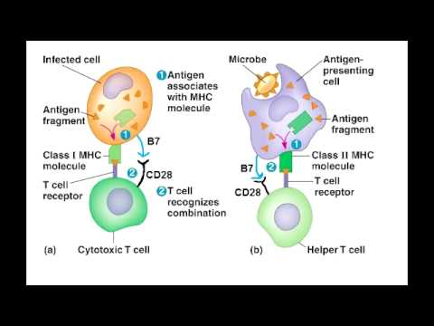

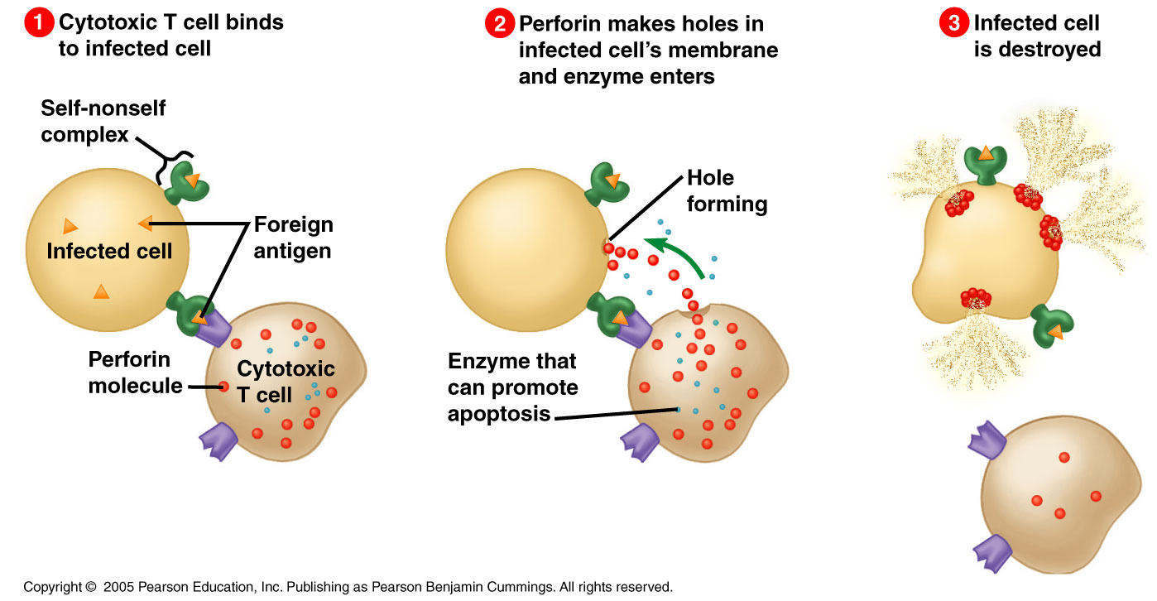

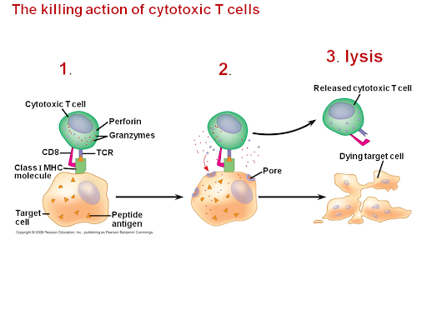

In the diagram above, notice the green ‘MHC Class I protein’ with the yellow triangle foreign protein (the virus).

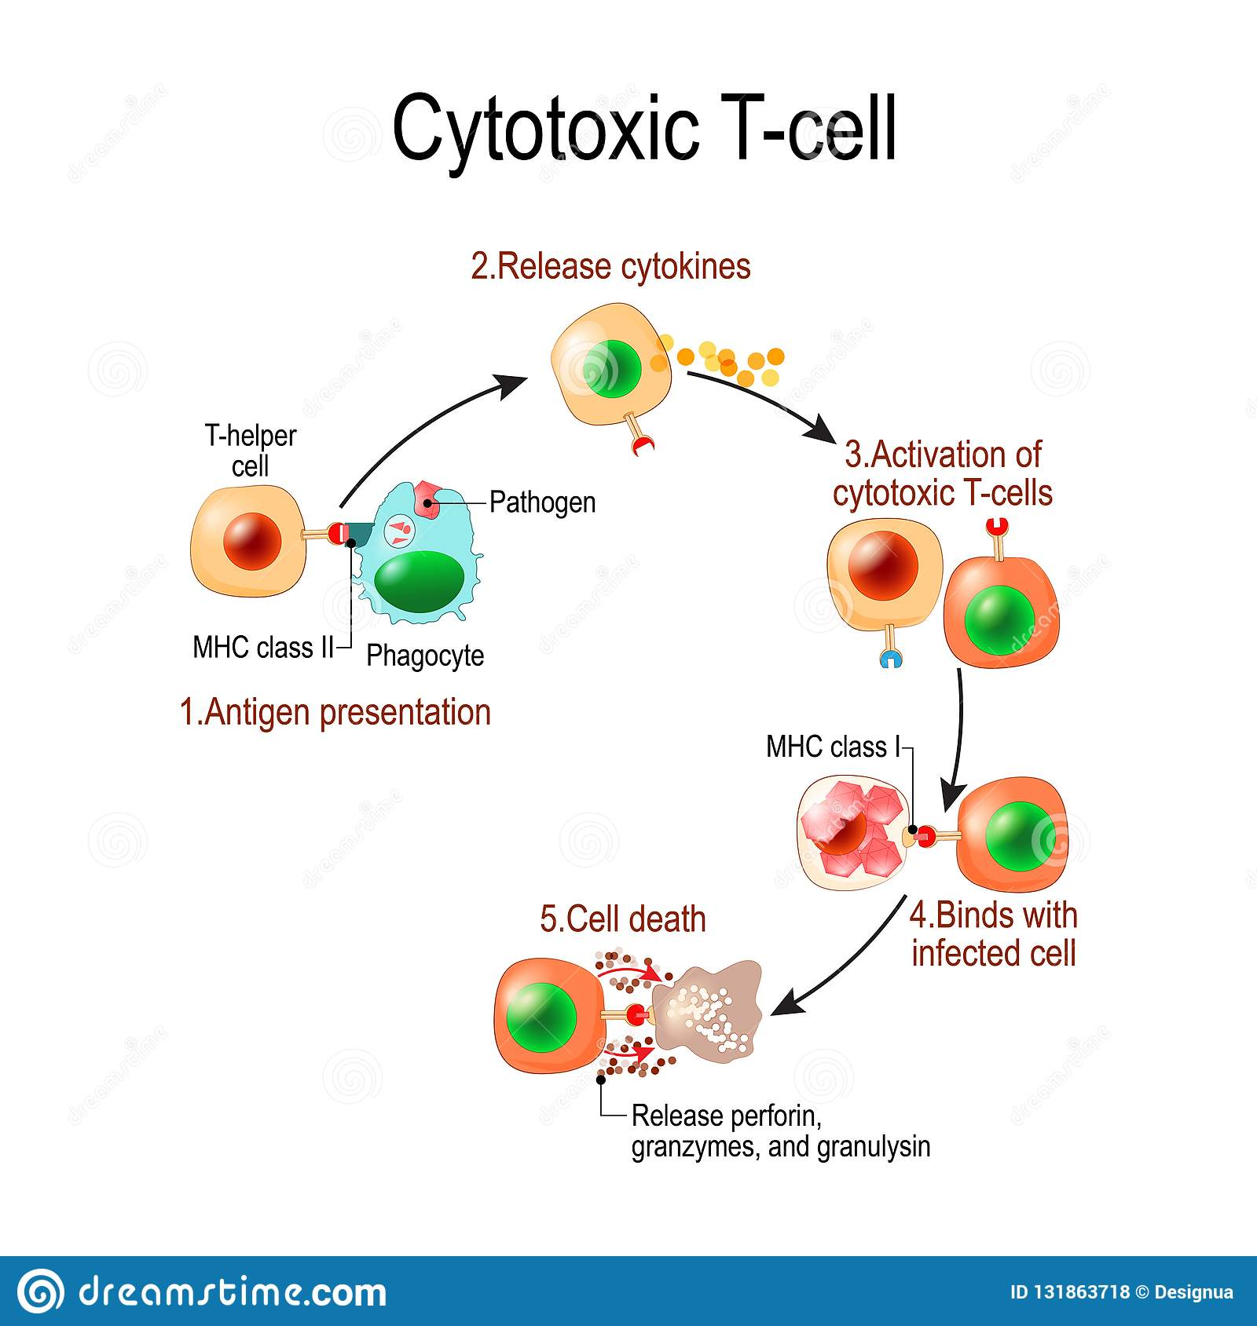

Good to know, but not tested on:

‘Tumor Necrosis Factor (TNF) inhibitors’ as a drug treatment against too much of an inflammatory response for autoimmune diseases.

TNF inhibitors are [drugs](https://www.webmd.com/drugs/index-drugs.aspx) that help stop [inflammation](https://www.webmd.com/arthritis/about-inflammation). They're used to treat diseases like [rheumatoid arthritis](https://www.webmd.com/rheumatoid-arthritis/default.htm) (RA), [juvenile arthritis](https://www.webmd.com/rheumatoid-arthritis/diagnosing-juvenile-arthritis), [psoriatic arthritis](https://www.webmd.com/arthritis/psoriatic-arthritis/default.htm), [plaque psoriasis](https://www.webmd.com/skin-problems-and-treatments/psoriasis/psoriasis-types), [ankylosing spondylitis](https://www.webmd.com/back-pain/guide/ankylosing-spondylitis), [ulcerative colitis](https://www.webmd.com/ibd-crohns-disease/ulcerative-colitis/default.htm) (UC), and [Crohn's disease](https://www.webmd.com/ibd-crohns-disease/crohns-disease/default.htm).

They're also called TNF blockers, biologic therapies, or anti-TNF drugs. TNF inhibitors are antibodies made in a lab from human or animal tissue. You’ll note the man-made antibody drugs end in …..mab. These synthetic antibodies are made in a lab and carefully administered to patients. Once they're put into your [blood](https://www.webmd.com/heart/anatomy-picture-of-blood), they cause a reaction in your [immune system](https://www.webmd.com/cold-and-flu/cold-guide/10-immune-system-busters-boosters) that blocks [inflammation](https://www.webmd.com/women/ss/slideshow-what-is-inflammation).

Your [immune system](https://www.webmd.com/diet/ss/slideshow-strengthen-immunity) makes a substance called tumor necrosis factor (TNF). Usually, your body keeps your TNF levels steady. But if you have an [autoimmune disease](https://www.webmd.com/a-to-z-guides/autoimmune-diseases) like RA, something goes wrong. You start making too much TNF, and that leads to inflammation.

Inflammation that's out of control can damage your body. You might have [pain](https://www.webmd.com/pain-management/default.htm) or swelling or feel ill. These drugs block the action of TNF.

Again, for your free time enjoyment, a nice scientific article of clinical relevance:

<https://www.ncbi.nlm.nih.gov/books/NBK27143/>

And yes, there is ‘scientific’ data to show that drugs (including marijuana) and alcohol weaken the immune response.

The end.