**Male Reproductive System.**

OK, so why do we have ‘boy parts’ and ‘girl parts’? From a biological standpoint? The ‘boy parts’ produce sperm. The ‘girl parts’ produce eggs AND carry the baby. You need a sperm and an egg in order to reproduce. Well, you could reproduce like a bacterial cell and just make identical copies of yourself where every cell you make is a clonal copy of yourself. But we humans (and most all other living creatures on this earth, big and small) reproduce by combining cells from two separate individuals. For us humans it is the sperm fertilizing the egg (or ovum). That’s called ‘sexual reproduction’. The bacteria undergo ‘asexual reproduction’. You see with sexual reproduction you are mixing up the chromosomes (the DNA) quite a bit taking some DNA from the father and some DNA from the mother to create the new human, the child.

So, life according to Paul states that the ‘boy parts’ are there to produce sperm and the ‘girl parts’ are to produce eggs AND carry the baby. Well, in a nutshell, that’s true. But once the sperm are produced in the male ‘reproductive organ’, the sperm then must be delivered out of the male’s body and deposited into the female where these sperm have a chance to meet up with an egg. So, the sperm have to be deposited into the female reproductive system. The sperm production happens in the TESTES. The process of spermatogenesis occurs in the male testes. From the testes, there are a system of ducts or tubules to carry the sperm out of the male reproductive system and into the female reproductive system. The male ejaculate has sperm in it along with the rest of the milky fluid. That milky fluid is the semen and is produced by a few glands: the prostate gland; the two seminal vesicles; the two Cowper’s glands (also called bulbourethral glands). So, there you have it. The male reproductive system, the male reproductive organs consist of the testes (sperm production), the glands that make the semen and some tubules.

And the female reproductive system consists of the organ that makes the eggs (the ova) which you probably already know are the ovaries. The organ that carries the baby if one is made is the uterus. What else does a girl need? Some ducts or tubules to connect these two organs (the Fallopian tubes) and an opening to receive the male sperm (more like a receptacle to receive the male penis) (the vagina).

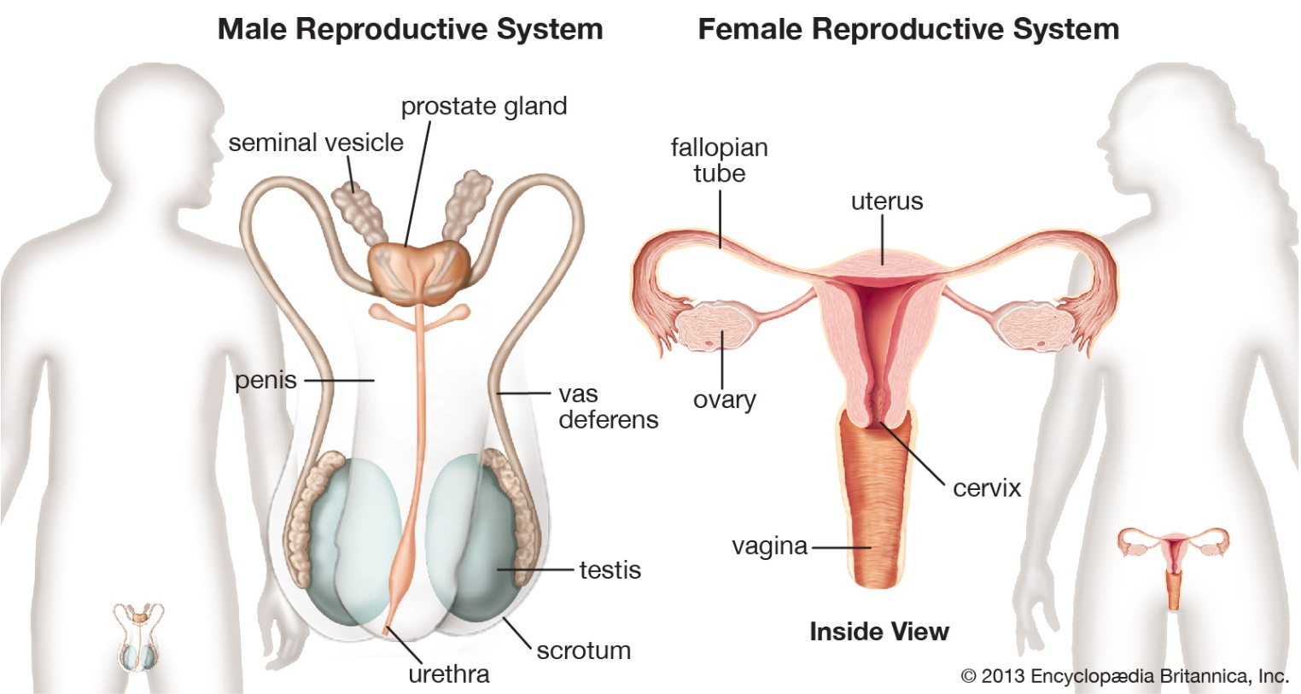

It is very important to understand the anatomy and physiology of both the male and female reproductive systems since there are many things that can go wrong:

<https://www.webmd.com/women/ss/slideshow-women-reproductive-problems>

**Male Reproductive Issues include:**

* Prostate cancer
* Testicular cancer
* Enlarged prostate or BPH
* Prostatitis
* Erectile dysfunction
* Male infertility
* Testosterone deficiency
* Undescended testicle
* Varicocele or dilated veins around testicle
* Hydrocele or fluid around testicle

The testes consist of miles of microscopic tubules called seminiferous tubules. It is within these miles of seminiferous tubules that the spermatogenesis occurs. So, it is important for us to understand spermatogenesis. Let me introduce the process of spermatogenesis by doing the math incorrectly to make my point. Fertilization is when the sperm penetrates the egg and deposits its male chromosomes. Remember that the head of the sperm contains the male chromosomes. When these male chromosomes are deposited into the female egg, this egg now has been fertilized and is no longer an egg made by the genetic mom with just her female chromosomes in it, but now it has both female and male chromosomes. It is that very first new human cell. Each one of us is derived from that fertilized egg. We all came from one first human cell. WOW.

Here is an interesting tangent. All of my Paul cells is derived from that first cell. That first cell was a cell in my mom’s ovary. It is a human cell with all the components that any human cell has: nucleus; cytoplasm; RER; mitochondria; etc. That human cell, one of my mom’s cells, is released from her ovary (she ovulated) and that ovulated egg happened to be fertilized by one of my dad’s sperm. All that the sperm donated to that female human cell were the male chromosomes. And all of my human cells are derived from that female cell. Here’s my point. All of my Paul cells are derived from my mom’s complete cell. All I ever got from dad was his set of male chromosomes (physiologically that is, Dad was a good dad). All of the mitochondria in all of my cells are copies of my mom’s mitochondria. An interesting fact for all of us. Mitochondria have their own DNA and all of that is from my mom, and in fact, from her mom, and from her mom, and so forth. Interesting fact.

Anyway, let me get back to doing the math wrong. All of our human cells have 23 pairs of chromosomes, a total of 46. My mom’s egg came from her so that egg must have had 46 chromosomes in it. Dad’s sperm is a human cell and so it too much have had 46 chromosomes in it. So, when dad’s sperm fertilized mom’s egg, that’s 46 + 46 = 92 chromosomes.

But that math won’t work. That fertilized egg had to have the same number of chromosomes as any human cell, after all it is my very first cell. That fertilized egg must have 46 total chromosomes in order to be a human cell. It cannot have 92 chromosomes. This math does not work.

So, if I do the math backwards it will work. I need to end up with a human cell, the very first human cell. It has to end up with 46 chromosomes (23 pairs). It is created by the union of sperm and egg. So, the sperm can only have 23 chromosomes in total and the egg can only have 23 chromosomes in total. That way, sperm (23 chromosomes) + egg (23 chromosomes) = 46 chromosomes in fertilized egg or zygote, the first new human cell. But how can a sperm and egg only have 23 chromosomes? They came from a human mom and a human dad and all human cells have to have 46 chromosomes! That’s my main point. In order for sexual reproduction to happen, union of sperm and egg, you have to use these specialized human cells that now only have half the normal number of chromosomes. Some special process has had to go on in order to make these one-of-a-kind cells that will only ever be used for sexual reproduction. And notice they are made in the male and female reproductive organs.

The purpose of the testes is to make cells that have half the normal number of chromosomes. The sperm cells.

The purpose of the ovaries is to make cells that have half the normal number of chromosomes. The eggs or ova.

I mentioned it before, what is going on inside the testes microscopically is a process called spermatogenesis. This process of spermatogenesis simply is the process of taking a regular human cell that has 46 chromosomes and converting it into a cell that now has only 23 chromosomes. Making it useful as a reproductive cell. We will learn that this process of going from a cell that has 46 chromosomes to a cell that has 23 chromosomes is called …..Meiosis!

NOT MITOSIS. But MEIOSIS. Sure they both start with the letter ‘M’ but there are very different processes.

Now some terminology that comes into play. Some relevant, some from the biologists who use these terms when they teach general biology. The testes and ovaries are very similar organs. Both have meiosis happening inside of them. Both are producing reproductive cells that have to have half the number of chromosomes a human cell is supposed to have. We’ve defined spermatogenesis, the production of sperm cells in the male testes. These sperm have 23 chromosomes. These sperm cells are derived from regular human cells that have 46 chromosomes. The process that converts the 46 chromosome containing ‘regular’ cells into the special 23 chromosome containing sperm cells is called meiosis. We’ll go through meiosis in a minute. It takes 3 steps. Any cell that contains the ‘regular’ number of chromosomes is called diploid. Any cell that has only half the normal amount of chromosomes is called haploid. See how this applies to us. The sperm cells, these specially produced reproductive cells, are haploid. The ‘regular’ cells that they are produced from are diploid (they contain the ‘regular’ amount of chromosomes, 46). How you go from diploid to haploid is by the 3 step process of meiosis. The haploid cells, the sperm cells, are used for only one thing. That is sexual reproduction. The reproductive cells for any organism is called a gamete. The human male gamete is the sperm cell. But any organism that undergoes sexual reproduction makes haploid gametes. So, if an octopus makes gametes, it undergoes gametogenesis. Gametogenesis is the process of making haploid gametes. And what is gametogenesis also then called? Why, gametogenesis is using the 3 steps of meiosis. What organ produces gametes? A ‘gonad’. The human male gonads are the testes. But in any other organism, it is within the gonads where gametogenesis occurs, the production of a haploid gamete by meiosis.

All this also holds true for the female. The human female gonads are the ovaries. The ovaries have ‘regular’ diploid human cells that contain 46 chromosomes. These cells in the ovaries undergo the 3 steps of meiosis and make haploid eggs. The female eggs are the gametes.

For our discussions which are centered around humans, we’ll be talking about ovaries and testes, sperm and eggs (ova). In your general biology course you’ll discuss gonads, gametogenesis, haploid gametes. Oh, so the production of sperm in the male ‘gonad’ is called spermatogenesis. What do we call the production of the eggs in the human female ovaries? Eggogenesis? Nope. The process of making haploid eggs in the female ovaries is called oogenesis.

One last thing to mention before we step by step explain spermatogenesis and oogenesis. That is MITOSIS is not the same as MEIOSIS. **Mitosis** you remember I was always scolding you (back in those lovely days we were in the same room together) to watch the YouTube videos showing it. Mitosis, cell division, Prophase, Metaphase, Anaphase, Telophase. One cell divides into two identical daughter cells, two clonal copies.

**Meiosis** takes 3 steps. Meiosis starts with a diploid cell and ends with a haploid gamete. A cell that has 46 chromosomes is converted into cells that have only 23 chromosomes. At the end of meiosis you have gametes ready for sexual reproduction. Think of it this way, the only reason you have to carry out meiosis is to produce reproductive cells, gametes. Nowhere else in the body would you ever need to go through meiosis but in the gonads, the testes and the ovaries. The only time we ever need to discuss meiosis is now since we are now discussing the reproductive system of the male and female. Contrast that with good old fashioned mitosis. Mitosis happens all over the place, in the liver, all epithelial cells, all over the body. Meiosis, only in ovaries and testes. Meiosis only used for reproduction. They are very different processes. Every biology book, every anatomy book, every physiology book seems to have to ask this question, “Compare and contrast meiosis and mitosis.” And I say, “WHY?” How about let’s not. They are too different. It is like comparing horses and cows. Way too different. Mitosis, all over. Meiosis, only in reproductive organs, only used for making haploid gametes. Why try to make it confusing. So I won’t ask that age old question.

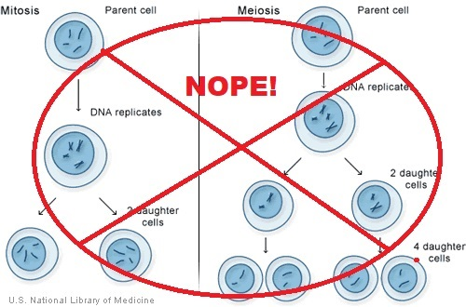

I will not ask us to ‘compare and contrast meiosis and mitosis.’

So, let’s talk about spermatogenesis which is meiosis happening in the male testes. It takes 3 steps. BUT WAIT. Before we begin step 1 of meiosis we need to actually do a turn of mitosis. Sorry. Don’t get confused. We are about to simply explain the 3 steps of meiosis. But first before we formally begin meiosis, we need to do a step of mitosis. We are going to use meiosis to make haploid gametes, the sperm cells. Here’s a question. Then what? What happens to the sperm cells once they’ve been made? Well, let’s go through all the possibilities. For one, they are ejaculated and find an egg and fertilize the egg. Well, they only survive so long (many sources say sperm can survive for 5 days in the female reproductive tract). If the sperm finds an egg and fertilizes that egg, that’s the end of that sperm. If the sperm are ejaculated and do not find an egg, they live for maybe 5 days and then that’s it for the sperm. If the sperm are never ejaculated, they only live for a few days in the male reproductive system and then fall apart and are cleaned up as cellular debris. So, we are going to make millions of them, but once they are made they only live a few days. They are being made from a ‘regular’, diploid cell found in the testes, called the spermatogonial cells or spermatogonium. The spermatogonium, the spermatogonial cells have 46 chromosomes. A spermatogonial cell will produce sperm. If the male continues to make sperm by the millions for his entire life following puberty, how can any one human male have that many spermatogonial cells? Well, he can have enough spermatogonial cells if he continues to make them via mitosis. So picture a single spermatogonial cell undergoing mitosis. One daughter cells (which is identical to the original) stays behind to continue to divide by mitosis while the other daughter cell enters into the 3 steps of meiosis and eventually being made into a sperm cell and dying after a few days.

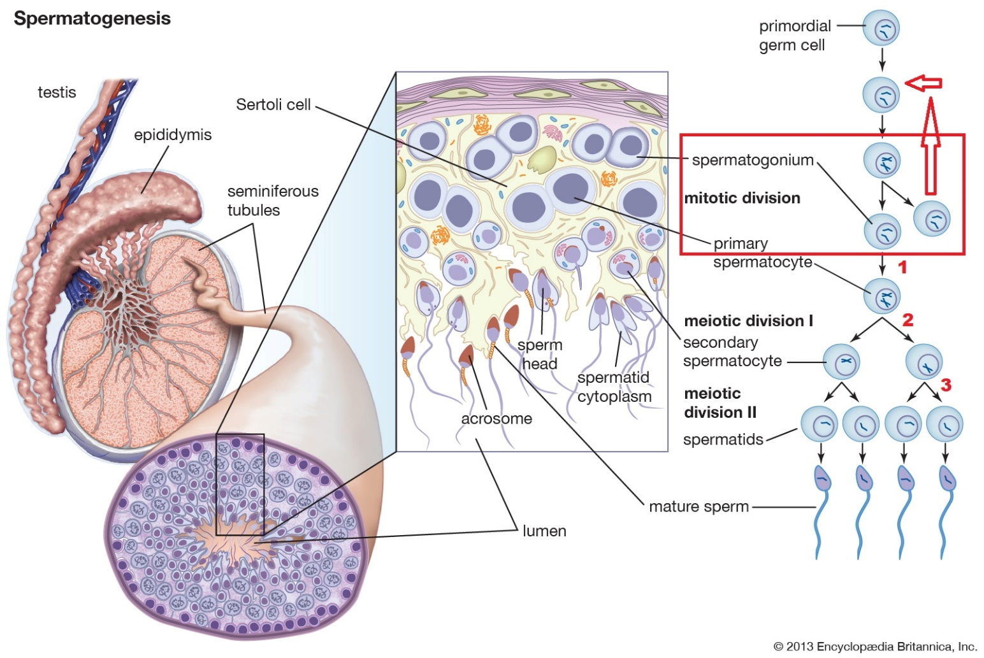

Notice on the left side of the diagram the red box. It shows this very first step, prior to beginning the 3 steps of meiosis, of spermatogenesis which is mitosis in order to make a backup spermatogonial cell or spermatogonium. That backup is shown going back up with red arrows to go through mitosis again and again. In this way, the testes can continuously make sperm. Notice also the 3 steps of meiosis are numbered in red.

Now we can discuss the 3 steps of meiosis. Step 1 is DNA replication. Step 2 is cell division. Step 3 is another cell division.

Now it might seem odd that what we are trying to do is cut the number of chromosomes in half, from 46 to 23 and that the first step in this process is actually doubling all the chromosomes. Be patient and we’ll see how nicely this works out. Step 1: DNA replication. We understand DNA replication. You take each and every one of the 46 chromosomes and make an identical copy of each and every one. You unzip the entire chromosome and make two copies of it.

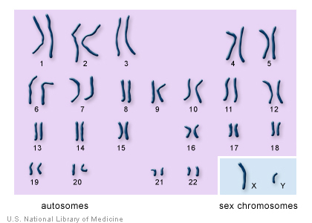

Remember you have 23 pairs of chromosomes in the nucleus of the cells. This is them lined up as a karyotype. There is chromosome #1 and chromosome #1’s pair. If you look at the diagram below you can imagine that those two chromosomes are chromosome pair #1. You received one from your genetic dad and the other from genetic mom. Looking back up at the above diagram, there is chromosome #2 and chromosome #2’s pair. Likewise for chromosome #3 and so on and so forth. One you received from genetic dad and its pair you received from genetic mom. What I’d like to stress is in the diagram below we are only ever looking at the nucleus with chromosomes. Notice the cytoplasm is not shown. That is always a bit confusing. Right now we are concerned with counting chromosomes and so only looking at the nucleus.

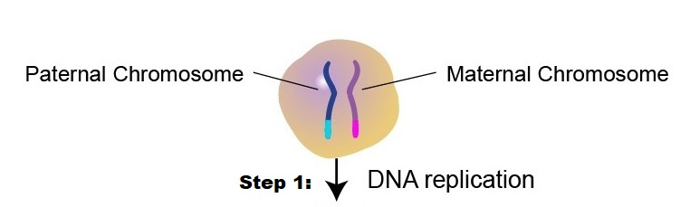

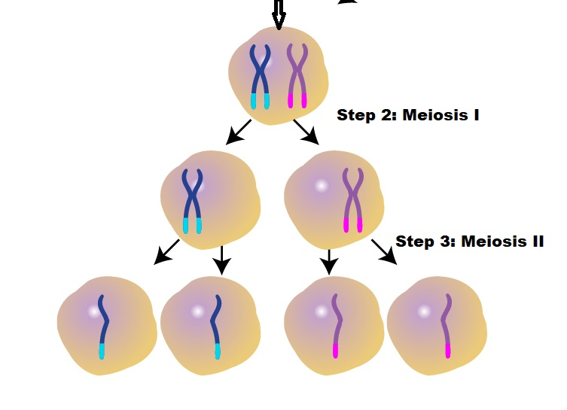

Just look at the top of the lower diagram. At the spermatogonium. As I mentioned the first thing that has to happen even before step 1 of meiosis is mitosis of the spermatogonium (the spermatogonial cell) so you have one left behind so you can make more sperm later. What they label as ‘daughter cell type A’ is left behind to make more later. The other cell produced from mitosis, ‘daughter cell type B’ is now going to enter meiosis as a spermatogonial cell. It undergoes DNA replication. See above and below diagrams. The diagram above shows the chromosomes, the diagram below does not. So looking up, you see that each of the two original chromosome #1’s have now duplicated themselves and notice the odd fact that the brand new copy of the chromosome is still attached to the original chromosome around the middle of the chromosome. Chromosome #1 (light blue on left) now has an identical copy of it also in light blue and still attached at the middle. It is like a double chromosome. Next to it is chromosome #1’s pair (looking pretty in pink) and its identical copy attached to it at the middle. The other 22 pairs of chromosomes do the same thing. This new cell that has a nucleus that looks like this is called a primary spermatocyte (see diagram below). The spermatogonial cell turns into the primary spermatocyte. The primary spermatocyte has a nucleus full of 46 chromosomes where each one of the 46 chromosomes is duplicated and stuck to its original. There are 46 chromosomes and each one is now a double chromosome, two identical copies attached at the middle.

Step 2 is to look at all 23 pairs of these double chromosomes and ‘even-steven’ divide then into two groups right down the middle so on the left you have 23 double chromosomes and on the right you have 23 double chromosomes. Following step 2 is step 3 which is also a division. So, steps 2 and 3 are division steps. In order to keep them clear the first division (step 2) is called meiosis I and the second division (step 3) is called meiosis II.

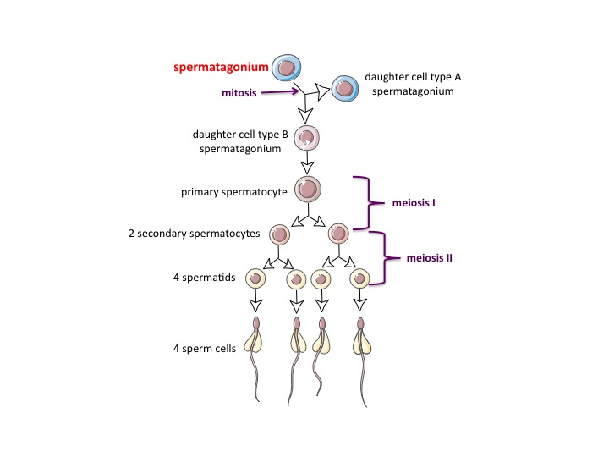

All that is left to do is steps 2 and 3 of meiosis. And steps 2 and 3 are nothing more than cell division where the cell divides ‘even-steven’. Below shows a human cell at the top. Its nucleus has 23 pairs of chromosomes lined up, chromosome pair #1 at the top, chromosome pair #2 just below it and so on, all the way down to chromosome pair #23 at the bottom of the nucleus. Now drawn moving down and to the left of this cell at the top of the diagram just shows an expanded view of the nucleus with the same 23 pairs of chromosomes, 46 chromosomes in total. The two red arrows pointing at chromosome #1 and chromosome #1’s pair.

Step 1 is labeled. It now shows all the chromosomes having divided, the new copy is in orange and still attached to the original chromosome. This nucleus shows the 23 pairs of chromosomes lined up still, but notice each chromosome is a double chromosome: the original chromosome in black ink and the identical copy attached at the middle in orange ink. (See blue arrow.)

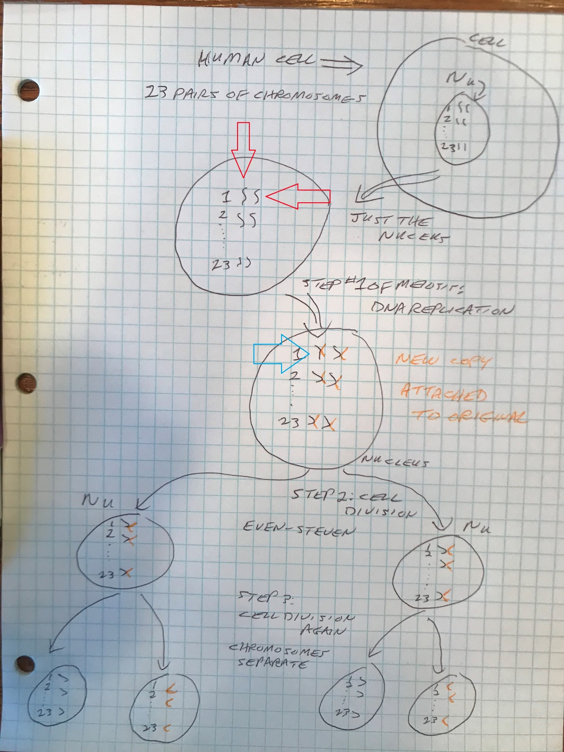

Now we are ready for step 2 of meiosis, the first of two division steps. Let’s look at the drawing below. I have drawn a red oval around a complete set of 23 double chromosomes on the left and I have drawn a red oval around a complete set of 23 double chromosomes on the right. This cell by the way is called the primary spermatocyte. This is why I keep saying ‘even-steven’ because when you do this division you simply divide the cell, divide the nucleus you are looking at right down the middle, half the chromosomes going to one daughter cell and the other half of the chromosomes going to the other daughter cell. As I have drawn it, just divide the cell and divide the chromosomes in the nucleus ‘even-steven’ right down the middle, half of all of the chromosomes going one way and the other half of all the chromosomes going the other way. ‘Even-steven’. Once this primary spermatocyte is done dividing, it has turned into two secondary spermatocytes.

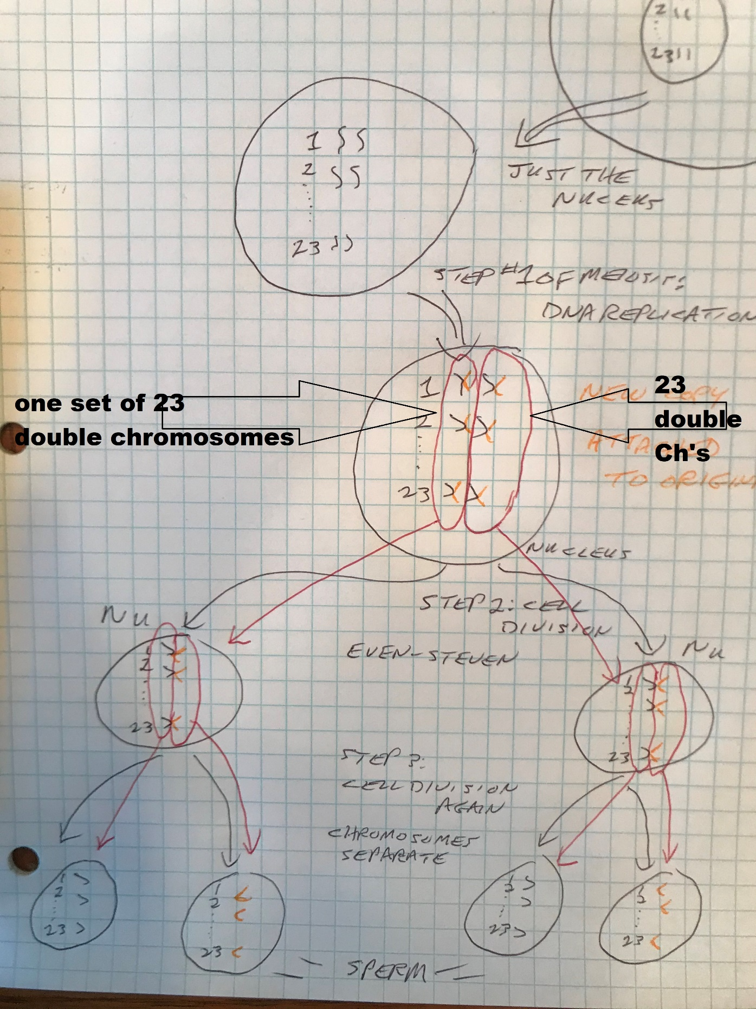

Now let’s look at the drawing below. We are now looking at the final step of meiosis, step 3. Inside the red outlined box seen below we start with the two secondary spermatocytes. They have double chromosomes. For step 3 all we do is have the secondary spermatocyte divide and finally now these double chromosomes separate. And again, ‘even-steven’, we separate the sets of chromosomes. I’ve again drawn a red oval around one complete set of chromosomes and I have drawn another red oval around the other complete set of 23 chromosomes. One half of these now separated double chromosomes goes to one daughter cell and the other set go to the opposite daughter cell. At the very bottom of the drawing shows nuclei that have……23 single chromosomes! We have a haploid gamete called a sperm cell. Remember we are only looking at the nucleus. We’d have that nucleus inside the sperm with a flagellar tail and all that famous sperm stuff. So to go from diploid to haploid (46 chromosomes to 23 chromosomes) we underwent meiosis, the 3 steps of meiosis. Notice that the last two steps involved cell division. Good ol’ fashioned cell division (mitosis) is part of the overall process of meiosis but I won’t stress that.

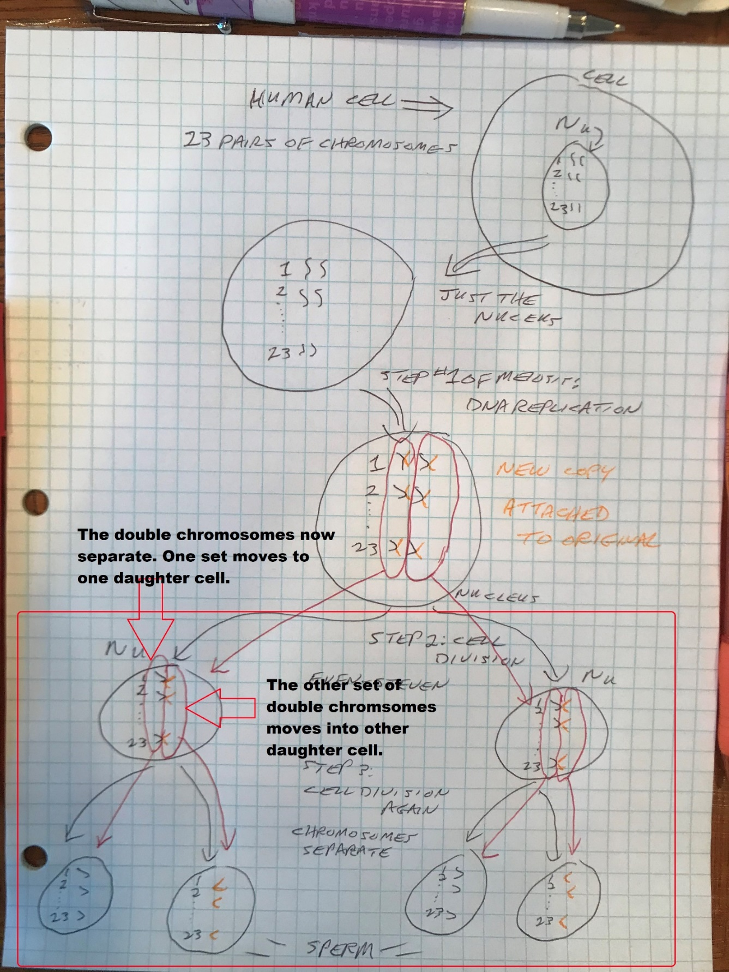

And all of this production of sperm occurs in the male gonads, the testes. The sperm are produced in very small tubules that wrap themselves around within the testes called seminiferous tubules. The testes consists of miles of seminiferous tubules. Outside and in between these seminiferous tubules are cells called Leydig cells (interstitial cells). These cells are very famous. They are the cells in the body that produce testosterone. Testosterone is produced in the testes.

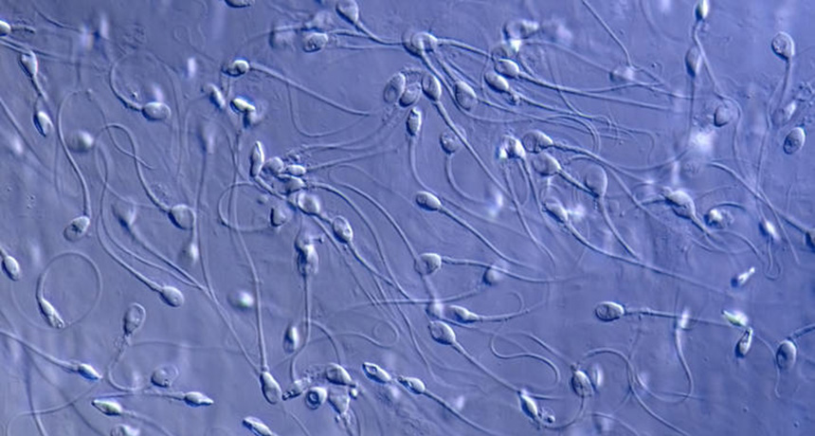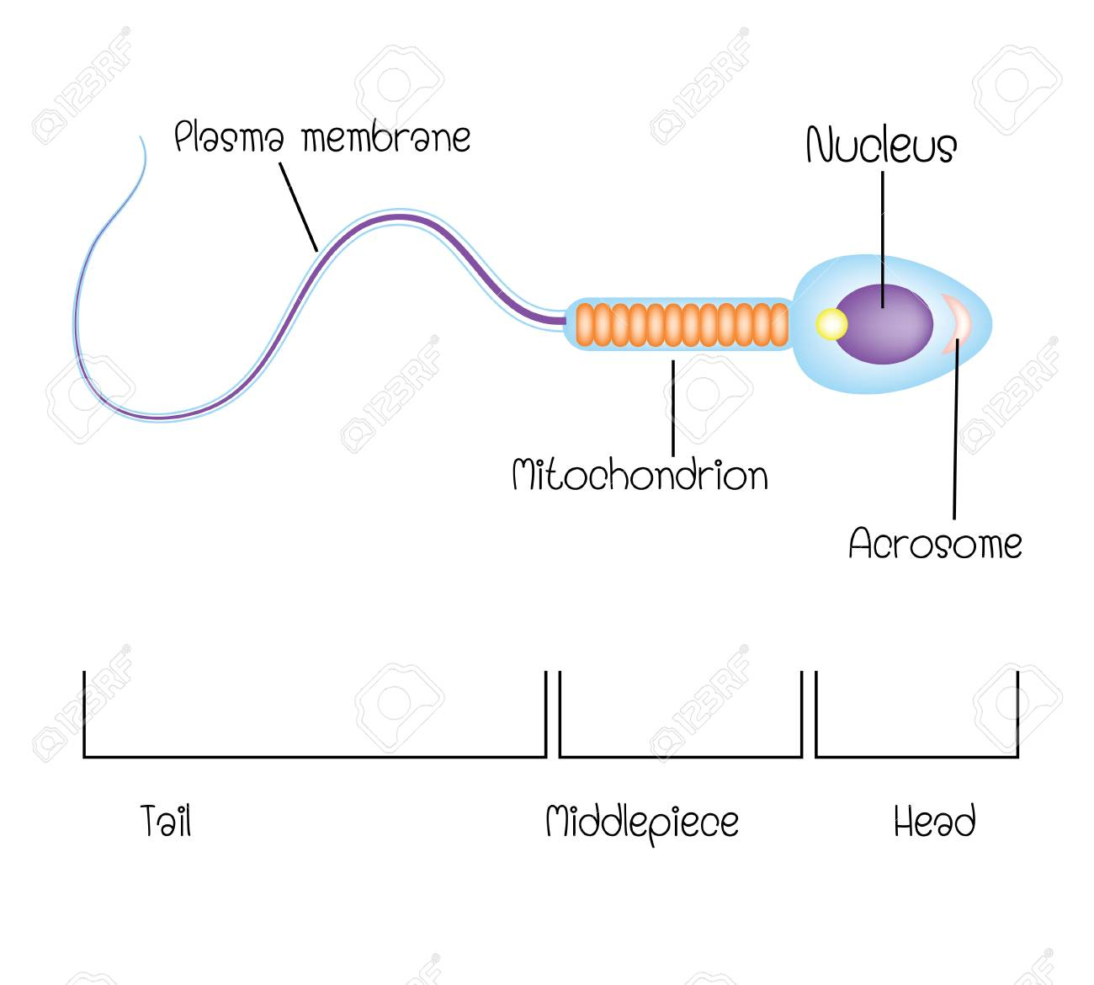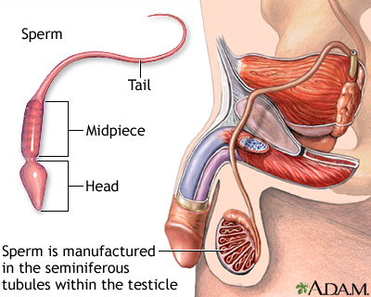

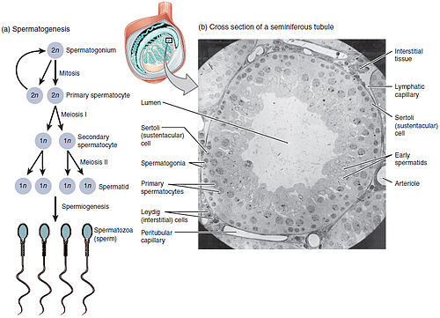

We now that in order to produce sperm you need to go through the 3 steps of meiosis. You start with the spermatogonial cell, it turns into a primary spermatocyte, which turns into two secondary spermatocytes and they divide into in total four sperm cells (or you can call then spermatids or spermatozoa). Notice above that the spermatogonial cells are found on the outermost part of the seminiferous tubules. As they progress into primary spermatocytes they are pushed closer to the center (the opening or lumen) of the seminiferous tubule. And when the primary spermatocyte changes into the secondary spermatocytes, these secondary spermatocytes are pushed even closer to the lumen of this seminiferous tubule so by the time it becomes a sperm it has arrived at the center of this seminiferous tubule and can swim away.

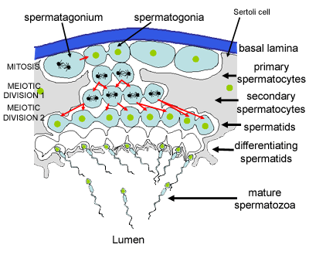

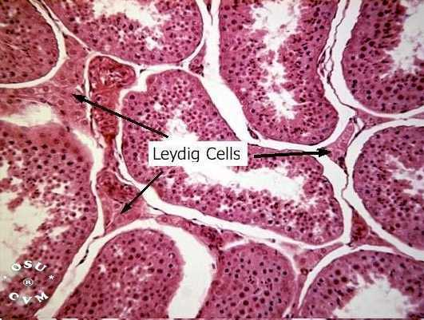

The above microscopic view of the testes shows several seminiferous tubules in cross section with the Leydig cells labeled. Notice that the Leydig cells are outside and in between the seminiferous tubules.

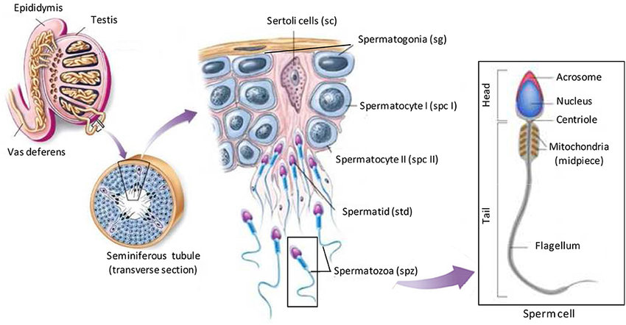

And where to the sperm go from here? They travel down the seminiferous tubule into the epididymis and into the vas deferens. The rest of the pathway is well described in your textbook. Along the way 5 glands secrete their fluid into the tubules. The combination of all of these secretions makes up the milky white portion of the ejaculate called the semen. The sperm are surrounded (floating) in the semen. These glands are the: (1)seminal vesicles (2 of them); (2)Prostate gland (only one); (3)Bulbourethral glands (2 of them, also called Cowper’s glands).

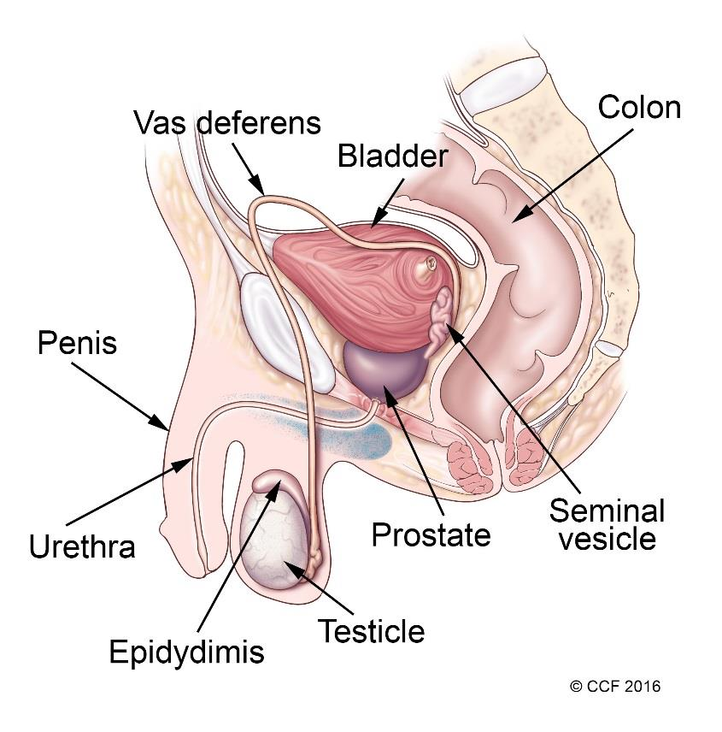

Use your textbook!

Go to DrawItToKnowIt and watch and learn under ‘Reproduction….’:

-anatomical overview of the male reproductive system;

-spermatogenesis.

Learn the physiology of the histologic structures of the testes (ex: what the Leydig cells do and the function of everything you find in a histological view).

~~Turn in the homework assignment from the class website. You do not need to hard write it.~~

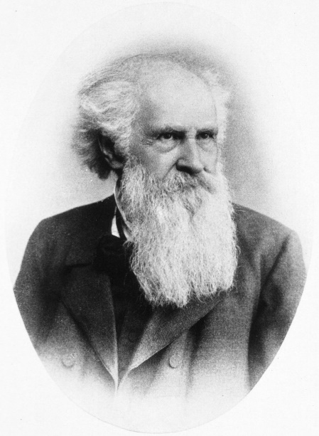 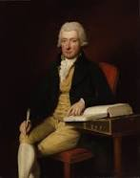

Franz von **Leydig** English surgeon William **Cowper**