**Testosterone, Estrogen, Progesterone.**

- They are all examples of steroid hormones. What is a ‘steroid hormone’?

(First of all, estrogen is actually a group of three steroid hormones Estradiol (also called 17-beta-estradiol), Estrone, and Estriol. Generally, when someone mentions estrogen, they are referring to estradiol. If you were to be talking about ‘estrogen replacement therapy’ you’d be talking about ‘estradiol’.)

-The steroid hormones are all derived from cholesterol. The enzymes that produce steroid hormones from cholesterol are found in the ER or mitochondria.

-Steroid hormones are lipid soluble and so are freely permeable to membranes and are not stored in cells.

-Steroid hormones are not packaged but are synthesized and immediately released.

-They are not water soluble so they have to be carried in the blood bound (complexed) to specific binding globulins.

-Steroid hormones enter the target cell by simple diffusion across the plasma membrane where they bind to receptors either in the cytoplasm or nucleus.

-When the hormone binds to the receptor this creates a new molecule that is a DNA binding protein.

-This DNA binding protein binds to regions of the genome turning on transcription and then followed by translation of proteins that will cause the effects for the cell.

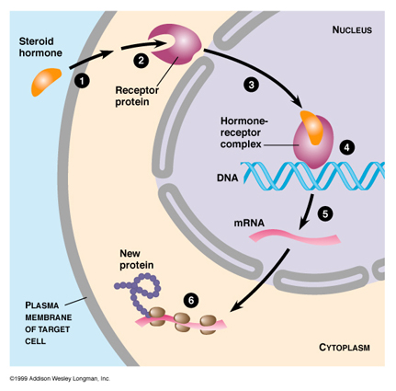

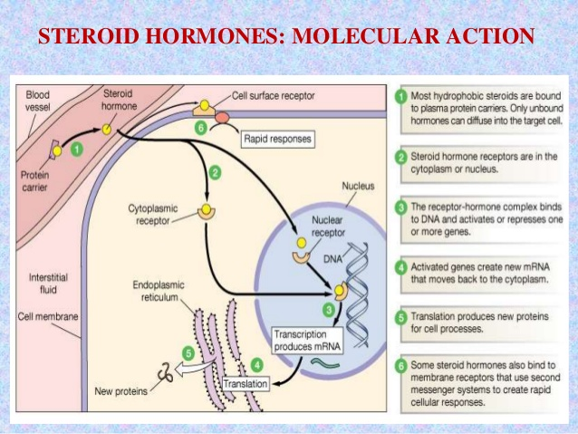

Below is the famous diagram showing the pathways to synthesize the steroid hormones. By this time in your life, you are not afraid or intimidated by a diagram such as this one. Give it a minute. You do not need memorize it but you do need to be able to interpret it. As you look it over, you see an old friend, aldosterone. Aldosterone is a steroid hormone made from cholesterol. Cortisol is produced from cholesterol. We’ll be talking about it later but I’m sure you’ve heard of it. But now we’re talking about: ‘estrogen’ = ‘estradiol’ = ’17-beta-estradiol’; progesterone; and testosterone. Can you find them? Easy, over on the right. What can make this diagram threatening is because as you’ll notice there are more than one pathway to synthesize some of these molecules (the hormones themselves and their precursor molecules). You might be able to use the proper enzymes to move to the right and then down or move down and then to the right.

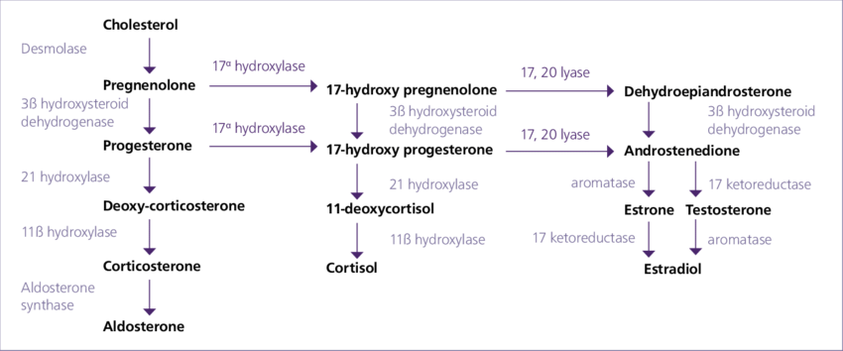

Let’s start with testosterone. Testosterone is produced by the Leydig cells in testes in men and by the ovaries, adrenal glands, fat cells and skin cells in women.

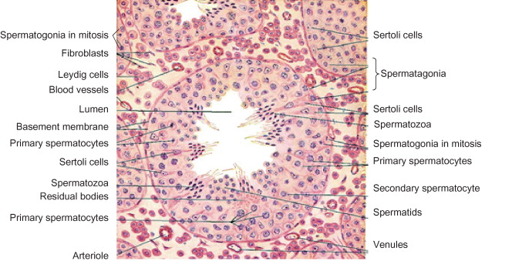

By the way, the Leydig cells in males produces estrogen.

The hormonal pathway and feedback is very straightforward (if you remember your anatomy well).

The ‘brain’ decides testosterone needs to be released into the bloodstream of the body. From the hypothalamus of the brain GnRH (gonadotropin-releasing hormone) is released into the special blood vessels that travels from the hypothalamus to the anterior pituitary gland, the hypophyseal portal veins. GnRH will stimulate the cells of the anterior pituitary gland to release into the blood FSH and LH. They will travel to the testes to stimulate the Sertoli cells and Leydig cells, respectively.

I like molecules so you know this is going to be important to me. FSH and LH use cAMP and PKA (protein kinase A) second messenger pathways to stimulate their target cells. But what we learned about from above, testosterone is a steroid hormone and acts as one on its target cells. Ah ha Paul, you didn’t mention what second messenger pathway GnRH used on the cells of the anterior pituitary gland? OK, GnRH uses the GnRH receptor embedded in the cells of the anterior pituitary gland and that GnRH receptor is a 7-transmembrane, G-protein coupled receptor. The GnRH receptor stimulates G-proteins that activate a [phosphatidylinositol](https://en.wikipedia.org/wiki/Phosphatidylinositol) (PtdIns)-[calcium](https://en.wikipedia.org/wiki/Calcium) [second messenger](https://en.wikipedia.org/wiki/Second_messenger) system. Activation of the GnRH receptor ultimately causes the release of [follicle stimulating hormone](https://en.wikipedia.org/wiki/Follicle_stimulating_hormone) (FSH) and [luteinizing hormone](https://en.wikipedia.org/wiki/Luteinizing_hormone) (LH).

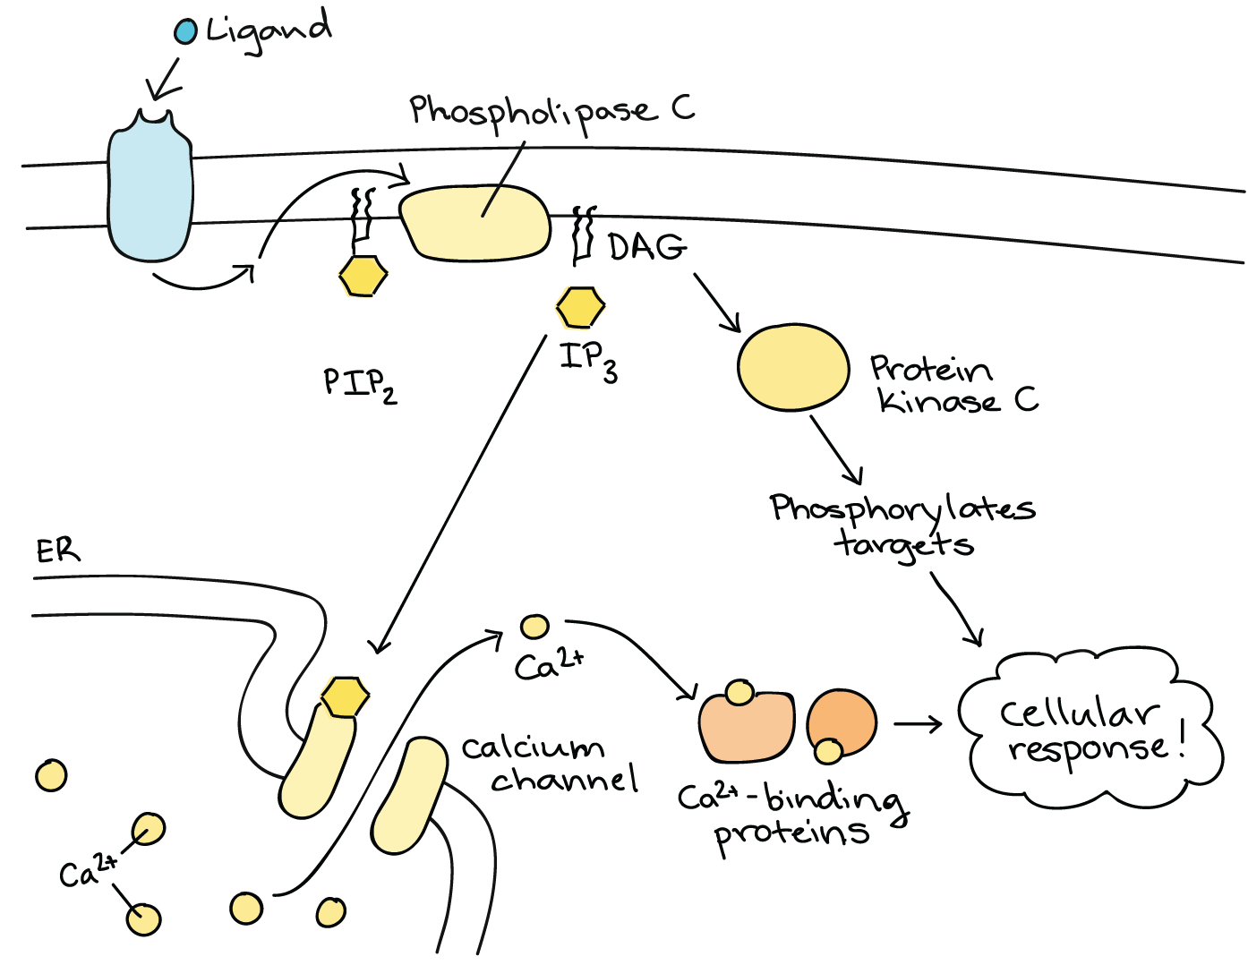

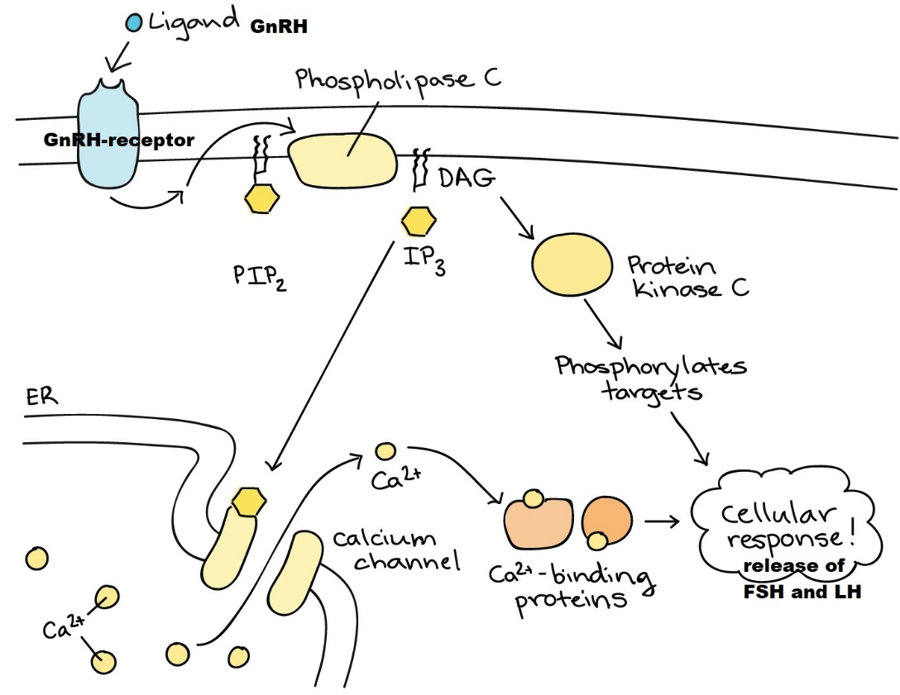

<https://youtu.be/8_YsRPcyDMY> or try

<https://www.youtube.com/watch?v=8_YsRPcyDMY&feature=youtu.be>

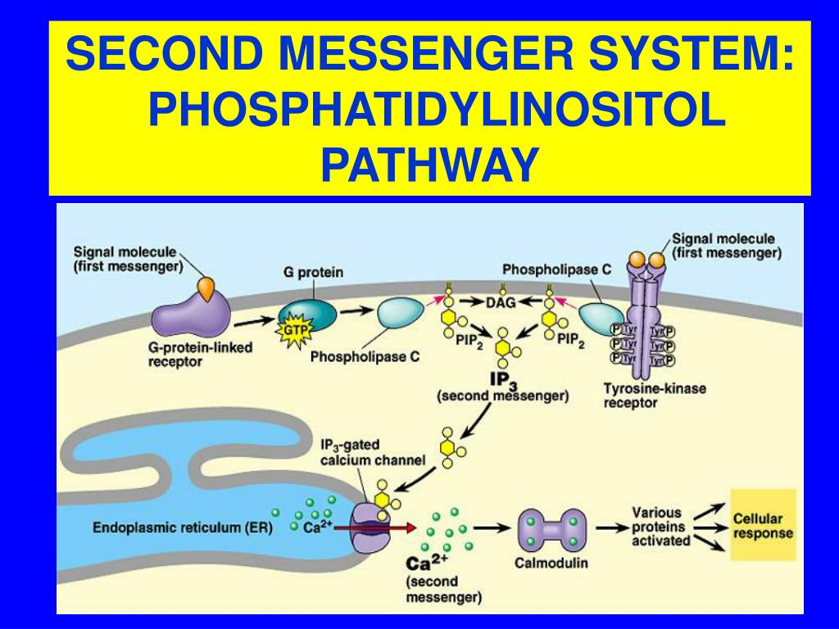

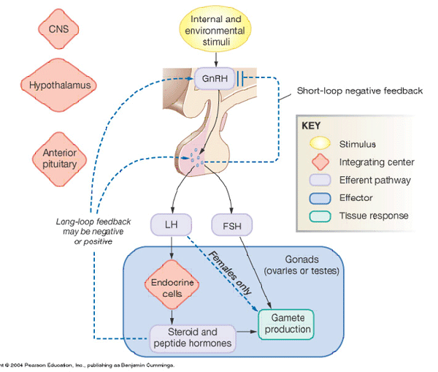

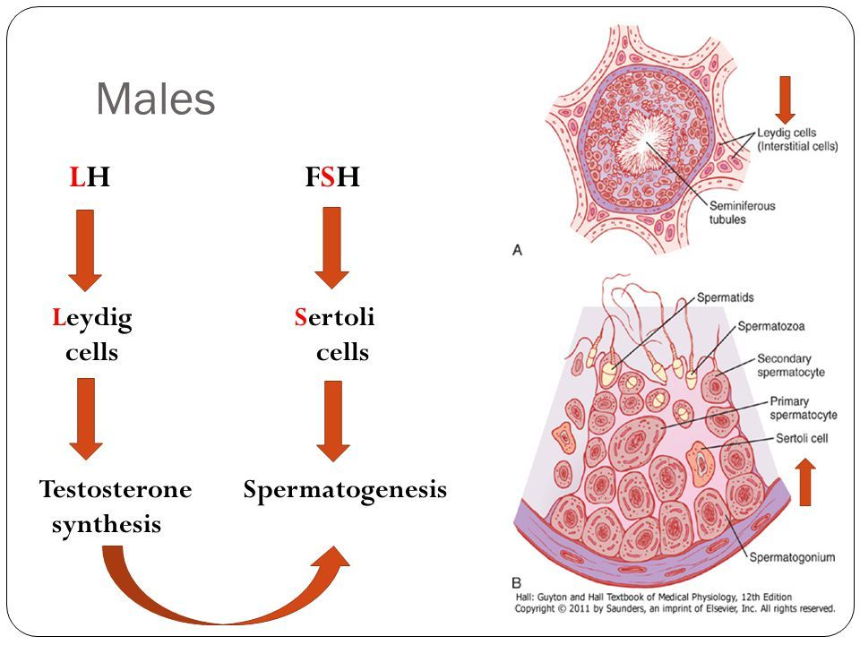

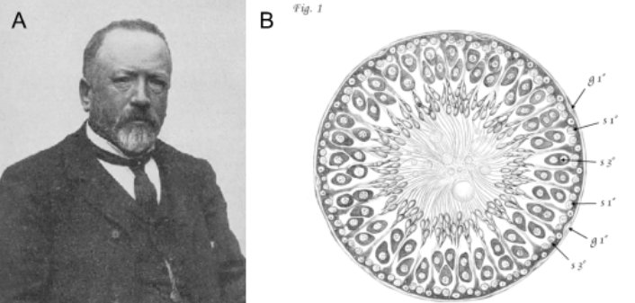 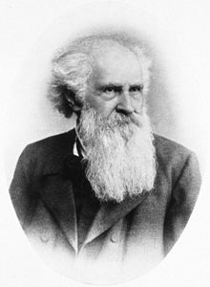

Enrico Sertoli, an Italian physiologist. Franz von Leydig.

Now what about estrogen, I mean, estradiol, I mean 17-beta-estradiol and progesterone?

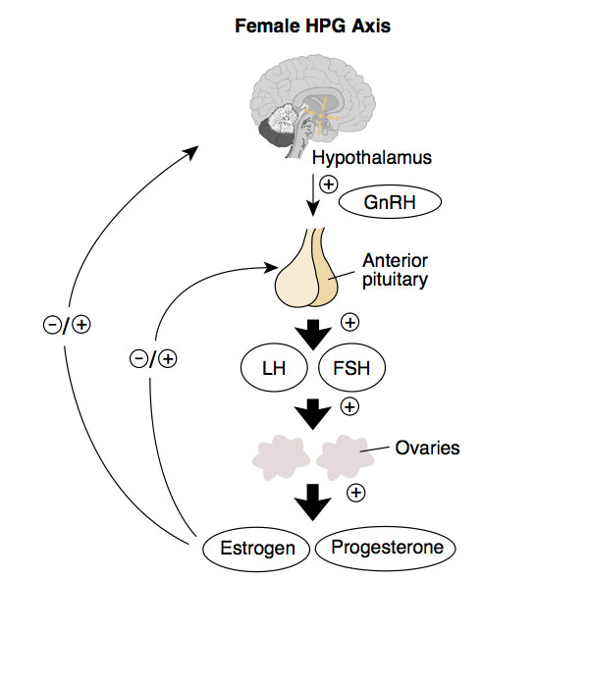

In women, FSH and LH from the anterior pituitary gland stimulate the cells of the ovaries (via cAMP and PKA) to release estradiol and progesterone into the blood to act on their target cells.

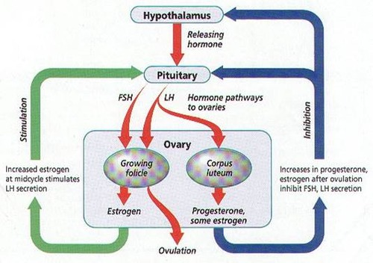

And what exactly is happening in the ovarian cells due to stimulation by FSH and LH? See below:

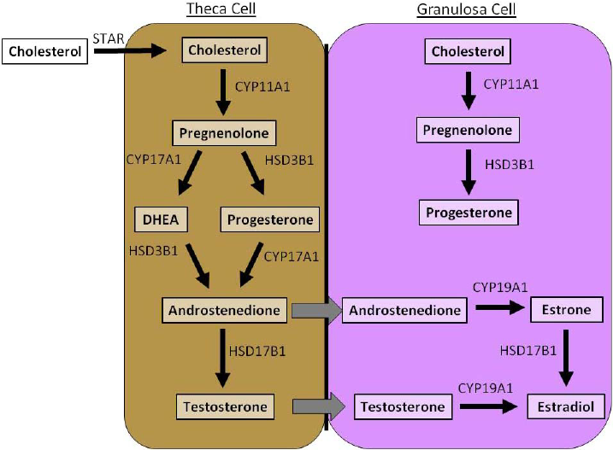

Yes, the ovarian cells use cholesterol to make estradiol and progesterone. Why? The estrogen and progesterone produced by the ovaries are the ovaries way of communicating with the uterus.

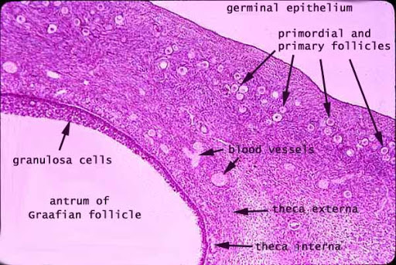 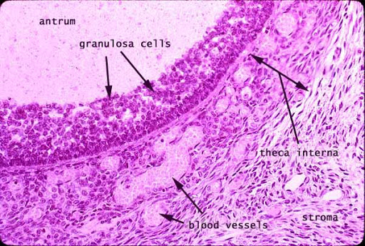

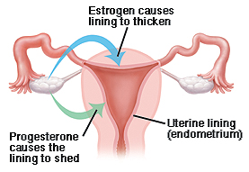

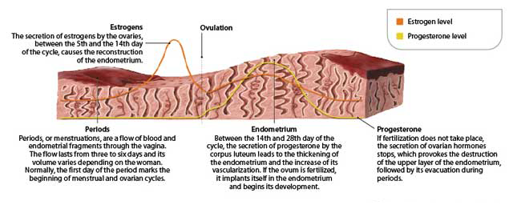

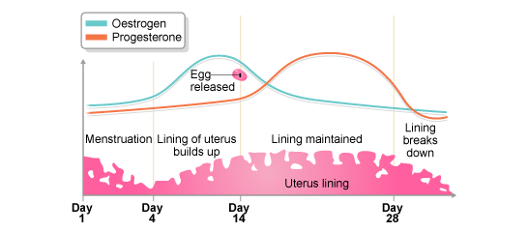

The End.