Pressure Ulcers: Pressure Injury:
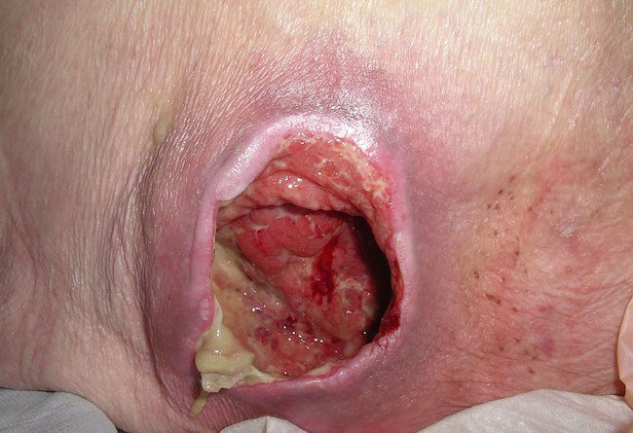
The above image demonstrates a category IV pressure injury, meaning that full-thickness skin and tissue loss has occurred.
Clinical practice guidelines from the National Pressure Ulcer Advisory Panel (NPUAP) defines a pressure injury (formerly referred to as a pressure ulcer) as “localized damage to the skin and underlying soft tissue, usually over a bony prominence or related to a medical or other device. The injury can present as intact skin or an open ulcer and may be painful. The injury occurs as a result of intense and/or prolonged pressure or pressure in combination with shear.”
Viewers of the slides should realize that, at times, it is difficult to appreciate color, wound depth, and other characteristics from a photograph. All classifications of slides in this paper were made by would-care professionals in person, not from photographs.

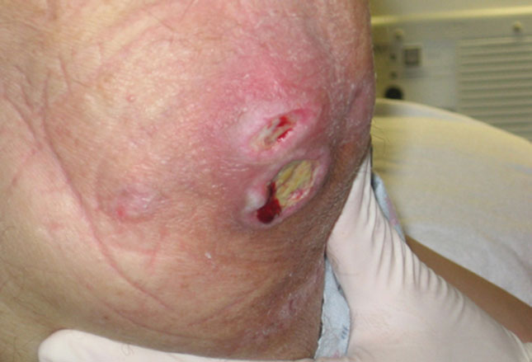
Category I – Nonblanchable erythema of intact skin;
Category II – Partial-thickness skin loss with exposed dermis;
Category III – Full-thickness skin loss;
Category IV – Full-thickness skin and tissue loss.
Eschar: Black, brown or tan necrotic tissue that demonstrates firm adherence to the wound bed or ulcer edges; compared with the surrounding skin, eschar may be firmer or softer.
Slough: Yellow, white, tan, gray, green or brown tissue that adheres to the wound bed in strings or thick clumps.
Granulation Tissue: Pink or beefy red tissue characterized by a moist, shiny, granular appearance.
Epithelial Tissue: New pink or shiny skin that is found growing inward from the ulcer’s edges or arising as islands on the ulcer’s surface.
Closed/Resurfaced: Complete coverage of the wound with new skin.

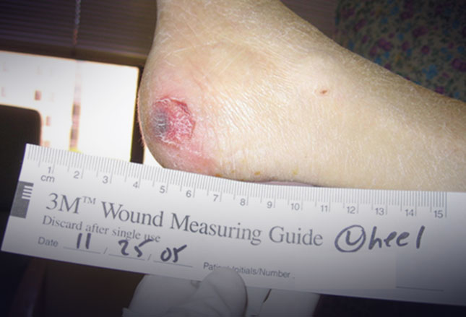
When measuring pressure injuries, first reposition the patient so that the area to be measured is completely exposed. Do not stretch or pull wound edges when measuring.
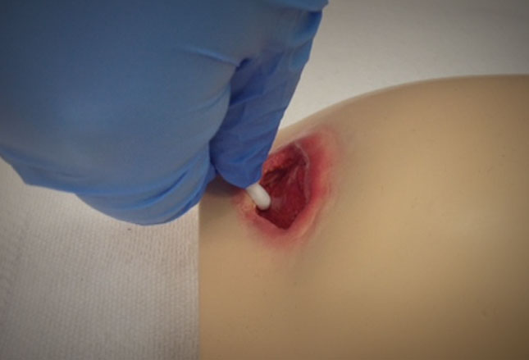
Depth can be measured (shown) using a sterile, saline-moistened, cotton-tipped applicator. The applicator should be inserted into the deepest part of the wound while being kept vertical to the wound bed.
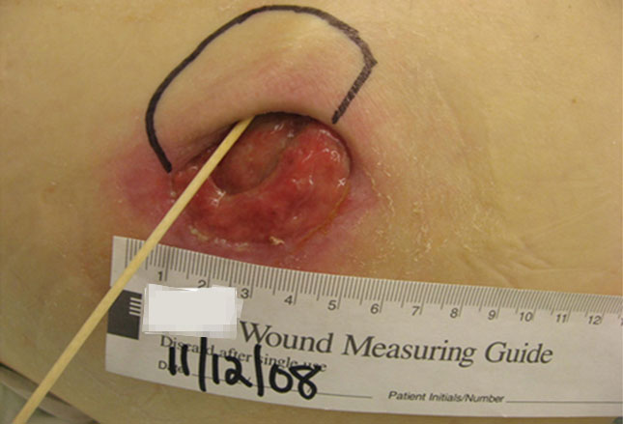
The term ‘tunneling’ specifically refers to open tunnels that extend from the wound, sometimes to other wounds. A sterile, cotton-tipped applicator moistened with saline should be inserted into the tunneled area.
The term ‘undermining’ refers to the extension of the wound to areas underneath the visible edge. Undermining is measured in the same way as tunneling.

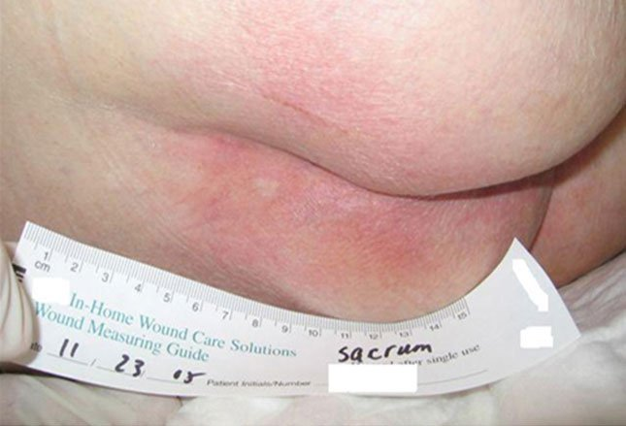
Question: Which category of pressure injury is shown above?
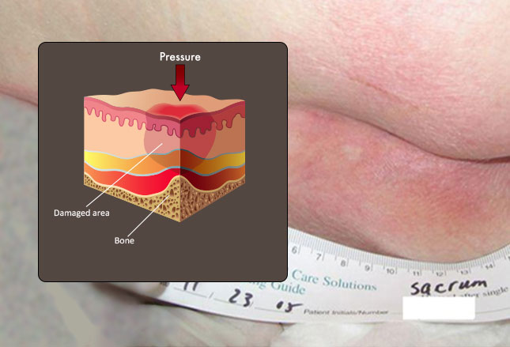
Answer: Category I – Nonblanchable erythema. At this stage, the skin is intact, with nonblanchable redness (does not fade with pressure) in a localized area. The area pictured, like the vast majority of category I wounds, is over a bony prominence.

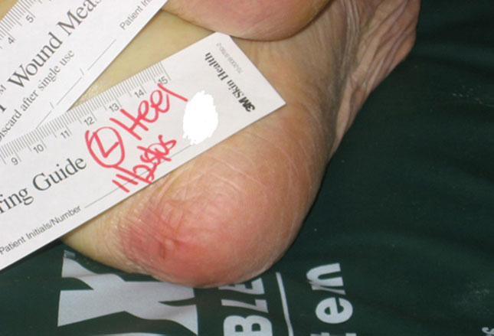
Question: Which category of pressure injury is shown above?
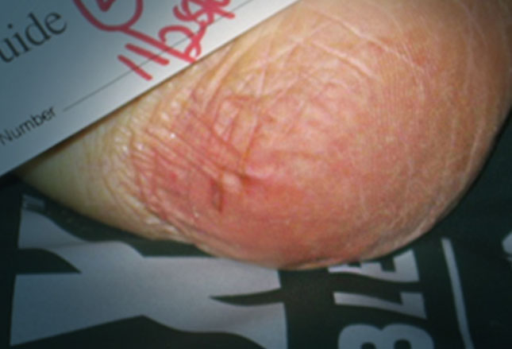
Answer: Category I with possible deep-tissue injury – Non blanchable erythema. Category I pressure injuries are considered reversible in that no irreparable tissue damage has occurred. These types of injuries can be seen after as little as 30 minutes of uninterrupted pressure.

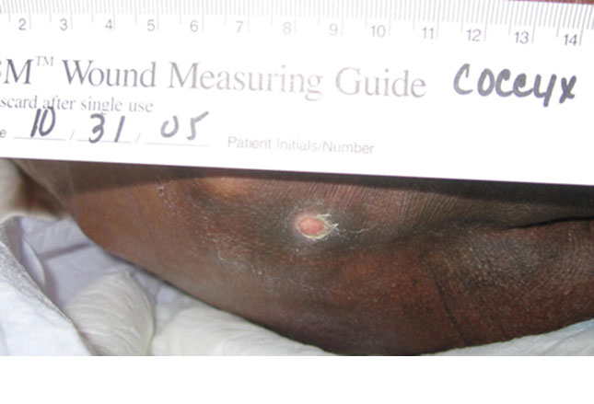
Question: Which category of pressure injury is shown above?
Answer: Category II- Partial-thickness skin loss with exposed, intact dermis. Partial-thickness skin loss has the appearance of a shallow, open ulcer. Indications of intact dermis include a flat, red-pink wound bed without slough. This category of pressure injury can also be present as an intact or open/ruptured blister.

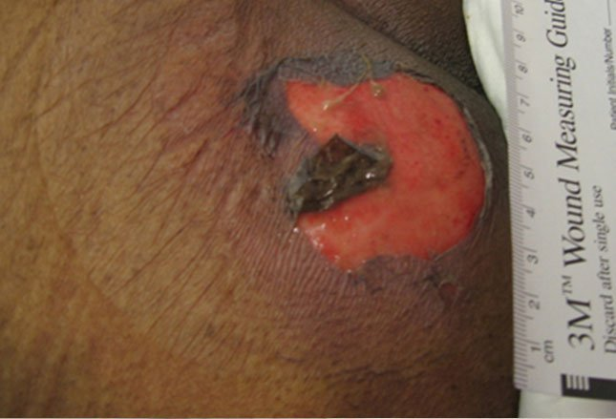
Question: Which category of pressure injury is shown above?
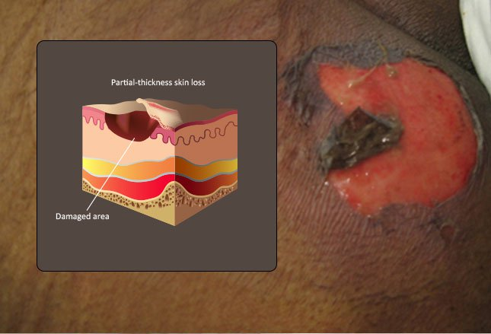
Answer: Category II – Partial-thickness skin loss with intact dermis. This pressure injury belongs in category II because of the loss of the epidermis and the presence of intact dermis. If slough or eschar were present, this would be classified as a category III. Exudate refers to the type of drainage present after the removal of a dressing. Describe the volume of exudate as none, light, moderate or heavy.

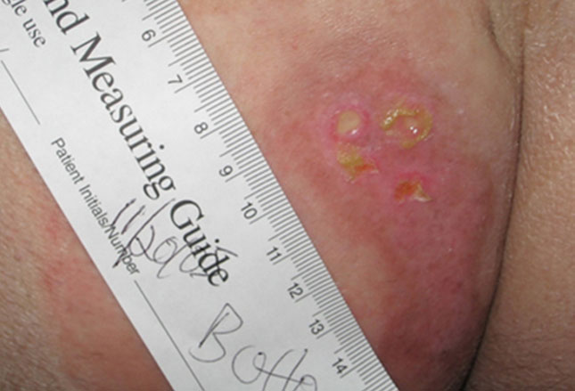
Question: Which type of pressure injury is shown above?
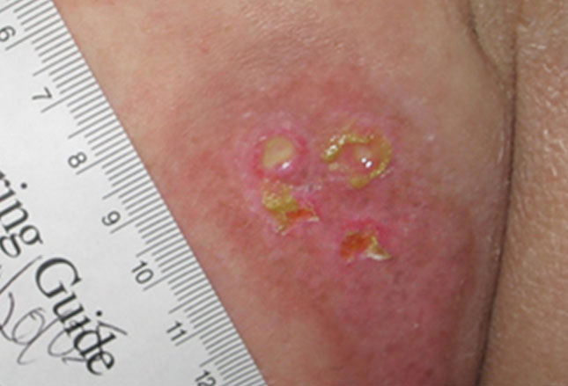
Answer: Category III – Full-thickness skin loss. This wound demonstrates full-thickness skin loss with necrosis of the epidermis and dermis. Subcutaneous fat may be visible in these types of wounds, but there is no visible bone, tendon or muscle.

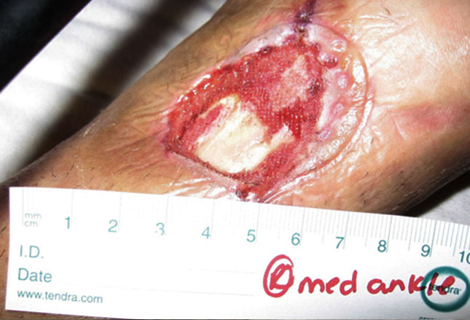
Question: Which category of pressure injury is shown above?
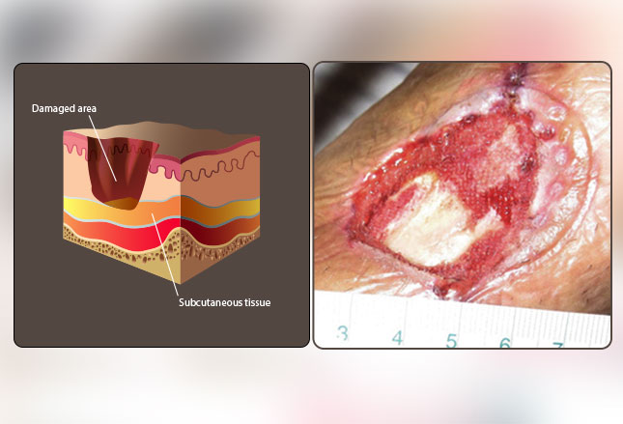
Answer: Category III – Full-thickness skin loss. Slough can be seen in the center of the wound bed, but there is no evidence of muscle, tendon or bone involvement. Notice the periwound epidermal breakdown.

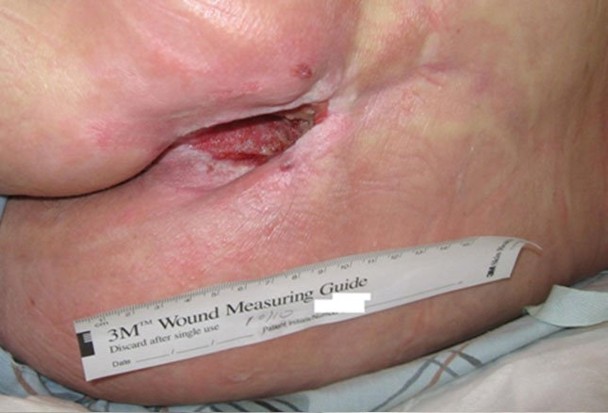
Question: Which category of pressure injury is shown above?
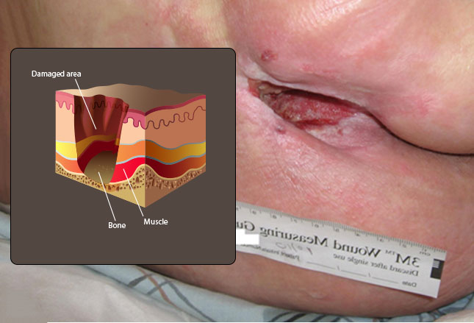
Answer: Category IV- Full-thickness skin and tissue loss. This is located on the coccyx. Note the full-thickness skin and tissue loss with exposure of bone, tendon or muscle.

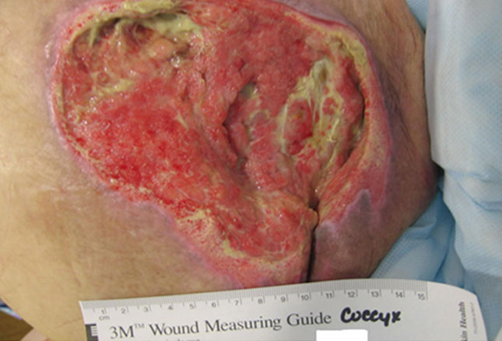
Question: Which category of pressure injury is shown above?
Answer: Category IV- Full-thickness skin and tissue loss. This is over the patient’s coccyx. Epidermis, dermis and subcutaneous tissue have been lost with exposure of muscle and possibly bone. The pale yellow areas represent slough. Slough develops from the build-up of normal products of wound healing, such as fibrin and superficial necrotic debris.

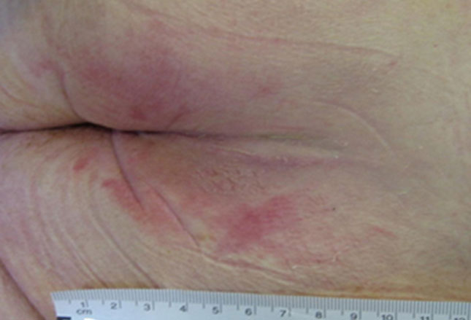
Question: Which category of pressure injury is shown above?
Answer: Suspected deep-tissue pressure injury – depth unknown. Injury to the deep, underlying soft tissue due to pressure and/or sheer produces intact, localized areas of purple or maroon skin (shown) or blood-filled blisters. In comparison to the adjacent tissue, the affected tissue may be painful, firm, mushy, boggy, and/or warm or cool. Sheer is a mechanical force that is in the same plane as the skin. Shear occurs when friction holds the skin in place but the body is pulled by gravity, as when a patient slips down in bed from a semi-upright position.

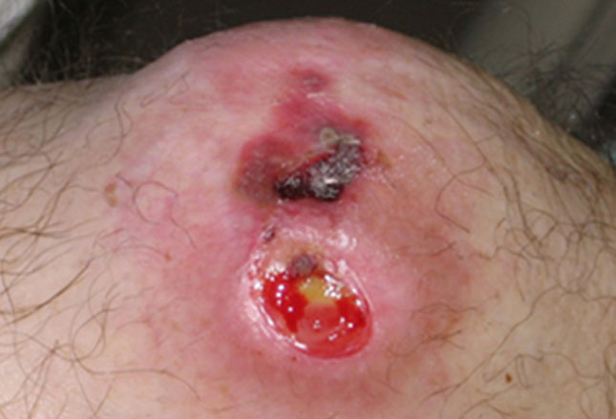
Question: Which categories of pressure injury are shown?
Answer: Category II (partial-thickness skin loss) and category III (full-thickness skin loss). The top pressure injury on the knee is a category II would that is resolving. Though there is discoloration indicative of deep-tissue pressure injury, careful examination reveals a blood blister that has burst, exposing granulation tissue. The bottom pressure injury shows full-thickness skin loss and a small area of slough.

From the article: Classifying Pressure Injuries (Ulcers): Cases to test your skills; Lu Ann Reed, RN, MSN, CRRN, BC-RN, LNHA, WCC, DWC; October 11, 2017 Medscape.

