What hormone stimulates glycogenolysis, gluconeogenesis, lipolysis and ketogenesis in the liver?

Explain where Insulin-Like Growth Factor comes from and what its target cells would be.

Aquaporins are associated with what hormone: (a)LH/FSH (b)Parathyroid Hormone (c)ADH (d)GnRH (e)insulin

What is cryptorchidism?

What is a vasectomy?

What is a Pap Smear and what does it involve?

What is uterine prolapse?

What is colposcopy?

What is a hysterectomy?

What is an episiotomy?

What is menarche?

What is amenorrhea?

(TRUE or FALSE) It is recommended that all men and women need to have annual prostate cancer examinations (a digital rectal exam) and blood PSA [prostate specific antigen] levels beginning about 50 years of age.

What is chemotaxis?

Your humoral immunity is provided by what?

Your cell mediated immunity is provided by what?

What is a plasma cell?

Where does histamine come from and what does it do?

What does opsonization mean?

Name two types of antigen presenting cells (APC’s).

Where are oxytocin and ADH released?

What does oxytocin do?

Where are GH and TSH released from?

The follicular cells of the thyroid gland release what hormone(s)?

What hormone is released from the parafollicular cells of the thyroid gland and what does that hormone do?

What is the action of parathyroid hormone?

What hormone is released from the testes?

What hormone(s) are released from the ovaries?

What hormone is released from the adrenal medulla?

What hormone targets the zona fasciculata of the adrenal cortex?

What role does LH play in the female and male reproductive cycle?

What role does FSH play in the female and male reproductive cycle?

What two hormones control ovulation?

What hormone(s) control menstruation?

What is menses and what day of the menstrual cycle does it correspond to?

Why is hCG used as a blood test for pregnancy?

List all the steroid hormones, that is, all the hormones derived from cholesterol.

What is the difference between amenorrhea and dysmenorrhea?

Will a decrease in blood pressure stimulate the release of ADH (YES or NO)?

Does oxytocin act as a steroid hormone or does it activate G-Protein associated 2nd messengers?

What hormone receptor is found on the myoepithelial cells of the mammary glands and on the smooth muscle fibers of the uterus?

What happens to the sperm while it is in the epididymis?

Explain what would happen during development of the reproductive organs of an XY individual with a mutation causing a nonfunctional SRY gene.

Name the target tissues for prolactin.

Define acromegaly and gigantism.

Is estradiol-17-beta a steroid or does it use a 2nd messenger pathway?

Is the male penile erection under sympathetic or parasympathetic control?

Is ejaculation under sympathetic or parasympathetic control?

Is vitamin-D a steroid or does it use a 2nd messenger pathway?

Where is calcitonin made?

Calcitonin works in opposition to what hormone?

Describe the pathway for lactation beginning with the baby suckling and ending with milk release.

What is a gonadotropin?

T4 and T3: which is the inactive and which is the active form?

Are T3 and T4 steroids or do they use 2nd messengers?

Which hormone (glucagon or insulin) regulates the conversion of stored glycogen into useable glucose in the blood?

What is hypercalcemia?

During oogenesis, an oogonium directly gives rise to a __________.

Place these into their correct order: T3 / T4 / TRH / TSH / anterior pituitary / hypophyseal portal veins / hypothalamus / thyroid gland.

Place these into their correct order: PTH / 1,25-dihydroxy vitamin D3 / 25-hydroxy vitamin D3 / cholecalciferol / 7-dehydrocholesterol / UV-light / liver / kidney.

Is cortisol a mineralocorticoid or a glucocorticoid?

Place these into their correct order: cortisol / corticotropin-RH / anterior pituitary / ACTH / zona fasciculata / hypothalamus.

Is aldosterone a mineralocorticoid or a glucocorticoid?

Where does aldosterone come from?

What does aldosterone do?

What organ does 17-beta-estradiol come from?

Place these into their correct order: receptor / phospholipase C activated / inositol trisphosphate (IP3) / hormone / diacylglycerol (DAG) / GTP-alpha-subunit released from G-protein / protein kinase activated / phosphatidylinositol-4,5-biphosphate (PIP2) cleaved / GDT replaced by GTP.

What is the difference between an embryo and a fetus?

After ovulation, the secondary oocyte is transformed into a corpus luteum? (TRUE or FALSE)

List the glands that supply all the components of semen.

How would you define/describe the cervix?

Is 17-beta-estradiol derived from amino acids or cholesterol?

What pituitary gland hormone is directly involved with spermatogenesis?

When blood calcium levels are low, what hormone is released from what gland and what are the target cells for this hormone?

Where is glycogen produced? (and don’t say the pancreas)

Where is insulin produced? (and don’t say the pancreas)

Contrast exocrine vs endocrine glands.

What are the three regions of the adrenal cortex and what hormones does each release?

Place these into their correct order: hormone+receptor / G-proteins dissociate / alpha-subunit / adenylate cyclase / cAMP / protein kinase.

How are aromatase and 5-alpha-reductase different?

What amino acid are T3 and T4 made from?

What is the role of thyroglobulin?

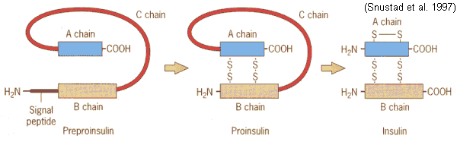

First preproinsulin is made…a long, folded string of amino acids. Then it is cut (cleaved) twice to make insulin.

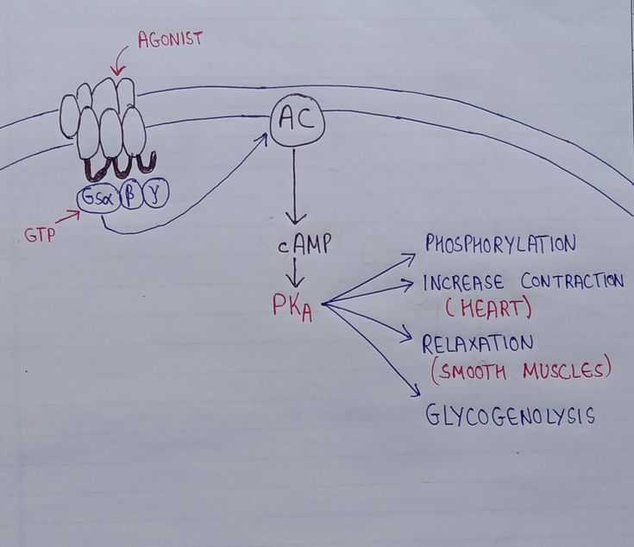 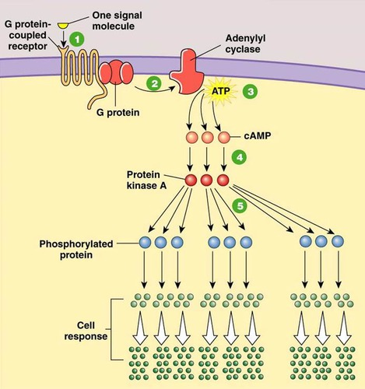

Explain the above diagram please.

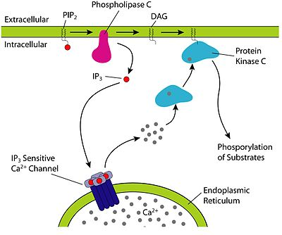

Explain the diagram above please.