And what are we looking at below?

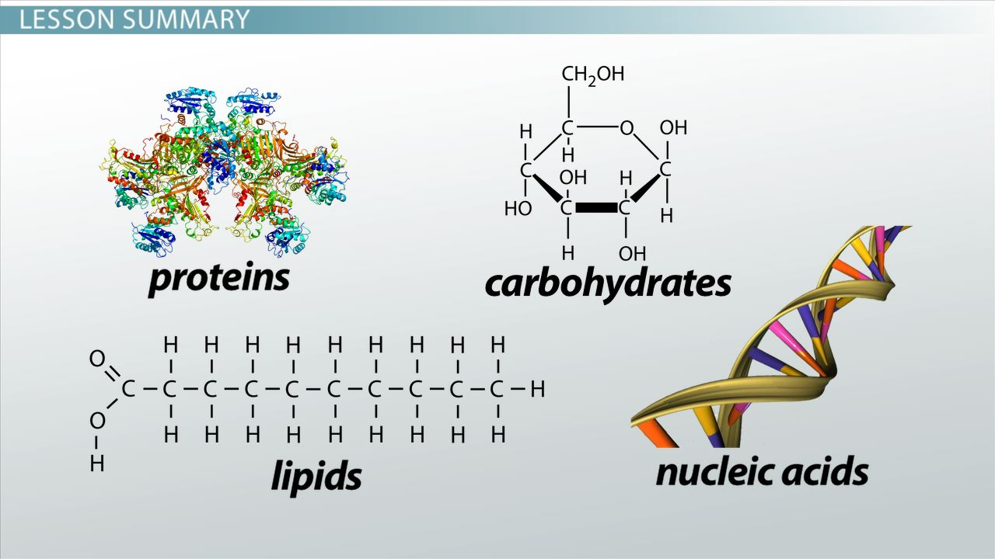

Yes, the FOUR categories of the most abundant molecules that exist in our bodies. Obviously, each is structurally quite different and now we understand those differences.

So, let’s talk about ‘proteins’. A string of amino acids, yes?

And what is an amino acid? Let’s look and review:

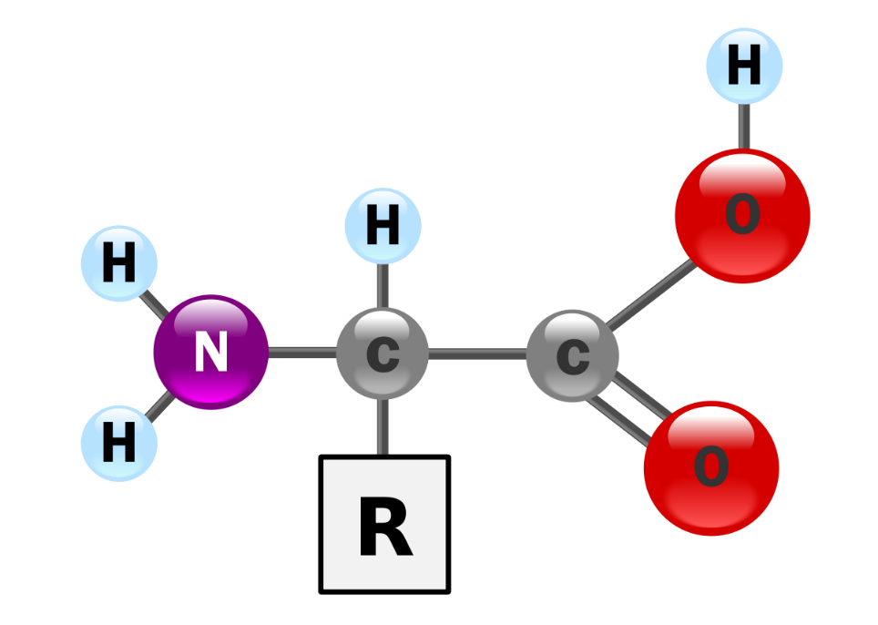

You start with the central carbon and add an amino-group (the amide group) derived from ammonia, NH3. And to the other side of the central carbon, you add the ‘acid’ group, COOH.

And how many amino acids are there? TWENTY.

What makes each amino acid different is what is bound to the central carbon, the “R” group. The simplest amino acid only has a hydrogen atom dangling down from the central carbon, see it up there in the upper left, Glycine?

Next to it is also an amino acid with a simple structure, only a CH3 group dangling down from the central carbon, Alanine.

And so on and so forth. So now we have discovered what gives each amino acid its unique chemical properties are the atoms in the attached “R” group.

You might as well look at Tyrosine and not be intimidated by its “R” group. Tyrosine is one amino acid we’ll be seeing a lot of in this class.

But right now, we are going to focus on **CYSTEINE**! Can you pronounce it correctly? **[Sista-een]**

And what is ‘special’ about cysteine’s side group? Yes, it contains ‘**sulfur**’. Sulfur would seem to be an uncommon atom in the human body. But then again, if sulfur is contained in the **cysteine** amino acids and if you think about all the millions of amino acids in the human body, many of which are **cysteine**, oh my gosh, I have a lot of sulfur in my body after all.

Don’t be frightened but the side group (functional group) that contains sulfur in **cysteine** is called by the chemists a ‘sulfhydryl group’. OK, that makes sense, but let me also mention it can be also called a ‘thiol’ group, or ‘sulfinyl’ group or even a ‘mercapto’ group. I will refer and test you on it by calling it a ‘sulfhydryl’ group. The takeaway lesson, the important part for our class, is that this sulfur can bind to another sulfur **linking two cysteines** producing the famous **“DISULFIDE BRIDGE”.**

And something else exciting happens when two **cysteines** are linked this way. What was **cysteine** all by itself is now called **cystine** when attached via a sulfide bond. See that in the below diagram. **Cystine** is pronounced **‘sis-teen’**.

Two sista-eens can link via a disulfide bond to form two attached sis-teens.

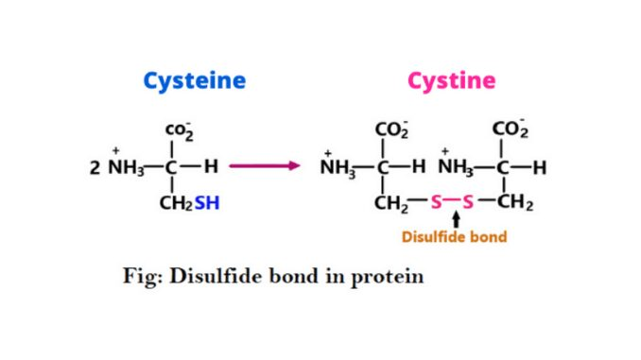

So, these links between cysteines, these disulfide bonds or bridges, produce tertiary and quaternary structures in a protein.

Here is a definition right out of a biochemistry book:

*‘Disulfide bridges formed between thiol groups in two*[*cysteine*](https://en.wikipedia.org/wiki/Cysteine)*residues are an important component of the tertiary and quaternary structure of*[*proteins*](https://en.wikipedia.org/wiki/Protein)*.’*

And finally, if you want to break apart the tertiary and quaternary structure of a protein, to denature a protein, you add a chemical that will disrupt (cleave) disulfide bonds.

As you can see in the diagram below, by placing cysteines in the appropriate places in the primary structure of a protein, you can engineer where that protein will fold. And always keep in mind, it is the final, three-dimensional shape of every protein that gives that protein its function.

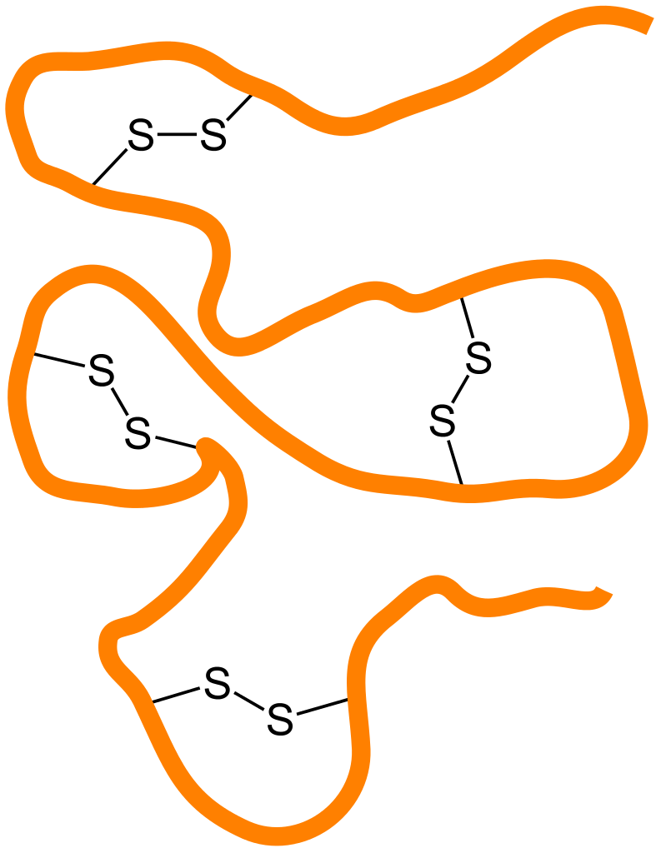

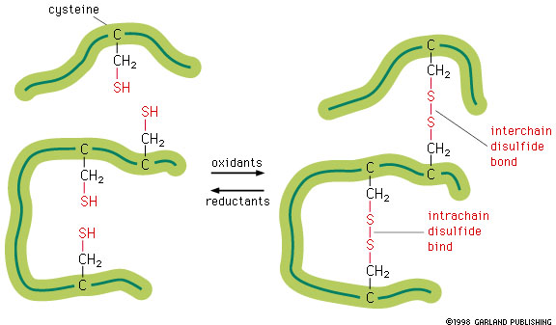

The disulfide bonds can cause a single protein (polypeptide chain) to fold-in on itself AND disulfide bonds can link two separate proteins together forming a quaternary structure.

Now think about the opposite, breaking the disulfide bonds in order to denature a protein, destroying it functionality.

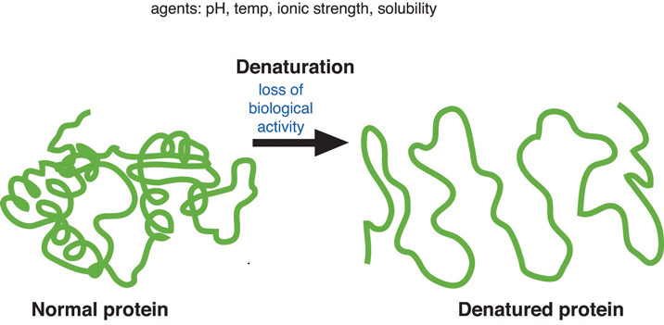

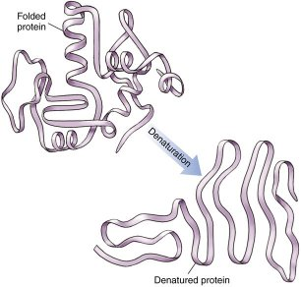

By the way, the secondary structure called the beta-pleated sheet is due to hydrogen bonds.

And the secondary structure called the alpha helix is also due to hydrogen bonds.

Since hydrogen bonds are weaker than disulfide bonds (bridges), which ever technique is used to denature a protein (heat, chemicals, pH), if the conditions are severe enough to disrupt the disulfide bonds then hydrogen bonds will also be broken, so that during denaturation secondary, tertiary and if present quaternary folding is lost.

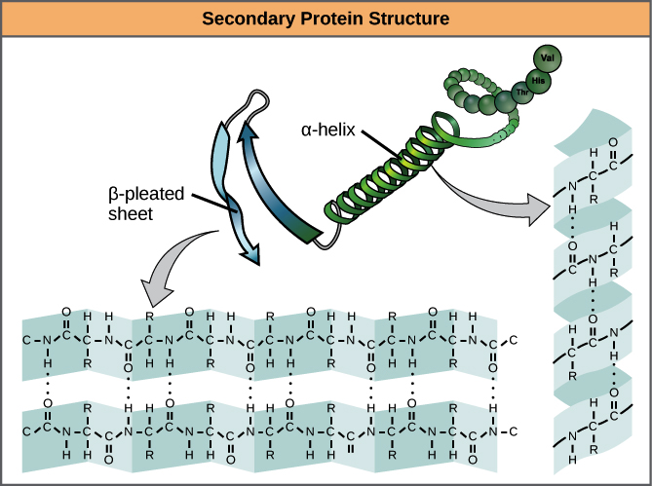

The alpha helix and beta pleated sheet are formed by hydrogen bonds.

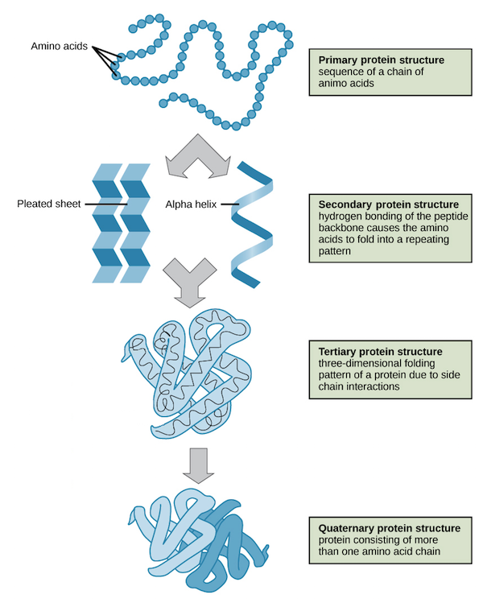

So, as you have most likely discovered, it is the specific “R” groups on all of the amino acids that construct the secondary, tertiary and possibly quaternary structure of any protein. So the primary structure, the order of the amino acids will dictate how that protein is eventually folded (with the help of enzymes found where in the cell?).