Resting Membrane Potentials and Action Potentials
(Neurons and Muscle Fibers):

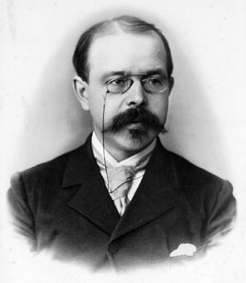
Walther Nernst: 1864 -1941

All cells have a resting membrane potential. Neurons can alter it for signal transduction.
First experiment to show this in 1934: electrical readings when shine light into eye (non-human), saw change in electrical reading, brighter the light → more signals (intensity = frequency)
First action potentials to be measured: all same magnitude (all or none); f = intensity; fast.
Typical RMP = -60 mv for nerve cell.
Put voltmeter into neuron, measure -60 mv. Now put battery into cell. If inside is negative, add more voltage, cell becomes more hyperpolarized. If put positive pole of battery into neuron, with increasing positive charge, will eventually hit threshold and generate AP.
During AP, inside goes from -60 mv to + 55 mv.
In 1902, knew this much:
-inside all cells are negatively charged proteins, cannot get out.
-inside high K⁺, low Na⁺
-outside high Na⁺, low K⁺
-cell membrane very permeable (leaky) to K⁺ only.

Could measure/test by 1930’s.
Nernst value for K⁺ should equal RMP, but doesn’t, due to leaking of K⁺ out.
Have negatively charged proteins within, cannot get out, attract positively charged K⁺’s.
So equilibrium for K⁺ is diffusing out from high to low concentration, but pulled back in
toward negatively charged proteins.
But even if RMP is determined by K⁺ concentrations, if double extracellular [K⁺], should see RMP increase by exactly 60 mv.

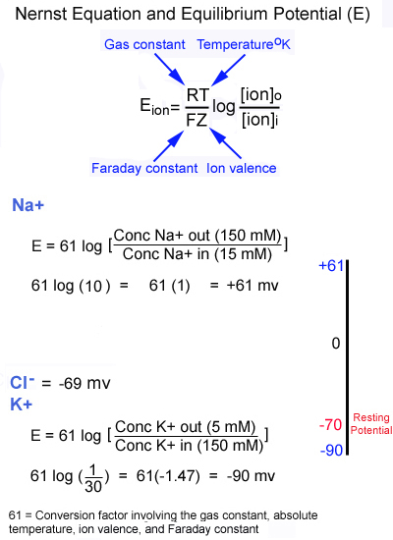

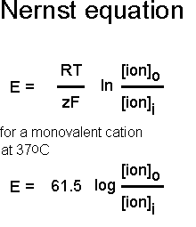

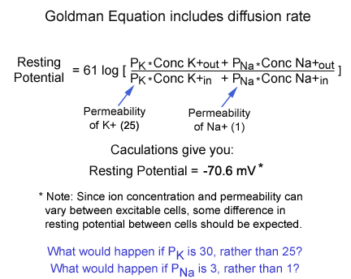

The Goldman-Hodgkin-Katz Equation

Potential for action potential should equal Nernst potential for Na⁺, and does.

Like a lake, the intracellular concentrations of Na⁺ and K⁺ do not change much. Whereas the concentrations do change a lot right at the membrane with the gates opening and closing.
The inflow and outflow of Na⁺ and K⁺ during the AP changes the overall intracellular
concentrations of Na⁺ and K⁺ minutely. The Na⁺/K⁺ ATPase membrane pump maintains the intracellular concentrations overall. Remember that the intracellular levels are in millimoles, the concentration change of Na⁺ and/or K⁺ at the membrane is in the picomole 1x10⁻¹² range.
In experiments with a giant squid neuron, it could fire 500,000 rapid APs before it even started to see change in intracellular levels of Na⁺ or K⁺.
Other another experiment, the Na⁺/K⁺ ATPase membrane pump was blocked, yet this neuron could still fire off 500,000 APs.
In hyperkalemia (blood potassium too high), K⁺ does not leak out of the neuron as fast as it normally would by diffusion (diffusion out slows for K⁺).
So retaining more K⁺ inside.
Some examples applying Nernst to the RMP and K⁺ concentrations inside and outside the neuron:
Kout = 10 Kin = 140 → -68.76

If increase extracellular K⁺:
Kout = 20 Kin = 140 → -50.70
(notice having increased extracellular K⁺ does not alter intracellular K⁺)

Kout = 30 Kin = 140 → -40.14

Kout = 100 Kin = 140 → -8.76
Moving up towards threshold.

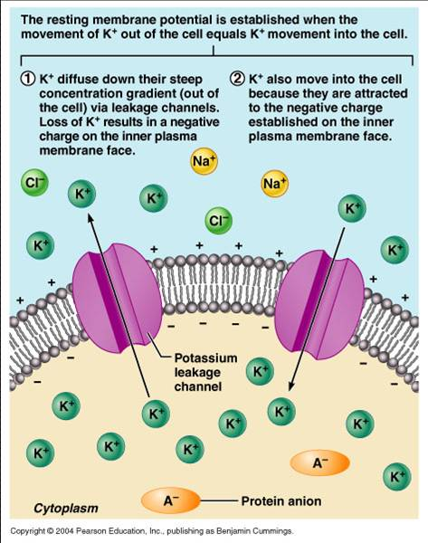
Since Nernst is inaccurate because it does not allow for leakage, use the Goldman, et. al. equation that factors in concentrations inside and outside plus the movement (leakage) of ions.

Note: most all talk about hyperkalemia centers around the kidneys doing their job right.
So hyperkalemia (as the book says) shifts the RMP up closer to threshold, so neuron will fire APs with smaller graded potentials.

In hypokalemia, RMP hyperpolarizes, moving farther from threshold. So ‘normal’ nerve impulse will not reach threshold and thus, this neuron will not fire (muscle weakness).

Disturbances in K⁺ balance are seen frequently. Changes in plasma K⁺ concentration have effects on neuromuscular excitability because of the importance of the K⁺ concentration gradient across cell membranes in determining the resting membrane potential. For example, an acute increase in the ECF (extracellular fluid) K⁺ concentration leads to depolarization of the resting potential, which by itself, would increase neuromuscular excitability; however, with chronic depolarization of the resting potential, the voltage-gated Na⁺ channels that are responsible for the rising phase of the action potential are inactivated, leaking to diminished excitability. Chronic hypokalemia has the opposite effect – the hyperpolarization of the membrane potential activates the Na⁺ channels. Whereas hypokalemia can be treated easily by dietary K⁺ supplements, or, if severe, by administering intravenous K⁺, the proper treatment of hyperkalemia requires a better understanding of its origin. Hyperkalemia results either from a shift of K⁺ out of the cells to the ECF or from reduced K⁺ excretion in the urine.

