Restriction Enzymes
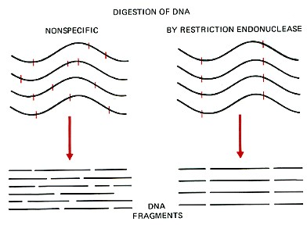
Restriction enzymes are DNA-cutting enzymes found in bacteria (and harvested from them for use). Because they cut within the molecule, they are often called restriction endonucleases.
In order to be able to sequence DNA, it is first necessary to cut it into smaller fragments. Many DNA-digesting enzymes (like those in your pancreatic fluid) can do this, but most of them are no use for sequence work because they cut each molecule randomly. This produces a heterogeneous collection of fragments of varying sizes. What is needed is a way to cleave the DNA molecule at a few precisely-located sites so that a small set of homogeneous fragments are produced. The tools for this are the restriction endonucleases. The rarer the site it recognizes, the smaller the number of pieces produced by a given restriction endonuclease
A restriction enzyme recognizes and cuts DNA only at a particular sequence of nucleotides. For example, the bacterium Hemophilus aegypticus produces an enzyme named HaeIII that cuts DNA wherever it encounters the sequence
5'GGCC3'
3'CCGG5'
The cut is made between the adjacent G and C. This particular sequence occurs at 11 places in the circular DNA molecule of the virus φX174. Thus treatment of this DNA with the enzyme produces 11 fragments, each with a precise length and nucleotide sequence. These fragments can be separated from one another and the sequence of each determined.
HaeIII and AluI cut straight across the double helix producing "blunt" ends. However, many restriction enzymes cut in an offset fashion. The ends of the cut have an overhanging piece of single-stranded DNA. These are called "sticky ends"because they are able to form base pairs with any DNA molecule that contains the complementary sticky end. Any other source of DNA treated with the same enzyme will produce such molecules.
Mixed together, these molecules can join with each other by the base pairing between their sticky ends. The union can be made permanent by another enzyme, a DNA ligase, that forms covalent bonds along the backbone of each strand. The result is a molecule of recombinant DNA (rDNA).
The ability to produce recombinant DNA molecules has not only revolutionized the study of genetics, but has laid the foundation for much of the biotechnology industry. The availability of human insulin (for diabetics), human factor VIII (for males with hemophilia A), and other proteins used in human therapy all were made possible by recombinant DNA.
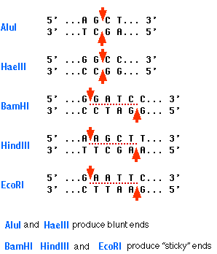

Restriction Enzymes
Restriction enzymes, also known as restriction endonucleases, are enzymes that cut a DNA molecule at a particular place. They are essential tools for recombinant DNA technology. The enzyme "scans" a DNA molecule, looking for a particular sequence, usually of four to six nucleotides. Once it finds this recognition sequence, it stops and cuts the strands. This is known as enzyme digestion. On double stranded DNA the recognition sequence is on both strands, but runs in opposite directions. This allows the enzyme to cut both strands. Sometimes the cut is blunt, sometimes the cut is uneven with dangling nucleotides on one of the two strands. This uneven cut is known as sticky ends.
A blunt end may look like this:
A sticky end like this:

Key points:
- Restriction enzymes are DNA-cutting enzymes. Each enzyme recognizes one or a few target sequences and cuts DNA at or near those sequences.
- Many restriction enzymes make staggered cuts, producing ends with single-stranded DNA overhangs. However, some produce blunt ends.
- DNA ligase is a DNA-joining enzyme. If two pieces of DNA have matching ends, ligase can link them to form a single, unbroken molecule of DNA.
- In DNA cloning, restriction enzymes and DNA ligase are used to insert genes and other pieces of DNA into plasmids.

How do you cut and paste DNA?
In DNA cloning, researchers make many copies of a piece of DNA, such as a gene. In many cases, cloning involves inserting the gene into a piece of circular DNA called a plasmid, which can be copied in bacteria.
How can pieces of DNA from different sources (such as a human gene and a bacterial plasmid) be joined together to make a single DNA molecule? One common method is based on restriction enzymes and DNA ligase.
- A restriction enzyme is a DNA-cutting enzyme that recognizes specific sites in DNA. Many restriction enzymes make staggered cuts at or near their recognition sites, producing ends with a single-stranded overhang.
- If two DNA molecules have matching ends, they can be joined by the enzyme DNA ligase. DNA ligase seals the gap between the molecules, forming a single piece of DNA.
Restriction enzymes and DNA ligase are often used to insert genes and other pieces of DNA into plasmids during DNA cloning.

Restriction enzymes
Restriction enzymes are found in bacteria (and other prokaryotes). They recognize and bind to specific sequences of DNA, called restriction sites. Each restriction enzyme recognizes just one or a few restriction sites. When it finds its target sequence, a restriction enzyme will make a double-stranded cut in the DNA molecule. Typically, the cut is at or near the restriction site and occurs in a tidy, predictable pattern.
As an example of how a restriction enzyme recognizes and cuts at a DNA sequence, let's consider EcoRI, a common restriction enzyme used in labs. EcoRI cuts at the following site:

5'-...GAATTC...-3' 3'-...CTTAAG...-5'
EcoRIsite
When EcoRI recognizes and cuts this site, it always does so in a very specific pattern that produces ends with single-stranded DNA “overhangs”:
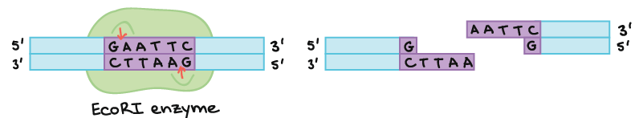
An EcoRI enzyme binds to an EcoRI site in a piece of DNA and makes a cut on both strands of the DNA. The pattern of the cut is:
5'-...G|AATTC...-3' 3'-...CTTAA|G...-5'
Thus, it produces an overhang of 5'-AATT-3' on each end of the cut DNA.
If another piece of DNA has matching overhangs (for instance, because it has also been cut by EcoRI), the overhangs can stick together by complementary base pairing. For this reason, enzymes that leave single-stranded overhangs are said to produce sticky ends. Sticky ends are helpful in cloning because they hold two pieces of DNA together so they can be linked by DNA ligase.
Not all restriction enzymes produce sticky ends. Some are “blunt cutters,” which cut straight down the middle of a target sequence and leave no overhang. The restriction enzyme SmaI is an example of a blunt cutter:
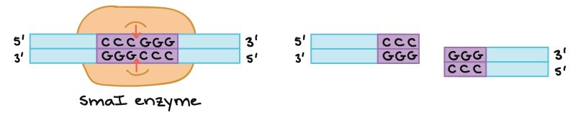
A SmaI enzyme binds to the SmaI restriction site, which is:
5'-...CCCGGG...-3' 3'-...GGGCCC...5'
It makes a cut right in the middle of this sequence on both strands, producing blunt ends. The cut sites are:
5'-...CCC|GGG...-3' 3'-...GGG|CCC...5'
Blunt-ended fragments can be joined to each other by DNA ligase. However, blunt-ended fragments are harder to ligate together (the ligation reaction is less efficient and more likely to fail) because there are no single-stranded overhangs to hold the DNA molecules in position.
 |  | 5′−GAATTC−3′3′−CTTAAG−3′ | 5′−G↓AATTC−3′3′−CTTAA↑G−3′
 |  | 5′−GGATCC−3′3′−CCTAGG−3′ | 5′−G↓GATCC−3′3′−CCTAG↑G−3′
 |  | 5′−AAGCTT−33′−TTCGAA−5′ | 5′−A↓AGCTT−33′−TTCGA↑A−5′
 |  | 5′−CCCGGG−33′−GGGCCC−5′ | 5′−CCC↓GGG−33′−GGG↑CCC−5′
 |  | 5′−GAGCTC−33′−CTCGAG−5′ | 5′−GAGCT↓C−33′−C↑TCGAG−5′

DNA ligase
If you’ve learned about DNA replication, you may already have met DNA ligase. In DNA replication, ligase’s job is to join together fragments of newly synthesized DNA to form a seamless strand. The ligases used in DNA cloning do basically the same thing. If two pieces of DNA have matching ends, DNA ligase can join them together to make an unbroken molecule.
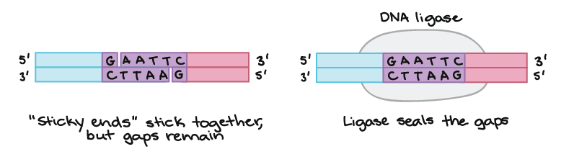
Fragment 1 of DNA:
5'-...G 3'-...CTTAA
Fragment 2 of DNA:
AATTC...-3' G...-5'
The single-stranded regions of the two molecules can stick together by hydrogen bonding, but there are still gaps in the backbone:
5'-...G|AATTC...-3' 3'-...CTTAA|G...-5'
DNA ligase seals the gaps to make an unbroken molecule of DNA:
5'-...GAATTC...-3' 3'-...CTTAAG...-5'
How does DNA ligase do this? Using ATP as an energy source, ligase catalyzes a reaction in which the phosphate group sticking off the 5’ end of one DNA strand is linked to the hydroxyl group sticking off the 3’ end of the other. This reaction produces an intact sugar-phosphate backbone.

Example: Building a recombinant plasmid
Let's see how restriction digestion and ligation can be used to insert a gene into a plasmid. Suppose we have a target gene, flanked with EcoRI recognition sites, and a plasmid, containing a single EcoRI site:
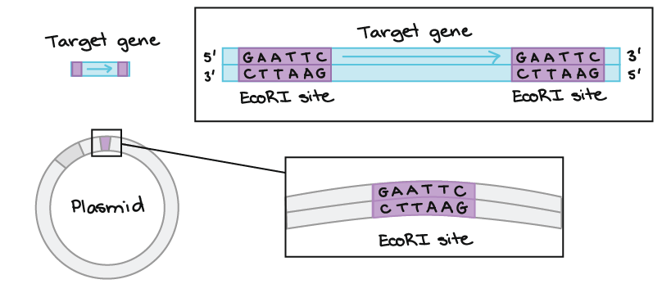
We start off with a target gene and a circular plasmid. The target gene has two EcoRI restriction sites near its ends. The plasmid has one EcoRI site in it, lying just after a promoter that drives expression in bacteria. The sequence of the EcoRI sites is:
5'-GAATTC-3' 3'-CTTAAG-5'
Our goal is to use the enzyme EcoRI to insert the gene into the plasmid. First, we separately digest (cut) the gene fragment and the plasmid with EcoRI. This step produces fragments with sticky ends:
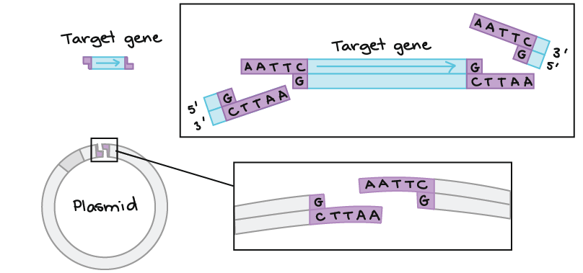
We separately digest (cut) the gene fragment and the plasmid with EcoRI. This step produces fragments with sticky ends. All of the ends have an overhang of four nucleotides, with the sequence 5'-AATT-3'. That's because EcoRI's cut pattern is:
5'-G|AATTC-3' 3'-CTTAA|G-5'
Next, we take the gene fragment and the linearized (opened-up) plasmid and combine them along with DNA ligase. The sticky ends of the two fragments stick together by complementary base pairing:
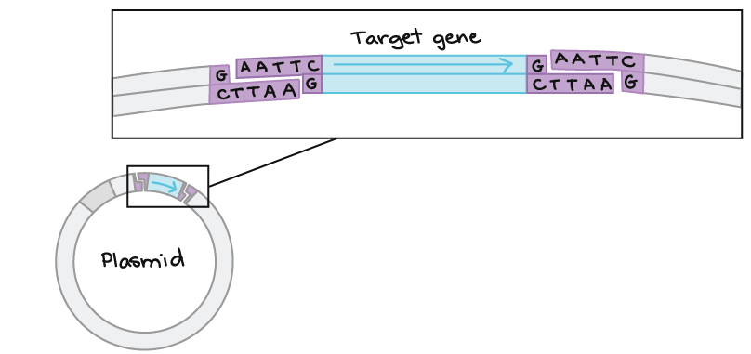
Next, we take the gene fragment and the linearized (opened-up) plasmid and combine them along with DNA ligase. The sticky ends of the two fragments stick together by complementary base pairing. However, there are still gaps in the sugar-phosphate backbones of the DNA double helix at the junction sites where the gene and plasmid DNA meet.
Once they are joined by ligase, the fragments become a single piece of unbroken DNA. The target gene has now been inserted into the plasmid, making a recombinant plasmid.
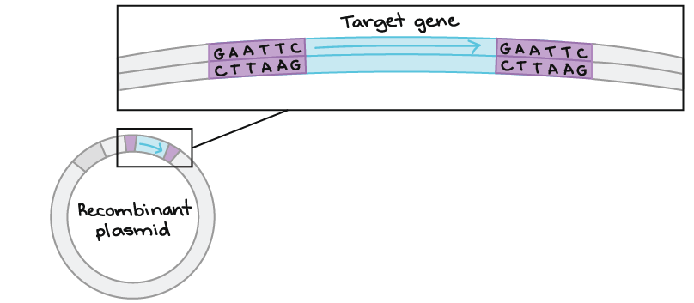
Once they are joined by ligase, the fragments become a single piece of unbroken DNA. The target gene has now been inserted into the plasmid, making a recombinant plasmid. In the plasmid, the gene is now flanked by two EcoRI sites that were generated when the cut ends were ligated together.

