Skin and Decubitus Ulcers:
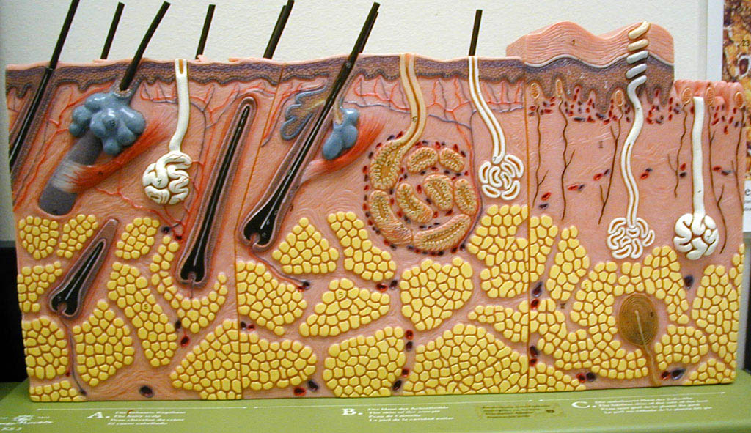

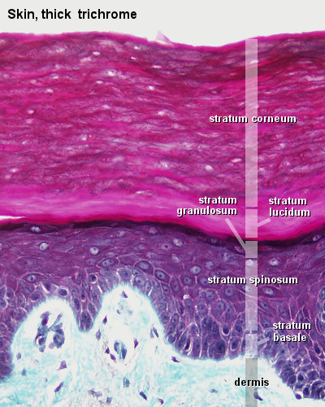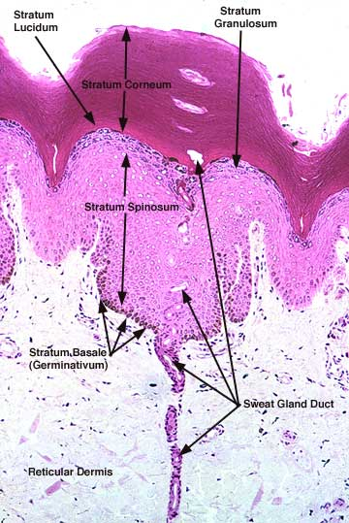

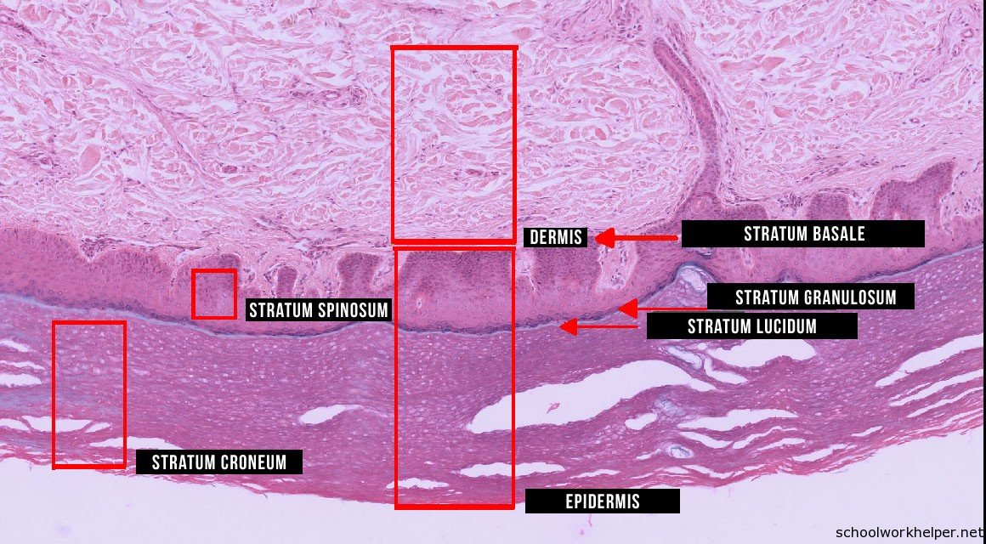

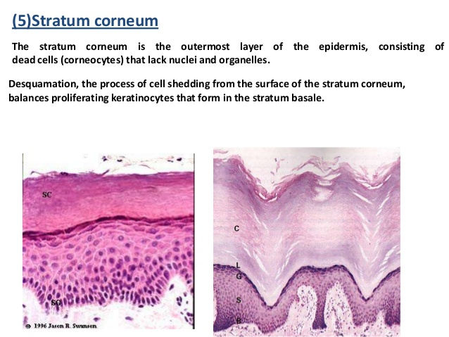

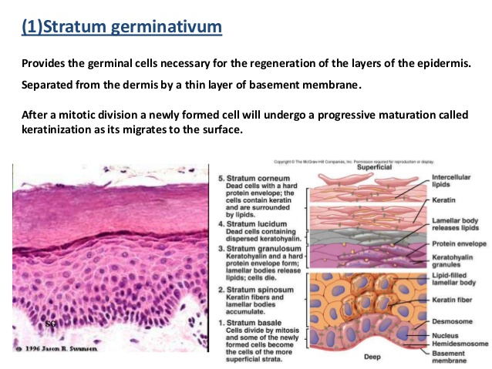

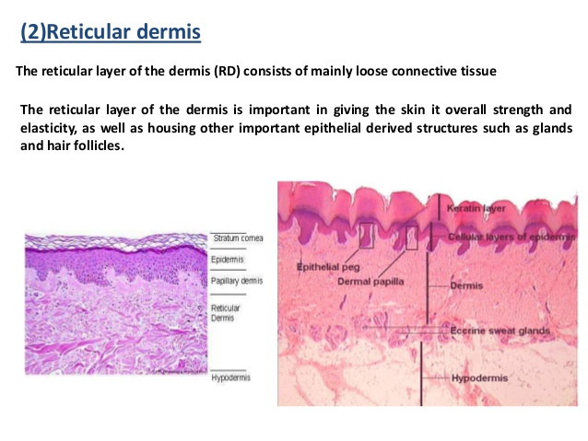
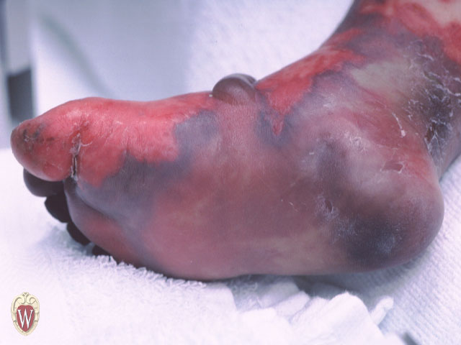

Pressure Ulcers:
Causes: Pressure: typically over a boney prominence
Shear: adjacent parts of body slide past each other,
tearing blood vessels
Friction: rubbing against a surface causing abrasion, blistering
Assess Risks: moisture; can patient change body position; look for initial signs of ulcers
Make a plan, educate patient, care-givers and family.
Legal Liability: Negligence = failing to provide proper care, or providing improper care.
Malpractice: negligence by a professional.
To prove negligence, need to prove all four: Duty; Breach; Causation and Damage.
Staging: Partial-thickness vs. Full-thickness
4 Stages of Pressure Ulcer Development:
'Stage I': intact skin, see a line of erythema where finger touches.
'Stage II': loss of epidermis or dermis or both; epithelium separated
from dermis (blistering).
'Stage III': full-thickness; skin loss; undermining; necrotic tissue.
'Stage IV': damage down to subcutaneous tissue or fascia or bone.
When staging, report 'depth'; 'amount of healing (granulation tissue'; 'eschar formation (necrotic tissue)'.
It will not heal by reverse staging.
A partial-thickness ulcer will resurface by re-epithelializing).
A full-thickness ulcer will undergo tissue repair with inflammation; contraction;
collagen remodeling; granulation.
Assessment: look for location (over boney prominence); width, depth, length; sinus tracts;
undermining; exudate; color; odor; percentage of granulation tissue; percent necrosis;
inspect periwound area.
Treatment: pressure relief (special mattress; foam cushions);
wound treatment: cleaning (DO NOT use iodine,
hydrogen peroxide or alcohol. These inhibit cell growth.)
Debridement of necrotic tissue.

Granulation tissue
This has nothing to do with either granulomas or granulomatous inflammation.
Granulation tissue is formed as part of the healing and repair process.
Granulation tissue is so named, because it has a granular appearance when viewed grossly.
Granulation tissue is the initial response to a wound and consists of a richly vascular connective
tissue, which contains new capillaries, abundant fibroblasts, and variable numbers of
inflammatory cells. Do not confuse with the term granuloma.
Eschar: A necrotic mass of tissue.
: Sloughed off dead tissue caused by burn or cauterization.
An escharotic is a substance that causes the tissue to die and slough off (eschar) and
includes acids, alkalies, carbon dioxide, metallic salts, or electric cautery.
A dry slough, crust, or scab, which separates from the healthy part of the body,
as that produced by a burn, or the application of caustics.

