There are approximately 200 different ‘types’ of cells in the human body as you learned in anatomy. They all have the same components (listed in no particular order):
-cytoskeleton (microtubules; microfilaments; intermediate filaments);
-microvilli (only found on certain cells);
-centrosome (centrioles);
-plasma membrane;
-vesicles;
-lysosomes;
-smooth endoplasmic reticulum;
-rough endoplasmic reticulum;
-peroxisomes;
-mitochondria;
-nucleus (chromatin; nucleolus);
-cytoplasm (consists of cytosol plus organelles);
-ribosomes (free and membrane bound);
-Golgi complex or apparatus;
-proteosomes.

The plasma membrane consists of a phospholipid bilayer. Along with the phospholipids are membrane proteins. Some of these proteins extend the entire width of the phospholipid bilayer and these are called integral membrane proteins or sometimes called transmembrane proteins. Other types of proteins associated with the membrane are found only on either the outside or inside of the membrane. These are called peripheral proteins. Both transmembrane and peripheral proteins may have sugar groups attached to them making them glycoproteins. You can also find cholesterol molecules associated with a plasma membrane.

Fluid within the cells is called intracellular fluid (the cytosol);
Fluid outside cells is called extracellular fluid or the ECF. Now you can find this fluid in three different body spaces or compartments: in the tiny space in between cells or in the blood vessels or in the lymphatic vessels. The fluid found in the lymph vessels is simply called lymph fluid or lymph. The fluid found in the blood is called blood plasma or plasma. The fluid found in between cells is called interstitial fluid.
Check your notes for:
-passive movement across a membrane vs. active movement across a membrane;
-simple diffusion/facilitated diffusion/osmosis;
-endocytosis/pinocytosis/phagocytosis/exocytosis
Cytoplasm is basically the substance that fills the cell. It is a jelly-like material that is eighty percent water and usually clear in color. It is more like a viscous (thick) gel than a watery substance. Cytoplasm, which can also be referred to as cytosol, means cell substance. This name is very fitting because cytoplasm is the substance of life that serves as a molecular soup in which all of the cell's organelles are suspended and held together by a fatty membrane. The cytoplasm is found inside the cell membrane, surrounding the nuclear envelope and the cytoplasmic organelles.
Cytoplasm is the home of the cytoskeleton, a network of cytoplasmic filaments that are responsible for the movement of the cell and give the cell its shape. The cytoplasm contains dissolved nutrients and helps dissolve waste products. The cytoplasm helps materials move around the cell by moving and churning through a process called cytoplasmic streaming. The nucleus often flows with the cytoplasm changing the shape as it moves. The function of the cytoplasm and the organelles which sit in it, are critical the cell's survival.

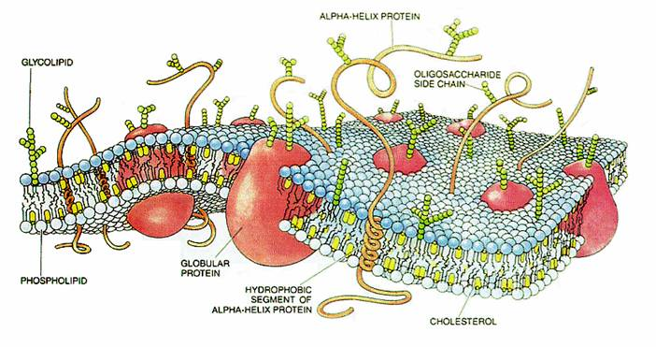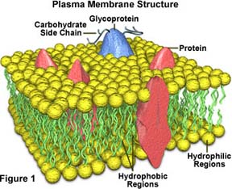

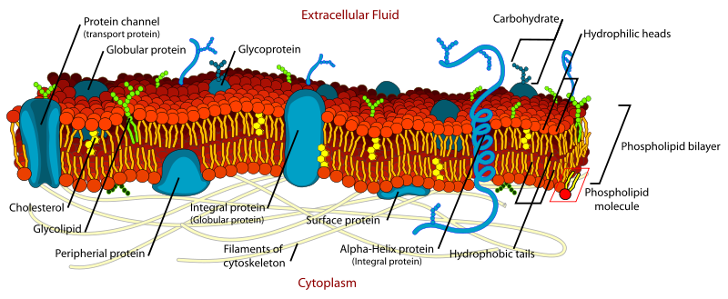
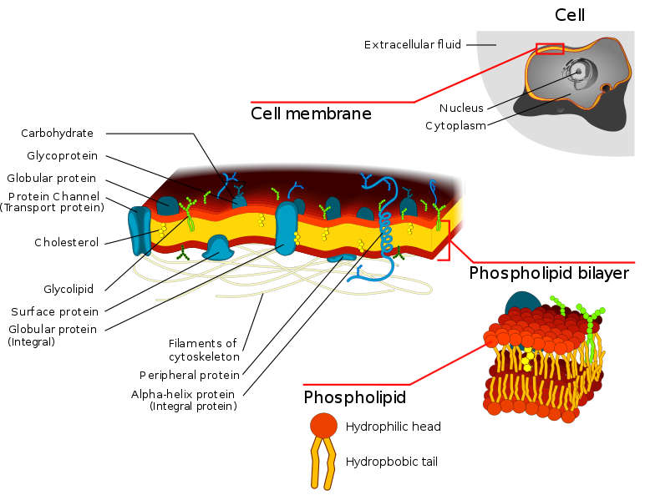

Not all cells have a nucleus. Biology breaks cell types into eukaryotic (those with a defined nucleus) and prokaryotic (those with no defined nucleus). The nucleus occurs only in eukaryotic cells. It is the location for most of the nucleic acids a cell makes, such as DNA and RNA. Deoxyribonucleic acid, DNA, is the physical carrier of inheritance and DNA is restricted to the nucleus. Ribonucleic acid, RNA, is formed in the nucleus using the DNA base sequence as a template. RNA moves out into the cytoplasm where it functions in the assembly of proteins. The nucleolus is an area of the nucleus (usually two nucleoli per nucleus) where ribosomes are constructed. When the cell is in a resting state there is something called chromatin in the nucleus. Chromatin is made of DNA, RNA, and nuclear proteins. DNA and RNA are the nucleic acids inside of the cell. When the cell is going to divide, the chromatin becomes very compact. It condenses. When the chromatin comes together, you can see the chromosomes.
The nuclear envelope is a double-membrane structure. Numerous pores occur in the envelope, allowing RNA and other chemicals to pass, but the DNA not to pass.

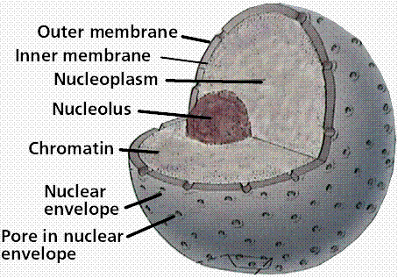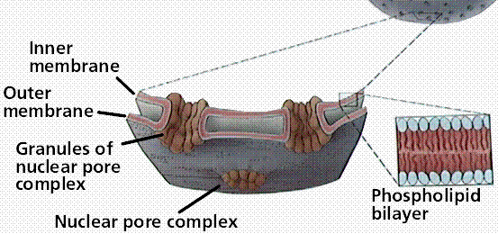

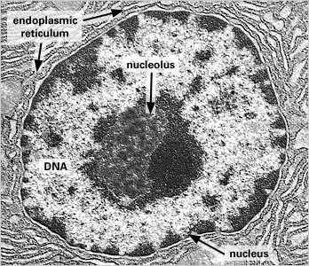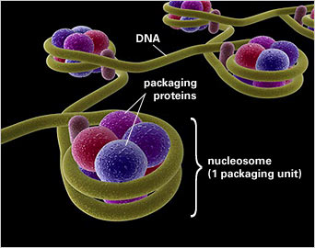

Packed inside the nucleus of every human cell is nearly 6 feet of DNA, which is subdivided into 46 individual molecules, one for each chromosome and each about 1.5 inches long. Collecting all this material into a microscopic cell nucleus is an extraordinary feat of packaging. For DNA to function when necessary, it can't be haphazardly crammed into the nucleus or simply wound up like a ball of string. Consequently, during interphase, DNA is combined with proteins and organized into a precise, compact structure, a dense string-like fiber called chromatin, which condenses even further into chromosomes during cell division.
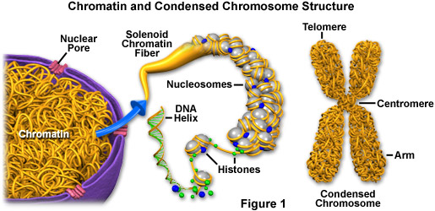
Each DNA strand wraps around groups of small protein molecules called histones.
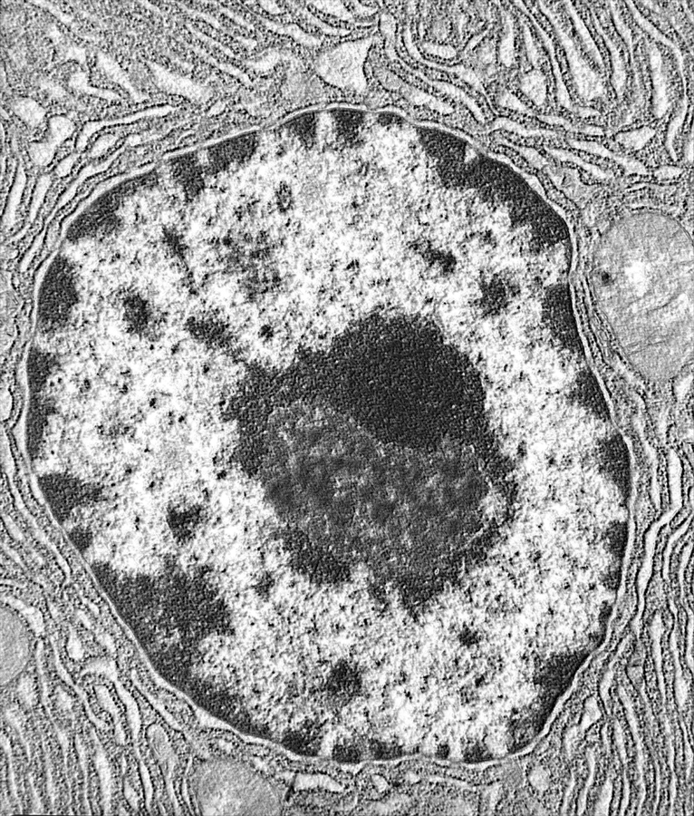
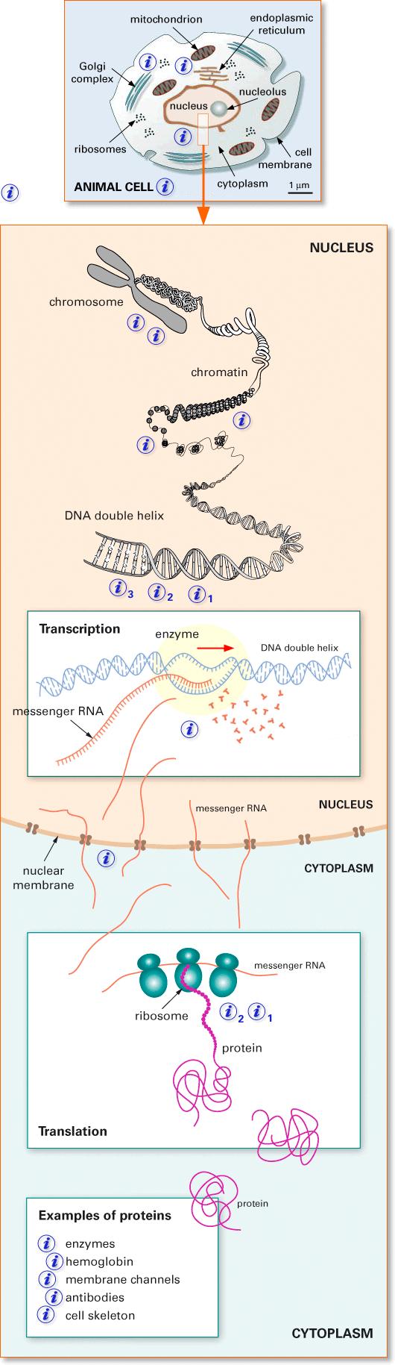
The ribosome is a large complex of RNA and protein which catalyzes protein translation, the formation of proteins from individual amino acids using messenger RNA as a template. This process is known as translation. Ribosomes are found in all living cells.
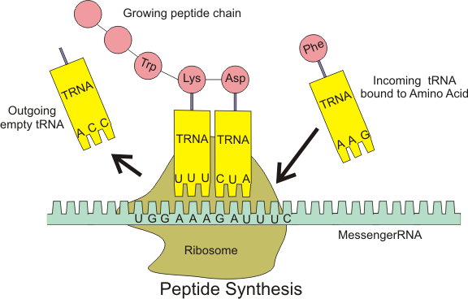

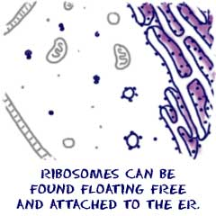
Cells need to make proteins. Those proteins might be used as enzymes or as support for other cell functions. When you need to make proteins, you look for ribosomes. Ribosomes are the protein builders or the protein synthesizers of the cell. They are like construction guys who connect one amino acid at a time and build long chains.
Ribosomes are found in many places around the cell. You might find them floating in the cytoplasm (cytosol). Those floating ribosomes make proteins that will be used inside of the cell. Other ribosomes are found on the endoplasmic reticulum. Endoplasmic reticulum with attached ribosomes is called rough. It looks bumpy under a microscope. Those attached ribosomes make proteins that will be used inside the cell and proteins made for export out of the cell.

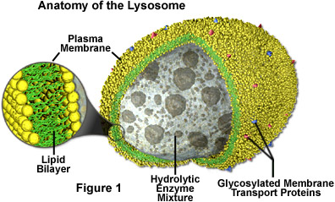

Lysosomes are cellular organelles that contain acid hydrolase enzymes that break down waste materials and cellular debris. These are non-specific. They can be described as the stomach of the cell. They are found in animal cells. Lysosomes digest excess or worn-out organelles, food particles, and engulf viruses or bacteria. The membrane around a lysosome allows the digestive enzymes to work at the 4.5 pH they require. Lysosomes fuse with vacuoles and dispense their enzymes into the vacuoles, digesting their contents. They are created by the addition of hydrolytic enzymes to early endosomes from the Golgi apparatus. The name lysosome derives from the Greek words lysis, to separate, and soma, body. They are frequently nicknamed "suicide-bags" or "suicide-sacs" by cell biologists due to their autolysis.
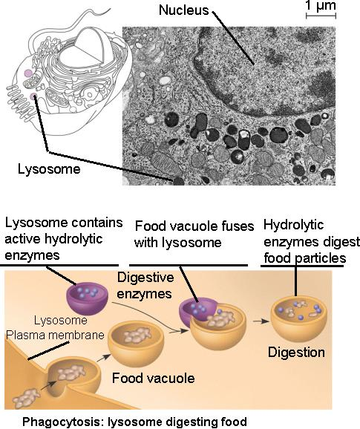

Lysosomes digest (hydrolyze) materials taken into the cell and recycle intracellular materials.
Molecules can be engulfed by infolding of the plasma membrane, yielding a food vacuole.
The food vacuole then fuses with a lysosome for digestion - phagocytosis.
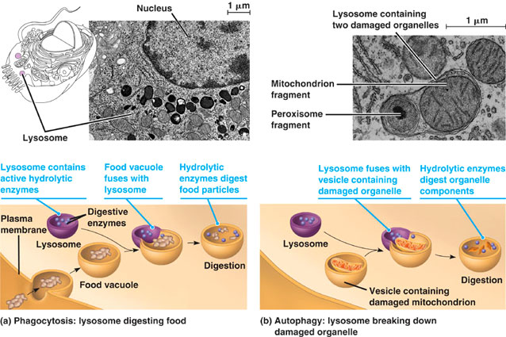

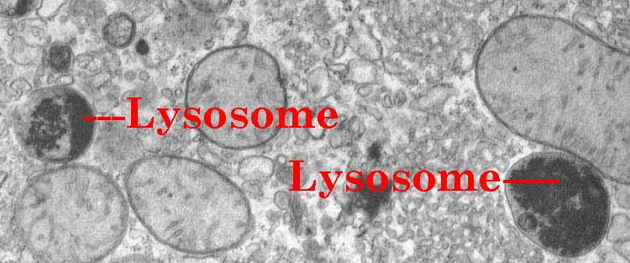

Peroxisomes are found in all eucaryotic cells. They contain oxidative enzymes, such as catalase and urate oxidase, at such high concentrations that in some cells the peroxisomes stand out in electron micrographs because of the presence of a crystalloid core.
Peroxisomes contain a variety of enzymes, which primarily function together to rid the cell of toxic substances, and in particular, hydrogen peroxide (a common byproduct of cellular metabolism). These organelles contain enzymes that convert the hydrogen peroxide to water, rendering the potentially toxic substance safe for release back into the cell. Some types of peroxisomes, such as those in liver cells, detoxify alcohol and other harmful compounds by transferring hydrogen from the poisons to molecules of oxygen (a process termed oxidation). Others are more important for their ability to initiate the production of phospholipids, which are typically used in the formation of membranes.
Peroxisomes are so named because they usually contain one or more enzymes that use molecular oxygen to remove hydrogen atoms from specific organic substrates (designated here as R) in an oxidative reaction that produces hydrogen peroxide (H₂O₂):
Catalase utilizes the H₂O₂ generated by other enzymes in the organelle to oxidize a variety of other substrates—including phenols, formic acid, formaldehyde, and alcohol—by the “peroxidative” reaction: H₂O₂ + R′ H₂ → R′ + 2H₂O. This type of oxidative reaction is particularly important in liver and kidney cells, where the peroxisomes detoxify various toxic molecules that enter the bloodstream. About 25% of the ethanol we drink is oxidized to acetaldehyde in this way. In addition, when excess H₂O₂ accumulates in the cell, catalase converts it to H₂O through the reaction:
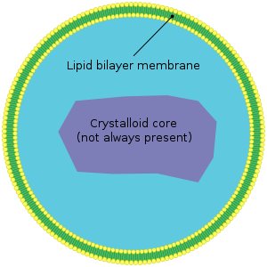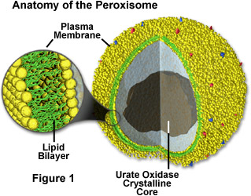

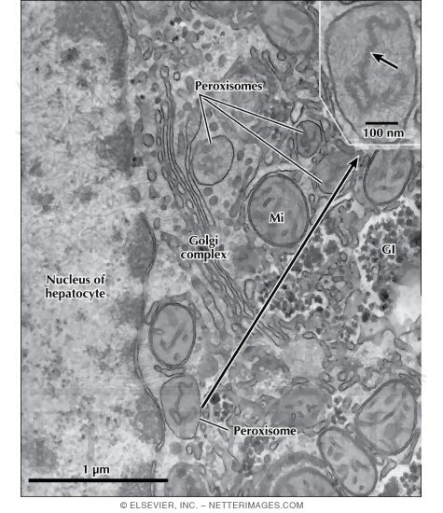

Mitochondria are the cell's power producers. They convert energy into forms that are usable by the cell. Located in the cytoplasm, they are the sites of cellular respiration which ultimately generates fuel for the cell's activities. Mitochondria are bounded by a double membrane. Each of these membranes is a phospholipid bilayer with embedded proteins. The outermost membrane is smooth while the inner membrane has many folds. These folds are called cristae. The folds enhance the "productivity" of cellular respiration by increasing the available surface area.
The double membranes divide the mitochondrion into two distinct parts: the intermembrane space and the mitochondrial matrix. The intermembrane space is the narrow part between the two membranes while the mitochondrial matrix is the part enclosed by the innermost membrane. Several of the steps in cellular respiration occur in the matrix due to its high concentration of enzymes.
Mitochondria are semi-autonomous in that they are only partially dependent on the cell to replicate and grow. They have their own DNA, ribosomes and can make their own proteins.
Mitochondria are rod-shaped organelles that can be considered the power generators of the cell, converting oxygen and nutrients into adenosine triphosphate (ATP). ATP is the chemical energy "currency" of the cell that powers the cell's metabolic activities. This process is called aerobic respiration and is the reason animals breathe oxygen. Without mitochondria (singular, mitochondrion), higher animals would likely not exist because their cells would only be able to obtain energy from anaerobic respiration (in the absence of oxygen), a process much less efficient than aerobic respiration. In fact, mitochondria enable cells to produce 15 times more ATP than they could otherwise, and complex animals, like humans, need large amounts of energy in order to survive.
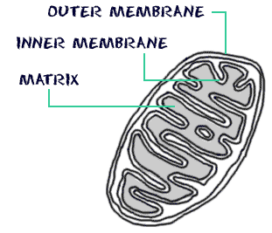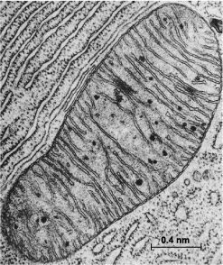

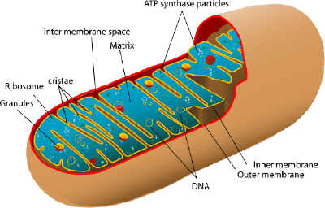

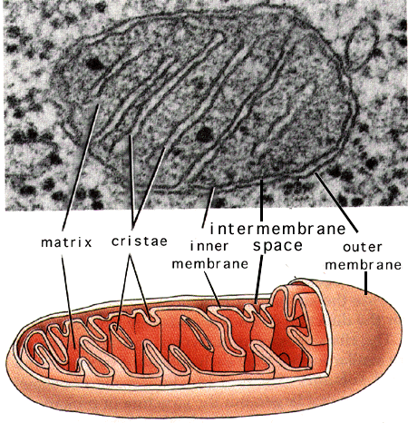
Smooth Endoplasmic Reticulum: A type of endoplasmic reticulum that is tubular in form (rather than sheet-like) and lacks ribosomes and is primarily used as a storage container. Its functions include lipid synthesis, carbohydrate metabolism, calcium storage, drug detoxification, and attachment of receptors on cell membrane proteins.
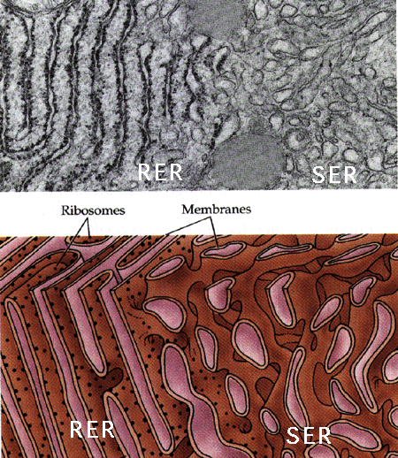
Proteasomes are protein complexes inside all eukaryotes. In eukaryotes, they are located in the nucleus and the cytoplasm. The main function of the proteasome is to degrade unneeded or damaged proteins by proteolysis, a chemical reaction that breaks peptide bonds. Enzymes that carry out such reactions are called proteases. Proteasomes are part of a major mechanism by which cells regulate the concentration of particular proteins and degrade misfolded proteins. Proteins are tagged for degradation with a small protein called ubiquitin. The tagging reaction is catalyzed by enzymes called ubiquitin ligases.
There are two major intracellular devices in which damaged or unneeded proteins are broken down:
- lysosomes and
- proteasomes
Lysosomes deal primarily with
- extracellular proteins, e.g., plasma proteins, that are taken into the cell, e.g., by endocytosis
- cell-surface membrane proteins.
- the proteins (and other macromolecules) engulfed by autophagosomes.

Proteasomes deal primarily with endogenous proteins; that is, proteins that were synthesized within the cell.
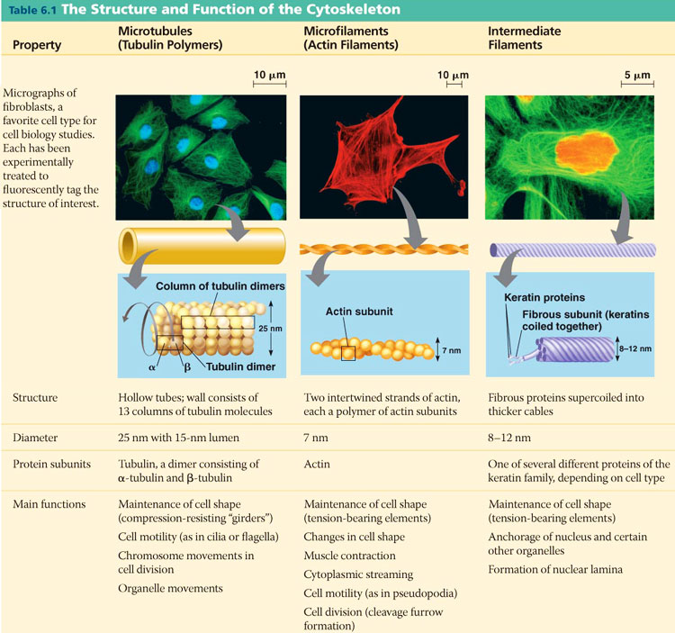

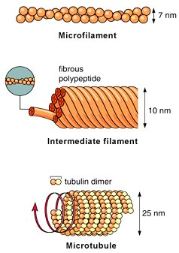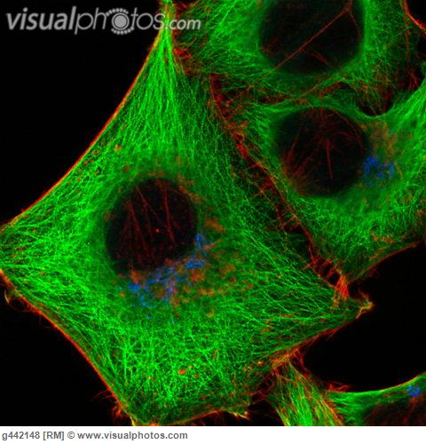
Protein fibers extend throughout the cytoplasm of a eukaryotic cell. They act as a framework to give shape to the cell and enable structures within it, or the entire cell, to move. Microfilaments and intermediate filaments are thin strands of 2 or more proteins wrapped around one another. Microtubules are hollow tubes made of globular proteins arranged in spirals.
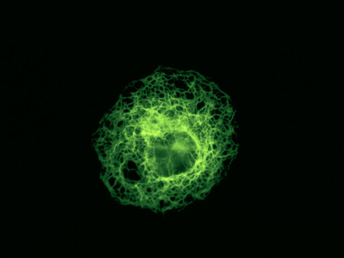
Intermediate filaments
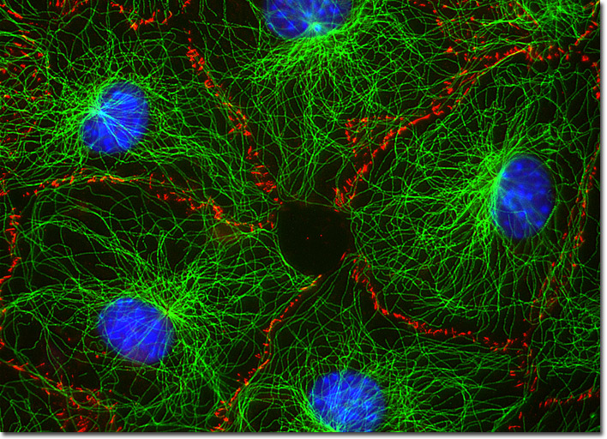
Microtubules
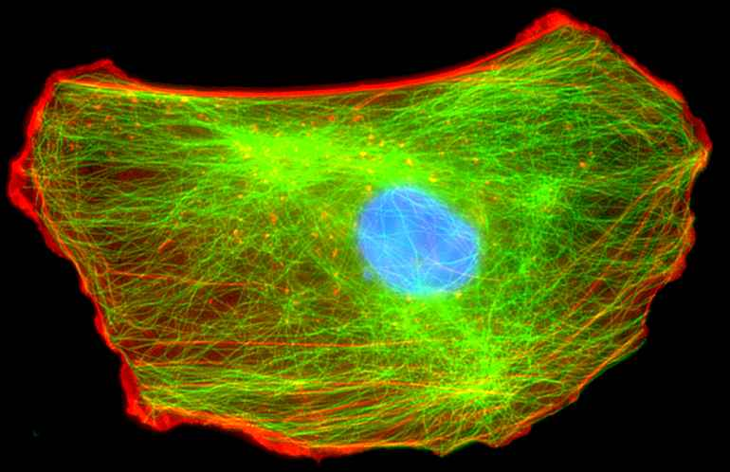
Actin
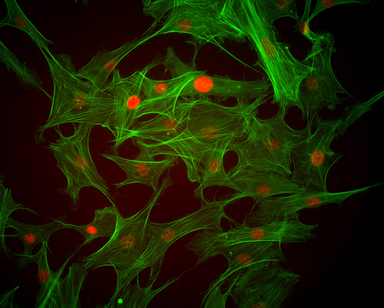
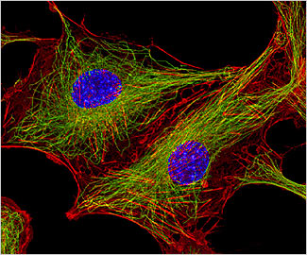
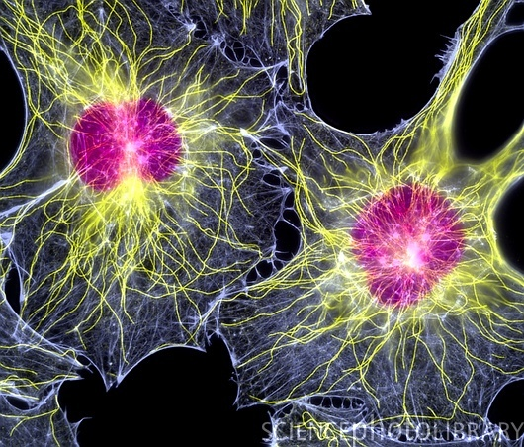
MICROTUBULES
Microtubules are hollow tubes like plumbing pipes. They are the Largest Strands of the Cytoskeleton. Microtubules are made of a PROTEIN called TUBULIN.
Microtubules have THREE FUNCTIONS:
- To maintain the shape of the cell and hold organelles in place.
- To serve as tracks for organelles and molecules to move along within the cell.
- When the Cell is about to divide, two short cylinders of Microtubules at right angles known as Centrioles can be found situated in the cytoplasm near the nuclear envelope. Centrioles organize the micortubules of the cytoskeleton during Cell Division in animal cells, plant cells lack centrioles.
MICROFILAMENTS
MICROFILAMENTS are NOT HoLLOW and have a structure that resembles ROPE made of
TWO TWISTED CHAINS OF PROTEIN called ACTIN. MICROFILAMENTS can CONTRACT, causing movement. Muscle Cells have many microfilaments.
INTERMEDIATE FILAMENTS
Intermediate filaments are rods that anchor the nucleus and some other organelles to their place in the cell. They maintain the internal shape of the nucleus. Hair-follicle (hair-root) cells produce large quantities of intermediate filament proteins. These proteins make up most of the hair shaft - your hair!
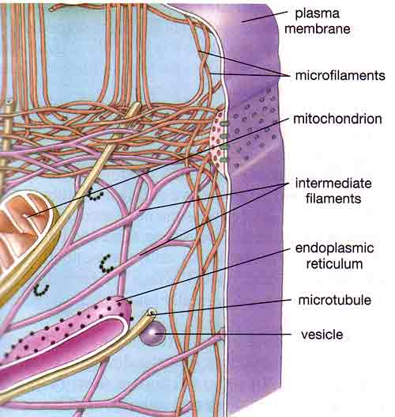

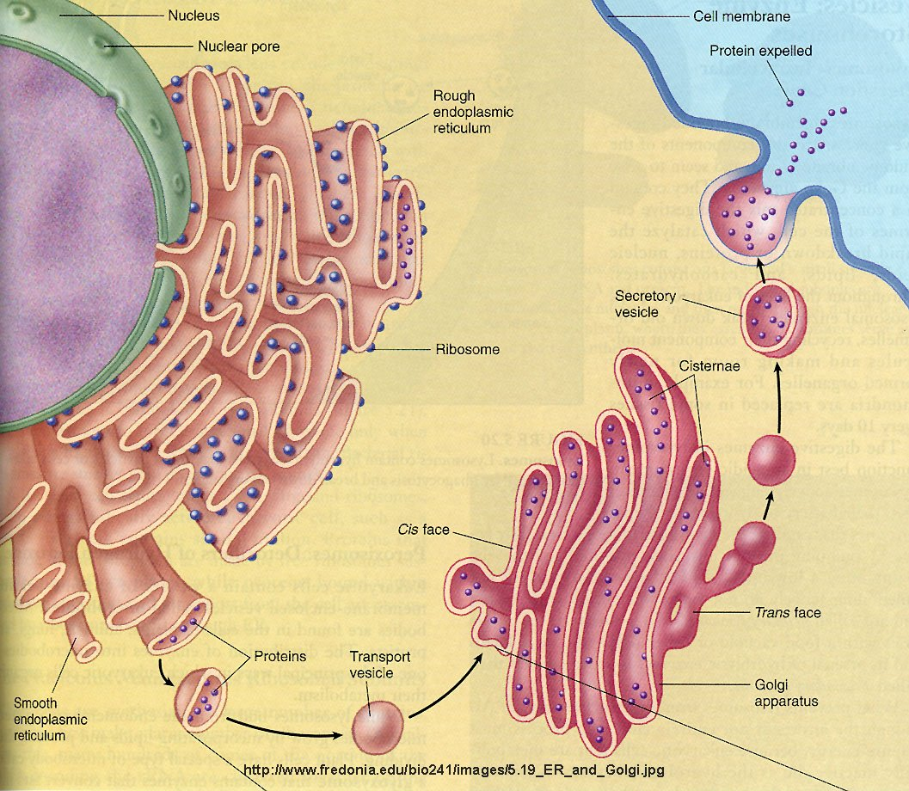

Getting Substances  In and Out of Cells | Endocystosis, is a general term for the process whereby very large particles of material are wrapped with plasma membrane and moved into the cell in the form of vesicles or vacuoles. None of the trapped material actually moves through the membrane, but remains on the other side of the original membrane, even while the vacuole is inside the cell.
Exocytosis | Exocytosis is the reverse of endocytosis. Quatities of material are expelled from the cell without ever passing through the membrane as individual molecules. By using the processes of endocytosis and exocytosis, some specialized types of cells move large amounts of bulk material into and out of themselves.
Phagocytosis | Solid particles are engulfed by phagocytosis ("cell eating"), a process that begins when solids make contact with the outer cell surface, triggering the movement of the membrane.  The desired particles are then enclosed within a small piece of the plasma membrane which forms a sac called a vacuole (or vesicle), with the food particle inside it. This vacuole is then moved to the interior of the cell. Strictly speaking, the food particles are not yet part of the cell as it is still surrounded by membrane.  Before food can be used, it must be broken down to smaller pieces and those pieces moved into the cytoplasm. Digestion occurs when the food vacuole is fused with a second vacuole, called a lysosome, that contains powerful digestive enzymes.  Food is degraded, its nutrients are absorbed by the cell and its waste products are left in the digestive vacuole, which may then leave the cell by exocytosis.  Phagocytosis occurs in the scavenging white blood cells of our body. They prowl around looking for invading bacteria and viruses which they engulf and destroy.
Pinocytosis | Pinocytosis ("cell drinking") is almost the same process as phagocytosis, except it involves liquids instead of solids.  During exocytosis a vacuole containing material to be excreated from the cell moves to the plasma membrane and fuses with it. The vacuole membrane becomes part of the plasma membrane and the contents are released to the outside.  Cells use this method to eliminate the wastes left after digestion and metabolism and also to release a whole variety of materials that have been synthesized inside the cell but which are needed outside the cell. Release of hormones and digestive enzymes, found in multicellular animals, are two examples of this process.  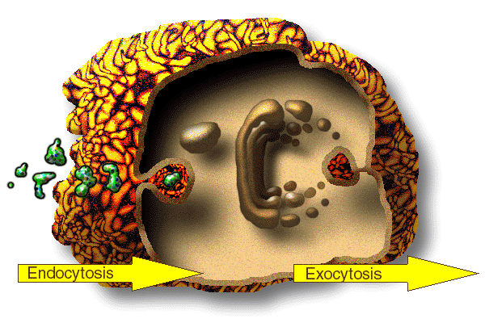  A vesicle is a small bubble enclosed by lipid bilayer. Vesicles can form naturally, for example, during the endocytosis, or they may be prepared. Artificially prepared vesicles are known as liposomes.  The membrane enclosing the vesicle is similar to that of the plasma membrane, and vesicles can fuse with the plasma membrane to release their contents outside of the cell. Vesicles can also fuse with other organelles within the cell.  Vesicles do many things. Because it is separated from the cytosol, the inside of the vesicle can be made to be different from the cytosolic environment. For this reason, vesicles are a basic tool used by the cell for organizing cellular substances. Vesicles are involved in metabolism, transport, buoyancy control, and enzyme storage. They can also act as chemical reaction chambers.  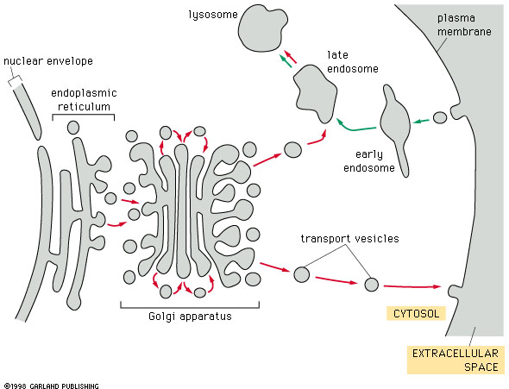  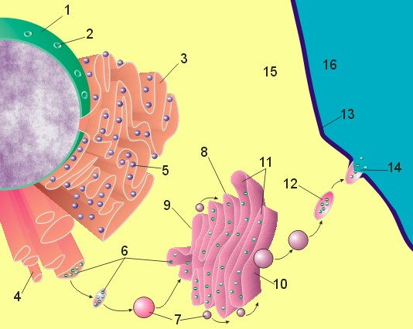  - Nuclear membrane  - Nuclear pore  - Rough endoplasmic reticulum (REM)  - Smooth endoplasmic reticulum  - Ribosome attached to REM  - Macromolecules  - Transport vesicles  - Golgi apparatus  - Cis face of Golgi apparatus  - Trans face of Golgi apparatus  - Cisternae of Golgi apparatus  - Secretory vesicle  - Cell membrane  - Fused secretory vesicle releasing contents  - Cell cytoplasm  - Extracellular environment
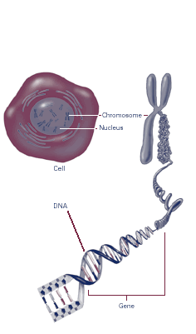
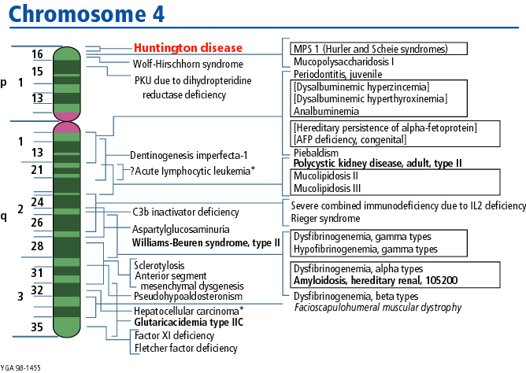
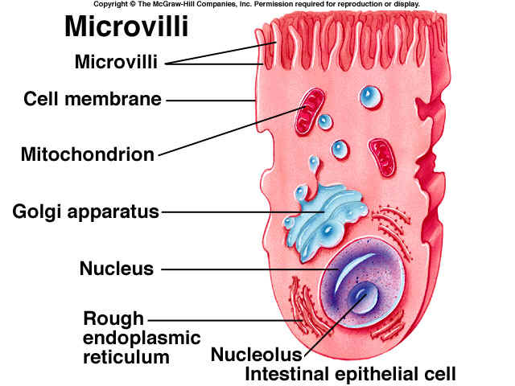
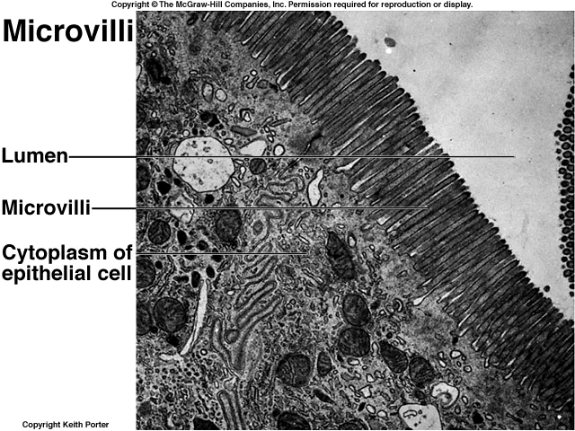
Microvilli

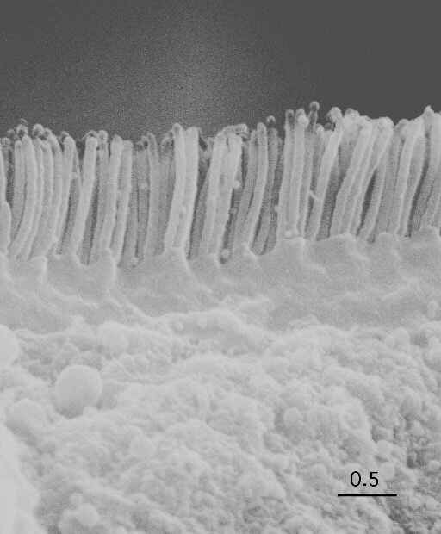
Microvilli
Microvilli are tiny hairlike folds in the plasma membrane that extend from the surface of many absorptive or secretory cells. They can act to increase the surface area. They are most clearly visible with an electron microscope but may be seen as a "brush border" with a light microscope.

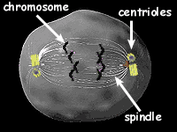
ANIMAL CELL CENTROSOME: The centrosome, also called the "microtubule organizing center", is an area in the cell where microtubles are produced. Within an animal cell centrosome there is a pair of small organelles, the centrioles, each made up of a ring of nine groups of microtubules. There are three fused microtubules in each group. The two centrioles are arranged such that one is perpendicular to the other.
