**The Story of Gout:**

Gout is caused initially by an excess of uric acid in the blood, or **hyperuricemia**. Uric acid is produced in the body during the breakdown of purines - chemical compounds that are found in high amounts in certain foods such as meat, poultry, and seafood. Normally, uric acid is dissolved in the blood and is excreted from the body in urine via the kidneys. If too much uric acid is produced, or not enough is excreted, it can build up and form needle-like crystals that trigger inflammation and pain in the joints and surrounding tissue.

* Gout is a form of arthritis caused by excess uric acid in the bloodstream.
* The symptoms of gout are due to the formation of uric acid crystals in the joints and the body's response to them.
* Gout most classically affects the joint in the base of the big toe.
* Gout attacks often occur without warning in the middle of the night.
* Most gout cases are treated with specific medications.

Medications can also be used to reduce the production of uric acid (xanthine oxidase inhibitors such as allopurinol).

**Allopurinol** is in a class of medications called xanthine oxidase inhibitors. It **works** by reducing the production of uric acid in the body. High levels of uric acid may cause **gout** attacks or kidney stones. **Allopurinol** is used to prevent **gout** attacks, not to treat them once they occur.

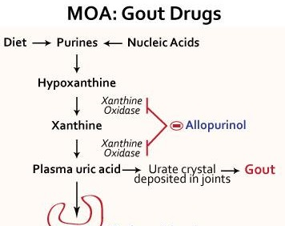

Guanine and Adenine are the two purine bases. They are nucleotides. **GMP** consists of the phosphate group, the pentose sugar ribose, and the nucleobase guanine; hence it is a ribonucleotide monophosphate. **Guanosine monophosphate.** The same is true for AMP.

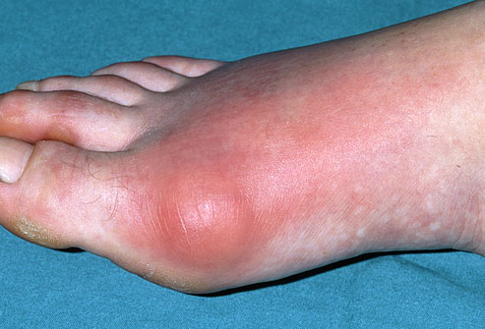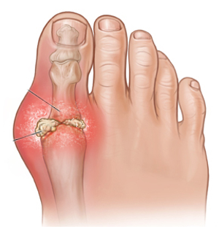

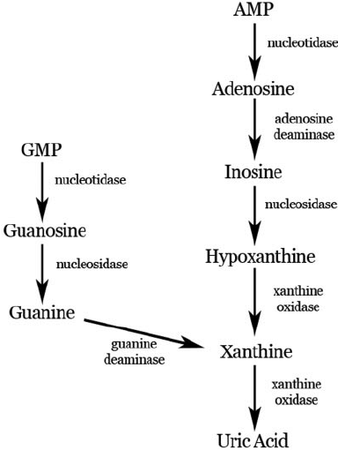

So in order to prevent the accumulation of uric acid in the blood, and also in the joints, allopurinol is given which inhibits the enzyme xanthine oxidase from converting hypoxanthine into xanthine as well as converting xanthine into uric acid. So in the breakdown pathway of both purines, they are left as Xanthine and Hypoxanthine. The hypoxanthine never causes crystal formation or gout. Hypoxanthine is filtered and eliminated by the kidneys.

There are two kinds of pathways in the biosynthesis of nucleotides: *de novo* and *salvage*.

*De novo* synthesis refers to the synthesis of complex molecules from simple molecules such as [sugars](https://en.wikipedia.org/wiki/Sugar) or [amino acids](https://en.wikipedia.org/wiki/Amino_acid), as opposed to recycling after partial degradation. *De novo* is a [Latin phrase](https://en.wikipedia.org/wiki/Latin_phrase), literally translating to "from the new", but implying "anew", "from scratch", or "from the beginning." *De novo* pathways of [nucleotides](https://en.wikipedia.org/wiki/Nucleotide) do not use free bases: [adenine](https://en.wikipedia.org/wiki/Adenine), [guanine](https://en.wikipedia.org/wiki/Guanine) (G), [cytosine](https://en.wikipedia.org/wiki/Cytosine) (C), [thymine](https://en.wikipedia.org/wiki/Thymine) (T), or [uracil](https://en.wikipedia.org/wiki/Uracil) (U). The [purine](https://en.wikipedia.org/wiki/Purine) and pyrimidine rings are built up one atom or a few atoms at a time and attached to [ribose](https://en.wikipedia.org/wiki/Ribose) throughout the process.

In the salvage pathway, bases are preformed, recovered, and reconnected to a ribose.  Salvage pathways are used to recover bases and nucleosides that are formed during degradation of RNA and DNA.

