The Thyroid and associated hormones.

So recall:

The **pituitary gland** is divided into the posterior portion (**posterior pituitary or neurohypophysis)** that is derived from the nervous tissue of the hypothalamus extending down through the infundibulum and into the anterior portion (**anterior pituitary or adenohypophysis)** that is derived from epithelial cells. The anterior pituitary gland, the adenohypophysis, releases Thyroid Stimulating Hormone (**TSH**) into the blood which stimulates the thyroid gland itself to manufacture and release its two hormones: **T3** and **T4**. Also remember that one interesting thing about T3 and T4 is that both use iodine in their structure: T3 has 3 iodines and T4 has 4 iodines.

Recall that the thyroid gland is beautiful underneath the microscope with the big, round, pink pools of colloid filling the center of a thyroid follicle. The colloid is non-cellular. It is a pool of iodine and other material used to make T3 and T4. A confusing fact is that the other name for **T4** is **thyroxine**.

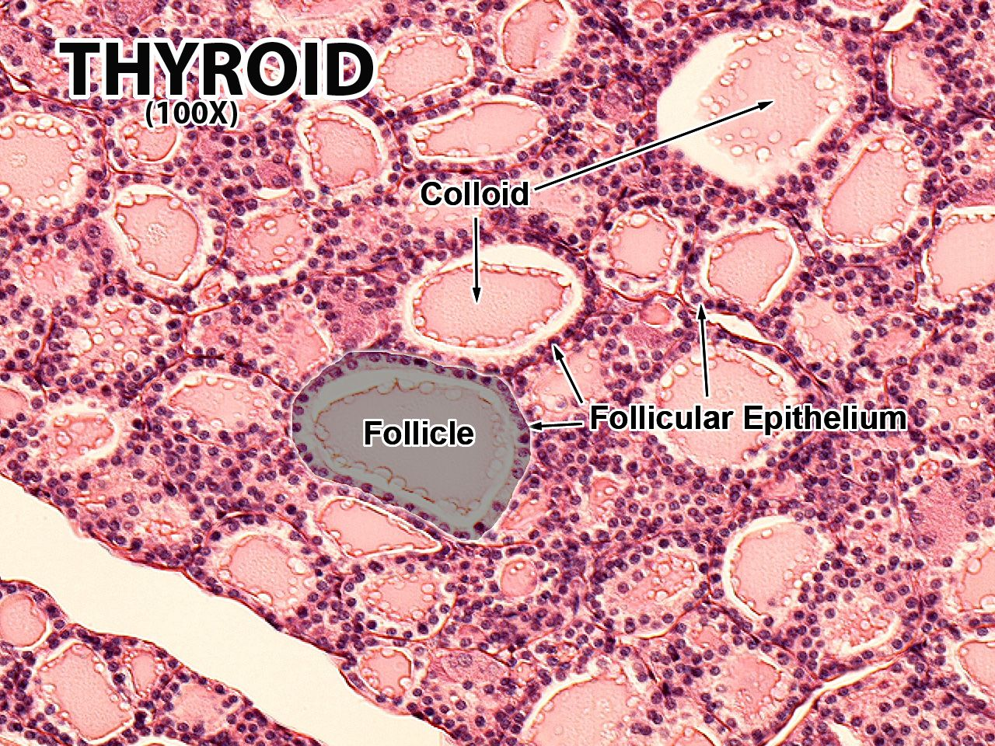

[Not part of this discussion is the fact that outside and in between the follicular cells are the parafollicular cells that release calcitonin. So the thyroid gland actually releases three hormones.]

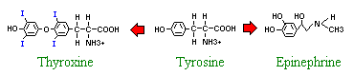

Thyroid hormones are derivatives of the amino acid **tyrosine** bound covalently to iodine. The two principal thyroid hormones are:

* **thyroxine** (also known as T4 or L-3,5,3',5'-tetraiodothyronine)
* **triiodothyronine** (T3 or L-3,5,3'-triiodothyronine)

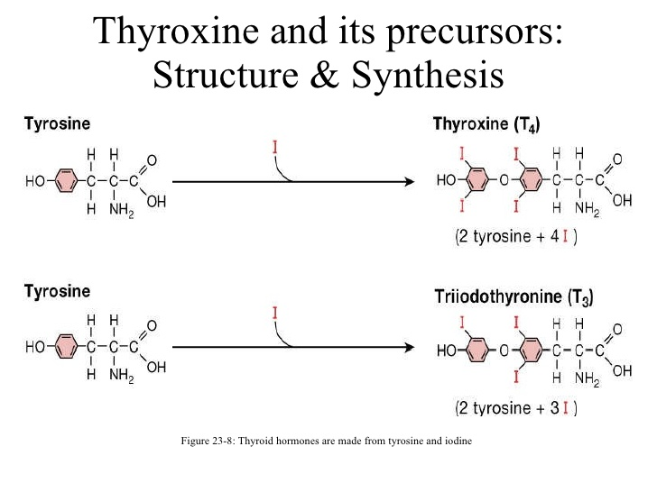

[You chemistry fans will want to eventually correct me so I’ll talk about it now. Iodide vs. Iodine (I-Oh-Dyed vs. I-Oh-Dyne).***Iodine*** is the element found on the periodic table. ***Iodide*** is the ion form of iodine, occurring when iodine bonds with another element, such as potassium. Dietary iodine also occurs naturally as an iodide, such as potassium iodide or sodium iodide.]

A little bit of foreshadowing here, T3 and T4 enter their target cells just as a steroid hormone would to bind to its receptor inside its target cell. But notice that T3 and T4 are not derived from cholesterol like the steroid hormones are.

As shown in the following diagram, the thyroid hormones are basically two tyrosines linked together with the critical addition of iodine at three or four positions on the aromatic rings. The number and position of the iodines is important. Several other iodinated molecules are generated that have little or no biological activity; socalled "reverse T3" is such an example.

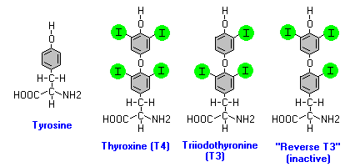

A large majority of the thyroid hormone secreted from the thyroid gland is T4, but T3 is the considerably more active hormone. Although some T3 is also secreted, the bulk of the T3 is derived by deiodination of T4 in peripheral tissues, especially liver and kidney. Deiodination of T4 also yields reverse T3, a molecule with no known metabolic activity. Since T4 (thyroxine) is used to make T3, T4 can be referred to as the prohormone to T3.

Confusing? Yes!

Thyroid hormones are poorly soluble in water, and more than 99% of the T3 and T4 circulating in blood is bound to carrier proteins. The principle carrier of thyroid hormones is ***thyroxine-binding globulin***, a glycoprotein synthesized in the liver. Two other carriers are transthyretin and albumin. You do not need to remember transthyretin, but do remember that albumin acts to transport T3 and T4 while in the blood. Carrier proteins allow maintenance of a stable pool of thyroid hormones from which the active, free hormones are released for uptake by target cells.

In review, the functional unit of the thyroid gland is the follicle, which is composed of epithelial cells arranged as hollow vesicles of various shapes. Chemically, thyroid hormones are α-amino acid derivatives of tyrosine and include thyroxine and triiodothyronine. Thyroxine contains four atoms of iodine and is abbreviated as T4; triiodothyronine, which has three atoms of iodine, is abbreviated as T3. Thyroxine, the major secretory product, is not the biologically active form of the hormone; however, it must be transformed to T3 at extrathyroidal sites.

Now in order to make or to undergo biosynthesis of T3 and T4 within a follicular cell the tyrosines that are going to have iodine added to them (iodinated) are bound and transported from within the follicular cells to the colloid and back into the follicular cell attached to thyroglobulin. **Thyroglobulin** (Tg) acts as a substrate for the synthesis of the thyroid hormones thyroxine (T4) and triiodothyronine (T3), as well as the storage of the inactive forms of thyroid hormone and iodine within the follicular lumen of a thyroid follicle. T3 and T4 are attached to thyroglobulin and this complex is moved around inside the follicular cell in order to add iodines and synthesize T3 and T4.

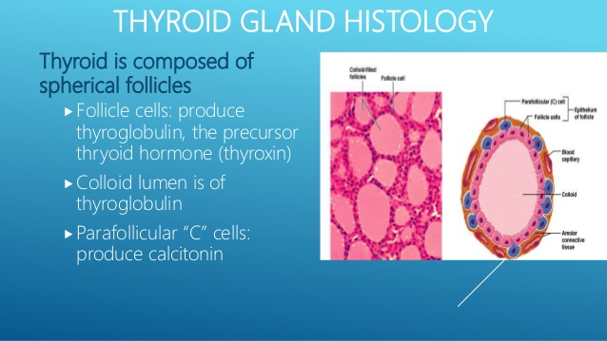

Many anatomy textbook will label the ‘colloid’ as ‘thyroglobulin’.

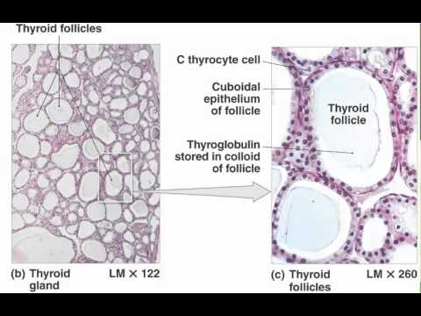

Colloid is the pink-staining, non-cellular material found inside the thyroid follicle. The thyroglobulin is a molecule used in the process of making T4 and T3.

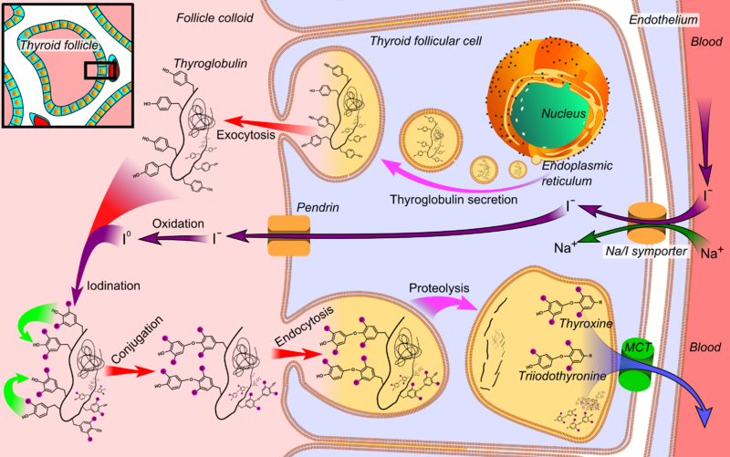

As you can see from the diagram above, iodine is transported out of the blood, through the follicular cell into the center of the follicle to become part of the mixture of molecules and atoms within what is called the colloid. The follicular cell produces thyroglobulin and transports it out of the follicular cell into the colloid. It acts as a molecular backbone for the synthesis of T3 and T4. The tyrosines are attached to thyroglobulin and from there the iodines are attached to the tyrosines. Once construction of T3 and T4 is complete, this entire compilation of thyroglobulin with attached T3 and T4 is transported back into the follicular cell where the T3 and T4 are removed from thyroglobulin and then the T3 and T4 can be released out of the follicular cell into the blood. It can vary a lot but generally what is released into the blood would be around 80% T4 to 20% T3. Remember T4 is inactive and has to be activated into the active T3 in target cells.

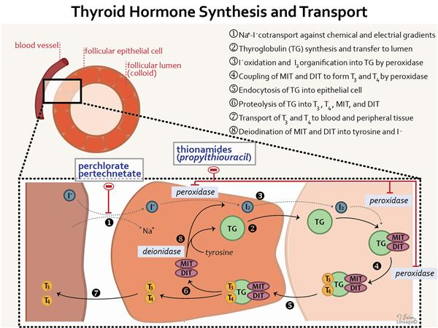

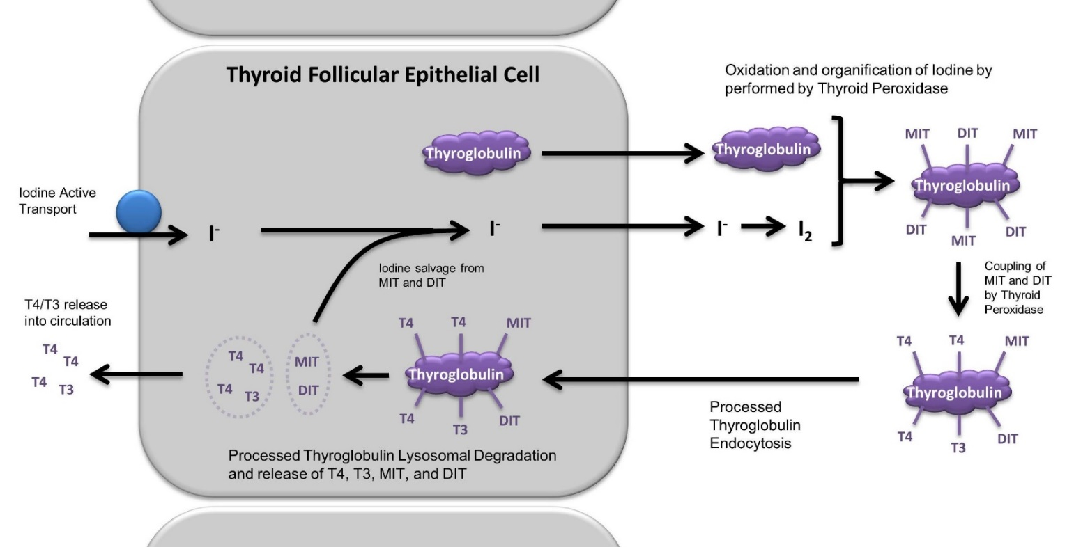

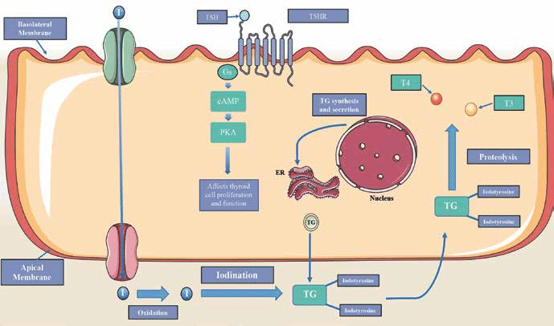

Now what happens to T3 and T4? They are ‘special’. They, as you now know, are not derived from cholesterol but they do enter their target cells and bind to their receptors within their target cells just like a steroid hormone would. **T4** must be **converted to T3** before the body can use it. Most of this **conversion** happens in the liver, but also takes place in cells of the heart, muscle, gut, and nerves. These cells **convert T4** to **T3** with an enzyme called tetraidothyronine 5' deiodinase, which removes one molecule of iodine.

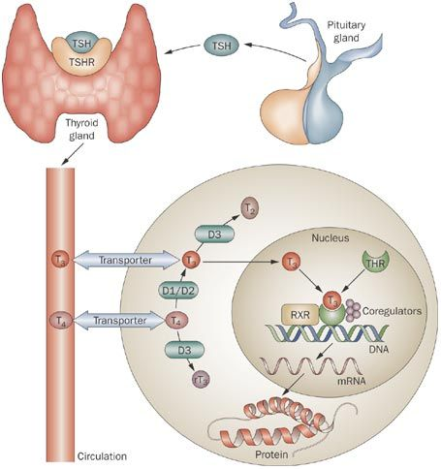

In fact, T3 binds to its receptor directly on the DNA.   
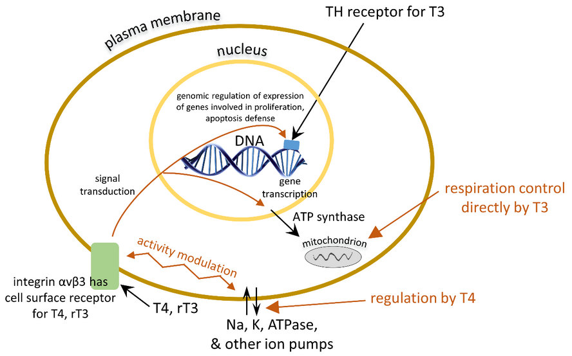

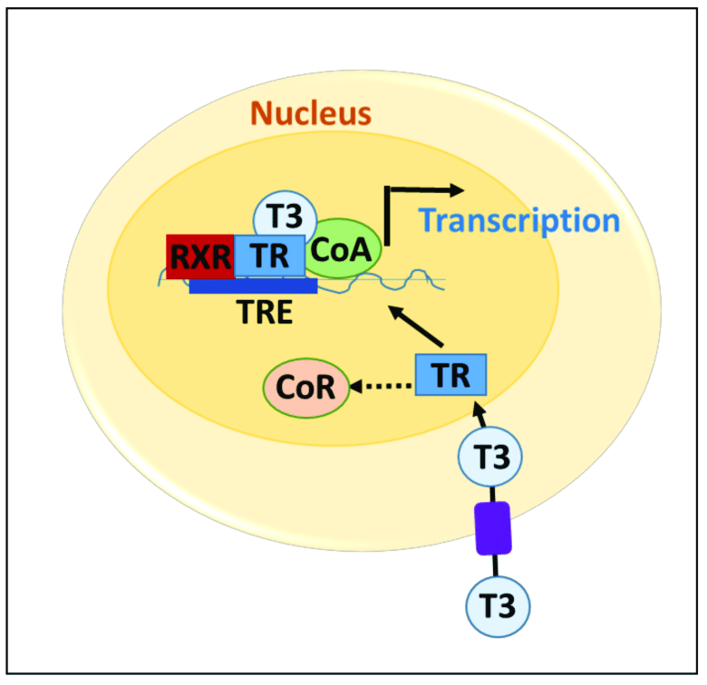

The physiological effects of thyroid hormones include growth and maturation of skeletal system, central and autonomic nervous systems, and cardiovascular system. The thyroid gland exerts profound effects on oxidative, carbohydrate, and lipid metabolism in humans. The principal regulator of thyroid function is the thyroid-stimulating hormone (TSH), which is secreted by thyrotropes in the pituitary gland; however, maintaining constant levels of thyroid hormones in blood depends upon negative feedback effects of T4 and T3, which inhibit synthesis and secretion of TSH. Evidence indicates that T3 and T4 produce the majority of their actions through nuclear receptors, but detailed understanding require further research.

One last thing. The very beginning step. How does the brain tell the adenohypophysis to release TSH? That as you already know is carried out by a ‘releasing factor’ or ‘releasing hormone’ that is deposited into the hypophyseal portal veins that travel directly from the hypothalamus to the anterior pituitary gland. See the diagram below to show all the steps.

