**Tumor Suppressor Genes AND MORE**

Tumor suppressor genes. What are they?

**“Tumor suppressor genes** are normal **genes** that slow down cell division. When **tumor suppressor genes** don't work properly, cells can grow out of control, which can lead to cancer. If a cell is not actively dividing (actively in the cell cycle), it is said then to be in G0 (G-zero). In order for a cell to not be dividing there must be a gene transcribing and translating a protein that binds to and prevents the proteins that would signal the cell to divide.

To have a cell actively in the cell cycle there must be proteins being produced inside that dividing cell telling it to divide, orchestrating the division. To stop the cell cycle, a gene must be active to produce a protein that will bind to the master protein in the dividing cell blocking that master protein that is turning on division. The gene that encodes this protein that binds and blocks the protein that turns on cell division (the cell cycle) is called a ‘tumor suppressor gene’. And the protein product of a tumor suppressor gene will bind to the master protein that is being produced telling the cell to divide. The tumor suppressor gene is a normal gene coding for a normal protein that when present stops the cell from dividing (being in the cell cycle). If you wanted to leave G0 and enter the cell cycle (the cell makes that decision to start dividing, say from a hormonal signal), you would find that the tumor suppressor gene would shut off and no longer make the protein that binds and blocks the proteins that run division and so the proteins that activate mitosis now operate unopposed. The tumor suppressor gene is turned off, the protein produce from the tumor suppressor gene is no longer around and so no blockage of the proteins that signal cell division and so cell division commences. That is how it is supposed to work under normal, healthy circumstances. But image if a cell is normally in G0, it is not supposed to be dividing and now there were to appear a mutation in that tumor suppressor gene. If it normally is in G0, it is not in the cell cycle and is not dividing because the tumor suppressor gene is on making the protein that stops divisions. But as I just explained, this tumor suppressor gene is mutated and is no longer making the ‘blocking-division’ protein. Would this cell them begin to divide when it is not supposed to? Well, yes and no. Logically you would say that without the protein product from the tumor suppressor gene to block the proteins that orchestrate divisions, the cell would begin to divide, and probably in a non-normal, unregulated way. But remember that all of your chromosomes and genes are paired. So if one of the chromosome’s tumor suppressor gene is mutated and does not produce the ‘blocking-division’ protein, there is still the other chromosome’s tumor suppressor gene that has not been mutated and so there still is ‘blocking-division’ protein being produced from the non-mutated gene. Yes, there is less of the ‘blocking-division’ protein since only one of the two genes is working, but that would still be enough to block divisions and the cell would be the way is it supposed to be, not dividing, in G0.

If you were unlucky enough to get a second mutation in that other tumor suppressor gene, to get a mutation in the ‘healthy’ gene on the unmutated chromosome, then there would be no ‘blocking-division’ protein available and even though the cell is supposed to be in G0, not dividing, you’ve lost the ‘blocking-division’ protein and so the cell would begin to divide possibly becoming cancerous! It takes two mutation is both copies of this tumor suppressor gene to turn a non-dividing cell into a mutated dividing cell. Two mutation…..Two Hits.

If you were born with the one tumor suppressor gene already mutated, then all you would need is the unlucky chance of getting the ‘healthy’ gene mutated sometime in your life. Familial. Inherited. Only need to obtain ‘one hit’ since you started out life with ‘a hit’, you inherited from your genetic mom or dad a mutation in a tumor suppressor gene.

If you were born with both tumor suppressor genes healthy, neither one mutated, then you would need the super unlucky chance of getting a mutation in both copies of these tumor suppressor genes. It would be classified as ‘sporadic’.

I’m still unclear, can you give me an example?

**Two-hit hypothesis**

The **Knudson hypothesis**, also known as the **two-hit hypothesis**, is the [hypothesis](https://en.wikipedia.org/wiki/Hypothesis) that most [tumor suppressor genes](https://en.wikipedia.org/wiki/Tumor_suppressor_genes) require both genes on both chromosomes to be inactivated through [mutations](https://en.wikipedia.org/wiki/Mutation) to cause uncontrolled cellular growth (cancer). It was first formulated by [Alfred G. Knudson](https://en.wikipedia.org/wiki/Alfred_G._Knudson) in 1971 and led indirectly to the identification of cancer-related [genes](https://en.wikipedia.org/wiki/Gene).

Knudson performed a statistical analysis on cases of [retinoblastoma](https://en.wikipedia.org/wiki/Retinoblastoma), a [tumor](https://en.wikipedia.org/wiki/Tumor) of the [retina](https://en.wikipedia.org/wiki/Retina) that occurs both as an inherited disease and sporadically. He noted that inherited retinoblastoma occurs at a younger age than the sporadic disease. In addition, the children with inherited retinoblastoma often developed the tumor in both eyes, suggesting an underlying predisposition.

Knudson suggested that two "hits" to DNA were necessary to cause the cancer. In the children with inherited retinoblastoma, the first mutation in what later came to be identified as the [RB1](https://en.wikipedia.org/wiki/RB1) gene, was inherited on one chromosome. The second mutation on the other chromosome was acquired. In non-inherited retinoblastoma, two mutations, or "hits", had to take place before a tumor could develop, explaining the later onset.

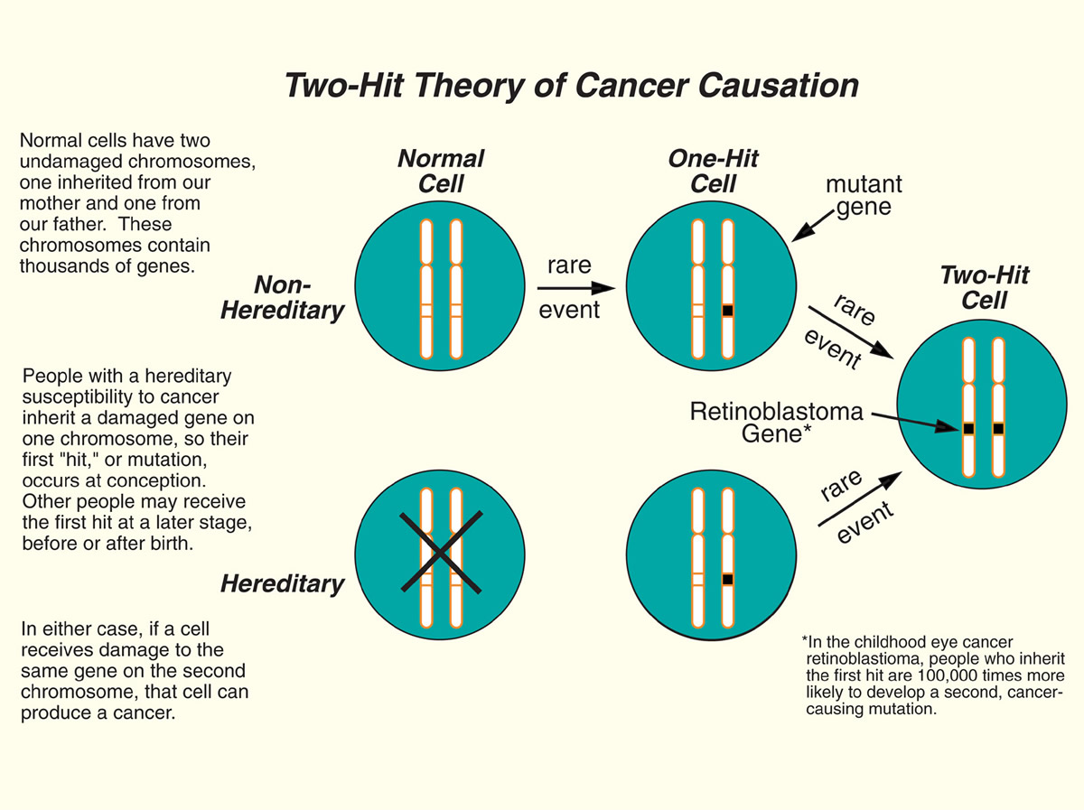

<https://youtu.be/h_sfOYFJTfU>

or

<https://www.youtube.com/watch?v=h_sfOYFJTfU&feature=youtu.be>

The ‘two-hit model’ for cancer, nicely explained:

<https://www.youtube.com/watch?v=LIgAmsG_P_w>

Going ‘hand-in-hand’ with the tumor suppressor genes are the **oncogenes**. An **oncogene** is a mutated gene that contributes to the development of a cancer. In their normal, unmutated state, oncogenes are called proto-**oncogenes**. Now that’s confusing. As we were just talking about, the tumor suppressor genes code for a protein that binds to and blocks the protein that turns on division (entering the cell cycle from G0). So what is that protein that turns on and orchestrates cell division? Where does that ‘master-of-division’ protein come from, what is its gene?

So let me get this straight. In order for a non-dividing cell to start to divide, to enter the cell cycle, there is a certain gene that transcribes and translates a protein and when that protein is present inside the cell it triggers cell division? There is a ‘master gene’ that when the protein produce of that gene is made inside the cell, that protein turns on division. That protein was first discovered by looking at cancer cells, cells that were dividing when they were not supposed to. Looking in cancer cells researchers found that ‘master-of-division’ protein having been made when it was not supposed to be there. So researchers look at the gene for this protein that triggers division and in a huge set of discoveries that gene was mutated. Cancer causing mutations were first found! And the genes that contained these mutations instantly became famous. The genes were called ‘oncogenes’.

An oncogene is a mutated version of the gene for the ‘master-of-division’ protein. Soon afterward the normal, unmutated version of the oncogenes were found and sequenced. The unmutated, ‘normal’, version of these cancer causing, mutation-containing oncogenes are called ‘proto-oncogenes’. The ‘normal’ gene is the proto-oncogene. It is certainly worth studying since it makes the normal ‘master-of-division’ protein and this proto-oncogene is turned on when the cell wants to ‘normally’ enter into the cell cycle and start dividing. But now image a mutation in the proto-oncogene and it is not on when it is not supposed to be and the ‘master-of-division’ protein is now being made. This would cause the cell to divide and most likely in an unregulated way. Cancer.

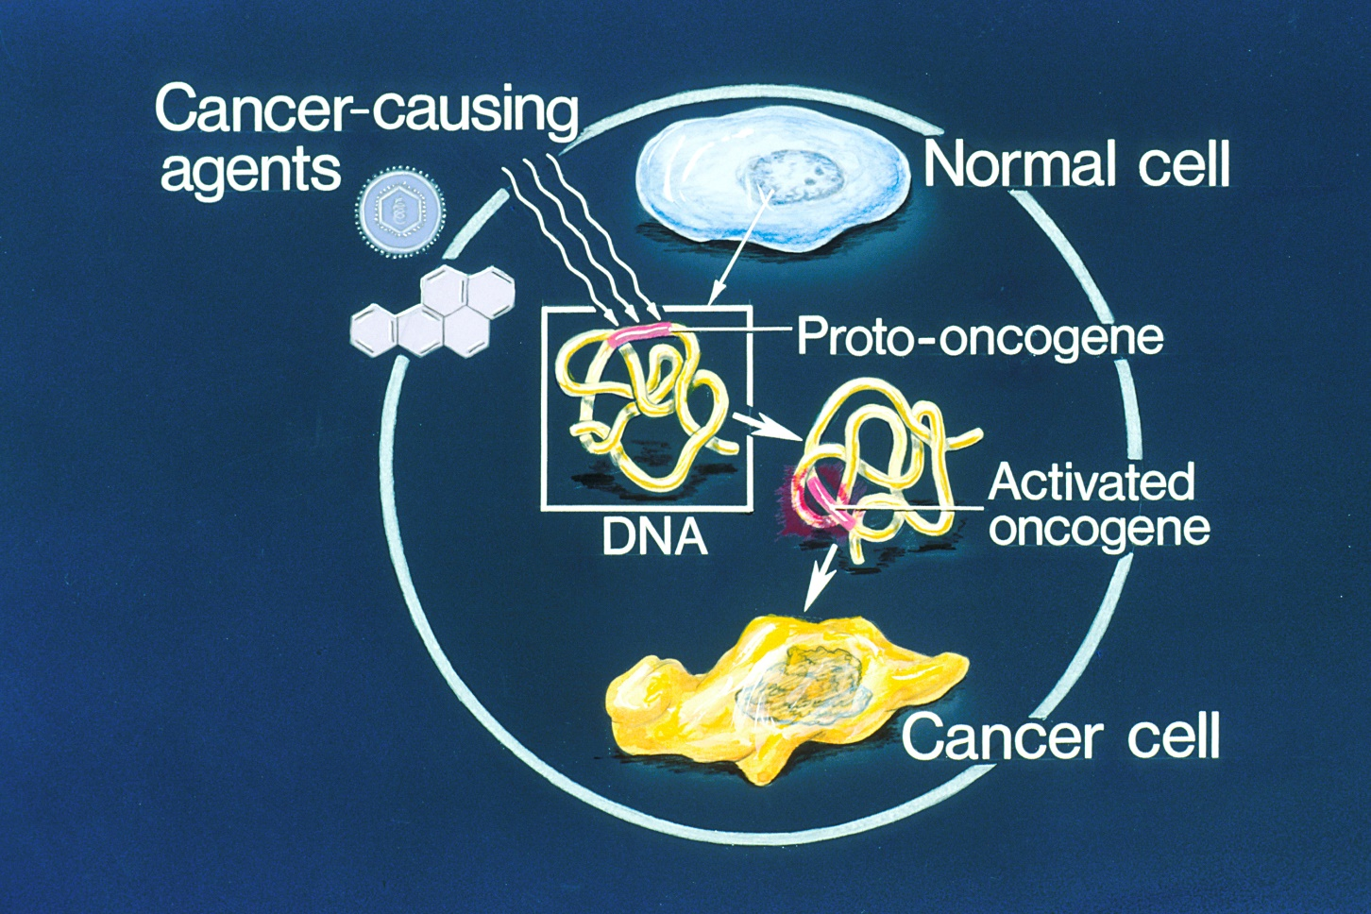

In the below diagram, the top shows the proto-oncogene.

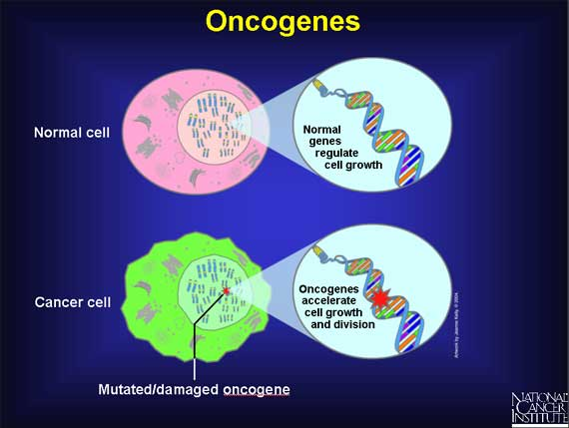

In the diagram below I would replace the word ‘activation’ with ‘mutated’:

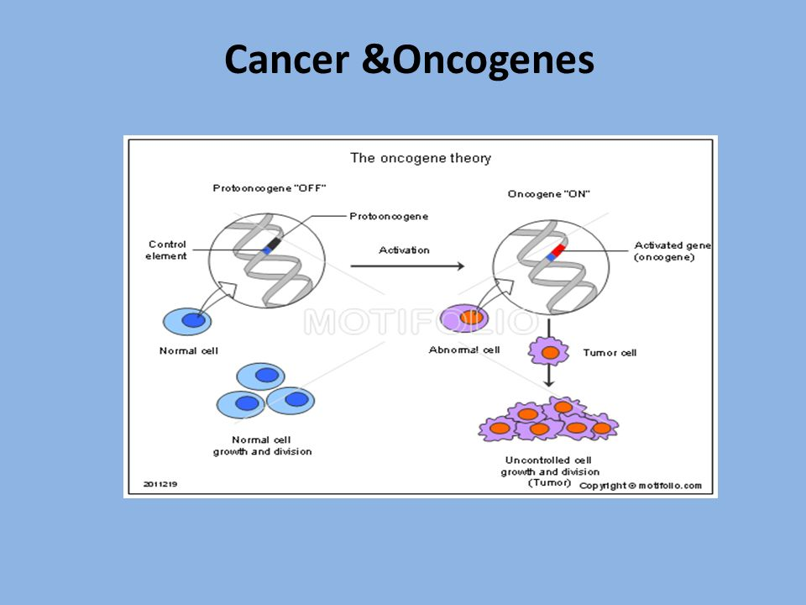

 In the early 1980s, John Michael Bishop and Harold Varmus discovered the very first human oncogene: c-Src. During his extensive research, Bishop not only studied oncogenes, but also their predecessors, the so called proto-oncogenes. In Bishop’s own words: “Src is a wayward version of a normal cellular gene (which we would now call a proto-oncogene) and converted to a cancer gene by mutation.”

Do I need both copies of the proto-oncogene to be mutated? No since only one mutated proto-oncogene that is now an oncogene will make the ‘master-of-division’ protein and that’s all the cell needs to begin divisions.

Let’s combine the two: tumor suppressor genes and oncogenes.

How to convert (transform) a non-dividing cell into an ‘out-of-control’ growing cancer cell?

Two things have to happen. Since it is not dividing, two things are in place. The proto-oncogene is ‘off’. The tumor suppressor gene in ‘on’, making the protein that would block the protein that would turn on division. But since the proto-oncogene is ‘off’, that protein is not being made anyway.

So to now move to an ‘out-of-control’ dividing state:

1. The tumor suppressor gene must be mutated on both chromosomes (two-hits) so that this blocking protein is no longer around;
2. The proto-oncogene is mutated into an oncogene and is turning on the production of the ‘master-of-division’ protein when it is not supposed to be there.

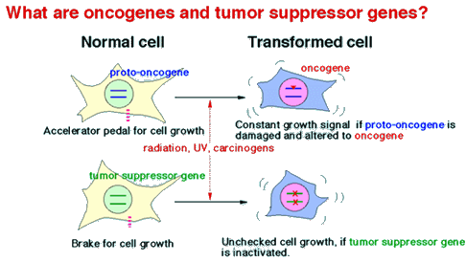

For transformation into a cancer cell you need to lose both brakes and keep the accelerator on:  
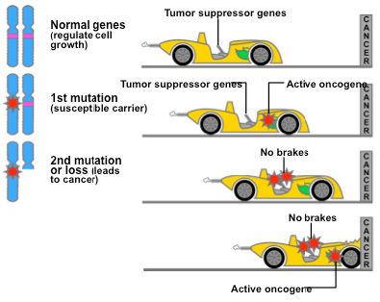

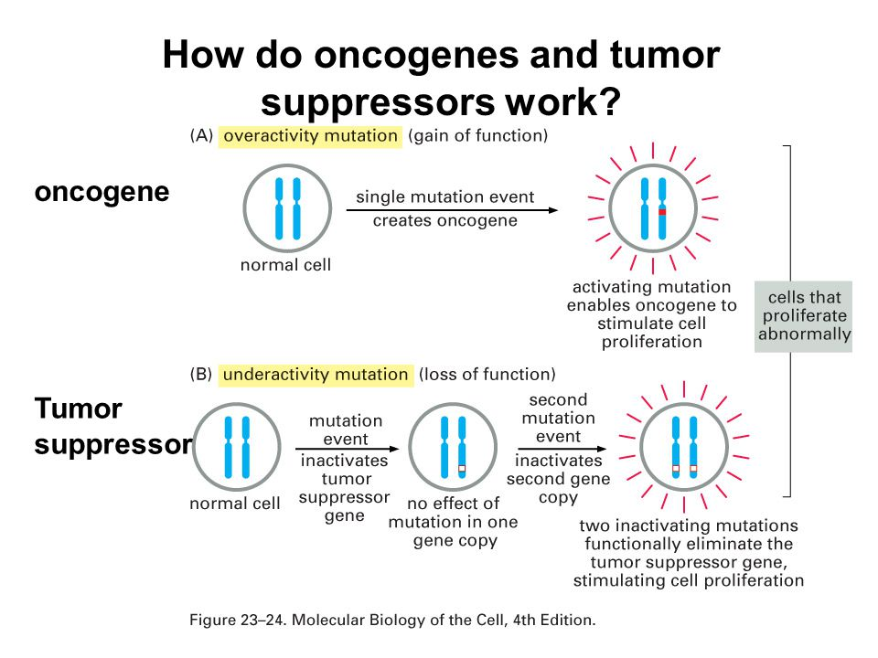

Now go ahead and do some research yourself and tell me the:

top 3 most famous tumor suppressor genes and top 3 most famous oncogenes.

But how does a ‘cancer’ cell ever survive? It has to mutate the specific gene to allow it to make an enzyme that can digest through the basement membrane if it is an epithelial cell tumor. It has to have a mutation in just the right gene to allow it to move. It has to have just the right mutation in just the right gene to survive away from other epithelial cells. It has to have just the right mutation in just the right gene to allow it to enter a blood vessel (or lymphatic vessel). It has to have just the right mutation in just the right gene to allow it to survive in the blood and escape the immune cells there. It has to have just the right mutation in just the right gene to allow it to leave the blood vessel. It has to have just the right mutation in just the right gene to allow it to survive in a foreign tissue (bone marrow, brain, liver). It has to have a mutation in the gene that will allow it to release chemicals that attract blood vessel growth so it can grow.