Can you now list the hormones that are made from cholesterol? The ‘steroid’ hormones?
Yes I Can!
There is testosterone, and estrogen (who’s chemical name is actually estradiol), and progesterone, and ….. ????
I can’t seem to remember the other two. Can you show me that famous chart that shows the biochemical pathways used to synthesize those hormones derived from cholesterol please.
OK, here you go. There are many versions of this chart out there but this one seems easy to read.
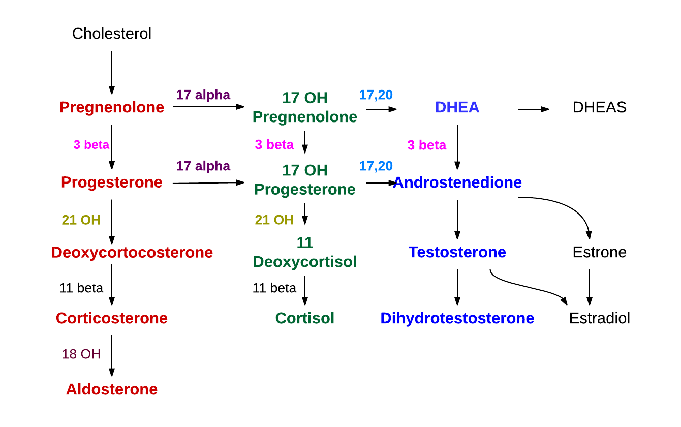
Ah, the last two are Aldosterone and Cortisol. And yes, I remember….Aldosterone is from the Adrenal Cortex, specifically the Zona Glomerulosa and Cortisol is also from the Adrenal Cortex, specifically the Zona fasciculata.
And yes, what stimulates the Zona Fasciculata to release Cortisol is ACTH from Anterior Pituitary gland.
But RATS, I can’t remember what that pathway (the books and the interwebs call it an Axis, that’s weird) is called.
Can you help me out again?
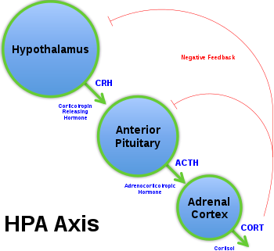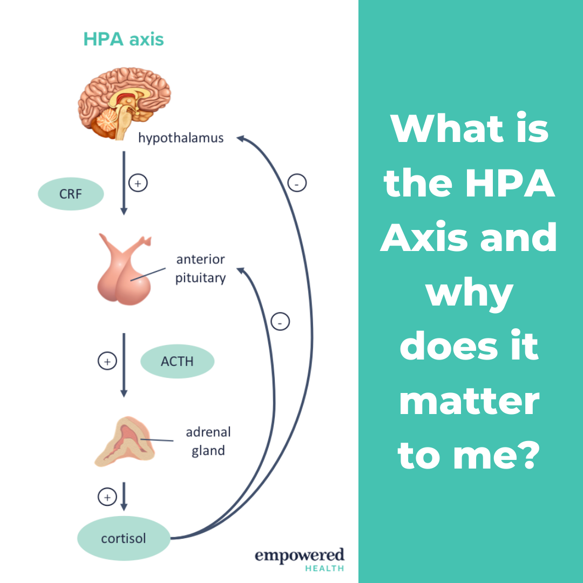
Why was it hard to remember? “H” is for ‘hypothalamus’. “P” is for ‘pituitary gland’ (anterior pituitary to be more precise). “A” is for Adrenal Cortex (Zona Fasciculata to be more precise). HPA. The one thing that is hard to remember is CRH: corticotropin releasing hormone. The way to remember that is to remember what is the final step in all of this: the release of cortisol, hence corticotropin releasing hormone. The “ACTH’ part is easy since it is probably easier to remember the full name of ACTH since its name says it all: Adren-o-cortic-o-tropic hormone….it goes to the adrenal cortex and is stimulatory.
Let me mention this about that. It is called an ‘axis’ since it loops back on itself with the negative feedback signaling.
OK, so where were we? Ah yes, the steroid hormones, the hormones that come from cholesterol. Yes, I can name them all now.
So you are now able to name all the hormones derived from cholesterol found in that famous chart. Now let me introduce you to one more hormone the body uses that is chemically, structurally, derived from cholesterol. That hormone is Vitamin D. You know of it, it is the famous ‘vitamin’ that you get from sunlight. People who don’t get enough sunlight lack Vitamin D and have problems all over the place:
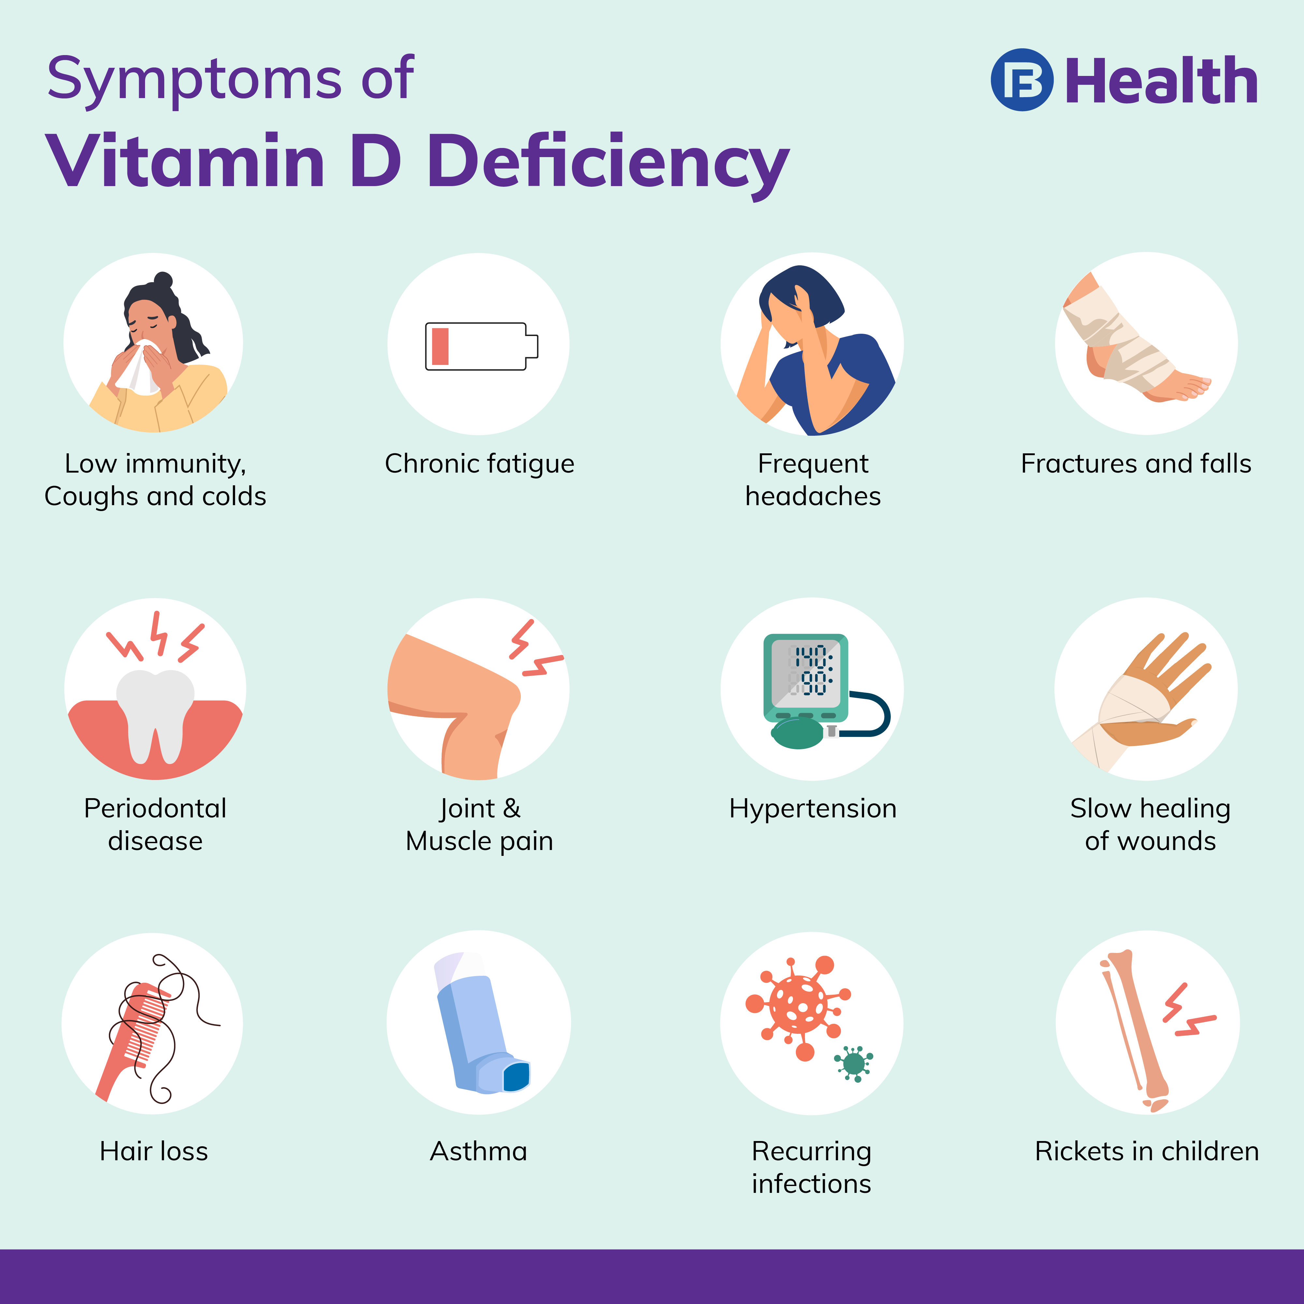
You are not responsible for learning all the symptoms of having a Vitamin D deficiency, but just realize that Vitamin D has an effect on a lot of various organs of the body. There must be lots of cells in the body that possess the Vitamin D receptor.
Hold on now, which is it? Is Vitamin D a ‘vitamin’ or a ‘hormone’? It is after all called ‘vitamin D’, not hormone-D.
Well, Vitamin D is a hormone. It travels in the blood, enters cells like a steroid hormone does and binds to specific receptors called, by the way, Vitamin D Receptors. As you see later on in this lesson, Vitamin D is synthesized from cholesterol. Well, technically not cholesterol but the molecule right before cholesterol if you were looking at the synthesis of cholesterol: 7-dehydrocholesterol. See it at the bottom, right before cholesterol. So Vitamin D should be grouped with the other steroid hormones that are derived from cholesterol.

Don’t panic, again you are not responsible for knowing the cholesterol synthesis pathway, but do notice HMG-CoA Reductase is involved in the synthesis of cholesterol.
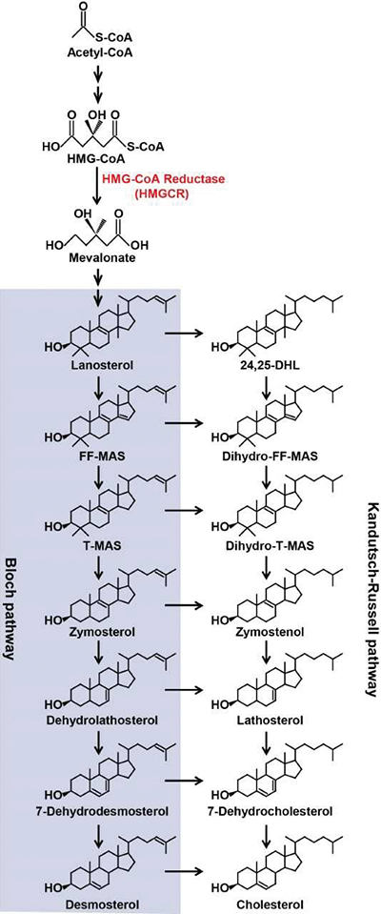
Remember that Statins inhibit HMG-CoA Reductase? So if you inhibit HMG-CoA Reductase, you lower the amount of cholesterol and thereby lower the amount of all these cholesterol hormones derived from cholesterol.
Well, this is an instructive moment. Would taking a Statin lower Vitamin D levels in your blood? Would taking a Statin lower testosterone levels? Would taking a Statin lower estrogen levels?
It is unclear from the studies. It gets complicated. There are different Statins and some may or may not lower these steroid hormones levels. In fact there is some evidence that some steroid hormone levels rise as a result of certain Statins. When one starts trying to follow hormone pathways and actions in the body, it gets very tangled and hard to predict very quickly.
OK, let’s get back to Vitamin D, the HORMONE called Vitamin-D. Why do you need sunlight to have enough Vitamin-D?
Well, this is why when you mention Vitamin-D it quickly becomes messy. Imagine this…..in your skin is a molecule, an inactive molecule that when sunlight strikes this molecule it is converted into another molecule and this new molecule is called Vitamin-D3.
BUT, this molecule called Vitamin-D3 is not active. We are not done yet even though this molecule is called Vitamin-D3.
There are two more steps, one in the liver and one in the kidney. Two more chemical conversions until you have the molecule that actually does something in the body. This final molecule is the ‘biologically active’ molecule. This final molecule will bind to the Vitamin-D-receptors found in the target cells.
So there are multiple steps to form the ‘biologically active’ molecule that we consider Vitamin-D. Let’s take it from the top: Inactive molecule “A” resides in your skin→ sunlight strikes it→it is converted into inactive molecule “B” which can enter the blood→as molecule “B” passes through the liver it is converted into inactive molecule “C”→ this inactive molecule “C” passes into the kidney and the kidney has an enzyme that can convert it finally into the active molecule “D”. Whew. Is the final molecule “D” called Vitamin-D? Cute coincidence, using four molecules named A, B, C and D and ending up with biologically active Vitamin-D.
I’m afraid you explained it using molecules named A, B, C, and D because each one has a long, complicated chemical name. Am I right?
Yes you are. And it only gets worse. Since these molecules I’m about to introduce you to, molecules A, B, C and D have long, complicated chemical names, they also have shorter easier names. But what that means is that each of these molecules has TWO names, the complicated one and the easy one. That actually doesn’t help, just makes it harder.
OK, Paul. I’m afraid. All I have to say is that I trust you. Be there for me, help me out of this jam.
So here goes, take a look below:
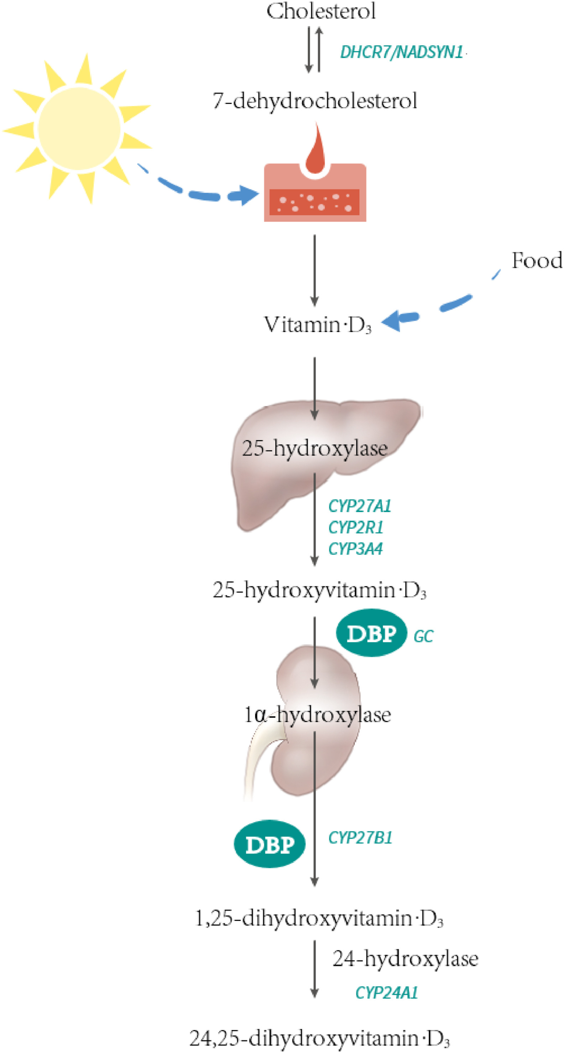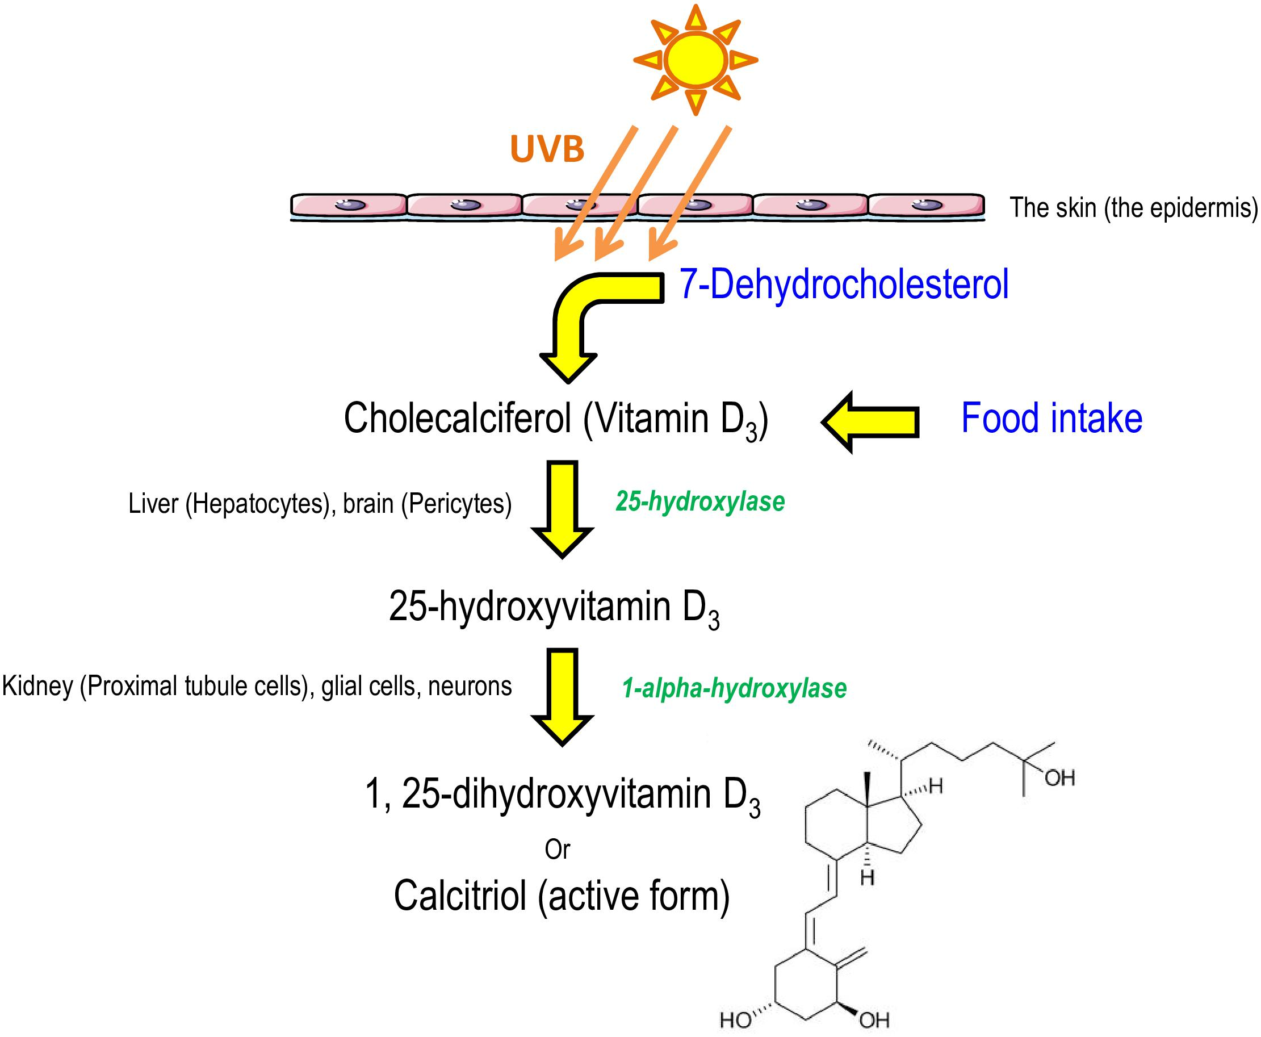

Let’s take is slow. First of all, if you scroll back up to the cholesterol synthesis diagram, you’ll see the molecule right before you get cholesterol is the “7-dehydrocholesterol”. That is the same molecule that you have in your skin right now waiting to be hit with sunlight of the correct wavelength. That’s why we can group Vitamin-D in with the other steroid hormones that are made using cholesterol as a backbone. This is the molecule “A” in my earlier explanation.
OK, so far so good. Inactive molecule “A” (7-dehydrocholesterol) is converted by sunlight into inactive molecule “B” which according to the diagrams is called “cholecalciferol”. Remember I mentioned that they also have an ‘easy name’. That easy name for cholecalciferol is to call it Vitamin-D3. Confusing since this Vitamin D-3 is inactive.
Now consider this my friend….for those people who don’t get enough sunlight they need to take a pill, a supplement. A ‘Vitamin-D’ pill. That Vitamin-D pill contains cholecalciferol or Vitamin-D3, bypassing the sunlight step. Ah ha, I see.
Certain foods are high in Vitamin-D they say. Well, these certain foods contain Vitamin D3 or cholecalciferol. Can you name any? You see in the diagrams above how ‘food’ is included in the pathway.
Remember that I said that molecule “B” was then converted into inactive molecule “C” when molecule “B” passes through the liver. Well, after cholecalciferol passes through the liver it is converted into 25-hydroxycholecalciferol. Supposedly the easy name for this molecule is 25-hydroxy-vitamin-D3. The one diagram even shows you the name of the enzyme that does this conversion in the liver. I trust you recognize the small image of the liver in the diagram above.
And now to the final step, the conversion of molecule “C” into molecule “D” in the kidney. So that must mean that 25-hydroxycholecalciferol or 25-hydroxy-vitamin-D-3 in the kidney is converted into the BIOLOGICALLY ACTIVE molecule called 1,25-dihydroxycholecalciferol or 1,25-dihydroxy-vitamin-D3. Now hang on, since this is finally the active molecule that actually does something in the body, namely binding to the ‘Vitamin-D-Receptor’, this final, active molecule has a simple, easy name…it is called “Calcitriol”.
I’ll give you a minute to go have some comfort food and try to relax.
OK, are you back? YES I am and I’m now a bit mad and bothered. So who or what actually is VITAMIN-D?
Will the real VITAMIN-D please come forward! Will the real VITAMIN-D please stand up!
The biologically active molecule, the molecule that binds to the Vitamin-D-Receptor is….Calcitriol or 1,25-dihydroxycholecalciferol.

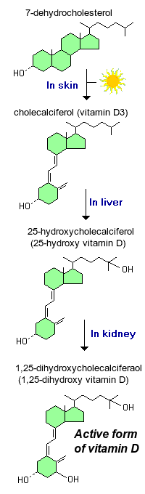
Consider this: The kidney has the enzyme that converts the inactive 25-hydroxycholecalciferol into the active 1,25-dihydroxycholecalciferol. The above diagrams show you that it is called 1-alpha-hydroxylase. If there were a hormone that would stimulate the kidney to make more 1-alpha-hydroxylase then that hormone would be causing the production of more Calcitriol (1,25-dihydroxycholecalciferol).
WAIT. Stop right there. Don’t you dare try to introduce another hormone to this story right now. I’m barely understanding Vitamin-D, whoever that is. No new hormones yet, please. And another thing, you haven’t even told me what this darn Vitamin-D, I mean Calcitriol, wait, let me call it 1,25-dihydroxycholecalciferol does.
What does it DO?
How’s this for a ‘non-answer’….it binds to the Vitamin-D-Receptor. As we saw before, it actually does many things in the body but the one, single thing we’ll focus on is this: Calcitriol acts to increase blood calcium levels.
It does this by signaling the absorptive cells of the small intestine to move calcium out of the lumen of the small intestine, into the absorptive cell, through the absorptive cell, out of the bottom of the absorptive cell and then into the blood. Simply ‘absorption’ of calcium in the small intestine.
Calcitriol, or 1,25-dihydroxycholecalciferol, increases the amount of calcium these absorptive cells absorb out of the lumen of the small intestine.
HOW?
Easy.
Just watch this video:
Ignore that he calls it ‘calcifidiol’, he means 25-hydroxycholecalciferol.
He calls it an ‘enterocyte’, we know it as an absorptive cell of the small intestine.
Only watch up to 3:30.
https://www.youtube.com/watch?v=YEnxruA-bsk
This video below might be helpful also.
Know only up to 6:25. You do not need to know “insulin sensitization/anti-inflammation/serum lipid balance’.
https://www.youtube.com/watch?v=DP9RHWgNZ2U

Goodness Gracious Agness, you took me through 7 pages of notes just to explain that ‘vitamin-d’ triggers absorptive cells to increase calcium reabsorption. Why reabsorb more calcium? Well, if your blood calcium levels were to drop below the normal level.
Before we go on, let’s read ‘textbook language’ explanations of what we’ve just been through…..

Vitamin D (Calcitriol) (also known as 1,25-dihydroxycholecalciferol) (from the kidney)

Bioactive vitamin D or calcitriol is a steroid hormone that has long been known for its important role in regulating body levels of calcium and phosphorus, and in mineralization of bone. More recently, it has become clear that receptors for vitamin D are present in a wide variety of cells, and that this hormone has biologic effects which extend far beyond control of mineral metabolism.

Structure and Synthesis
The term vitamin D is, unfortunately, an imprecise term referring to one or more members of a group of steroid molecules. Vitamin D₃, also known as cholecalciferol is generated in the skin of animals when light energy is absorbed by a precursor molecule 7-dehydrocholesterol. Vitamin D is thus not a true vitamin, because individuals with adequate exposure to sunlight do not require dietary supplementation. There are also dietary sources of vitamin D, including egg yolk, fish oil and a number of plants. The plant form of vitamin D is called vitamin D₂ or ergosterol. However, natural diets typically do not contain adequate quantities of vitamin D, and exposure to sunlight or consumption of foodstuffs purposefully supplemented with vitamin D are necessary to prevent deficiencies.
Vitamin D, as either D₃ or D₂, does not have significant biological activity. Rather, it must be metabolized within the body to the hormonally-active form known as 1,25-dihydroxycholecalciferol. This transformation occurs in two steps:
- Within the liver, cholecalciferol is hydroxylated to 25-hydroxycholecalciferol by the enzyme 25-hydroxylase.
- Within the kidney, 25-hydroxycholecalciferol serves as a substrate for 1-alpha-hydroxylase, yielding 1,25-dihydroxycholecalciferol, the biologically active form.
Each of the forms of vitamin D is hydrophobic and is transported in blood bound to carrier proteins. The major carrier is called, appropriately, vitamin D-binding protein. The halflife of 25-hydroxycholecalciferol is several weeks, while that of 1,25-dihydroxycholecalciferol is only a few hours.

Control of Vitamin D Synthesis
Hepatic synthesis of 25-hydroxycholecalciferol is only loosely regulated, and blood levels of this molecule largely reflect the amount of vitamin D produced in the skin or ingested. In contrast, the activity of 1-alpha-hydroxylase in the kidney is tightly regulated and serves as the major control point in production of the active hormone. The major inducer of 1-alpha-hydroxylase is parathyroid hormone; it is induced by low blood levels of calcium.

The Vitamin D Receptor and Mechanism of Action
The active form of vitamin D binds to intracellular receptors that then function as transcription factors to modulate gene expression. Like the receptors for other steroid hormones and thyroid hormones, the vitamin D receptor has hormone-binding and DNA-binding domains.
The vitamin D receptor binds several forms of cholecalciferol. Its affinity for 1,25-dihydroxycholecalciferol is roughly 1000 times that for 25-hydroxycholecalciferol, which explains their relative biological potencies.

Physiological Effects of Vitamin D
Vitamin D is well known as a hormone that facilitates intestinal absorption of calcium, although it also stimulates absorption of phosphate and magnesium ions. In the absence of vitamin D, dietary calcium is not absorbed at all efficiently. Vitamin D stimulates the expression of a number of proteins involved in transporting calcium from the lumen of the intestine, across the absorptive cells of the small intestine and into blood.
______________________________________________________________________________
So the biologically active form of Vitamin D acts to increase blood calcium.
SO DOES THE PARATHYROID GLAND! The hormone released from the parathyroid glands (there are 4 of them) is called parathyroid hormone (PTH) and this hormone acts to increase blood calcium.
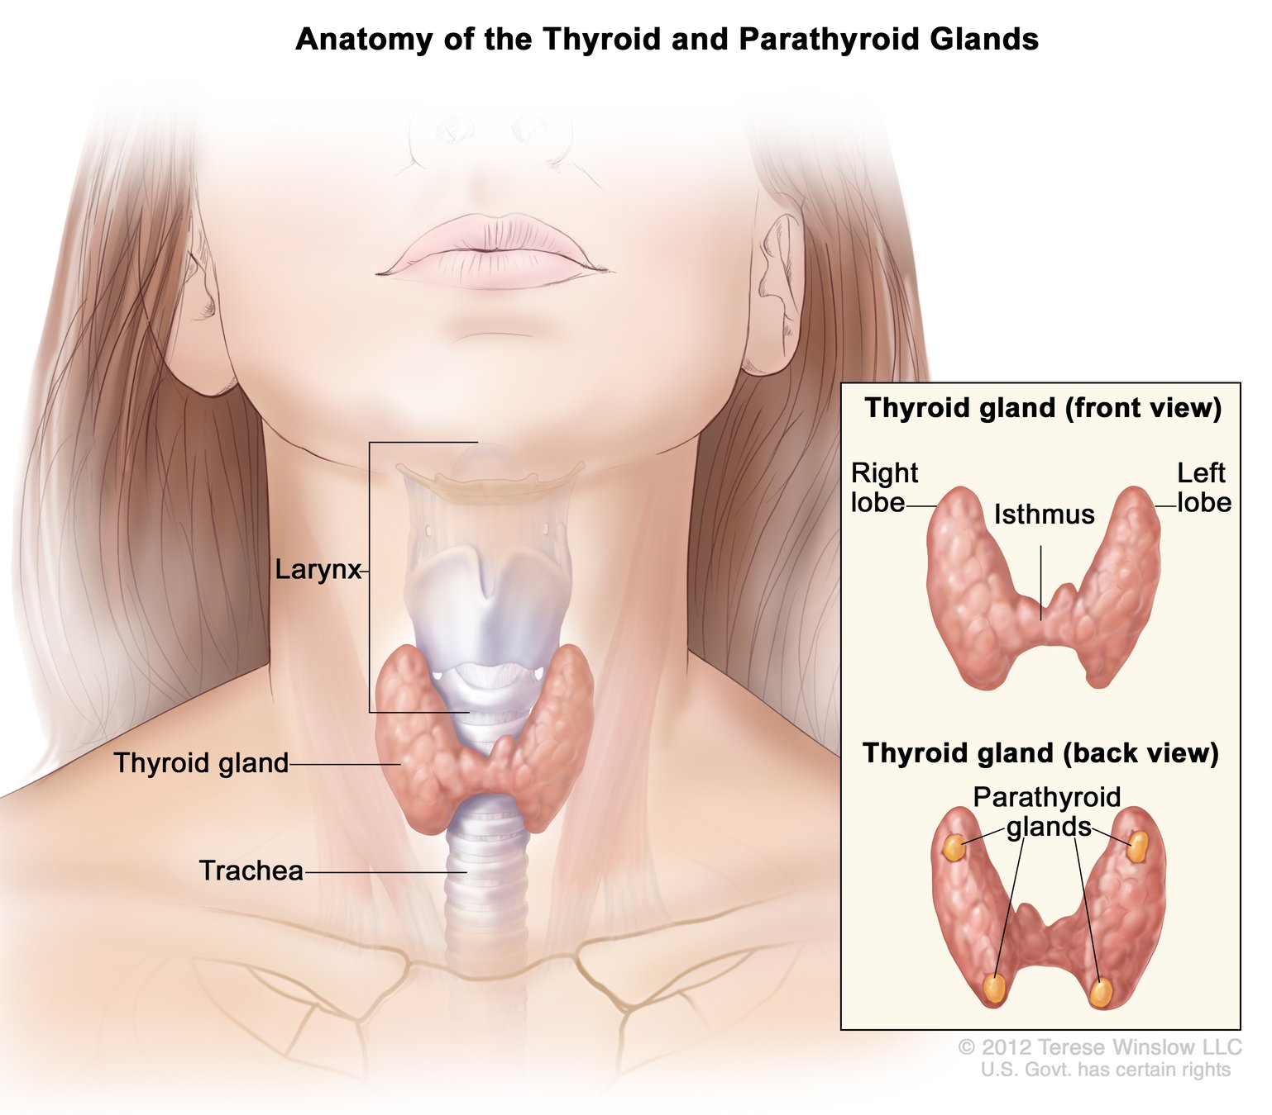
I’ll let him help explain. Enjoy his accent (I enjoy how he says ‘liver’ and ‘together’).
So it turns out that Calcitriol is a minor player. The much more powerful hormone involved in increasing blood calcium is …… Parathyroid Hormone!
If your blood calcium gets low, the parathyroid glands will sense that, and they will release parathyroid hormone out into the blood. The parathyroid hormone acts 3 ways to increase blood calcium. It targets the intestines to absorb more calcium. It targets the kidneys to reabsorb more calcium from the filtrate. It targets bone to release calcium (reabsorption of bone by osteoclasts).
https://www.youtube.com/watch?v=JYQL7JEsF_4
Parathyroid hormone stimulates 1-alpha-hydroxylase in the kidney to do the last step in the synthesis of calcitriol. More calcitriol acts on the absorptive cells of the small intestine to increase calcium reabsorption (as you learned in the first video).

Disease States
Vitamin D deficiency: This can result from lack of sunlight, genetic mutations in the Vitamin-D receptor, and severe liver or kidney diseases.

If you recently had a blood test that showed very high or very low calcium levels, your doctor may suggest you get another type of blood test.
This test would measure your parathyroid hormone (PTH) levels.
PTH is made by four tiny parathyroid glands in your neck. These glands control calcium levels in your blood. When calcium levels are too low, the glands release PTH to bring the calcium levels back up into a normal range. When your calcium levels rise, the glands stop releasing PTH.
Measuring PTH can help explain the reason for abnormal calcium levels. PTH increases blood calcium levels.
The major target end organs for parathyroid hormone (PTH) action are the kidneys, skeletal system, and intestine. The primary response to parathyroid hormone (PTH) by the kidney and the intestine is to increase renal calcium resorption to increase blood calcium. Likewise, PTH triggers release of calcium from storage in the bone to increase calcium in the blood.
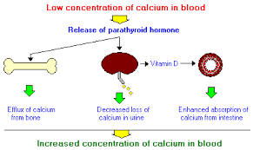

Calcitriol is the active form of vitamin D, normally made in the kidney. It is also known as 1,25-dihydroxycholecalciferol. It is a hormone which binds to and activates the vitamin D receptor in the nucleus of the cell, which then increases the expression of many genes. Calcitriol increases blood calcium (Ca²⁺) mainly by increasing the uptake of calcium from the intestines.
PTH increases synthesis of calcitriol. Calcitriol, in turn, increases calcium absorption from the intestine.

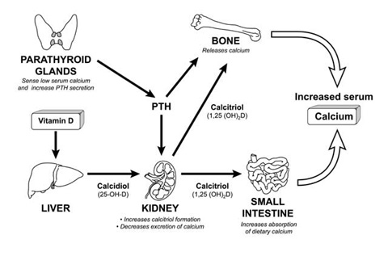
The parathyroid glands sense the serum calcium level and secrete parathyroid hormone (PTH) if it becomes too low, for example, when dietary calcium intake is inadequate. PTH stimulates the activity of the 1-hydroxylase enzyme in the kidney, resulting in increased production of calcitriol, the biologically active form of vitamin D₃. Increased calcitriol production restores normal serum calcium levels by activating the vitamin D-dependent transport system in the small intestine, increasing the absorption of dietary calcium. PTH is also required to increase bone calcium mobilization and calcium reabsorption by the kidneys.
The End.
WAIT!
What?
Thanks for the lecture notes and all, but this is no time to just end it. I learned some ‘good stuff’ and I’m grateful for that but I don’t know what I learned overall. Is this lecture about Vitamin-D (or whatever you want to call it) OR is this lecture about parathyroid hormone? Can you just sort of give the ‘wrap-it-up’ overview of what you’re talking about. Please.
OK, here goes. From the top.
How does the body regulate blood calcium levels? Well, with parathyroid hormone (PTH) if the blood calcium level is too low.
If the blood calcium level drops below normal, the Calcium Sensing Receptors (CaSR) in the parathyroid cells detect this and signal the cells of the parathyroid gland to release parathyroid hormone. That’s easy.
That is easy. Are you going to keep it easy? Do we have to know how the CaSR triggers the parathyroid gland cells to release parathyroid hormone? Some sort of G-protein pathway? No. Just know the CaSR are used by the cells of the parathyroid gland to detect blood calcium levels and that the parathyroid gland cells release parathyroid hormone when blood calcium drops below normal. Still easy.
What does parathyroid hormone do out in the body? Well, it targets three tissues primarily: The Bone / The Kidney / The Intestines.
Parathyroid hormone signals the osteoclasts to do what they do and reabsorb bone, releasing calcium into the blood. Do we have to know that biochemical pathway?
Well, here is that pathway, so NO we don’t. Kind of complicated:
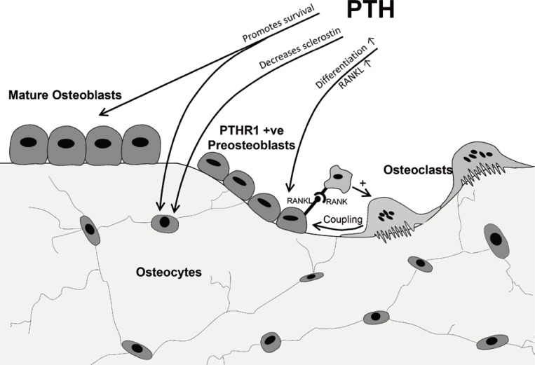
So we’re done with the bone part. Next is PTH acting on the kidneys. PTH triggers the tubular cells of the kidneys to reabsorb calcium from the filtrate into the blood, thus raising the blood calcium level. That’s that. We are not going to learn how the tubular cells of the kidneys move calcium from the filtrate to the blood.
Part 3: How does PTH act on the small intestine to have the absorptive cells of the small intestine absorb calcium from within the small intestine into the blood?
VITAMIN – D (Well, the biologically active form: 1,25-dihydroxycholecalciferol).
Check out this pathway. PTH acts on the kidney to increase the production of this enzyme:
1-hydroxylase. And what does that specific enzyme do? It enzymatically converts the inactive 25-hydroxycholecalciferol into the active form of Vit-D = 1,25 dihdroxycholecalciferol. BOOM.
What does 1,25 dihdroxycholecalciferol do? Rewatch the video (only up to 3:30): it binds to
the Vitamin-D receptor in the absorptive cells of the small intestine, this binds the DNA to produce several mRNAs which translate into these vital proteins:
-calcium transporter -calbindin -Calcium ATPase pump
and in this way calcium is absorbed into the blood in the small intestine.
And where did the precursor to the biologically active version of Vitamin-D, 25-hycroxycholecalciferol come from? The Vitamin-D synthesis pathway.
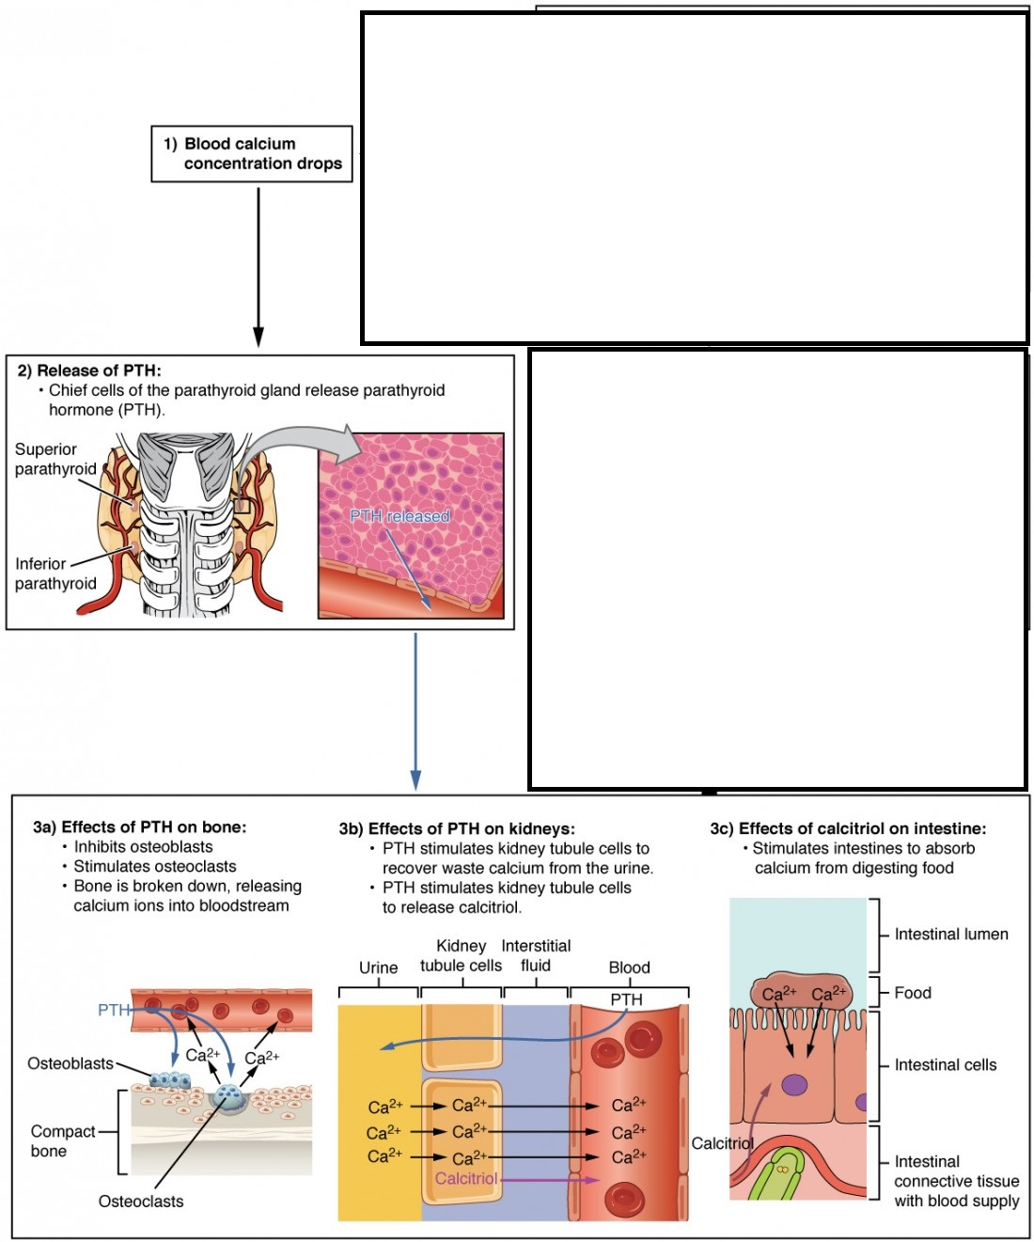
When someone says ‘Vitamin-D’, they mean 1,25-dihydroxycholecalciferol and it is a HORMONE.

