**Hormones:**

**Endocrine glands** release chemical substances directly into the bloodstream or tissues of the body. The chemical substances released by the endocrine glands are known as hormones. **Exocrine glands** release chemical substances through ducts to outside the body or onto another surface within the body.

Examples of **exocrine glands** include: salivary glands; bile-producing glands of liver; sweat glands; gastric glands; digestive enzyme producing cells of pancreas.

**Endocrine gland: A gland that secretes a substance (a hormone) into the bloodstream. The endocrine glands are "glands of internal secretion."**

**Endocrine hormones** like estrogen are messenger molecules that are secreted by endocrine glands into the bloodstream. They travel throughout the body in the circulation. Although they reach virtually every cell in the body in this way, each hormone affects only certain cells, called target cells. A **target cell** is the type of cell on which a hormone has an effect. A target cell is affected by a particular hormone because it has receptor proteins — either on the cell surface or within the cell — that are specific to that hormone. An endocrine hormone travels through the bloodstream until it finds a target cell with a matching receptor to which it can bind. When the hormone binds to the receptor, it causes changes within the cell. The manner in which it changes the cell depends on whether the hormone is a steroid hormone or a non-steroid hormone.

***Steroid Hormones***

A **steroid hormone** such as estrogen is made of lipids. It is fat soluble, so it can diffuse across a target cell’s plasma membrane, which is also made of lipids. Once inside the cell, a steroid hormone binds with receptor proteins in the cytoplasm. As you can see in the diagram below, the steroid hormone and its receptor form a complex, called a steroid complex, which moves into the nucleus where it influences the expression of genes. Examples of steroid hormones include cortisol, which is secreted by the adrenal glands, and sex hormones, which are secreted by the gonads.

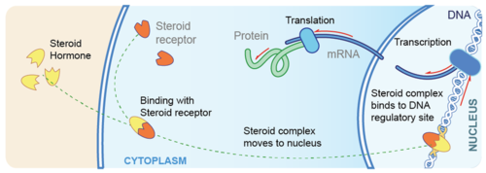

A steroid hormone crosses the plasma membrane of a target cell, binds with a receptor protein within the cytoplasm, and forms a complex that moves to the nucleus where it affects gene expression.

The steroid hormones are derived from cholesterol.

The gonads release steroid hormones.

The adrenal cortex releases steroid hormones.

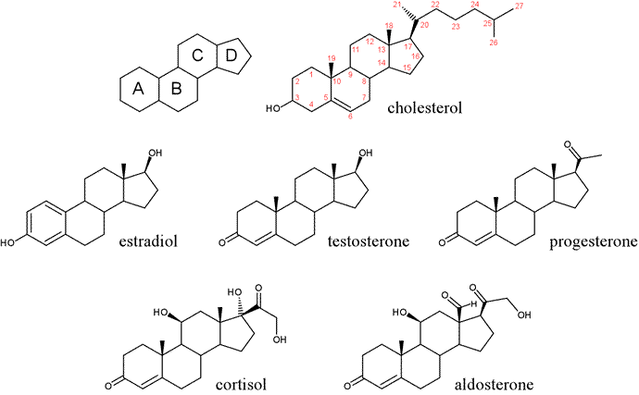

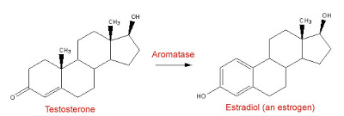

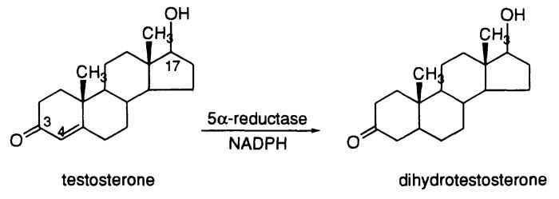

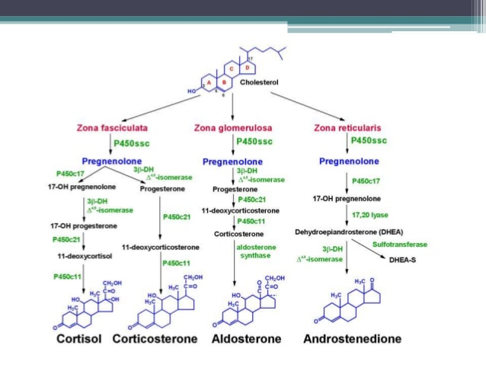

Dihydrotestosterone is a hormone that stimulates the development of male characteristics (an androgen). It is made through conversion of the more commonly known androgen, testosterone. Dihydrotestosterone is many times more potent than testosterone, and many of the effects that testosterone has in the body only happen after it is converted to dihydrotestosterone.

Testosterone molecules are secreted directly into the bloodstream – where many of them soon bind to other molecules known as sex hormone binding globulin, or SHBG. Other testosterone molecules bind to albumin – an important type of blood protein. And the rest of your testosterone – the unbound testosterone? This testosterone is – quite appropriately – termed “free testosterone,” or free T, because it isn’t attached to other molecules. Your body actively uses free T molecules since they are at liberty to enter the body’s cells – unimpeded by SHBG or albumin – to carry out their function as signaling molecules that regulate metabolism and other cellular functions.

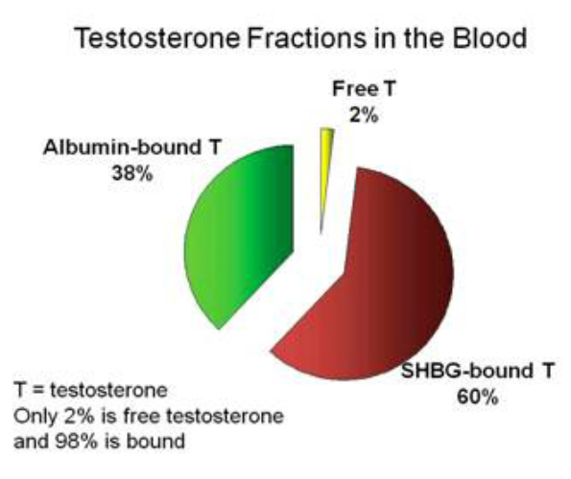 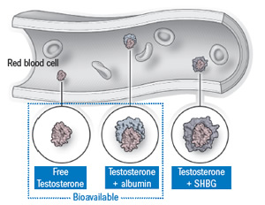

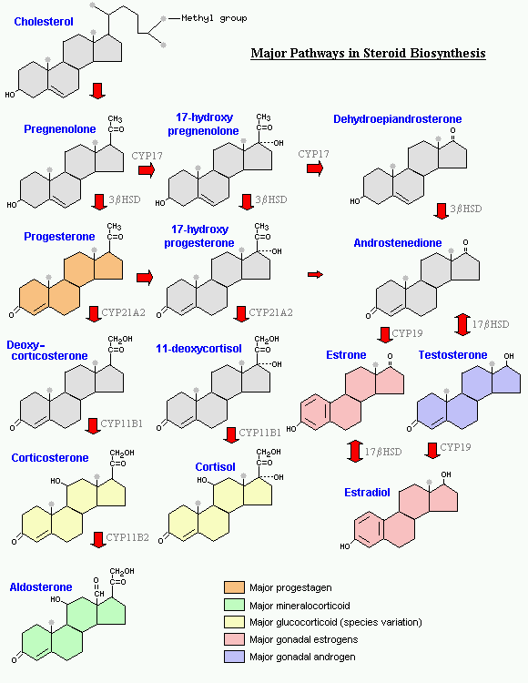

Estradiol is the predominant estrogen during reproductive years both in terms of absolute serum levels as well as in terms of estrogenic activity. During menopause, estrone is the predominant circulating estrogen.

Cholesterol is the precursor of the five steroid hormones: progesterone, the glucocorticoid cortisol, the mineralocorticoid aldosterone, testosterone (dihydrotestosterone) and estrogen (estradiol). These hormones are powerful signal molecules that regulate a host of organismal functions. Progesterone prepares the lining of the uterus for implantation of an ovum. Progesterone is also essential for the maintenance of pregnancy. Testosterone, an androgen, is necessary for the development of male secondary sex characteristics, whereas estrogen is required for the development of female secondary sex characteristics. Estrogens, along with progesterone, also participate in the ovarian cycle.

Glucocorticoids (such as cortisol) promote gluconeogenesis, enhance the degradation of fat and protein, and inhibit the inflammatory response. They enable animals to respond to stress—indeed, the absence of glucocorticoids can be fatal. Mineralocorticoids (primarily aldosterone) act on the distal tubules of the kidney to increase the reabsorption of Na+, followed by CL- and hence reabsorption of water molecules which leads to an increase in blood volume and blood pressure. The major sites of synthesis of these classes of hormones are the corpus luteum, for progesterone; the ovaries, for estrogens; the testes, for the androgen testosterone; and the adrenal cortex, for glucocorticoids and mineralocorticoids.

Steroid hormones bind to and activate receptor molecules that serve as transcription factors to regulate gene expression. These small, relatively similar molecules are able to have greatly differing effects because the slight structural differences among them allow interactions with specific receptor molecules.

Since steroid hormones are fat soluble in order to freely pass through the phospholipid bilayer they are transported in the blood attached to carrier proteins which then gives them longer half-lives than non-steroidal hormones.

And by the way, Bioactive vitamin D or calcitriol is a steroid hormone that has long been known for its important role in regulating body levels of calcium and phosphorus, and in mineralization of bone.

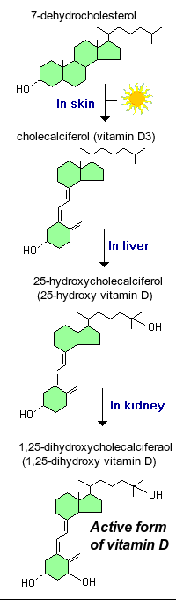

#### Structure and Synthesis

The term vitamin D is, unfortunately, an imprecise term referring to one or more members of a group of steroid molecules. Vitamin D3, also known as **cholecalciferol** is generated in the skin of animals when light energy is absorbed by a precursor molecule 7-dehydrocholesterol. Vitamin D is thus not a true vitamin, because individuals with adequate exposure to sunlight do not require dietary supplementation. There are also dietary sources of vitamin D, including egg yolk, fish oil and a number of plants. The plant form of vitamin D is called vitamin D2 or ergosterol. However, natural diets typically do not contain adequate quantities of vitamin D, and exposure to sunlight or consumption of foodstuffs purposefully supplemented with vitamin D are necessary to prevent deficiencies.

Vitamin D, as either D3 or D2, does not have significant biological activity. Rather, it must be metabolized within the body to the hormonally-active form known as 1,25-dihydroxycholecalciferol. This transformation occurs in two steps, as depicted in the diagram to the left:

1. **Within the liver**, cholecalciferol is hydroxylated to *25-hydroxycholecalciferol* by the enzyme 25-hydroxylase.
2. **Within the kidney**, 25-hydroxycholecalciferol serves as a substrate for 1-alpha-hydroxylase, yielding *1,25-dihydroxycholecalciferol*, the biologically active form.

Each of the forms of vitamin D is hydrophobic, and is transported in blood bound to carrier proteins. The major carrier is called, appropriately, vitamin D-binding protein.

Intracellular hormone receptors are located inside the cell. Hormones that bind to this type of receptor must be able to cross the cell membrane. Steroid hormones are derived from cholesterol and therefore can readily diffuse through the lipid bilayer of the cell membrane to reach the intracellular receptor. Thyroid hormones, which contain benzene rings studded with iodine, are also lipid-soluble and can enter the cell.

The location of steroid and thyroid hormone binding differs slightly: a steroid hormone may bind to its receptor within the cytosol or within the nucleus. In either case, this binding generates a hormone-receptor complex that moves toward the genes in the cell nucleus and binds to a particular segment of the cell’s DNA. In contrast, thyroid hormones bind to receptors already bound to DNA. Thyroid hormones, T3 and T4, are not derived from cholesterol but are made up of iodine (of course) and amino acids and are lipid soluble. For both steroid and thyroid hormones, binding of the hormone-receptor complex with DNA triggers transcription of a target gene to mRNA, which moves to the cytosol and directs protein synthesis by ribosomes.

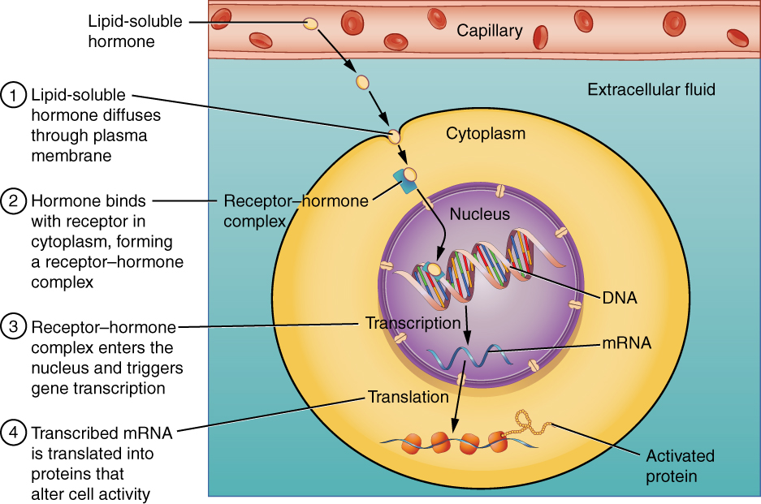

Binding of Lipid-Soluble Hormones

A steroid hormone directly initiates the production of proteins within a target cell. Steroid hormones easily diffuse through the cell membrane. The hormone binds to its receptor in the cytosol, forming a receptor–hormone complex. The receptor–hormone complex then enters the nucleus and binds to the target gene on the DNA. Transcription of the gene creates a messenger RNA that is translated into the desired protein within the cytoplasm.

***Non-steroid Hormones***

A **non-steroid hormone** is made of amino acids. It is not fat soluble, so it cannot diffuse across the plasma membrane of a target cell. Instead, it binds to a receptor protein on the cell membrane. In the following diagram, you can see that the binding of the hormone with the receptor activates an enzyme in the cell membrane. The enzyme then stimulates another molecule, called the second messenger, which influences processes inside the cell. Most endocrine hormones are non-steroid hormones. Examples include glucagon and insulin, both produced by the pancreas.

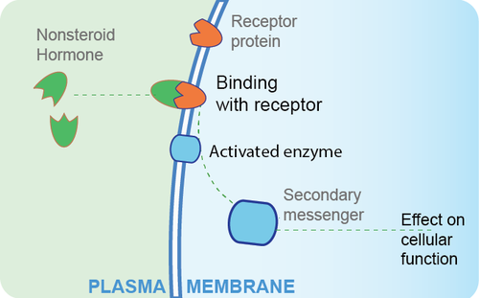

A non-steroid hormone binds with a receptor protein on the plasma membrane of a target cell. This activates an enzyme, which controls a secondary messenger molecule.

Hydrophilic, or water-soluble, hormones are unable to diffuse through the lipid bilayer of the cell membrane and must therefore pass on their message to a receptor located at the surface of the cell. Except for thyroid hormones, which are lipid-soluble, all amino acid–derived hormones bind to cell membrane receptors that are located, at least in part, on the extracellular surface of the cell membrane. Therefore, they do not directly affect the transcription of target genes, but instead initiate a signaling cascade that is carried out by a molecule called a **second messenger**. In this case, the hormone is called a **first messenger**.

The second messenger used by most hormones is **cyclic adenosine monophosphate (cAMP)**. In the cAMP second messenger system, a water-soluble hormone binds to its receptor in the cell membrane (Step 1). This receptor is associated with an intracellular component called a **G protein**, and binding of the hormone activates the G-protein component (Step 2). The activated G protein in turn activates an enzyme called **adenylyl cyclase**, also known as adenylate cyclase (Step 3), which converts adenosine triphosphate (ATP) to cAMP (Step 4). As the second messenger, cAMP activates a type of enzyme called a **protein kinase** that is present in the cytosol (Step 5). Activated protein kinases initiate a **phosphorylation cascade**, in which multiple protein kinases phosphorylate (add a phosphate group to) numerous and various cellular proteins, including other enzymes (Step 6).

**cAMP:**

ADH; Calcitonin; Glucagon; FSH; LH; MSH; Parathyroid Hormone; TSH; Somatostatin;

Chorionic gonadotropin hormone.

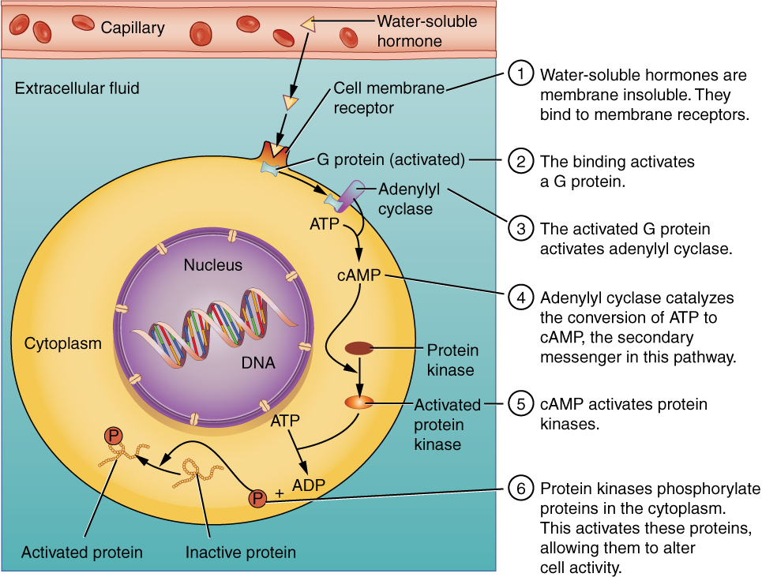

Binding of Water-Soluble Hormones

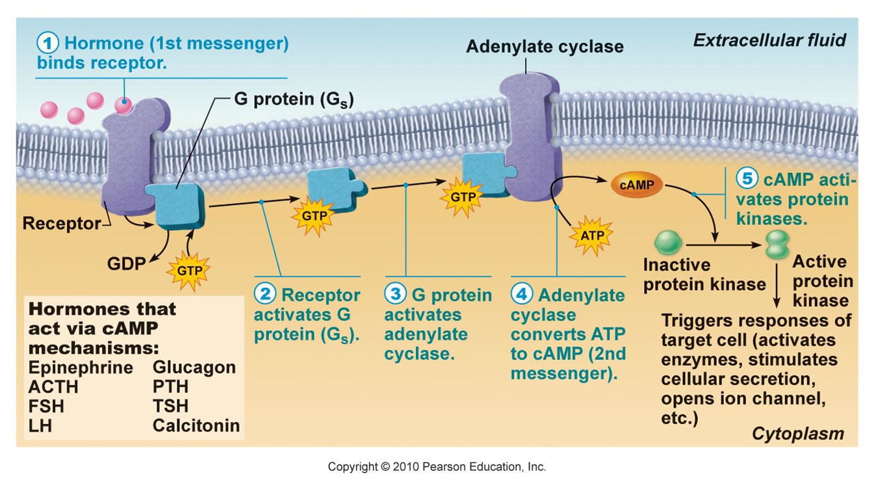

Water-soluble hormones cannot diffuse through the cell membrane. These hormones must bind to a surface cell-membrane receptor. The receptor then initiates a cell-signaling pathway within the cell involving G proteins, adenylyl cyclase, the secondary messenger cyclic AMP (cAMP), and protein kinases. In the final step, these protein kinases phosphorylate proteins in the cytoplasm. This activates proteins in the cell that carry out the changes specified by the hormone.

The phosphorylation of cellular proteins can trigger a wide variety of effects, from nutrient metabolism to the synthesis of different hormones and other products. The effects vary according to the type of target cell, the G proteins and kinases involved, and the phosphorylation of proteins. Examples of hormones that use cAMP as a second messenger include calcitonin, which is important for bone construction and regulating blood calcium levels; glucagon, which plays a role in blood glucose levels; and thyroid-stimulating hormone, which causes the release of T3 and T4 from the thyroid gland.

Overall, the phosphorylation cascade significantly increases the efficiency, speed, and specificity of the hormonal response, as thousands of signaling events can be initiated simultaneously in response to a very low concentration of hormone in the bloodstream. However, the duration of the hormone signal is short, as cAMP is quickly deactivated by the enzyme **phosphodiesterase (PDE)**, which is located in the cytosol. The action of PDE helps to ensure that a target cell’s response ceases quickly unless new hormones arrive at the cell membrane.

Not all water-soluble hormones initiate the cAMP second messenger system. One common alternative system uses calcium ions as a second messenger. In this system, G proteins activate the enzyme phospholipase C (PLC), which functions similarly to adenylyl cyclase. Once activated, PLC cleaves a membrane-bound phospholipid, **Phosphatidylinositol 4,5-bisphosphate (PIP2),** into two molecules: **diacylglycerol (DAG)** and **inositol triphosphate (IP3)**. Like cAMP, DAG activates protein kinases that initiate a phosphorylation cascade. At the same time, IP3 causes calcium ions to be released from storage sites within the cytosol, such as from within the smooth endoplasmic reticulum. The calcium ions then act as second messengers in two ways: they can influence enzymatic and other cellular activities directly, or they can bind to calcium-binding proteins, the most common of which is calmodulin. Upon binding calcium, calmodulin is able to modulate protein kinase within the cell. Examples of hormones that use calcium ions as a second messenger system include angiotensin II, which helps regulate blood pressure through vasoconstriction, and growth hormone–releasing hormone (GHRH), which causes the pituitary gland to release growth hormones.

**DAG:**

Oxytocin; GnRH; GHRH; TRH.

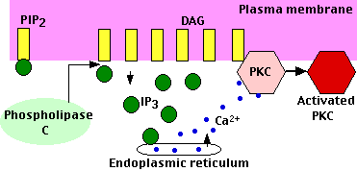

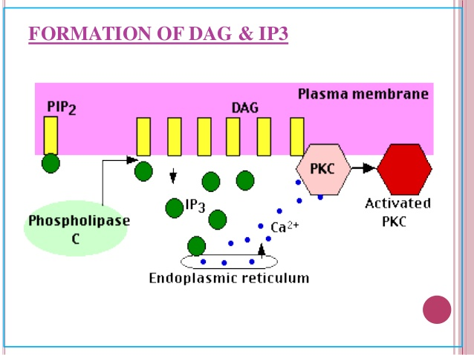

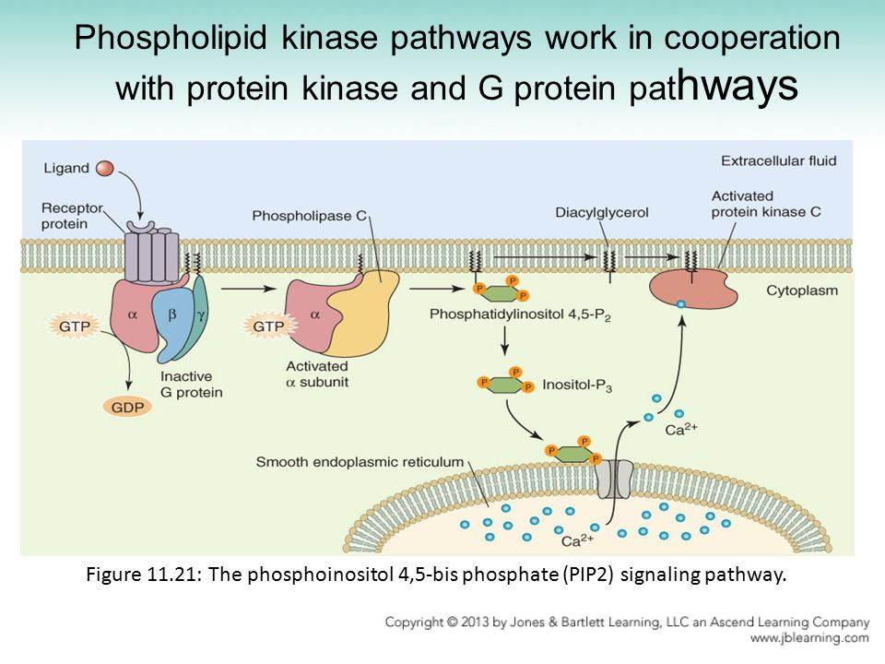

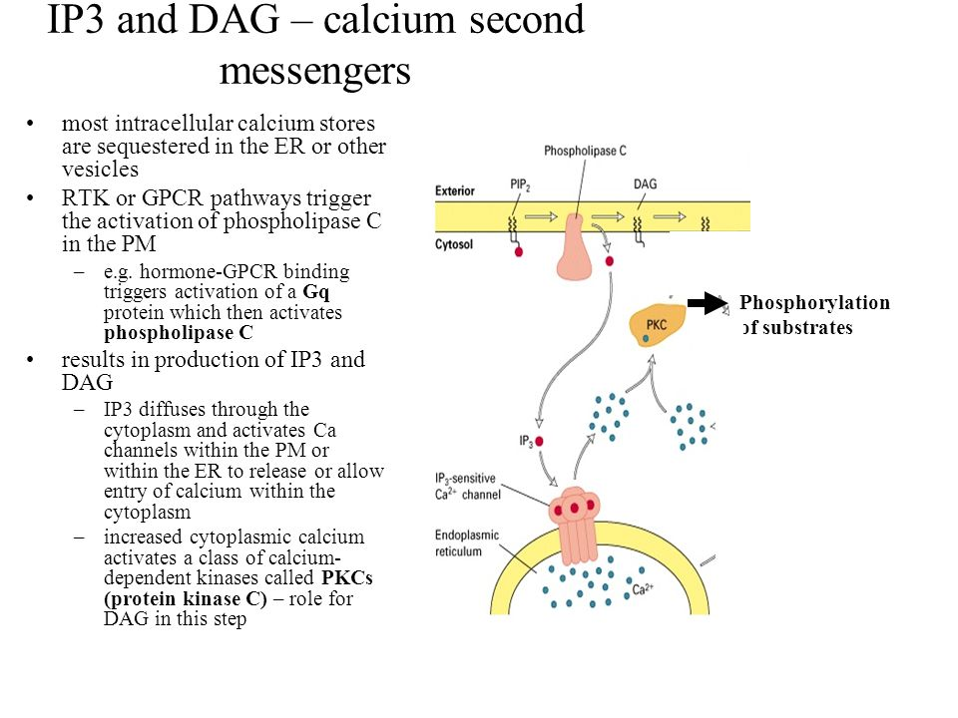

**JAK2:**

Prolactin; GH.

(we will not be responsible for learning the JAK2 second messenger pathway).

**Regulation of Endocrine Hormones**

Endocrine hormones regulate many body processes, but what regulates the secretion of endocrine hormones? Most endocrine hormones are controlled by feedback mechanisms. A feedback mechanism is a loop in which a product feeds back to control its own production. Feedback loops may be either negative or positive.

* Most endocrine hormones are regulated by negative feedback loops. Negative feedback keeps the concentration of a hormone within a relatively narrow range and maintains homeostasis.
* Very few endocrine hormones are regulated by positive feedback loops. Positive feedback causes the concentration of a hormone to become increasingly higher.

***Regulation by Negative Feedback***

A negative feedback loop controls the synthesis and secretion of hormones by the thyroid gland. This loop includes the hypothalamus and pituitary gland in addition to the thyroid, as shown in the diagram below. When the levels of thyroid hormones circulating in the blood fall too low, the hypothalamus secretes thyrotropin releasing hormone (TRH). This hormone travels directly to the pituitary gland through the thin stalk connecting the two structures. In the pituitary gland, TRH stimulates the pituitary to secrete thyroid stimulating hormone (TSH). TSH, in turn, travels through the bloodstream to the thyroid gland and stimulates it to secrete thyroid hormones. This continues until the blood levels of thyroid hormones are high enough. At that point, the thyroid hormones feedback to stop the hypothalamus from secreting TRH and the pituitary from secreting TSH. Without the stimulation of TSH, the thyroid gland stops secreting its hormones. Eventually, the levels of thyroid hormones in the blood start to fall too low again. When that happens, the hypothalamus releases TRH, and the loop repeats.

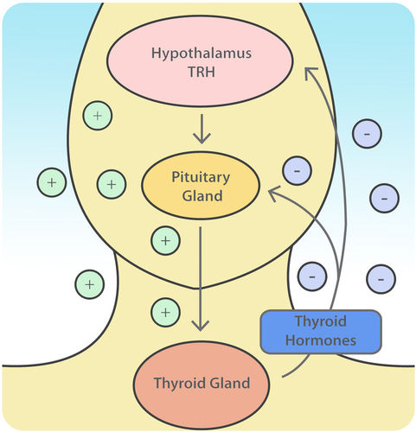

This diagram shows how the thyroid gland is regulated by a negative feedback loop that also involves the hypothalamus and pituitary gland.

What about how insulin signals the cells to decrease blood glucose? How does the insulin receptor work? The insulin receptor is called the ‘insulin receptor tyrosine kinase’, so when bound by insulin it phosphorylates many other molecules triggering many different pathways. As you can see from the diagram below, we will skip those pathways for now:

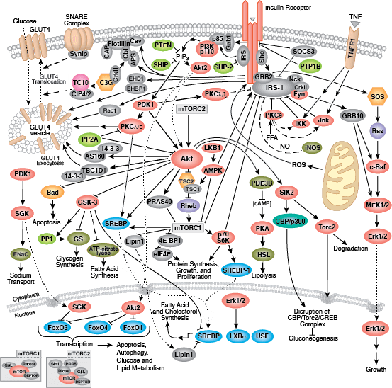

Growth hormone-releasing hormone is a hormone produced in the hypothalamus. The main role of growth hormone-releasing hormone is to stimulate the pituitary gland to produce and release growth hormone into the bloodstream. This then acts on virtually every tissue of the body to control metabolism and growth. Growth hormone stimulates production of insulin-like growth factor 1 in the liver and other organs, and this acts on tissues in the body to control metabolism and growth. GHRH uses the G-Protein/cAMP pathways.

**Growth Hormone** and **Insulin-like growth factor (IGF):**

Growth hormone stimulates many tissues, particularly the liver, to synthesize and secrete IGF-1, which in turn stimulates both hypertrophy (increase in cell size) and hyperplasia (increase in cell number) of most tissues, including bone.

Growth hormone is made in the anterior pituitary gland, is released into the blood stream, and then stimulates the liver to produce IGF-1. IGF-1 then stimulates systemic body growth, and has growth-promoting effects on almost every cell in the body, especially skeletal muscle, cartilage, bone, liver, kidney, nerve, skin, hematopoietic, and lung cells. GH triggers liver cells to release IGF-1 via the JAK2 second messenger pathway.

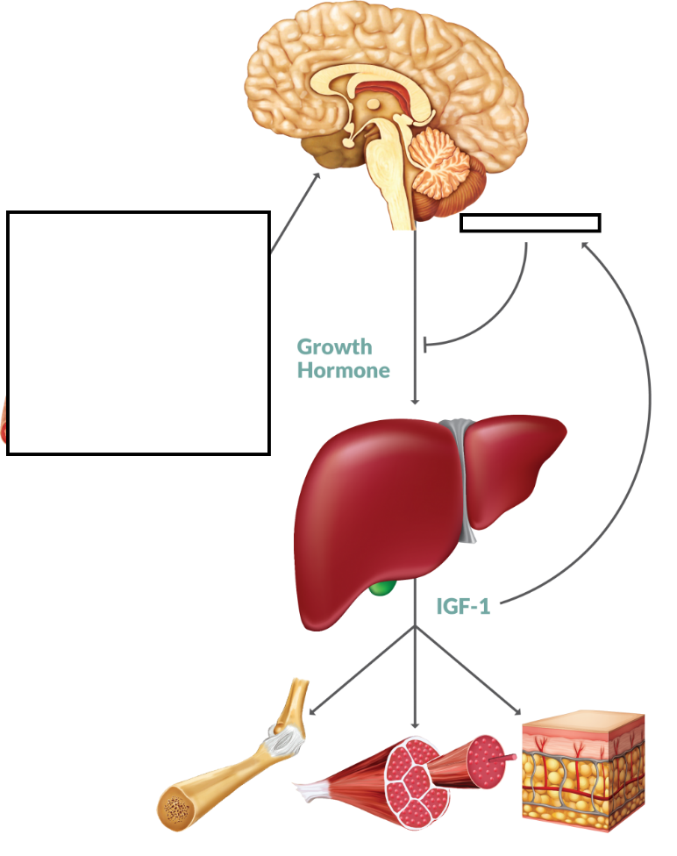

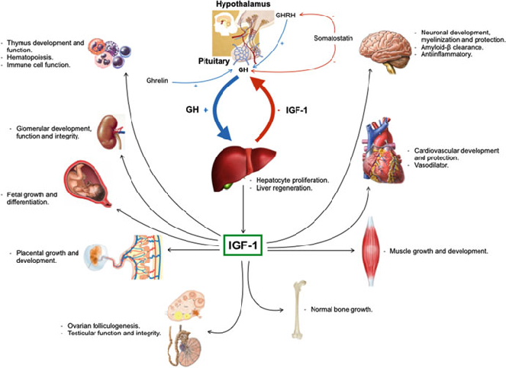

Gonadotropin-releasing hormone (GnRH):

Gonadotropin-releasing hormone is a releasing hormone responsible for the release of follicle-stimulating hormone and luteinizing hormone from the anterior pituitary. GnRH is a peptide hormone synthesized and released from GnRH neurons within the hypothalamus.

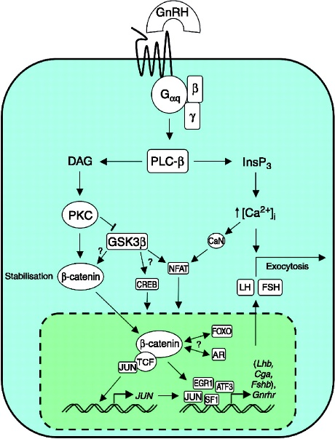Do not fear. The only thing to notice on the GnRH signaling pathway seen to the left is that GnRH uses the G-protein/DAG/IP3 pathway that results in the exocytosis of LH and FSH.

Once released into the blood, notice that FSH uses the G-Protein/cAMP pathway. Also, LH uses the G-Protein/cAMP pathway.

Be sure and study what FSH does in the female and in the male. As well as what LH does in the female and male.

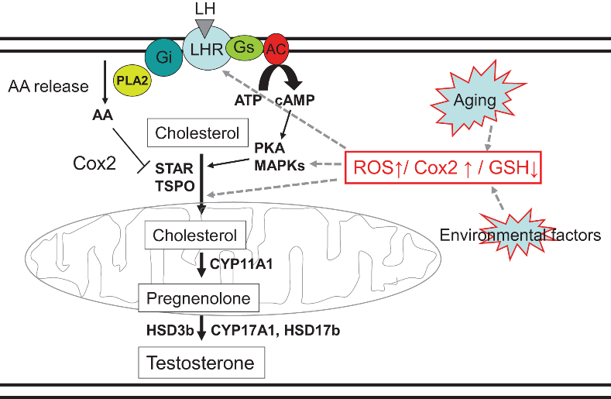

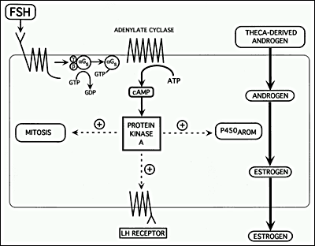

Remember that estrogen, 17B-estradiol, is a steroid hormone, entering the target cell, binding to its receptor, creating a ‘dimer’ which enters the nucleus to turn on the target cell’s function (ignore the TF and ERE):

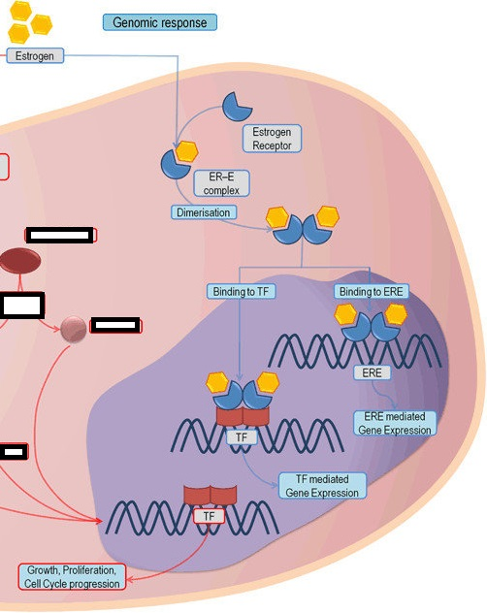 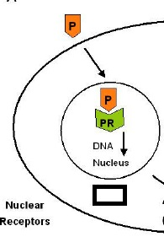

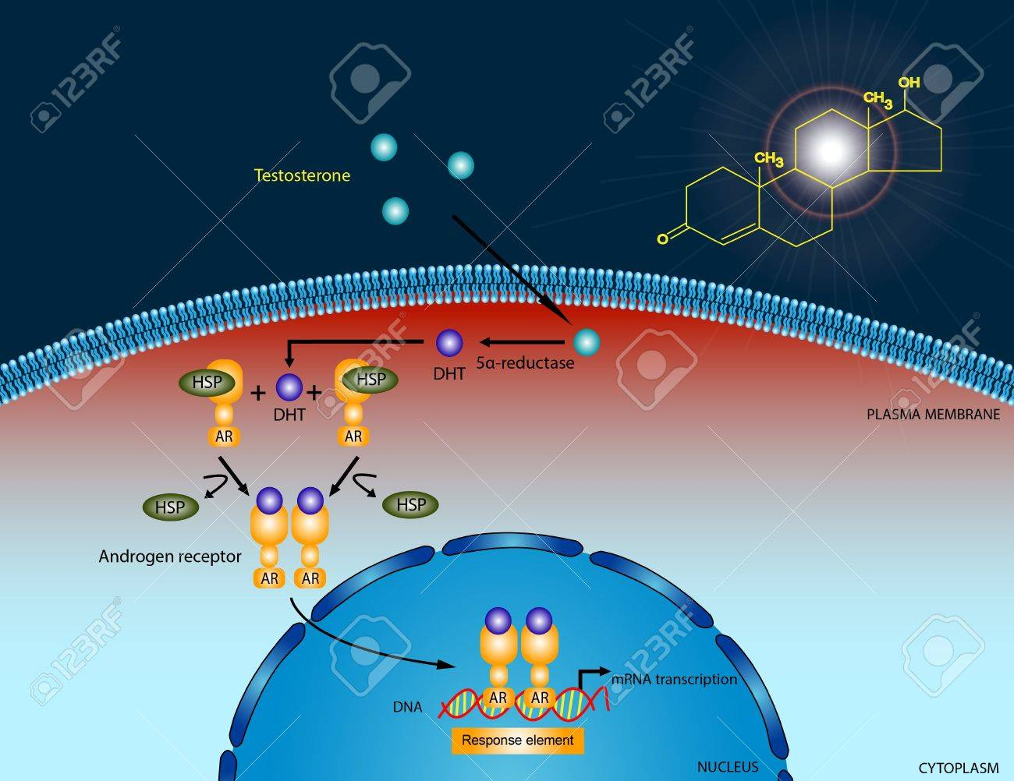

Testosterone diffuses through the plasma membrane and binds AR (androgen receptor), that enters the nucleus and binds to DNA.

**ACTH receptor** is primarily found in the zona fasciculata of the human adrenal cortex. Just note from the diagram that ACTH uses the G-Protein/cAMP pathway.

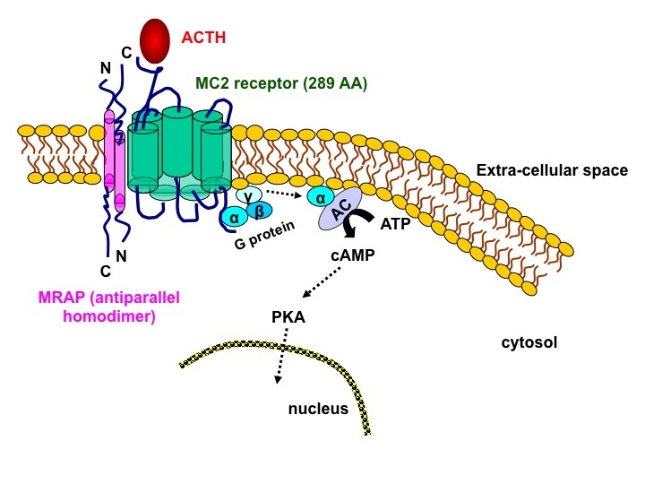

So then how does Cortisol work? Cortisol remember is a steroid hormone. In the diagram below you see it, represented as the small, dark hexagons entering the target cell and binding to GR (glucocorticoid receptor), this dimer then moving into the nucleus to bind to DNA.

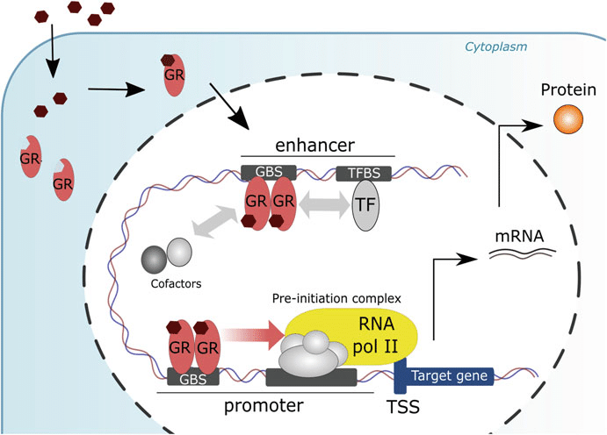

**Angiotensin II** **stimulates** the **secretion** of the hormone **aldosterone** from the adrenal cortex. Angiotensin II receptor stimulates the DAG/IP3 pathway for the release of aldosterone. You do not need to know these molecules, just recognize the G-protein/PIP2/IP3/DAG pathway. Aldosterone is a steroid hormone and so you can see it enters the target cell, binds to its receptor, MR, forms a dimer and that dimer enters the nucleus. Why do you think they labeled the aldosterone receptor, MR? Because it is a mineralocorticoid receptor.

