Phys 3 – EKG Instructions (Fall 2012)
Switch on the EKG by pressing the green ‘ON’ key. It is turned off by the red ‘OFF’ key.
Connecting the subject to the EKG:
White (has an ‘RA’ printed on it) goes to the Right Arm.
Green (has ‘RL’ printed on it) goes to the Right Leg.
Black (has an ‘LA’ printed on it) goes to the Left Arm.
Red (has ‘LL’ printed on it) goes to the Left Leg.
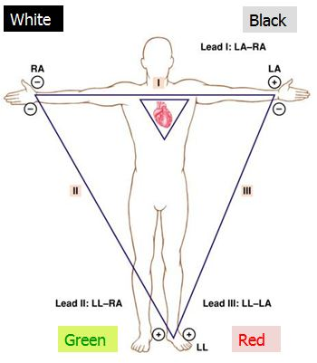
Note: Ankle electrodes should be placed with the tabs facing down (towards the ground). The snap-clips should not touch the “sticky” residue of the electrodes.
Auditory warning beeps and the “LEAD OFF” warning LED blinking light can be ignored, after electrodes and clips are connected.
Once the subject is hooked up:
Select the “(I, II, II)” lead channel using the blue up and down arrows.
To start the ECG recording, press the ‘MANUAL PRINT’ button.
Press the red “STOP” button to stop recording.

